


A PROJECT REPORT
ON
Mood-Time Based Recommendation Site

Submitted To:
Department of Computer Science and Multimedia
National College of Management and Technical Science
Samakhusi, Ranibari Marg
Kathmandu, Nepal
Submitted By:
Kapur Acharya
Dipin Puri
In the partial fulfillment of the requirement for
the 2nd Semester 1st Project

Date: 30th March 2026

ABSTRACT
In today's world, there are many movies and series across multiple platforms. It leads to confusion and decision fatigue when choosing the right movie for the right time. Most existing recommendation systems relieve complex algorithms, user history, popularity, trending, and user ratings and reviews. This recommendation system suggests too many movies, and the users must hustle to find the right one. This project, “Mood-Based Recommendation site”, aims to address this problem by providing a simple user interface and a rule-based recommendation system where the user needs to choose their mood and time availability, and the system recommends according to the user's input.The proposed system uses rule-based logic through a frontend such as HTML, CSS, JS, along with third-party APIs (TMDB) for fetching movie data. Users are required to choose their mood and time duration, then the system will display a single recommendation, which eliminates the hassle of choosing from many options.This project demonstrates the effective use of frontend development, UI/UX designs and API Integration, and decision-making logic to create a simple recommendation site. This site serves as an alternative for sites that use a Search-based recommendation system by offering simple, easy-to-use and faster access.

ACKNOWLEDGEMENT
I want to express my sincere gratitude to the Department of Computer Science and Multimedia, National College of Management and Technical Science, for providing me with the opportunity to work on this project. I am thankful to all my teachers for the knowledge and support provided during my academic journey. I also appreciate the encouragement and assistance provided by my friends and family members, which motivated me to complete this project proposal.

PREFACE
The motivation behind choosing this project is to reduce the fatigue of choosing the right movie for the right time. With the exposure to thousands of movies and series, it has become hectic to choose the right one. This project allows the user to find the best movie suited to their time and mood. It will help to eliminate confusion by selecting a movie.

DECLARATION
I hereby declare that the project work entitled
"Mood-Time Based Recommendation Site"
Submitted to the Department of Computer Science and Multimedia, National College of Management and Technical Science, is my original work carried out for the Second Semester Project of the Bachelor of Information Technology (BIT).
This work has not been submitted to any other institution for the award of any degree or diploma.

Kapur Acharya
Dipin Puri
Date: 2nd April 2026

CERTIFICATE FROM SUPERVISOR
This is to certify that the project work is entitled
"Mood-Time Based Recommendation Site"
Submitted by Kapur Acharya and Dipin Puri in partial fulfilment of the requirement for the 2nd Semester 1st Project of the Bachelor of Information Technology has been carried out under my supervision.
To the best of my knowledge, the matter embodied in this report is original work and has not been submitted earlier for the award of any degree or diploma to any institution.

_______________________
Shubham Gurung Lama
National College of Management and Technical Science
Kathmandu, Nepal

Table of Contents
ABSTRACT ii
ACKNOWLEDGEMENT iii
PREFACE iv
DECLARATION v
CERTIFICATE FROM SUPERVISOR vi
LIST OF FIGURES ix
LIST OF TABLES x
LIST OF ABBREVIATIONS xi
1. INTRODUCTION 1
1.1 Background of the study 1
1.2 Problem statement 1
1.3 Objectives of the Project 1
1.4 Scope of the Project 1
1.5 Significance of the Project 1
2. LITERATURE REVIEW 3
2.1 Review of Existing Systems 3
2.2 Comparative Analysis 3
2.3 Research Gap 4
3. SYSTEM ANALYSIS AND DESIGN 5
3.1 Feasibility Study 5
3.2 Requirements Specification 5
3.3 System Design 6
4. IMPLEMENTATION PLAN 7
4.1 Development Methodology 7
4.2 Module Breakdown 8
4.3 Tools, Platforms, and Languages 8
4.4 Project Timeline 8
4.5 Risk Analysis 9
5. Outcomes and Limitations 10
5.1 Product Features 10
5.2 User Benefits and Impacts 10
5.3 Limitations of the system 10
6. CONCLUSION 11
6.1 Summary 11
6.2 Future Scope 11
7. REFERENCES 12

LIST OF FIGURES
Figure 1: Flow Chart 6
Figure 2: Waterfall Model 7
Figure 3: Gantt Chart 8

LIST OF TABLES
Table 1: comparative Analysis 3
Table 2: Risk Analysis 9

LIST OF ABBREVIATIONS
UI | User Interface
UX | User Experiences
HTML | Hyper Text Markup Language
CSS | Cascading Style Sheet
TMDB | The Movies Database
API | Application Programming Interfaces

INTRODUCTION

Background of the study
With the increasing number of movies and series, users often struggle to find the right movies for themselves. Existing movie platforms offer extensive lists of films and series, but this can lead to decision fatigue. A good, mood-based recommendation site mitigates this problem by providing a single suggestion tailored to the user’s mood and time availability.

Problem statement
Users face many problems while choosing a movie or series to watch. There are too many options available, which makes it difficult to decide quickly. It is also hard for users to find something that matches their mood and the amount of time they have. Because of this, users often spend a lot of time searching and end up feeling tired and confused before selecting a movie or series.

Objectives of the Project
The objective of the MoodMatch movie recommendation project is to help users quickly find a suitable movie based on their current mood and available time. It uses a simple rule-based system with data from an external movie database to reduce decision fatigue and make movie selection faster and easier. The system also allows users to save their favorite movies in a watchlist for future viewing, improving overall user convenience and experience.

Scope of the Project
Included: Mood Selection, time-based filtering, rule-based recommendation logic, and sign-up page.
Excluded: Backend Database API, User review and ratings, users' history, etc.

Significance of the Project
The significance of this project lies in its ability to reduce decision fatigue by helping users quickly find the right movie based on their mood and available time. It provides a simple and user-friendly interface, serving as an effective alternative to traditional search engines where users often spend a considerable amount of time browsing to select a suitable movie. Additionally, from an academic perspective, this project helps students build a strong foundation in frontend web development, UI/UX design, and basic decision-making logic through practical implementation.

LITERATURE REVIEW

Review of Existing Systems
(GeeksforGeeks, 2006)There are already numerous sites that exist, such as Netflix, Amazon Prime, and IMDb, which provide movie recommendations based on popularity, ratings, trends, or users' watch histories. However, these sites are more complex and primarily use AI and machine learning to track the time users spend on their sites, the language users prefer, the devices users watch from, and other factors to find the correct movies. Google's search engine also recommends movies based on the keywords that users type in.

Comparative Analysis

Table 1: Comparative Analysis
Platform | Recommendation Method | Advantages | Disadvantages
Google Search Engine | Keyword-based search | Very fast and easy to access | General result, and decision fatigue, multiple links, time-consuming
IMDB | Users ‘ratings, popularity, genres, etc. | Trusted and detailed information about the movies and series | Too many options, large lists, confusion and hectic
Netflix | User history and AI-based recommendations | Personalised suggestions based on the movies the user had watched. ^{[1]} | Requires user login information and Paid access.
Proposed  Mood-Based Site | Mood and time-based rule logic |  | Predefined rules to recommend rather than Advanced AI.

Research Gap
Most systems that exist focus on search or complex AI-based recommendations that require a backend system and hold user data. However, this project is different as it mostly depends on the frontend system only, which focuses on the user's mood and time availability. It provides one simple recommendation at a time rather than multiple ones that confuse the user and make them fatigued. It will help to save time and effort from endlessly scrolling.

SYSTEM ANALYSIS AND DESIGN

Feasibility Study
- Technical feasibility: This project can be built using HTML, CSS, JavaScript, TMDB(API) ^{[2]}, and LocalStorage.
- Operational feasibility: The User can easily use the system due to its simple layout.
- Economic Feasibility: This project has no extra cost and can be hosted for free.
- Legal and Ethical feasibility: This project doesn’t collect sensitive data and is legal to operate.
- Schedule Feasibility: This project can be completed within 7-8 weeks.

Requirements Specification
    - Functional Requirements
- The user can select mood and available time.
- The system displays movie recommendation according to the user’s choice.
- User can save or skip movie recommended by the system.
- The system also displays the information about the site where the movie can be watched.
- User can change the theme between light and dark mode, according to their preferences.
    - Non-Functional Requirements
- Fast loading time (within 2–3 seconds)
- Smooth UI transitions and animations
- Simple and intuitive user interface
- Easy navigation for all users
- Works on desktop browsers
- Works on mobile devices

System Design
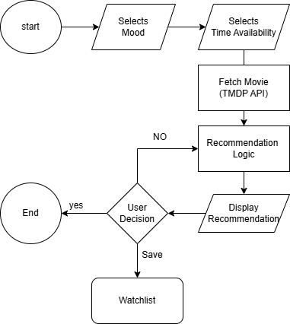
Figure 1: Flow Chart

IMPLEMENTATION PLAN

Development Methodology
(GeeksforGeeks, 2006)It uses the Iterative Waterfall model. The Iterative Waterfall model is a software development approach that combines the sequential steps of the traditional Waterfall model with the flexibility of iterative design. It allows for improvements and changes to be made at each stage of the development process, instead of waiting until the end of the project.
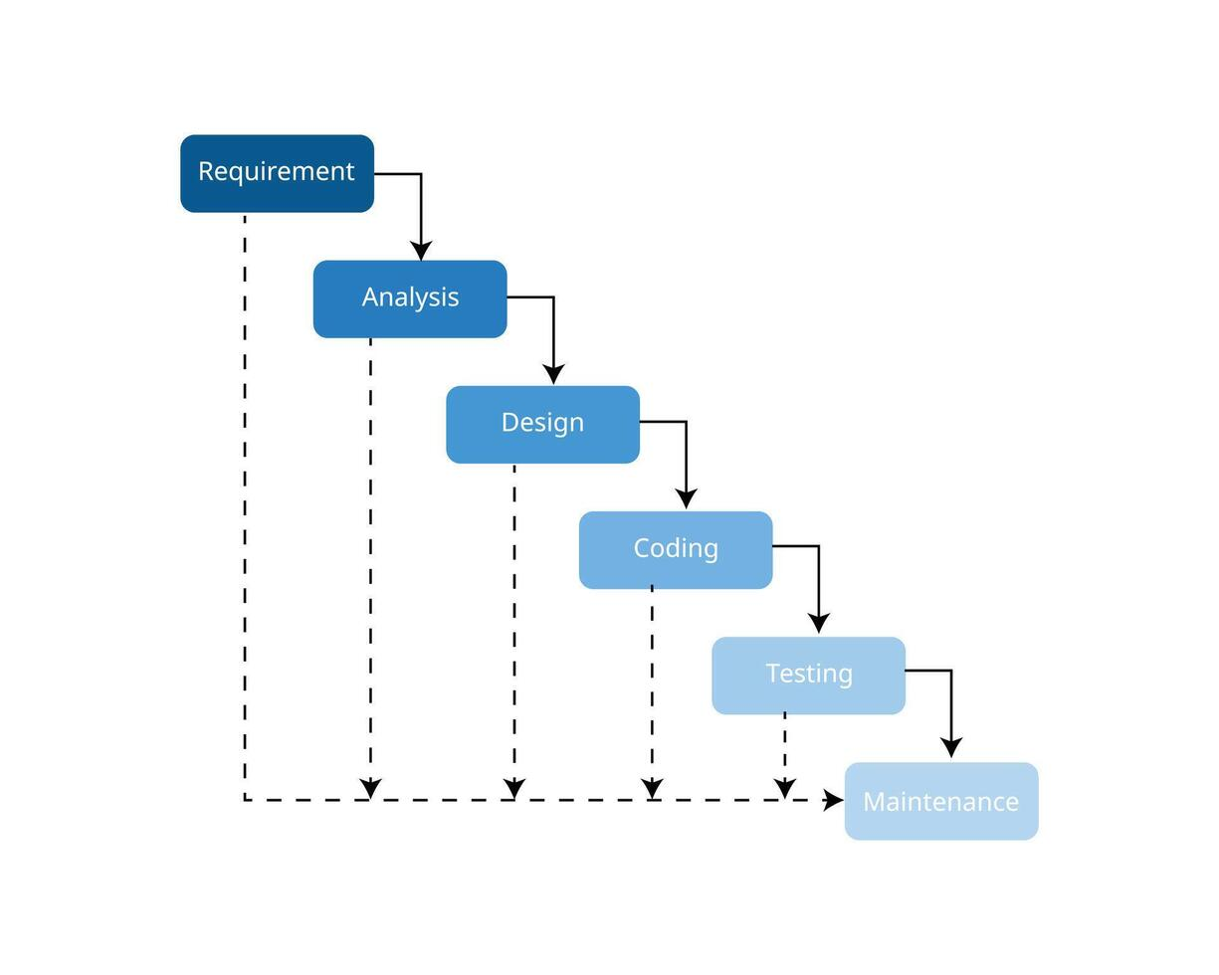
Figure 2: Waterfall Model

Module Breakdown
- Mood-time module: Takes input from the user
- Recommendation module: Selects a movie using rules.
- UI module: handles design and responsiveness

Tools, Platforms, and Languages
- HTML, CSS, JavaScript
- localStorage for data storage
- GitHub pages for hosting
- Visual Code as an IDE
- Figma for creating user interfaces

Project Timeline
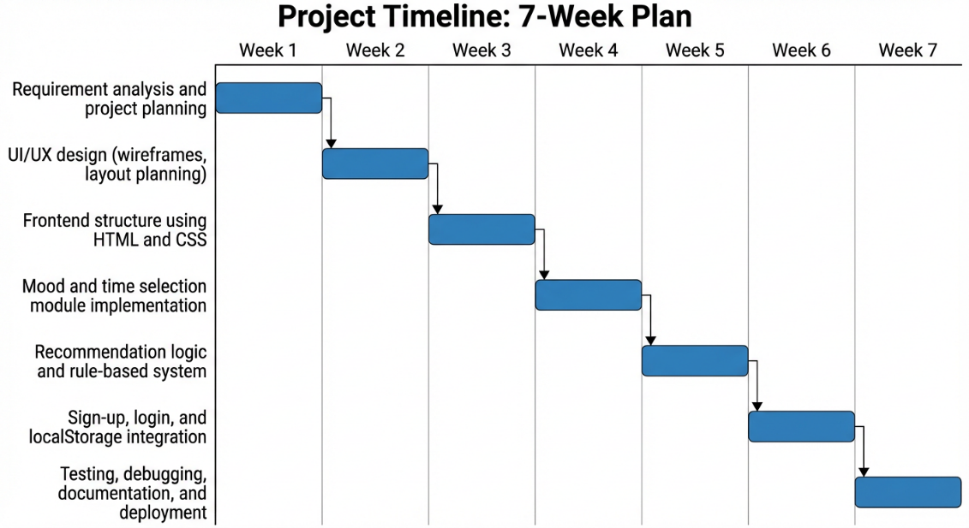
Figure 3: Gantt Chart

4.5 Risk Analysis

Table 2: Risk Analysis
Risk Description | Likelihood | Severity | Impact
Delay in mobile Deployment | High | Medium | Medium
API Dependency | High | High | High
Lack of technical  Expertise | Low | High | High
Date Breach | Low | Low | low
Limited testing resource | Medium | Medium | medium

Outcomes and Limitations

Product Features
- Users' Mood-Time-based suggestions
- Save and skip options
- Responsive design
- Single recommendation display
- APIs Integration

User Benefits and Impacts
- Saves time
- Reduces confusion
- Easy and enjoyable movie selection Experiences

Limitations of the system
- There is no backend for this system.
- Data can be lost easily as it is stored only in the browser.
- There may be only a limited movie list for some filters.

CONCLUSION

Summary
This is a simple project that presents a web-based movie recommendation site that suggests movies based on the user's mood and time. This project is built on frontend technologies. It is a simple and easy-to-use site that reduces users' effort and energy to find the movies best suited for them.

Future Scope
- Using the backend for login and to store users' data and details.
- Improve recommendations using AI.
- Developing a mobile application for easier access.

References
GeeksforGeeks. (2006, April 3). Retrieved from GeeksforGeeks: geeksforgeeks.org

