JAYPEE INSTITUTE OF INFORMATION
TECHNOLOGY, NOIDA
B. TECH COMPUTER SCIENCE & ENGINEERING
VII SEMESTER
MID-SEMESTER REPORT
MAJOR PROJECT
(15B19CI791)

Setup Pilot

An AI Agent for Automated Local Development Environment Setup
Supervision of: | Submitted by:
Mr Akshit Raj Patel | Anshul A Singh – 23103072  Honey Verma – 23103071  Mohammad Kashif – 23103097

Acknowledgment
We would like to express our sincere gratitude to Mr Akshit Raj Patel, our mentor for Major Project 1, for his invaluable guidance, constant encouragement, and motivation throughout the course of this work. His supervision and insights have been instrumental in shaping this project into its present form.
We are also deeply thankful to our friends and family for their unwavering support and encouragement, which played a vital role in the progress made so far.

Table of Contents
S. No. | Heading | Page No.
1 | Introduction | 4
2 | Problem Statement | 4
3 | Objectives | 4
4 | Motivation | 5
5 | Technology Stack | 5
6 | Literature Review | 6
7 | System Workflow | 9
8 | Methodology | 10
9 | Work Completed So Far | 10
10 | Expected Output | 12
11 | Future Scope | 13
12 | Conclusion | 13
13 | References | 14

Introduction
Setting up a local development environment for an unfamiliar codebase can be a frustrating and time-consuming task, especially for newcomers, open source contributors, and students working with assigned repositories. A project may require a specific programming language version, package manager, third party libraries, or tools such as Docker. In many cases, the setup instructions are spread across README files, outdated documentation, or are not available at all. This often leaves developers figuring things out through trial and error.
Setup Pilot is an AI-driven agent designed to simplify this entire process. It analyses a repository, identifies its technology stack, checks whether the required tools are available, and helps configure the development environment on the user's machine. The goal is to make project setup faster, more reliable, and easier to understand.
At the same time, Setup Pilot keeps the developer in control. Instead of making changes automatically, it pauses at important decision points and asks for explicit approval before cloning a repository, installing dependencies, or executing commands that could modify the system. This provides the convenience of automation while keeping the process transparent and safe for the user.
Problem Statement
Developers often spend significant time setting up unfamiliar repositories due to incomplete documentation, unclear dependencies, and varying project requirements. There is a need for a fast and reliable setup process that can identify these requirements, reduce setup errors, and save developers significant time while keeping them in control of system-level changes.
Objectives

To develop an agent that can clone a public GitHub repository to a destination folder specified by the developer.

To analyse the repository and identify important configuration and manifest files that define how the project is built, configured, or run.

To identify the project's technology stack, including Python, Node.js, Go, Rust, Ruby, Java, and Docker, based on the files found in the repository.

To check whether the tools required by the detected technology stack are available on the developer's system before suggesting any installation.

To create an isolated virtual environment for Python projects, avoiding unnecessary system-wide package installations.

To keep the developer involved by requiring explicit confirmation before running installation commands or any shell command that can modify the system.

To make the same core functionality accessible through both a command line interface and a browser-based interface.

Motivation

• Reducing setup time: Setting up a new project can take a significant amount of time, especially when developers have to deal with missing documentation, dependency issues, or configuration problems. Automating this process allows them to spend more time working on the actual project.

• Safety and user control: Giving an AI agent complete freedom to execute system commands can lead to unintended changes. Setup Pilot keeps the developer involved by requiring approval before performing installations or other system-level actions.

• Practical application of the internship learning: The project applies concepts and technologies covered during the internship, including agentic workflows, LLMs, LangGraph orchestration, tool calling, and human-in-the-loop interaction.

• Adaptability across projects: Instead of relying on project-specific assumptions, Setup Pilot analyses the repository itself to determine its requirements. This allows it to work with a wide range of public repositories and provide setup recommendations based on the actual project structure.

Technology Stack

Agent Orchestration: DeepAgents and LangGraph for agent workflows and human approval.

LLM Inference: Groq API with the openai/gpt-oss-20b model.

Environment Management: uv and Python venv for dependency and virtual environment management.

Web Interface: Flask.

Language: Python 3.13.

Literature Review

Schick, T., Dwivedi-Yu, J., Dessì, R., Raileanu, R., Lomeli, M., Hambro, E., Zettlemoyer, L., Cancedda, N., & Scialom, T. (2023). Toolformer: Language Models Can Teach Themselves to Use Tools. [1]

This paper introduces Toolformer, a language model that can learn to use external tools such as calculators, search engines, question-answering systems, translation systems, and calendars without requiring large amounts of human supervision. The approach uses a self-supervised process where the model generates possible API calls, executes them, and keeps only those calls that help improve its prediction of future tokens. The model is then fine-tuned on this augmented dataset, allowing it to learn when to use a tool, which tool to use, and what information to request. Experiments with a 6.7B parameter GPT-J model show significant improvements in zero-shot performance across factual question answering, mathematical reasoning, multilingual tasks, and temporal reasoning, with Toolformer even outperforming much larger models on several benchmarks. However, the approach is limited in its ability to chain multiple tools or interactively refine tool calls

Zhang, Y., Sun, R., Chen, Y., Pfister, T., Zhang, R., & Arik, S. Ö. (2024). Chain of Agents: Large Language Models Collaborating on Long-Context Tasks. [2]

This paper introduces Chain-of-Agents (CoA), a multi-agent framework designed to help Large Language Models handle long-context tasks more effectively. Traditional approaches such as Retrieval-Augmented Generation (RAG) may miss important information, while simply increasing the context window can cause models to lose focus on relevant content. CoA addresses these issues by dividing long inputs into smaller chunks and assigning them to a sequence of worker agents. Each worker processes its chunk while communicating useful information to the next agent, allowing knowledge to accumulate across the entire context. A manager agent then combines this information to generate the final response. Experiments across question answering, summarisation, and code completion show that CoA improves performance over RAG, full-context models, and other multi-agent approaches, while also reducing the computational cost of processing long inputs.

Abubakar, M. A., Mohsenimofidi, S., Lulla, J. L., Zhang, J. M., Treude, C., Baltes, S., & Galster, M. (2026). An Exploratory Study of Agent Plans for Agentic AI Coding Tools in Open-Source Software. [3]

This paper presents an exploratory study of Agent Plans, task-oriented Markdown files used to guide agentic AI coding tools during software development. Unlike general repository context files such as AGENTS.md, Agent Plans focus on specific development tasks and provide actionable instructions for agents. The researchers analysed 85 plan files from 10 repositories after screening 36,710 GitHub repositories. The study found that these plans support activities such as software maintenance, construction, testing, quality improvement, configuration, and design. The most common information included implementation steps, relevant files and locations, and testing and validation procedures, helping agents understand what to change, where to make changes, and how to verify the results. The findings suggest that Agent Plans act as a lightweight record of human-agent collaboration and provide a task-specific layer of guidance beyond traditional repository-level context files.

Steinmacher, I., Silva, M. A. G., & Gerosa, M. A. (2014). Barriers Faced by Newcomers to Open Source Projects: A Systematic Review. [4]

This paper presents a systematic literature review investigating the barriers faced by newcomers when they begin contributing to Open Source Software projects. The researchers analysed 21 studies and grouped the identified barriers into five major categories: finding a way to start, social interactions, code issues, documentation problems, and newcomers’ prior knowledge. The review shows that newcomers often struggle to identify suitable tasks, understand project architecture, set up their local workspace, deal with outdated or excessive documentation, and develop the technical and domain knowledge required by the project. Social factors are also important, particularly receiving timely and meaningful responses, building connections with project members, and finding mentors or experts. The study highlights that these barriers can make onboarding difficult and may cause newcomers to abandon their contributions. The proposed classification provides a foundation for developing tools and strategies to improve newcomer onboarding in OSS projects.

Wu, X., Xiao, L., Sun, Y., Zhang, J., Ma, T., & He, L. (2022). A Survey of Human-in-the-loop for Machine Learning. [5]

This paper presents a comprehensive survey of Human-in-the-loop (HITL) machine learning, focusing on how human knowledge and expertise can be integrated into ML systems to improve performance while reducing the cost of data annotation and model development. The authors organise existing research into three major areas: data processing, model training and inference, and system construction and applications. The survey covers approaches such as interactive data annotation, iterative labelling, active learning, human feedback, and human-AI collaboration across NLP, computer vision, and other domains. It highlights how human intervention can address problems such as limited labelled data, difficult samples, and model uncertainty. The paper also discusses challenges including effective interaction design, incorporating human knowledge, and reducing human effort. Overall, the survey provides a structured overview of HITL techniques and identifies future research opportunities for building more effective human-AI systems.

Shinn, N., Cassano, F., Berman, E., Gopinath, A., Narasimhan, K., & Yao, S. (2023). Reflexion: Language Agents with Verbal Reinforcement Learning. [6]

This paper introduces Reflexion, a framework that enables language agents to learn from previous failures through verbal feedback rather than updating the model's parameters. The approach consists of an Actor, Evaluator, and Self-Reflection model, where the agent performs a task, receives feedback, generates a textual reflection about its mistakes, and stores this experience in memory for future attempts. This allows the agent to improve its behaviour through repeated trials without expensive model fine-tuning. Reflexion maintains both short-term trajectory information and long-term reflective experiences, helping agents identify recurring errors and adjust their strategies. Experiments on ALFWorld, HotPotQA, HumanEval, MBPP, and LeetCodeHard demonstrate improvements in sequential decision-making, reasoning, and code generation. The study shows how self-reflection and persistent memory can provide an effective form of reinforcement for language-based agents.

Summary Table
S.No | Title | Highlights | Merits | Demerits | Research Gap
1 | Toolformer: Language Models Can Teach Themselves to Use Tools (2023) [1] | Uses a self-supervised approach to teach language models to use external tools such as calculators, search engines, QA systems, translation systems, and calendars. | Reduces human supervision and improves performance in mathematical, factual, multilingual, and temporal reasoning tasks. | Limited ability to chain multiple tools or interactively refine tool calls. | Developing agents capable of chaining multiple tools and refining tool usage through iterative interaction.
2 | Chain of Agents: Large Language Models Collaborating on Long-Context Tasks (2024) [2] | Divides long inputs into smaller chunks processed by sequential worker agents, followed by a manager agent that combines the information. | Improves long-context question answering, summarisation, and code completion while reducing computational cost. | Sequential processing can create dependencies between agents and requires effective coordination. | Improving multi-agent coordination and information sharing for complex long-context tasks.
3 | An Exploratory Study of Agent Plans for Agentic AI Coding Tools in Open-Source Software (2026) [3] | Studies task-specific Markdown Agent Plans containing implementation steps, relevant files, and testing instructions for coding agents. | Provides focused guidance that helps agents understand what to modify and how to validate changes. | Exploratory study based on Agent Plans from only 10 repositories. | Developing systematic methods for automatically generating and maintaining Agent Plans for agentic software development.
4 | Barriers Faced by Newcomers to Open Source Projects: A Systematic Review (2014) [4] | Identifies five major barriers: starting contributions, social interactions, code issues, documentation problems, and prior knowledge. | Provides a structured classification of onboarding difficulties and supports the development of tools for newcomers. | Focuses on traditional OSS environments and does not directly address modern AI-assisted development. | Developing AI-assisted onboarding systems that help newcomers understand repositories, documentation, architecture, and workflows.
5 | A Survey of Human-in-the-loop for Machine Learning (2022) [5] | Surveys human involvement in data processing, model training and inference, and system construction and applications. | Shows how human knowledge and feedback can improve ML systems while reducing annotation effort. | Human intervention can still require considerable effort and effective interaction design. | Developing efficient human-AI collaboration methods that minimise human effort while effectively using human feedback.
6 | Reflexion: Language Agents with Verbal Reinforcement Learning (2023) [6] | Uses an Actor, Evaluator, and Self-Reflection model to learn from failures through verbal feedback and persistent memory. | Enables agents to improve through repeated attempts without updating model parameters or expensive fine-tuning. | Performance depends on effective evaluation, reflection, repeated trials, and memory management. | Developing more reliable self-improving agents with stronger memory, reflection, and feedback mechanisms for complex software tasks.

Table 1. Summary of Literature Review

System Workflow

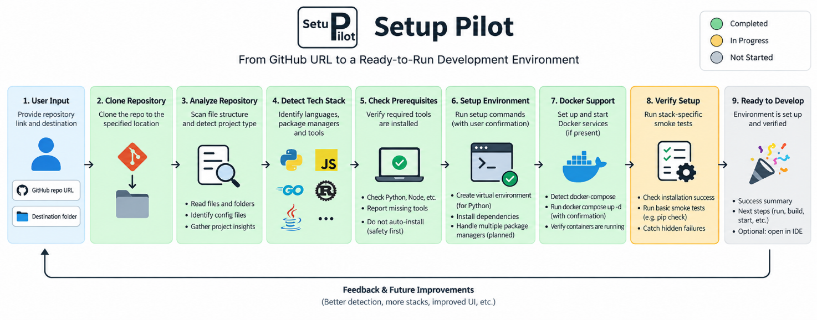
Fig 1. Workflow diagram of the project

The user provides a repository URL and destination folder. Setup Pilot then clones the repository, analyses its structure, identifies the technology stack, and checks the required tools. It presents the findings and asks for approval before making any changes.

Based on the detected stack, it sets up the environment using the appropriate tools. Python projects use isolated virtual environments, while other stacks use their respective package managers or Docker Compose. Each shell command requires explicit user confirmation before execution.

Methodology

Repository Cloning: The agent clones the selected repository into a dedicated subfolder within the destination provided by the user.

Repository Analysis: The project structure is scanned to identify important files such as README files, manifests, lock files, and Docker configurations.

Technology Stack Detection: Manifest files such as requirements.txt, pyproject.toml, package.json, go.mod, Cargo.toml, pom.xml, and build.gradle are used to determine the project's technology stack and setup requirements.

Prerequisite Check: The agent checks whether the required tools are installed and reports any missing dependencies along with relevant guidance.

Setup Report: The detected stack, required tools, and relevant project files are presented to the user based only on the information obtained from the repository.

User Approval: Before making any system changes, the agent pauses and waits for explicit user confirmation.

Environment Setup: After approval, the appropriate setup process is followed based on the detected stack, including virtual environments for Python, package managers for other languages, or Docker Compose for containerised projects.

Command Confirmation: Each shell command requires separate user approval before execution, ensuring that the developer remains in control throughout the process.

Result Reporting: The agent reports the setup outcome and relevant command output to the user.

Work Completed So Far

The project has been developed and tested in multiple phases. The following components have been completed successfully:

• Phase 0, Environment Setup: Setup Pilot was configured using uv for dependency management, with DeepAgents and Groq successfully integrated and tested.

• Phase 1, Repository Analysis: The agent can clone public GitHub repositories, analyse their structure, and generate reports based on the actual files and folders found in the repository.

• Phase 2, Stack Detection and Setup: The agent supports Python, Node.js, Go, Rust, Ruby, and Java projects. It identifies the required tools and package managers, verifies their availability, creates isolated Python environments, and requires user approval before installation.

• Phase 3, Docker Support: The agent detects supported Docker Compose configuration files, starts the required services, and verifies that the containers are running successfully.

• Agent Logic Refactoring: The model, system prompt, tools, and checkpointer were moved into a shared module, allowing both the CLI and web interface to use the same agent.

• Streamlit Frontend (In Progress): A browser-based interface is being developed with repository and destination inputs, a folder picker, live tool execution logs, and a two-step approval flow. The interface also maintains a persistent run log so that progress can be tracked throughout the setup process.

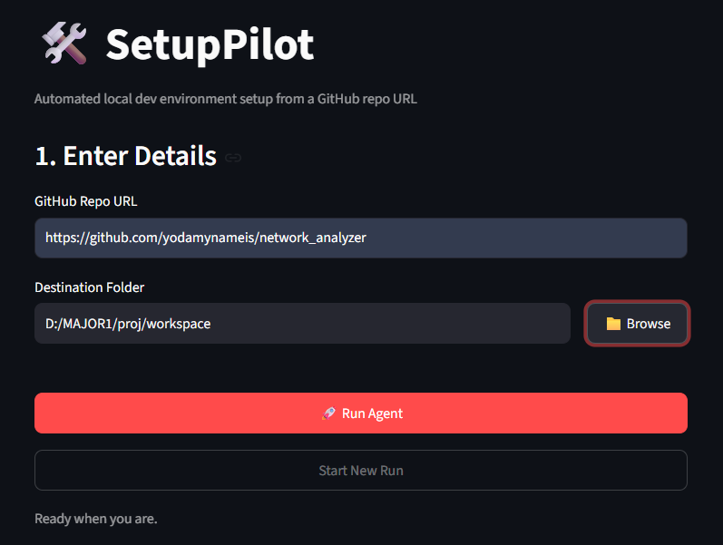
Fig 2. Temporary Home Page

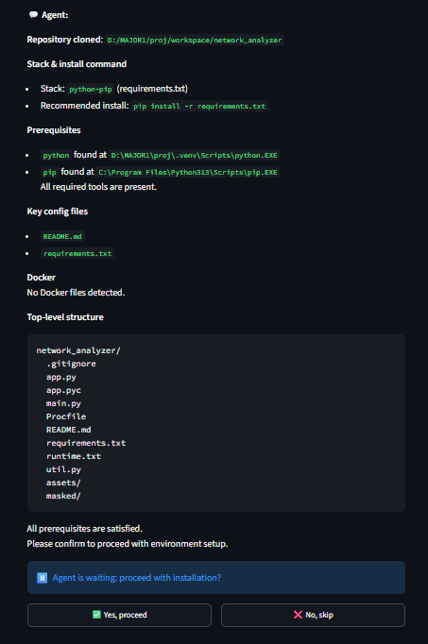
Fig 3. Human Approval for environment setup

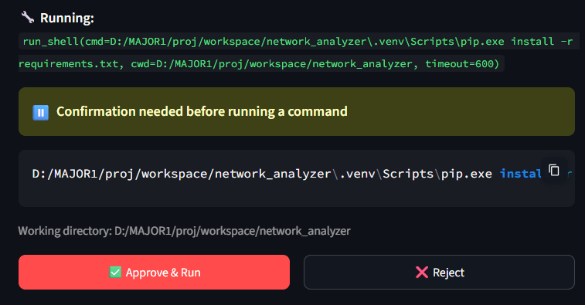
Fig 4. Human Approval for installing dependencies

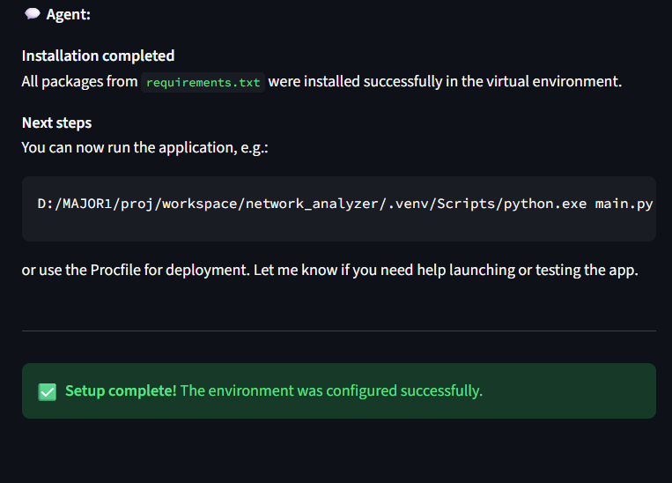
Fig 5. Final Output after setup completion

Expected Output

By the end of the project, Setup Pilot is expected to provide:

• Repository Analysis: A reliable report of the repository's technology stack, configuration files, and required tools based on actual repository data.

• Automated Environment Setup: A properly configured and isolated development environment based on the detected project requirements, with user approval before system changes.

• Setup Verification: A verification process that checks whether the environment is actually ready to use, beyond simply relying on command exit codes.

• Unified User Experience: Both command line and browser based interfaces that provide the same core functionality in a clear and accessible way.

Future Scope

The project can be further extended in the following areas:

Security & Safe Execution: Implementing permission controls, secure credential handling, dependency security checks, and sandboxed execution to reduce risks during automated setup.

Chat-Based Repository Interaction: Adding a conversational interface where users can interact with the repository, ask questions about the project, understand errors, and request setup or configuration actions through natural language.

Interactive Error Resolution: Enabling the agent to explain setup failures and suggest or automatically apply appropriate fixes based on the project structure and error logs.

Dependency & Vulnerability Analysis: Detecting outdated or vulnerable dependencies and providing recommendations during the setup process.

Environment Reproducibility: Generating configuration files or setup specifications that can recreate the same development environment on another machine.

Project Health Checks: Extending verification beyond installation to identify common configuration issues, missing environment variables, incompatible versions, and other runtime problems.

Standalone Distribution: Packaging Setup Pilot as an easily installable tool that developers can use across different projects without needing to work from the Setup Pilot repository itself.

Conclusion

Setup Pilot aims to simplify the process of setting up unfamiliar repositories by automating repository analysis, stack detection, prerequisite checking, and environment setup. It reduces setup time and common configuration issues while keeping developers in control through human approval before system-level changes.

The core agent has been successfully developed and tested for multiple languages, package managers, and Docker based workflows. The remaining work focuses on stronger setup verification, handling complex repositories, and improving the CLI and web interfaces.

References

[1] T. Schick, J. Dwivedi-Yu, R. Dessì, R. Raileanu, M. Lomeli, E. Hambro, L. Zettlemoyer, N. Cancedda, and T. Scialom, “Toolformer: Language Models Can Teach Themselves to Use Tools,” 2023.

[2] Y. Zhang, R. Sun, Y. Chen, T. Pfister, R. Zhang, and S. Ö. Arik, “Chain of Agents: Large Language Models Collaborating on Long-Context Tasks,” 2024.

[3] M. A. Abubakar, S. Mohsenimofidi, J. L. Lulla, J. M. Zhang, C. Treude, S. Baltes, and M. Galster, “An Exploratory Study of Agent Plans for Agentic AI Coding Tools in Open-Source Software,” 2026.

[4] I. Steinmacher, M. A. G. Silva, and M. A. Gerosa, “Barriers Faced by Newcomers to Open Source Projects: A Systematic Review,” 2014.

[5] X. Wu, L. Xiao, Y. Sun, J. Zhang, T. Ma, and L. He, “A Survey of Human-in-the-loop for Machine Learning,” 2022.

[6] N. Shinn, F. Cassano, E. Berman, A. Gopinath, K. Narasimhan, and S. Yao, “Reflexion: Language Agents with Verbal Reinforcement Learning,” 2023.

