**timestamp.ts**

Timestamp in unix time format when audio.wav starts.

**.xml**

Timestamp in unix time format when first frame in .mvx happens.

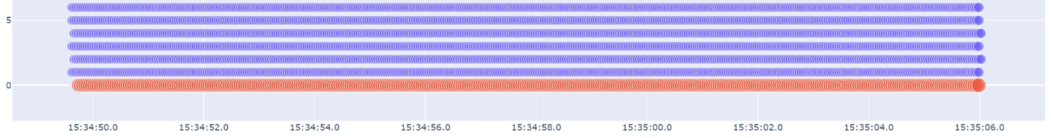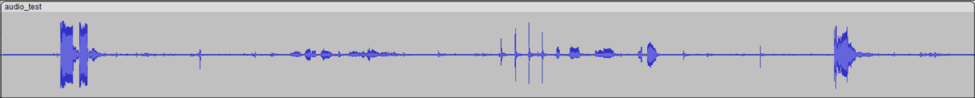

1. Run inject_audio.xml graph

This requires paths to "input_joined.mvx", "output_joined.mvx", "new_audio.wav" and "new_audio.ts".

- input_joined.mvx: raw data from VoCap

- output_joined.mvx: new raw data file with new audio to be meshed

- new_audio.wav: Audio from different source (Stereo tested)

- new_audio.ts: Timestamp in UNIX-milliseconds-format. Points to the time when audio starts (not beep) (Does it require it? Can this be specified in graphs? Is it read automatically?)

2. Run meshing tsdf/poisson to new joined.mvx

3. Output mesh.mvx should have new audio track