ls /dev/video* video1

dmesg

查询到摄像头的参数为：USB\VID_1BCF&PID_2281&REV_0419&MI_00

sudo apt-get install xawtv
但出现错误：Unmet dependencies. Try 'apt --fix-broken install' with no packages (or specify a solution).
于是：
sudo apt --fix-broken install
sudo apt-get update
sudo apt-get upgrade

xawtv /dev/video1

出现如下错误：v4l2：oops：select timeout，且界面显示的图像卡顿
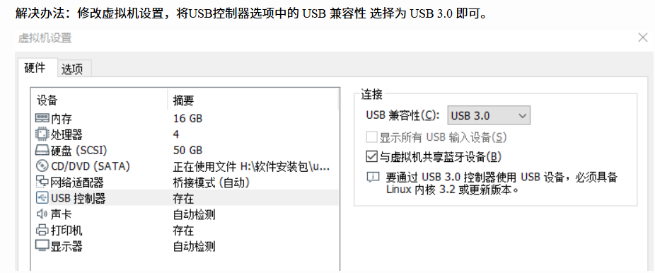

将摄像头插到主机上，连到虚拟机上运行xaw /dev/video1
成功点亮

/tools/test_uvc and /tools/test_uvc 测试camera
成功在板子上点亮

"C:\desk\project things\EdgeWatcher\do_my_test\ring_buffer.c"
"C:\desk\project things\EdgeWatcher\do_my_test\ring_buffer.h"
环形缓冲区的文件编写
"C:\desk\project things\EdgeWatcher\do_my_test\test_ring_buffer.c"
对环形缓冲区的测试

"C:\desk\project things\EdgeWatcher\do_my_test\test_v4l2_capture.c"
"C:\desk\project things\EdgeWatcher\do_my_test\v4l2_capture.c"
"C:\desk\project things\EdgeWatcher\do_my_test\v4l2_capture.h"
开始v4l2的编写，对于v4l2设备的采集。

