**NoSQL (COSMODB):**

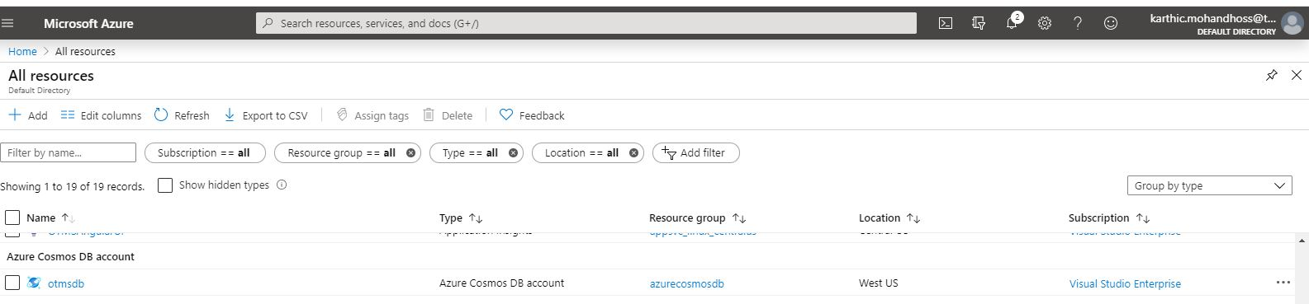

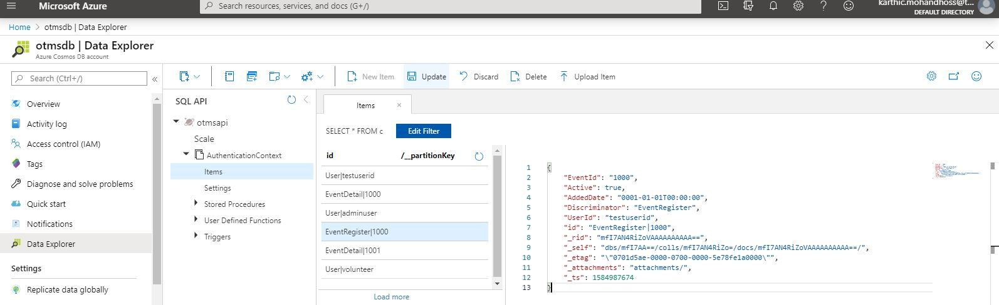

**APPS**

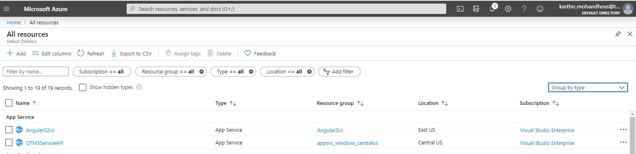

Deployment Update

