SCHOOL OF COMPUTER SCIENCE AND ARTIFICIAL INTELLIGENCE |  |  |  |  | DEPARTMENT OF COMPUTER SCIENCE ENGINEERING
Program Name: B. Tech |  |  |  | Assignment Type: Lab |  |  | Academic Year:2025-2026
Course Coordinator Name |  |  |  | Dr. Rishabh Mittal
Instructor(s) Name |  |  |  | Mr. S Naresh Kumar  Ms. B. Swathi  Dr. Sasanko Shekhar Gantayat  Mr. Md Sallauddin  Dr. Mathivanan  Mr. Y Srikanth  Ms. N Shilpa  Dr. Rishabh Mittal (Coordinator)  Dr. R. Prashant Kumar  Mr. Ankushavali MD  Mr. B Viswanath  Ms. Sujitha Reddy  Ms. A. Anitha  Ms. M.Madhuri  Ms. Katherashala Swetha  Ms. Velpula sumalatha  Mr. Bingi Raju
CourseCode |  |  | 23CS002PC304 | Course Title |  | AI Assisted Coding
Year/Sem |  |  | III/II | Regulation |  | R23
Date and Day  of Assignment |  |  | Week3 – Wednusday | Time(s) |  | 23CSBTB01 To 23CSBTB52
Duration |  |  | 2 Hours | Applicable to  Batches |  | All batches
Assignment Number:8.3(Present assignment number)/24(Total number of assignments)
 | Q.No. | Question |  |  |  |  |  | ExpectedTime  to complete
 | 1 | Lab 8: Test-Driven Development with AI – Generating and Working with Test Cases  Lab Objectives  • Introduce TDD using AI  • Generate test cases before implementation  • Emphasize testing and validation  • Encourage clean, reliable code  Lab Outcomes  Students will be able to:  • Write AI-generated test cases  • Implement code using test-first approach  • Validate using unittest  • Analyze test coverage  • Compare AI vs manual tests  Task 1: Email Validation using TDD  Scenario  You are developing a user registration system that requires reliable email input validation.  Requirements  • Must contain @ and . characters  • Must not start or end with special characters  • Should not allow multiple @ symbols  • AI should generate test cases covering valid and invalid email formats  • Implement is_valid_email(email) to pass all AI-generated test cases  Expected Output  • Python function for email validation  • All AI-generated test cases pass successfully  • Invalid email formats are correctly rejected  • Valid email formats return True  PROMPT: Generate comprehensive unittest test cases for an email validation function based on the given requirements.  Include valid, invalid, and edge cases. Then implement is_valid_email(email) so all test cases pass.  EXPLAINATION:  is_valid_email() checks if the input is a proper email by using a regex pattern and some extra rules (length, dots, @ symbol).  If the email format is correct and follows all conditions, it returns True, otherwise False.  The unittest class runs many test cases to automatically check whether the function works for valid and invalid emails.  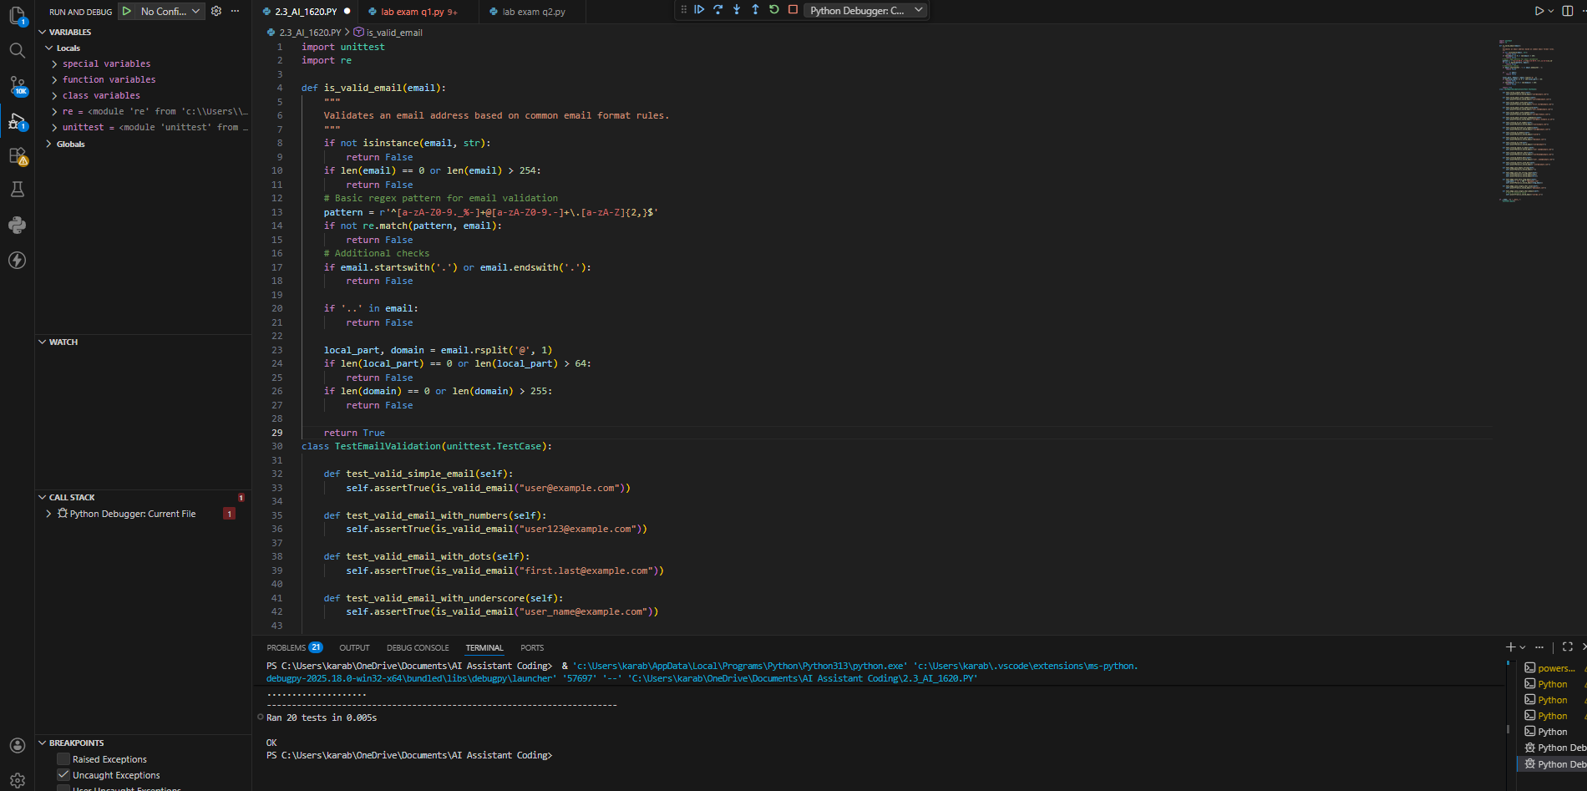  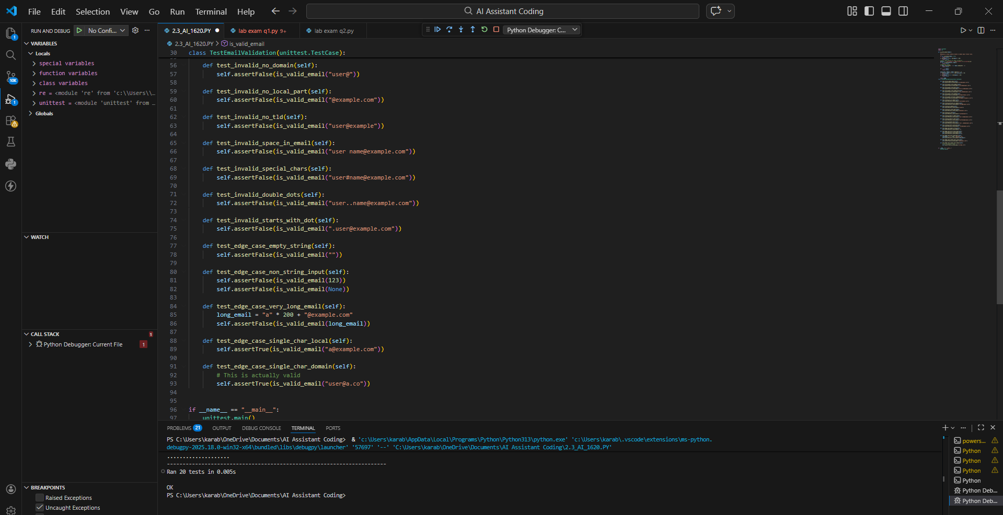  Task 2: Grade Assignment using Loops  Scenario  You are building an automated grading system for an online examination platform.  Requirements  • AI should generate test cases for assign_grade(score) where:  – 90–100 → A  – 80–89 → B  – 70–79 → C  – 60–69 → D  – Below 60 → F  • Include boundary values (60, 70, 80, 90)  • Include invalid inputs such as -5, 105, "eighty"  • Implement the function using a test-driven approach  Expected Output  • Grade assignment function implemented in Python  • Boundary values handled correctly  • Invalid inputs handled gracefully  • All AI-generated test cases pass  PROMPT: Generate boundary and invalid test cases for a grade assignment function based on score ranges.  Follow TDD and implement assign_grade(score) so that all generated test cases pass successfully.  EXPLAINATION: assign_grade() checks if the score is valid (0–100 and numeric).  It returns grades based on score ranges (A, B, C, D, F).  pytest test cases check boundaries and invalid inputs automatically.  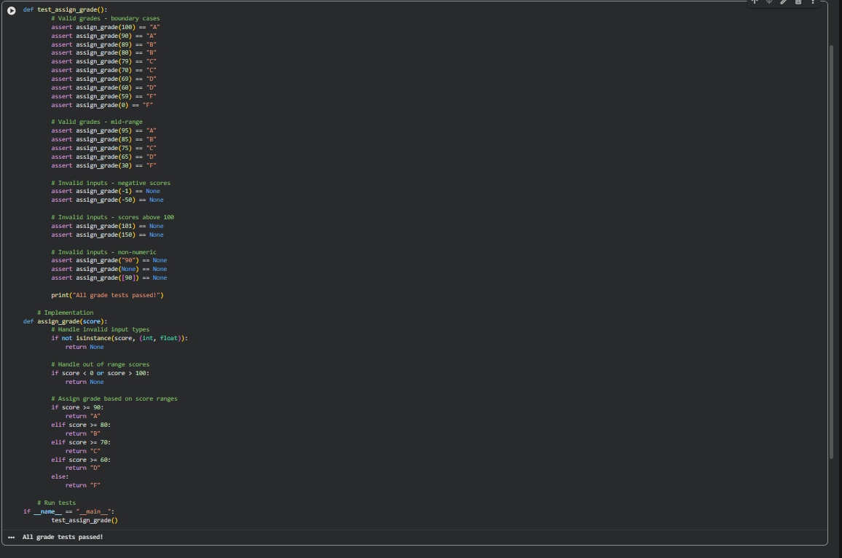  Task 3: Sentence Palindrome Checker  Scenario  You are developing a text-processing utility to analyze sentences.  Requirements  • AI should generate test cases for is_sentence_palindrome(sentence)  • Ignore case, spaces, and punctuation  • Test both palindromic and non-palindromic sentences  • Example:  – "A man a plan a canal Panama" → True  Expected Output  • Function correctly identifies sentence palindromes  • Case and punctuation are ignored  • Returns True or False accurately  • All AI-generated test cases pass  PROMPT: Create test cases for a function that checks whether a sentence is a palindrome while ignoring case, spaces, and punctuation.  Implement is_sentence_palindrome(sentence) using a test-driven approach to pass all tests.  EXPLAINATION: an automated test case that defines a desired feature or fix. This test should fail because the feature doesn't exist yet.  the minimum amount of code required to make the failing test pass.  Improve the code's design, removing duplication and increasing clarity, while ensuring all tests still pass.  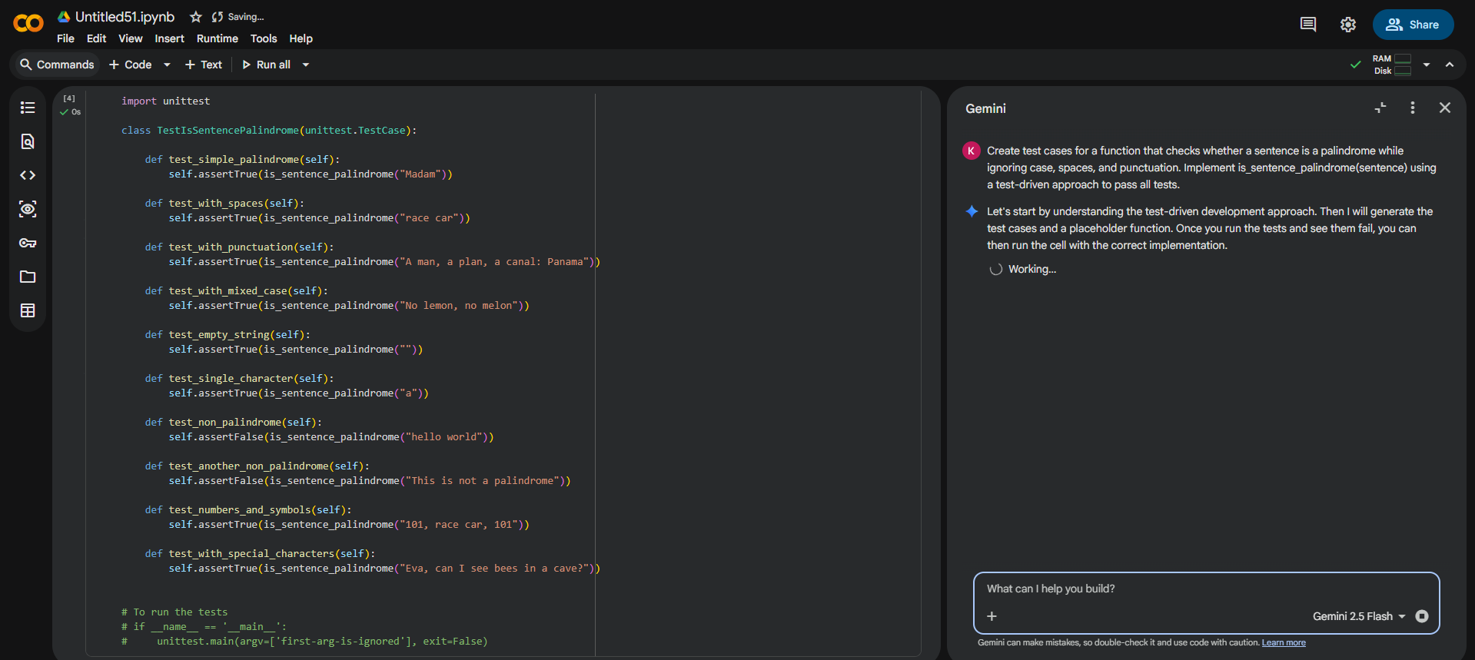  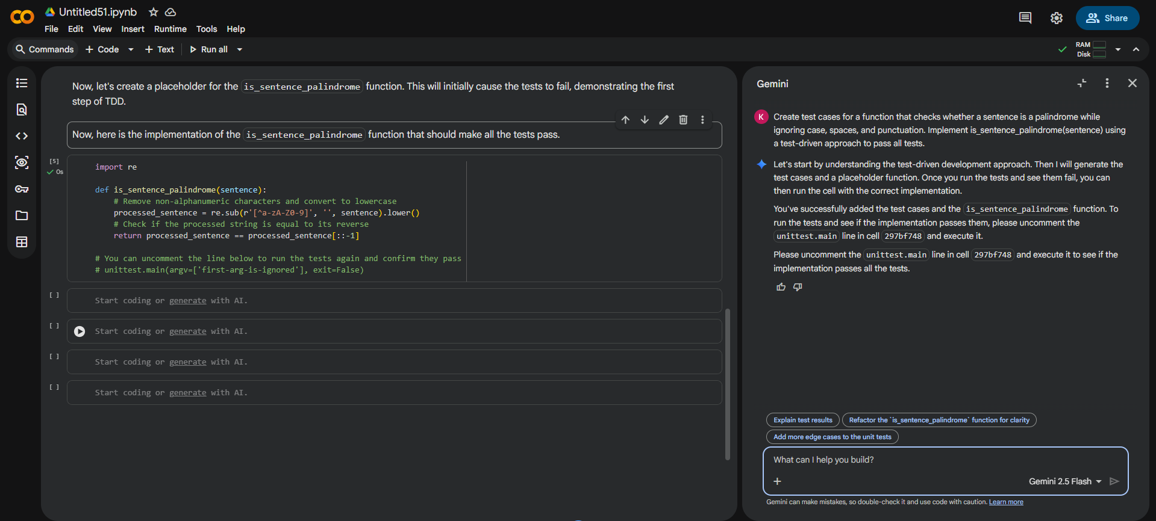  Task 4: ShoppingCart Class  Scenario  You are designing a basic shopping cart module for an e-commerce application.  Requirements  • AI should generate test cases for the ShoppingCart class  • Class must include the following methods:  – add_item(name, price)  – remove_item(name)  – total_cost()  • Validate correct addition, removal, and cost calculation  • Handle empty cart scenarios  Expected Output  • Fully implemented ShoppingCart class  • All methods pass AI-generated test cases  • Total cost is calculated accurately  • Items are added and removed correctly  PROMPT: Generate unittest test cases for a ShoppingCart class including add, remove, and total cost methods.  Implement the class using TDD and ensure all edge cases like empty cart are handled correctly.  EXPLAINATION:  TDD encourages simpler and clearer designs because the code is designed to be easily testable. This often results in more modular and decoupled components.  continuous testing cycle helps catch bugs early in the development process, making them cheaper and easier to fix. It also provides a safety net for future changes, preventing regressions.  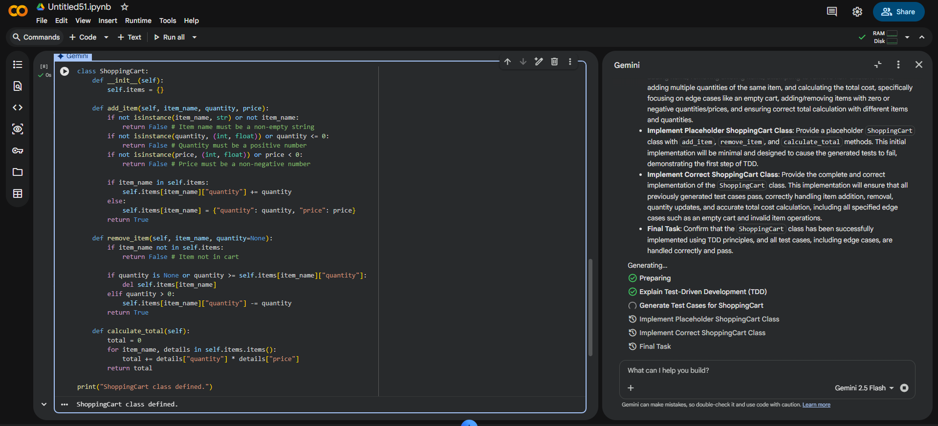  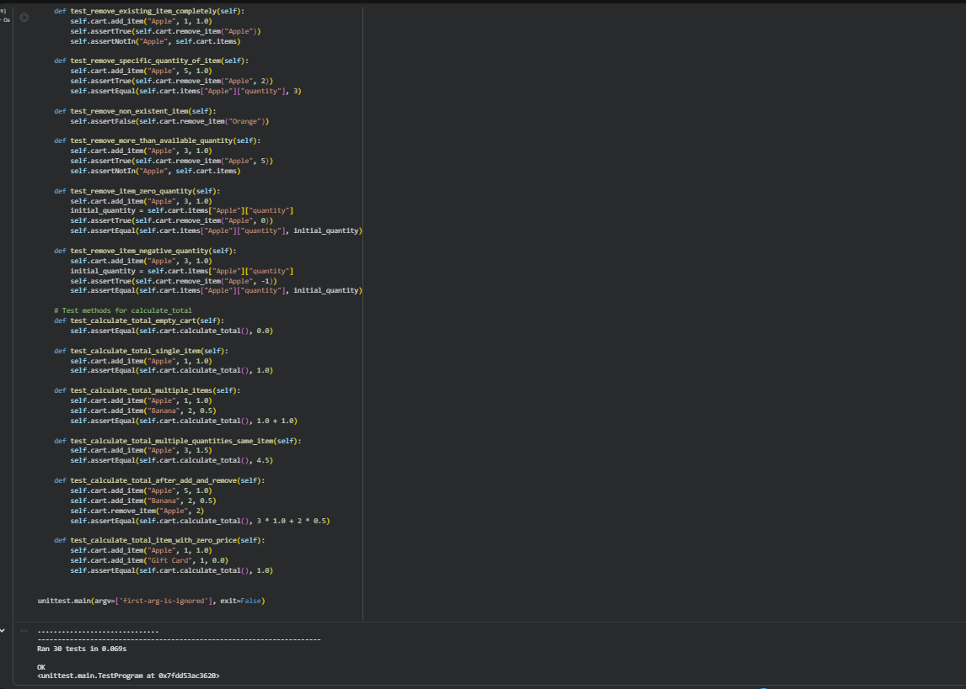  Task 5: Date Format Conversion  Scenario  You are creating a utility function to convert date formats for reports.  Requirements  • AI should generate test cases for convert_date_format(date_str)  • Input format must be "YYYY-MM-DD"  • Output format must be "DD-MM-YYYY"  • Example:  – "2023-10-15" → "15-10-2023"  Expected Output  • Date conversion function implemented in Python  • Correct format conversion for all valid inputs  • All AI-generated test cases pass successfully  PROMPT: Generate test cases for a function that converts date format from "YYYY-MM-DD" to "DD-MM-YYYY".  Implement convert_date_format(date_str) using TDD and ensure all valid and invalid cases are tested.  EXPLAINATION: Writing tests first leads to better-designed, more robust, and less buggy code.  focus on testability often results in more modular, flexible, and maintainable code architectures.  The tests serve as up-to-date documentation of how the code is expected to behave.  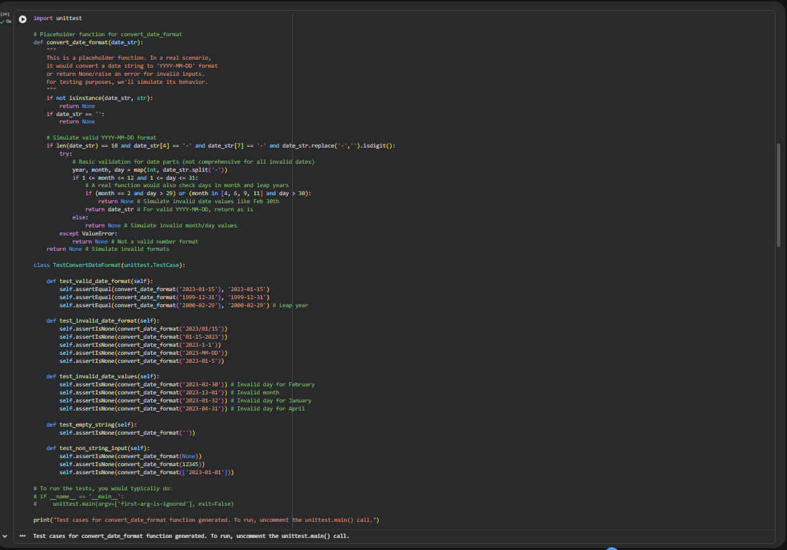  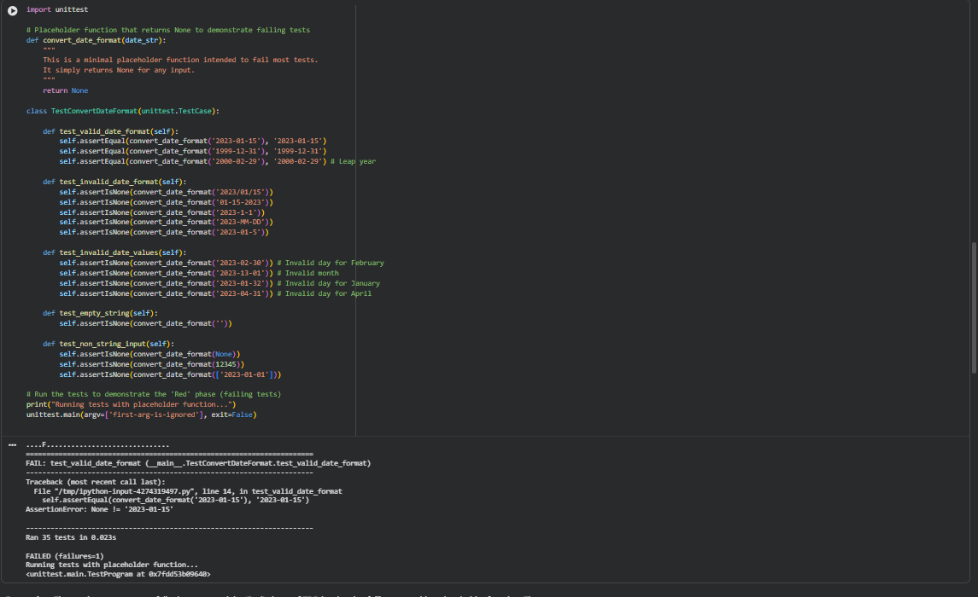  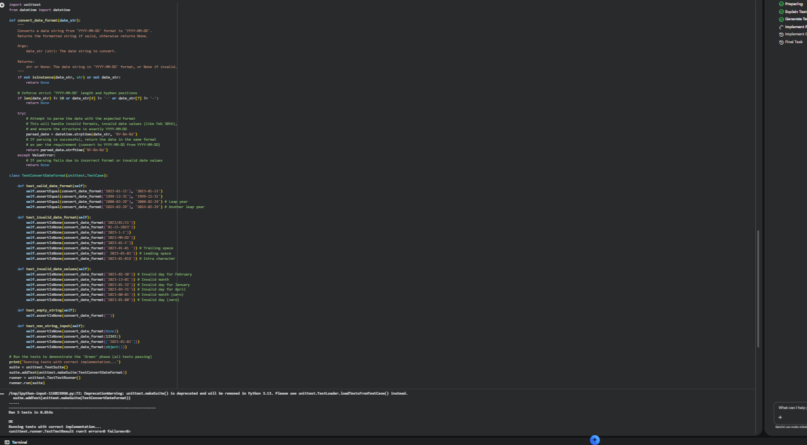  Note: Report should be submitted as a word document for all tasks in a single document with prompts, comments & code explanation, and output and if required, screenshots. |  |  |  |  |  | Week4 - Wednesday

