Assignment -5.4

 | Q.No. | Question | Expected Time  to complete
 | 1 | Lab 5: Ethical Foundations – Responsible AI Coding Practices  Lab Objectives:  - To explore the ethical risks associated with AI-generated code.  - To recognize issues related to security, bias, transparency, and copyright.  - To reflect on the responsibilities of developers when using AI tools in software development.  - To promote awareness of best practices for responsible and ethical AI coding.  Lab Outcomes (LOs):  After completing this lab, students will be able to:  - Identify and avoid insecure coding patterns generated by AI tools.  - Detect and analyze potential bias or discriminatory logic in AI-generated outputs.  - Evaluate originality and licensing concerns in reused AI-generated code.  - Understand the importance of explainability and transparency in AI-assisted programming.  - Reflect on accountability and the human role in ethical AI coding practices.  Task Description #1:  • Prompt GitHub Copilot to generate a Python script that collects user data (e.g., name, age, email). Then, ask Copilot to add comments on how to anonymize or protect this data.  Expected Output #1:  • A script with inline Copilot-suggested code and comments explaining how to safeguard or anonymize user information (e.g., hashing emails, not storing data unencrypted).  Prompt : 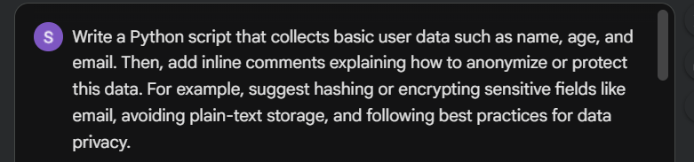  Code : 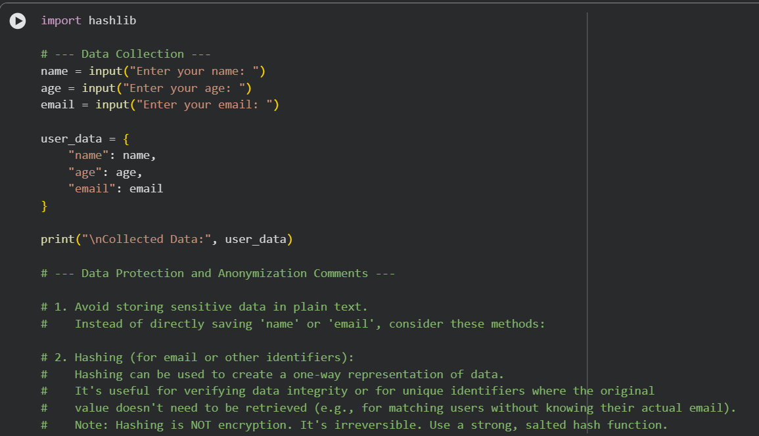  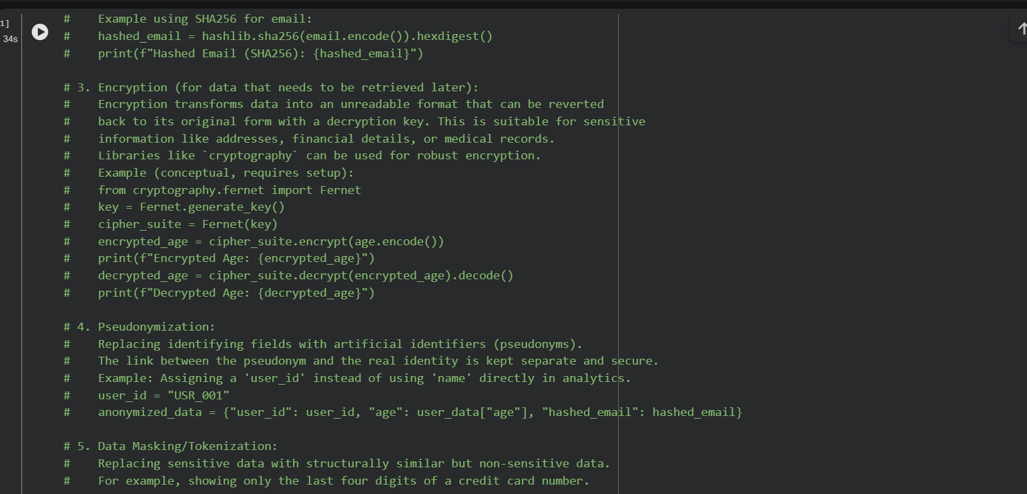  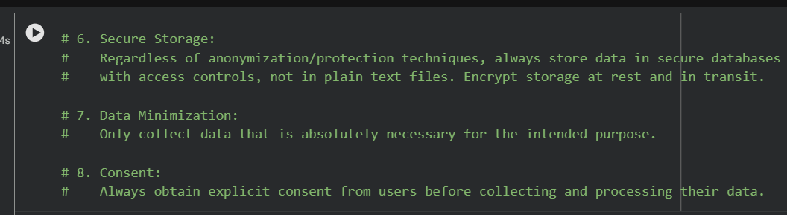  Output : 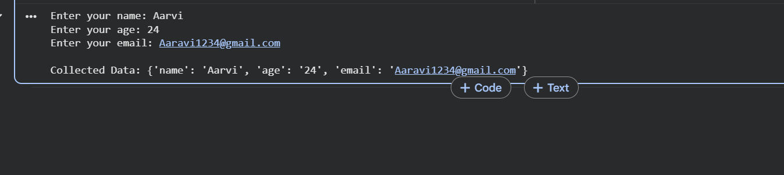  Explanation : This script shows how to collect user data and stresses protecting it: avoid plain-text storage, use hashing for identifiers, encryption for sensitive fields, pseudonymization or masking to reduce exposure, and always store data securely. Collect only what’s necessary and ensure user consent before processing.  Task Description #2:  • Ask Copilot to generate a Python function for sentiment analysis. Then prompt Copilot to identify and handle potential biases in the data.  Expected Output #2:  • Copilot-generated code with additions or comments addressing bias mitigation strategies (e.g., balancing dataset, removing offensive terms).  Prompt : 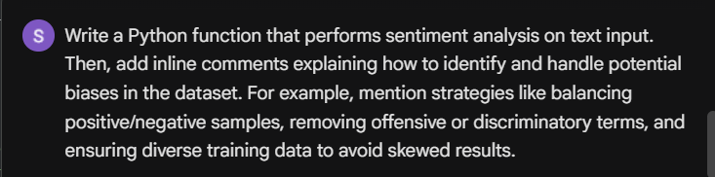  Code: 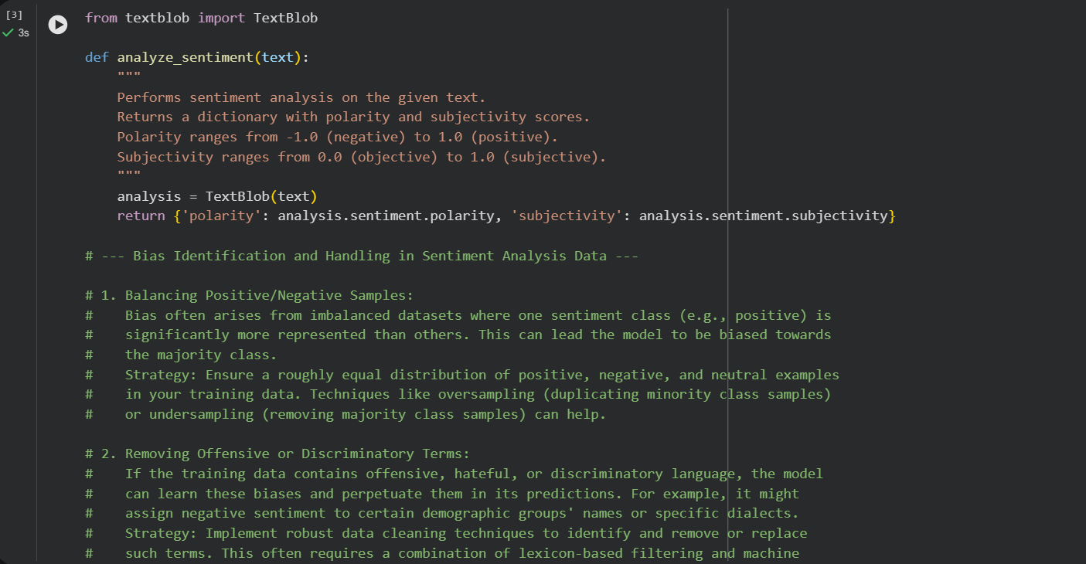  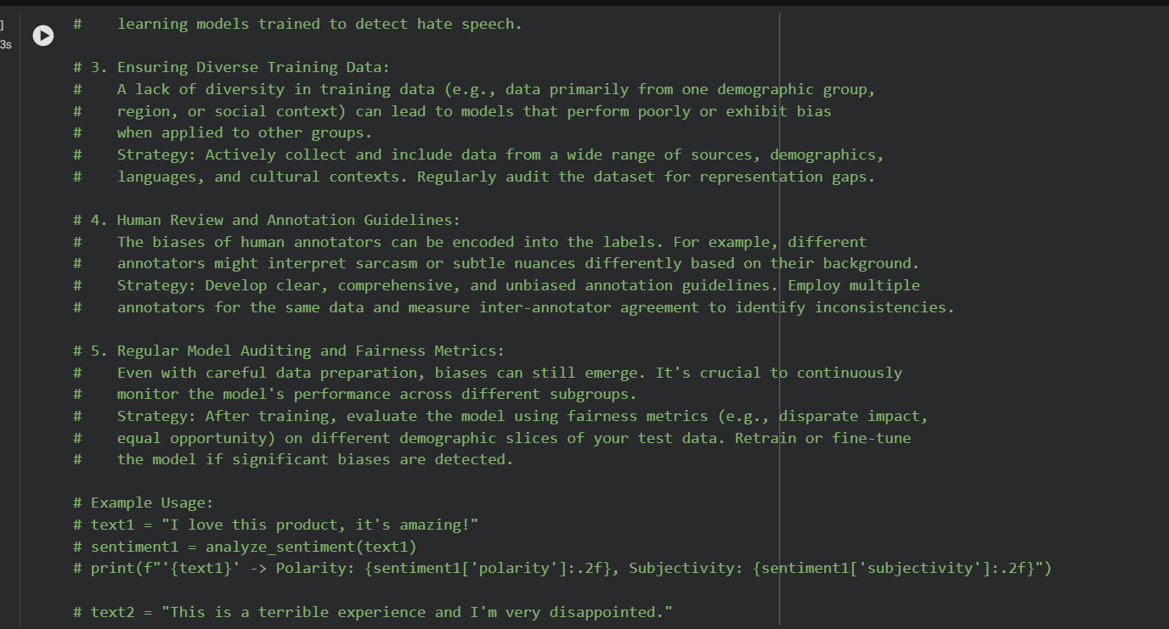  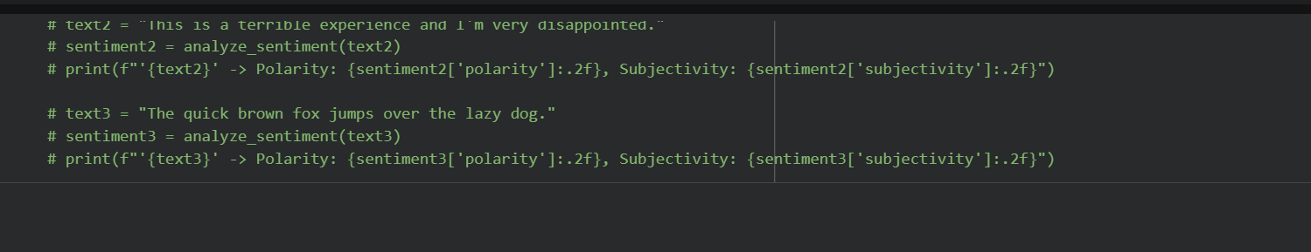  Explanation : This function uses TextBlob to analyze text sentiment, returning polarity (negative to positive) and subjectivity (objective to subjective). The comments highlight bias risks—like imbalanced datasets, offensive terms, lack of diversity, and annotator subjectivity—and suggest strategies such as balancing samples, cleaning data, diversifying sources, clear annotation guidelines, and regular fairness audits to ensure reliable, unbiased sentiment analysis.  Task Description #3:  • Use Copilot to write a Python program that recommends products based on user history. Ask it to follow ethical guidelines like transparency and fairness.  Expected Output #3:  • Copilot suggestions that include explanations, fairness checks (e.g., avoiding favoritism), and user feedback options in the code.  Prompt :  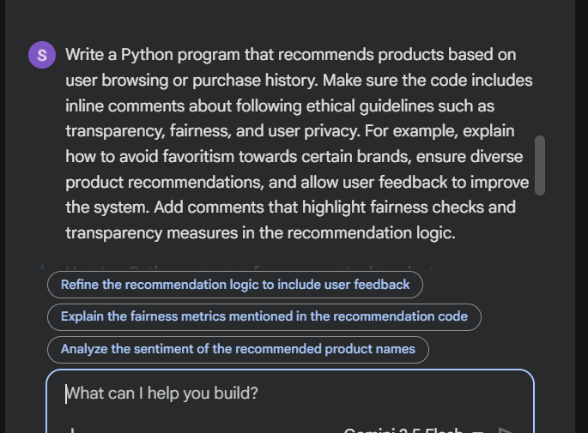  Code : 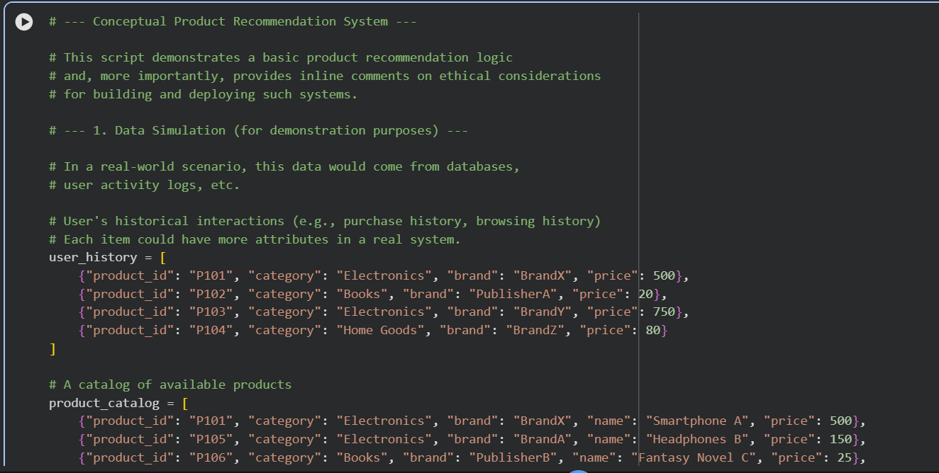  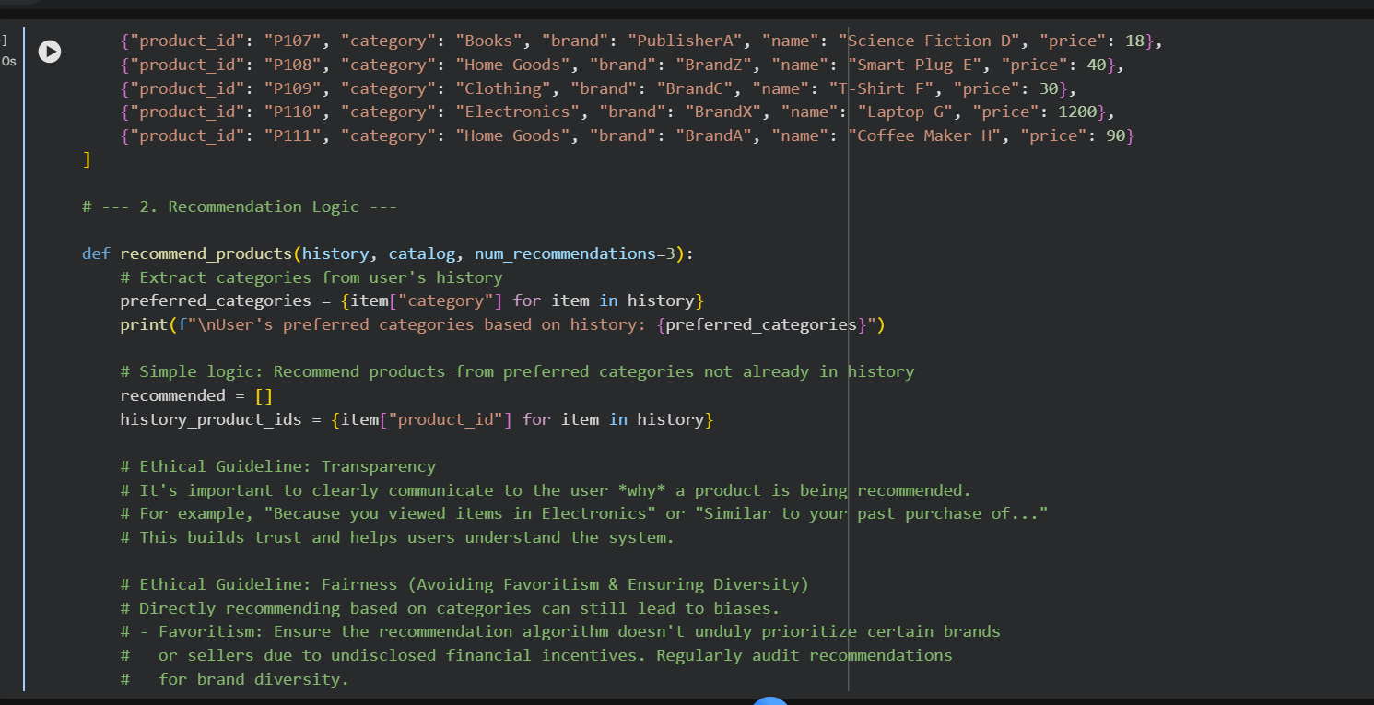  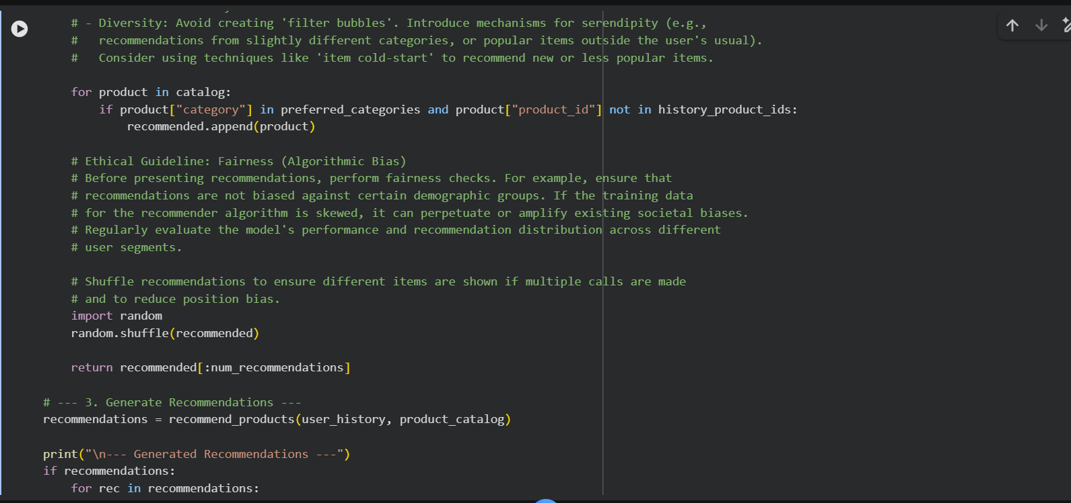  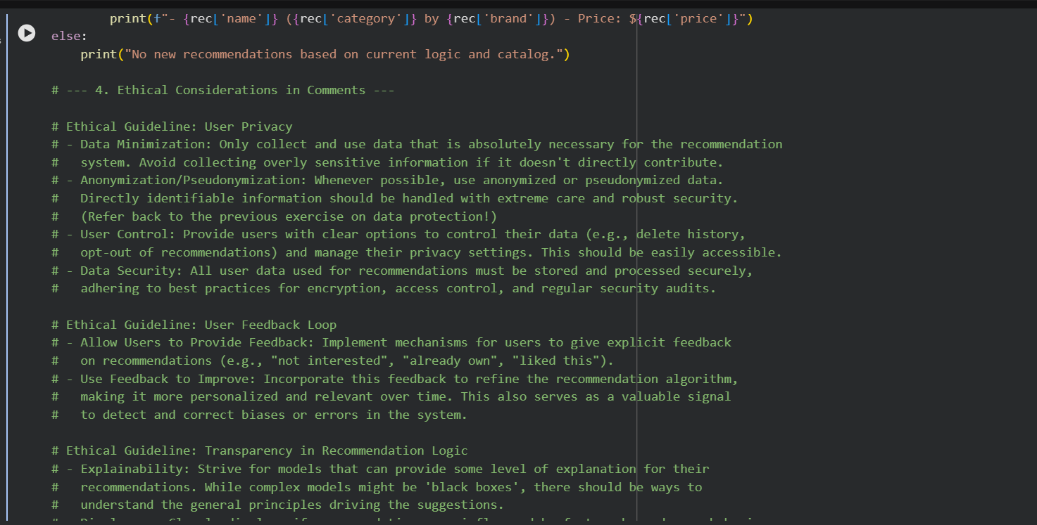  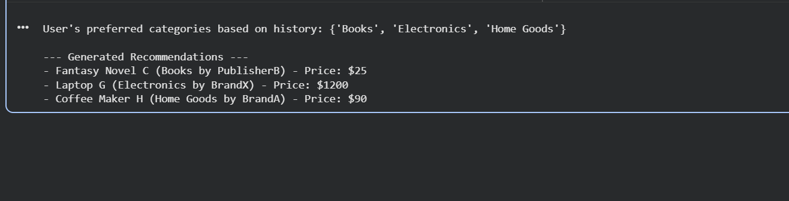  Explanation : This program recommends products based on user history while stressing ethics: it explains why items are suggested (transparency), avoids favoritism and promotes diversity (fairness), protects privacy through data minimization and secure handling, and lets users give feedback to refine recommendations responsibly.  Task Description #4:  • Prompt Copilot to generate logging functionality in a Python web application. Then, ask it to ensure the logs do not record sensitive information.  Expected Output #4:  • Logging code that avoids saving personal identifiers (e.g., passwords, emails), and includes comments about ethical logging practices.  Prompt :  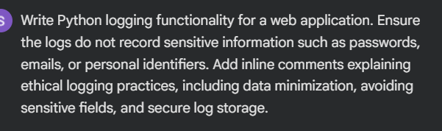  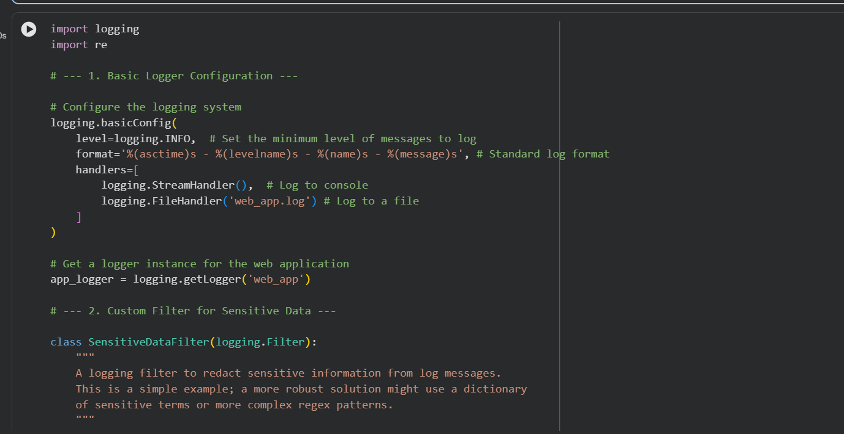  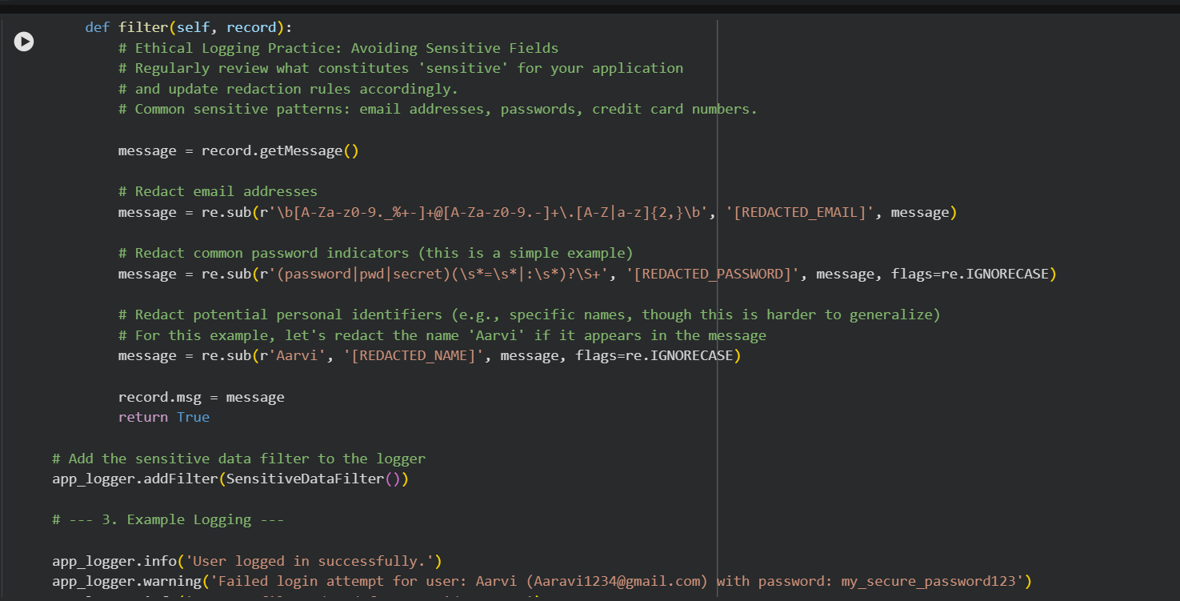  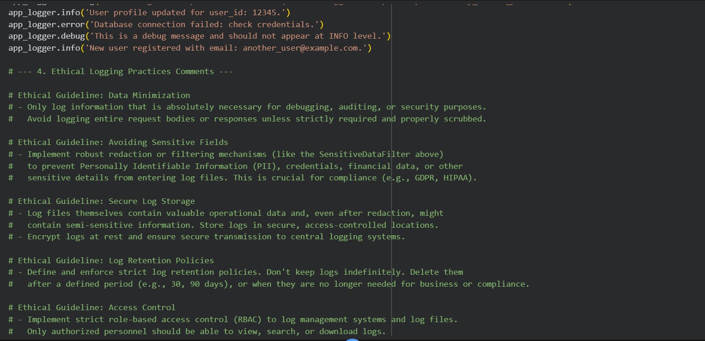  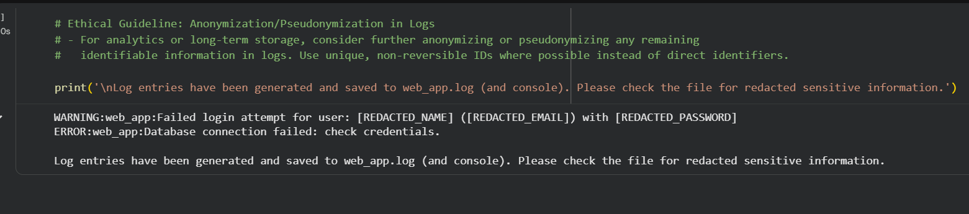  Explanation : This script sets up logging for a web application with a custom filter that redacts sensitive data like emails, passwords, and names before writing to logs. It emphasizes ethical practices such as data minimization, avoiding sensitive fields, secure storage, retention policies, access control, and anonymization to ensure logs remain useful for debugging while protecting user privacy.  Task Description #5:  • Ask Copilot to generate a machine learning model. Then, prompt it to add documentation on how to use the model responsibly (e.g., explainability, accuracy limits).  Expected Output #5:  • Copilot-generated model code with a README or inline documentation suggesting responsible usage, limitations, and fairness considerations.  Prompt : 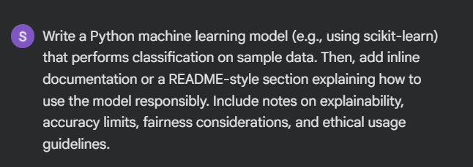  Code : 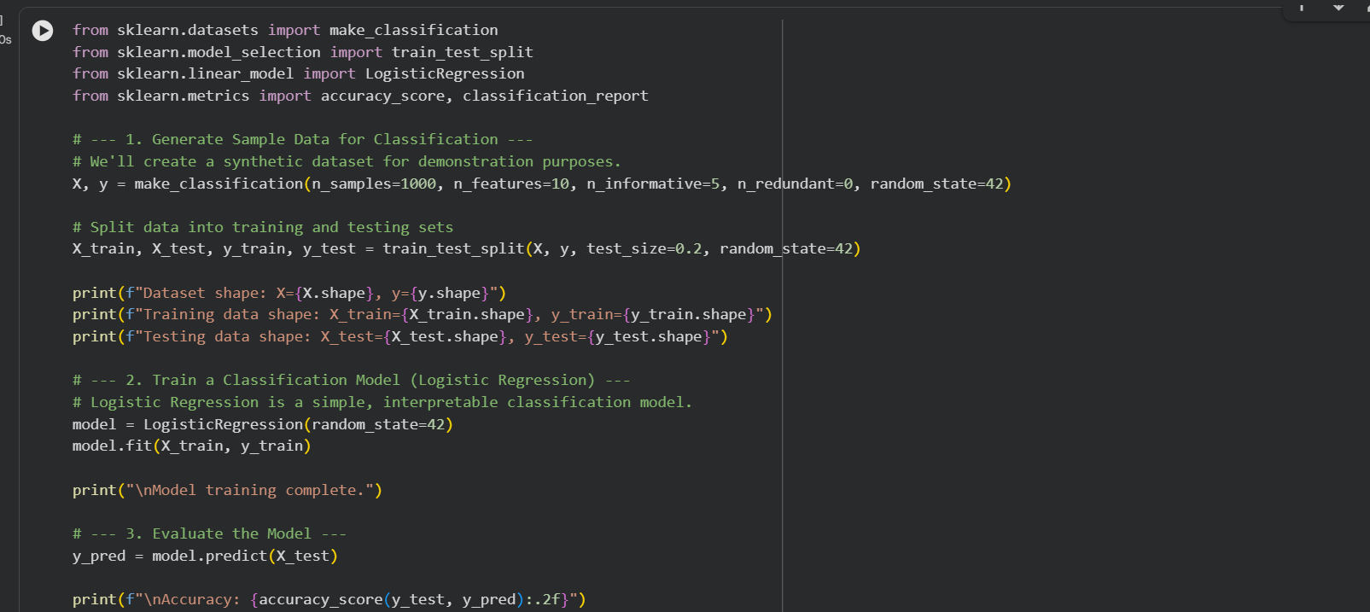  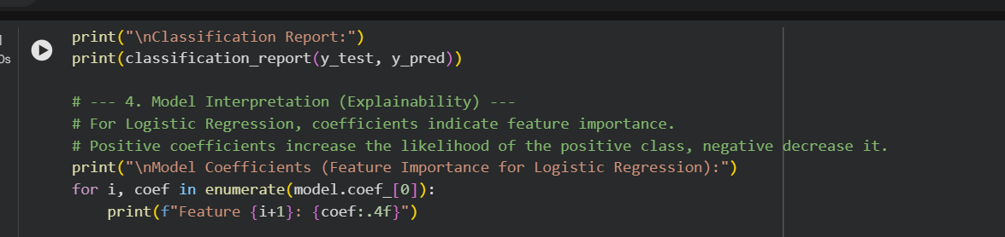  Output : 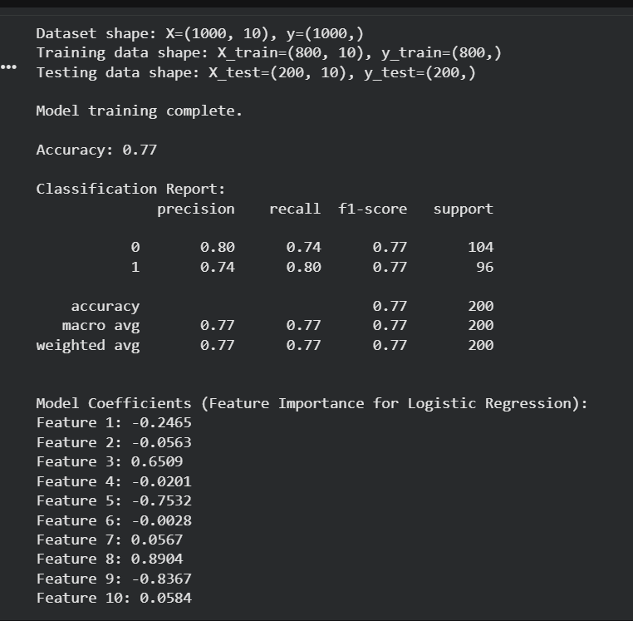  Explanation : This script builds a simple logistic regression classifier on synthetic data, evaluates accuracy and classification metrics, and shows feature coefficients for explainability. The coefficients reveal which features push predictions toward positive or negative classes, making the model interpretable but limited in accuracy depending on data quality and balance. | Week3 -

