SCHOOL OF COMPUTER SCIENCE AND ARTIFICIAL INTELLIGENCE |  |  |  |  | DEPARTMENT OF COMPUTER SCIENCE ENGINEERING
Program Name:B. Tech |  |  |  | Assignment Type: Lab |  |  | Academic Year:2025-2026
Course Coordinator Name |  |  |  | Dr. Rishabh Mittal
Instructor(s)Name |  |  |  | Mr. S Naresh Kumar  Ms. B. Swathi  Dr. Sasanko Shekhar Gantayat  Mr. Md Sallauddin  Dr. Mathivanan  Mr. Y Srikanth  Ms. N Shilpa  Dr. Rishabh Mittal (Coordinator)  Dr. R. Prashant Kumar  Mr. Ankushavali MD  Mr. B Viswanath  Ms. Sujitha Reddy  Ms. A. Anitha  Ms. M.Madhuri  Ms. Katherashala Swetha  Ms. Velpula sumalatha  Mr. Bingi Raju  Mr. G. Kranthi
Course Code |  |  | 23CS002PC304 | Course Title |  | AI Assisted Coding
Year/Sem |  |  | III/I | Regulation |  | R23
Date and Day  of Assignment |  |  | Week 7 - Thursday | Time(s) |  | 23CSBTB01 To 23CSBTB52
Duration |  |  | 2 Hours | Applicable to  Batches |  | All Batches
AssignmentNumber:14.4 (Present assignment number)/24(Total number of assignments)
 | Q.No. | Question |  |  |  |  |  | ExpectedTime  to complete
 | 1 | Lab 14: Web Frontend Development – AI-Assisted HTML/CSS/JS Generation  Lab Objectives  - Design functional, visually appealing web applications using HTML, CSS, and JavaScript with AI assistance.  - Apply responsive, accessible, and interactive design principles.  - Create practical UI components for real-world web applications.  - Use AI to optimize layout, UX, and performance.  Lab Outcomes  - Applying AI assistance to frontend development tasks  - Understanding how HTML, CSS, and JavaScript work together  - Improving responsiveness, interactivity, and usability  - Evaluating and refining AI-generated frontend code |  |  |  |  |  | Week 7

Task 1: Responsive Homepage Layout for a Startup Website

Scenario
You are designing a basic homepage for a startup company that needs to look good on desktops, tablets, and mobile devices.

Task Description
- Create a web page structure using HTML that includes:
  - A header with navigation links
  - A main content section
  - A footer with basic information
- Use AI assistance to generate responsive CSS using media queries.
- Ensure the layout adjusts smoothly across different screen sizes.

Expected Output
- A responsive web page where:
  - Header, content, and footer are clearly separated
  - Layout adapts correctly to mobile, tablet, and desktop views
  - Code is clean and well-structured
PROMPT:
I am building a marketing web page and need a Call-to-Action button.
Please create HTML for a button and JavaScript code that shows an alert message when the button is clicked.
The JavaScript should include clear comments explaining how the click event works, and the page should not reload when the button is pressed.
EXPLAINATION: HEader contains navigation links.
Main shows website content.
Footer displays company information.
Media queries adjust layout for tablet and mobile screens.

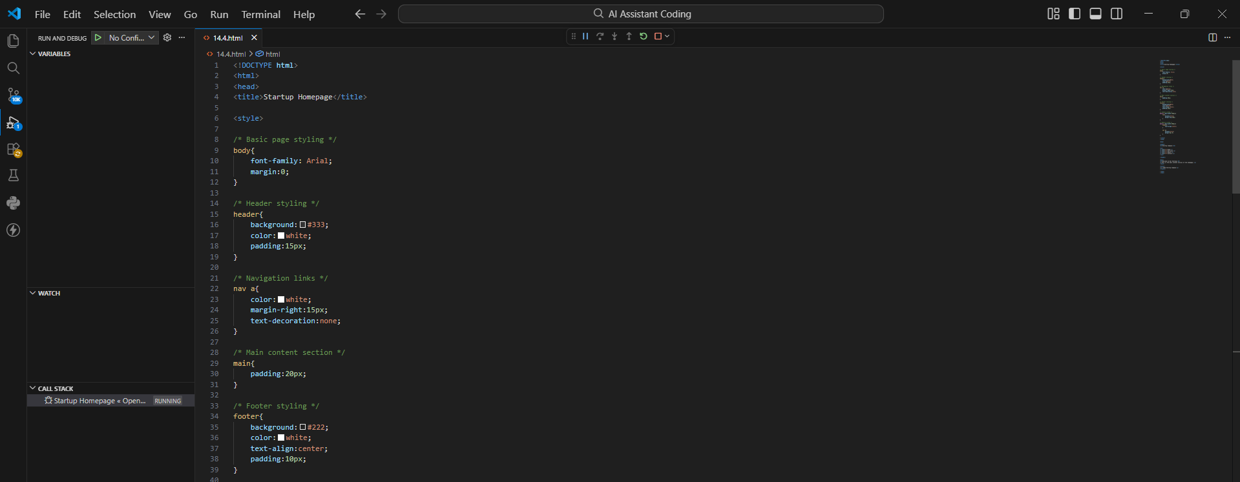
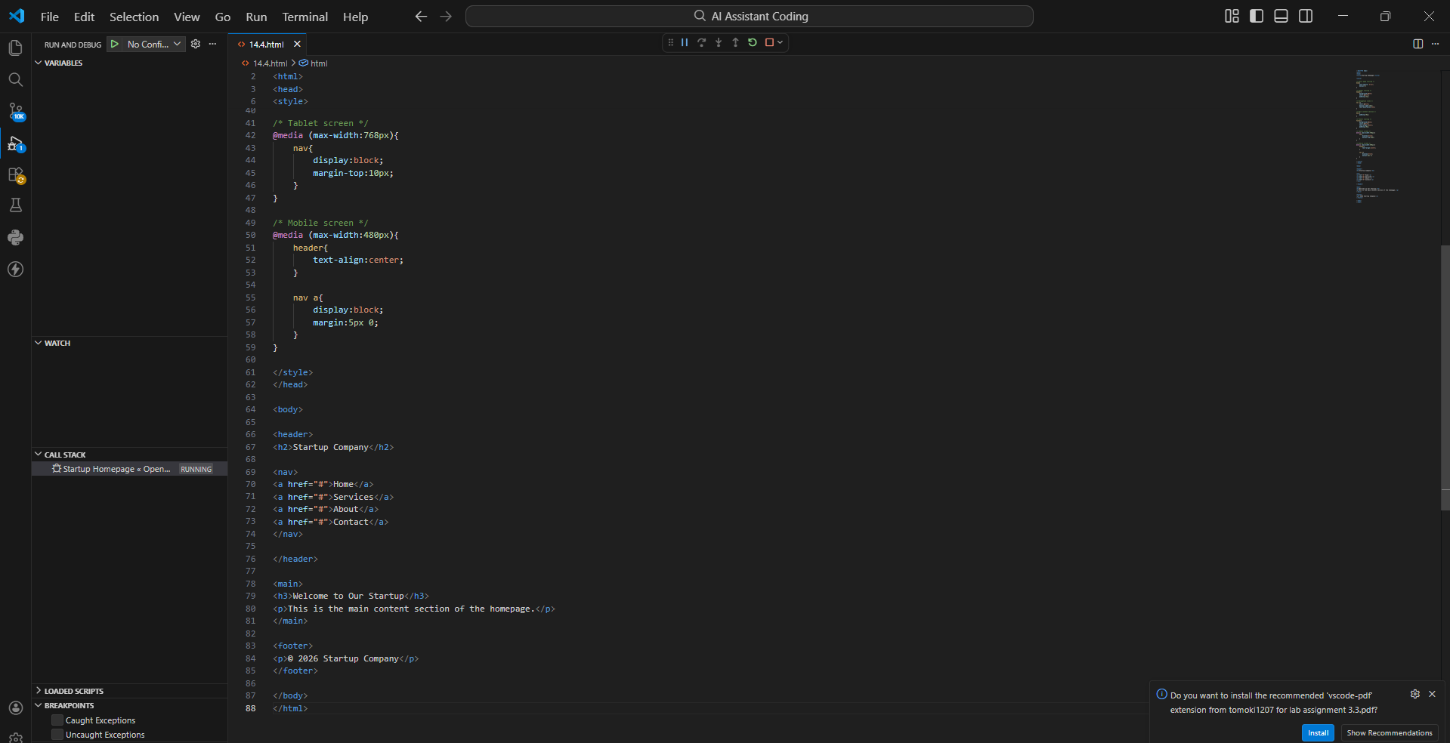
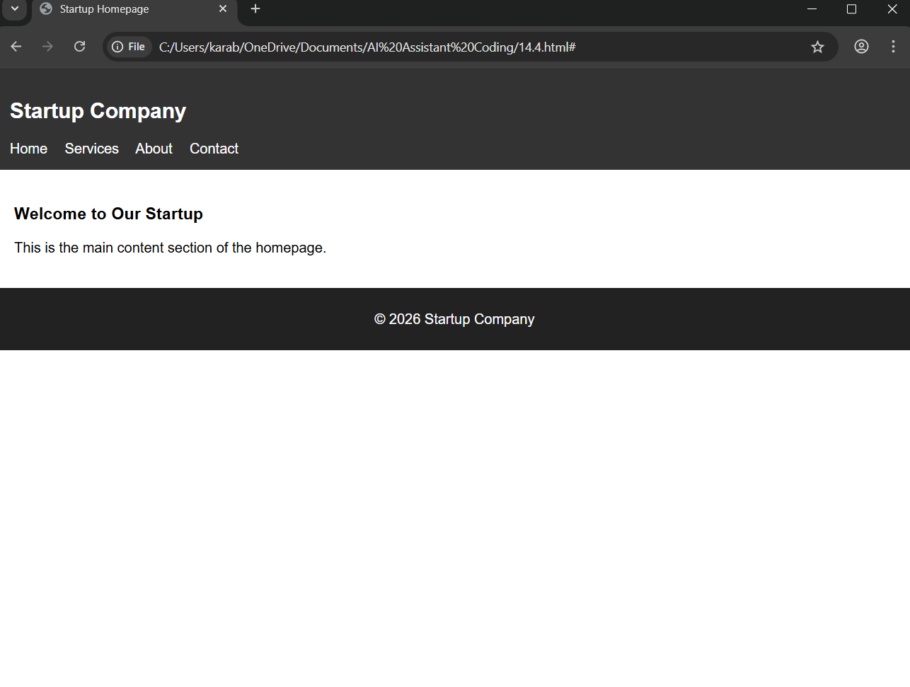

Task 2: Interactive Call-to-Action Button

Scenario
A marketing page requires a call-to-action button that responds when users interact with it.

Task Description
- Add a button to a web page using HTML.
- Use AI to generate JavaScript that responds to the button click by:
  - Displaying a message or alert
- Ask AI to add meaningful comments explaining the JavaScript logic.

Expected Output
- A web page where:
  - Clicking the button triggers a visible response (alert or message)
  - JavaScript code is readable and commented
  - No page reload occurs
PROMPT: I am building a marketing web page and need a Call-to-Action button.
Please create HTML for a button and JavaScript code that shows an alert message when the button is clicked.
The JavaScript should include clear comments explaining how the click event works, and the page should not reload when the button is pressed.
EXPLAINATION: • The button calls showMessage() when clicked.
• JavaScript displays an alert message.
• No page reload occurs.

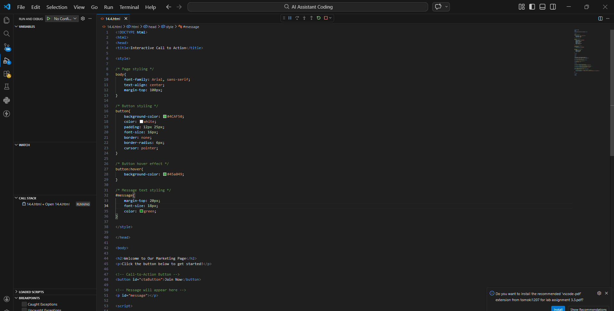
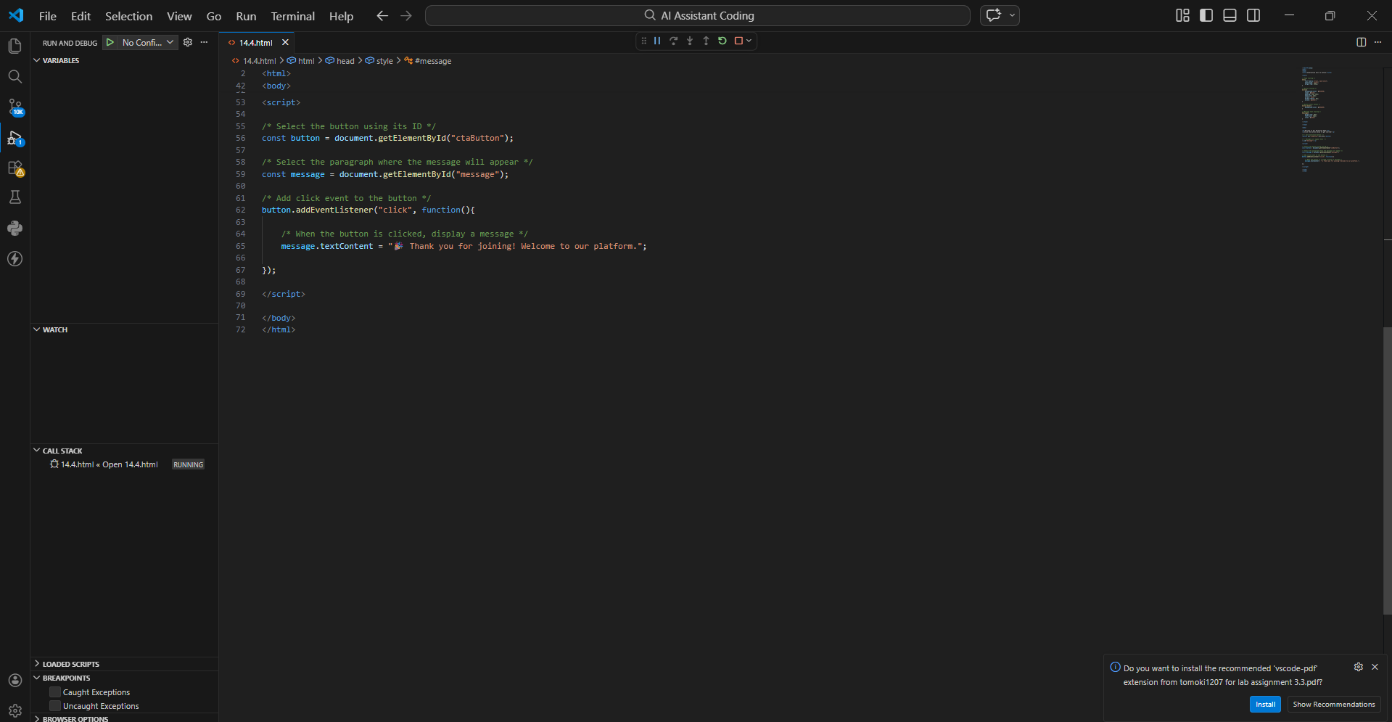
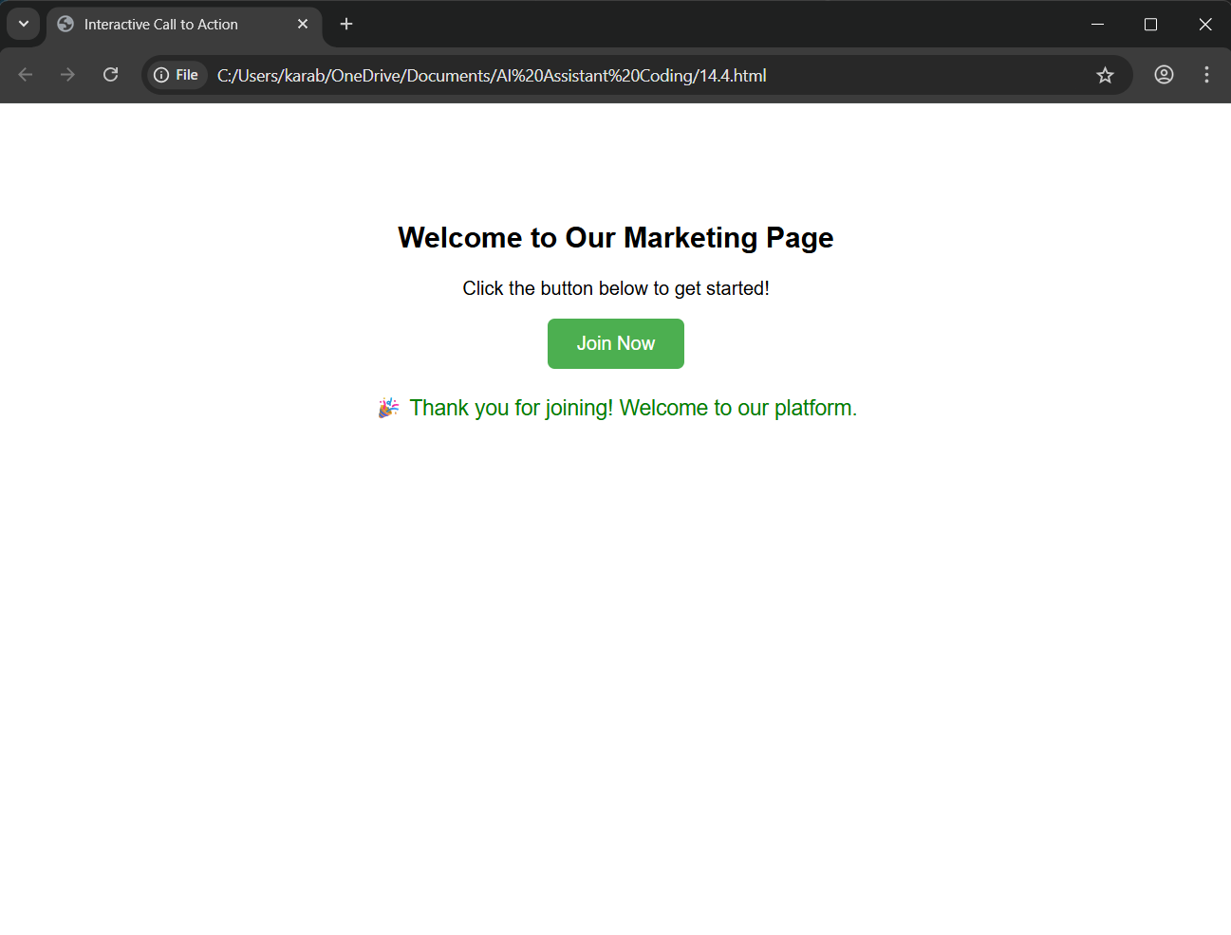

Task 3: Contact Form with Client-Side Validation

Scenario
You are developing a contact form for a company website to collect user queries safely and correctly.

Task Description
- Design a form with fields for:
  - Name
  - Email
  - Message
- Use AI to generate JavaScript validation logic that:
  - Prevents empty submissions
  - Checks for a valid email format
- Display clear error messages for invalid input.

Expected Output
- A functional form where:
  - Invalid input shows inline error messages
  - Valid input displays a success message
  - Validation happens on the client side using JavaScript
PROMPT: I want to create a contact form for a website using HTML.
The form should include Name, Email, and Message fields.
Please generate JavaScript validation code that:
- Prevents empty submissions
- Checks if the email format is valid
- Shows clear error messages if input is incorrect
- Displays a success message when the form is valid
The validation should happen on the client side using JavaScript, and the code should be easy to understand with comments.

EXPLAINATION:Checks empty fieldValidates email format.
Displays error messages.
Shows success alert for valid input.

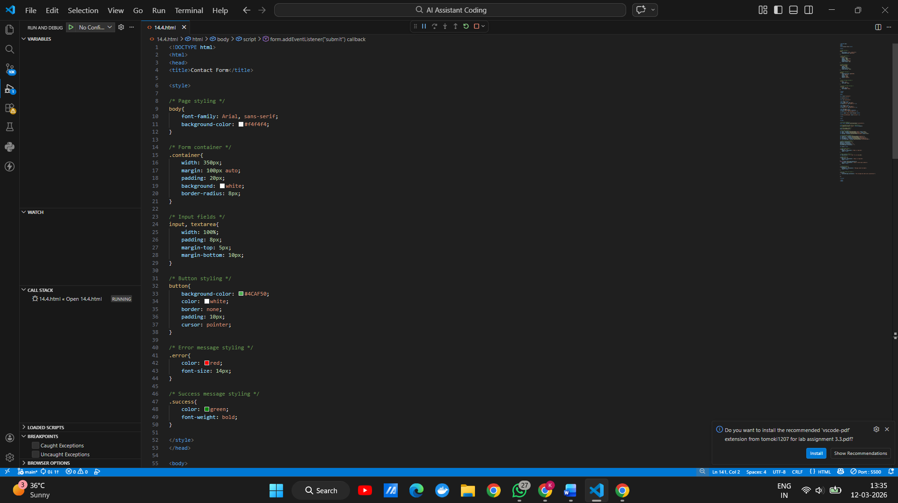
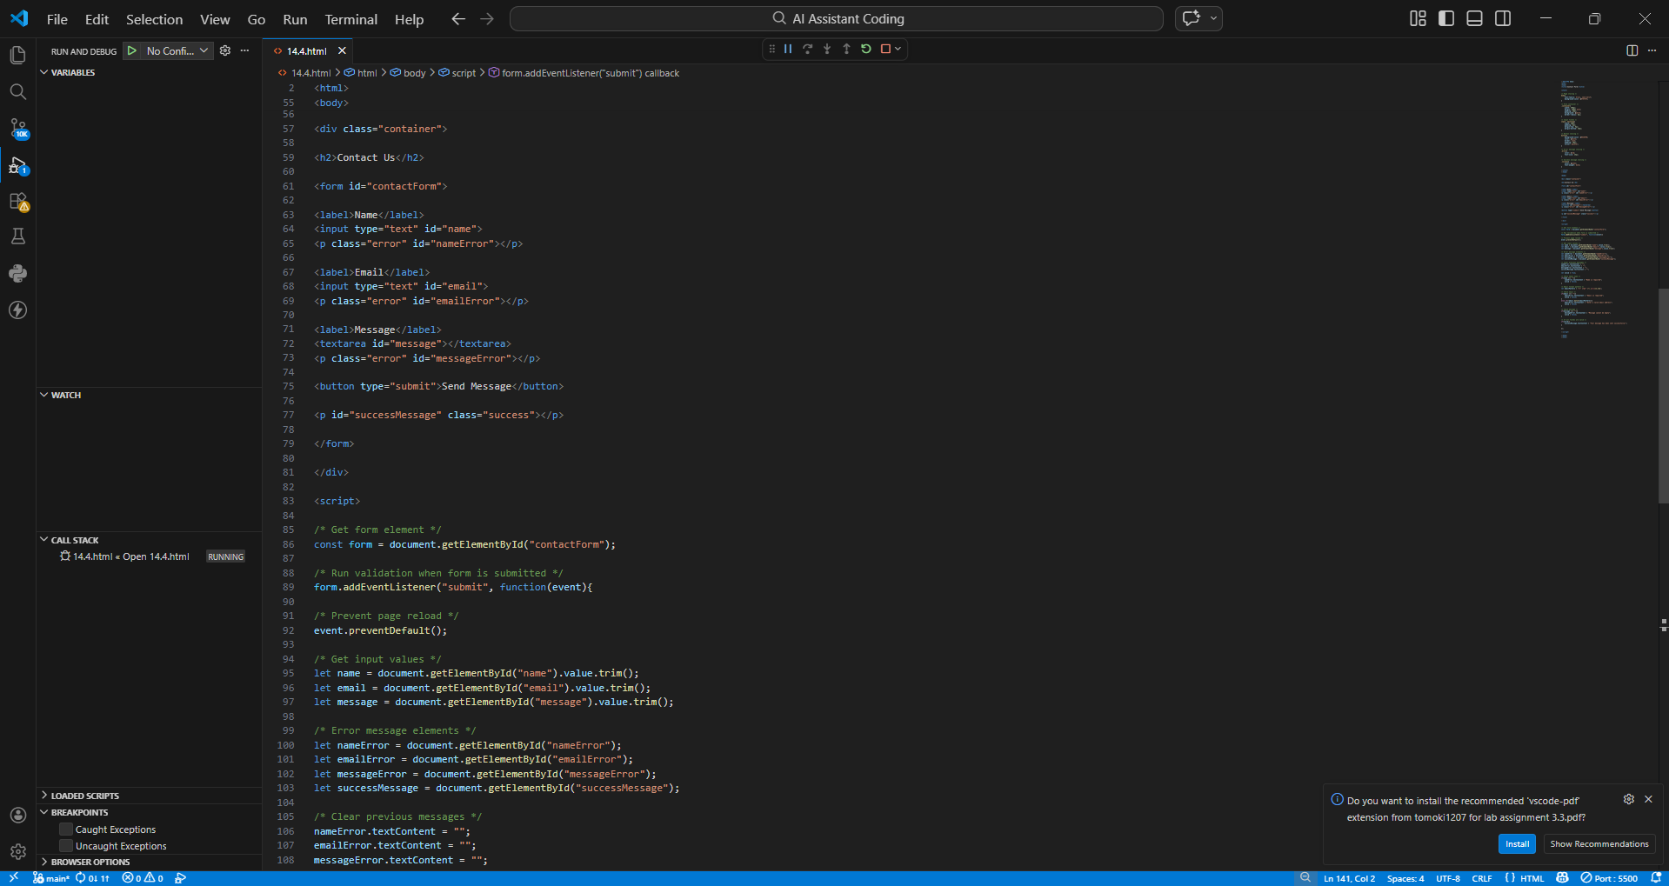
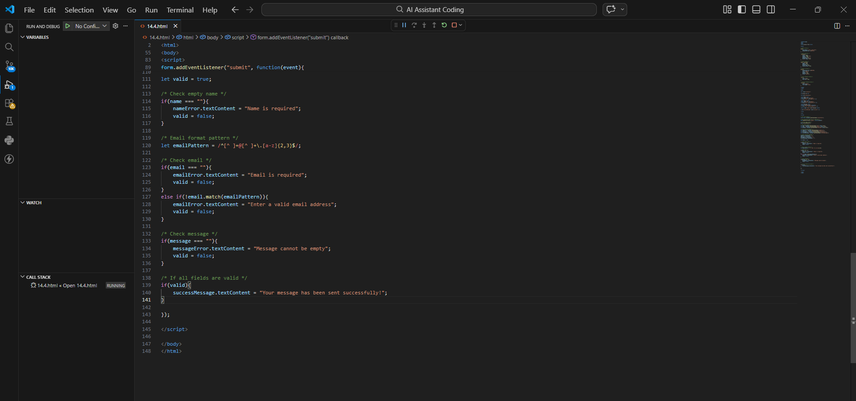
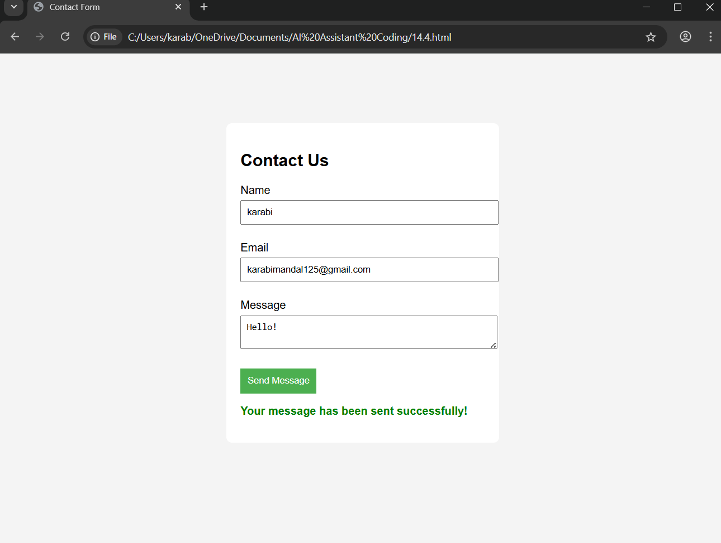

Task 4: Dynamic List Management for a Product Page

Scenario
A product listing page needs to add or remove items dynamically without refreshing the page.

Task Description
- Create a simple HTML list to display items.
- Use AI to generate JavaScript that:
  - Adds a new item when an “Add” button is clicked
  - Removes the last item when a “Remove” button is clicked
- Ensure the DOM updates dynamically.

Expected Output
- A web page where:
  - Items can be added and removed dynamically
  - Changes appear instantly without page reload
  - JavaScript logic is clear and maintainable
PROMPT: I am creating a product list page using HTML and JavaScript.
Please generate code that shows a list of items with two buttons: Add Item and Remove Item.
When the Add button is clicked, a new item should be added to the list.
When the Remove button is clicked, the last item should be removed.
The list should update dynamically using JavaScript without refreshing the page, and the code should include comments explaining the DOM manipulation.

EXPLAINATION: addItem() creates a new list item dynamically.
removeItem() removes the last item from the list.
DOM updates without page reload.

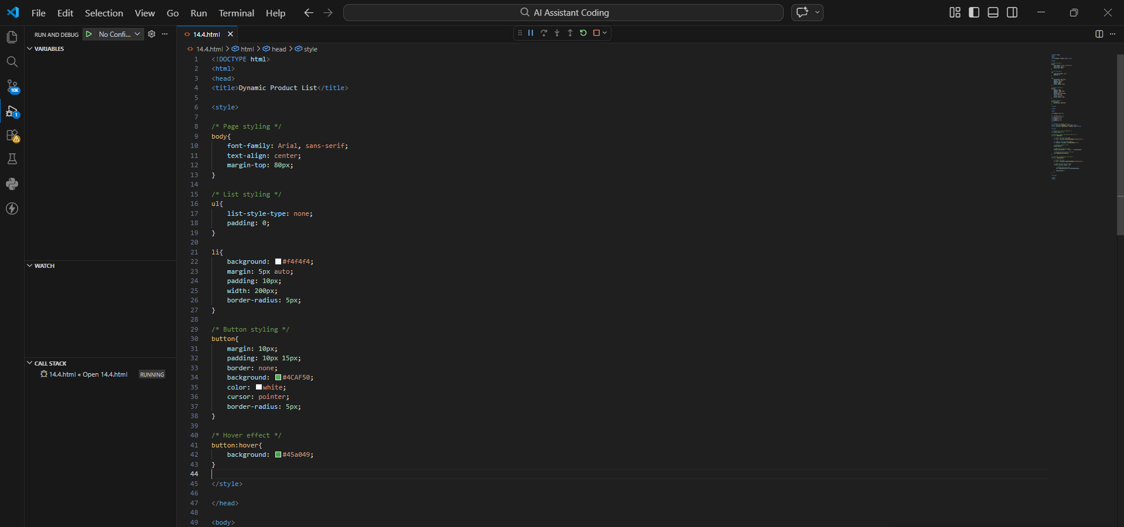
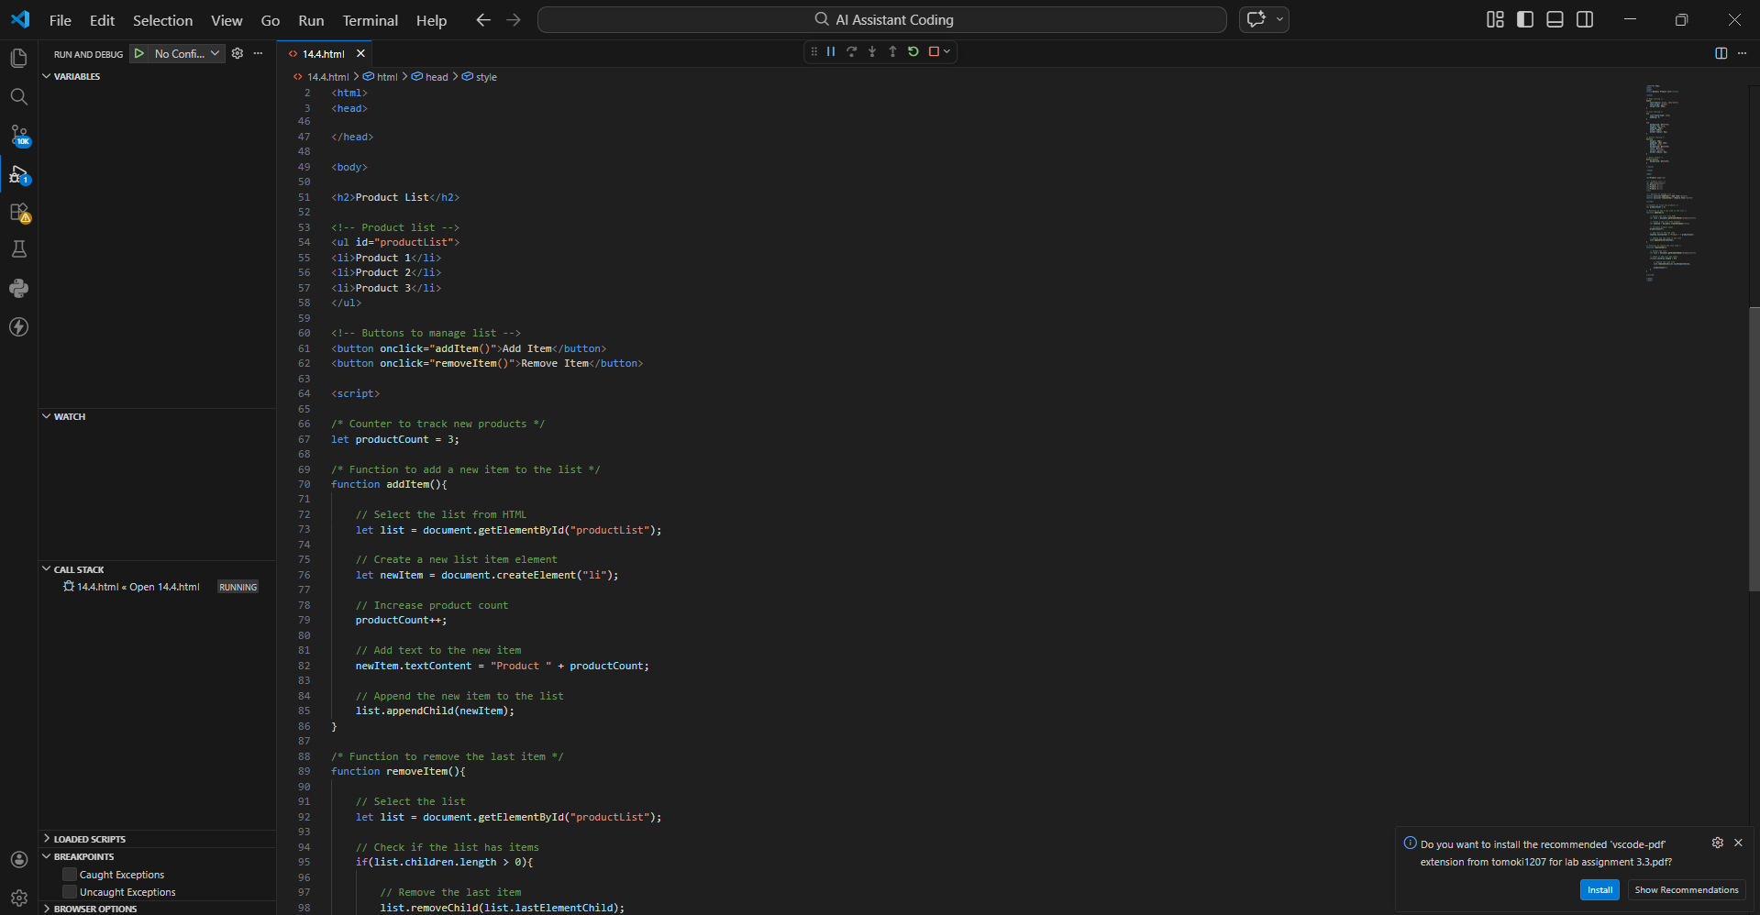
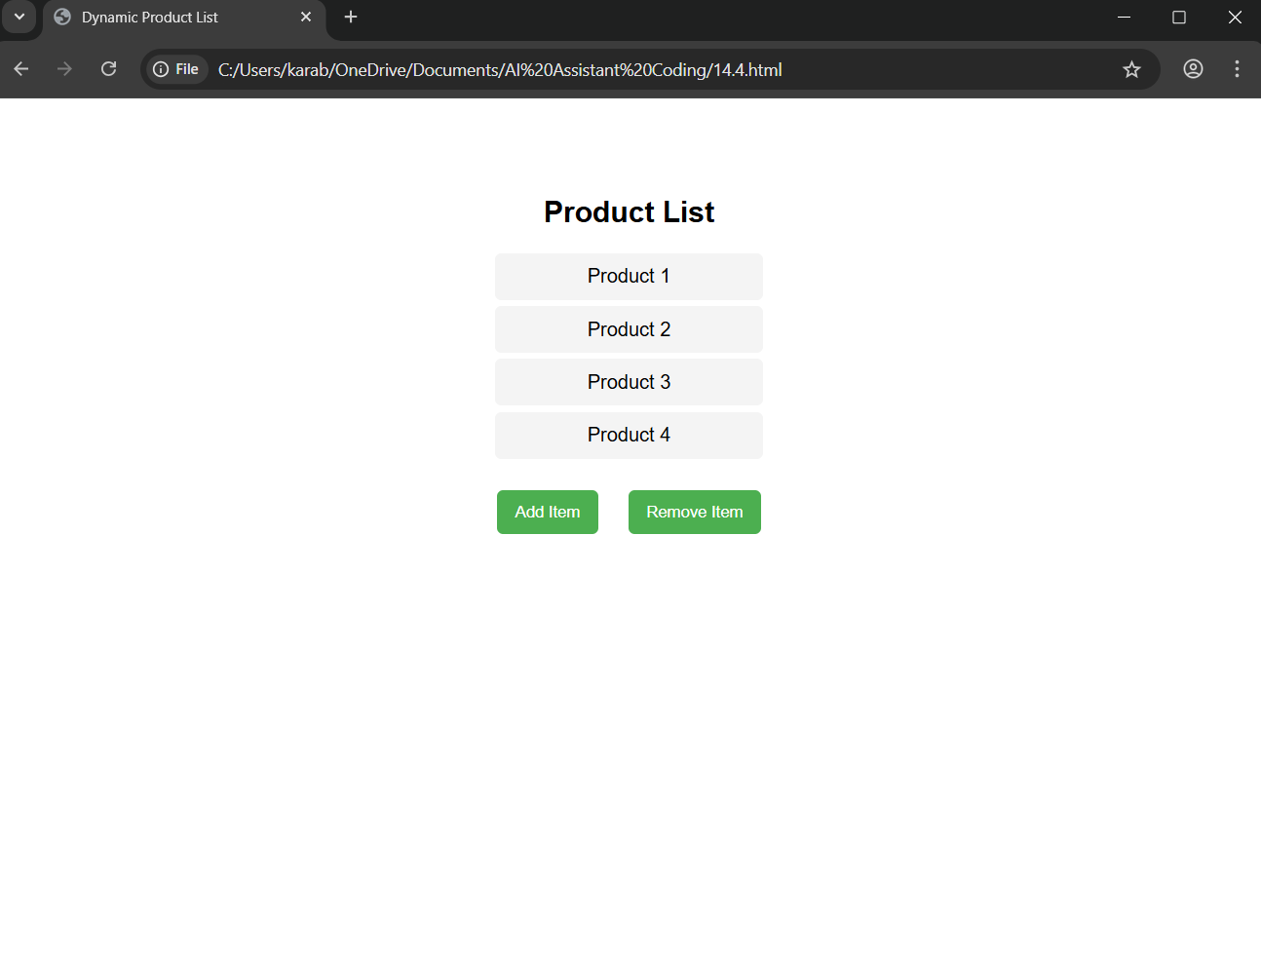
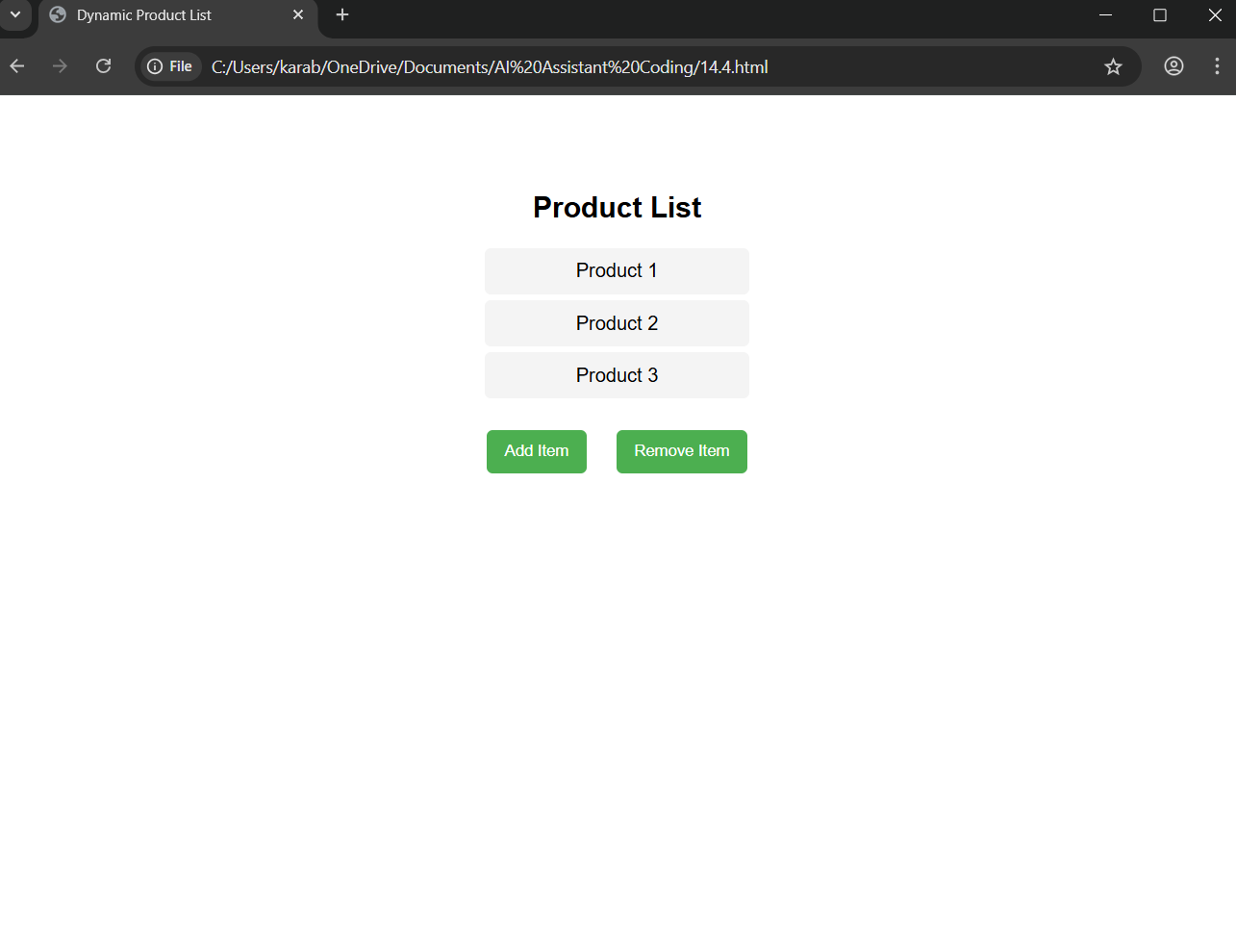
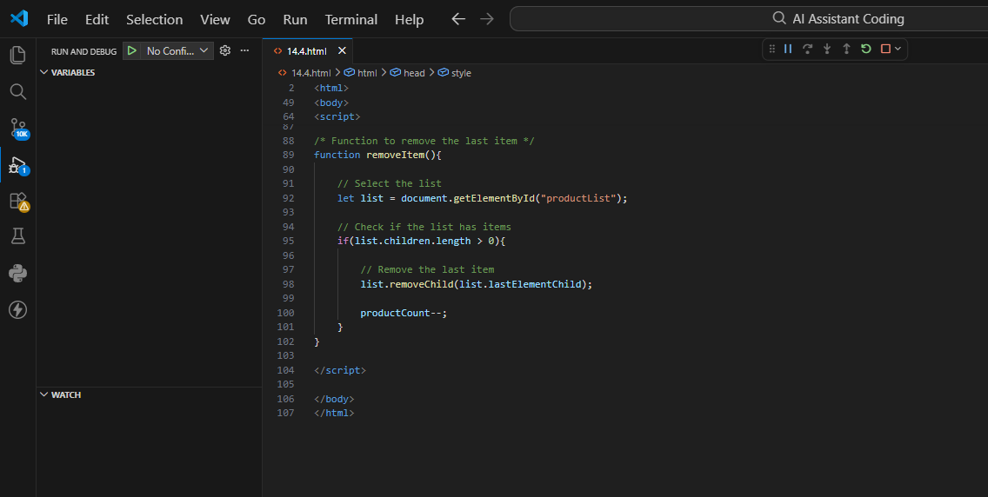

Task 5: Modal Popup for User Notifications

Scenario
You are building a user notification popup for announcements or alerts on a website.

Task Description
- Use AI to help generate:
  - HTML structure for a modal popup
  - CSS styling with a semi-transparent background overlay
  - JavaScript to open and close the modal
- Include multiple ways to close the modal (button or overlay click).

Expected Output
- A web page where:
  - Clicking “Open Modal” displays the popup
  - Popup overlays the page content clearly
  - Modal closes smoothly when instructed
PROMPT: I want to implement a modal popup notification on a website.
Please generate:
- HTML structure for the modal
- CSS styling with a semi-transparent background overlay
- JavaScript to open and close the modal popup
The modal should open when an "Open Modal" button is clicked and should close when:
- The close button is clicked, or
- The user clicks outside the modal (overlay)
The code should be simple and well-commented for learning purposes.
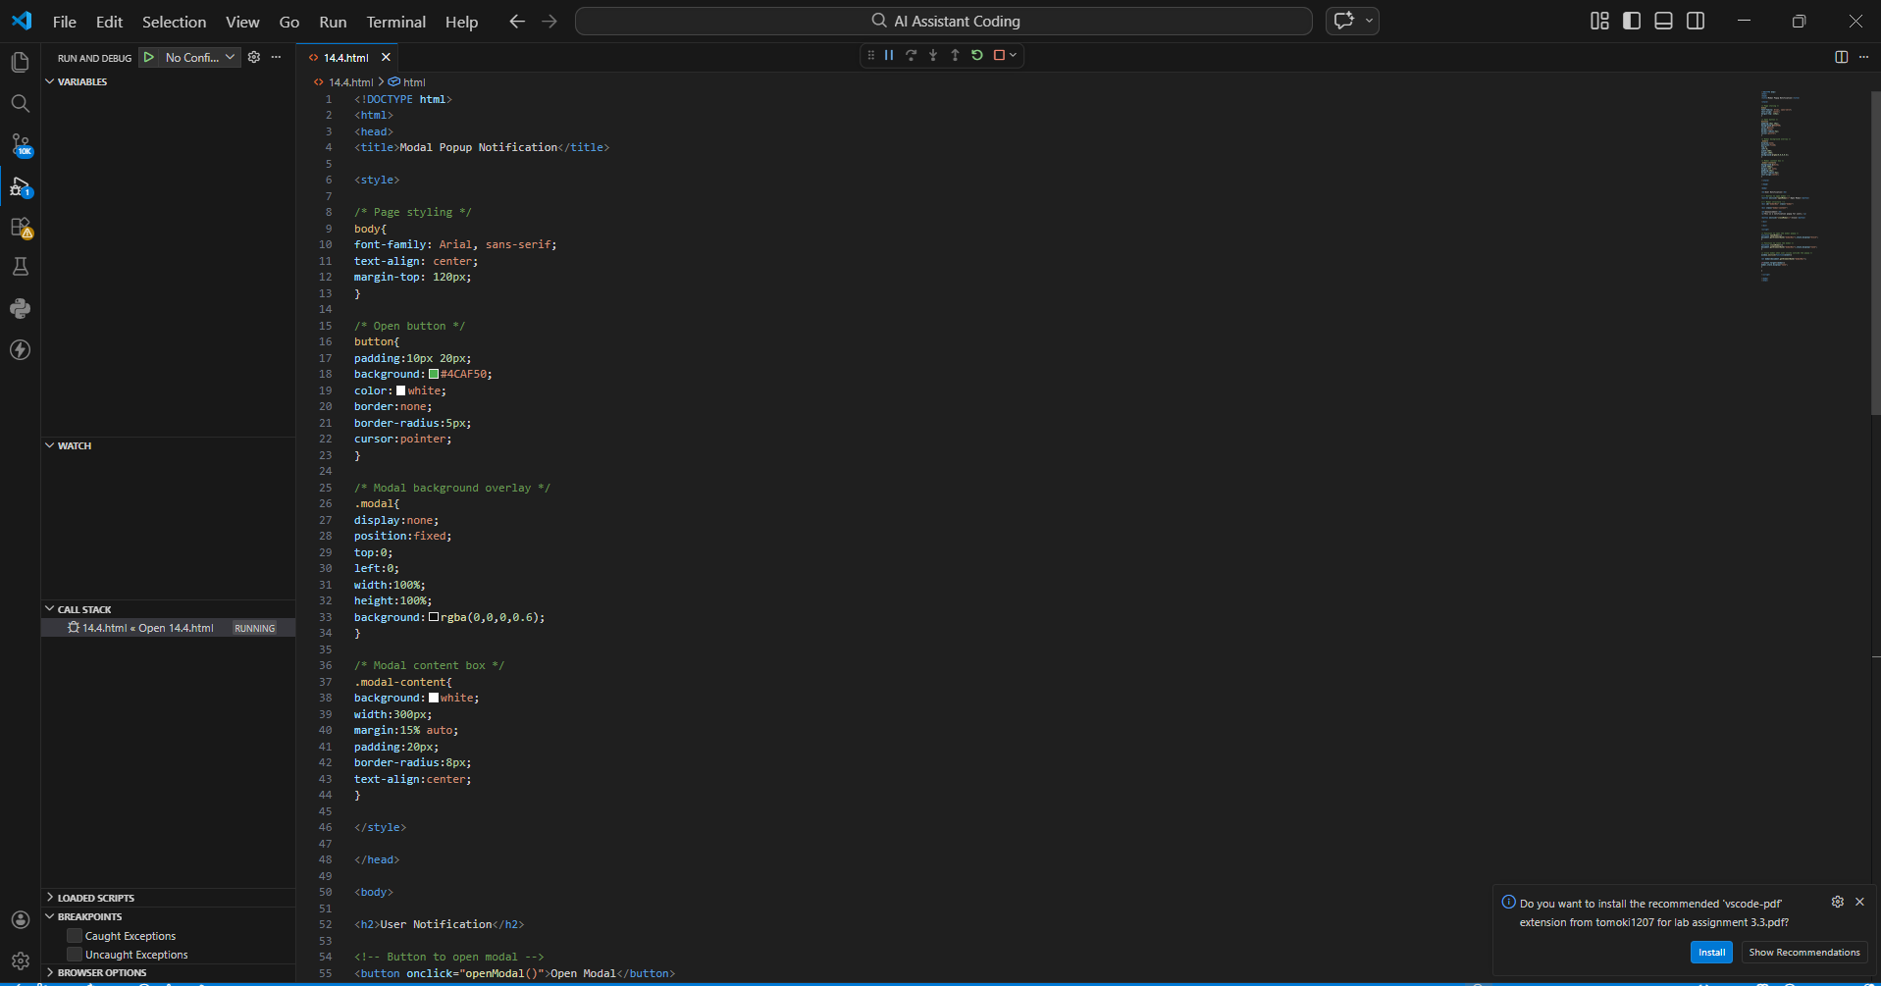
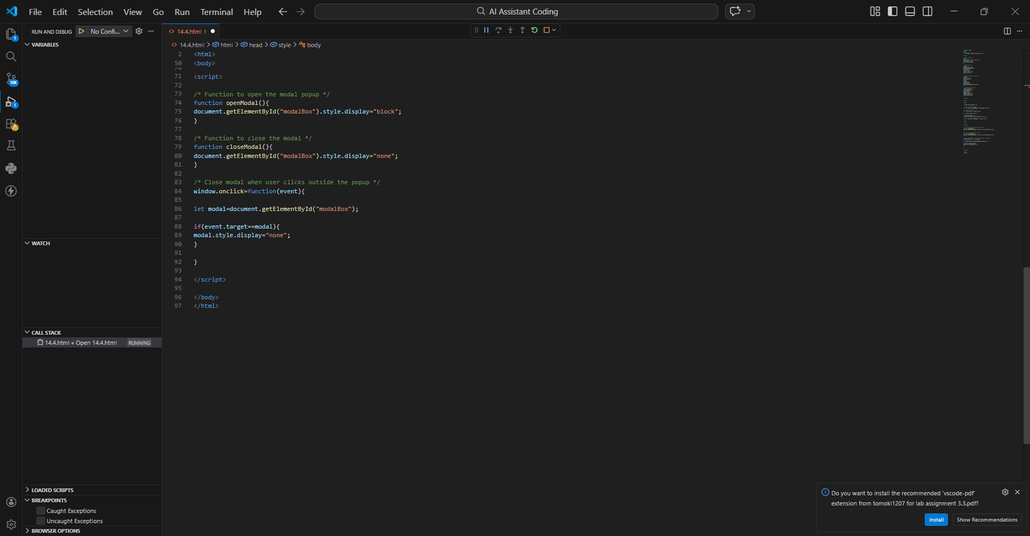
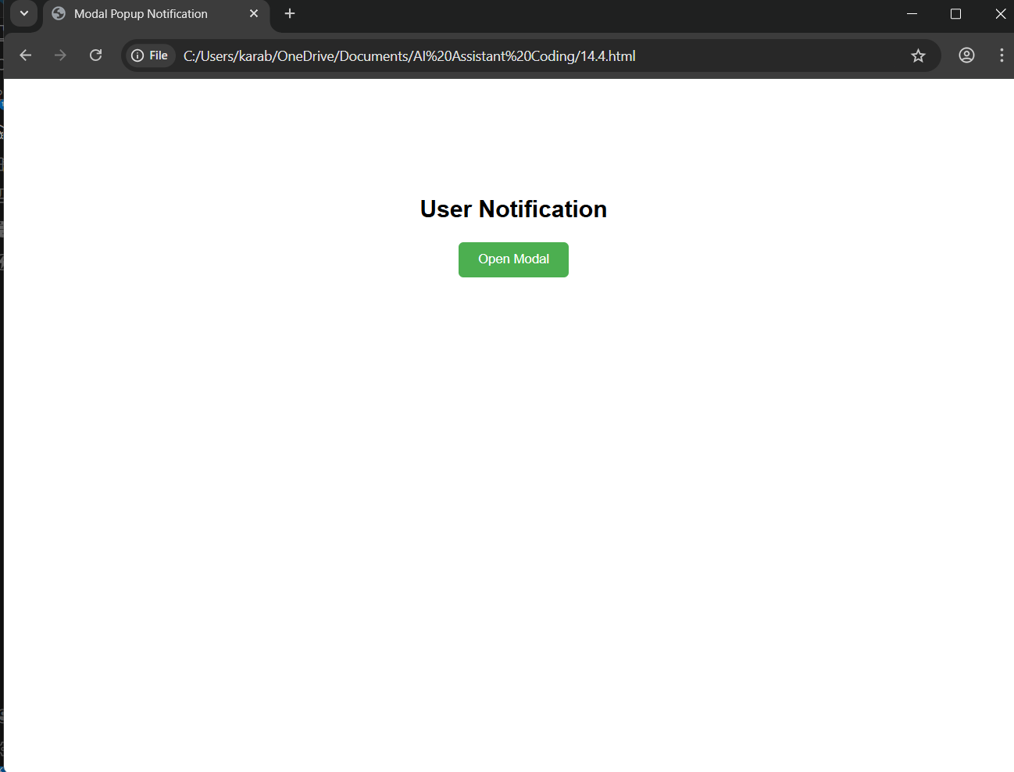
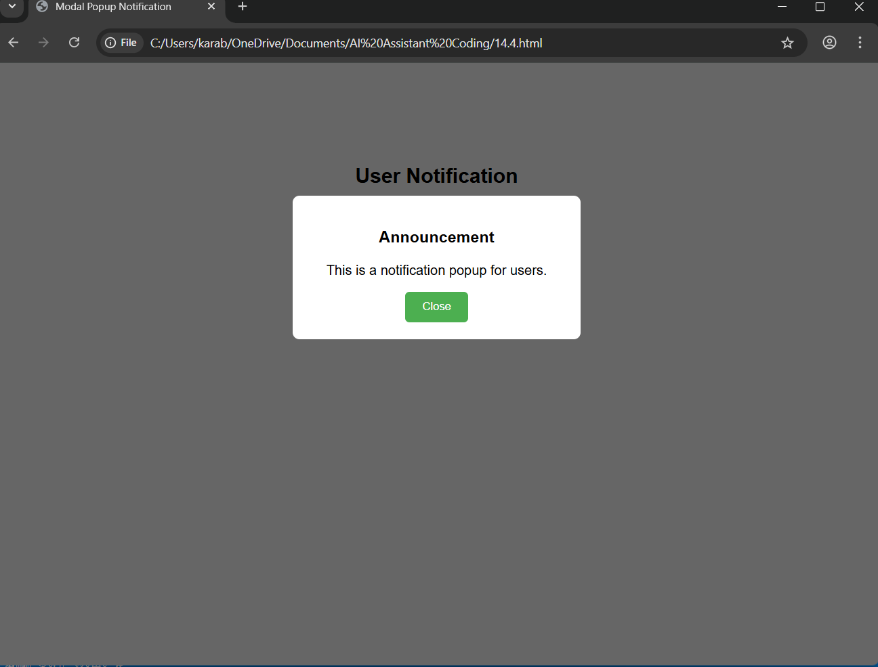

- EXPLAINATION: Modal overlay appears on top of the page.
- Open Modal button shows the popup.
- Users can close the modal by:
  - Clicking Close button
  - Clicking outside the popup (overlay).

Note: Report should be submitted a word document for all tasks in a single document with prompts, comments & code explanation, and output and if required, screenshots

