SCHOOL OF COMPUTER SCIENCE AND ARTIFICIAL INTELLIGENCE |  |  |  |  | DEPARTMENT OF COMPUTER SCIENCE ENGINEERING
Program Name: B. Tech |  |  |  | Assignment Type: Lab |  |  | Academic Year:2025-2026
Course Coordinator Name |  |  |  | Dr. Rishabh Mittal
Instructor(s) Name |  |  |  | Mr. S Naresh Kumar  Ms. B. Swathi  Dr. Sasanko Shekhar Gantayat  Mr. Md Sallauddin  Dr. Mathivanan  Mr. Y Srikanth  Ms. N Shilpa  Dr. Rishabh Mittal (Coordinator)  Dr. R. Prashant Kumar  Mr. Ankushavali MD  Mr. B Viswanath  Ms. Sujitha Reddy  Ms. A. Anitha  Ms. M.Madhuri  Ms. Katherashala Swetha  Ms. Velpula sumalatha  Mr. Bingi Raju
CourseCode |  |  | 23CS002PC304 | Course Title |  | AI Assisted Coding
Year/Sem |  |  | III/II | Regulation |  | R23
Date and Day  of Assignment |  |  | Week2 | Time(s) |  | 23CSBTB01 To 23CSBTB52
Duration |  |  | 2 Hours | Applicable to  Batches |  | All batches
Assignment Number: 4.4(Present assignment number)/24(Total number of assignments)
 | Q.No. | Question |  |  |  |  |  | Expected Time  to complete
 | 1 | 1. Sentiment Classification for Customer Reviews  Scenario:  An e-commerce platform wants to analyze customer reviews and classify them into Positive, Negative, or Neutral sentiments using prompt engineering.  Tasks:  - Prepare 6 short customer reviews mapped to sentiment labels.  - Design a Zero-shot prompt to classify sentiment.  - Design a One-shot prompt with one labeled example.  - Design a Few-shot prompt with 3–5 labeled examples.  - Compare the outputs and discuss accuracy differences.  Zero-Shot PROMPT: Classify this customer review as Positive, Negative, or Neutral: {review}  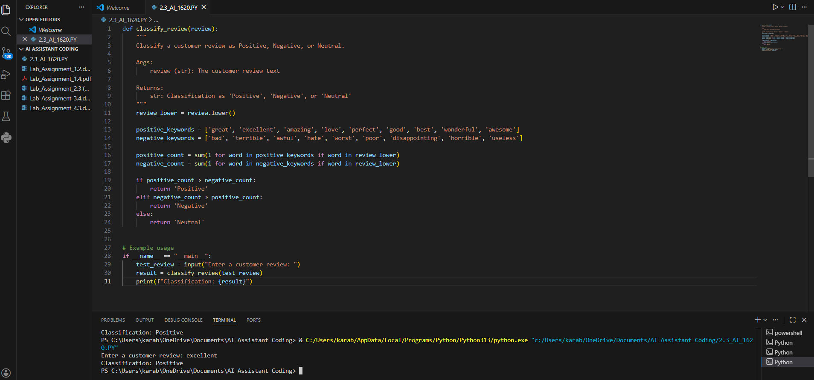  One-shot prompt: Great product!" → Positive. "{review} 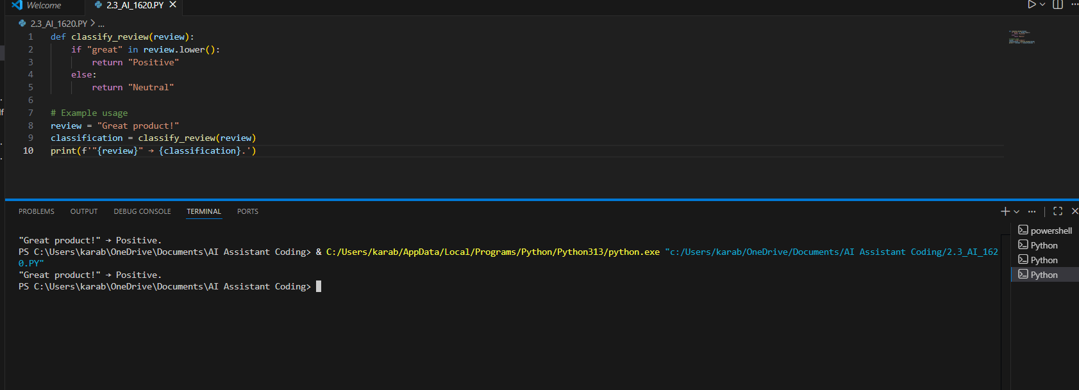  Few-shot prompt: Positive: "Love it!"; Negative: "Terrible"; Neutral: "OK".  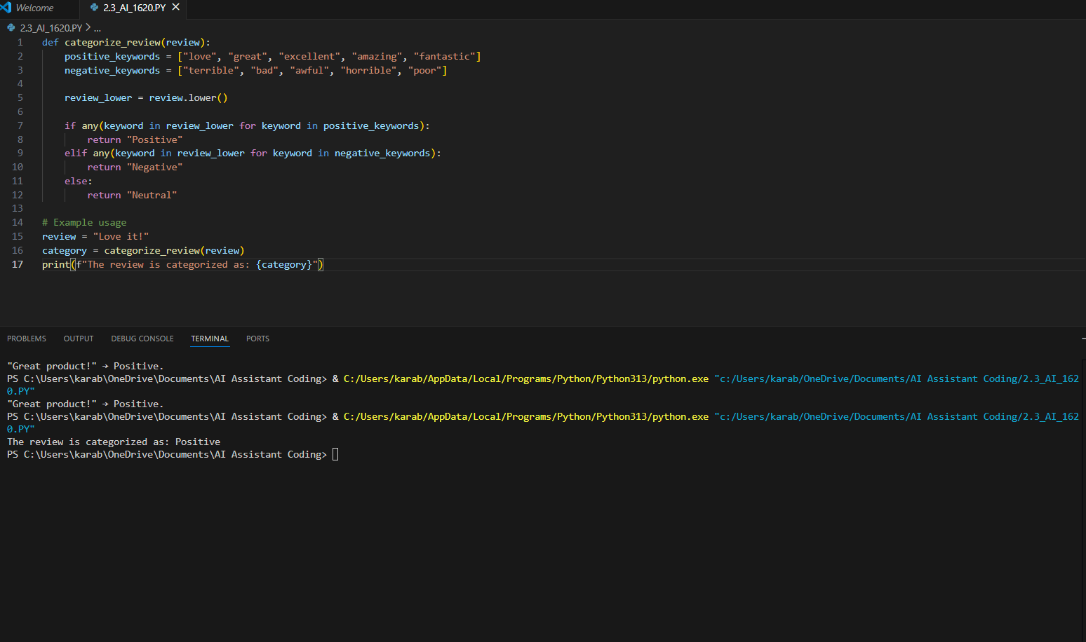  Explaination: Zero-shot: Works without examples but has lower accuracy for unclear reviews.  One-shot: One example improves understanding and gives better accuracy than zero-shot.  Few-shot: Multiple examples give the highest accuracy and most consistent results.  2. Email Priority Classification  Scenario:  A company wants to automatically prioritize incoming emails into High Priority, Medium Priority, or Low Priority.  Tasks:  - Create 6 sample email messages with priority labels.  - Perform intent classification using Zero-shot prompting.  - Perform classification using One-shot prompting.  - Perform classification using Few-shot prompting.  - Evaluate which technique produces the most reliable results and why.  Zero-shot PROMPT: Classify email priority as High, Medium, or Low  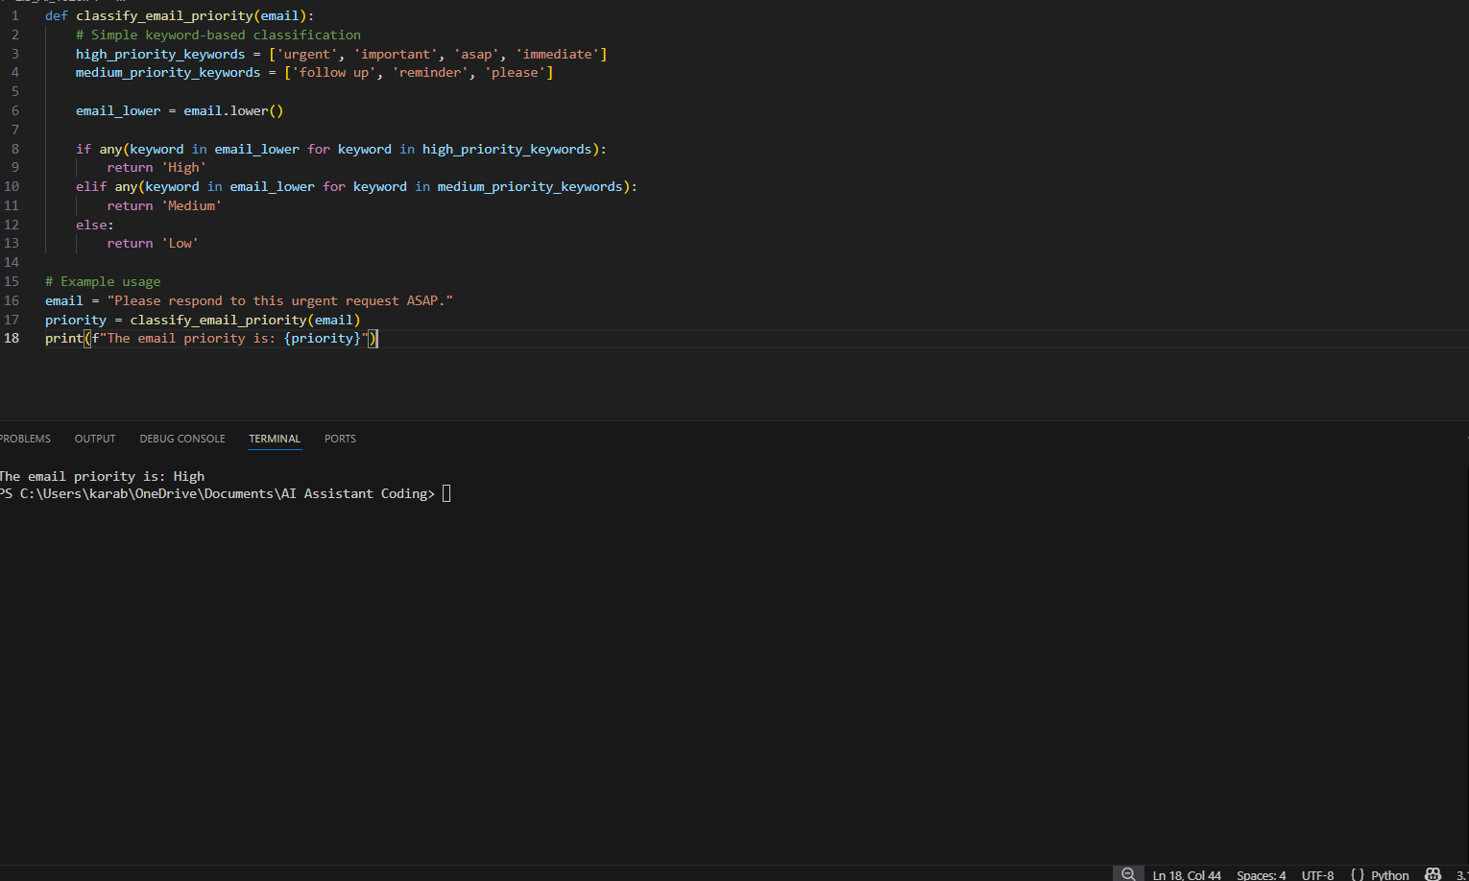  One-shot prompt: URGENT server down" → High.  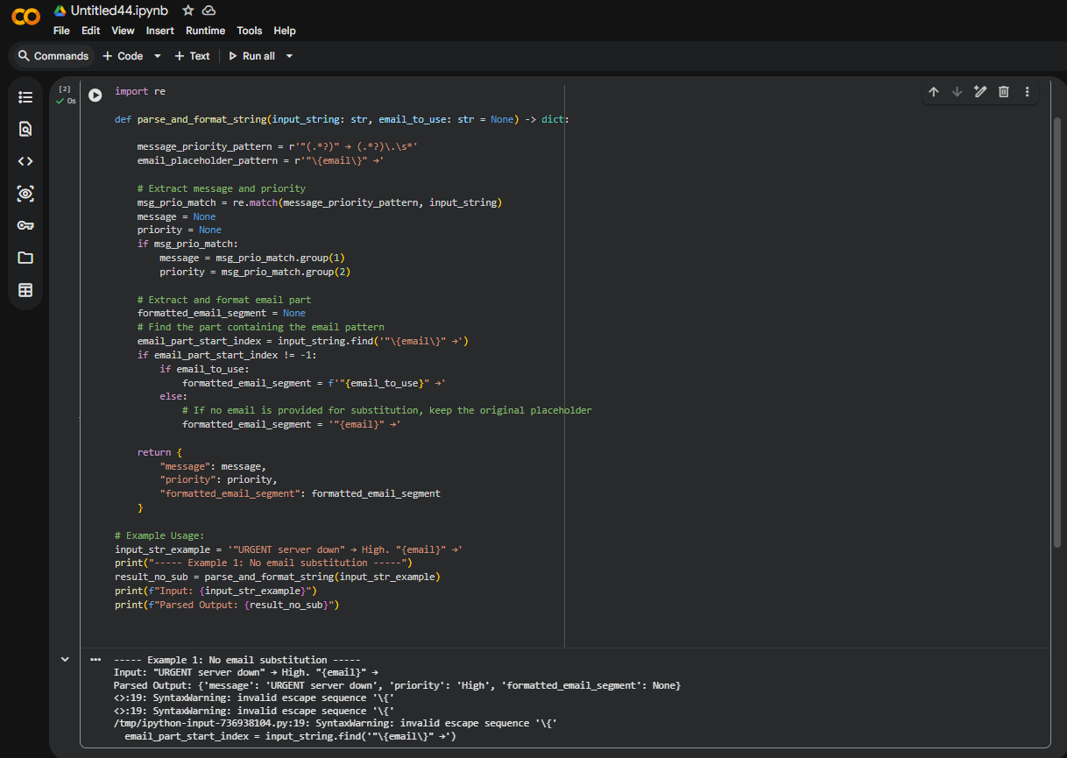  Few-shot Prompt: CRITICAL outage"; Medium: "Meeting tomorrow"; Low: "Newsletter". "{email}"  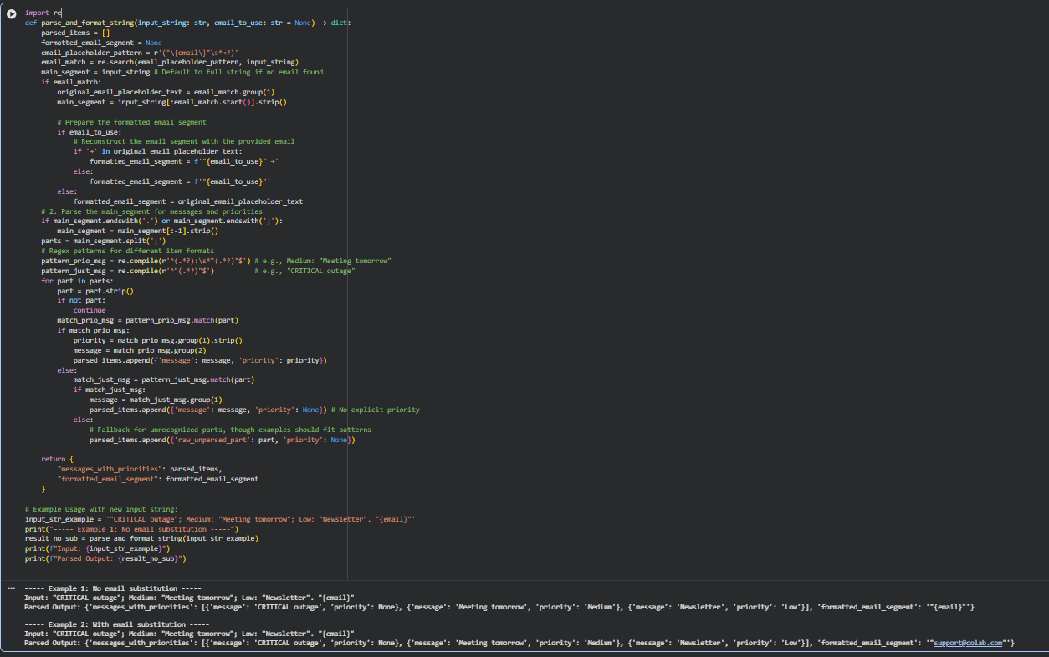  EXPLAINATION:  Zero-shot: Classifies priority without examples, accuracy may drop for unclear emails.  One-shot: One example helps the model identify urgency better than zero-shot.  Few-shot: Multiple examples give the most accurate and consistent priority classification.  3. Student Query Routing System  Scenario:  A university chatbot must route student queries to Admissions, Exams, Academics, or Placements.  Tasks:  - Create 6 sample student queries mapped to departments.  - Implement Zero-shot intent classification using an LLM.  - Improve results using One-shot prompting.  - Further refine results using Few-shot prompting.  - Analyze how contextual examples affect classification accuracy.  Zero-shot prompt: Route to Admissions, Exams, Academics, or Placements  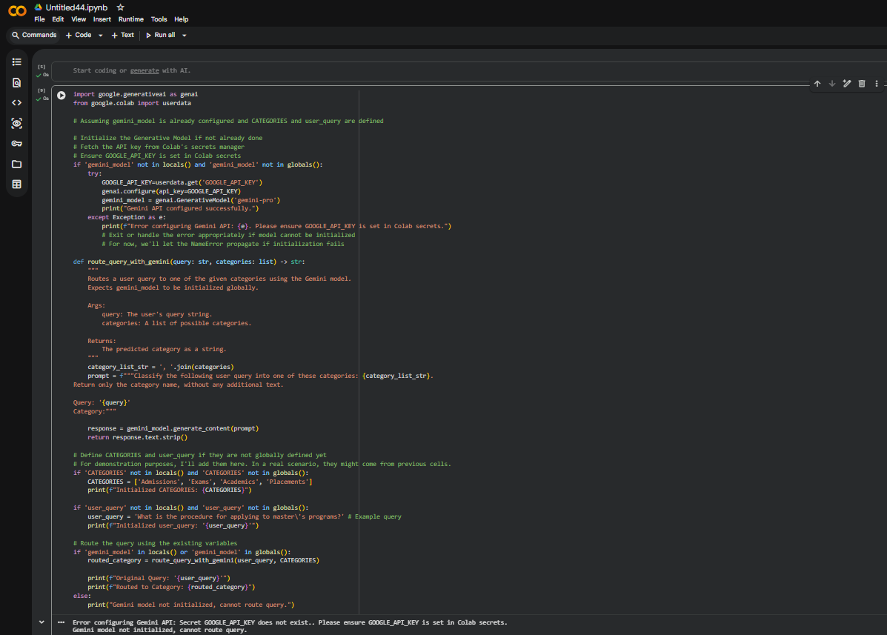  One-shot prompt: MBA application" → Admissions. "{query}  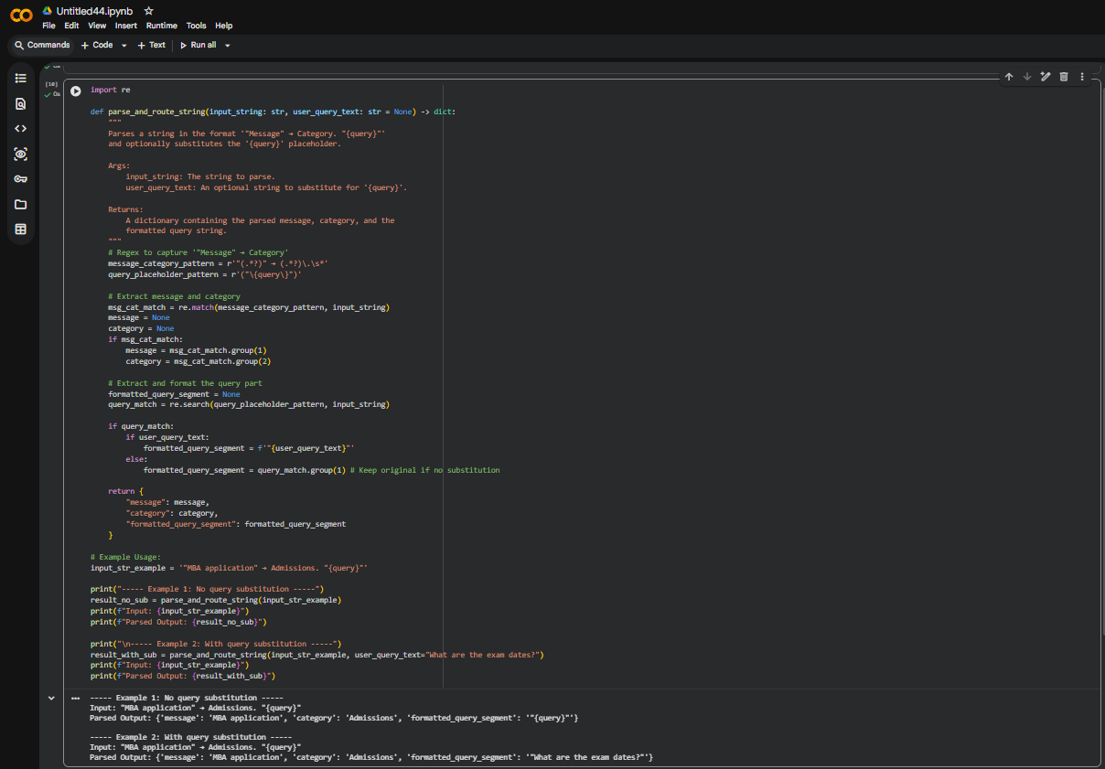  Few-shot prompt: Exam dates" → Exams; "Job fair" → Placements; "Course list" → Academics.  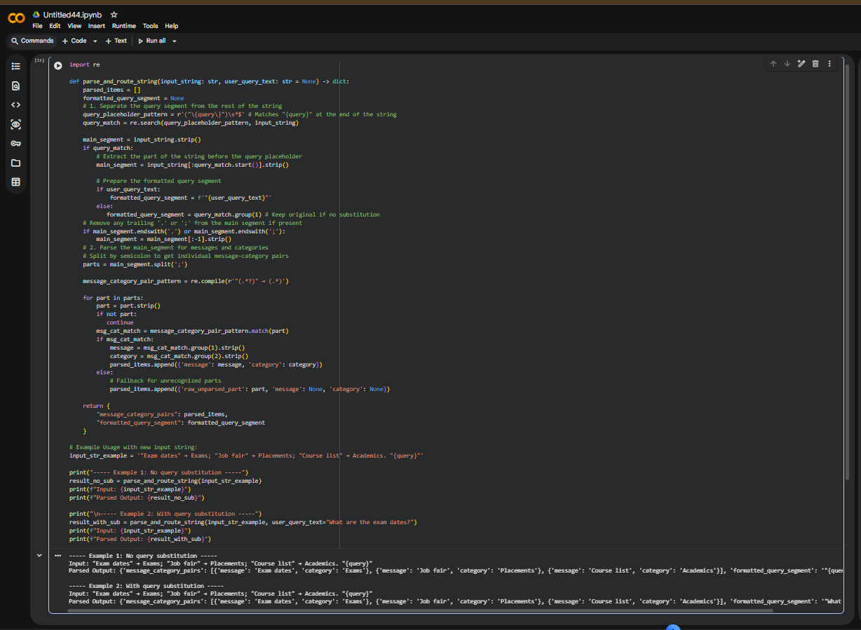  EXPLAINATION:  Zero-shot: Routes the query using instructions only, accuracy may be lower for vague queries.  One-shot: One example improves routing accuracy compared to zero-shot.  Few-shot: Multiple examples give the highest accuracy and most reliable routing.  4. Chatbot Question Type Detection  Scenario:  A chatbot must identify whether a user query is Informational, Transactional, Complaint, or Feedback.  Tasks:  - Prepare 6 chatbot queries mapped to question types.  - Design prompts for Zero-shot, One-shot, and Few-shot learning.  - Test all prompts on the same unseen queries.  - Compare response correctness and ambiguity handling.  - Document observations.  Zero-shot prompt: "Classify as Informational, Transactional, Complaint, or Feedback  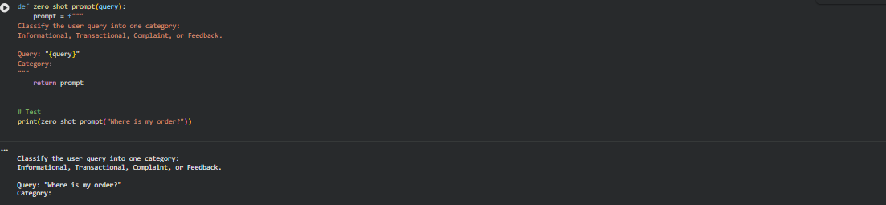  One-shot prompt: '"Store hours?" → Informational.  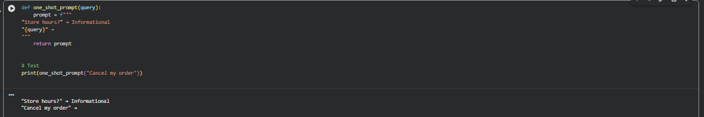  Few-shot prompt: '"Cancel order" → Transactional; "Bad service" →  Complaint; "Love update" → Feedback.  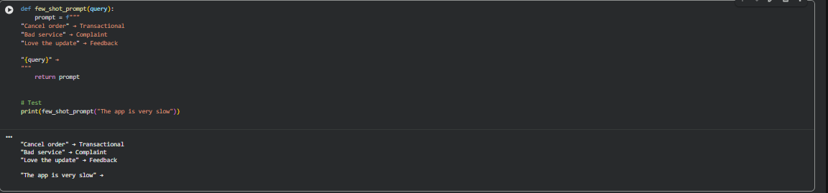  EXPLAINATION:  Zero-shot: Uses only instructions, so accuracy can be lower for ambiguous queries.  One-shot: One example improves understanding and gives better results than zero-shot.  Few-shot: Multiple examples provide the highest accuracy and most consistent classification  5. Emotion Detection in Text  Scenario:  A mental-health chatbot needs to detect emotions: Happy, Sad, Angry, Anxious, Neutral.  Tasks:  - Create labeled emotion samples.  - Use Zero-shot prompting to identify emotions.  - Use One-shot prompting with an example.  - Use Few-shot prompting with multiple emotions.  - Discuss ambiguity handling across techniques.  Zero-shot prompt: Emotion from Happy, Sad, Angry, Anxious, Neutral  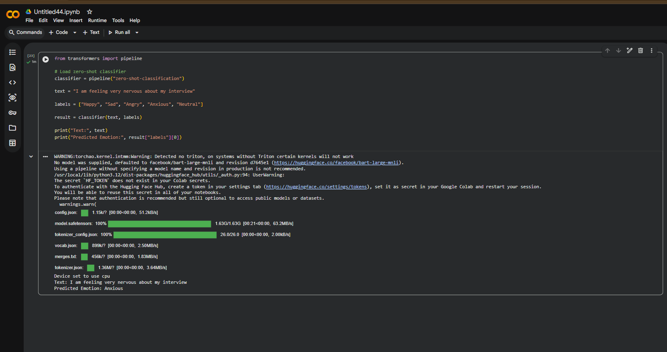  One-shot prompt: Got promoted!" → Happy.  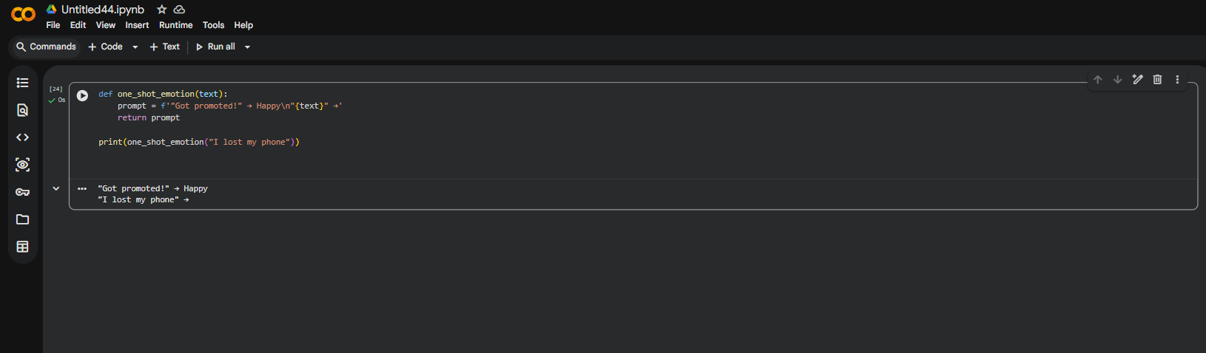  Few-shot prompt: Failed test" → Sad; "So angry!" → Angry; "Feeling calm" → Neutral.  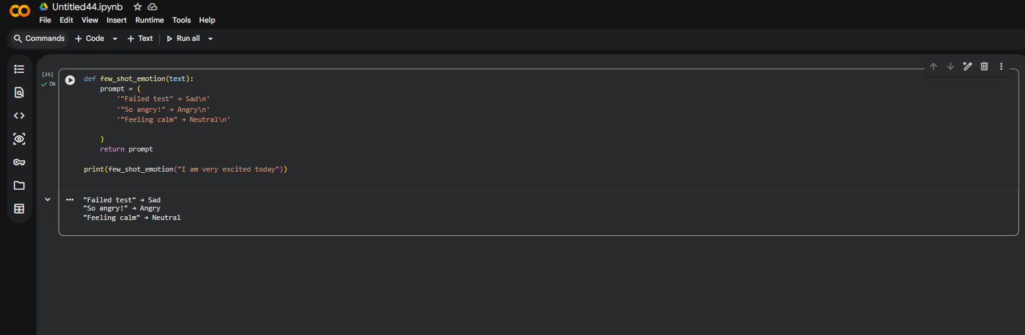  EXPLAINATION:  - Zero-shot: Detects emotion using only instructions, accuracy may drop for mixed emotions.  - One-shot: One example helps the model detect emotion more accurately than zero-shot.  - Few-shot: Multiple examples give the highest accuracy and most reliable emotion detection. |  |  |  |  |  | Week2

