Karabo Radebe
ST10520550
proposal

Organisation Overview:
- MojaBuild Constructions.
- 10 years in the construction industry. MojaBuild Constructions has earned a reputation for delivering top-quality residential, commercial, and industrial projects.
- Their Mission is to Deliver exceptional craftsmanship in every project.
Embrace innovation to create sustainable and efficient structures.
Complete projects on time and within budget without compromising quality.
- MojaBuilds Constructions plans to target ambitious customers who want to bring their ideas to life.

Website goals and Objectives:
- Primary goal: Establish a professional, trustworthy online presence that generates qualified leads and showcases the company's completed work.

- Specific objectives:
Generate quote/consultation requests through a clear contact and quote-request pathway.
Showcase past projects to build credibility with prospective clients
Communicate services offered clearly within seconds of landing on the site

Key performance indicators (KPIs)
KPI | Target | How it's measured
Quote request submissions | 15+ per month | Form submission count
Average session duration | 2+ minutes | Google Analytics
Bounce rate | Under 50% | Google Analytics
Mobile conversion rate | Within 10% of desktop | Google Analytics goal tracking
Page load time | Under 3 seconds | Google PageSpeed Insights
Local search ranking | Top 3 for target keywords | Google Search Console
Contact/phone click-throughs | 20+ per month | Click event tracking

Proposed website Features and Functionality:
- Homepage — hero banner, services overview, trust signals, clear call-to-action
- Services pages — dedicated section per service category with descriptions and photos
- Project portfolio/gallery — before/after photos, filterable by project type
- About page — company history, team, certifications/licensing, safety record
- Quote request form — captures project type, scope, budget range, contact details
- Contact page — address, phone, email, embedded map, business hours
- Social media links

Design and User Experience:
- The site should feel sturdy, professional, and trustworthy — avoiding anything overly playful or generic-corporate. Visuals should lean on real project photography rather than stock imagery.

Colour scheme
- Primary — Navy blue #1B2A41 (trust, professionalism)
- Accent — Safety orange #E8590C (energy, calls-to-action, echoes construction signage)
- Neutral — Concrete grey #6C6F70 (structure, secondary text)
- Base — Off-white #F7F7F5 (clean background)

Typography
- Headings — a bold, condensed sans-serif such as Oswald or Montserrat Bold, conveying strength and structure
- Body text — a highly readable sans-serif such as Open Sans or Roboto, 16px minimum for accessibility

Layout and design principles
- Grid-based, consistent spacing
- Generous white space to avoid a cluttered feel

UX considerations
- Maximum 2-3 clicks to reach the quote form from any page
- Fast load times for on-site browsing with limited signal

Low-fidelity wireframe — homepage
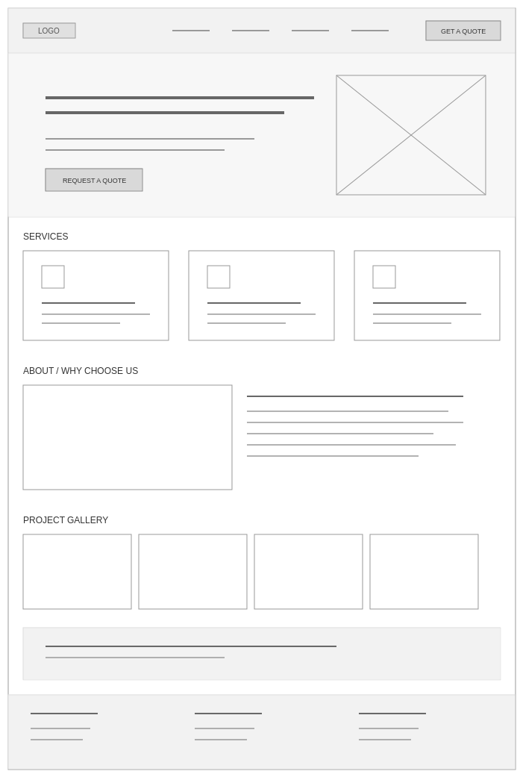

Hierarchy

Technical Requirements

Domain name:
Register a domain matching the company name via a registrar such as GoDaddy.

Hosting:
Shared or managed hosting is sufficient for a small-to-medium business site (e.g. Bluehost, SiteGround, Hostinger).

Timeline and Milestones
Week | Phase | Milestone
Week 1 | Discovery & planning | Finalize proposal, gather content/branding assets, confirm sitemap
Week 2 | Design | Low-fidelity wireframes finalized, colour/typography approved
Week 3 | Design | High-fidelity mockups of key pages (home, services, contact)
Week 4 | Development start | Set up hosting/domain, build homepage and navigation
Week 5 | Development | Build remaining pages (services, gallery, about)
Week 6 | Development | Build and test quote form, integrate analytics and maps
Week 7 | Testing | Cross-browser/device testing, accessibility check, content review
Week 8 | Launch | Final revisions, go live, submit project documentation

Budget
Item | Estimated cost | Notes
Domain registration | R199/year | One-time annual
Web hosting | R150-R250/month | Ongoing
Design/development | R7000 | Once Off
Ongoing maintenance | R400/month | Real-world: updates, backups, security monitoring
Total estimated | R8000 | Domain + hosting + minor assets

References
- Nielsen Norman Group. Available at: nngroup.com (UX research and best practices)
- W3C Web Accessibility Initiative. Available at: w3.org/WAI (WCAG 2.1 guidelines)
- Google Web.dev. Available at: web.dev (performance and Core Web Vitals guidance)
- WordPress.org. Available at: wordpress.org (CMS documentation)
- Google Search Central. Available at: developers.google.com/search (SEO best practices)
- Pitures
https://pin.it/5F0OWotzj
https://pin.it/3gCZzCr2G
https://pin.it/5EHtFkA1b
https://pin.it/SZ5gAAzg4
https://pin.it/OQE8CGLsy

