ECO5040 Project
Karabo Tigedi, Kerry-Lynn Whyte, Nikola Milosavljevic, Annita Ngoma, Lilitha Mzamo

Business and Technical Specification:

- Business problem – Nikola

- Business Problem
Sending money from South Africa to neighbouring countries remains expensive, particularly on the corridor to Zimbabwe, one of the country's largest remittance routes. The World Bank's Remittance Prices Worldwide database records what major providers charge for its USD 200 benchmark transfer, combining the transfer fee and the exchange-rate margin into a single total cost. In data collected in August 2025, that cost ranged from 5.15% through WorldRemit's online service to 31.81% through Western Union's agent network, with MoneyGram at 15.43% and Mukuru at 10.28% (World Bank, 2025). The corridor average was 12.49%, more than four times the Sustainable Development Goal target of 3%, and even the cheapest option exceeded the goal's separate aim of eliminating corridors that cost more than 5% (United Nations, 2015).
These costs fall on the migrant workers who rely on this corridor and others like it. About R19 billion was sent formally from South Africa to other Southern African Development Community (SADC) countries in 2024, nearly 90% of it to Lesotho, Zimbabwe, Mozambique and Malawi (FinMark Trust, 2024). Most of that money moves in small, regular amounts set aside from wages, which is precisely where fixed fees do the most damage.
Stablecoin platforms provide a way to circumvent this. Because a dollar-pegged token such as USDC or USDT can move directly between accounts, the chain of correspondent banks is removed, and value can be transferred almost instantly and at little cost. Many of these platforms, however, are designed primarily for people who already use cryptocurrency, and they leave both ends of the transfer to the user. The sender must first buy the stablecoin with rand before sending it, and the recipient must hold it as a crypto asset and then sell it to obtain cash. For a migrant worker and a family at home who simply want the money to arrive, each of these steps adds cost, effort and room for error. Stablecoins make the transfer itself cheap, however, on their own they do not amount to a remittance service.
The proposed platform is built to turn stablecoin settlement into a complete remittance service. Senders pay in rand, just as they would with MoneyGram, Western Union or Mukuru, while the transfer itself settles on the XRP Ledger in RLUSD, giving the transfer the cost and speed of a stablecoin. Neither party has to handle the stablecoin directly: the platform converts the rand on the sender's behalf, and a custodial wallet, in which the platform holds the private keys on the recipient's behalf, lets the recipient keep the funds in RLUSD or cash out to US dollars or local currency. In a production system, that cash-out would rely on local payout partners able to convert RLUSD into local currency. In the prototype, this step is simulated.

- User Stories

2.1 Sender
As a migrant worker in South Africa, I want to send part of my wages to my family in Zimbabwe at a lower cost and have it arrive the same day, so that more of my money reaches them and they are not left waiting days for money they depend on.

2.2 Receiver
As a family member in Zimbabwe who depends on money sent from South Africa, I want to receive it as dollar value I can keep or cash out, without having to manage or sell cryptocurrency myself, so that a cheaper transfer does not come at the cost of more difficulty for me.

- Competitor comparison

The comparison focuses on four conventional money transfer operators on the South Africa to Zimbabwe corridor: the global incumbents MoneyGram and Western Union, Mukuru, whose business is built around the migrant-remittance pattern described in Section 1, and WorldRemit, the cheapest digital provider in the World Bank's data. VALR Pay is also looked at as a stablecoin-native provider, and Wise as a low-cost digital benchmark. While not extensive, it paints a picture of the current market landscape.
3.1 Conventional money transfer operators
All four operators are compared using the World Bank's Remittance Prices Worldwide data collected between 15 and 26 August 2025, which provides independently collected, directly comparable pricing from a single non-commercial source. Each figure is the total cost of sending USD 200, the World Bank's benchmark amount.

 | MoneyGram | Western Union | Mukuru | WorldRemit
Channel | Agent; cash pickup | Agent; cash pickup | Call centre; cash pickup | Online; mobile wallet
Total cost | 15.43% | 31.81% | 10.28% | 5.15%
Cost structure | Flat fee plus 0.83% exchange-rate margin | Flat fee; exchange rate marginally favourable | Flat fee plus 0.35% exchange-rate margin | Flat fee plus 3.15% exchange-rate margin
Speed | Next day | Two days | Same day | Under one hour
Pain points | Cost roughly five times the SDG target; slower than digital providers | Highest cost of the four; price varies widely by channel (15.85% via Absa online banking) | Twice the cost of the cheapest digital providers; customers report limited collection points, strict name-matching at payout and slow dispute resolution | Lowest cost, but available only online by bank transfer or card, excluding senders without either
Source: World Bank (2025), Remittance Prices Worldwide, South Africa to Zimbabwe corridor, Q3 2025. Total cost combines the fee and the exchange-rate margin as a percentage of the amount sent, while speeds are as recorded in the same database.

The comparison reveals a market in which price bears very little relation to the rendered service. Western Union's agent channel charges around six times as much as WorldRemit yet takes two days to deliver, while money sent through WorldRemit arrives in under an hour. On the World Bank's USD 200 benchmark, that gap amounts to roughly USD 53 per transfer, a considerable sum for a worker sending money home every month. The digital providers have brought costs much closer to the target, but even the cheapest remains above 3%, leaving room for a model that can reduce costs further.

3.2 VALR Pay
VALR Pay is a direct stablecoin competitor on this corridor, and it addresses the same problem as the proposed platform. VALR, a South African crypto-asset exchange with over 1.8 million users (VALR, n.d.-c), frames the corridor in the same terms as this analysis: it identifies Western Union and Mukuru as the familiar options for sending money to Zimbabwe, and argues that their fees and exchange rates make them costly for people who send regularly, while many recipients lack the bank accounts that cheaper transfers require (VALR, 2025a). Its answer is to move the money as a stablecoin such as USDC or USDT, instantly and without a transfer fee. In doing so, VALR shows that stablecoin settlement can remove the cost of the transfer itself. What it does not remove is the cost of converting into and out of the stablecoin, and that is where it falls short of a complete remittance service.
- Access: both sender and recipient need a VALR account, and opening one requires identity verification, including proof of a residential address. Payments to accounts that are not fully verified are reversed within 72 hours.
- Pricing: the transfer itself is free, but the steps on either side are not. To send dollar value rather than rand, the sender must first convert rand into a stablecoin, for which VALR's Simple Buy service charges a conversion fee of 1.6%. A recipient who moves the stablecoin off the platform pays a network-dependent withdrawal fee, which VALR quotes at the time of withdrawal and which may exceed the network's actual charge. The cost of then converting the stablecoin into cash is set by whichever exchange or agent the recipient uses, and is not known in advance.
- Speed: instant between VALR accounts, since the transfer is recorded on VALR's own platform rather than passed through correspondent banks. The time taken to reach cash depends on the steps the recipient takes afterwards.
- Pain points: VALR's fiat services are built around the rand. Its help centre notes that deposits in other currencies are credited as a stablecoin, with ZAR the only currency it credits directly (VALR, n.d.-a), and no option was found to withdraw directly to a Zimbabwean bank account or mobile wallet. A recipient in Zimbabwe who needs cash must therefore hold the stablecoin, move it to another platform and sell it there, taking on the associated fees and risks.
VALR's stablecoin infrastructure is also beginning to reach customers through the conventional operators themselves. In November 2025, VALR and Mukuru launched a USDC wallet in South Africa, offered through Mukuru's WhatsApp platform, which allows Mukuru's customers to buy, hold and sell USDC. The service is presented as a way to save in dollars rather than as a cross-border transfer, but it shows a major operator on this corridor adopting the same stablecoin infrastructure that underpins VALR Pay.
3.3 Wise
Wise is a significant new entrant into South Africa's outbound market. The company serves over 18.9 million customers worldwide and converts money at the mid-market exchange rate, charging a separately disclosed fee rather than building its margin into the rate (Wise, 2025, 2026). In December 2025 it received conditional approval from the South African Reserve Bank to operate as a Category 2 Authorised Dealer in Foreign Exchange with Limited Authority, its first regulatory approval in Africa, and in April 2026 its infrastructure began powering international transfers for Capitec, a bank with more than 25 million customers. That combination gives Wise almost immediate reach into a large share of South Africa's banked population. On this corridor, however, its presence is limited. Wise does not appear among the providers surveyed on the South Africa to Zimbabwe route (World Bank, 2025), and its South African service runs through bank accounts, whereas several of the corridor's established providers are built around cash collection. Its licence and Capitec's customer base give Wise the infrastructure to extend its model to regional corridors, and if it did so on this route, its pricing would make it a direct competitor on cost. Wise therefore sets the standard for price transparency that any competitor on this corridor must meet, but it does not yet serve the cash-based remittances that migrant workers rely on.

3.4 Summary
Taken together, the comparison shows a market split three ways. The global incumbents offer wide cash networks at 15% to 32% of the amount sent. Digital providers such as WorldRemit have brought costs down to around 5%, with delivery in under an hour, yet none reaches the 3% target. VALR Pay removes the transfer fee but leaves buying, holding and selling the stablecoin to its users. The platform competes on exactly this ground. It delivers a complete service from rand to cash, targets a total cost below that of the digital providers by settling in a stablecoin, and gives the recipient the option to hold the funds as dollar value rather than cash out immediately.

- Regulatory Considerations

Settling transfers in RLUSD rather than through banking rails does not remove a remittance platform from the scope of South African financial regulation. The most relevant areas are customer verification and anti-money-laundering controls, licensing, exchange control, consumer protection and the safekeeping of customer assets.

4.1 KYC and AML
Since December 2022, any company providing crypto-asset services in South Africa has counted as an accountable institution under the Financial Intelligence Centre Act (FICA), placing them under the same obligations as banks. In practice, that means verifying who a customer is before any money moves, watching transactions for suspicious activity and reporting suspicious or large transfers to the Financial Intelligence Centre. Extending these obligations to crypto-asset firms formed part of South Africa's response to weaknesses identified by the Financial Action Task Force, which placed the country on its grey list from 2023 to 2025, and supervisory attention in this area remains high.

The platform's KYC process collects identity, address and source-of-funds information and allows only approved users to send money, and its daily and monthly limits provide the transaction controls a monitored service requires.
4.2 Licensing
In South Africa, any platform working with stablecoins and cross-border money transferring will require two forms of authorisation to operate.

The first concerns the crypto assets themselves. In October 2022, the Financial Sector Conduct Authority classified all crypto assets as financial products, so any company handling them on behalf of customers needs a licence under a dedicated crypto-assets category (Financial Sector Conduct Authority, 2022). Operating without one is a criminal offence, punishable by a fine of up to R10 million or up to ten years in prison (Republic of South Africa, 2002).

The second concerns moving money across the border, which the South African Reserve Bank regulates. Wise, for instance, was only able to start serving South African customers after the Reserve Bank conditionally approved it as an Authorised Dealer in Foreign Exchange with Limited Authority (Wise, 2025). The platform needs the same kind of licence, or a partnership with a dealer that already holds one. Holding that authorisation also means enforcing the Reserve Bank's limits on how much customers may send abroad. Each resident can currently send up to R2 million a year without special approval (South African Reserve Bank, 2026). Residency here depends on where a person lives, rather than on their nationality, so the allowance also applies to migrant workers who have settled in South Africa (Webber Wentzel, n.d.). It is less clear whether these limits apply to crypto assets, since South African courts have reached conflicting decisions and new regulations covering crypto are still in draft (National Treasury, 2026). The platform therefore treats RLUSD transfers like any other transfer and applies the same limits.

4.3 Consumer protection
The General Code of Conduct under the Financial Advisory and Intermediary Services Act requires providers to act honestly, fairly, with due skill, care and diligence, and in the interests of their clients (Republic of South Africa, 2002). The platform applies this first to price. Senders see every fee, the exchange rate and the exact amount their recipient will receive before they confirm a transfer, rather than discovering part of the cost later in the rate.
The same duty extends to personal information. The Financial Intelligence Centre Act requires providers such as the platform to collect identity numbers, addresses and source-of-funds details, while the Protection of Personal Information Act governs how that information is kept. It must be secured against loss and unauthorised access, and it may only be sent outside South Africa under certain conditions, for example with the person's consent or where the recipient offers adequate data protection (Republic of South Africa, 2013).

4.4 Custody and safeguarding of customer assets
Because the platform holds customers' RLUSD and the private keys that control it, it carries responsibility for keeping those assets safe. Customer balances are recorded separately from the platform's own funds, so that each customer's holding can be identified at any time and is never mixed with the money the business uses to operate. The private keys receive the same care. They are stored in encrypted form, the key needed to decrypt them is kept separately, and only the part of the system that signs transactions can decrypt them.

- User journey:

The journey followed by the user can be seen in the sequence diagrams below:

  - Onboarding

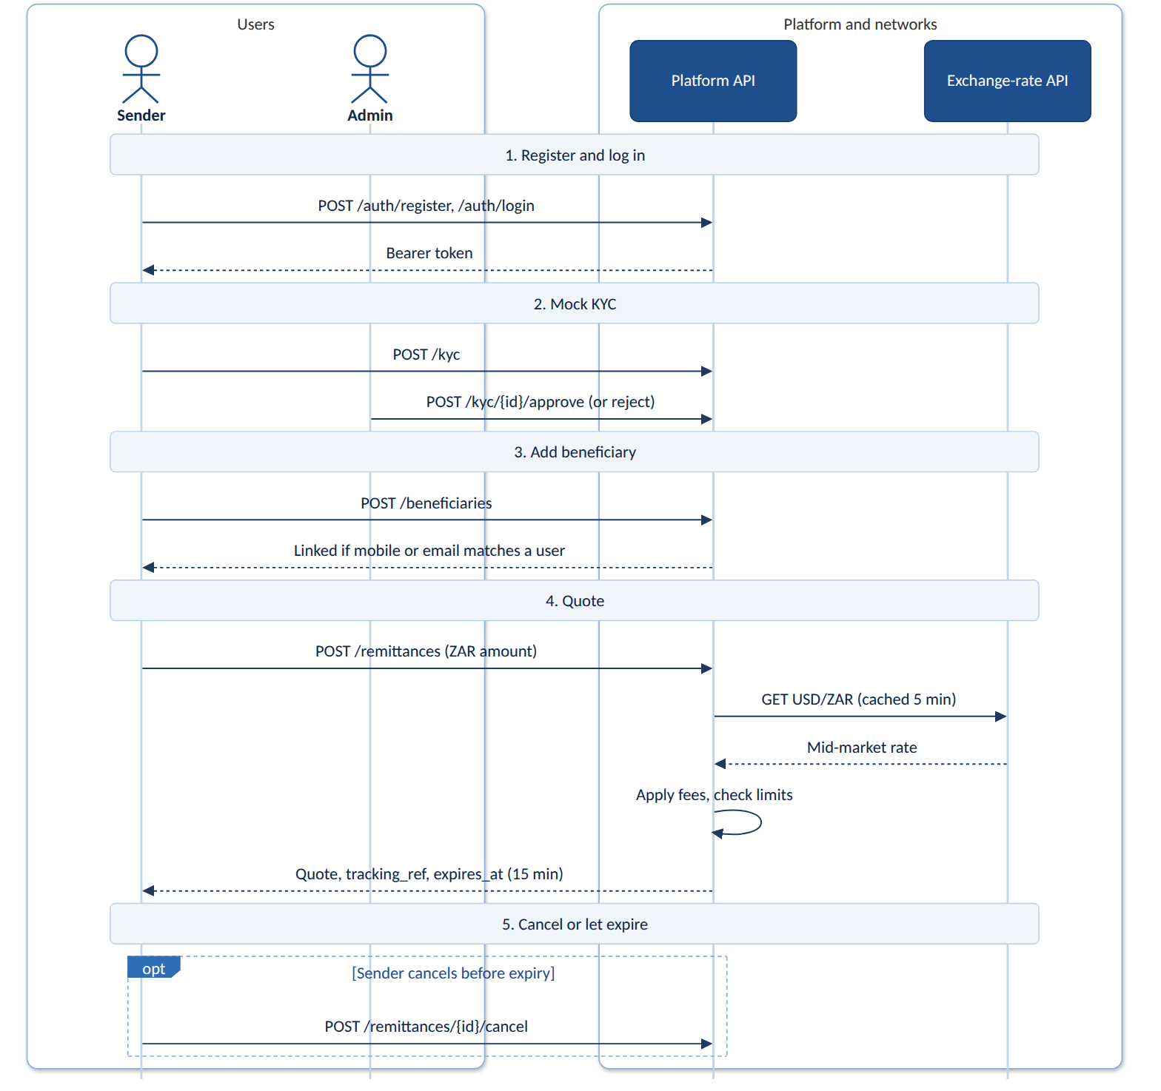
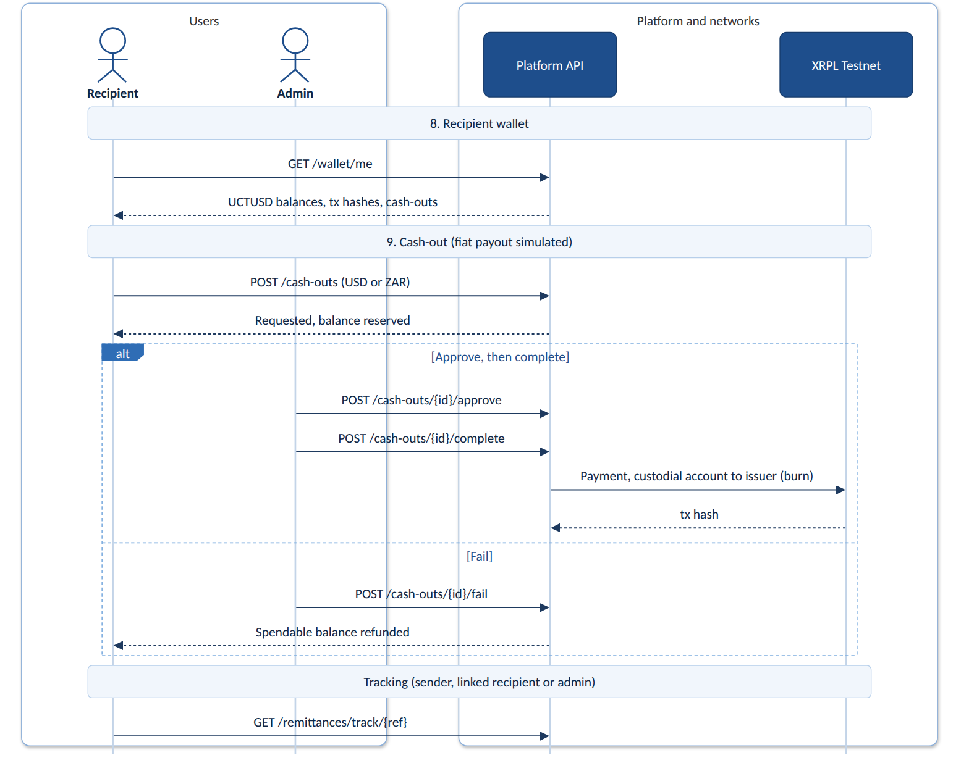

2.2 Cash-in settlement:

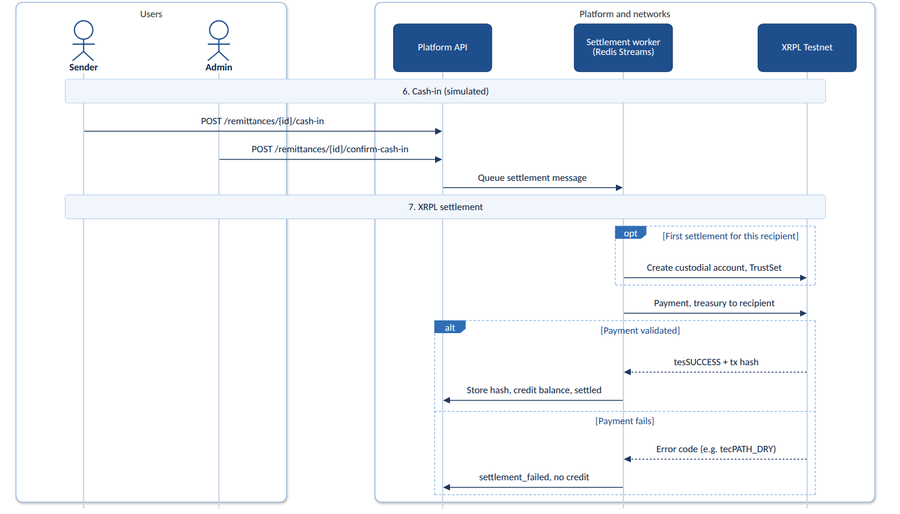

  - Wallet cashout:

- Functional requirements

  - 3Registration and Authentication

ID | Requirement | Implemented in
FR-01 | Register an account with personal details (full name, email address, mobile number, and a password) | POST /auth/register; UI /register.  - Mobile numbers must be 8–15 digits with an optional leading + (ensures complying with international standards)  - passwords are bcrypt-hashed.
FR-02 | Log in with registered credentials. | POST /auth/login returns a bearer token (only its SHA-256 hash is stored) and logs user in.
FR-02a | Log out, terminating the session. | POST /auth/logout sets revoked_at on the session and logs user out.
FR-03 | Email address and mobile number are unique across accounts. | Unique constraints on users.email and users.mobile_number ensure that a duplicate registration returns 409.
FR-04 | Distinguish sender, recipient, and administrator roles. | Partial, by design. Stored roles are customer and admin; sender and recipient are what a customer does on a given transfer (Section 13). Admins come only from scripts/create_admin.py or the ADMIN_EMAIL/ADMIN_PASSWORD start-up setting.
FR-04a | View and update basic profile information. | GET/PATCH /users/me; UI /app/profile.

  - KYC Requirements

ID | Requirement | Implemented in
FR-05 | Collect full name, date of birth, nationality, identification number, residential address, mobile number, email address, and source of funds. | POST /kyc stores all eight fields. The ID number (6–20 characters) is encrypted with the KYC Fernet key.
FR-06 | Submit a completed KYC application for review. | POST /kyc sets status pending; resubmission overwrites the application until it is approved.
FR-07 | Administrator can view a submitted application. | GET /kyc, GET /kyc/{id}; UI /admin/kyc.
FR-08 | Administrator can approve or reject an application. | POST /kyc/{id}/approve or /reject (with a reason); the UI confirms the decision in a dialog naming the applicant.
FR-08a | User can view their own KYC status. | GET /kyc/me/status, GET /kyc/me; shown on the sender home screen.
FR-09 | No remittance without approved KYC. | POST /remittances requires approved KYC; the UI shows “KYC pending” instead of the send form.
FR-09a | No cash-out without approved KYC. | POST /cash-outs requires approved KYC. A recipient can still receive and hold UCTUSD without it.
The assumption attached to FR-09a is adopted as stated: senders need approved KYC before sending and recipients before cashing out, but receiving and holding needs none
  - Beneficiary Management

ID | Requirement | Implemented in
FR-10 | Approved sender adds a beneficiary with full name, mobile number or email, country, payout currency, and relationship. | POST /beneficiaries, approved senders only; all five fields stored. UI /app/beneficiaries.
FR-11 | Require at least a mobile number or an email address. | Request validation rejects a beneficiary with neither (422).
FR-12 | Sender can list their beneficiaries. | GET /beneficiaries, each with a Linked or Unlinked badge in the UI.
FR-12a | Link a beneficiary to a recipient account by matching mobile number or email. | Auto-match when the beneficiary is added, and again whenever a new account registers (services/beneficiary_linking.py).
FR-12b | If no account matches, leave the beneficiary unlinked; no wallet and no settlement until a matching account registers. | The record stays unlinked. If cash-in is confirmed anyway, the worker refuses to settle (“Beneficiary is not linked to a registered recipient account”), creates no wallet, credits nothing, and marks the transfer settlement_failed; an administrator retries once the recipient registers and is linked.
FR-12c | Provision a custodial wallet only once the beneficiary is linked to a registered recipient account. | The recipient’s custodial Testnet account is created at first settlement, and only for the linked user.

  - Quotes, fees and Limits

ID | Requirement | Implemented in
FR-13 | Determine the USD/ZAR rate when the transaction is created (public API, mock, or rate table). | open.er-api.com at quote creation, cached for five minutes, with a .env fallback rate (Section 5). The rate used is stored on the quote.
FR-14 | Quote shows ZAR amount, rate, transaction fee, FX margin, RLUSD amount, cash-out fee, and estimated payout. | POST /remittances returns zar_amount, exchange_rate, transaction_fee_zar, fx_margin_percentage, rlusd_amount, estimated_cash_out_fee, and estimated_recipient_payout, plus tracking_ref and expires_at.
FR-15 | Fees use a configurable fixed fee, percentage fee, FX margin, and cash-out fee. | One FeeConfig row (Section 4).
FR-15a | Administrator can view and update the fee parameters. | GET/PUT /admin/fee-config; UI /admin/config.
FR-16 | Check the amount against daily and monthly limits before proceeding. | Checked before the quote is inserted; cancelled and expired quotes do not count (Section 6).
FR-16a | Sender can view limits and remaining allowance. | GET /limits/me returns limits, usage, and remaining amounts for today and this month.
FR-16b | Administrator can view and update limit tiers. | GET /admin/limit-tiers, PUT /admin/limit-tiers/{tier_key}; UI /admin/config.
FR-17 | Reject a request that would exceed a limit, and say why. | HTTP 422 naming the limit, e.g. “This remittance would exceed your daily limit of … ZAR”.

  - Simulated cash-in
ID | Requirement | Implemented in
FR-18 | Sender initiates a simulated ZAR payment by a supported method. | POST /remittances/{id}/cash-in with agent_cash, bank_transfer, or card; only for an unexpired, uncancelled quote.
FR-19 | Administrator or mock service confirms the payment. | POST /remittances/{id}/confirm-cash-in; UI /admin/cash-in.
FR-20 | No settlement until cash-in is confirmed. | Settlement is enqueued only inside confirm-cash-in; no Payment is submitted before it.
  - Queue and Settlement
ID | Requirement | Implemented in
FR-21 | Queue a settlement message once cash-in is confirmed. | Confirm-cash-in writes a SettlementMessage row (outbox) and adds it to the Redis Stream settlement_messages.
FR-22 | A worker consumes messages and submits the transfer to XRPL Testnet. | scripts/run_settlement_worker.py or POST /admin/settlement/run reads the stream as a consumer group and submits a UCTUSD Payment with xrpl-py.
FR-23 | Record each outcome, with the transaction hash on success. | Hash or failure reason stored on the remittance and the message; GET /admin/settlement; UI /admin/settlement.
FR-24 | A failed transaction does not credit the recipient. | Status becomes settlement_failed with no credit; covered by tests/test_settlement.py.
FR-25 | A duplicate message cannot credit twice. | One message per remittance (unique constraint); if a hash is already stored the worker marks the job complete without paying or crediting; retrying a completed message returns 409.
FR-26 | Update the wallet balance once settlement is confirmed on-ledger. | The worker waits for ledger validation, then stores the hash, credits the balance, and sets settled in one database commit.

  - Recipient Wallet and Sender History

ID | Requirement | Implemented in
FR-27 | Each recipient has a custodial web wallet. | A custodial Testnet account per recipient, secret encrypted with its own Fernet key; GET /wallet/me; UI /app/wallet.
FR-28 | Wallet shows balance, incoming transfers, cash-outs, status, date, and transaction hash. | Spendable and on-chain balances; incoming transfers with amount, status, dates, and hash; cash-outs with amount, currency, status, dates, and burn hash.
FR-28a | Sender can view status and history of sent remittances. | GET /remittances/me and GET /remittances/track/{ref}; UI /app/history and /app/track/{ref} show the quote breakdown, a status timeline, the hash, and a scannable QR code for the track page.

  - Simulated cash-out
ID | Requirement | Implemented in
FR-29 | Establish a TrustLine to the issuer for any wallet holding the token. | TrustSet for the platform treasury (scripts/setup_platform_wallet.py or POST /admin/platform-wallet/trustline) and for each recipient account before its first payment.
FR-30 | Recipient requests a cash-out to USD or local fiat. | POST /cash-outs to USD or ZAR; the amount is reserved from the spendable balance at once.
FR-31 | Payout uses the applicable rate, less the cash-out fee. | Fee taken from the UCTUSD amount; USD pays out 1:1, ZAR at the live or fallback USD/ZAR rate without the FX margin.
FR-32 | Track cash-outs as requested, approved, completed, or failed. | requested → approved → completed, or failed from requested or approved. Complete burns the reserved UCTUSD by paying the issuer; fail refunds the spendable balance.

3.9 Administration
ID | Requirement | Implemented in
FR-33 | Admin interface for KYC applications. | UI /admin/kyc (FR-07, FR-08).
FR-34 | Admin interface for confirming cash-in. | UI /admin/cash-in (FR-19).
FR-35 | Admin interface for actioning cash-outs. | UI /admin/cash-out: POST /cash-outs/{id}/approve, /complete, /fail.

FR-15a and FR-16b are also administration functions; they are listed with the fees and limits they configure. Beyond the requirements, the system adds a 15-minute quote expiry with cancel (POST /remittances/{id}/cancel), MG tracking references, admin settlement retry, and a platform-wallet screen reporting treasury TrustLine and liquidity.
- Fee model
Several fees are added to transactions. These include a transaction fee when the sender pays in rand, a margin on the exchange rate, and a fee when the recipient cashes out. The amounts for these fees are stored in a single settings record, FeeConfig. This enables an administrator to change them on the Config screen, and the next quote uses the new values, with no code change or restart. Quotes already issued are unaffected, because each quote stores the fee and rate it was priced at.

The baseline system starts with a fixed fee of R25.00, a percentage fee of 1% of the amount sent, an FX margin of 2%, and a cash-out fee of 1.5%. Percentages are stored as fractions, so 1% is stored as 0.0100.

The process for calculating a quote is as follows:

The transaction fee is the fixed fee plus a percentage of the amount sent (zar_amount), and it is deducted from the rand amount first. The remainder (net_zar) is then converted to dollars at the effective rate (mid-market rate, marked up by the FX margin). The resulting amount (rlusd) is the amount of UCTUSD the recipient receives:

transaction_fee= fixed fee + zar_amount * percentage
effective_rate= midmarket * (1 + fx_margin)
net_zar= zar_amount − transaction_fee
rlusd= net_zar / effective_rate

Since the margin increases the rand amount needed for each dollar, the sender receives fewer dollars than the mid-market rate would provide. The difference between the mid-market and effective rate is the platform's exchange-rate income, and this margin is shown in the quote. The token is treated as being worth exactly one US dollar. Fees are rounded to the nearest cent and token amounts to six decimal places, with halves rounded up. If the fee is as large as the amount sent, then the quote is refused (with an HTTP 422 error), since no money is left to convert.

However, the cash-out fee on the quote is only an estimate, as the recipient may cash out in part, at a later time or in a different currency. When they do, the cash-out fee is subtracted from the token amount using the cash-out fee set at that time. If a USD cash-out is selected then one dollar per token is paid. If a ZAR cash-out is selected then a conversion is performed at the current USD/ZAR rate, or the fallback rate, with no FX margin added.

- Exchange-rate calculation

The platform uses a public API to retrieve exchange rates, with a configured rate as the backup.
When a quote is created, the system requests the latest US dollar rates from a free public service
(open.er-api.com) and retrieves the rand rate from the reply. This rate is retained for five minutes and
is reused for every quote made in that period, such that a burst of users does not flood the free service
with requests. For every first quote after each five-minute period ends, a new rate is fetched.
If the exchange rate request fails for reasons such as a timeout, an error response, or a reply with no
rand rate, the system uses a fixed backup rate (USD_ZAR_RATE =18.50), which is configured in the settings
file and keeps it for five minutes before trying the live service again.

The backup rate can only be changed in the settings file and not the admin screens. For backup rate changes to reflect the server needs to be restarted. The rate used, with the FX margin applied, is stored on each quote, so the sender sees the rate
they were actually charged.

The automated tests conducted never contact the live service and instead substitute a fixed or simulated rate to ensure that test results are reproducible.

- Remittance limits

Remittance limits depend on whether is verified or unverified:
Status | Daily limit | Montly limit
Unverified | R0 | R0
Verified | R3000 | R25 000

Admins may change these limits via PUT /admin/limit-tiers/{tier_key}, the zero limits exist such that unverified users cannot send remittances.
Usage sums the sender’s ZAR since the start of the UTC day or calendar month, with two exclusions:
- Cancelled requests never count
- quoted rows with expires_at already in the past never count.
Everything else counts: unexpired quotes, and every status from cash-in onwards, including settlement_failed. This is because a failed on-chain payment still follows a confirmed cash-in, so the sender’s rand was received, and the amount stays counted. An administrator can retry the settlement, but nothing releases the amount early. Thus, the usage sum only stops counting when the day or month ends.
Table 11: Remittance statuses on one evolving row.
Status | How we get there | Counts to limit?
quoted | POST /remittances | Yes, until TTL
cancelled | Sender cancels while still unexpired | No
quoted (past TTL) | Clock runs out; cash-in returns 409 | No
cash_in_pending | Sender cash-in | Yes
cash_in_confirmed | Admin confirms | Yes
settlement_queued | Enqueued after confirm | Yes
settled | Worker Payment + credit | Yes
settlement_failed | Worker error; no credit | Yes

- Architecture diagram
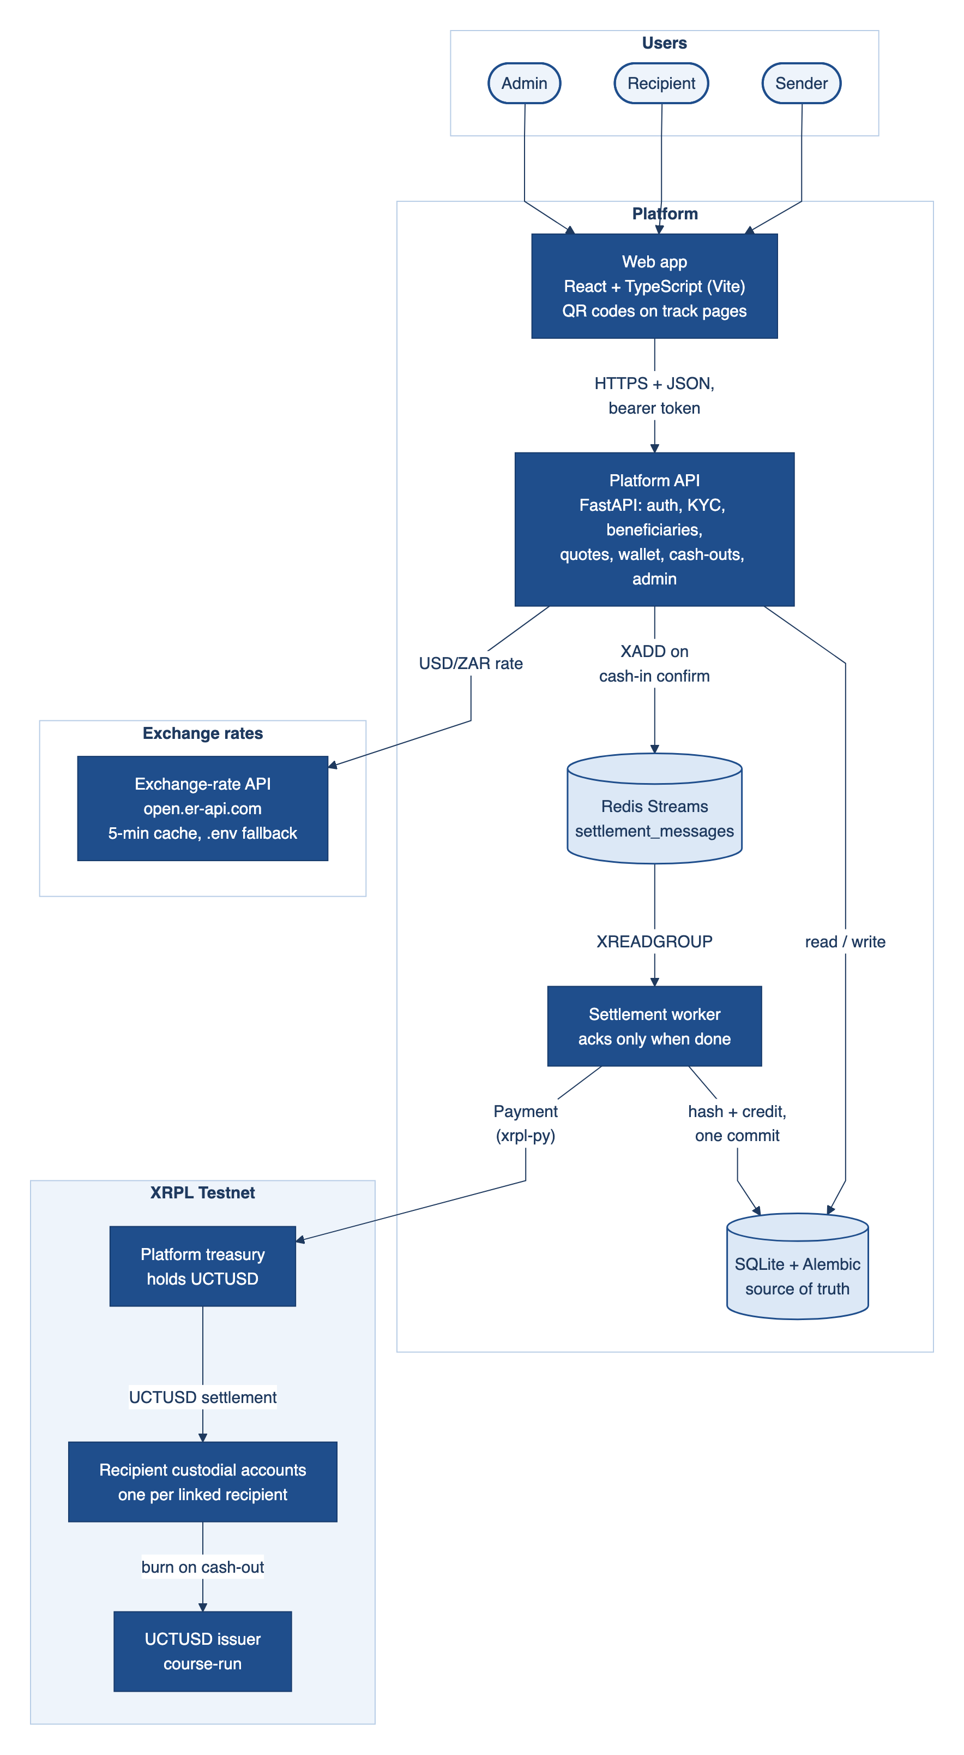

- Cash-in flow
- RLUSD settlement flow
- Cash-out flow

- Database design
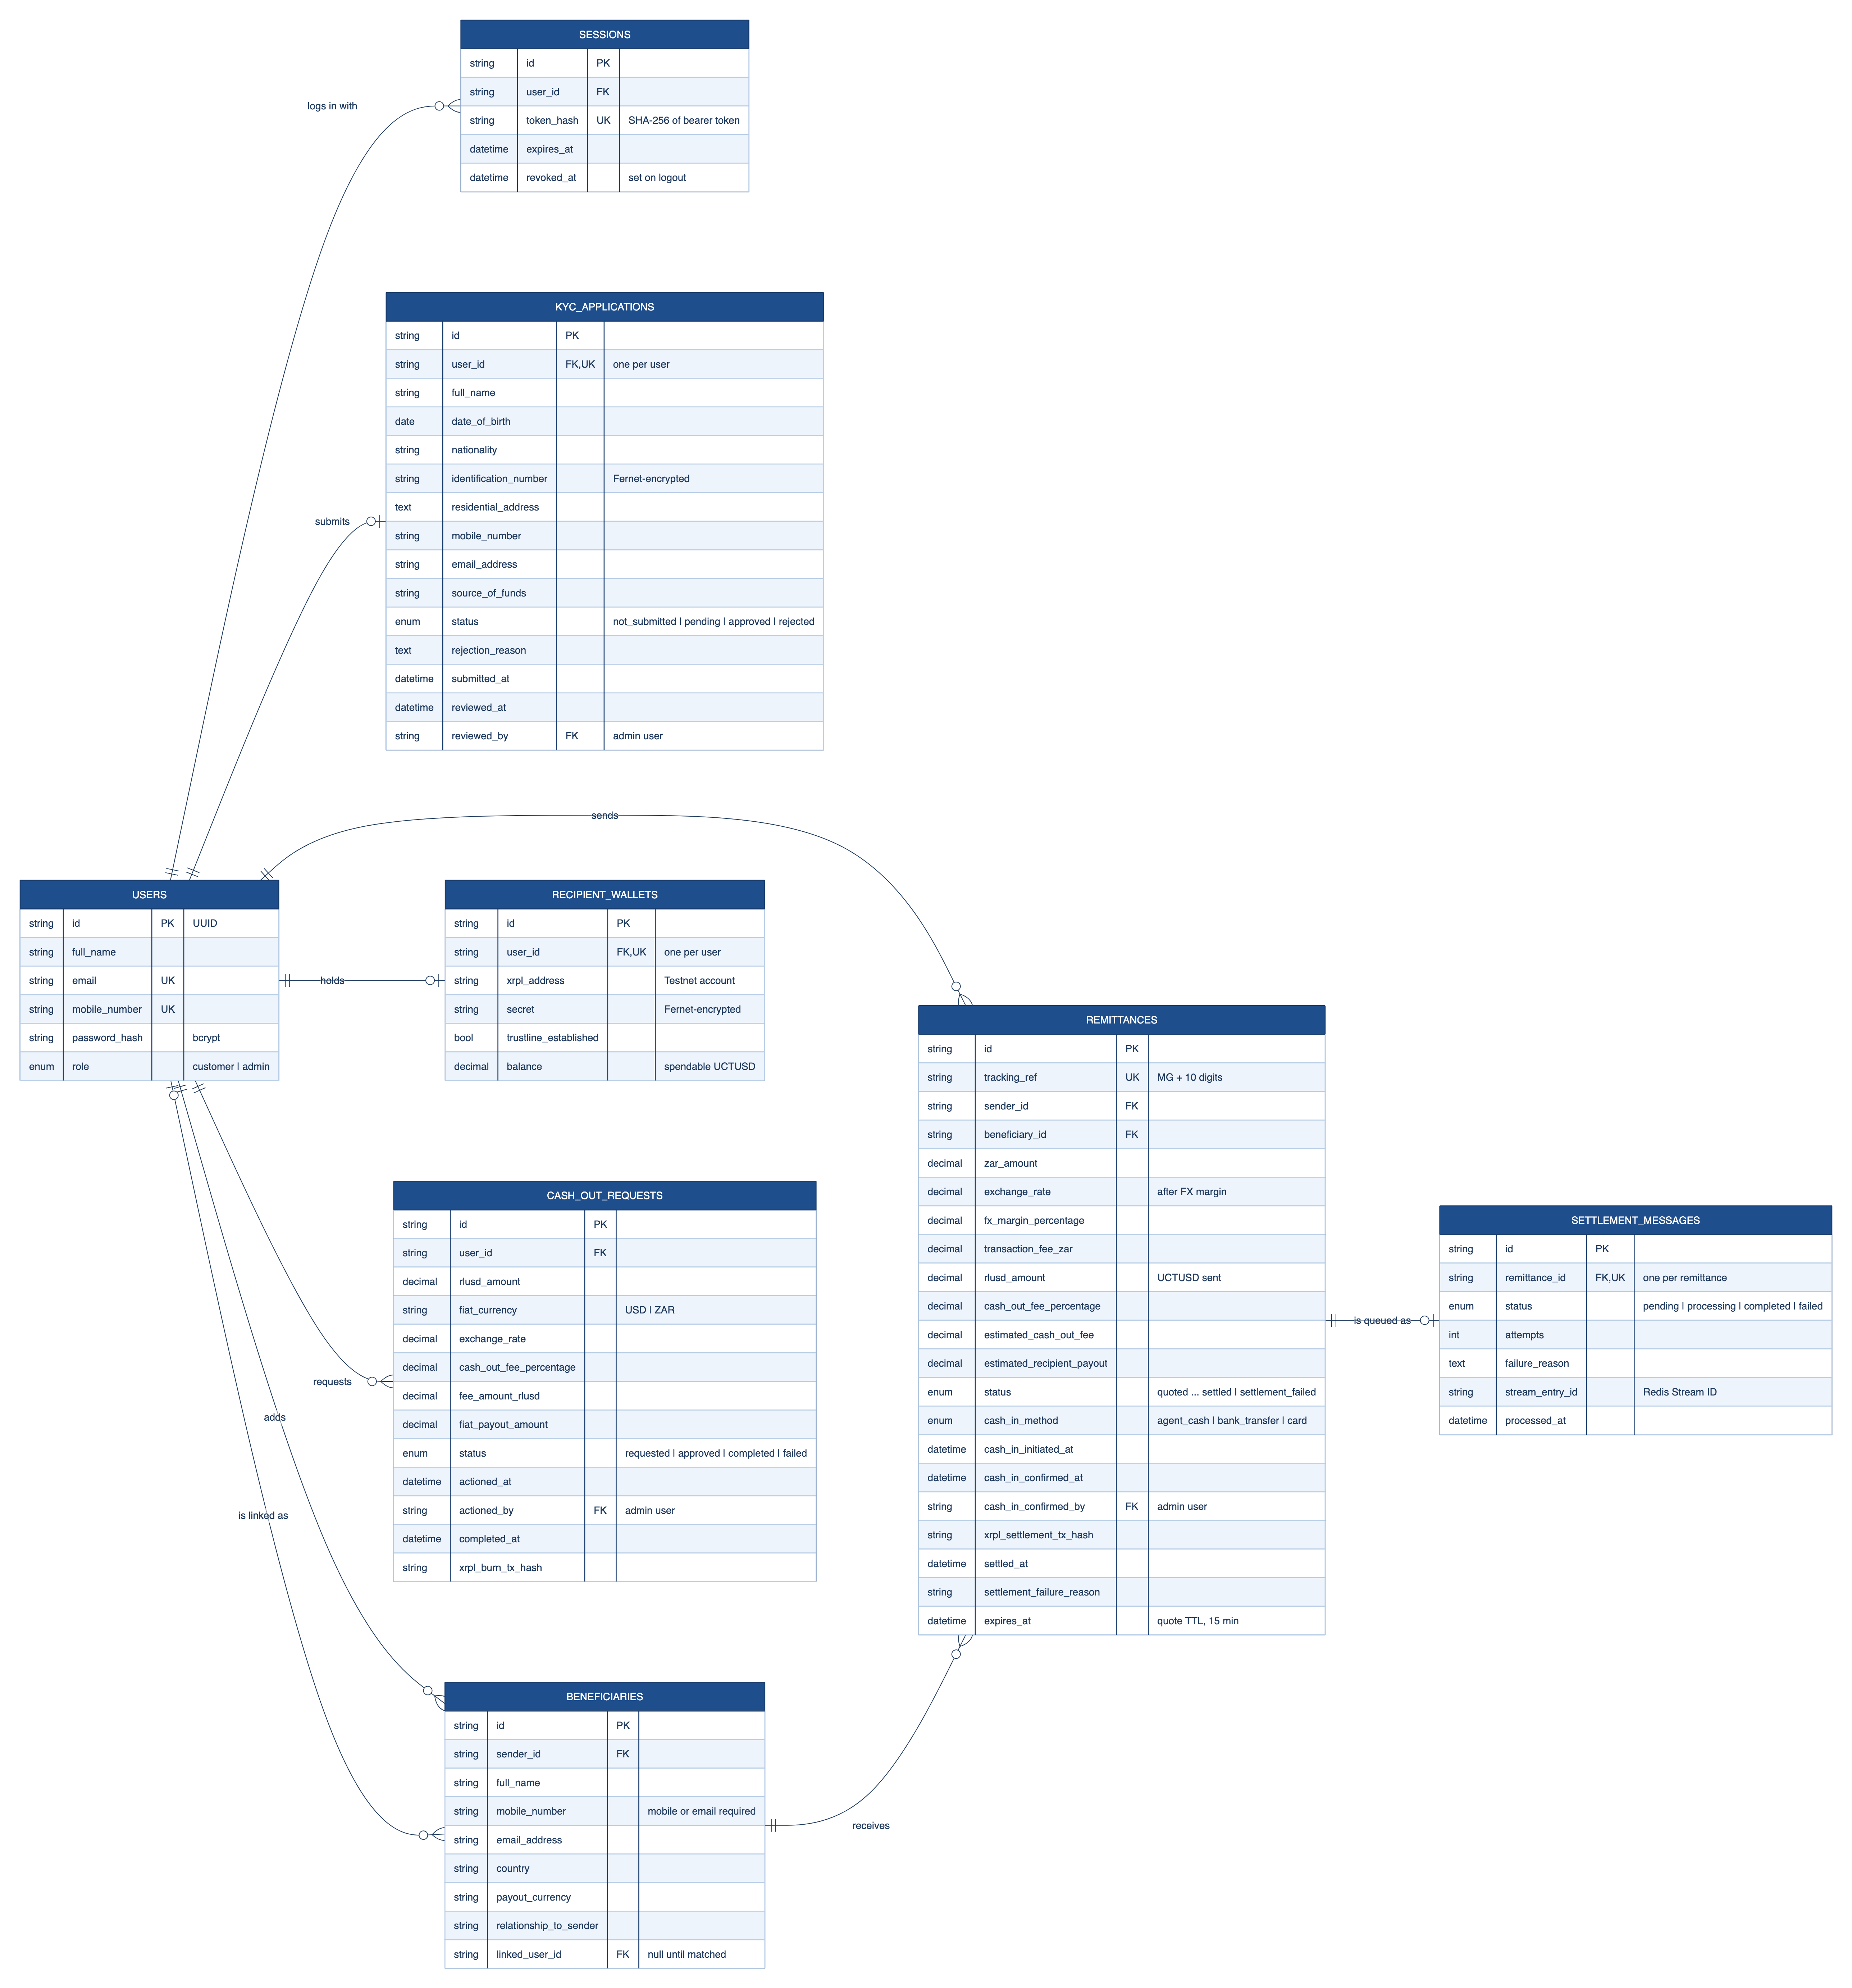

The database design configuration can be seen below:
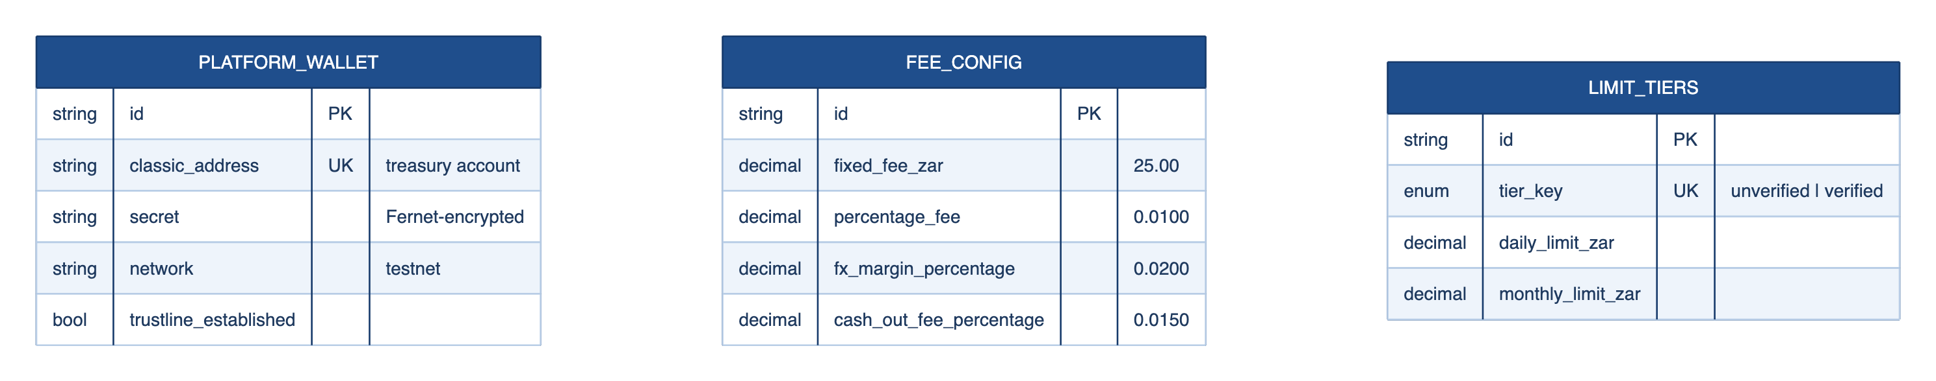
- API overview
- Security design
- Regulatory considerations;
- Assumptions and limitations.

