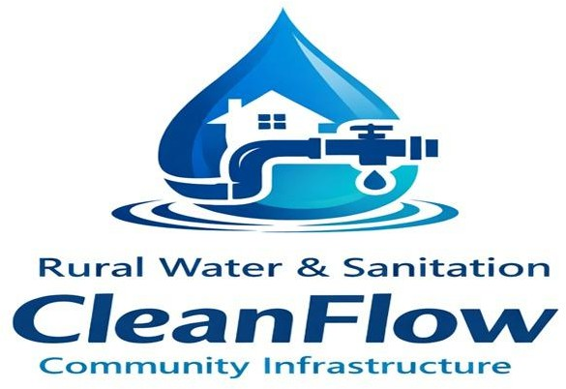

CleanFlow Community Infrastructure

Rural Water & Sanitation

WIL Project Charter / Plan
Task 1 | Work Integrated Learning | XISD5319 | Updated Semester 2

# | Full Name | Student Number | Role
1 | Karabo Tshivhase | ST10439529 | Project Manager/Developer
2 | Ompha Mudau | ST10442687 | System Analyst/Developer
3 | Faranani Netshirando | ST10443627 | Requirements Analyst
4 | Phathutshedzo Marema | ST10442530 | System Analyst
Github link: https://github.com/karabotshivhase/CleanFlow-Infrastructure-WIL
Table of Contents
Rural Water & Sanitation 1
1. Introduction 3
Purpose of Project Charter 3
2. Project and Product Overview 3
Problem Statement 3
Proposed Solution 3
3. Justification 4
Business Need 4
3.1 Public Health and Business Impact 4
3.2 Strategic Alignment 5
4. Scope 5
Objectives 5
High-Level Requirements 5
Major Deliverables 6
Fully Functional Website 6
Fully Functional Mobile Application 6
Water Conservation Tips Module 6
Approved Project Charter 6
System Requirements Specification (SRS) 7
System Architecture and Design Documentation 7
Integrated Database System 7
System Integration and Testing Reports 7
User Acceptance Testing (UAT) Approval 7
Deployment and Implementation Plan 7
5. Work Breakdown Structure 8
Purpose and Scope 9
Roles and Responsibilities 9
Source Control & Branching Strategy 10
Continuous Integration and Continuous Deployment (CI/CD) Pipeline 10
Environment Strategy 11
7.Duration 13
Timeline Table 13
Executive Milestones 13
8. Project Schedules 14
Gantt Chart 14
Interpretation of the Gantt Chart 14
9. Budget Estimate 16
Funding Source 16
Project Budget Estimate 16
10. Assumptions, Constraints and Risks 17
Assumptions 17
Constraints 17
Risks 17
11.Technical and Economic Feasibility 19
Technical Feasibility 19
Hardware Resources 19
Software Resources 19
Economic Feasibility 20
12. Project Organization 21
Stakeholders (Internal and External) 21
Internal Stakeholders 21
External Stakeholders 21
13. Wireframes 22
Mobile app sitemap 30
30
References 31

Introduction

Purpose of Project Charter
The purpose of this Project Charter is to formally authorize and define the development of a digital platform comprising a website and mobile application for CleanFlow Community Infrastructure, a non-profit organization operating within the rural water and sanitation sector.
This charter establishes the project's objectives, scope, high-level requirements, deliverables, timeline, budget considerations, risks, and governance structure.

The document serves as an official agreement between key stakeholders and the project team, providing strategic direction and ensuring alignment with the NPO's mission to support access to safe water and sustainable sanitation infrastructure in underserved rural communities.
It also provides a framework for decision-making, accountability, and performance monitoring throughout the project lifecycle.

Project and Product Overview
CleanFlow Community Infrastructure is a non-profit organization focused on improving access to clean water and sanitation in underserved rural communities through infrastructure initiatives such as boreholes and sanitation facilities. However, the organization currently relies on manual and paper-based systems, which limit operational efficiency, transparency, and scalability.
This project proposes the development of a centralized digital platform consisting of a responsive website and mobile application to enhance infrastructure tracking, donor engagement, volunteer coordination, real-time issue reporting, and water conservation education.

Problem Statement
Despite ongoing efforts to improve rural water and sanitation infrastructure, many communities continue to experience delayed maintenance responses, broken water systems, and limited transparency regarding project progress. CleanFlow Community Infrastructure currently lacks a centralized digital system for managing infrastructure data, tracking project status, coordinating volunteers, and providing transparent reporting to donors.
Additionally, community members in rural areas have limited access to water conservation education, leading to unnecessary wastage of the very resource the organization works to protect. As a result, infrastructure faults are often reported late, maintenance scheduling is inefficient, donor confidence may be affected, and communities remain unaware of how to conserve water effectively.

Proposed Solution
To address these challenges, the project proposes the development of an integrated digital platform consisting of a responsive website and mobile application.
The website will serve as a public-facing platform for donors, partners, volunteers, administrators, and other stakeholders. It will provide project dashboards, donation management, infrastructure information, volunteer coordination, and transparency reporting tools.

The mobile application will enable community members and field workers to report damaged infrastructure using GPS-enabled features, upload relevant information, receive notifications, track reported issues, and support maintenance activities.
The system will also include a Water Conservation Tips module that provides community members with practical water-saving and sanitation guidance. Tips will be organised into categories such as Home, Garden, Community, and Emergency. Users will be able to view, save, and share useful water conservation tips.

Justification

Business Need

Current Challenge | Description | Proposed Solution | Expected Benefit
Manual Processes | Paper-based systems for tracking projects leading to inefficiencies | Implement a centralized digital platform with a cloud-based database | Improved data accuracy, accessibility, and operational efficiency
Delayed Issue Reporting | Infrastructure faults reported through informal channels causing delays | Mobile application for real-time issue reporting with GPS | Faster response times and reduced infrastructure downtime
Limited Transparency | Donor reporting is manually compiled, reducing visibility | Digital dashboards and automated reporting tools | Increased transparency and improved donor confidence
Poor Communication | Lack of structured communication between stakeholders | Integrated communication and notification features | Improved stakeholder engagement and coordination
No Water Education | Community members lack knowledge of water conservation practices | Water Conservation Tips module in the mobile app | Improved community awareness and reduced water wastage

Public Health and Business Impact

Public Health Impact | Business Impact
Limited access to clean water increases the risk of waterborne diseases, particularly among vulnerable populations such as children and the elderly. | Improved transparency through digital dashboards enhances donor trust and accountability.
Real-time reporting of infrastructure issues enables faster identification and repair of damaged water systems, reducing service downtime. | Automated reporting and system tracking improve operational efficiency and reduce manual processes.
Improved maintenance of water and sanitation systems leads to better hygiene standards and overall community well-being. | Real-time data analytics supports strategic planning and better resource allocation.

Water conservation education through the Tips module reduces unnecessary wastage and promotes sustainable water use. | The Water Tips feature strengthens CleanFlow's educational mission and may attract new donors focused on sustainability.

Strategic Alignment
This project aligns with broader national and global development priorities focused on sustainable development, rural upliftment, and public health improvement. Access to clean water and sanitation remains a key development objective within South Africa's infrastructure planning frameworks and international sustainability goals.
Internally, the project aligns with CleanFlow Community Infrastructure's strategic objectives of enhancing operational efficiency, increasing community participation, strengthening stakeholder engagement, and ensuring long-term sustainability of rural infrastructure initiatives. The addition of the Water Conservation Tips module directly supports Sustainable Development Goal 6, Clean Water and Sanitation, by promoting responsible water use at the community level.

Scope

Objectives
The primary objective of the project is to design and develop a digital platform consisting of responsive website and mobile application to support CleanFlow Community Infrastructure in managing infrastructure issues, volunteers, donations, and community information.

Specific objectives are to:
  - Reduce infrastructure issue reporting time by at least 40% compared with the existing manual reporting process.
- Provide administrators with a centralized dashboard for monitoring 100% of infrastructure reports submitted through the system.
- Provide registered volunteers with a digital platform for viewing and managing assigned maintenance activities.
- Digitally record and store infrastructure reports, volunteer information, donation records, and maintenance tasks in a centralized database.
- Implement user authentication and role-based access control for all registered system users.
- Provide real-time notifications and status updates for infrastructure reports and maintenance tasks.
- Provide at least four categories of water conservation tips: Home, Garden, Community, and Emergency.
- Allow users to save favourite water conservation tips and share selected tips through supported messaging applications.

High-Level Requirements
Website Requirements
- A responsive website compatible with desktop computers, tablets, and smartphones.
- Secure user registration and authentication.
- Role-based access control.
- An administrative dashboard for monitoring infrastructure activities.
- Donation management functionality with secure payment gateway integration.
- Volunteer registration and management functionality.
- Project and infrastructure information accessible to relevant stakeholders.

Mobile Application Requirements
- A dedicated Android mobile application for community members, volunteers, and field workers.
- Infrastructure issue reporting functionality.
- GPS location capture for reported infrastructure problems.
- Image upload functionality for issue reports.
- Issue status tracking.
- Notifications and updates regarding reported issues and assigned tasks.
- Low-bandwidth and offline data support where possible.

Database and System Requirements
- A cloud-based database for centralized data storage and synchronization.
- Secure storage of user, infrastructure, donation, volunteer, and task information.
- Real-time synchronization between the website, mobile application, and centralized database.

Water Conservation Tips Requirements
- A Water Conservation Tips module accessible through the system.
- Tips organised into categories including Home, Garden, Community, and Emergency.
- The ability for users to save favourite tips.
- The ability for users to share selected tips.
- Water conservation information sourced from verified and reliable guidelines.

Major Deliverables

Fully Functional Website
A responsive and secure website developed for CleanFlow Community Infrastructure. It will include donor management, project dashboards, infrastructure tracking, volunteer registration, and transparency reporting features. The website will serve as the organization's primary public digital platform.

Fully Functional Mobile Application
A mobile application designed for community members, field workers, and volunteers. It will allow real-time reporting of infrastructure issues, GPS location tagging, task coordination, and notifications. The app will improve communication and response time in rural areas.

Water Conservation Tips Module
A feature integrated into the mobile application that provides community members with practical water conservation tips. Tips are organized into four categories: Home, Garden, Community, and Emergency. The module includes a featured tip, a scrollable list of tips, a favourite tips saving feature, and a sharing function. All tip content will be verified against published water conservation guidelines before deployment.

Approved Project Charter
This document formally authorizes the project and defines its objectives, scope, stakeholders, timeline, budget, risks, and governance structure. It provides guidance for managing and monitoring the project throughout its lifecycle.

System Requirements Specification (SRS)
The SRS document outlines the functional and non-functional requirements of the system, including user roles, infrastructure reporting features, donation management, security requirements, Water Conservation Tips functionality, and performance expectations.

System Architecture and Design Documentation
Includes system architecture diagrams, database design, entity relationship diagrams, sitemaps, wireframes, user interface mockups, and technical design specifications that provide a blueprint for system development.

Integrated Database System
A secure database system that stores user, infrastructure, donation, volunteer, task, Water Tips, and reporting data. The database supports centralized data management and synchronization between relevant system components.

System Integration and Testing Reports
Documentation of system testing activities, including functional testing, integration testing, security testing, and performance validation.

User Acceptance Testing (UAT) Approval
User Acceptance Testing involves testing the system with relevant stakeholders to verify its usability and functionality across all system modules, including the website, mobile application, and Water Conservation Tips feature.

Deployment and Implementation Plan
Outlines how the system will be deployed and implemented, including installation procedures, system configuration, data setup, user access, and rollout activities.
Outlines how the system will be launched including installation procedures, configuration steps, and rollout strategy.

5. Work Breakdown Structure
The WBS for the CleanFlow Digital Platform provides a hierarchical, deliverable-oriented decomposition of the project scope. The project is organized into seven major deliverable categories: Project Management, Requirements, System Design, System Development, Testing, Deployment, and Training and Support.
The System Development category includes Website Development, Mobile Application Development, Database Development, and the Water Conservation Tips Module.

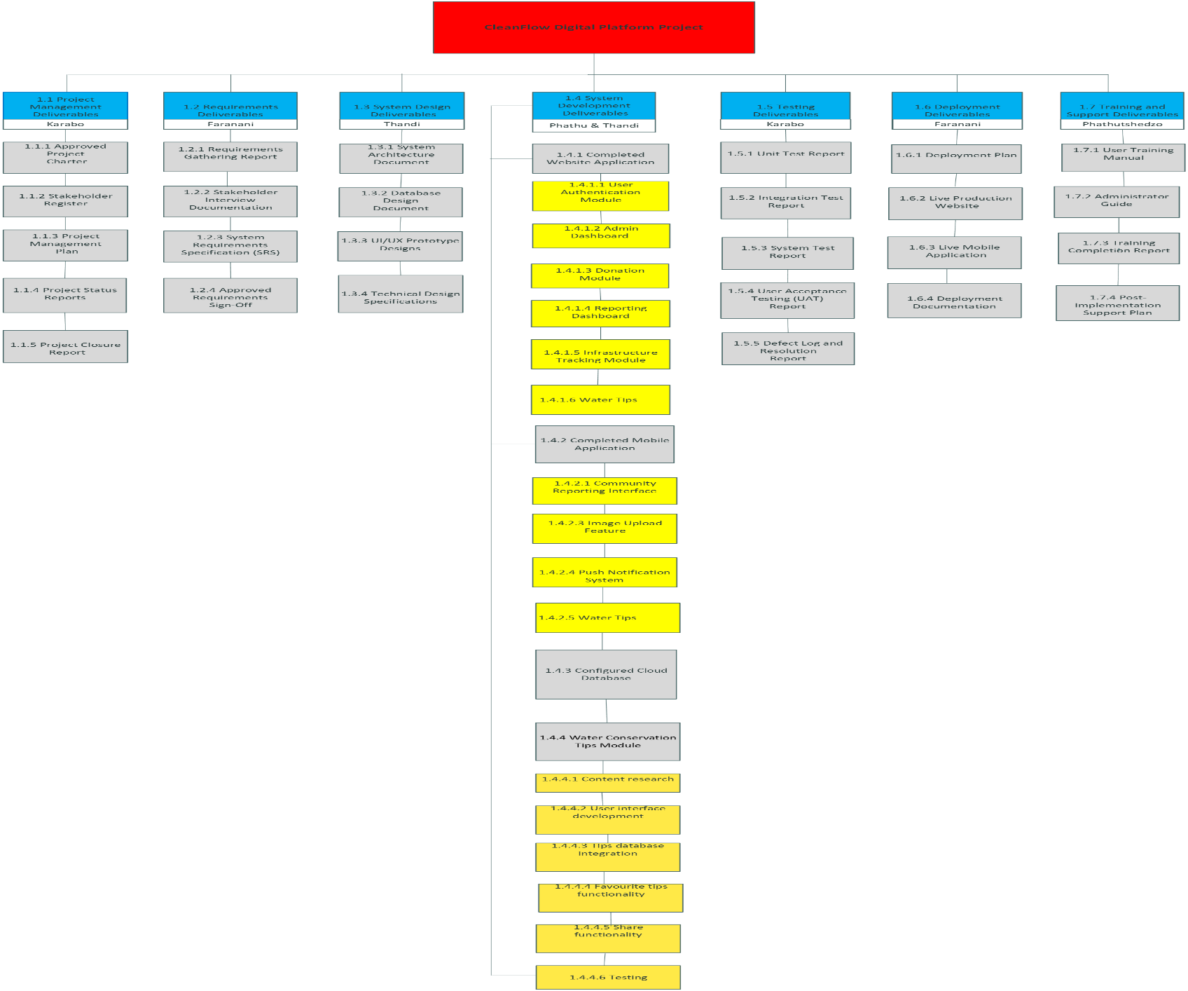

6.DevOps Plan
The DevOps approach for the CleanFlow Digital Platform Project supports the development, testing, deployment, and maintenance of the website and mobile application. It focuses on source control, continuous integration, testing, deployment, monitoring, backup, and release management.
The purpose of DevOps in this project is to improve collaboration between team members and ensure that changes to the system are regularly tested, stored, and managed throughout the development lifecycle.

Purpose and Scope

The DevOps Plan ensures that project code moves through development, testing, and deployment in a structured and controlled manner.

The DevOps approach applies to:
- Website development
- Mobile application development
- Database development
- Source code management
- Testing
- System deployment
- Monitoring and maintenance

GitHub will be used to manage source code and track the development progress of the project. Team members will regularly commit and push their work to the project repository.

Roles and Responsibilities

Role | Owner | Responsibility | Tools
Project Manager | Karabo Tshivhase | Coordinates development activities, monitors progress, and manages project milestones | GitHub, Project Planning Tools
Website Developer | Ompha Mudau | Develops and maintains the CleanFlow website and commits website changes to GitHub | Visual Studio Code, GitHub
Mobile Application Developer | Karabo Tshivhase | Develops and tests the Android mobile application | Android Studio, GitHub
Requirements Analyst | Faranani Netshirando | Ensures implemented features meet documented system requirements | Documentation Tools, GitHub
System Analyst / Designer | Marema Phathutshedzo and Thandi Mudau | Supports system analysis, architecture, interface design, and testing | Draw.io, Figma/Canva, GitHub
Testing Team | All Team Members | Tests system functionality and reports defects | GitHub, Testing Tools

Source Control & Branching Strategy
All code is managed in Git with the following branch model:
- Main: production-ready code only, protected, deploys automatically to Production
- Develop: integration branch for completed features, deploys to Staging
- Feature: individual feature branches, merged into develop via Pull Request
- Hotfix: urgent production fixes, merged into main and back-merged into develop Pull Requests require at least one peer review and a passing CI build before merge.

Continuous Integration and Continuous Deployment (CI/CD) Pipeline

Continuous Integration and Continuous Deployment will be supported using GitHub and GitHub Actions, where applicable.
The CI/CD process will follow these stages:

Build: The website and mobile application source code will be checked and prepared for testing.

Test: Relevant tests will be performed to identify errors and ensure that important system functionality works correctly.

Code Review: Team members will review major changes before they are merged into the main project branch.

Integration: Completed features will be integrated with other parts of the system.

Deployment: Approved versions of the website and mobile application will be prepared for deployment.
The CI/CD process helps the team identify problems earlier and ensures that the latest version of the project is properly manag

Environment Strategy

Environment | Purpose | Deploys From
Development | Used by developers to create and test new features | feature branches
Staging | Used to test integrated system features before release | develop branch
Production | Live system used by donors, admins, and the public | main branch

Infrastructure and Configuration Management
The project configuration and database-related files will be managed carefully through version control.
The following practices will be followed:
- Database scripts and configuration files will be stored in the project repository where appropriate.
- Sensitive information such as passwords, API keys, and authentication credentials will not be committed directly to GitHub.
- Environment variables will be used to manage sensitive configuration information.
- Major configuration changes will be documented and reviewed by the team.

Monitoring and Logging
Monitoring and logging will be used to identify system problems during testing and after deployment.
The project team will monitor:
- Application errors
- Failed system functions
- Database errors
- Website availability
- Mobile application issues
- Failed deployments
Errors identified during testing will be documented and corrected before the final system release.

Backup and Recovery
To reduce the risk of data loss, the project will use the following backup and recovery practices:
- Source code will be regularly pushed to GitHub.
- Important project documentation will be backed up.
- Database backups will be created regularly where applicable.
- A previous stable version of the project will be retained.
- If a deployment introduces a serious problem, the system can be restored to a previous stable version.
These practices help protect the project against accidental data loss and failed deployments.

Release Management
Project releases will be managed using version numbers to identify different versions of the system.
The project may use the following versioning format:
MAJOR.MINOR.PATCH
For example:
- 1.0.0 — First major system release.
- 1.1.0 — New feature added.
- 1.1.1 — Small bug fix.
Before a major release:
- The system will be tested.
- Major defects will be corrected.
- Team members will review the completed functionality.
- The project manager will confirm that the release is ready for submission or deployment.

DevOps Deliverables
The DevOps activities will produce the following deliverables:
- GitHub Repository
- Source Code Version History
- Branching Strategy
- CI/CD Workflow Configuration
- Testing and Defect Reports
- Environment Configuration Documentation
- Backup and Recovery Procedures
- Deployment Documentation
- Release Version History

7.Duration

Timeline Table
The project timeline outlines the major phases and activities required to complete the CleanFlow Digital Platform.

Weeks | Phase | Key Activities
Week 31 | Planning | Project initiation, team formation, project planning and schedule
Week 31–32 | Requirements Analysis | Stakeholder interviews, requirements gathering and documentation
Week 33 | System Design | UI/UX design, database and system architecture planning
Week 34–36 | Website Development | Full website prototype development in HTML, CSS, and JavaScript
Week 37–38 | Mobile App Development | Android mobile application development in Kotlin with Room DB
Week 39–40 | Water Tips Development | Water Conservation Tips feature — content research, UI build, DB integration, testing
Week 41 | Testing | Unit and integration testing, User Acceptance Testing (UAT)
Week 41–42 | Deployment & Presentation | System deployment, final fixes, documentation, and final presentation

Executive Milestones

Milestone | Week | Purpose
Requirements Approval | Week 32 | Confirm validated system requirements and obtain stakeholder sign-off
Design Approval | Week 33 | Confirm technical architecture and UI/UX readiness before development
Website Prototype Complete | Week 36 | Deliver initial functional version of the website for review
Mobile App Beta Release | Week 38 | Provide testable mobile version for internal evaluation
Water Tips Feature Complete | Week 40 | Water Conservation Tips module fully developed and integrated into the app

Integration Complete | Week 41 | Confirm all system modules are successfully integrated
UAT Approval | Week 41 | Obtain formal stakeholder acceptance of the complete system
Final Deployment and Presentation | Week 42 | Official demonstration and submission of all deliverables

Project Schedules

Gantt Chart
The Gantt chart below include the Water Conservation Tips Feature Development phase scheduled for Weeks 39 to 40. This new phase sits between Mobile App Development and the Testing phase, reflecting the additional development work required for the new feature.
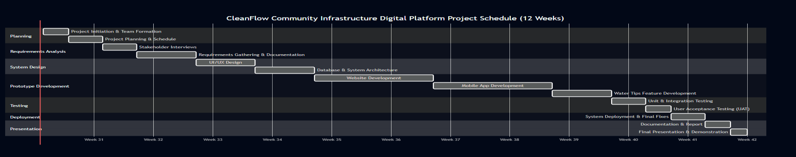
Figure 6.1 — CleanFlow Community Infrastructure Digital Platform Project Schedule (12 Weeks) — Updated Semester 2

Interpretation of the Gantt Chart
The Gantt chart translates the WBS into a structured schedule illustrating the timeline and sequencing of project activities from Week 31 through to Week 42. The project progresses logically through phases including planning, requirements gathering, system design, website development, mobile app development, water tips feature development, testing, deployment, and presentation.
Key milestones such as Requirements Approval, Design Approval, Website Prototype Complete, Mobile App Beta Release, Water Tips Feature Complete, UAT Approval, and Final Deployment serve as control points throughout the schedule.
The Water Conservation Tips Feature Development phase, Weeks 39 to 40, is a new addition for Semester 2. It follows Mobile App Development and runs concurrently with the early stages of testing, allowing the previously completed modules.

Development activities for the website and mobile application are executed sequentially to allow focused development effort per platform, while testing phases are carried out after development completion to ensure proper validation before deployment.

Budget Estimate

Funding Source
The CleanFlow Digital Platform Project will be funded through a combination of internal and external financial sources. Primary funding will be allocated from the NPO's operational budget dedicated to infrastructure improvement and digital transformation initiatives. Additional financial support will be obtained through donor sponsorships specifically earmarked for technology-driven community development projects.
The use of donor funding aligns with the organization's transparency goals, as the digital system itself enhances accountability and reporting to sponsors. Where possible, cost-effective open-source technologies will be used to reduce financial strain and ensure sustainability beyond the initial implementation phase.

Project Budget Estimate
The project budget estimate includes the costs associated with planning, analysis, design, development, testing, documentation, deployment, and the Water Conservation Tips module.

Task | Team Member | Hours | Rate | Cost
Planning | Karabo Tshivhase | 10 hrs | R150 | R1 500
Requirements Analysis | Faranani Netshirando | 15 hrs | R150 | R2 250
System Design | Marema Phathutshedzo | 20 hrs | R150 | R3 000
Database Design | Ompha Mudau | 15 hrs | R150 | R2 250
Website Development | Ompha Mudau | 35 hrs | R150 | R5 250
Mobile App Development | Karabo Tshivhase | 35 hrs | R150 | R5 250
Water Tips Feature Development | Karabo Tshivhase | 15 hrs | R150 | R2 250
Testing | All Members | 15 hrs | R150 | R2 250
Documentation | All Members | 10 hrs | R150 | R1 500
Presentation Preparation | All Members | 10 hrs | R150 | R1 500
TOTAL PROJECT COST |  |  | R27 000

10. Assumptions, Constraints and Risks

Assumptions
- Stakeholders will provide timely feedback during requirements and testing phases
- The development team possesses the required technical skills and experience
- Stable internet access will be available during deployment and system maintenance
- Required third-party services such as payment gateway APIs will remain available
- Water conservation tip content will be sourced from verified and publicly available resources
- Community members will have sufficient literacy to read and understand water conservation tips

Constraints

Constraint | Type | Impact
Limited budget | Financial | Requires cost-effective technology choices and limits premium tools
Fixed 12-Week Timeline | Schedule | Restricts major scope changes and requires strict time management
Rural connectivity challenges | Technical | Mobile application must function in low-bandwidth conditions
Limited testing devices | Technical | May limit full cross-device compatibility testing
Limited human resource | Resource | Requires efficient task allocation and possible parallel development
Content accuracy for Water Tips | Quality | Water tips must be verified against published guidelines before release

Risks
The following risks may affect the successful completion and implementation of the CleanFlow Digital Platform. Each risk includes its probability, potential impact, effect on the project, and proactive mitigation strategy.

Risk | Probability | Impact | Effect on Project | Mitigation Strategy
Team member becomes unavailable | Medium | High | Delays in deliverables and increased workload for remaining members | Distribute tasks among all members and maintain documentation

Development delays | Medium | High | May extend project timeline and delay deployment | Create project schedule and monitor milestones weekly
System integration failures | Medium | High | May require rework and additional testing time | Conduct regular integration testing throughout development
Cybersecurity threats | Low-Medium | High | Data breaches may damage NPO credibility | Implement authentication, encryption, and secure coding practices
Low user adoption | Medium | Medium | Reduced system effectiveness and return on investment | Provide user training and design for low-literacy users
Internet connectivity failure | Medium | Medium | Reduced accessibility in rural areas | Design app for offline use with Room DB local caching
Database failure or data loss | Low | High | Loss of critical operational information | Perform regular backups and use cloud storage solutions
Water Tips content inaccuracy | Low-Medium | Medium | Incorrect tips could mislead community members and damage NPO credibility | Source all tips from verified published guidelines — WHO, DWS. Review content before release
Budget limitations | Low-Medium | High | May limit feature implementation or maintenance | Use open-source software and free development tools

11.Technical and Economic Feasibility

Technical Feasibility

Hardware Resources

Hardware Resource | Available? | Solution if Not Available
Laptop / Computer | Yes | Existing team devices will be used
Android Smartphone | Yes | Team-owned smartphones will be used for testing
Internet Connection | Yes | Home Wi-Fi and mobile data available
External Storage Device | Yes | Used for backups of project files

Software Resources

Software Resource | Available? | Purpose
Visual Studio Code | Yes | Free and open-source code editor for website development
Android Studio | Yes | Free development environment for Kotlin Android app
Room Database | Yes | Local SQLite database for prototype, part of Android Jetpack
Firebase | Yes | Cloud database and authentication for production system
GitHub | Yes | Free version control and collaboration platform
Draw.io / Canva | Yes | Free tools for diagrams, sitemaps, and wireframes

Technical Feasibility Conclusion

The CleanFlow Digital Platform is technically feasible because the required development hardware and software resources are available to the project team. The team has access to computers, Android smartphones, internet connectivity, and backup storage devices required for development and testing.

The required software tools, including Visual Studio Code, Android Studio, GitHub, Room Database, Firebase, and design tools such as Draw.io or Canva, are available and suitable for the proposed development work.
The Water Conservation Tips module is also technically feasible because it can be implemented using the same mobile application environment and database technologies already selected for the project.

Economic Feasibility
The CleanFlow Digital Platform Project is economically feasible because the estimated project cost is reasonable compared to the expected long-term benefits. The proposed digital platform is expected to reduce reliance on manual administrative processes, improve infrastructure reporting efficiency, and increase transparency for donors and other stakeholders.

The project is expected to provide value through improved infrastructure tracking, faster reporting of infrastructure problems, better coordination of project activities, and improved communication between community members, field workers, volunteers, and CleanFlow management.

The Water Conservation Tips feature adds additional educational value to the mobile application at a relatively low development cost of approximately R2 250. The feature uses publicly available and verified water conservation information and builds on the existing mobile application structure, reducing the need for significant additional development resources.

Based on the estimated total project cost of R27 000, the expected operational, social, and organizational benefits justify the investment. The use of open-source and freely available development tools also helps to reduce development costs.
Therefore, the CleanFlow Digital Platform Project is considered economically feasible, as the expected benefits outweigh the estimated development costs.

12. Project Organization
Roles and Responsibilities

Role | Responsibilities
Project Manager (Karabo Tshivhase) | Oversees project planning. Manages project schedule. Controls project budget. Stakeholder communication. Coordinates Water Tips feature delivery.
Business / Requirements Analyst (Faranani Netshirando) | Gathers system requirements. Defines system specifications. Documents functional and non-functional requirements for all features including Water Tips.
System analyst (Marema Phathutshedzo) | Architecture planning. Database design. UI/UX design for all screens including the Water Tips module interface.
Website and Mobile Developer (Ompha Mudau / Karabo) | Designs and develops website modules. Develops mobile application features including the Water Tips screen. Tests and maintains all platform functionality.

Stakeholders (Internal and External)

Internal Stakeholders
- NPO Management Team
- Project Team Members
- Administrative Staff

External Stakeholders
- Rural Community Members, primary users of the Water Tips feature
- Donors and Sponsors
- Government Partners, Department of Water and Sanitation
- Volunteers
- Maintenance and Field Worker Teams

13. Wireframes

Water tips page

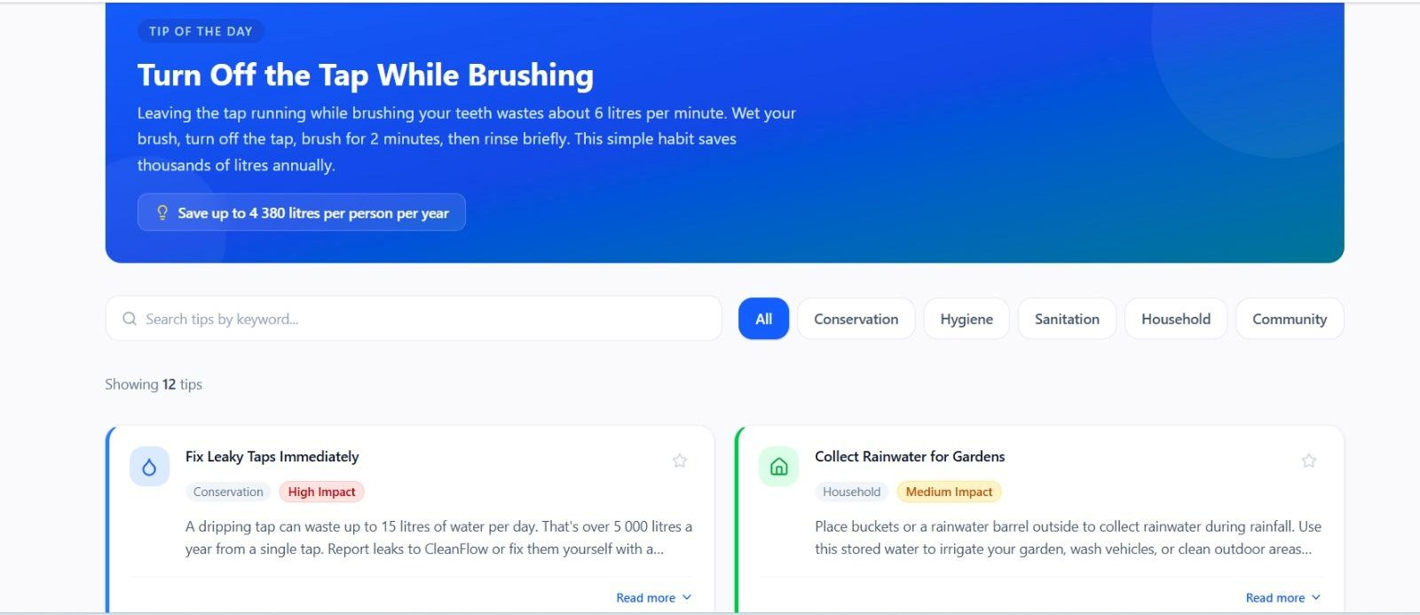
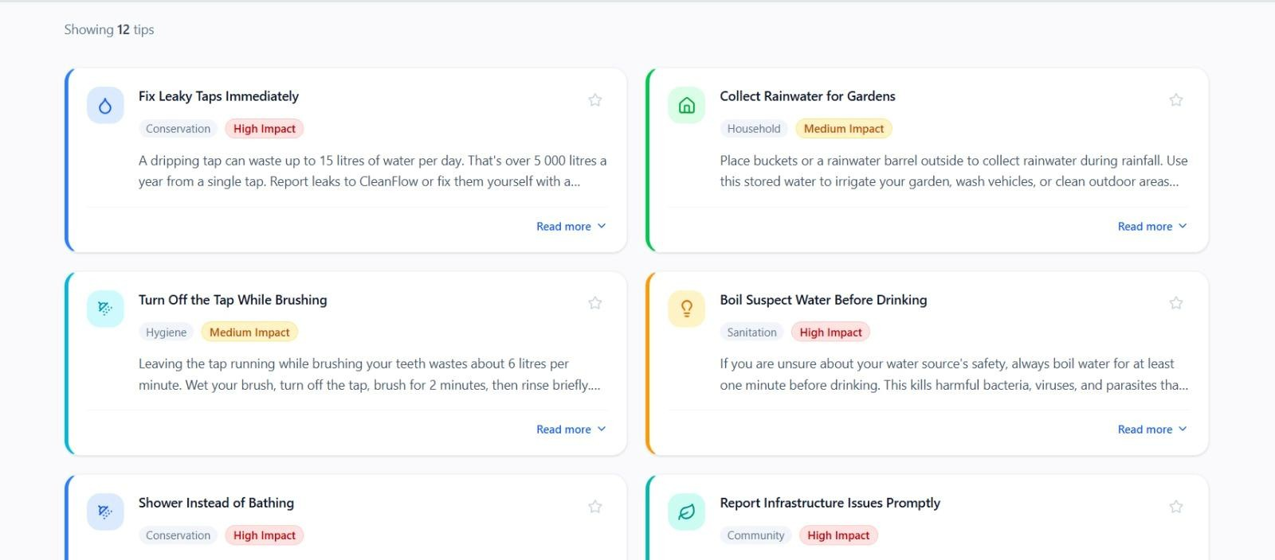

Donation Page

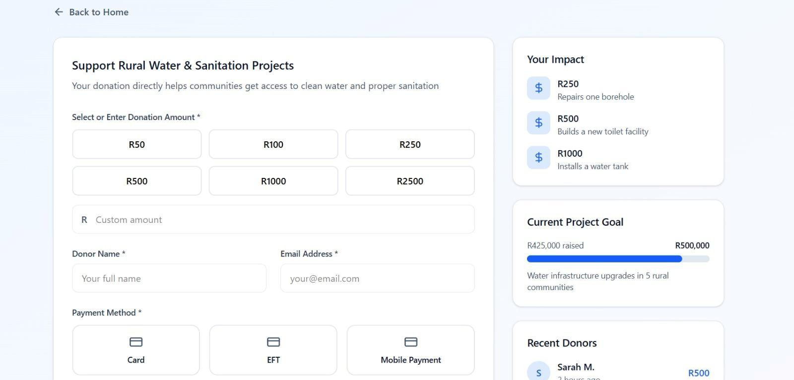

Report issue page
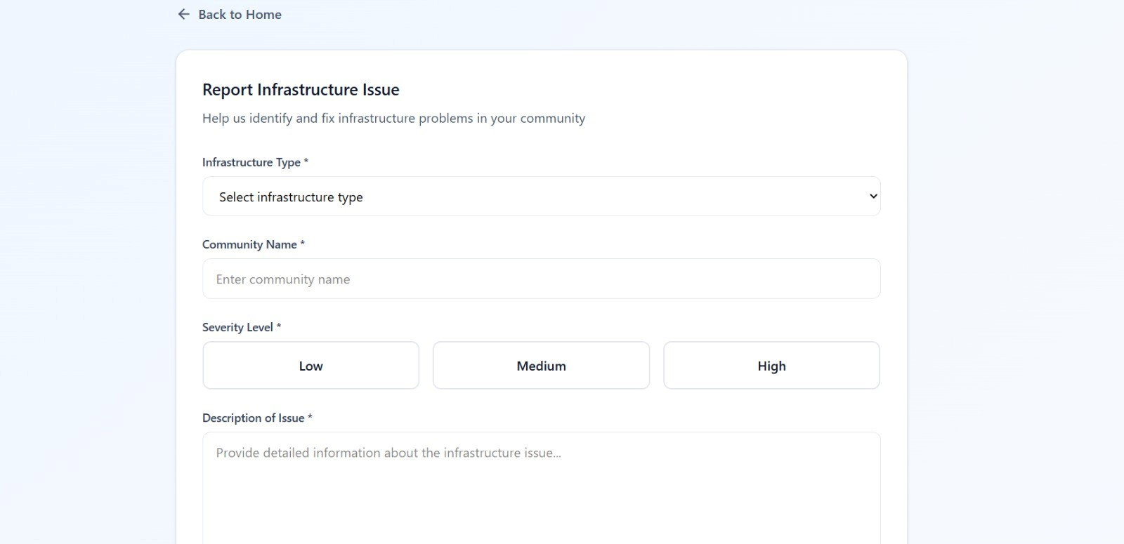

Volunteer page

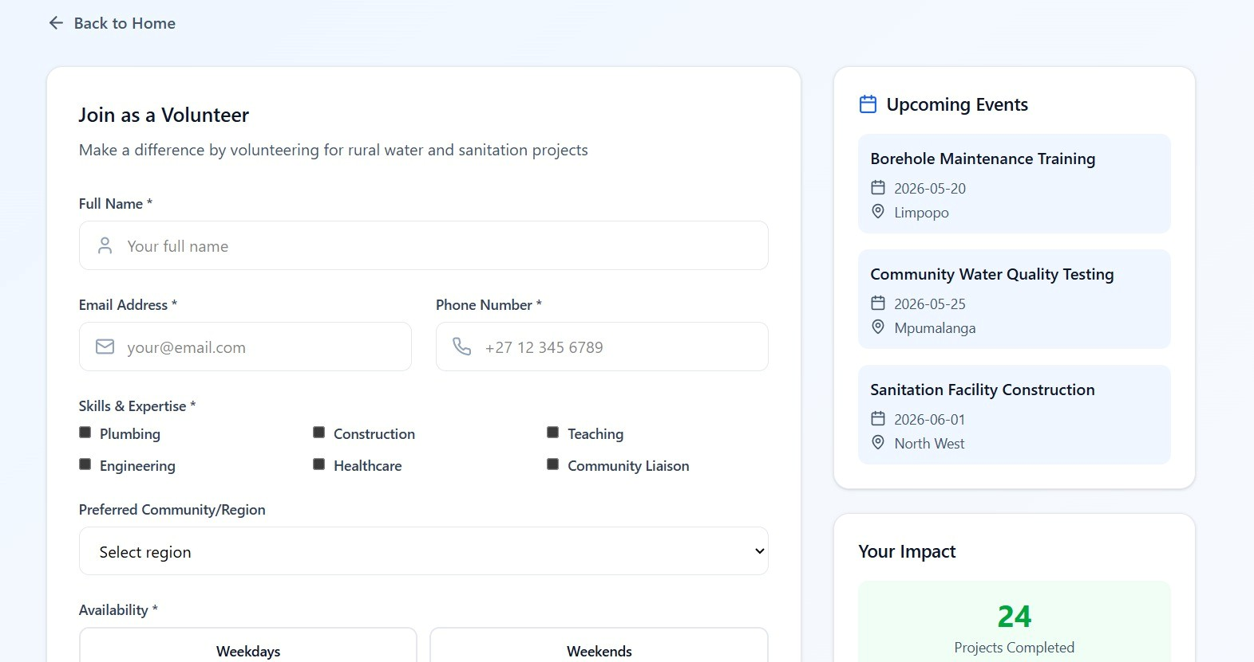

Login page
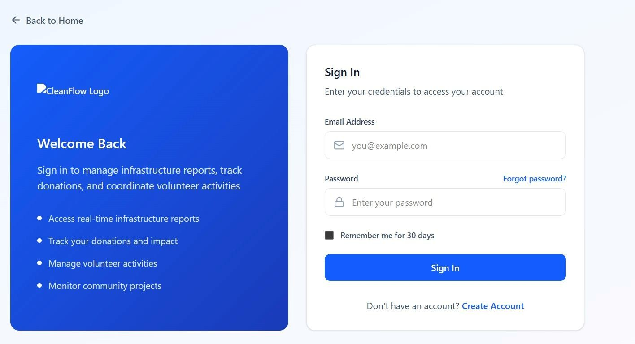

Register page

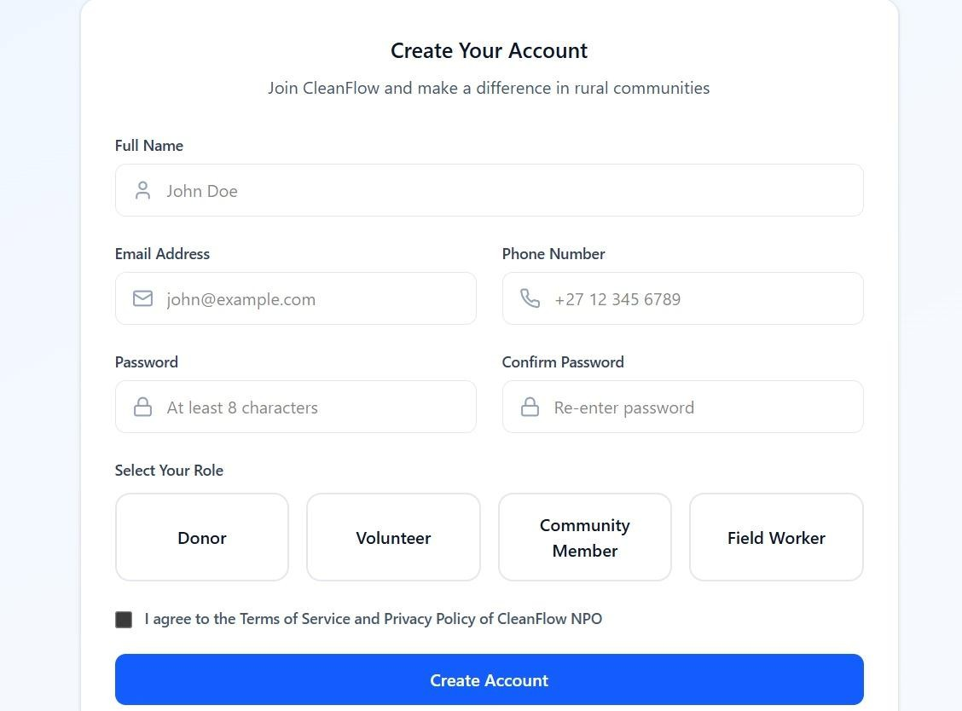

Mobile App Homepage

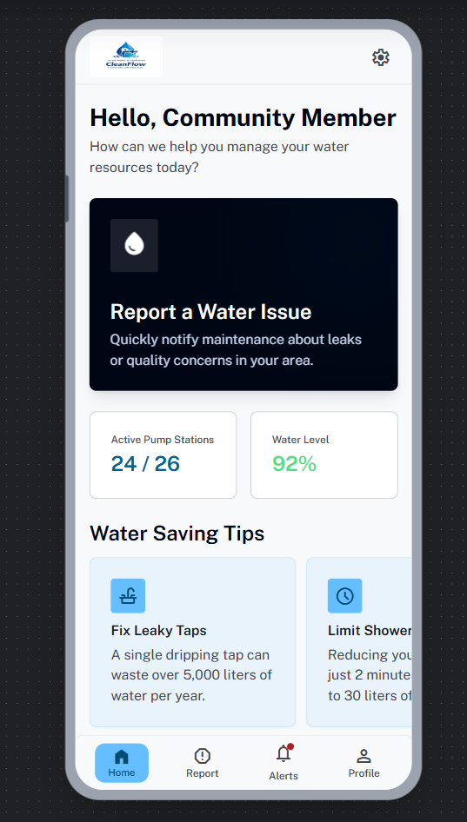
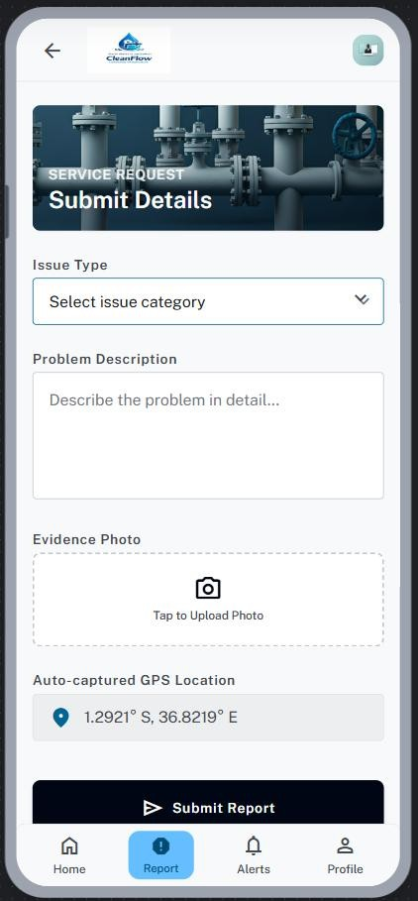

Login page
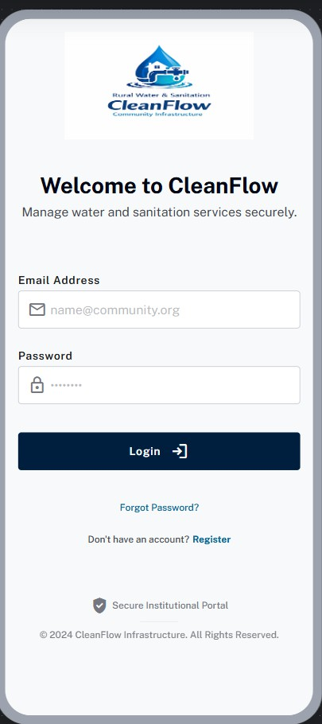

14. SiteMaps
Website sitemap
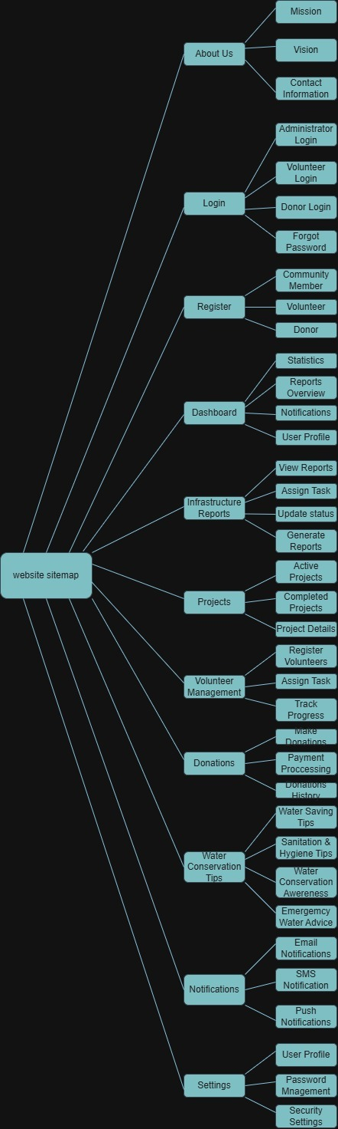

Mobile app sitemap

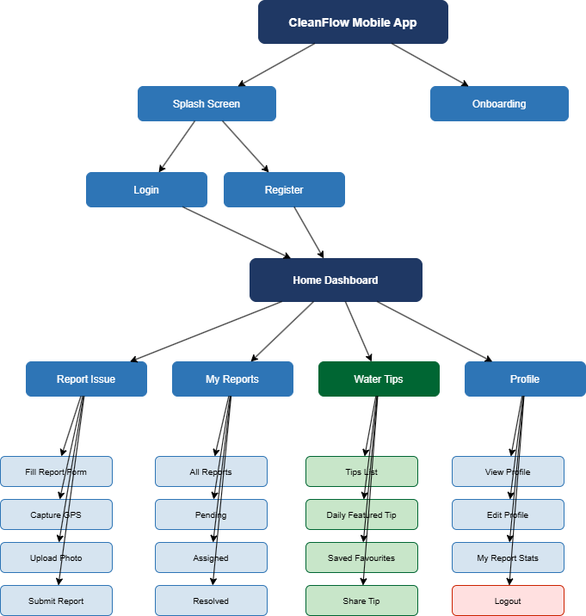

References
Department of Social Development 2022. Nonprofit organisations in South Africa. [Online]. Available at: https://www.dsd.gov.za [Accessed 24 February 2026].
Department of Water and Sanitation 2022. National water and sanitation master plan. [Online]. Pretoria: Government of South Africa. Available at: https://www.dws.gov.za [Accessed 24 February 2026].

Heeks, R. 2018. Information and communication technology for development (ICT4D). London: Routledge.

Laudon, K.C. and Laudon, J.P. 2020. Management information systems: Managing the digital firm. 16th ed. Harlow: Pearson.

Project Management Institute 2021. A guide to the project management body of knowledge (PMBOK Guide). 7th ed. Newtown Square, PA: Project Management Institute.

United Nations 2023. Sustainable Development Goal 6: Ensure access to water and sanitation for all. [Online]. Available at: https://sdgs.un.org/goals/goal6 [Accessed 24 February 2026].

UNICEF 2022. Water, sanitation and hygiene (WASH). [Online]. Available at: https://www.unicef.org/wash [Accessed 24 February 2026].

Whitman, M.E. and Mattord, H.J. 2022. Principles of information security. 7th ed. Boston: Cengage Learning.

World Bank 2023. Water supply, sanitation, and hygiene overview. [Online]. Available at: https://www.worldbank.org/en/topic/watersupply [Accessed 24 February 2026].

World Health Organization 2023. Drinking-water. [Online]. Available at: https://www.who.int/news-room/fact-sheets/detail/drinking-water [Accessed 24 February 2026].

World Health Organization and UNICEF 2023. Progress on household drinking water, sanitation and hygiene 2000–2022. [Online]. Available at: https://washdata.org [Accessed 24 February 2026].

