**Trakkart**

Premise:

Trakkart is a fast paced, futuristic racing game where racers shoot each other down. Players earn cash to customize their ride.

Features:

* Weapons
  + Oil slick
  + Homing Missile
  + Freeze Block
* Shields
  + More Cover Area
  + Less Energy Cost
  + Absorbs Impact, Replenishes Health
  + Deflects Shots Back At Attacker
* Power-ups
  + Restore Health
  + Steal Other People’s Power-ups
* Coins
* Car Customization
* Alternate Routes

Genre:

Top-Down Racing Shooter

Purpose:

Trakkart is meant to be an exciting game that keeps the player on the edge of their seat. Replay value is high with customizability and the joy of shooting others down on your way to victory!

Platform:

Trakkart is meant to be played on PC. It can handle Xbox 360 controller input and keyboard/ mouse.

Audience / Player Mode:

Trakkart is a single player game. This game is aimed at competitive players at all ages.

Rating:

E – Everyone

Time Interval:

Real Time

Backstory:

You are a driver who wants to win this race.

Character Description:

Opponents are other vehicles; their racing style determines how they are perceived. How their stats are aligned determines how they drive.

Competitive Analysis:

Trakkart can be comparable to:

* Mario Kart
  + Power-ups
  + Pushing people around
  + Potentially falling off map
  + Coin collection
* F-Zero
  + Aesthetics
  + Gameplay
* Sonic Racing
  + Gameplay

Rules:

* Player uses either Xbox 360 controller or keyboard/mouse to interact with the game
* Player’s goal is to win the race
* Player may shoot opponents to deplete their health, they will do the same
* If any racer’s health reaches 0, they “die”, and re-spawn near where they died, doing so causes the racer to fall behind in the race
* Player may use their shield to avoid losing health
* Player may use boost
* Shield increases their temperature
* Boost increases their temperature
* Temperature rejuvenates over time
* Power-ups may be picked up to help racers
* Power-ups have a temporary effect
* Coins may be collected by the player during the race
* These coins help the player customize their vehicle between races
* The game ends when all the racers finish the race
* Player stats such as:
  + Speed
  + Attack
  + Defense
  + Turning
  + Acceleration
  + Luck

…are to be decided before the race begins. How the player decides to delegate these stats determines how their vehicle will drive, shoot, and defend

Challenges:

Player must race better than their opponents and avoid being taken out by them while shooting back at them. More coins are found in areas that are out of the way. In order to win the big reward, you must be far enough ahead to spend the extra time on the trak.

Strategies:

Different delegation of stats is different strategies. If the player chooses to be well rounded, then they are considered a jack of all trades. If they place all their eggs in speed, they better hope they are not shot down.

Game Balance:

Since all racers have the same amount of stat points that they can use on their vehicle, the game is designed to be fairly balanced.

Game View:

Top-Down 2D

Level Design Notes 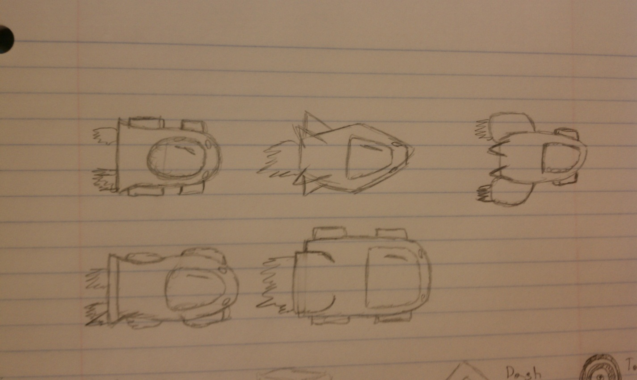 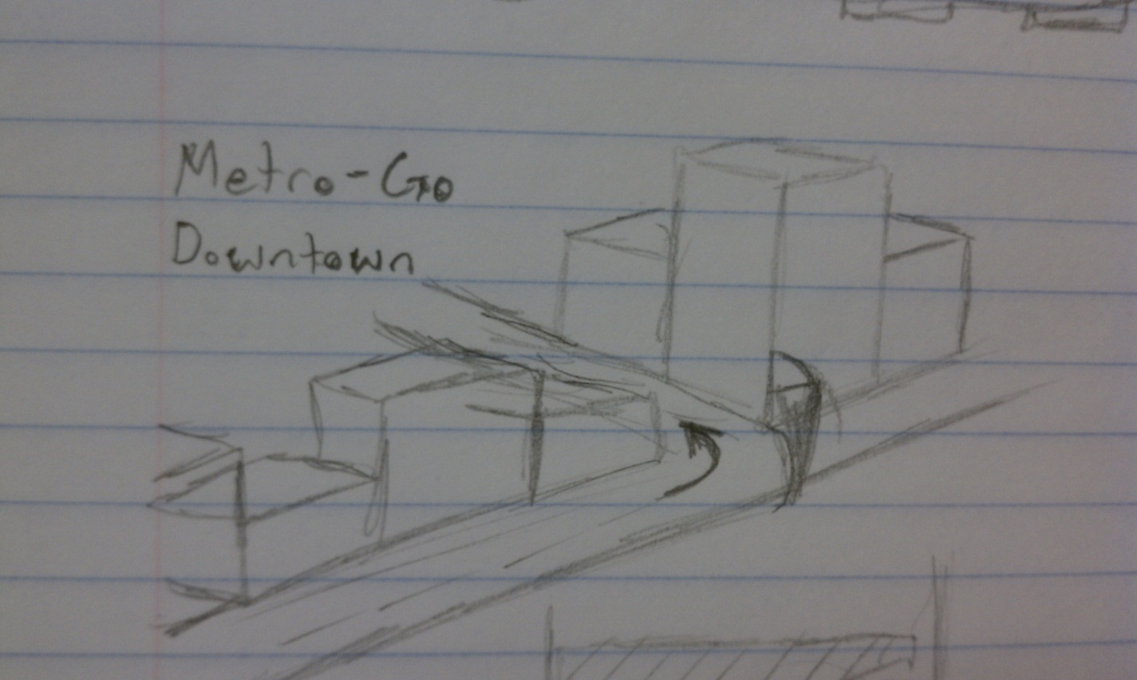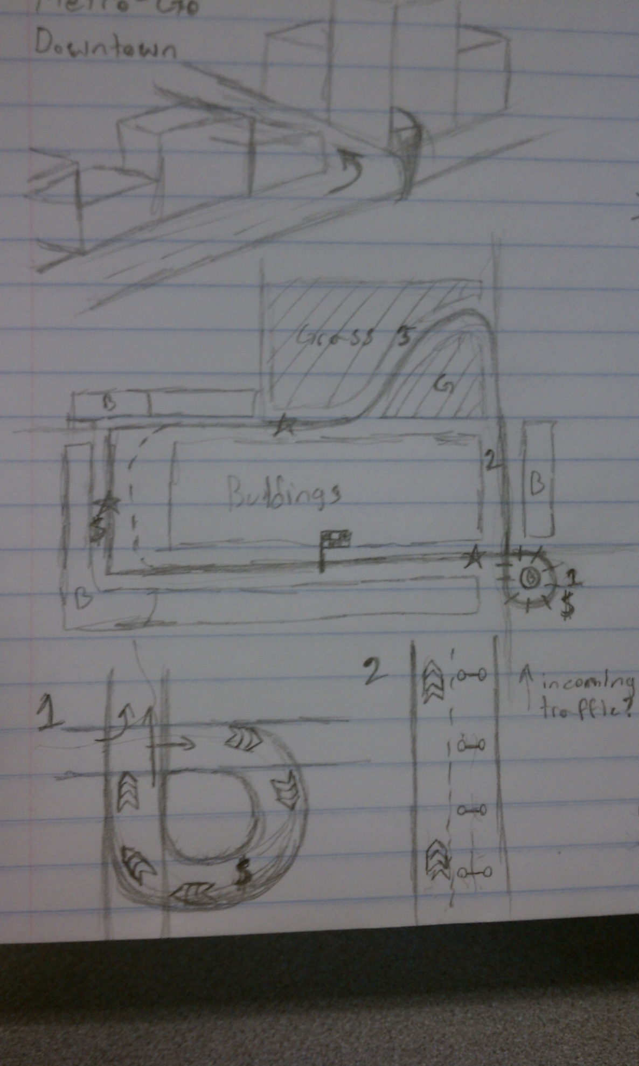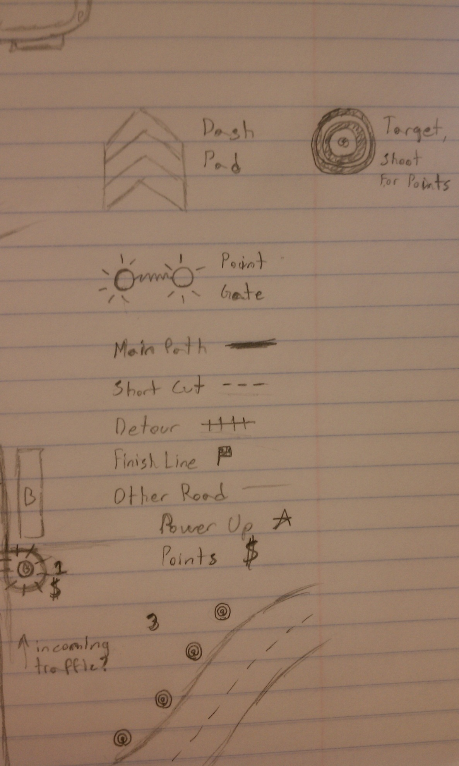

User Interface

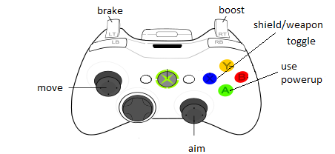

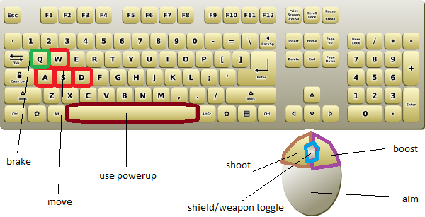

Audio:

TODO: figure out audio

Conclusion:

TrakKart is a fun, fast shooter where you have the power to take down other racers while also trying to save yourself. It has power-ups, weapons, shields, and multiple enemies to help this feel.