# Model Documentation and Reported Values

Portfolio value today = 2.459556520976903e+08

CR01 = 17,100

Duration = 8.05

Convexity = 0.96

DV01 = 210,300

Notation: All numbers consider the gains distribution

## 1 day Market Monte Carlo Simulation: 5000 simulations

The data was gathered and cleaned as discussed above. The risk factor returns were computed for all risk factors. The risk factors were modelled as a multivariate normal random vector. A basic Monte Carlo simulation was used to compute the statistical measures reported below.

**Value at Risk**

1 day 99%

-3.794412794066981e+06

1 day 95%

-2.682935604614869e+06

10 day 99%

-1.199898681213510e+07

10 day 95%

-8.484187326143945e+06

**Conditional Value at Risk**

1 day 99%

-4.331694948432796e+06

1 day 95%

-3.349219375900260e+06

**Marginal Value at Risk (First percentile conditional expectation approximation)**

MVaRBonds = -3.875677101084818e+06

MVaRCDS =1.583664991607715e+04

MVaROptions = -8.132530598024673e+03

MVaRSTOCKS =-5.142686786892892e+04

Sum of Marginal VaR’s = -3.919399849635694e+06 (pretty close to actual value at risk (modulo some numerical precision!))

**Incremental One Day 99% Value at Risk = VaR – VaR without asset class**

Bonds = 3.457357705787945e+06

CDS = 4.639840700576007e+05

Options = 5.397995765466839e+05

Stocks = 6.785293734007329e+05

**Value at Risk by Asset Class ( 1 day 99%)**

NO BONDS: -3.370550882790359e+05

NO CDS: -3.330428724009380e+06

NO OPTIONS: -3.254613217520297e+06

NO STOCKS: -3.115883420666248e+06

ONLY BONDS: -3.143531419669971e+06

ONLY CDS: -2.467024394043556e+08

ONLY OPTIONS: -3.914184377430077e+04

ONLY STOCKS: -2.811170144531494e+05

## Historic Scenarios Computation of Value at Risk

**Value at Risk**

1 day 99%

-4.574142177442358e+06

1 day 95%

-2.965721716378355e+06

10 day 99%

-1.446470762215992e+07

10 day 95%

-9.378435529979493e+06

**Conditional Value at Risk**

1 day 99%

-1.132913456732699e+07

1 day 95%

-5.400742248045450e+06

**Comparison between Historic and MC**

By definition, the historic computation captures correlation and risk factors movements of past history.

The MC simulation is not capturing some of the risks. Therefore, its value at risk is less in absolute value.

**Marginal Value at Risk (First percentile conditional expectation approximation)**

Due to a lack of historic data, marginal value at risk computations could not be computed accurately.

**Incremental One Day 99% Value at Risk = VaR – VaR without asset class**

Bonds = 4.055062095744104e+06

CDS = -3.255234391375762e+05

Options = -3.225662024852028e+05

Stocks = -2.559787501177602e+05

**1 Year Monte Carlo Market Value at Risk (1000 simulations)**

A 1 year Monte Carlo Value at Risk was computed due a lack of accuracy inherent in the square root of time rule. The spreads of the CDS’s, equities and option spot prices were modelled using GBM. The FX rates were modelled using a CIR model. The interest rates were simulated using principal component analysis assuming that the first principal component followed a Vasicek Process. All models were calibrated under the real world probability measure. The correlated processes were simulated over a year 1 year period using a 1 day time step. The following statistical measures were computed on the empirical distribution of the change in portfolio value:

**Value at Risk**

1 Year 99%

-3.276529358499929e+06

**Conditional Value at Risk**

1 Year 99%

-5.344575520138693e+06

**1 Year Credit Value at Risk (2000 simulations)**

The CreditMetrics approach using a Gaussian copula was used to compute the CreditVaR. The correlations between the issuers of the corporate bonds was estimated using the sector correlation matrix. The intra sector correlation was chosen to be the minimum value such that correlation matrix remained positive semi-definite. The intra sector correlations were determined to be 0.94. The theta of the bonds were not considered since it was already considered in the market value at risk computation. Therefore, we assume the shock occurs instantaneously.

*Credit Value at Risk (1 year)*

95% -2.755638799243206e+07

99% -4.876796838026759e+07

99.9% -5.068460416855773e+07

**Correlation between Market and Credit Risk**

Clearly there is correlation between market and credit risk. In there were perfect correlation, the total value at risk would be the sum of the CreditVaR and MarketVaR. In other cases,

$$Total VaR=\sqrt{MarketVaR^{2}+CreditVaR^{2}+ 2ρ*MarketVaR*CreditVaR}$$

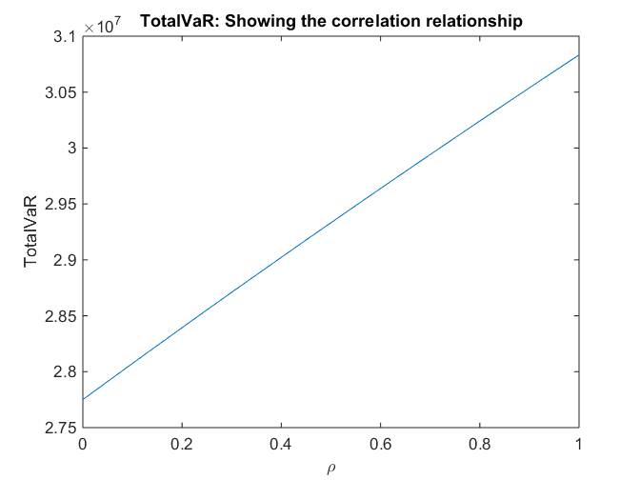

Therefore, we have the following bounds on the TotalVaR.

27750498.4428490 $≤$ TotalVaR. $≤$ 30832917.3509320

**Stressed Value at Risk using Historical Simulation**

To compute the stressed value at risk, data was taken from 03/01/07 - 12/31/09. It was found that the most stressed 504 day window occurred from 03/07/07 – 03/07/09. The reported stressed value at risk during this period was -5.490570602563009e+06.

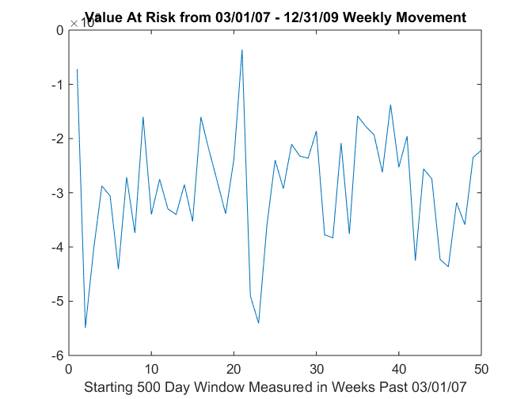

**CDS Pricing**

The pricing of the Credit Default Swaps was done similarly to that of Hull in Chapter 25. In particular, the probability of survival to a period end and probability of default during a period was used to compute the present value of the expected payments, expected payoffs and accrual payments. In Hull, it is assumed that defaults can only occur at the midpoint of payment periods. We relax this assumption by allowing default events to occur on a daily basis. This greatly reduces numerical integration errors.

The CDS prices are reported as follows:

-3844133.31471624

-3211645.76442841

-1740857.70894546

-829861.519547225

-633670.452465153

-68110.6327644099

1629742.02252925

705762.662829994

-573604.271939782

**Credit Value Adjustment and Debt Value Adjustment**

Let $q_{i}$ be the risk neutral probability of default of the counterparty defaulting during the $i^{th}$ interval. Let $v_{i}$ be the present value of the expected loss to the bank if the counterparty defaults at the midpoint of the $i^{th}$ interval. Let $q_{i }^{*}$ be the risk neutral probability of the bank defaulting during the $i^{th}$ interval. Let $v_{i}$ be the present value of the expected loss to the counterparty if the bank defaults at the midpoint of the $i^{th}$ interval.

$$CVA= \sum_{i=1}^{N}{q_{i}v_{i}}$$

$$DVA= \sum_{i=1}^{N}{q_{i}^{*}v_{i}^{*}}$$

The probability of the counterparty defaulting during the $i^{th}$ interval is given by

$$q_{i}=\exp\left(-λ_{i-1 }t_{i-1}\right)-exp⁡(-λ_{i}t_{i})$$

The hazard rates are a function of the credit quality of the counterparty. Therefore, the default probability is a function of the current spread curves implied by the market. The computation of the $v_{i}'s$ involved a very time consuming Monte Carlo simulation. The spreads were simulated under the risk neutral pricing measure using the Ho-Lee model. On each simulation trial, the potential exposure to the counterparty was computed at the midpoint of each interval. The exposure is equal to the max(V,0), where V is the expected value of each CDS contract at that future point in time. The variable, $v_{i}$ was set equal to the present value of the average exposure across each simulation multiplied by one minus the recovery rate. The variable $v_{i}^{*}$ was calculated similarly using the max(-V,0) to get the counterparty’s exposure to us. We assumed that the we are a AA rated firm.

The results are as follows:

CVA

4094.59605183508

1790.59080152533

0

0

7.14516539461641

12228.5385587937

42515.4317850556

53922.3989966669

281.764799690500

DVA

84570.0413030876

155831.594008841

3556.64714573887

1632.99310644233

1259.28492899519

5468.16123778521

1674.98574817641

571.604766328071

2808.94352655410

Then, the price adjusted value of the CDS’s are:

$$V^{new}=V^{old}-CVA+DVA$$

-3763657.86946499

-3057604.76122109

-1737301.06179972

-828228.526440783

-632418.312701553

-74871.0100854184

1588901.57649237

652411.868599656

-571077.093212918

## Model Vetting

The pricing models were vetted using a variety of methods. The instrument prices were checked with current market prices today. The Value at Risk calculations were checked within models. For example, we found that the historical Value at Risk was not too different from the Monte Carlo Value at Risk. The models were also vetted by comparing them with elementary example found in Hull.

The most important model vetting technique we used was back testing. The back testing technique we used involved considering a moving window. For each window, we recalibrated the model and computed the Value at Risk. We then compared the next out of sample change in price to check if had breached the VaR (99%). This was done for the Monte Carlo and Historical Value at Risk computations over 125 windows. The number of breaches in 125 trials was 5. Therefore, the empirical probability of breaching is approximately 4%.

The number of breaches in 125 trials is distributed according to a binomial distribution with probability of success equal to 5%. The probability of 5 or more breaches can be computed as:

1 – BINOMDIST(4, 125, 0.01, TRUE) = 0.872513%

At a 5% confidence level, we cannot reject the model. This implies that the Monte Carlo simulation is not an unsuccessful model.

A similar computation was considered for Historical Value at Risk; however, it was deemed that the computation was rather meaningless since it only tells us if past historic data was indicative/predictive of future historic data.