|  |
| --- |
|  |
|  |
| |  |  |  |  |  | | --- | --- | --- | --- | --- | | MMF2025 – Risk Management Lab  Pantelis Isaiah – 995354593  Sergio Ortiz Orendain - 1002248533  José Saad Canales - 999048392  Ryan Shrott - | |  | | --- | |  | |  | |  | | |
| |  |  |  | | --- | --- | --- | | July 2016 | Risk | **Report** | |

# Portfolio decompositions

## By sector

Say something about the decomposition by sector.

# By asset class and by currency

Say something about the decomposition by asset class.

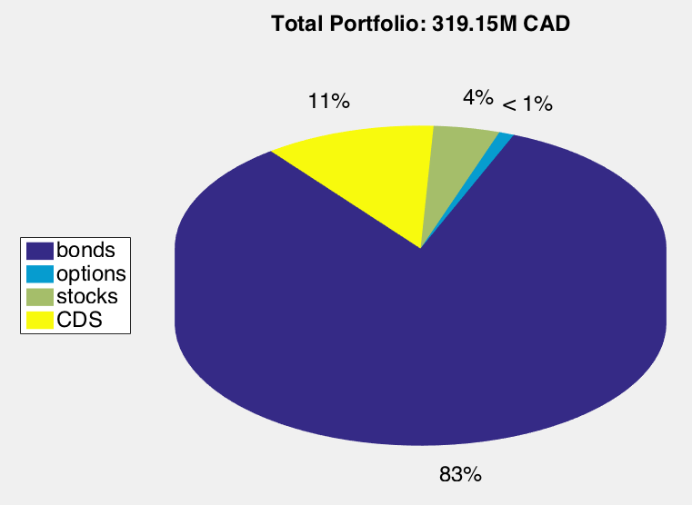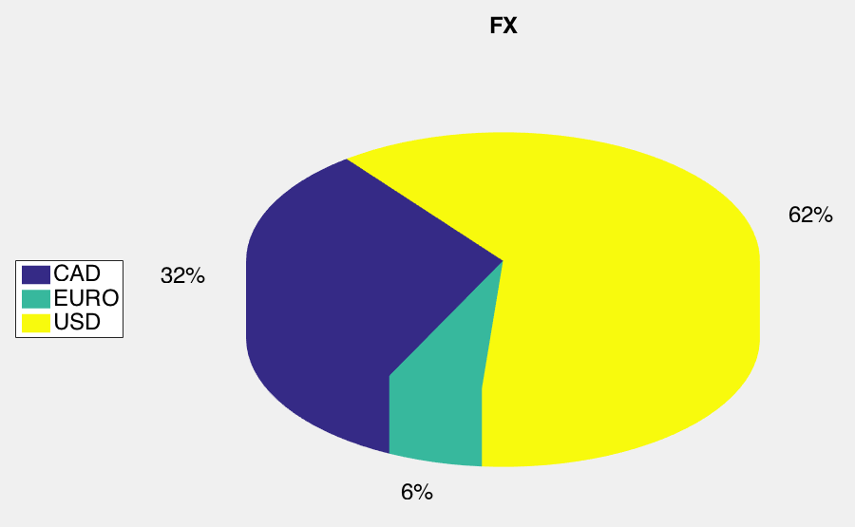

# Var and Marginal VaR