|  |
| --- |
|  |
|  |
| |  |  |  |  |  | | --- | --- | --- | --- | --- | | MMF2025 – Risk Management Lab  Pantelis Isaiah – 995354593  Sergio Ortiz Orendain - 1002248533  José Saad Canales - 999048392  Ryan Shrott - 998931223 | |  | | --- | |  | |  | |  | | |
| |  |  |  | | --- | --- | --- | | July 2016 | Risk | **Report** | |

# Portfolio decompositions

## By sector

The portfolio consists of 32 Bonds, 11 government bonds and 21 corporates. Out of the Bonds, 7 have either expired or been called, which leaves the total composition of the portfolio to 25 bonds. The portfolio also consists of 3 US Stocks, 2 of them listed in the NYSE and 1 in NASDAQ, 2 European Options, 1 American Option; both on US Stocks. Finally, there are 10 Credit Default Swaps (CDS) in the portfolio out of which 1 has expired. These instruments add up to a total value of 248.5M(CAD) dollars. There are several sectors represented in the portfolio, the following table represents the total exposure of our portfolio by sector:

# It can be noted that there is a large concentration to 2 sectors, Communications and Government, however we have enough sectors to potentially rebalance the portfolio in order for it to be more diversified sector-wise.

# By asset class and by currency

In terms of asset classes, the portfolio is mainly concentrated in Fixed Income instruments, while Equities (Stocks and Options) represent around 5% of the portfolio. We are exposed to 3 different currencies: Euro, Canadian Dollar and US Dollar. All of the Equity instruments of the portfolio are in US Dollars as well as the CDS contracts. The Bond portfolio consists on 9 USD Bonds, 1 Euro Bond and 15 Canadian Bonds.

It is important to note that almost all of the Bonds in the portfolio are Investment Grades, however there are 2 Corporate Bonds with BB S&P-rating.

# Sensitivities

Market risk takes into account the losses that surge from fluctuation in the market value of our positions due to changes in interest rates, credit spreads, foreign exchange rates and values of equities. The portfolio is exposed to changes in interest rates curves through our position in fixed income (Bonds and CDS). Additionally, there’s exposure to 3 different currencies (USD, CAD and Euro) so we will assume we are an investor that manages its assets and liabilities in Canadian Dollars, therefore we are exposed to fluctuations in the value of our portfolio due to changes in the USDCAD and/or EURCAD FX rate. Finally, we are exposed to credit spreads through our corporate bond positions and also through our CDS holdings. The measures we will use for market risk will be portfolio sensitivities (such as DV01, CR01, Duration and Convexity), VaR, Stressed VaR and Stress Scenarios.

# Portfolio Sensitivities

It is important to include the dollar sensitivities of the positions in the portfolio to changes in the underlying interest rate and credit spread.

DV01: It is the dollar value of one basis point that captures the change in value of the portfolio due to a downward parallel shift of 1bp in the yield to maturity (YTM).

CR01: It is the credit risk of one basis point that captures the change in value of the portfolio due to a downward parallel shift of the credit spread.

Since our portfolio has an overall long position in bonds, we can except to benefit from a decrease in interest rate. As for our position in CDS, the portfolio has a negative impact in case of a decrease in the credit spread.

|  |  |
| --- | --- |
| **Sensitivities** | |
| Duration | 8.05 |
| Convexity | 0.96 |
| DV01 | $210,300 |
| CR01 | $-17,100 |

# Value-at-Risk calculations — Monte Carlo

## Value at Risk (VaR) and Conditional Value at Risk (CVaR)

Under Basel II.5, Regulatory Value-at-Risk (VaR) is the estimate of the potential decline in the value of a position/portfolio under normal market conditions. We will consider a 10-day time VaR at the 99th percentile for all our estimations, however in the table below we present values for different confidence level and time horizon. Our model incorporates the volatilities and correlations of 150 market factors. For the calculation of VaR we consider a time horizon that goes from December 31, 2013 to June 30, 2016. We will use 2 methods for estimating VaR: Monte Carlo and Historical. Our calculations also include the Expected Shortfall (or CVaR), which gives more information about the tail of our Profit and Losses distribution by calculating the average of the losses that exceed VaR. The following table illustrates the values obtained for these measures:

|  |  |  |  |  |
| --- | --- | --- | --- | --- |
| **VaR** | **95%** | | **99%** | |
| 1-day | 2.68M | 1.09% | 3.79M | 1.54% |
| 10-day | 8.48M | 3.45% | 12.00M | 4.88% |
| 1-year | 54.45M | 22.14% | 78.39M | 31.87% |
| **CVaR** | 95% | | 99% | |
| 1-day | 3.35M | 1.36% | 4.33M | 1.76% |
| 1-year | 68.52M | 27.83% | 86.84M | 35.31% |

From our results we can see that the Historical VaR is higher than the VaR calculated using Monte Carlo. We must take into account that the analytical VAR is more models dependent. To map the portfolio P&L to linear risk factors we work with the DV01 and CR01 (for bonds and CDS respectively). The mapping probably won’t be a good approximation for large movements. That’s why; the historical VAR number would be a better representation of our PNL distribution.

## Marginal Value at Risk (MVaR)

From our results we can see that the Historical VaR is higher than the VaR calculated using Monte Carlo. We must take into account that the analytical VAR is more models dependent. To map the portfolio P&L to linear risk factors we work with the DV01 and CR01 (for bonds and CDS respectively). The mapping probably won’t be a good approximation for large movements. That’s why; the historical VAR number would be a better representation of our PNL distribution.

|  |  |  |
| --- | --- | --- |
| **1-day 99% MVaR** | | |
| Bonds | 3.87M | 1.58% |
| CDS | -0.015M | 0.01% |
| options | 0.01M | 0.005% |
| stocks | 0.05M | -0.02% |

## Incremental Value at Risk (IVaR)

|  |  |  |
| --- | --- | --- |
| **1-day 99% IVaR** | | |
| bonds | 3.46M | 1.39% |
| CDS | 0.46M | 0.19% |
| options | 0.54M | 0.22% |
| stocks | 0.68M | 0.27% |

# Value-at-Risk calculations — Historical

## Value at Risk (VaR) and Conditional Value at Risk (CVaR)

|  |  |  |  |  |
| --- | --- | --- | --- | --- |
| **VaR** | **95%** | | **99%** | |
| 1-day | 2.97M | 1.19% | 4.57 | 1.84% |
| 10-day | 9.38M | 3.77% | 14.46 | 5.82% |
| 1-year (estimate) | 47.08M | 18.94% | 72.61M | 29.22% |
| **CVaR** | 95% | | 99% | |
| 1-day | 5.40M | 2.17% | 11.33M | 4.56% |

## Incremental Value at Risk

|  |  |  |
| --- | --- | --- |
| **1-day 99% IVaR** | | |
| bonds | 4.06M | 1.63% |
| CDS | -0.33M | -0.13% |
| options | -0.32M | -0.13% |
| stocks | -0.26M | -0.10% |

# Credit VaR

## Bonds

|  |  |  |
| --- | --- | --- |
| **Credit VaR for the bond portfolio** | | |
| 95% | 20.04M | 8.07% |
| 99% | 40.40M | 16.25% |
| 99.9% | 50.64M | 20.38% |

## CDS

|  |  |  |
| --- | --- | --- |
| **Credit VaR for the CDS portfolio** | | |
| 95% | 27.56M | 11.09% |
| 99% | 48.77M | 19.62% |
| 99.9% | 50.68M | 20.39% |

# Credit and Debt Value Adjustments (CVA and DVA)

In thousands CAD

|  |  |
| --- | --- |
| **CVA** | **DVA** |
| 114840 | 257374 |

# Stressed VaR (SVaR)

The methodology for the SVaR is the same as for the Regulatory VaR methodology (99% confidence level and 10 day holding period) with the exception of the look back period. For the SVaR we calibrate the model to historical data from a continuous 24-month period that reflects significant financial stress. The period considered was 2007-09 financial crisis aftermath. We can see that SVaR is $17.39 MM, which exceeds both VaR calculated before under Monte Carlo and historical methods. Therefore, it is important to take into account SVaR which gives a better insight of the portfolio potential decline in stressed periods.

When computing the stressed Value-at-Risk it was found that the most stressed 504-day window occurred from 03/07/07 through 03/07/09. The reported stressed value at risk during this period was

|  |  |
| --- | --- |
| **Stressed VaR** | |
| Daily | 5.5M |
| Ten Day | 17.4M |

# Stress scenarios

To complement our VaR and SVaR results we will compute the value of the portfolio under determined historical scenarios/crisis under the historical scenario approach. This will help us estimate the impact of our portfolio to extreme market movements and evaluate the potential effects of tail events on our portfolio and consider periods where the portfolio had make significant losses due to the market conditions.

We chose 4 Historical scenarios and one Hypothetical, the losses of this scenarios are represented in the following figure.

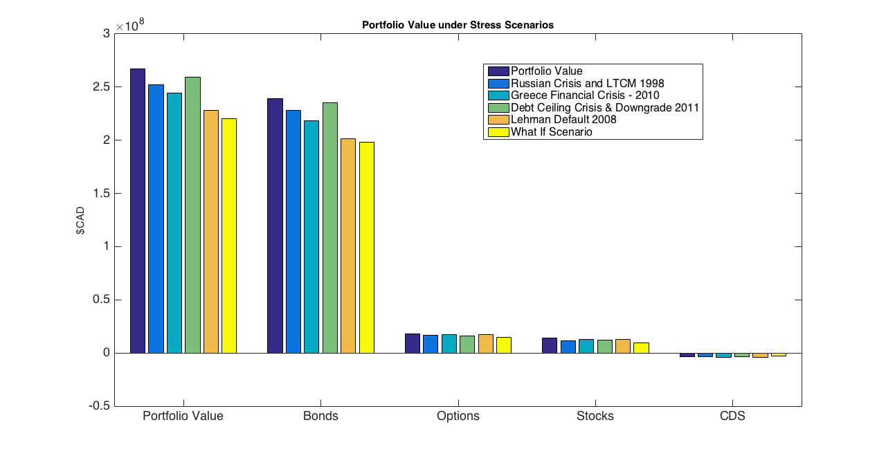

Given that the composition of our portfolio consists mainly on bonds, the Credit Crisis of 2008 shows the worst historical loss; this gives an idea of the exposure to credit and fixed income instruments. The hypothetical scenario shows a severe loss in our Bond Portfolio, however we can see that all the other asset classes have a substantial loss.

# Capital Requirements

## Market Risk

On Basel Regulatory Capital there are two principal components required to obtain the capital requirements: one market component and one credit risk component.

Based on the Basel II.5 document, the following formula needs to be used to calculate our market risk regulatory capital:

$$K=\max\left(VaR_{10d 99\%};mc VaR_{avr 10d 99\%}\right)+max⁡(SVaR_{10d 99\%};mc SVaR_{avr 10d 99\%})$$

The following table represents the total Regulatory Market Capital:

|  |  |
| --- | --- |
| **Market Regulatory Capital** | |
| 98.6M | 39.7% |

## Incremental Risk Charge (IRC)

The incremental risk charge (IRC) complements the VaR framework by projecting the effect of credit rating migration into VaR. Unlike, IRB where only the default events are considered in the credit risk capital, in IRC, downgrades are also considered in credit risk modeling. To consider the migration we will use a Transition Matrix obtained from S&P

CreditMetrics methodology as well as Gaussian copulas is used to model the rating transitions. The details of the methodology can be found in our documentations. The one-year 99.9% VaR is calculated using 2000 MC simulations

|  |  |
| --- | --- |
| **IRC VaR - 99.9% 1y** | |
| 50.6M | 20.4% |

Adding both the market and the credit factors, we obtain a total capital requirement of 149.2M; which represents 60% of the total value of the portfolio.

## Economic Capital

The Economic Capital is the Capital designated to cover unexpected Market losses. The Economic Capital provides a forward-looking estimate of the difference in the maximum potential loss and our expected loss:

$$K_{economic}=VaR_{10d99\%}-Expected Loss$$

The total value of the Economic Capital adds up to 13.6M; which represent 5.5% of the portfolio value.

## Standardized Approach for CCR

The capital allocation is based on the following formula proposed in Basel I, where the weights and credit equivalent add-on factors are:

$$K=0.08 (Σ_{j}RWA_{j})$$

This adds up to 0.27M, which represent 3.1% of the total exposure to CDS.

## Standardized CVA Capital

In the standardized approach, the portfolio CVA capital charge is calculated using the following formula:

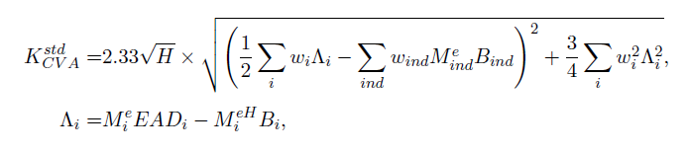

The capital we obtain for the CVA is the following: $K=0.22M$, representing 2.6% of the Total CDS Exposure.

# Model Risk

Model risk is the possible losses due to faults in the development and application of the valuation models considered.

**Interpolation of Zero Curves and Spread Curves:** For our pricing models we had to interpolate the interest rate curves as well as the CDS spread curves. Given that we only have an observation for determined tenors, an interpolation has to be done to obtain a curve. This position mapping was done with a linear approach, although several other methods exist. A disadvantage of the linear interpolation is that it can either underestimate or overestimate volatility of the cash flows being discounted.

**Agency Rating Risk:** For credit risk we use the agency ratings for valuing our portfolio. It has been proven that these ratings might not be correct and may overestimate the value of the financial instrument. Another problematic that rises is that the bonds with the same rating not necessarily have the same spread.

**Liquidity:** Within our models we are not considering the liquidity risk of the instruments. We are valuing the instruments without pricing in a liquidity factor. This then might implicate an overestimation or underestimation of the instruments prices.

**Jointly Normal Assumption:** We assumed that the risk factors are jointly normal in calculation of the analytical VaR. This is also the case of model risk. As we know Normality assumption is not a realistic assumption. A better approach would have been using a distribution with skewness and kurtosis for calculation of analytical VaR.

**Gaussian Copula:** Gaussian copula generally cannot capture the tail dependence very well, however it is known that T-copulas are a good candidate for capturing the tail dependence. It is expected by switching to t-copulas, the VaR value calculated by the IRC approach increases which provide a better (more realistic) estimate for worst case capital loss and capital allocation.

**Double default:** In our CCR model we have not considered the existence of correlation between the counterparty and the reference entity in the CDSs. In practice in the extreme market conditions default correlation becomes high which impacts the default risk capital allocation. The double default has been considered in the Basel III framework but it has not been zincluded in our models.