Does sunshine make people happy?

F. Rodriguez-Sanchez

Tuesday, November 25, 2014

## Introduction

It is well known that individual well-being can be influenced by climatic conditions. However, ...

## Methods

We collected data on 100 individuals and fitted a linear model.

## Results

We found that...

|  |  |  |  |  |
| --- | --- | --- | --- | --- |
|  | Estimate | Std. Error | t value | Pr(>|t|) |
| (Intercept) | -0.0985609 | 0.4271455 | -0.2307432 | 0.8179954 |
| sunshine | 0.0100652 | 0.0004238 | 23.7472557 | 0.0000000 |

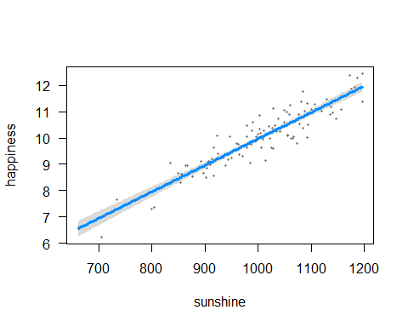

## Discussion

These results confirm that sunshine is good for happiness (slope = 0.0100652).

## Acknowledgements

Y. Xie, J. MacFarlane, Rstudio...