Is the World Bank Financing Bad Governance in Developing Countries?

Raulin L. Cadet

4 octobre 2019

It is well documented that bad governance and corruption adversely affect economic growth and development (Fayissa and [Nsiah](https://muse.jhu.edu/search?action=search&query=author:Christian%20Nsiah:and&min=1&max=10&t=query_term), 2013; Cooray, 2009, [Seldadyo](https://onlinelibrary.wiley.com/action/doSearch?ContribAuthorStored=Seldadyo%2C+Harry) et al., 2007). In this case, aid to development may be ineffective when the governance is bad in beneficiaries’ countries. Indeed, Countries with bad governance may not use efficiently the aid. However, during the recent decades, as underlined by Kaufmann (2009), aid tends to be more sensitive to supporting policy reform in developing countries. Such policies should improve governance and reduce corruption.

In spite that donors are more sensitive to supporting policy reform, it is possible that some beneficiaries do not improve governance, and do continue to apply ineffective economic policies. If donors, such as the World Bank, continue to grant funds to countries with bad governance, their aid is wasting money. To ensure that aid is effective, the decision to grant fund should account for progress improving governance.

The donors, such as the World Bank, usually monitor and evaluate the result of the projects related to funds they granted to developing countries (REF). If we consider the World Bank which is one of the leading advocator of good governance, does it account for the quality of governance when deciding to grant funds to developing countries? The World Bank has published several indicators related to the quality of governance: voice and accountability; political stability and absence of violence/terrorism; government effectiveness; regulatory quality; rule of law; control of corruption. Considering the World Bank, this paper argues that although it is a leading promoter of governance, it does not account for government effectiveness to grant funds to developing countries.

In developing countries with high level of corruption, governance become worst when they receive grants from the World Bank.

Considering a scotter plot, for the same variables, but by region, only the graphic related to Africa reveals that grants tend to increase with high perception of government effectiveness. However, this relation seems to bo weak. Considering East Asia and Pacific, the curve estimating the raltion between grants and government effectiveness is almost flat, showing no relation between them. For the other regions, the relation is not consistent, suggesting that the World Bank is not following a rule related to government effectiveness to grant fund.

The absence of such a rule sould not encourage government of developing countries to improve the effectiveness of public policy.

Let us verify if there is a significant linear relationship between the grants and government effectiveness.

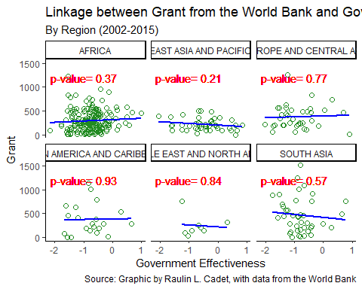

Bibliography

Cooray, Arusha V. (2009).**Government Expenditure, Governance and Economic Growth,** [Comparative Economic Studies](https://link.springer.com/journal/41294), Volume 51, [Issue 3](https://link.springer.com/journal/41294/51/3/page/1), pp 401–418.

Kaufmann, Daniel ( 2009), Aid Effectiveness and Governance The Good, the Bad and the Ugly,

Development Outreach **Volume** 11, **Issue** 1 **Published:** February 2009, **Pages:** 26 – 29.

Fayissa, [Bichaka](https://muse.jhu.edu/search?action=search&query=author:Bichaka%20Fayissa:and&min=1&max=10&t=query_term)  and [Christian Nsiah](https://muse.jhu.edu/search?action=search&query=author:Christian%20Nsiah:and&min=1&max=10&t=query_term) (2013). The impact of governance on economic growth in Africa, [The Journal of Developing Areas](https://muse.jhu.edu/journal/258), [Volume 47, Number 1,](https://muse.jhu.edu/issue/26665) pp. 91-108.

[Seldadyo](https://onlinelibrary.wiley.com/action/doSearch?ContribAuthorStored=Seldadyo%2C+Harry), Harry, [Emmanuel Pandu Nugroho](https://onlinelibrary.wiley.com/action/doSearch?ContribAuthorStored=Nugroho%2C+Emmanuel+Pandu) and [Jakob De Haan](https://onlinelibrary.wiley.com/action/doSearch?ContribAuthorStored=de+Haan%2C+Jakob) (2007). Governance and growth revisited, Kyklos, [Volume60, Issue 2](https://onlinelibrary.wiley.com/toc/14676435/2007/60/2), Pages 279-290.