Customer Tracker Report

This report shows pecentage change by: Total (segment); Total (group); and Week (period).

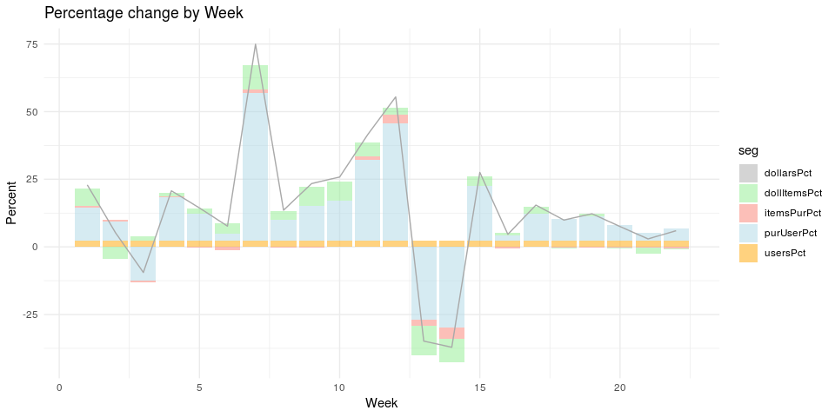

|  |  |  |  |  |  |
| --- | --- | --- | --- | --- | --- |
| week | dollarsPct | usersPct | purUserPct | itemsPurPct | dollItemsPct |
| 1 | 22.93 | 2.38 | 12.06 | 0.78 | 6.33 |
| 2 | 5.35 | 2.38 | 7.07 | 0.50 | -4.37 |
| 3 | -9.46 | 2.38 | -12.38 | -0.71 | 1.66 |
| 4 | 20.74 | 2.38 | 16.03 | 0.43 | 1.22 |
| 5 | 14.41 | 2.38 | 9.99 | -0.30 | 1.90 |
| 6 | 7.68 | 2.38 | 2.38 | -1.13 | 3.91 |
| 7 | 74.93 | 2.38 | 54.48 | 1.42 | 9.06 |
| 8 | 13.57 | 2.38 | 7.59 | -0.19 | 3.29 |
| 9 | 23.41 | 2.38 | 12.89 | -0.12 | 6.91 |
| 10 | 25.82 | 2.38 | 14.61 | -0.02 | 7.25 |
| 11 | 41.49 | 2.38 | 29.96 | 1.01 | 5.28 |
| 12 | 55.46 | 2.38 | 43.22 | 3.25 | 2.68 |
| 13 | -34.84 | 2.38 | -26.92 | -2.39 | -10.77 |
| 14 | -37.11 | 2.38 | -29.73 | -4.40 | -8.57 |
| 15 | 27.55 | 2.38 | 20.15 | 0.04 | 3.66 |
| 16 | 4.65 | 2.38 | 1.97 | -0.71 | 0.97 |
| 17 | 15.47 | 2.38 | 9.80 | 0.00 | 2.73 |
| 18 | 9.91 | 2.38 | 7.81 | -0.37 | -0.05 |
| 19 | 12.25 | 2.38 | 8.83 | -0.28 | 1.03 |
| 20 | 7.53 | 2.38 | 5.67 | -0.39 | -0.22 |
| 21 | 2.95 | 2.38 | 2.98 | -0.38 | -1.98 |
| 22 | 5.98 | 2.38 | 4.33 | -0.63 | -0.15 |