Project 1: Environmental analysis

We did something great here

August 2020

Table of Contents

Summary 1

Data overview 3

Charts 5

Analysis 7

Maps 7

Site maps 9

Collapsible content 10

Conclusion 11

# Heads up!  
  
## Install these packages before running the report  
install.packages(c("devtools","hrbrthemes","tidyverse","DT"))  
  
remotes::install_github("MPCA-data/mpcadb")  
remotes::install_github("MPCA-data/mncolors")  
remotes::install_github("MPCA-data/mpcaej")

# Summary

The goal of this project is to identify the four Pokemon[1] that are polluting the local stream and causing it to glow a beautiful translucent purple on several occasions.

This document was written and created with R Markdown, a flexible text format that provides easy export to a variety of formats such as PDFs, Word docs, PowerPoint, and Web sites.

Here are some Markdown basics to get started writing R Markdown documents:

## Add a link

To add a link in your text use the syntax:

[Click here for MPCA](www.pca.state.mn.us)

The reader will see the following: Click here for MPCA

## Add an image

To insert an image use the syntax:

![Text about my image](link_to_the_image.png)

A large library of MPCA created images and visuals are available on [MPCA’s flickr](https://www.flickr.com/photos/mpcaphotos/albums) site.

* Here’s an example showing an image of a turtle:

![Runaway Turtle](https://live.staticflickr.com/1747/40922837020_5c2d3133e3_w.jpg)

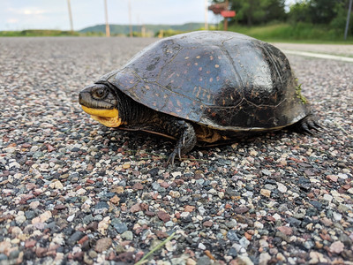

Runaway Turtle

**To change the image’s size**

Add {width = big_number} at the end of the line used to insert the image.

Here’s how to make a tiny turtle by setting the image to only extend 25% across the available space:

![Runaway Turtle](https://live.staticflickr.com/1747/40922837020_5c2d3133e3_w.jpg){width = 25%}



Runaway Turtle

## Add a list

You can add bulleted lists with dashes as below:

- July 12, 2020  
- July 18, 2020  
- July 23, 2020

* July 12, 2020
* July 18, 2020
* July 23, 2020

Or create numbered lists by adding 1. in front of each item.

1. July 12, 2020  
1. July 18, 2020  
1. July 23, 2020

1. July 12, 2020
2. July 18, 2020
3. July 23, 2020

## Add a call-out box

You can create grey call-out boxes for special notes or quotes by adding the right carrot (>) —also known as the greater than sign— in front of text.

Like so:

> **Project details**   
>  
> Where:   
> Who:   
> What:

**Project details**

Where:  
Who:  
What:

More great Markdown features —like adding sortable tables and maps— are shown below.

# Data overview

The table below shows a glimpse of the results. You can add a caption to your table by adding caption="My caption" to the kable() function as below.

knitr::kable(head(mtcars), caption = '**TABLE 1.** A subset of mtcars.')

**TABLE 1.** A subset of mtcars.

|  |  |  |  |  |  |  |  |  |  |  |  |
| --- | --- | --- | --- | --- | --- | --- | --- | --- | --- | --- | --- |
|  | mpg | cyl | disp | hp | drat | wt | qsec | vs | am | gear | carb |
| Mazda RX4 | 21.0 | 6 | 160 | 110 | 3.90 | 2.620 | 16.46 | 0 | 1 | 4 | 4 |
| Mazda RX4 Wag | 21.0 | 6 | 160 | 110 | 3.90 | 2.875 | 17.02 | 0 | 1 | 4 | 4 |
| Datsun 710 | 22.8 | 4 | 108 | 93 | 3.85 | 2.320 | 18.61 | 1 | 1 | 4 | 1 |
| Hornet 4 Drive | 21.4 | 6 | 258 | 110 | 3.08 | 3.215 | 19.44 | 1 | 0 | 3 | 1 |
| Hornet Sportabout | 18.7 | 8 | 360 | 175 | 3.15 | 3.440 | 17.02 | 0 | 0 | 3 | 2 |
| Valiant | 18.1 | 6 | 225 | 105 | 2.76 | 3.460 | 20.22 | 1 | 0 | 3 | 1 |

## Data sources

The data were downloaded from the following online resources:

1. US EPA
2. MN GEO Commons
3. TEMPO

library(tidyverse)  
  
# Download data  
data <- read_csv("")

## DELTA is where data lives

Explore all the data available in MPCA’s DELTA database with the [RAINIER documentation](http://rainier/documentation/DataDictionary/DELTAW/index.html) pages.

## Data dictionary

**A raw Markdown table**

|  |  |  |
| --- | --- | --- |
| Column | Description | Example value |
| geoid | Unique ID assigned to each Pokemon. | *2430262* |
| lat | Latitude coordinate of object’s center. | *-94.021* |
| lon | Longitude coordinate of object’s center. | *44.521* |

## Data glimpse

For this project, facilities were pulled from MPCA’s TEMPO database.  
You can use the mpcadb package to access TEMPO from R.

library(mpcadb) #remotes::install_github("MPCA-data/mpcadb")  
  
## TEMPO AI's  
# Get a subset of AI names with get_ai()  
ai_names <- get_ai(ai = c(420, 564, 878), keep_alt_names = F)

We use the DT package to create scrollable, searchable, interactive web tables. The default for DT tables is to extend the full width of the page.

library(DT)  
library(dplyr)  
  
# Keep the alternative name columns  
ai_names <- get_ai(ai = c(420, 564, 878),   
 keep_alt_names = T)  
  
# Drop underscores from column names  
names(ai_names) <- names(ai_names) %>%   
 gsub("_", " ", .)  
  
# Scrolly pretty table  
DT::datatable(ai_names,   
 caption = 'TABLE 2. Selected facilities.',  
 rownames = F,  
 options = list(pageLength = 4,   
 scrollX = T,   
 dom = 'ftip'))

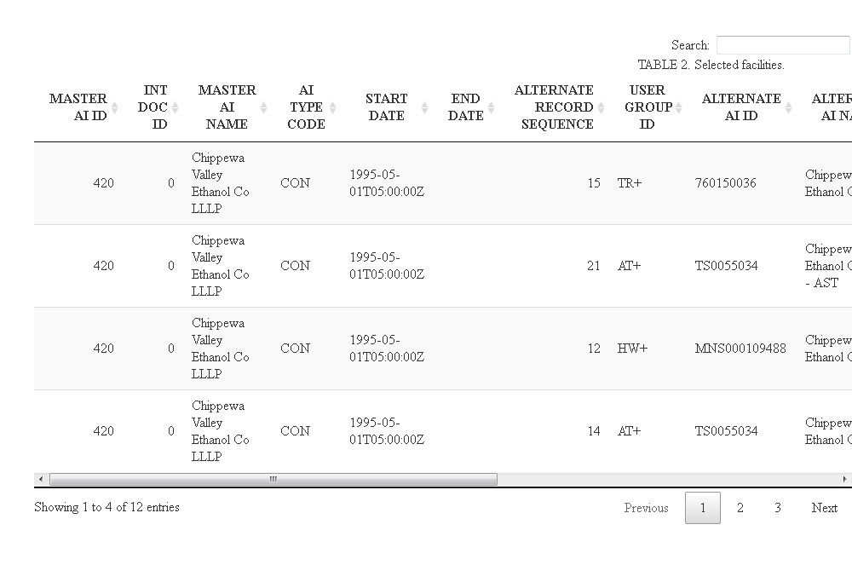

## *(help)* Access spatial data from MN’s GIS Rest API

## *(help)* Read data from: PDF’s, Excel, Access

# Charts

To place figures in the margin you can use the **knitr** chunk option fig.margin=TRUE.

Here’s an example using a fuel efficiency chart:

{r fig-margin, fig.margin=TRUE, fig.cap="MPG vs Horsepower, colored by transmission."}

library(ggplot2)  
library(mncolors) #remotes::install_github("MPCA-data/mncolors")  
  
mtcars <- mtcars  
  
mtcars$Transmission <- factor(mtcars$am,   
 labels = c('automatic',   
 'manual'))  
  
ggplot(mtcars, aes(hp, mpg, color = Transmission)) +  
 geom_point() +   
 geom_smooth() +  
 scale_color_mn(palette = "accent", reverse = T) +  
 theme(legend.position = 'top')

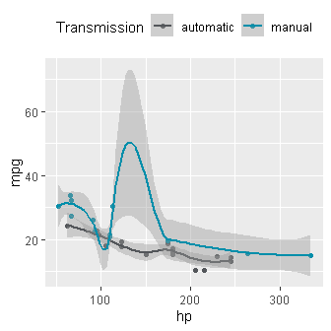

**FIG 1.** MPG vs horsepower, colored by transmission.

## MN Colors

Here’s one way to set the colors for your plots to align with the MN state brand.

library(mncolors) #remotes::install_github("MPCA-data/mncolors")   
library(ggplot2)  
library(hrbrthemes)  
  
ggplot(diamonds, aes(carat, price)) +  
 geom_smooth(aes(color = cut), size = 1.5, show.legend = F) +  
 scale_color_mn(palette = "green") +  
 facet_wrap(vars(cut), nrow = 1) +  
 labs(title = "Increasing cost of cleanups",  
 subtitle = "Brownfield site classifications",  
 caption = "Source: EPA Data Mart 2018",  
 x = "Site score") +  
 scale_y_comma() +  
 theme_ipsum_rc() +  
 theme(plot.title = element_text(color = mncolors(5, "blue")[5]),  
 plot.caption = element_text(color = mncolors(5, "blue")[2],   
 face = 'bold'))

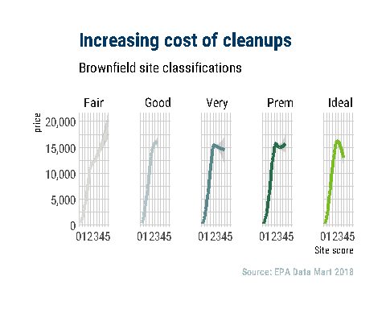

# Analysis

for $x$ in $[a, b]$:  
$$\frac{d}{dx}\left( \int_{a}^{x} f(u)\,du\right)=f(x)$$

We used the equation on the right to scale the Pokemon contribution to its relative size and spatial distribution in the watershed.

To set figures to span the entire page use the {r} chunk option fig.fullwidth = TRUE.

ggplot(diamonds, aes(carat, price)) +   
 geom_smooth() +  
 facet_grid(~ cut)

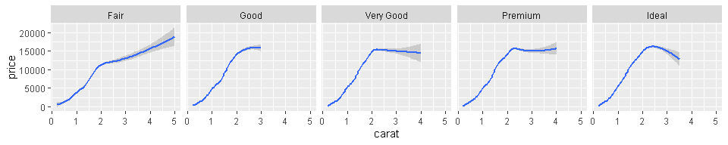

**FIG 2.** A full width figure.

## *(help)* Non-detect and Censored data summaries

## *(help)* Multivariate predictions

# Maps

Leaflet maps are an easy way to add interactive maps to your report. Here’s an example displaying the polygon shapefile of tribal nations located across MN.

<br>  
<br>  
   
Find shapefiles and spatial data in the [MN GEOCOMMONS](https://gisdata.mn.gov/).

library(mpcaej) #remotes::install_github("MPCA-data/mpcaej")  
library(leaflet)  
library(sf)  
library(tidyverse)  
  
ej_shapes <- ej_shapes  
  
tribal_areas <- tribe_shapes  
  
#------ Map the polygons ---------#  
leaflet(st_transform(tribal_areas, 4326)) %>%  
 addProviderTiles(providers$Stamen.TonerLines,  
 options = providerTileOptions) %>%  
 addProviderTiles(providers$CartoDB.Voyager,  
 options = providerTileOptions(opacity = 0.8)) %>%  
 addPolygons(color = "purple",  
 weight = 1,  
 smoothFactor = 1.4,  
 opacity = 0.9,  
 fillOpacity = 0.2)

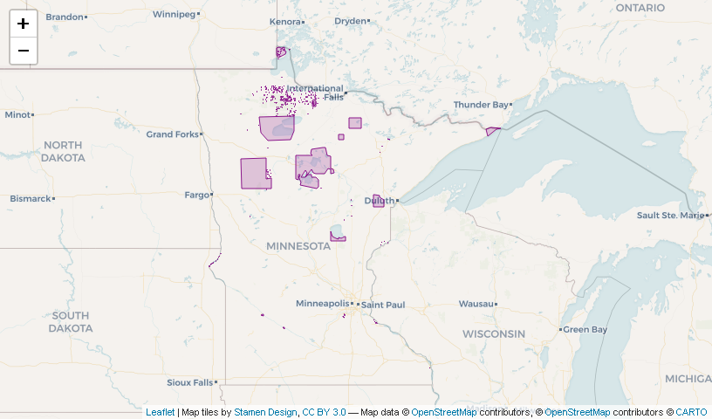

*Ref. MPCA Geocommons 2020-10-10*

# Site maps

**Map markers**  
This is a map of the project monitoring sites dispersed around St. Paul.

sites <- read_csv('https://raw.githubusercontent.com/MPCA-air/aqi-watch/master/data-raw/locations.csv')  
  
sites <- filter(sites, str_detect(`Site Name`, "Paul"))  
  
# Add Markers and popup info  
leaflet(sites) %>%  
 addProviderTiles(providers$CartoDB) %>%  
 addMarkers(popup = ~`Site Name`)

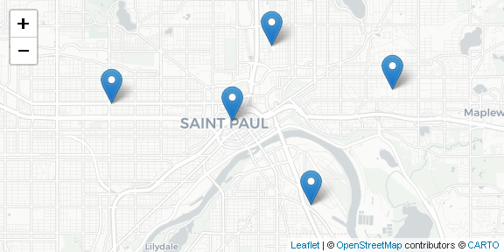

**Circle markers**  
The circles show the monitoring range of the monitors.

# Add Darkness  
leaflet(sites) %>%  
 addProviderTiles(providers$CartoDB) %>%  
 addCircleMarkers(label = ~`Site Name`)

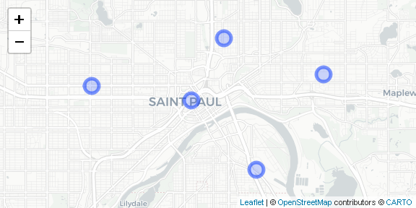

**Labeling a single site**

As you can see, the site highlighted below has elevated levels of Pokemon.

# Add Darkness  
leaflet(sites) %>%  
 addProviderTiles(providers$CartoDB.DarkMatter) %>%  
 addCircleMarkers(label = ~`Site Name`) %>%  
 addCircleMarkers(data = sites[3, ],  
 color = "hotpink",  
 radius = 15,  
 label = ~`Site Name`,  
 labelOptions = labelOptions(noHide = T,   
 textsize = "15px"))

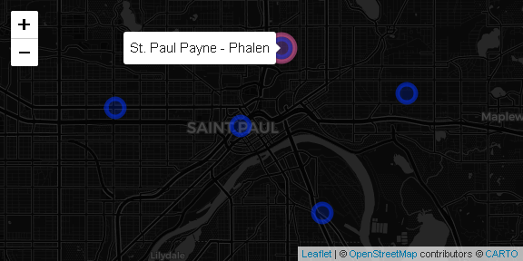

# Conclusion

You can add quotes or highlight some text with the tint::quote_footer() function.

*I can win an argument on any topic, against any opponent. People know this, and steer clear of me at parties. Often, as a sign of their great respect, they don’t even invite me.*

— Dave Barry

## References

2012, A

* kjhkjlj

2015, B

kljlkjlj

* 2018, C

1. Pokemon are a new invasive species in MN. See [Pokemen explosion in MN](https://en.wikipedia.org/wiki/Pok%C3%A9mon).