1.3 Basic SQL Queries

Step1 : Creating a school database

Step2: Creating a student table in school database

create table student

(

name varchar(20),

class varchar(20),

address varchar(20),

email varchar(20)

)

Step3: Using INSERT to add data

insert into student (name, class, address, email) values ('Tom', '7a', 'kadapa', 'tom@email.com');

insert into student (name, class, address, email) values ('Thomas', '7a', 'tirupati', 'thomas@email.com');

insert into student (name, class, address, email) values ('Manuel', '7a', 'delhi', 'manuelm@email.com');

Step 4:Using SELECT to view the data

select * from student;

select name from student;

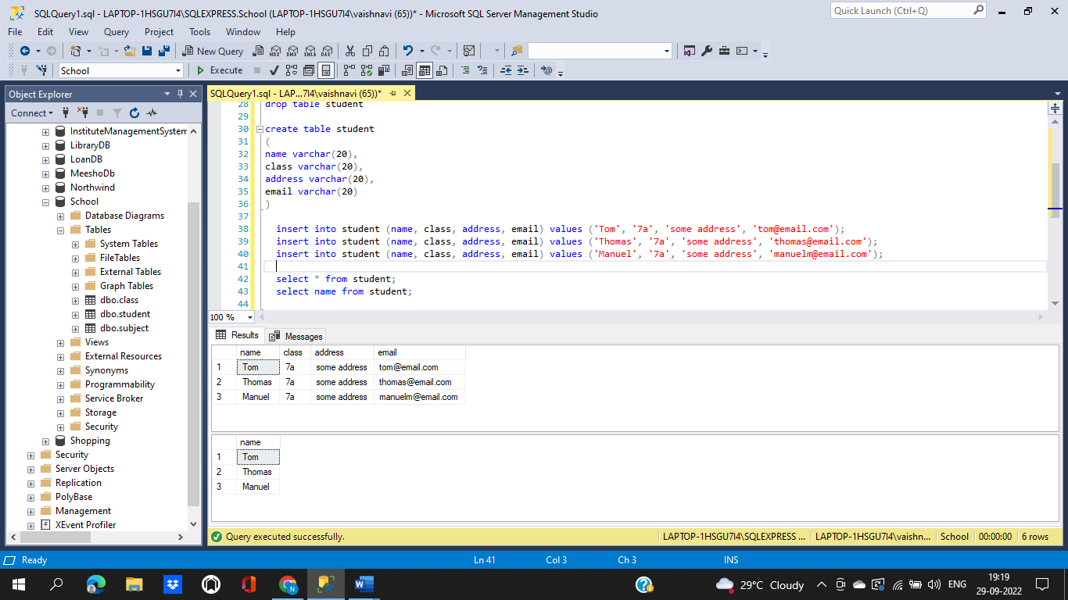

Step 5:Using UPDATE to update data

update student set class = '8a';

update student set name = 'Tom Clancy' where name = 'Tom';

Step 6: Using DELETE to delete data

delete from student where name = 'Tom Clancy'

delete from student

Step 7: Using filter and sorting for displaying data

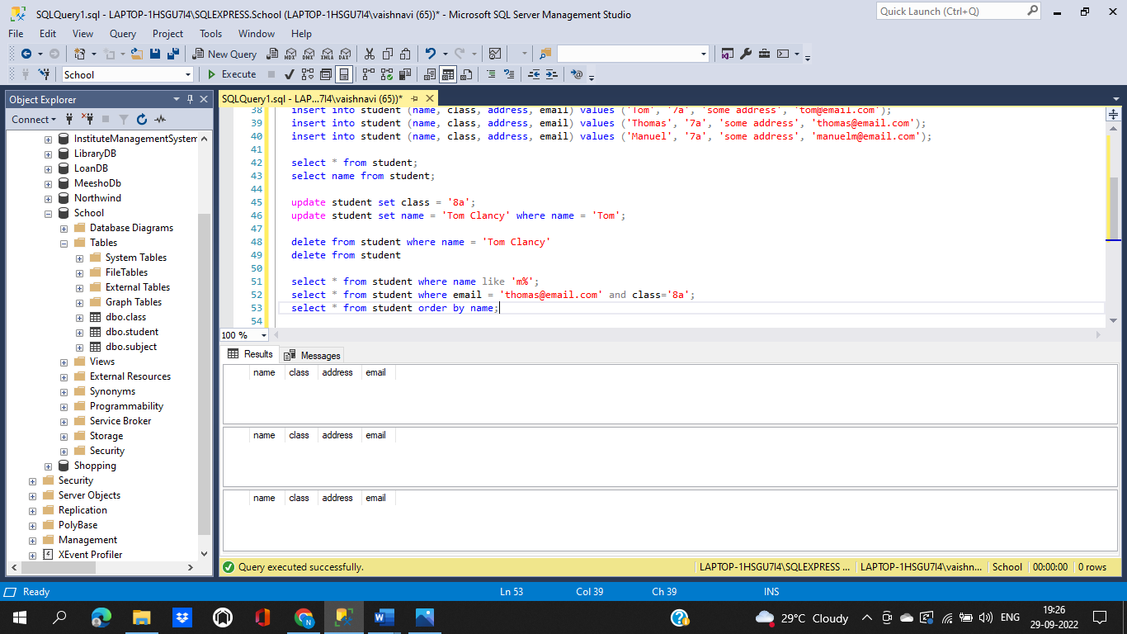

Step 8: Using variables in queries

declare @namevalue as varchar(100)

set @namevalue = 'Mitchell'

use school

select * from student where name = @namevalue

Step9: Pushing the code to your GitHub repository

* Open your command prompt and navigate to the folder where you have created your files.

**cd <folder path>**

* Initialize your repository using the following command:

**git init**

* Add all the files to your Git repository using the following command:

**git add .**

* Commit the changes using the following command:

**git commit . -m “Changes have been committed.”**

* Push the files to the folder you initially created using the following command:

**git push -u origin master**