1.2 Create Database and Tables

Step1: Creating a database “School”

create database School

Step2: Creating the Student class and Subject tables in the school database.

use school

create table student

(

studid int primary key,

studname varchar(20),

studclass int

)

create table subject

(

subid int primary key,

subname varchar(20)

)

create table class

(

classno int primary key,

classname varchar(20)

)

Select * from student

Select * from class

Select * from subject

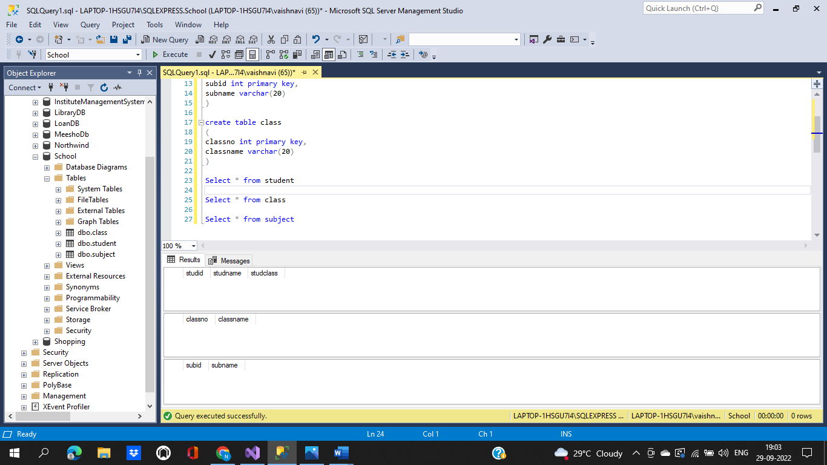

**Step 1.2.3:** Push the code to your GitHub repository

* Open your command prompt and navigate to the folder where you have created your files.

**cd <folder path>**

* Initialize your repository using the following command:

**git init**

* Add all the files to your Git repository using the following command:

**git add .**

* Commit the changes using the following command:

**git commit . -m “Changes have been committed.”**

* Push the files to the folder you initially created using the following command:

**git push -u origin master**