**Create a School Database**

Github link : : <https://github.com/KarakambadiNaveena/SimplilearnProjects.git>

Step1: Creating a database “School”

create database School

Step2: Creating the Student class and Subject tables in the school database.

use School

create table Class

(

classno int primary key

)

create table student

(

studid int primary key,

studname varchar(20)

)

create table subject

(

subid int primary key,

subname varchar(20)

)

alter table subject

add classno int constraint fk_cfk foreign key references class(classno)

alter table class

add studid int constraint fk_sfk foreign key references student(studid)

alter table class

add subid int constraint fk_stfk foreign key references subject(subid)

alter table student

add subid int constraint fk_tfk foreign key references subject(subid)

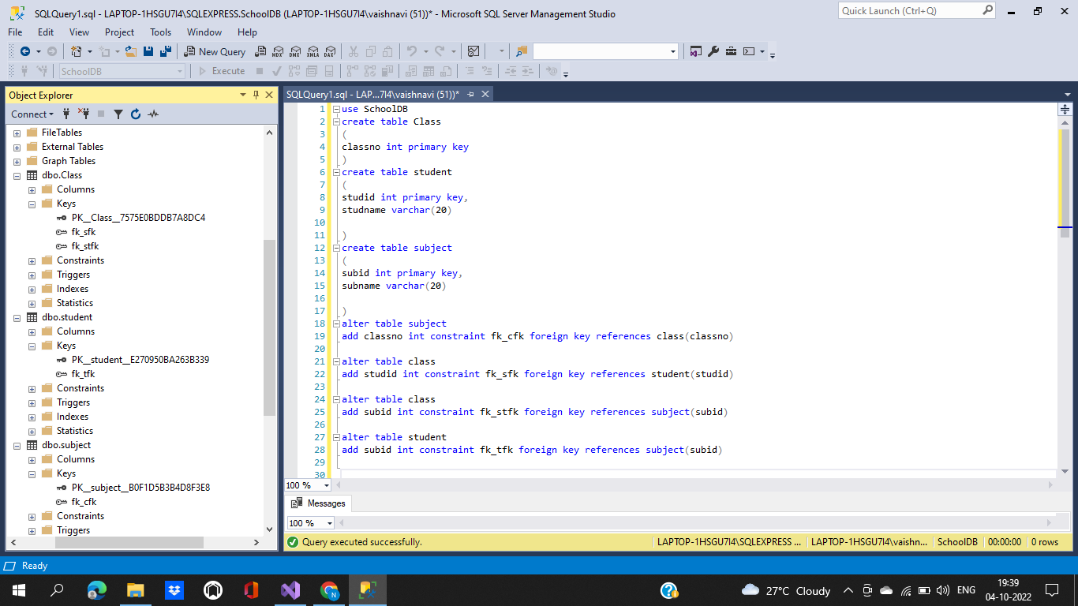

**Step 3:** Push the code to your GitHub repository

* Open your command prompt and navigate to the folder where you have created your files.

**cd <folder path>**

* Initialize your repository using the following command:

**git init**

* Add all the files to your Git repository using the following command:

**git add .**

* Commit the changes using the following command:

**git commit . -m “Changes have been committed.”**

* Push the files to the folder you initially created using the following command:

**git push -u origin master**