**1.15.Retrieve Student Data from a Text File with the Option of Sorting and Searching.**

Github link : <https://github.com/KarakambadiNaveena/SimplilearnProjects.git>

**Step 1**: Creating a Simple text file externally using Notepad pre-popoluated with the Student data and naming it as “search.txt”.

**Step 2**: Creating a Windows Console project in Visual Studio to display the student data.

1. Open Visual Studio.
2. From the top menu select **File->New->Project.**
3. In **Create A New Project** Screen, select **Console app (.NET Core)** from the list of available project types and click on **Next.**
4. Enter **Project Name** as PP1.6 and click on **Create.**
5. This will create the files for a Windows Console Project.

**Step 3**: Select the program.cs as the current tab and enter the code for searching and sorting the student data.

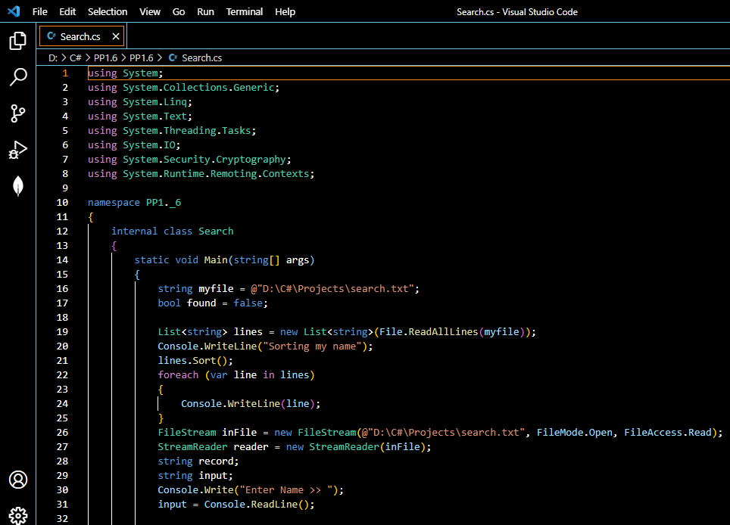

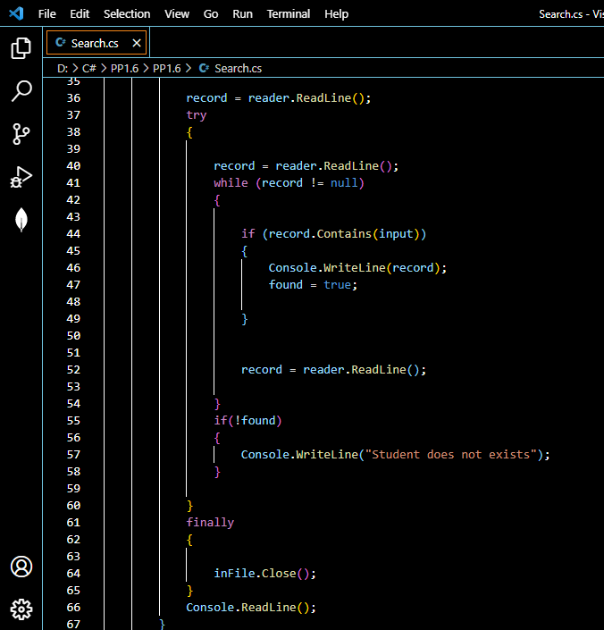

**Step 4:** Building the project

* From the top menu choose **Build->Build Solution.**
* If any compile errors are shown, fix them as required.

**Step 5:** Publishing and running the project

* From the top menu select **Debug->Start Without Debugging.**
* This will execute the program in a console window.

**Step 6:** Pushing the code to your GitHub repositories

Open your command prompt and navigate to the folder where you have created your files.

cd <folder path>

Initialize your repository using the following command:

git init

Add all the files to your git repository using the following command:

git add .

Commit the changes using the following command:

git commit -m “Changes have been committed.”

Push the files to the folder you created initially using the following command:

git push -u origin master