**1.4.Create and Deploy Files to GitHub via Git**

**Github Link:** : <https://github.com/KarakambadiNaveena/SimplilearnProjects.git>

**Step1:** Creating a repository in your GitHub account.

1. Go to the homepage of GitHub.com and click on **New Repository**

2. Enter the name file and click on **Create repository** as shown in the example screenshot below.

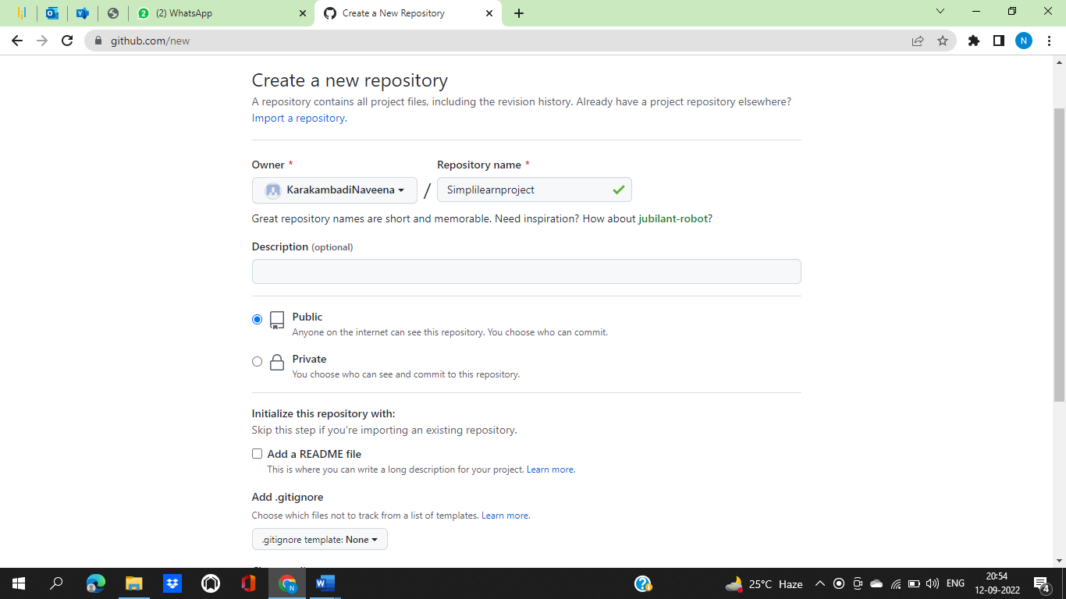

**Step 2:** Choosing an Angular application to push into the Git Repository.

**Step 3:** Pushing the code to your GitHub repository

1.Open your command prompt and navigate to the folder where you have created your files.

cd <folder path>

2.Initialize your repository using the following command:

git init

3.Add all the files to your git repository using the following command:

git add .

4.Commit the changes using the following command:

git commit -m “Uploadingproject.”

5.Push the files to the folder you created initially using the following command:

git push -u origin main

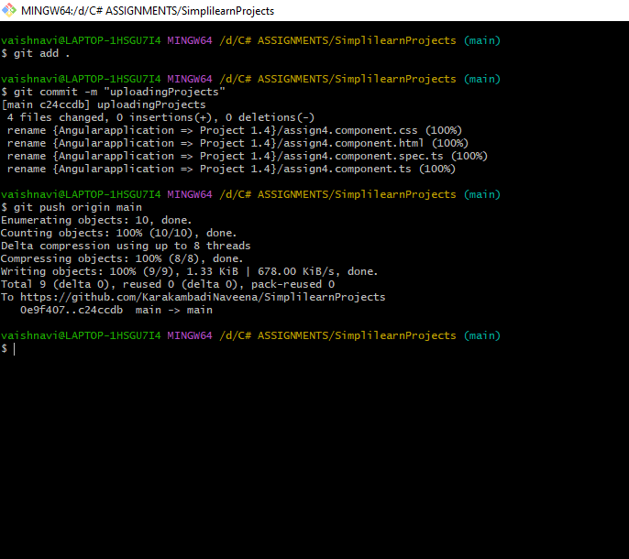

**Step 4:**  Uploaded files on the Github repository as shown below.

