**ASSIGNMENTS**

**Assignment 1:**

$ git config --global --list

$ ls -al

vaishnavi@LAPTOP-1HSGU7I4 MINGW64 /d/Assignments/GitDemo (main)

$ echo "Creating new text file">>sam.txt

vaishnavi@LAPTOP-1HSGU7I4 MINGW64 /d/Assignments/GitDemo (main)

$ ls -al

total 14

drwxr-xr-x 1 vaishnavi 197121 0 Aug 20 22:18 ./

drwxr-xr-x 1 vaishnavi 197121 0 Aug 20 18:37 ../

drwxr-xr-x 1 vaishnavi 197121 0 Aug 20 21:35 .git/

-rw-r--r-- 1 vaishnavi 197121 20 Aug 20 18:48 .gitignore

-rw-r--r-- 1 vaishnavi 197121 31 Aug 20 19:38 hello.txt

-rw-r--r-- 1 vaishnavi 197121 82 Aug 20 21:29 hello.xml

-rw-r--r-- 1 vaishnavi 197121 0 Aug 20 18:50 hi.txt

-rw-r--r-- 1 vaishnavi 197121 23 Aug 20 22:18 sam.txt

-rw-r--r-- 1 vaishnavi 197121 19 Aug 20 18:52 sample.log

-rw-r--r-- 1 vaishnavi 197121 32 Aug 20 18:37 welcome.txt

vaishnavi@LAPTOP-1HSGU7I4 MINGW64 /d/Assignments/GitDemo (main)

$ cat sam.txt

Creating new text file

vaishnavi@LAPTOP-1HSGU7I4 MINGW64 /d/Assignments/GitDemo (main)

$ git status

On branch main

Your branch is up to date with 'origin/main'.

Untracked files:

(use "git add <file>..." to include in what will be committed)

sam.txt

nothing added to commit but untracked files present (use "git add" to track)

vaishnavi@LAPTOP-1HSGU7I4 MINGW64 /d/Assignments/GitDemo (main)

$ git add .

warning: in the working copy of 'sam.txt', LF will be replaced by CRLF the next time Git touches it

vaishnavi@LAPTOP-1HSGU7I4 MINGW64 /d/Assignments/GitDemo (main)

$ git commit -m "firstcommit"

[main 389ec3c] firstcommit

1 file changed, 1 insertion(+)

create mode 100644 sam.txt

vaishnavi@LAPTOP-1HSGU7I4 MINGW64 /d/Assignments/GitDemo (main)

$ git push origin main

Enumerating objects: 4, done.

Counting objects: 100% (4/4), done.

Delta compression using up to 8 threads

Compressing objects: 100% (2/2), done.

Writing objects: 100% (3/3), 294 bytes | 294.00 KiB/s, done.

Total 3 (delta 1), reused 0 (delta 0), pack-reused 0

remote: Resolving deltas: 100% (1/1), completed with 1 local object.

To https://github.com/KarakambadiNaveena/GitDemo

d862a28..389ec3c main -> main

vaishnavi@LAPTOP-1HSGU7I4 MINGW64 /d/Assignments/GitDemo (main)

$ git pull origin main

From https://github.com/KarakambadiNaveena/GitDemo

* branch main -> FETCH_HEAD

Already up to date.

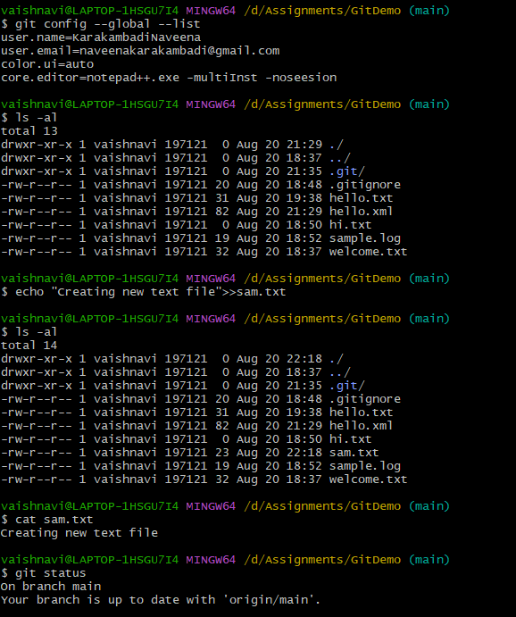

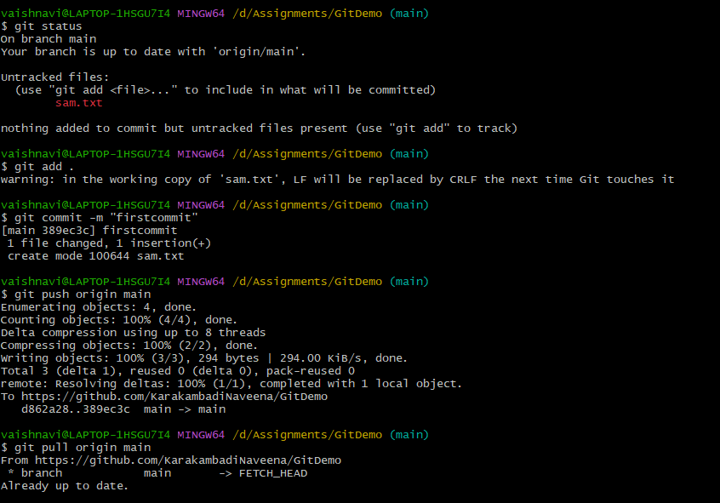

ASSIGNMENT -2

vaishnavi@LAPTOP-1HSGU7I4 MINGW64 /d/Assignments/GitDemo (main)

$ touch .gitignore

vaishnavi@LAPTOP-1HSGU7I4 MINGW64 /d/Assignments/GitDemo (main)

$ cat .gitignore

vaishnavi@LAPTOP-1HSGU7I4 MINGW64 /d/Assignments/GitDemo (main)

$ cat .gitignore

*.log

/new folder/*

vaishnavi@LAPTOP-1HSGU7I4 MINGW64 /d/Assignments/GitDemo (main)

$ git add .

vaishnavi@LAPTOP-1HSGU7I4 MINGW64 /d/Assignments/GitDemo (main)

$ git status

On branch main

Your branch is up to date with 'origin/main'.

Changes to be committed:

(use "git restore --staged <file>..." to unstage)

new file: .gitignore

vaishnavi@LAPTOP-1HSGU7I4 MINGW64 /d/Assignments/GitDemo (main)

$ touch sample.log

vaishnavi@LAPTOP-1HSGU7I4 MINGW64 /d/Assignments/GitDemo (main)

$ cat sample.log

vaishnavi@LAPTOP-1HSGU7I4 MINGW64 /d/Assignments/GitDemo (main)

$ git add .

vaishnavi@LAPTOP-1HSGU7I4 MINGW64 /d/Assignments/GitDemo (main)

$ touch hi.txt

vaishnavi@LAPTOP-1HSGU7I4 MINGW64 /d/Assignments/GitDemo (main)

$ git add .

vaishnavi@LAPTOP-1HSGU7I4 MINGW64 /d/Assignments/GitDemo (main)

$ git commit -m "gitignore"

[main 0cdbec1] gitignore

2 files changed, 2 insertions(+)

create mode 100644 .gitignore

create mode 100644 hi.txt

vaishnavi@LAPTOP-1HSGU7I4 MINGW64 /d/Assignments/GitDemo (main)

$ git push origin main

Enumerating objects: 5, done.

Counting objects: 100% (5/5), done.

Delta compression using up to 8 threads

Compressing objects: 100% (2/2), done.

Writing objects: 100% (4/4), 339 bytes | 339.00 KiB/s, done.

Total 4 (delta 0), reused 0 (delta 0), pack-reused 0

To https://github.com/KarakambadiNaveena/GitDemo

f2eaf18..0cdbec1 main -> main

vaishnavi@LAPTOP-1HSGU7I4 MINGW64 /d/Assignments/GitDemo (main)

$ echo "this is an example">>sample.log

vaishnavi@LAPTOP-1HSGU7I4 MINGW64 /d/Assignments/GitDemo (main)

$ cat sample.log

this is an example

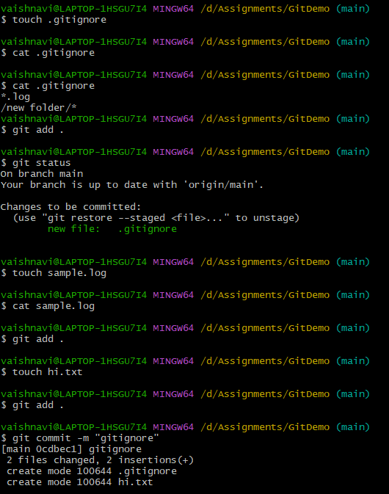

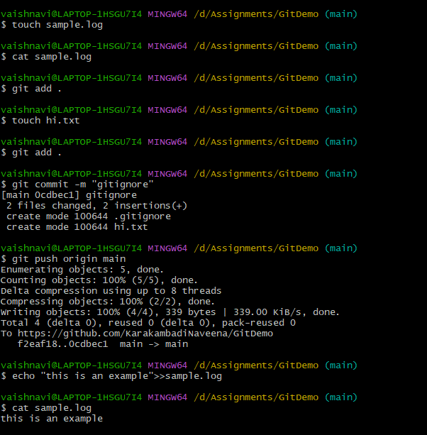

ASSIGNMENT 3

vaishnavi@LAPTOP-1HSGU7I4 MINGW64 /d/Assignments/GitDemo (main)

$ git branch

* main

vaishnavi@LAPTOP-1HSGU7I4 MINGW64 /d/Assignments/GitDemo (main)

$ git branch branch1

vaishnavi@LAPTOP-1HSGU7I4 MINGW64 /d/Assignments/GitDemo (main)

$ git branch

branch1

* main

vaishnavi@LAPTOP-1HSGU7I4 MINGW64 /d/Assignments/GitDemo (main)

$ git checkout branch1

Switched to branch 'branch1'

vaishnavi@LAPTOP-1HSGU7I4 MINGW64 /d/Assignments/GitDemo (branch1)

$ touch hello.txt

vaishnavi@LAPTOP-1HSGU7I4 MINGW64 /d/Assignments/GitDemo (branch1)

$ echo "Adding file to the new branch">>hello.txt

vaishnavi@LAPTOP-1HSGU7I4 MINGW64 /d/Assignments/GitDemo (branch1)

$ git add .

warning: in the working copy of 'hello.txt', LF will be replaced by CRLF the next time Git touches it

vaishnavi@LAPTOP-1HSGU7I4 MINGW64 /d/Assignments/GitDemo (branch1)

$ git commit -m "newcommit"

[branch1 aa3780f] newcommit

1 file changed, 1 insertion(+)

create mode 100644 hello.txt

vaishnavi@LAPTOP-1HSGU7I4 MINGW64 /d/Assignments/GitDemo (branch1)

$ git status

On branch branch1

nothing to commit, working tree clean

vaishnavi@LAPTOP-1HSGU7I4 MINGW64 /d/Assignments/GitDemo (branch1)

$ git push origin branch1

Enumerating objects: 4, done.

Counting objects: 100% (4/4), done.

Delta compression using up to 8 threads

Compressing objects: 100% (2/2), done.

Writing objects: 100% (3/3), 370 bytes | 370.00 KiB/s, done.

Total 3 (delta 0), reused 0 (delta 0), pack-reused 0

remote:

remote: Create a pull request for 'branch1' on GitHub by visiting:

remote: https://github.com/KarakambadiNaveena/GitDemo/pull/new/branch1

remote:

To https://github.com/KarakambadiNaveena/GitDemo

* [new branch] branch1 -> branch1

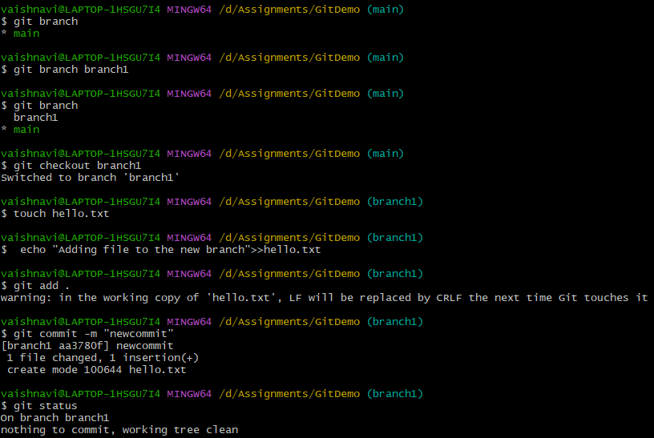

**MERGING:**

vaishnavi@LAPTOP-1HSGU7I4 MINGW64 /d/Assignments/GitDemo (main)

$ git log --oneline --graph --decorate

* 0cdbec1 (HEAD -> main, origin/main, origin/HEAD) gitignore

* f2eaf18 First commit

vaishnavi@LAPTOP-1HSGU7I4 MINGW64 /d/Assignments/GitDemo (main)

$ git checkout branch1

Switched to branch 'branch1'

vaishnavi@LAPTOP-1HSGU7I4 MINGW64 /d/Assignments/GitDemo (branch1)

$ git log --oneline --graph --decorate

* aa3780f (HEAD -> branch1, origin/branch1) newcommit

* 0cdbec1 (origin/main, origin/HEAD, main) gitignore

* f2eaf18 First commit

vaishnavi@LAPTOP-1HSGU7I4 MINGW64 /d/Assignments/GitDemo (branch1)

$ git checkout main

Switched to branch 'main'

Your branch is up to date with 'origin/main'.

vaishnavi@LAPTOP-1HSGU7I4 MINGW64 /d/Assignments/GitDemo (main)

$ git merge branch1

Updating 0cdbec1..aa3780f

Fast-forward

hello.txt | 1 +

1 file changed, 1 insertion(+)

create mode 100644 hello.txt

vaishnavi@LAPTOP-1HSGU7I4 MINGW64 /d/Assignments/GitDemo (main)

$ git log --oneline --graph --decorate

* aa3780f (HEAD -> main, origin/branch1, branch1) newcommit

* 0cdbec1 (origin/main, origin/HEAD) gitignore

* f2eaf18 First commit

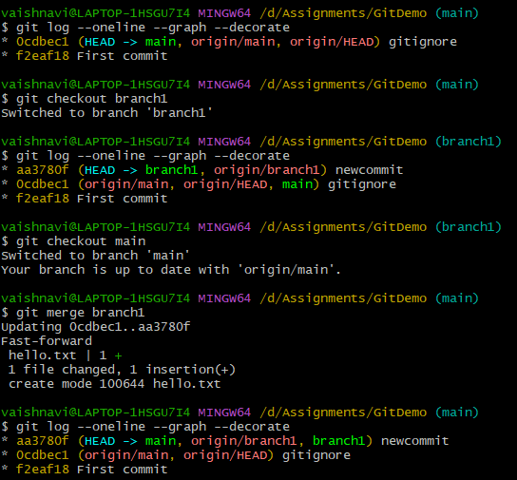

==========================================================================

**DELETING:**

vaishnavi@LAPTOP-1HSGU7I4 MINGW64 /d/Assignments/GitDemo (main)

$ git branch -d branch1

Deleted branch branch1 (was aa3780f).

vaishnavi@LAPTOP-1HSGU7I4 MINGW64 /d/Assignments/GitDemo (main)

$ git push origin --delete branch1

To https://github.com/KarakambadiNaveena/GitDemo

- [deleted] branch1

vaishnavi@LAPTOP-1HSGU7I4 MINGW64 /d/Assignments/GitDemo (main)

$ git add .

vaishnavi@LAPTOP-1HSGU7I4 MINGW64 /d/Assignments/GitDemo (main)

$ git commit -m "deleting branch"

On branch main

Your branch is up to date with 'origin/main'.

nothing to commit, working tree clean

vaishnavi@LAPTOP-1HSGU7I4 MINGW64 /d/Assignments/GitDemo (main)

$ git push origin main

Everything up-to-date

vaishnavi@LAPTOP-1HSGU7I4 MINGW64 /d/Assignments/GitDemo (main)

$ git status

On branch main

Your branch is up to date with 'origin/main'.

nothing to commit, working tree clean

vaishnavi@LAPTOP-1HSGU7I4 MINGW64 /d/Assignments/GitDemo (main)

$ git branch

* main

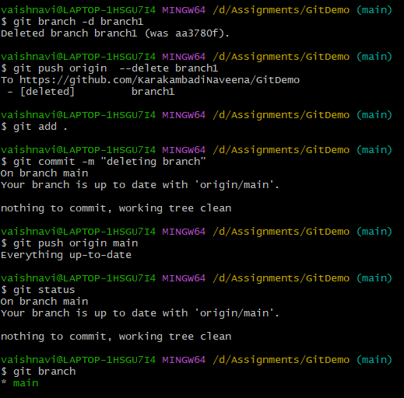

**ASSIGNMENT 4:**

vaishnavi@LAPTOP-1HSGU7I4 MINGW64 /d/Assignments/GitDemo (main)

$ git status

On branch main

Your branch is up to date with 'origin/main'.

nothing to commit, working tree clean

vaishnavi@LAPTOP-1HSGU7I4 MINGW64 /d/Assignments/GitDemo (main)

$ git branch gitWork

vaishnavi@LAPTOP-1HSGU7I4 MINGW64 /d/Assignments/GitDemo (main)

$ git checkout gitWork

Switched to branch 'gitWork'

vaishnavi@LAPTOP-1HSGU7I4 MINGW64 /d/Assignments/GitDemo (gitWork)

$ touch hello.xml

vaishnavi@LAPTOP-1HSGU7I4 MINGW64 /d/Assignments/GitDemo (gitWork)

$ git add .

vaishnavi@LAPTOP-1HSGU7I4 MINGW64 /d/Assignments/GitDemo (gitWork)

$ cat hello.xml

<movie>

<writer>Rajamouli</writer>

<hero>Prabhas</hero>

<heroine>Anushka</heroine>

</movie>

vaishnavi@LAPTOP-1HSGU7I4 MINGW64 /d/Assignments/GitDemo (gitWork)

$ git status

On branch gitWork

Changes to be committed:

(use "git restore --staged <file>..." to unstage)

new file: hello.xml

Changes not staged for commit:

(use "git add <file>..." to update what will be committed)

(use "git restore <file>..." to discard changes in working directory)

modified: hello.xml

vaishnavi@LAPTOP-1HSGU7I4 MINGW64 /d/Assignments/GitDemo (gitWork)

$ git commit -m "committing from main"

[gitWork 63e3e0f] committing from main

1 file changed, 0 insertions(+), 0 deletions(-)

create mode 100644 hello.xml

vaishnavi@LAPTOP-1HSGU7I4 MINGW64 /d/Assignments/GitDemo (gitWork)

$ git checkout main

Switched to branch 'main'

Your branch is up to date with 'origin/main'.

vaishnavi@LAPTOP-1HSGU7I4 MINGW64 /d/Assignments/GitDemo (main)

$ touch hello.xml

vaishnavi@LAPTOP-1HSGU7I4 MINGW64 /d/Assignments/GitDemo (main)

$ cat hello.xml

<biodata>

<name>Naveena</name>

<surname>sam</surname>

<age>21</age>

</biodata>

vaishnavi@LAPTOP-1HSGU7I4 MINGW64 /d/Assignments/GitDemo (main)

$ git commit -m "from main branch"

On branch main

Your branch is up to date with 'origin/main'.

Untracked files:

(use "git add <file>..." to include in what will be committed)

hello.xml

nothing added to commit but untracked files present (use "git add" to track)

vaishnavi@LAPTOP-1HSGU7I4 MINGW64 /d/Assignments/GitDemo (main)

$ git add .

vaishnavi@LAPTOP-1HSGU7I4 MINGW64 /d/Assignments/GitDemo (main)

$ git commit -m "committing from main branch"

[main d862a28] committing from main branch

1 file changed, 5 insertions(+)

create mode 100644 hello.xml

vaishnavi@LAPTOP-1HSGU7I4 MINGW64 /d/Assignments/GitDemo (main)

$ git log --oneline --graph --decorate

* d862a28 (HEAD -> main) committing from main branch

* 3d83e1b (origin/main, origin/HEAD) commit

* 22f8903 from main branch

* aa3780f newcommit

* 0cdbec1 gitignore

* f2eaf18 First commit

vaishnavi@LAPTOP-1HSGU7I4 MINGW64 /d/Assignments/GitDemo (main)

$ git log --oneline --graph --decorate --all

* d862a28 (HEAD -> main) committing from main branch

* 3d83e1b (origin/main, origin/HEAD) commit

* 22f8903 from main branch

| * a9dd748 (origin/gitWork, gitWork) commit

| * 63e3e0f committing from main

| * 57b0617 commit

| * 6b6c8c1 latestcommit

| * 9fc099e committing

|/

* aa3780f newcommit

* 0cdbec1 gitignore

* f2eaf18 First commit

vaishnavi@LAPTOP-1HSGU7I4 MINGW64 /d/Assignments/GitDemo (gitWork)

$ git diff gitWork main

diff --git a/hello.xml b/hello.xml

index db07fb0..7ce012f 100644

--- a/hello.xml

+++ b/hello.xml

@@ -1,5 +1,5 @@

-<movie>

-<writer>Rajamouli</writer>

-<hero>Prabhas</hero>

-<heroine>Anushka</heroine>

-</movie>

\ No newline at end of file

+<biodata>

+<name>Naveena</name>

+<surname>sam</surname>

+<age>21</age>

+</biodata>

\ No newline at end of file

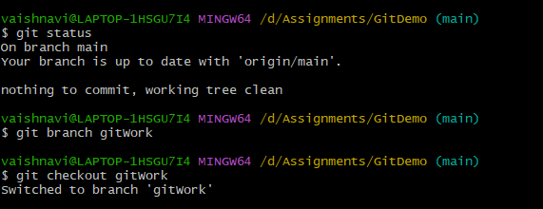

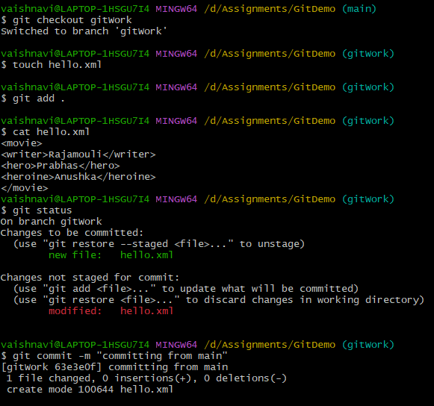

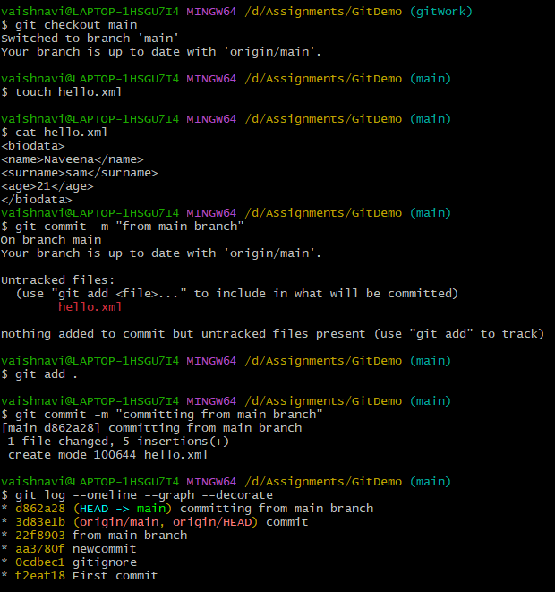

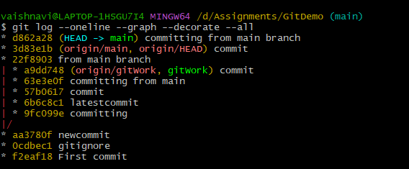

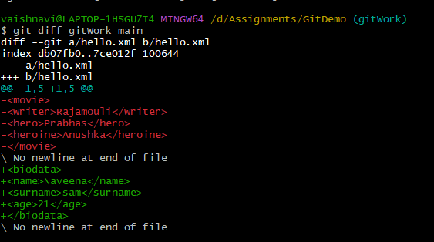

**ASSIGNMENT 5:**

vaishnavi@LAPTOP-1HSGU7I4 MINGW64 /d/Assignments/GitDemo (main)

$ git status

On branch main

Your branch is ahead of 'origin/main' by 1 commit.

(use "git push" to publish your local commits)

nothing to commit, working tree clean

vaishnavi@LAPTOP-1HSGU7I4 MINGW64 /d/Assignments/GitDemo (main)

$ git push origin main

Enumerating objects: 4, done.

Counting objects: 100% (4/4), done.

Delta compression using up to 8 threads

Compressing objects: 100% (3/3), done.

Writing objects: 100% (3/3), 339 bytes | 339.00 KiB/s, done.

Total 3 (delta 1), reused 0 (delta 0), pack-reused 0

remote: Resolving deltas: 100% (1/1), completed with 1 local object.

To https://github.com/KarakambadiNaveena/GitDemo

3d83e1b..d862a28 main -> main

vaishnavi@LAPTOP-1HSGU7I4 MINGW64 /d/Assignments/GitDemo (main)

$ git pull origin main

From https://github.com/KarakambadiNaveena/GitDemo

* branch main -> FETCH_HEAD

Already up to date.

vaishnavi@LAPTOP-1HSGU7I4 MINGW64 /d/Assignments/GitDemo (main)

$ git branch

gitWork

* main

vaishnavi@LAPTOP-1HSGU7I4 MINGW64 /d/Assignments/GitDemo (main)

$ git diff main gitWork

diff --git a/hello.xml b/hello.xml

index 7ce012f..db07fb0 100644

--- a/hello.xml

+++ b/hello.xml

@@ -1,5 +1,5 @@

-<biodata>

-<name>Naveena</name>

-<surname>sam</surname>

-<age>21</age>

-</biodata>

\ No newline at end of file

+<movie>

+<writer>Rajamouli</writer>

+<hero>Prabhas</hero>

+<heroine>Anushka</heroine>

+</movie>

\ No newline at end of file

