|  |  |
| --- | --- |
|  | **2023** |
|  | **Near East University**  **Mechatronics Department** |



|  |
| --- |
| **[sound wave to electric signal transformation]** |
| This involves understanding the principles of acoustics, audio engineering, and signal processing, as well as the fundamental concepts of electrical and computer engineering. The goal is to explore the transformation of sound waves into electrical signals, which can then be further processed or utilized for various applications, including audio recording, communication systems, and medical devices. |

**MCT-435 MECHATRONICS ENGINEERING**

**SUBMITTED BY: KARAM AHMED**

**STD# 20223390**

**DR. CEMAL KAVALCIOĞLU**

**Table of Content Page(s)#**

1. Introduction…………………………………………………….2
2. Component Used In The Project……………………………….3
   1. Electromechanical Transducer………………………….3

2.1.1. The Microphone as Input Sound Transducers….3

2.2- Integrated Circuit IC- CD4017………………………...4

2.2.1- Pin Configuration Description…………….4

2.2.2- CD4017 Electrical Features………………..5

2.2.3. Application………………………………...6

2.2.4. Differences and Replacements…………….6

2.3. 2N2222 Transistor……………………………………...6

2.3.1. Features and Applications…………………6

2.3.2. Pin-out and Usage…………………………6

3. Control Circuit Description……………………………………7

4. Conclusion……………………………………………………..8

5. References……………………………………………………. 8

1. **INTRODUCTION**

**S**ound is the generalized name given to “acoustic waves”. Sound transducers can detect these acoustic waves which have frequencies ranging from just 1Hz up to many tens of thousands of Hertz with the upper limit of human hearing being around the 20 kHz, (20,000Hz) range.

The sound that we hear is basically made up from mechanical vibrations produced by an **Audio Sound Transducer** used to generate the acoustic waves, and for sound to be “heard” it requires a medium for transmission either through the air, a liquid, or a solid.

Also, the actual sound need not be a continuous frequency sound wave such as a single tone or a musical note, but may be an acoustic wave made from a mechanical vibration, noise or even a single pulse of sound such as a “bang”.

**Audio Sound Transducers** include both input sensors, that convert sound into and electrical signal such as a microphone, and output actuators that convert the electrical signals back into sound such as a loudspeaker.

We tend to think of sound as only existing in the range of frequencies detectable by the human ear, from 20Hz up to 20kHz (a typical loudspeaker frequency response), but sound can also extend way beyond these ranges.

Sound transducers can also both detect and transmit sound waves and vibrations from very low frequencies called *infra-sound* up to very high frequencies called *ultrasound*. But in order for a sound transducer to either detect or produce “sound” we first need to understand what sound is.

Sound is basically a waveform of energy that is produced by some form of a mechanical vibration such as a tuning fork, and which has a “frequency” determined by the origin of the sound for example, a bass drum has a low frequency sound while a cymbal has a higher frequency sound.

A sound waveform has the same characteristics as that of an electrical waveform which are **Wavelength** (λ), **Frequency** (ƒ) and **Velocity** (m/s). Both the sounds frequency and wave shape are determined by the origin or vibration that originally produced the sound but the velocity is dependent upon the medium of transmission (air, water etc.) that carries the sound wave.

When converting sound to a signal, there are various methods and technologies involved. Here's a breakdown of the process and the different techniques used:

1. **Component Used In The Project:**
   1. **Electromechanical Transducer:**

Most microphones use either an electromagnetic or an electrostatic technique to convert sound waves into electrical signals. The dynamic microphone, for example, is constructed with a small magnet that oscillates inside a coil attached to the diaphragm. When a sound wave causes the diaphragm of the microphone to vibrate, the relative motion of the magnet and coil creates an electrical signal by magnetic induction.

* + - 1. 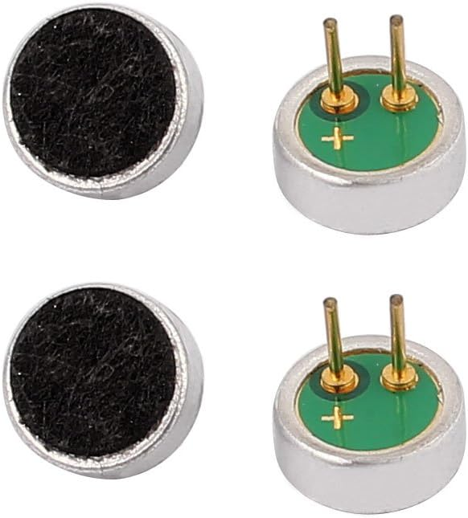**The Microphone As Input Sound Transducers**

The **Microphone**, also called a “mic”, is a sound transducer that can be classed as a “sound sensor”. This is because it produces an electrical analogue output signal which is proportional to the “acoustic” sound wave acting upon its flexible diaphragm. This signal is an “electrical image” representing the characteristics of the acoustic waveform. Generally, the output signal from a microphone is an analogue signal either in the form of a voltage or current which is proportional to the actual sound wave.

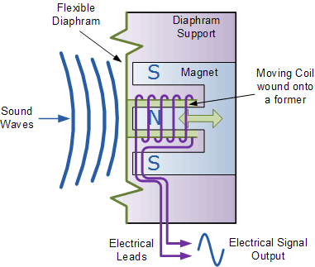The most common types of microphones available as sound transducers are *Dynamic*, *Electret Condenser*, *Ribbon* and the newer *Piezo-electric Crystal* types. Typical applications for microphones as a sound transducer include audio recording, reproduction, broadcasting as well as telephones, television, digital computer recording and body scanners, where ultrasound is used in medical applications. An example of a simple “Dynamic” microphone is shown below fig [1].

The movement of the coil within the magnetic field causes a voltage to be induced in the coil as defined by Faraday’s law of Electromagnetic Induction. The resultant output voltage signal from the coil is proportional to the pressure of the sound wave acting upon the diaphragm so the louder or stronger the sound wave the larger the output signal will be, making this type of microphone design pressure sensitive.

As the coil of wire is usually very small the range of movement of the coil and attached diaphragm is also very small producing a very linear output signal which is 90o out of phase to the sound signal. Also, because the coil is a low impedance inductor, the output voltage signal is also very low so some form of “pre-amplification” of the signal is required.

* 1. **Integrated Circuit IC- CD4017:**

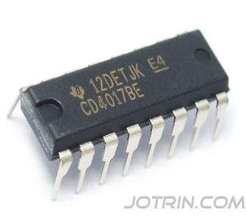The CD4017 IC is a widely used decade counter with decoded outputs. It is a CMOS decade counter/divider with 10 decoded outputs, making it suitable for various counting applications. Here are some key points about the CD4017 IC:

Functionality: The CD4017 IC is a decade counter that counts to ten. It has 10 outputs that represent the numbers 0 to 9.

* + 1. **Pin Configuration Description**

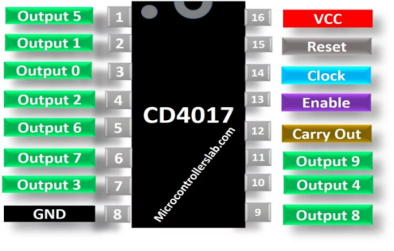The CD4017 IC has output pins (Pin 1 to 7 & 9 to 11) that change to high level one by one in a sequence for each clock signal received. It also has an enable pin/clock in. [[1]]

|  |  |  |
| --- | --- | --- |
| **Pin Number** | **Pin Name** | **Description** |
| 1 | Output 5 | When the value of counts is 5, it gets HIGH |
| 2 | Output 1 | When the value of counts is 1, it gets HIGH |
| 3 | Output 0 | When the value of counts is 0, it gets HIGH |
| 4 | Output 2 | When the value of counts is 2, it gets HIGH |
| 5 | Output 6 | When the value of counts is 6, it gets HIGH |
| 6 | Output 7 | When the value of counts is 7, it gets HIGH |
| 7 | Output 3 | When the value of counts is 1, it gets HIGH |
| 8 | GND | Make connection to the ground of the circuit. |
| 9 | Output 8 | When the value of counts is 8, it gets HIGH |
| 10 | Output 4 | When the value of counts is 4, it gets HIGH |
| 11 | Output 9 | When the value of counts is 9, it gets HIGH |
| 12 | CARRY-OUT | This pin goes HIGH, when the counts exceed 10 and useful for cascading IC’s. |
| 13 | ENABLE | The enable pin is active low. When it is high, the circuit will not receive clock signals and the counter will not count. |
| 14 | CLOCK | This is the clock input signal. On every positive edge of a clock, counter value gets increment by 1. |
| 15 | RESET | Restart the counter from 0. |
| 16 | Vcc | It is connected to the positive supply |

* + 1. **CD4017 Electrical Features**
* High operating frequency 16 pin CMOS Decade counter
* Decoded outputs pins = 10
* Clock input is Schmitt triggered which provides pulse shaping and therefore it has no rise and fall times' limitation.
* The voltage supply range is from 3V to 15V but in normal operation, +5V is used.
* CD4017 is TTL compatible
* It has a medium operational speed which is typically 5MHz and the maximum clock frequency is 5.5Mhz
* Multiple 16-pin packages PDIP, GDIP, PDSO packages
  + 1. **Applications:**

The CD4017 IC is extensively used in different applications, including decoder, binary counter, frequency division, decade counter, and various electronics projects such as remote controlled switches, light chasers, alarms, and more. It is also used in different industries like automotive, alarms, and electronic manufacturing of medical instruments and instrumentation devices.

* + 1. **Differences and Replacements:**

If the CD4017 IC is not available, alternatives such as the CD4022 is similar to the CD4017, but with 8 outputs.

* 1. **2N2222 Transistor**

The 2N2222 is a common NPN bipolar junction transistor (BJT) used for general purpose low-power amplifying or switching applications. It is designed for low to medium current, low power, medium voltage, and can operate at moderately high speeds. It is frequently used as a small-signal transistor and remains a small general-purpose transistor of enduring popularity. The 2N2222 was part of a family of devices described by Motorola at a 1962 IRE convention. Since then, it has been made by many semiconductor companies, for example, Texas Instruments.

* + 1. **Features and Applications**

The 2N2222 transistor can be used either as a switch or as an amplifier. When used as a switch, the transistor starts to work when the switch is closed, and the load ON and OFF intervals are controlled by the resistance value. As an amplifier, it can receive a weak signal through the base junction and release the amplified signal through the collector. Transistors are commonly used in RF (radio frequency), OFC (optical fiber communication), audio amplification, and other applications.

* + 1. **Pin-out and Usage**

The Base-Emitter voltage of this transistor is 0.6V, so a base voltage of 5V and a value of 1K as a current limiting resistor can be used. The Base resistor, also known as the current limiting resistor, will limit the current flowing through the transistor to prevent it from damaging. The value for this resistor can be calculated using the formula RB = VBE / IB. In actual circuit modifications might be required.

1. **Control Circuit Description:**

R1, C1, & 5VDC are used within microphone circuit.

Microphone can sense the sound wave and transform it to electrical random waves, which cannot be considered as a pulse to control CD4017.

Q2, R2, and R3 are used as amplifier to manage and convert sound wave obtained from mic circuit to useful pulse, which can control CD4017.

R2, C4 used as filter for any noisy or spikes, and R2 to avoid cutting off and saturation region, it should be adjusted to operate the transistor Q2 in leaner active region.

C2 is very important to pass only the pulses and prevent any DC voltage from Vcc to come across.

Thus, the pulse drawn to U1-CLK clock pin, output pin U1-Q1 is connected to the load via transistor or any other switching element like relay, U1-Q2 is connected to the reset pin U1-MR.

When the mic sense the sound via its circuit and obtain the wave which is filtered and amplified to be a pulse can trigger CD4017 at U1-CLK, thus U1-Q1 is activated and triggering transistor Q1 to switch connected load on.

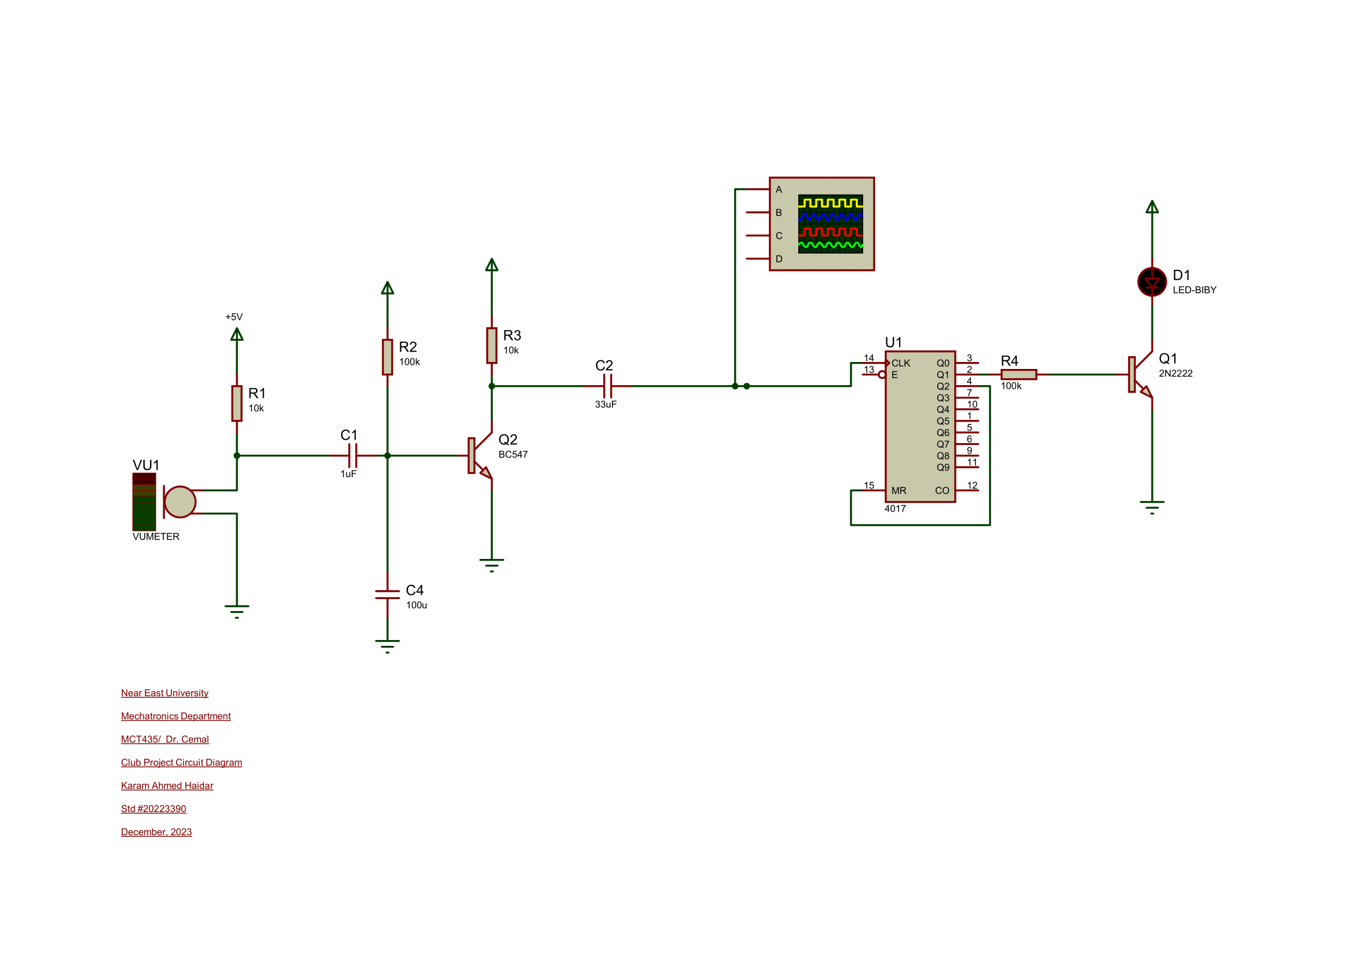If the second pulse has been sensed by mic circuit, the U1-CLK will be triggered again and deactivated U1-Q1 as well as connected load, and activate U1-Q2 which will reset the IC-U1, that leads to activate U1-Q0 again, so the IC-U1 ready to receive another pulse for switching the load on.

**Realistic Image of the Project**

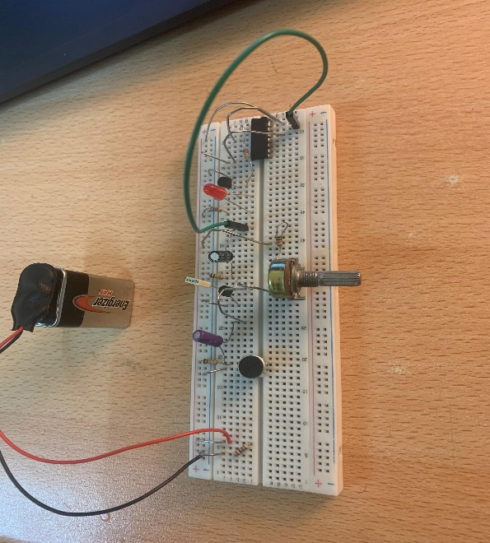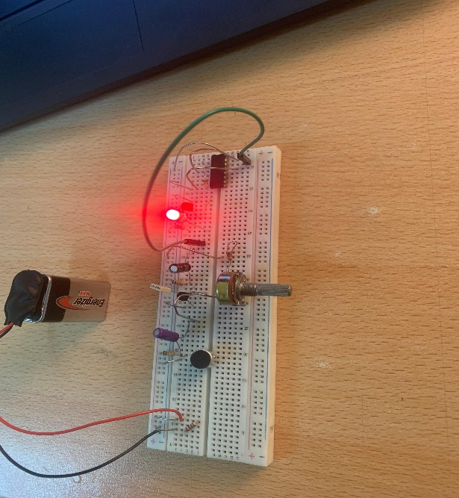

1. **Conclusion**

Converting sounds into electrical signals is a multifaceted process that involves the integration of principles from acoustics, signal processing, and electrical engineering. This project aims to delve into the theoretical foundations and practical applications of this transformation, shedding light on its significance in diverse fields. The CD4017 IC is a versatile component widely used in various electronic applications, offering a straightforward solution for counting and decoding tasks. Its compatibility with different technologies and its widespread availability make it a popular choice for electronic projects and industrial applications.

**5.** **References:**

[[1]] [CD4017 Counter Pinout, Examples, Applications, Equivalents, Datasheet (microcontrollerslab.com)](https://microcontrollerslab.com/cd4017-ic-pinout-examples-applications-equivalents-datasheet/)

[[2]] [The Ultimate Guide to CD4017 Decade Counter IC: Datasheet & Its Application - Jotrin Electronics](https://www.jotrin.com/technology/details/the-ultimate-guide-to-cd4017-decade-counter-datasheet-application#contents-item-14)

[[3]] [Sound Transducers for Sensing and Generating Sounds (electronics-tutorials.ws)](https://www.electronics-tutorials.ws/io/io_8.html)