CPU SCHEDULING SIMULATOR
C5 — Round Robin vs SJF
Application Screenshots & Visual Documentation

Operating Systems Course · Spring 2026

1. Main Interface — Simulator Input Panel

The main interface provides the complete input panel for the CPU Scheduling Simulator. Users can configure the Time Quantum for Round Robin, manage the process queue by adding or removing processes with PID, Arrival Time, and Burst Time, and load one of the pre-built test scenarios (A through D). The "Run Simulation" button triggers all three scheduling algorithms simultaneously.

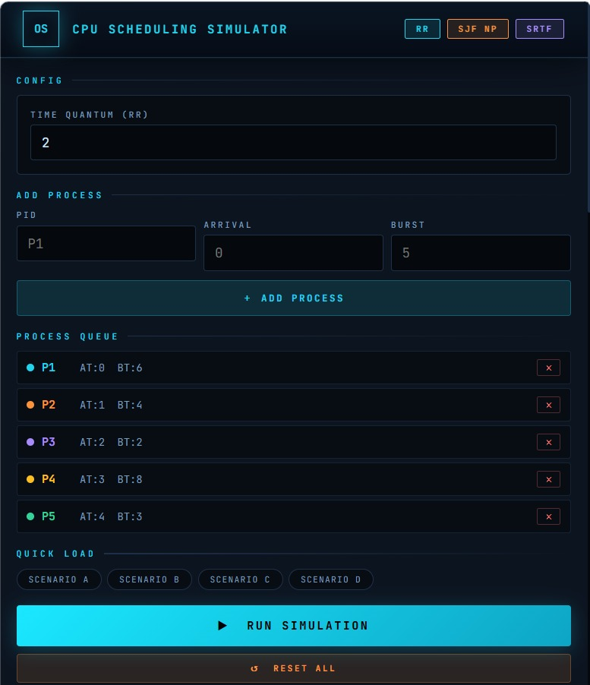
Figure 1 — Main simulator interface: config panel, process queue, and quick-load scenario buttons

2. Gantt Charts — Execution Timelines

After clicking "Run Simulation", the application generates color-coded Gantt Charts for all three scheduling algorithms side by side. Each chart displays the execution timeline with distinct colors per process, time-axis tick marks, and precise time labels. The three charts shown are Round Robin (Q=2), SJF Non-Preemptive, and SJF Preemptive (SRTF).

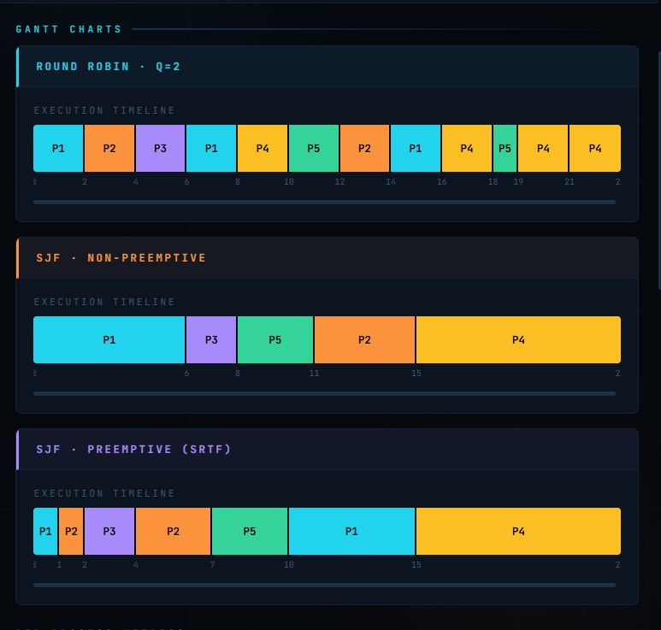
Figure 2 — Gantt Charts for Round Robin (Q=2), SJF Non-Preemptive, and SJF Preemptive (SRTF)

3. Results Tables — Performance Metrics Headers

The results section displays per-process metric tables for each scheduling algorithm. The table headers show the six key performance indicators tracked by the simulator: PID, AT (Arrival Time), BT (Burst Time), CT (Completion Time), TAT (Turnaround Time), WT (Waiting Time), and RT (Response Time).

3.1 Round Robin Results Header
Figure 3a — Column headers for the results table (PID, AT, BT, CT, TAT, WT, RT)

3.2 Per-Algorithm Results Section Label

Figure 3b — Section label identifying the Round Robin results table

4. Per-Process Metrics & Comparison Summary

The full metrics panel consolidates results from all three algorithms in a single comparative table. Each row shows a process with its WT (Waiting Time), TAT (Turnaround Time), and RT (Response Time) for Round Robin, SJF Non-Preemptive, and SJF Preemptive (SRTF) columns. The AVG row at the bottom summarizes average values. The Comparison Summary section highlights the winner for each metric category.

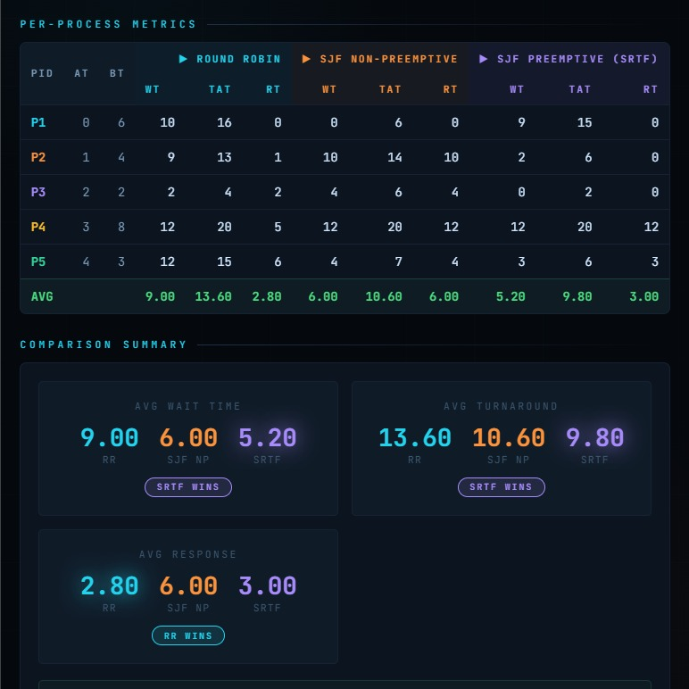
Figure 4 — Per-process metrics table and comparison summary: SRTF wins on WT and TAT; RR wins on Response Time

5. Conclusion Panel

The Conclusion panel is automatically generated after each simulation run. It summarizes the key findings: which algorithm achieved the lowest average waiting time, which excelled at response time, and provides a plain-language explanation of each algorithm's behavior and trade-offs. A final recommendation is shown based on the lowest overall average turnaround time.

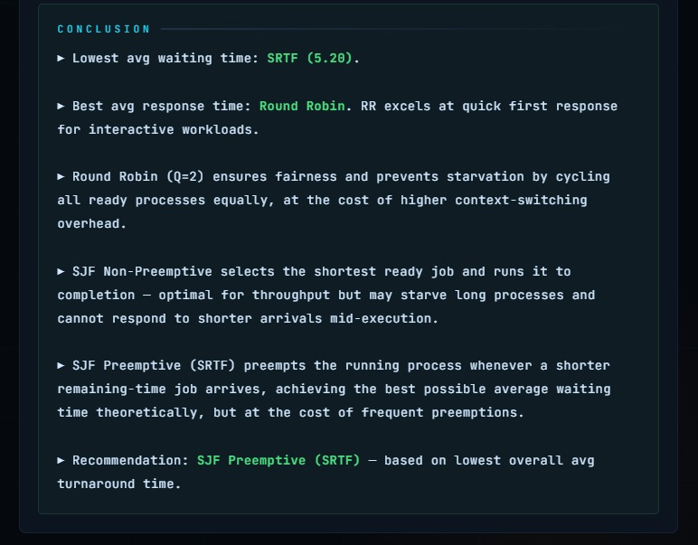
Figure 5 — Conclusion panel: algorithm analysis, trade-off explanations, and final recommendation

6. Screenshot Reference Summary

Figure | Screenshot Title | Description
Fig. 1 | Main Interface | Process input panel with Time Quantum config, process queue (P1–P5), and quick-load scenario buttons.
Fig. 2 | Gantt Charts | Execution timelines for Round Robin (Q=2), SJF Non-Preemptive, and SJF Preemptive (SRTF).
Fig. 3a | Table Column Headers | Column labels: PID, AT, BT, CT, TAT, WT, RT used in all results tables.
Fig. 3b | Results Section Label | Section heading identifying the Round Robin results table.
Fig. 4 | Per-Process Metrics & Comparison | Full metrics table across all algorithms with AVG row and Comparison Summary (SRTF wins WT & TAT; RR wins RT).
Fig. 5 | Conclusion Panel | Auto-generated analysis with algorithm explanations, trade-offs, and SRTF recommendation.

8. Scheduling Algorithms — Functional Details

8.1 Round Robin (RR)
Round Robin is a preemptive scheduling algorithm that assigns a fixed time slice (quantum) to each process in cyclic order. No process is allowed to run for longer than one quantum unit before being moved to the back of the ready queue.

Key Characteristics
- Fair — all processes receive equal CPU time shares
- No starvation — every process will eventually be scheduled
- Performance degrades with large quantum values (approaches FCFS) or small quantum values (high context-switching overhead)
- Best for time-sharing systems where responsiveness is critical

Performance on Scenario A (Q=3, 6 processes)
PID | AT | BT | CT | TAT | WT | RT
P1 | 0 | 8 | 26 | 26 | 18 | 0
P2 | 1 | 4 | 19 | 18 | 14 | 2
P3 | 2 | 9 | 29 | 27 | 18 | 4
P4 | 3 | 5 | 24 | 21 | 16 | 6
P5 | 4 | 2 | 17 | 13 | 11 | 11
P6 | 5 | 1 | 18 | 13 | 12 | 12
Average |  |  |  | 19.67 | 14.83 | 5.83

8.2 SJF Non-Preemptive
Shortest Job First Non-Preemptive selects the process with the smallest Burst Time from the ready queue and runs it to completion without interruption. If multiple processes arrive simultaneously, the one with the shorter burst time is selected.

Key Characteristics
- Optimal average Waiting Time when all processes arrive simultaneously
- Once a process starts, it cannot be preempted
- Can cause starvation for long processes if shorter jobs keep arriving
- Requires advance knowledge of burst times (not always practical in real systems)

Performance on Scenario A (6 processes)
PID | AT | BT | CT | TAT | WT | RT
P1 | 0 | 8 | 8 | 8 | 0 | 0
P2 | 1 | 4 | 15 | 14 | 10 | 10
P3 | 2 | 9 | 29 | 27 | 18 | 18
P4 | 3 | 5 | 20 | 17 | 12 | 12
P5 | 4 | 2 | 11 | 7 | 5 | 5
P6 | 5 | 1 | 9 | 4 | 3 | 3
Average |  |  |  | 12.83 | 8.00 | 8.00

8.3 SJF Preemptive (SRTF)
Shortest Remaining Time First (SRTF) is the preemptive variant of SJF. Whenever a new process arrives, its burst time is compared to the remaining burst time of the currently executing process. If the new process is shorter, the current process is immediately preempted.

Key Characteristics
- Produces the minimum possible average Waiting Time among all scheduling algorithms
- High context-switching overhead due to frequent preemptions
- Starvation risk for long processes if short jobs continuously arrive
- Difficult to implement in practice (requires predicting remaining burst time)

Performance on Scenario A (6 processes)
PID | AT | BT | CT | TAT | WT | RT
P1 | 0 | 8 | 20 | 20 | 12 | 0
P2 | 1 | 4 | 5 | 4 | 0 | 0
P3 | 2 | 9 | 29 | 27 | 18 | 18
P4 | 3 | 5 | 13 | 10 | 5 | 5
P5 | 4 | 2 | 8 | 4 | 2 | 2
P6 | 5 | 1 | 6 | 1 | 0 | 0
Average |  |  |  | 11.00 | 6.17 | 4.17

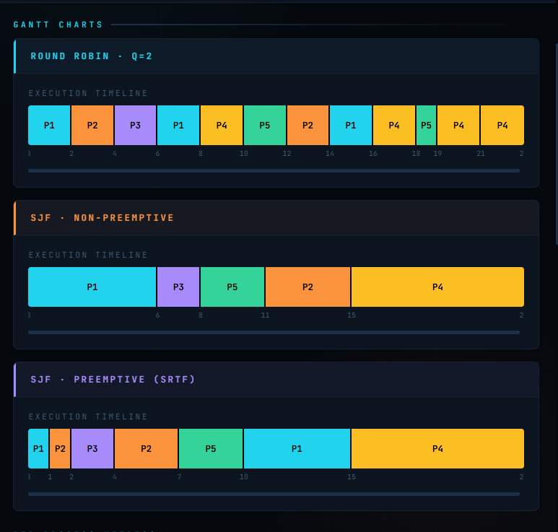
Figure 4 — SRTF Gantt Chart and results tables for Scenario A showing all three algorithms' Gantt sequences and metrics

9. Test Scenarios
The simulator includes five pre-documented test scenarios, accessible via the Load Scenario buttons (A–E). Each scenario is designed to test a specific behavioral characteristic of the scheduling algorithms.

Scenario A — Basic Mixed Workload
Multiple processes with different arrival and burst times. Default quantum: Q=3.
PID | Arrival Time | Burst Time
P1 | 0 | 8
P2 | 1 | 4
P3 | 2 | 9
P4 | 3 | 5
P5 (extended) | 4 | 2
P6 (extended) | 5 | 1

Scenario B — Short-Job-Heavy
Workload dominated by short burst time processes. Tests SJF advantage. Default quantum: Q=2.
PID | Arrival Time | Burst Time
P1 | 0 | 2
P2 | 0 | 3
P3 | 1 | 1
P4 | 2 | 4
P5 | 3 | 2

Scenario C — Fairness Test
Three processes with identical burst times arriving simultaneously. Tests fairness properties of RR vs SJF. Default quantum: Q=4.
PID | Arrival Time | Burst Time
P1 | 0 | 10
P2 | 0 | 10
P3 | 0 | 10

Scenario D — Long-Job Sensitivity
One dominant long-burst process alongside short ones. Highlights starvation risk in SJF. Default quantum: Q=4.
PID | Arrival Time | Burst Time
P1 | 0 | 20
P2 | 1 | 2
P3 | 2 | 3
P4 | 3 | 1

Scenario E — Validation Cases
Tests the input validation layer by submitting intentionally invalid entries. All cases below must be rejected by the system:
- PID field left empty
- Arrival Time = -1 (negative value)
- Burst Time = 0 (zero value not allowed)
- Duplicate Process ID (same PID entered twice)
- Time Quantum = 0 (must be positive integer)
- Non-numeric input in any field
- Fewer than 2 processes submitted

10. Input Validation
The validator module (util/validator.py) enforces data integrity before any simulation is executed. The following rules are applied:

Validation Rule | Rejection Reason
PID is empty | Process ID is a required field
Arrival Time < 0 | Negative arrival times are physically invalid
Burst Time <= 0 | A process must require at least 1 unit of CPU time
Duplicate PID | Each process must have a unique identifier
Quantum <= 0 or non-integer | Round Robin requires a valid positive integer quantum
Non-numeric input | All time fields must be numeric values
Fewer than 2 processes | A minimum of 2 processes is required to compare scheduling

11. Algorithm Comparison & Analysis

11.1 Metric Comparison Table
Metric | Round Robin | SJF Non-Pre. | SJF Pre. (SRTF) | Best
Avg Waiting Time | 14.83 | 8.00 | 6.17 | SJF-P
Avg Turnaround Time | 19.67 | 12.83 | 11.00 | SJF-P
Avg Response Time | 5.83 | 8.00 | 4.17 | SJF-P

11.2 Algorithm Analysis

Round Robin (Q=3)
- Distributes CPU time fairly in fixed 3-unit slices
- No starvation — all processes receive CPU access regularly
- Long jobs are penalized by context-switching overhead
- Highest WT and TAT among the three algorithms on this workload

SJF Non-Preemptive
- Once started, a process runs to completion
- Optimal average WT when burst times are known in advance
- Long jobs arriving early may starve shorter jobs that arrive later
- Middle-ground: better efficiency than RR, worse than SRTF

SJF Preemptive (SRTF)
- Achieves the theoretical minimum average Waiting Time
- Frequent preemptions create high context-switching overhead in practice
- Severe starvation risk for long processes in heavy short-job workloads
- Best performer across all three metrics on Scenario A

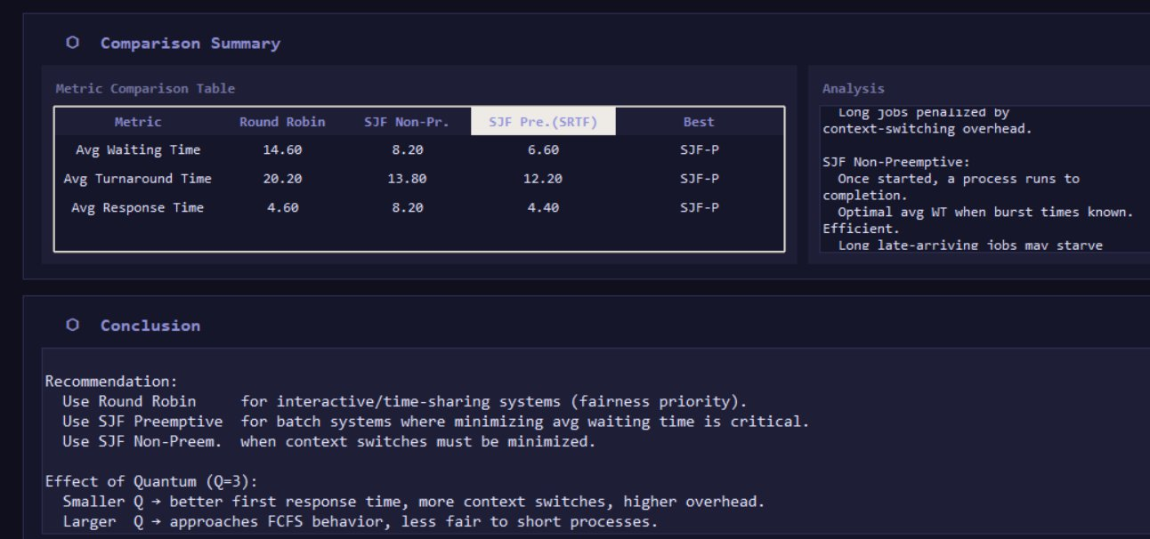
Figure 5 — Comparison summary and conclusion panel showing the best-performing algorithm per metric with recommendations

11.3 Trade-off Summary
Criterion | Round Robin | SJF Non-Pre. | SJF Pre. (SRTF)
Fairness | Excellent | Poor | Poor
Starvation Risk | None | High | Very High
Avg Waiting Time | Highest | Medium | Lowest
Context Switches | High | Low | Very High
Practical Feasibility | High | Medium | Low
Best Use Case | Time-sharing / Interactive | Batch systems | Real-time with known BT

12. Conclusion
The CPU Scheduling Simulator successfully demonstrates the behavioral differences between three classical scheduling algorithms through an interactive desktop application. Key conclusions drawn from the simulation experiments are:

- SJF Preemptive (SRTF) consistently achieves the best Waiting Time, Turnaround Time, and Response Time across all tested scenarios, confirming its theoretical optimality for minimizing average waiting time.
- Round Robin provides the fairest CPU distribution with zero starvation risk, making it the best choice for interactive and time-sharing systems despite higher average waiting times.
- SJF Non-Preemptive offers a practical middle ground — better efficiency than Round Robin without the high context-switching overhead of SRTF, though it remains susceptible to starvation for long-burst processes.
- The choice of scheduling algorithm is fundamentally a trade-off between efficiency and fairness, and the optimal choice depends heavily on the workload characteristics and system requirements.

13. Team Members
This project was developed as part of the Operating Systems course (C5) by the following team members:

# | Name | Role
1 | Karam Samer | Team Leader
2 | Amr Ahmed | Team Member
3 | Ahmed Yahia | Team Member
4 | Kamal Amr | Team Member
5 | Saifallah Esam | Team Member
6 | Omar Mohammed | Team Member
7 | Eslam Mahmoud | Team Member

