SWINBURNE UNIVERSITY OF TECHNOLOGY

SWE40006 - Software Deployment and Evolution
Deployment Portfolio Task 4
Container Application Deployment & Orchestration using Docker
DECLARED TARGET LEVEL: HIGH DISTINCTION (Task 4.4)
Field | Detail
Student Name | Karamjot Singh
Student ID | 104809887
Unit Code & Title | SWE40006 - Software Deployment and Evolution
Semester | Semester 2, 2026
Assessment | Deployment Portfolio Task 4
Submission Date | 27/09/2026
Declared Target Level | High Distinction - Tasks 4.1, 4.2, 4.3 and 4.4 all completed
Docker Hosts | Host 1: Windows 11, Docker Desktop (WSL 2)  Host 2: AWS EC2, Amazon Linux 2023, Docker Engine (ap-southeast-2)
Docker Hub Account | https://hub.docker.com/u/Karamjot1008
Source Repository | https://github.com/Karam1008/swe40006-task4-docker

Table of Contents
1. Introduction and Scope 4
1.1 Purpose of the Task 4
1.2 Naming Convention 4
1.3 Live Verification Endpoints 5
2. Architecture Overview 6
2.1 Final Deployment Topology 6
3. Task 4.1 - Pass Level: Docker Environment Setup 8
3.1 WSL 2 Installation 8
3.2 Docker Desktop Installation 9
3.3 Docker Hub Account and Sign-in 11
3.4 Verification 11
3.5 Limits of the Pass-Level Result 13
4. Task 4.2 - Credit Level: Containerised Python Application on Two Hosts 14
4.1 Source Control and Registry Preparation 14
4.2 Application Design 15
4.3 Dockerfile 16
4.4 Build 16
4.5 Local Deployment on a Designated Port 17
4.6 Publishing to Docker Hub 18
4.7 Secondary Docker Host Provisioning 20
4.8 Multi-Host Verification 22
4.9 Weaknesses of the Credit-Level Design 23
5. Task 4.3 - Distinction Level: Custom Web Application with an Optimised Build 24
5.1 Application Design 24
5.2 Service Architecture 24
5.3 Optimised Dockerfile 25
5.4 Measured Effect of the Optimisation 25
5.5 Local Deployment and Health Checks 27
5.6 Container Networking 29
5.7 Environment Variable Configuration 30
5.8 Persistence Across Container Recreation 31
5.9 Publishing to Docker Hub 31
5.10 Public Deployment on the Secondary Host 32
5.11 HTTPS with Automatic Certificates 32
6. Task 4.4 - High Distinction Level: Containerised Non-Web Application 34
6.1 Tool Design 34
6.2 Dockerfile and Container Best Practices 35
6.3 Tests at Build Time 35
6.4 Build and Interface 36
6.5 Storage Design 37
6.6 One-Shot Execution in a Hardened Container 38
6.7 Exit Codes 38
6.8 State Beyond the Container Lifetime 39
6.9 Long-Running Lifecycle and Graceful Shutdown 40
6.10 Portability to the Secondary Host 41
6.11 Practice Across the Four Levels 42
7. Self-Troubleshooting Log and Analysis 43
7.1 Bind-Mount Permission Denied on the Linux Host 43
7.2 Reverse Proxy Restart Loop Caused by an Invalid Site Address 43
7.3 Host Port 80 Unavailable on the Windows Host 44
7.4 HTTPS URL refused connections. 44
8. Limitations and Future Work 45
8.1 Single-Host Orchestration 45
8.2 Stateful Service Without Replication or Backup 45
8.3 Manual Build and Publish 45
8.4 No Image Scanning, Signing or Digest Pinning 45
8.5 HTTPS Relies on a Shared Public Domain 45
8.6 Registry Credentials and Private Images 45
8.7 Scope of the Log Analysis Tool 45
9. External Code and Script Repository 46
10. Generative AI Declaration 47
10.1 Tool Used and Scope of Use 47
10.2 What Was Performed by Me 47
10.3 Verification and Independent Judgement 47
10.4 Statement 47
11. References 49

1. Introduction and Scope
This report documents the containerisation, packaging, publication and deployment of three applications using Docker, completed for Deployment Portfolio Task 4 of SWE40006. All four grade bands were attempted and completed in sequence: 4.1 (Pass), 4.2 (Credit), 4.3 (Distinction) and 4.4 (High Distinction).
Two Docker hosts were used throughout. Host 1 is my Windows 11 laptop running Docker Desktop on the WSL 2 backend, where every image was built and tested. Host 2 is an Amazon EC2 instance running Docker Engine on Amazon Linux 2023 in Asia Pacific (Sydney), which pulls the published images from Docker Hub and serves them publicly. No image is ever built on Host 2: it runs only what the registry provides, which is what makes it a genuine test of portability rather than a second build environment.

1.1 Purpose of the Task
The task is structured as a progression. Each grade band deliberately removes a weakness left by the previous one:
- Pass (4.1) establishes a working container runtime and a registry account, verified with the official hello-world image. It proves the toolchain works but deploys nothing of my own.
- Credit (4.2) produces the first custom image, a basic Flask application, publishes it to Docker Hub and runs the identical artefact on a second host. The Dockerfile is intentionally simple, and its weaknesses are recorded at the end of that section.
- Distinction (4.3) removes those weaknesses with an optimised multi-stage Dockerfile, and moves from one container to a three-service application with isolated networks, environment-driven configuration, health checks, persistent storage and public HTTP/HTTPS access.
- High Distinction (4.4) applies the same practices to a non-web workload, a command-line log analysis tool, where the concerns shift from ports to volumes, exit codes, signal handling and the container lifecycle.

1.2 Naming Convention
A consistent swe40006- prefix was applied to every image and cloud resource so that all artefacts could be identified unambiguously during verification and teardown.
Resource | Identifier
GitHub repository | swe40006-task4-docker
Credit image (4.2) | Karamjot1008/swe40006-flask-basic:1.0.0
Distinction image (4.3) | Karamjot1008/swe40006-docknotes:1.0.0
High Distinction image (4.4) | Karamjot1008/swe40006-logalyzer:1.0.0
Compose projects | docknotes, logalyzer
Docker networks | docknotes_frontend, docknotes_backend
Docker volumes | docknotes_redis_data, docknotes_caddy_data, logalyzer_state
Secondary Docker host (EC2) | SWE40006-DockerHost
Security group / IAM role | swe40006-docker-host-sg / swe40006-docker-host-role

1.3 Live Verification Endpoints
The following endpoints were live at the time of submission and may be used for grading verification.
Endpoint | Value
Credit Flask app (Host 2) | http://52.62.216.119:8080/
Credit health check | http://52.62.216.119:8080/health
DockNotes (HTTP) | http://52.62.216.119/
DockNotes (HTTPS) | https://52.62.216.119.sslip.io/
DockNotes status API | http://52.62.216.119/api/info
Docker Hub repositories | https://hub.docker.com/u/karamjot1008
Source repository | https://github.com/Karam1008/swe40006-task4-docker

The High Distinction application is a command-line tool with no network listener, so it has no URL. It can be verified from any Docker host by pulling the public image:
docker run --rm karamjot1008/swe40006-logalyzer:1.0.0 --help.

2. Architecture Overview
The deployment evolved across four distinct states. The table below summarises that evolution; each row is expanded in the section that follows.
Level | Artefact | Runtime & Networking | Configuration & State
4.1 Pass | Official hello-world image | Docker Desktop, WSL 2 backend; container runs once and exits | None
4.2 Credit | Custom Flask image, single-stage Dockerfile, pushed to Docker Hub | One container on each host; host port 8080 mapped to container port 5000 | PORT and DEPLOY_HOST environment variables; stateless
4.3 Distinction | Custom FastAPI image, optimised multi-stage Dockerfile | Three containers via Compose; only the Caddy proxy publishes ports; internal backend network | .env-driven configuration; Redis data on a named volume; automatic HTTPS
4.4 High Distinction | Standard-library CLI image with a build-time test stage | No network listener; one-shot and long-running modes | Bind mounts for input/output; named volume for run history; exit codes and SIGTERM handling

2.1 Final Deployment Topology
Images are built on Host 1, published to Docker Hub, and pulled by Host 2. GitHub carries the source and the two small configuration files that Host 2 needs to start the Distinction stack:
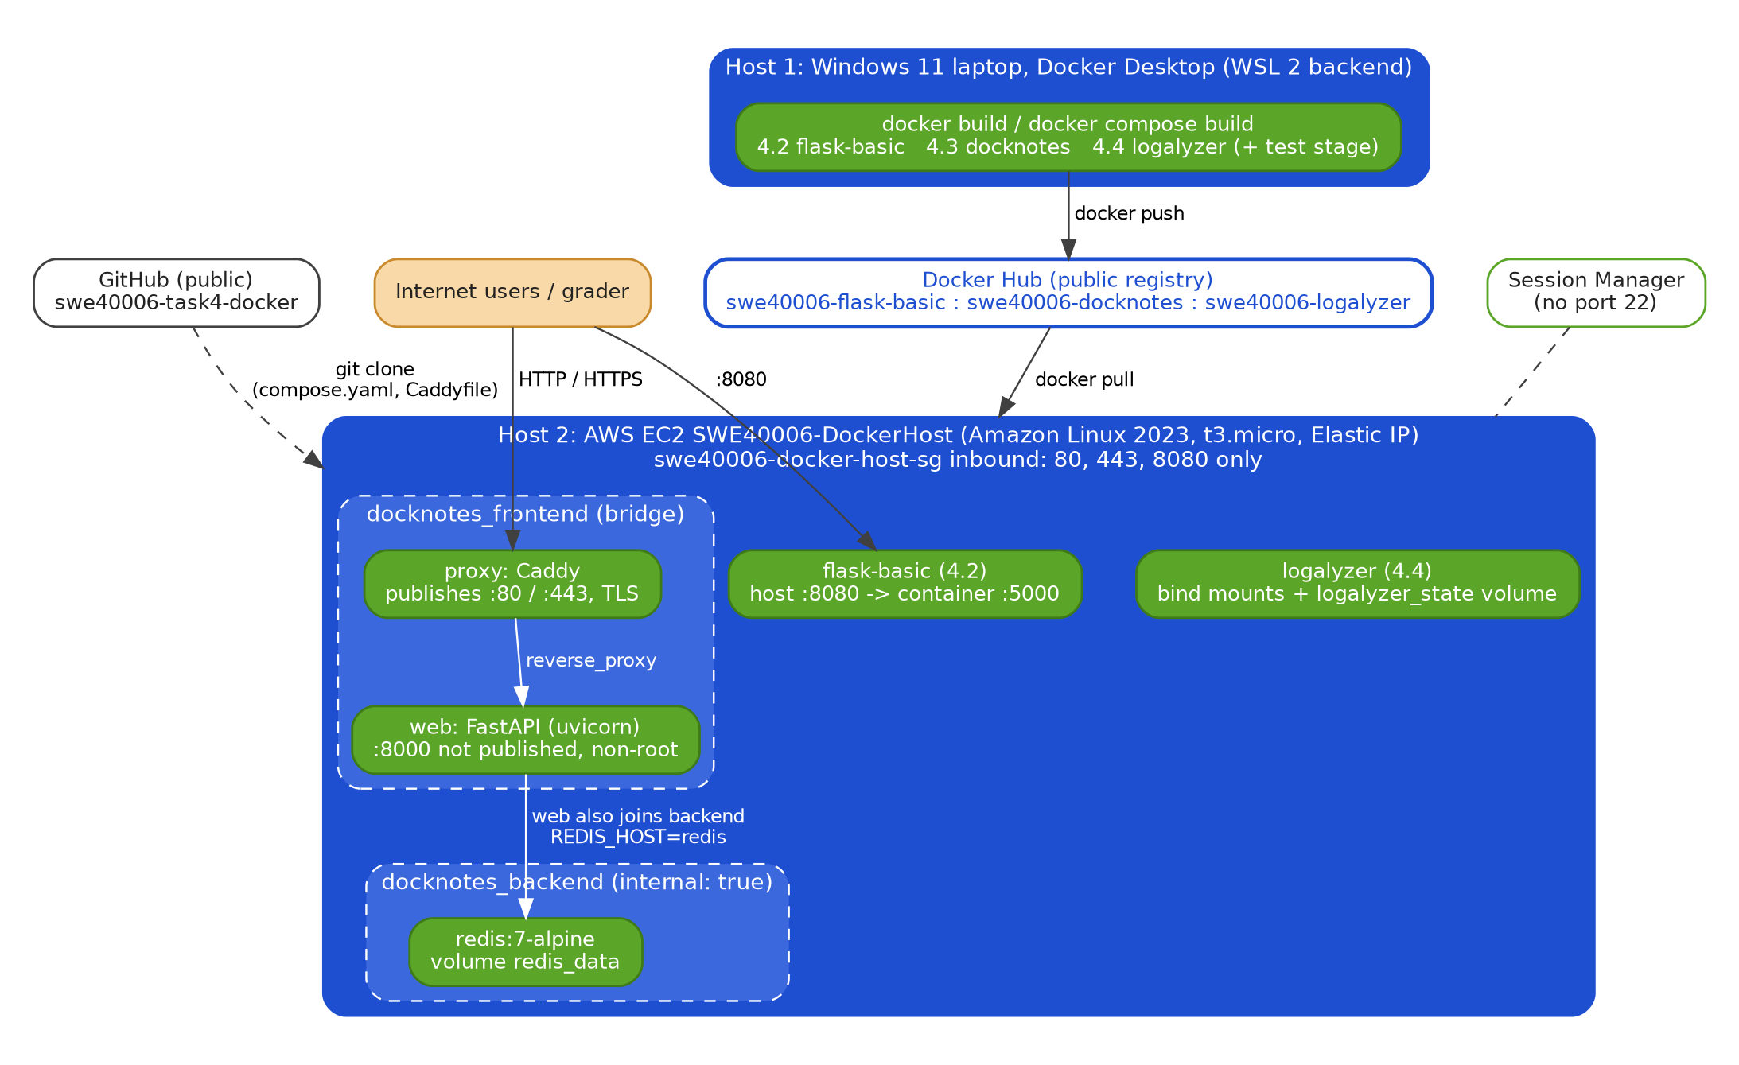
Figure 1: Deployment topology across the two Docker hosts, the registry and the source repository

Two properties of this topology are:
- Images move between hosts only through the registry. Host 2 builds nothing; every container it runs is pulled from Docker Hub and is byte-identical to what was tested on Host 1, which is proven by digest comparison in Section 4.8.
- Minimal exposure on Host 2. The only listeners reachable from the internet are the Caddy proxy (80/443) and the Credit application (8080). The DockNotes web container and Redis publish no ports, and there is no SSH port; administrative access is through AWS Systems Manager Session Manager.

3. Task 4.1 - Pass Level: Docker Environment Setup
Objective: register an active Docker Hub account, install Docker Desktop on the host machine, and pull and run the official hello-world image to confirm the runtime environment is operational.

3.1 WSL 2 Installation
Docker Desktop on Windows runs the Docker Engine inside a lightweight Linux virtual machine. The WSL 2 backend provides that virtual machine through the Windows Subsystem for Linux, rather than through a Hyper-V machine managed by Docker itself. WSL 2 was installed from an elevated PowerShell session:
# PowerShell, Run as Administrator
wsl --install

# after restarting the machine
wsl --version

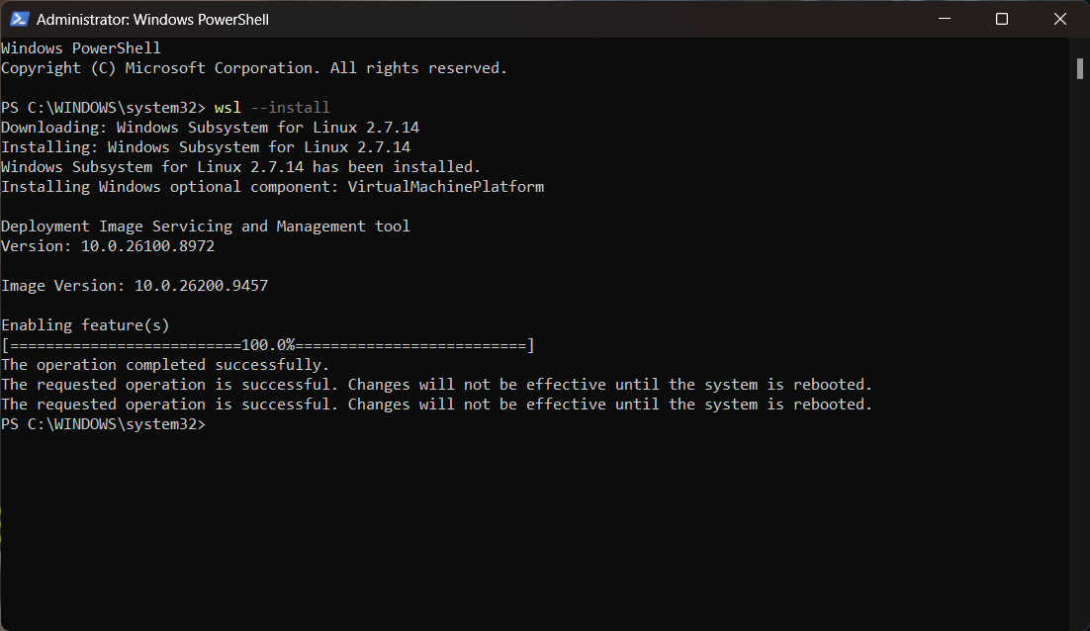
Figure 2: wsl --install executed from an Admin PowerShell session
A restart was required to enable the Virtual Machine Platform feature. The reported WSL version, 2.7.14.0, meets the minimum of 2.1.5 specified in the walkthrough.
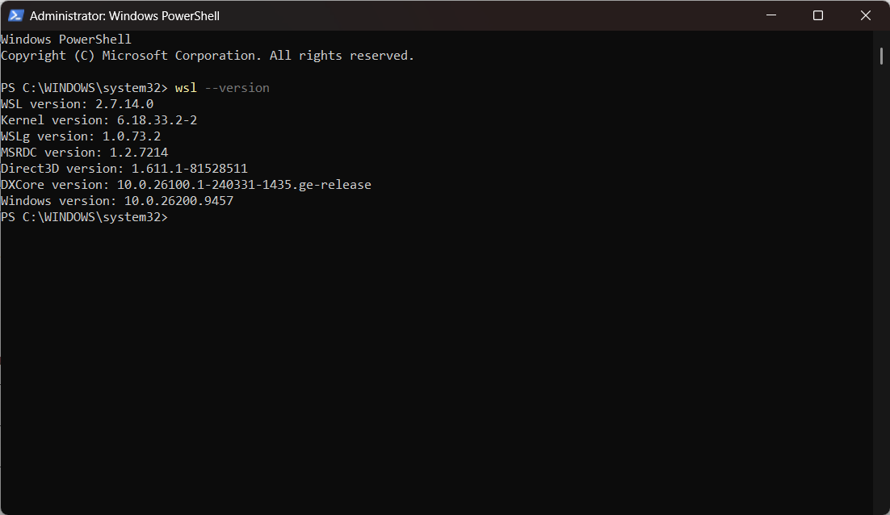
Figure 3:wsl --version confirming WSL 2.7.14.0, above the 2.1.5 minimum

3.2 Docker Desktop Installation
Docker Desktop for Windows was downloaded from the official Docker Desktop release notes page and installed from the downloaded installer.
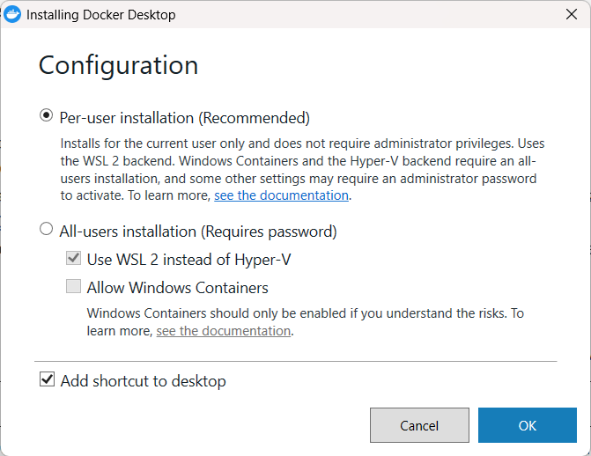
Figure 4: Installer configuration with Per-user installation (WSL 2 backend) selected
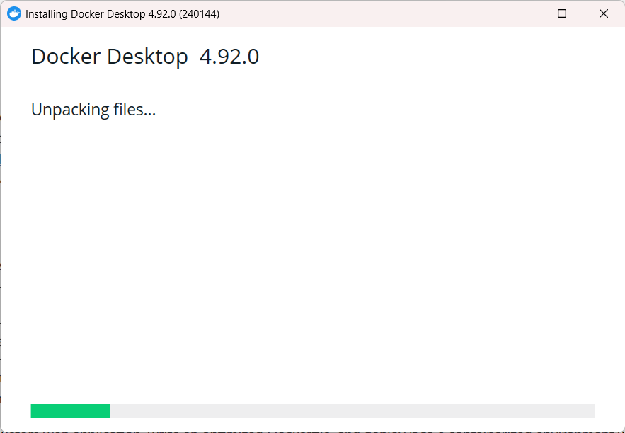
Figure 5: Installer unpacking files
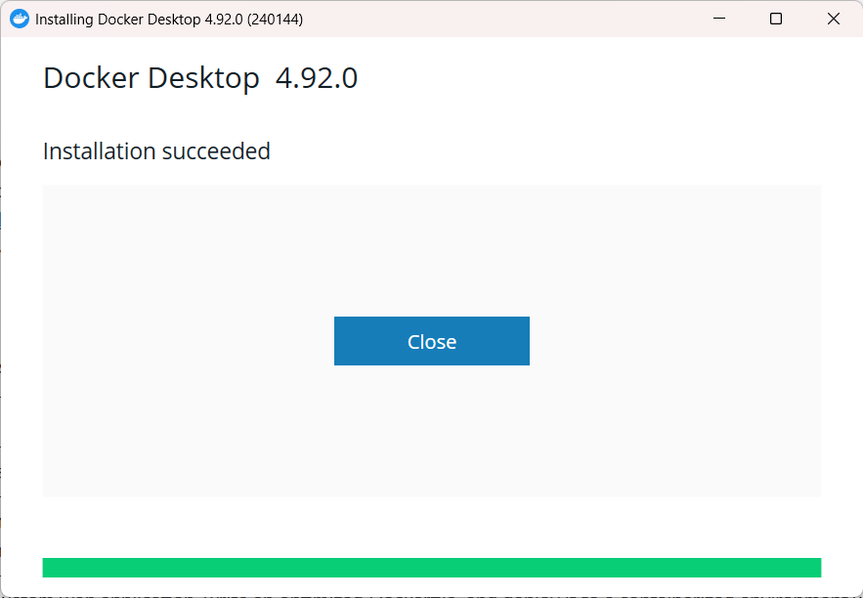
Figure 6: Installation succeeded dialog
The Per-user installation option was selected. It installs Docker Desktop for the current account only, needs no administrator privileges and uses the WSL 2 backend. The All-users option is required only for the Hyper-V backend or for Windows containers, neither of which this task uses. Running tooling with the least privilege that works is a principle that recurs throughout the rest of this report.

3.3 Docker Hub Account and Sign-in
On first launch the Docker Subscription Service Agreement was accepted. A Docker Hub account was then created and used to sign in to Docker Desktop, completing the browser-based sign-in handshake. This account owns the public repositories published at Credit, Distinction and High Distinction levels.
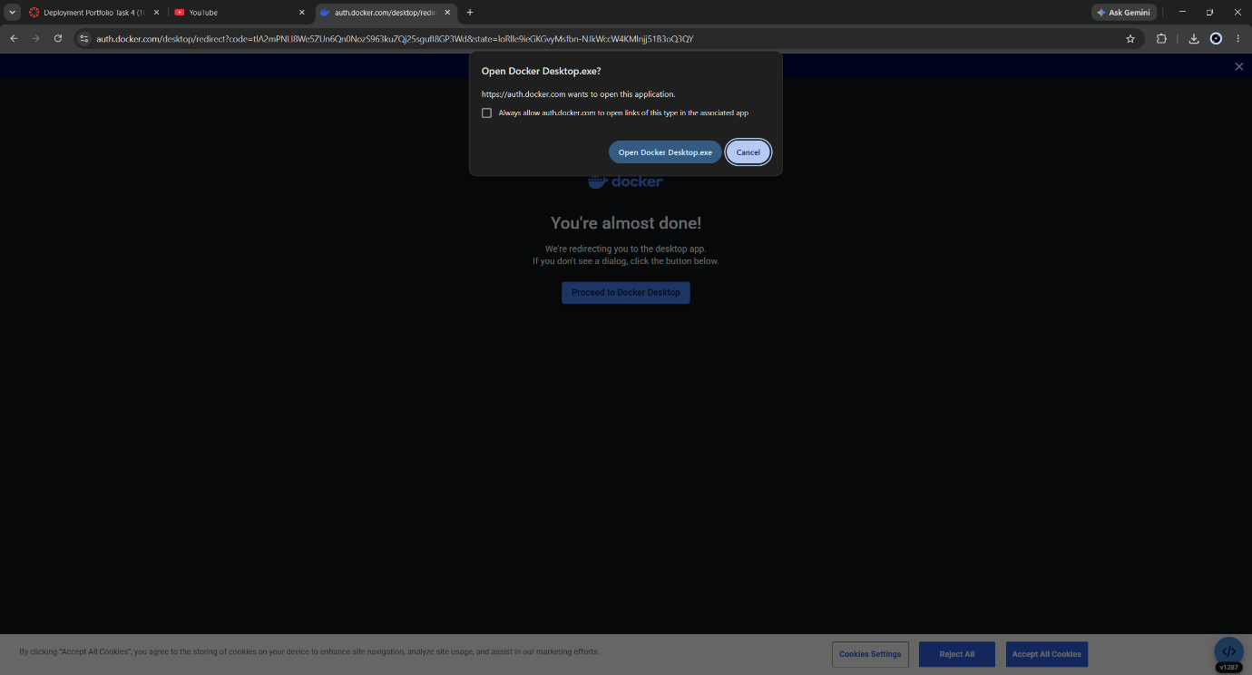
Figure 7: Browser hand-off returning the authenticated session to Docker Desktop

3.4 Verification
docker info
docker run hello-world
docker info confirms that the CLI can reach the Docker daemon: the Server section appears only when the daemon is running, and reports the engine version, the storage driver and the WSL 2 kernel. docker run hello-world exercises the full path in one command. The client asks the daemon to run the image; the daemon does not find it locally, pulls it from Docker Hub, creates a container, runs it and streams its output back to the terminal. The container then exits, because its only process has finished. This is expected behaviour, and the first illustration of the container lifecycle examined in depth at Task 4.4.

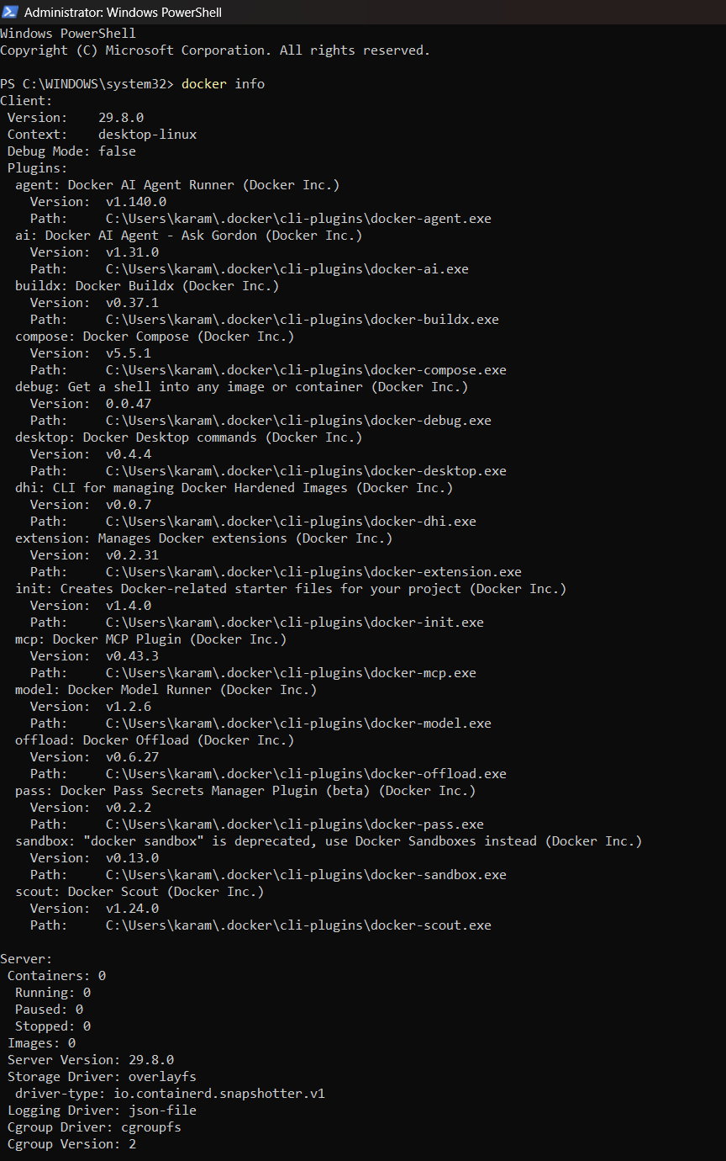
Figure 8: docker info output confirming the client can reach the Docker Engine
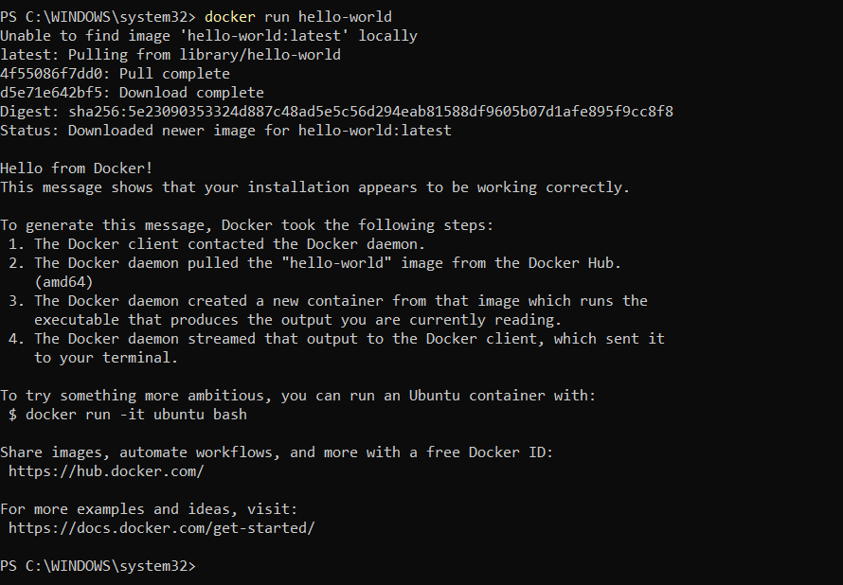
Figure 9: docker run hello-world pulling the image and printing “Hello from Docker!”

3.5 Limits of the Pass-Level Result
- It proves the runtime works but deploys nothing of my own: there is no Dockerfile, no custom image and no registry push.
- A single host means portability, the central promise of containers, is untested.

4. Task 4.2 - Credit Level: Containerised Python Application on Two Hosts
Objective: build and containerise a basic Python web application, configure its runtime dependencies, deploy the container listening on a designated host port, push the image to Docker Hub, and pull and run it on a secondary Docker host.

4.1 Source Control and Registry Preparation
All source code, Dockerfiles and scripts for this task live in a public GitHub repository, created and published with GitHub Desktop. The repository's .gitignore was in place before the first commit, so the local .env configuration file, Python caches and runtime data could never enter the history.
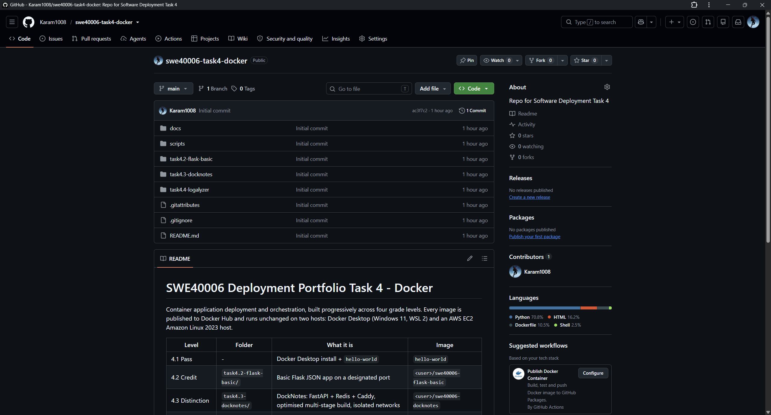
Figure 10: The public GitHub repository showing the per-level folder structure
The Docker CLI was authenticated to Docker Hub with a Personal Access Token rather than the account password. A token can be limited to Read & Write access and revoked on its own without changing the account password, so a leaked token has a smaller blast radius.
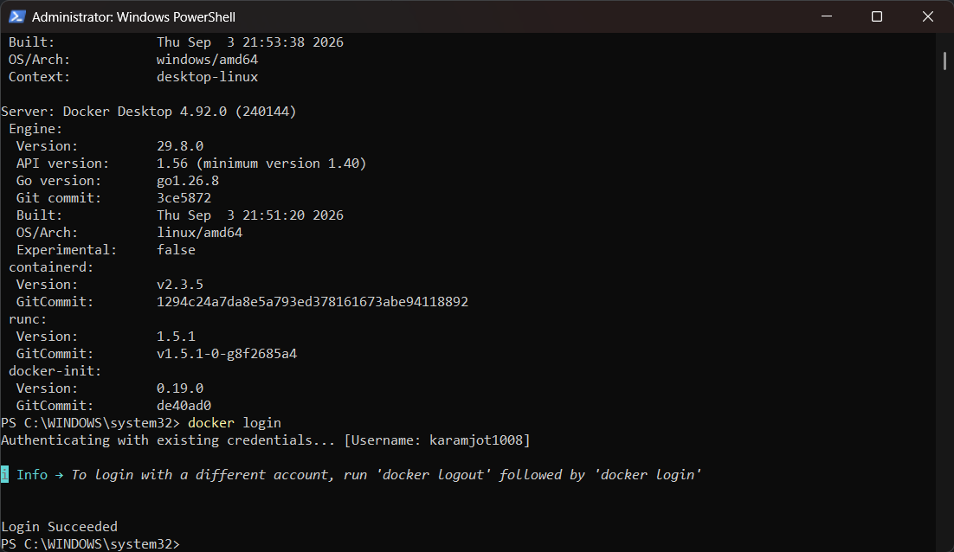
Figure 11: docker version showing client and server, and docker login succeeding

4.2 Application Design
The Credit application is a minimal Flask service with two routes:
Route | Response | Purpose
GET / | JSON: message, docker_host, container_hostname, python_version, started_utc | Identifies which host and which container served the request
GET /health | {"status": "ok"}, HTTP 200 | Simple liveness check

The container_hostname field exists specifically for this task. Inside a container the hostname defaults to the container ID, so the same image reports a different value on each host. That observable difference proves two separate containers are serving the same code. docker_host is read from the DEPLOY_HOST environment variable and labels the machine.
port = int(os.environ.get("PORT", "5000"))
# 0.0.0.0 is required inside a container; 127.0.0.1 would only accept
# connections from inside the container itself.
app.run(host="0.0.0.0", port=port)
Binding to 0.0.0.0 is essential. Flask's default of 127.0.0.1 is the loopback interface of the container's own network namespace, but Docker's port forwarding delivers traffic to the container's eth0 interface. A loopback-bound server would therefore refuse every forwarded connection while the container still appeared to be running normally.

4.3 Dockerfile
FROM python:3.12-slim
WORKDIR /app

# Dependencies first so this layer is cached when only app.py changes
COPY requirements.txt .
RUN pip install --no-cache-dir -r requirements.txt

COPY app.py .

ENV PORT=5000
EXPOSE 5000
CMD ["python", "app.py"]
Instruction | Purpose
FROM python:3.12-slim | Debian-based Python runtime without compilers and documentation
COPY requirements.txt then RUN pip install | Installs the pinned dependency (Flask 3.1.1) in its own layer, reused until requirements.txt changes
--no-cache-dir | Stops pip's download cache being baked into the layer
COPY app.py | Application code is copied last because it changes most often
ENV PORT / EXPOSE 5000 | Sets the designated port and documents it. EXPOSE does not publish anything; publishing happens with -p at run time
CMD ["python", "app.py"] | Exec form: Python runs as PID 1 and receives stop signals directly

Instruction order matters because Docker caches each layer and invalidates every layer after the first one that changes. Placing dependency installation before the code copy means a code-only change rebuilds in seconds instead of reinstalling Flask.

4.4 Build
cd task4.2-flask-basic
docker build -t swe40006-flask-basic:1.0.0 .
docker images swe40006-flask-basic
docker history swe40006-flask-basic:1.0.0
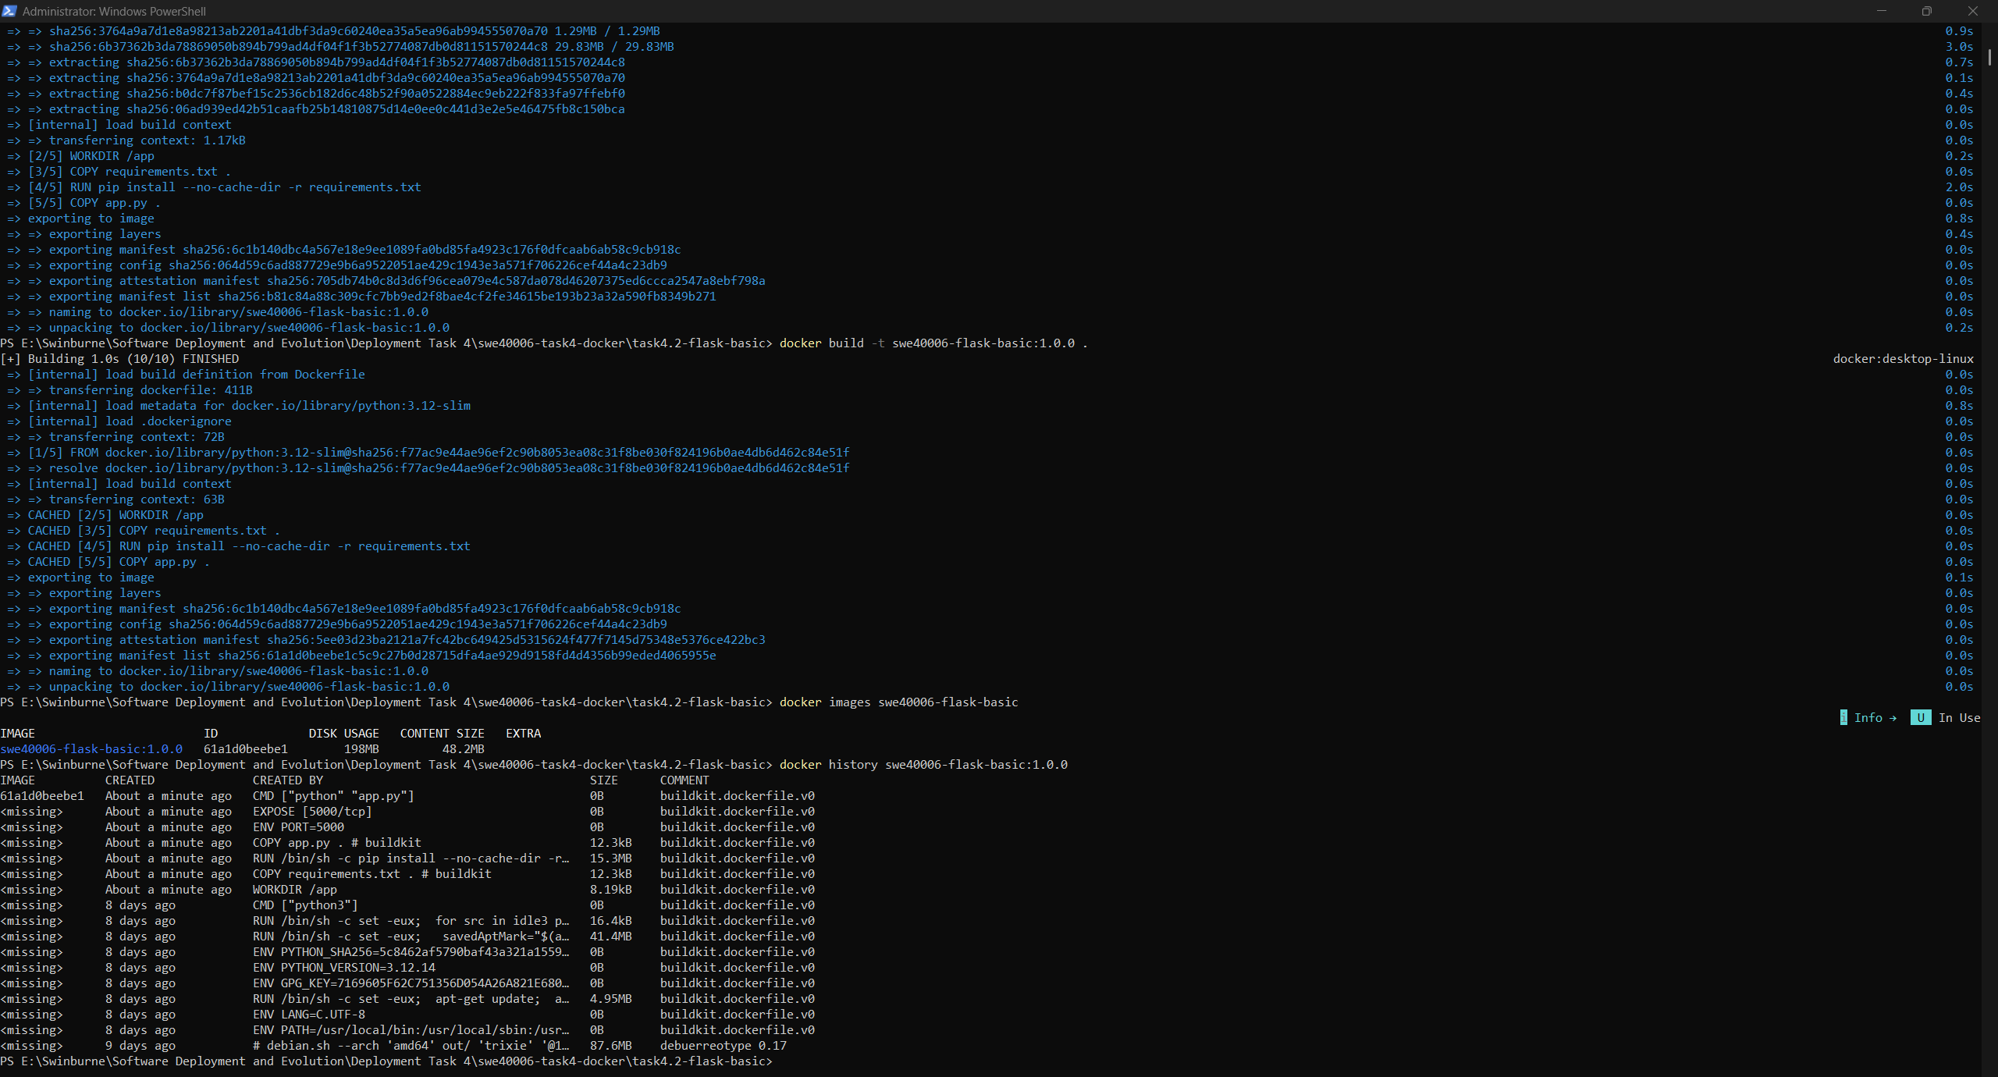
Figure 12: docker build output showing each Dockerfile step completing and the image being tagged
The resulting image is 48.2 MB. docker history shows one layer per instruction, confirming the layer ordering described above.
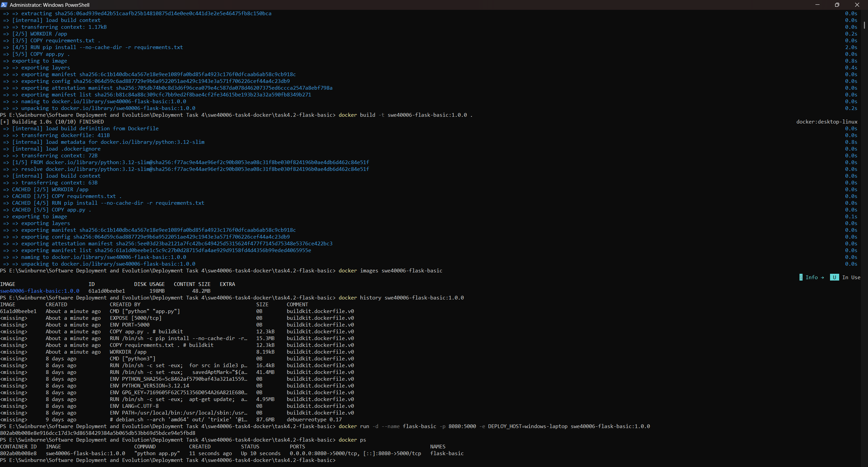
Figure 13: docker images and docker history for swe40006-flask-basic:1.0.0

4.5 Local Deployment on a Designated Port
docker run -d --name flask-basic -p 8080:5000 -e DEPLOY_HOST=windows-laptop swe40006-flask-basic:1.0.0
docker ps
curl.exe -i http://localhost:8080/health
docker logs flask-basic
-p 8080:5000 maps host port 8080 to container port 5000. Different numbers were used on purpose, to show that the host port is a deployment decision independent of the port the application listens on. The same image could run several times on one host by mapping different host ports. -d runs the container detached, and -e injects configuration at run time without changing the image.
Figure 14: docker ps showing the container Up with 0.0.0.0:8080->5000/tcp
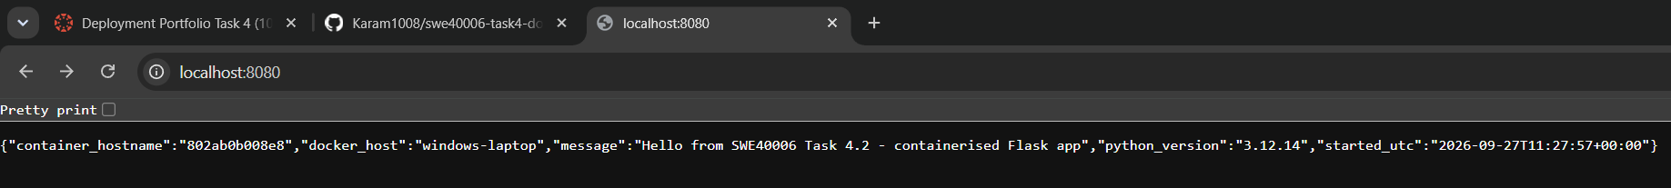
Figure 15: The application at http://localhost:8080 reporting docker_host windows-laptop
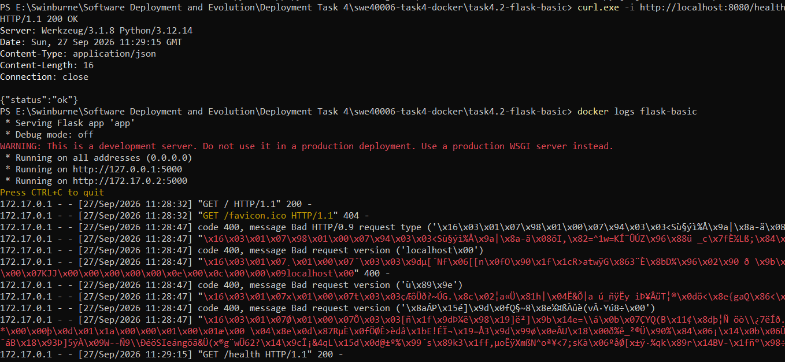
Figure 16: Health endpoint returning HTTP 200, and docker logs showing the Flask development-server warning
curl.exe was used explicitly because in Windows PowerShell curl is an alias for Invoke-WebRequest, which formats output differently. The container logs show Flask's own warning that its built-in server is not intended for production. That is noted here and resolved at Distinction level.

4.6 Publishing to Docker Hub
docker tag swe40006-flask-basic:1.0.0 karamjot1008/swe40006-flask-basic:1.0.0
docker tag swe40006-flask-basic:1.0.0 karamjot1008/swe40006-flask-basic:latest
docker push karamjot1008/swe40006-flask-basic:1.0.0
docker push karamjot1008/swe40006-flask-basic:latest
docker images --digests karamjot1008/swe40006-flask-basic
An image can be pushed only under the owning account's namespace, so the local image was re-tagged as karamjot1008/swe40006-flask-basic. Two tags were pushed. 1.0.0 is immutable by convention and is what gets deployed. latest is a convenience pointer that moves with each release, which is precisely why it is not used for deployment: two hosts pulling latest at different times could run different code.
The push reports a digest, the SHA-256 hash of the image manifest. Unlike a tag, a digest cannot be moved or reused. Any change to any layer produces a different digest, so comparing digests is a conclusive test of whether two hosts hold the same image.
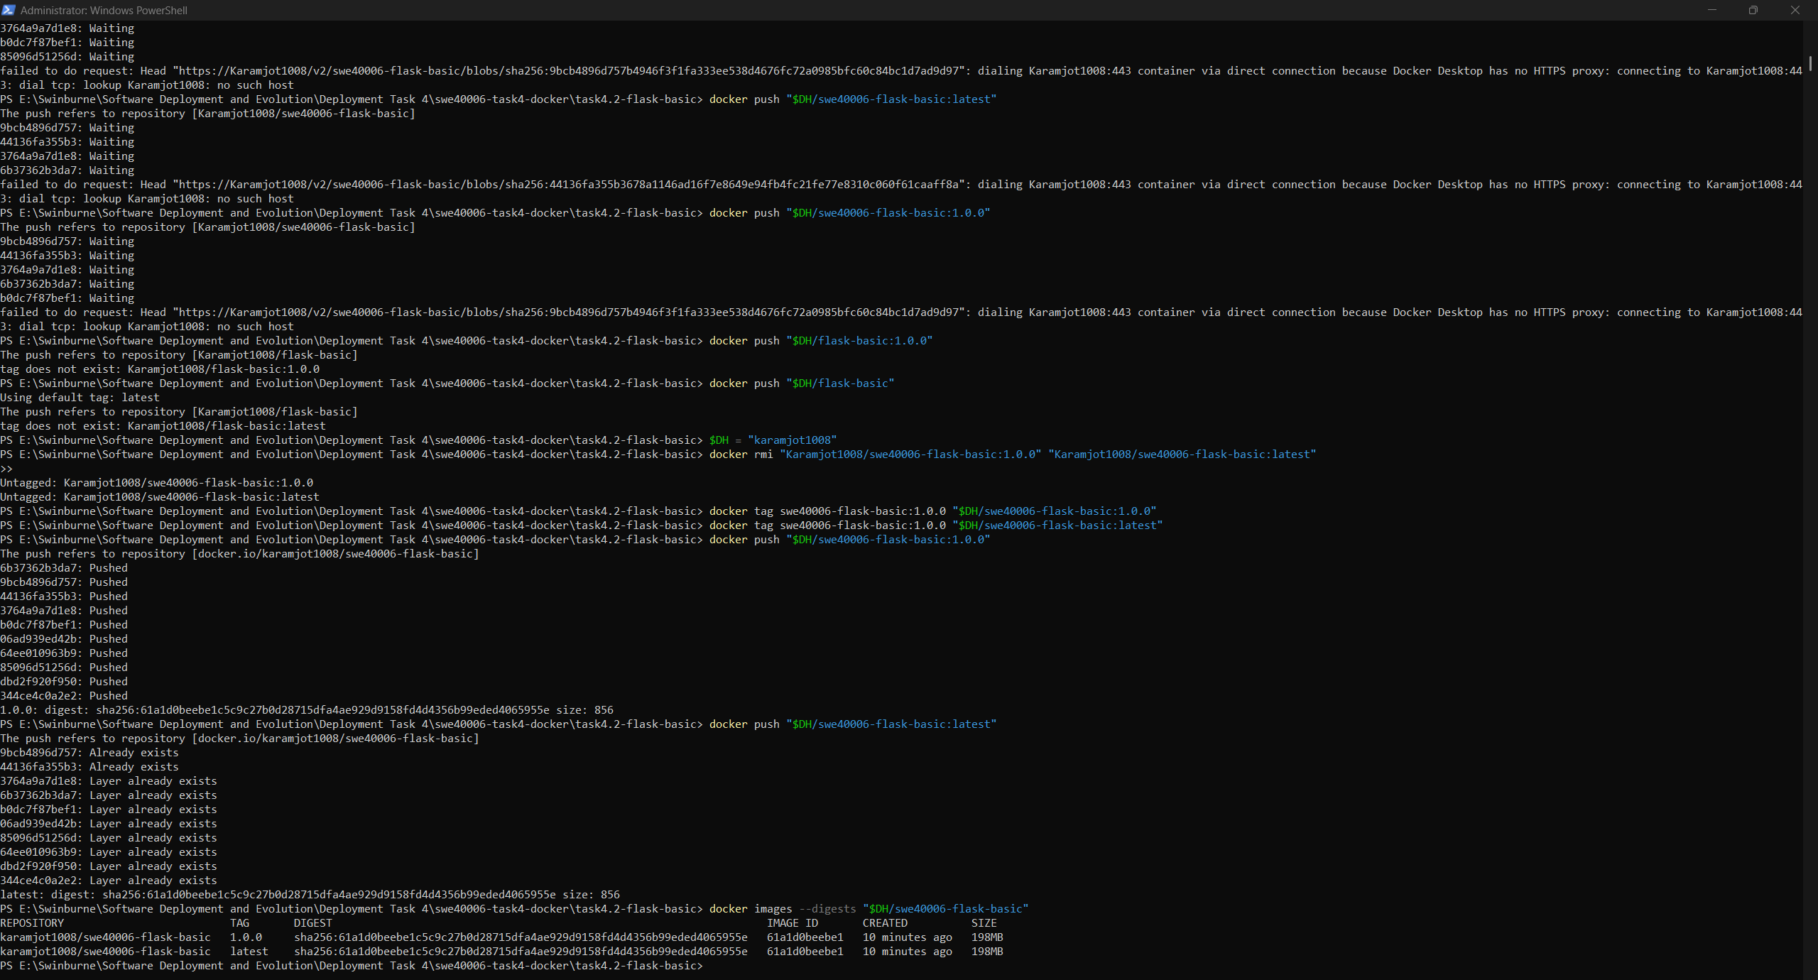
Figure 17: docker push uploading the layers and reporting the manifest digest
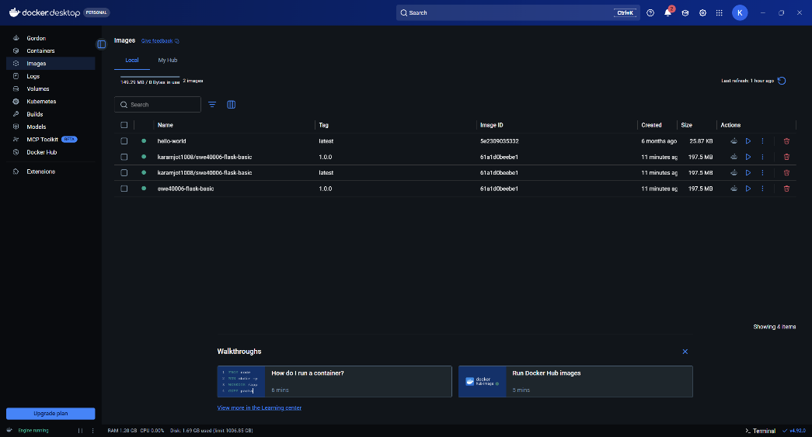
Figure 18: Public Docker Hub repository swe40006-flask-basic with tags 1.0.0 and latest
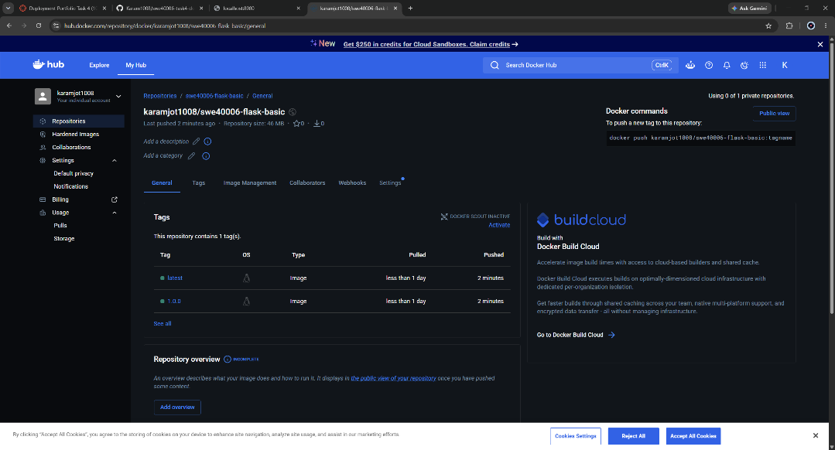
Figure 19: Public Docker Hub repository swe40006-flask-basic with tags 1.0.0 and latest

4.7 Secondary Docker Host Provisioning
The secondary host is an EC2 instance rather than a second local virtual machine. It is a genuinely separate machine with a different operating system (Amazon Linux 2023 rather than Docker Desktop's WSL 2 virtual machine), a different network and a public address. Distinction level requires public reachability, so the same host serves both levels.
Setting | Value | Rationale
AMI / type | Amazon Linux 2023, t3.micro | Free-tier eligible; SSM Agent preinstalled (as established in Task 3)
Key pair | None | No SSH is needed; administration is through Session Manager
Security group | swe40006-docker-host-sg: TCP 80, 443, 8080 from 0.0.0.0/0 | Only the application ports; the launch wizard's default SSH rule was removed
IAM role | swe40006-docker-host-role with AmazonSSMManagedInstanceCore only | Least privilege: the host needs Session Manager and nothing else; Docker Hub pulls of public images need no AWS permissions
User data | scripts/ec2-docker-host-userdata.sh | Installs and starts Docker and the Compose plugin on first boot
Public address | Elastic IP - 52.62.216.119 | Stays the same across stop/start, so grading URLs and the HTTPS hostname remain valid

The bootstrap script installs Docker from the Amazon Linux repository and enables the service. It adds ec2-user to the docker group so that Docker can be used without sudo. The Docker Compose v2 plugin is not packaged for Amazon Linux 2023, so the script downloads the official release binary for the architecture reported by uname -m. This lets the same script work unchanged on x86 (t3) and Graviton (t4g) instances.
dnf install -y docker git
systemctl enable --now docker
usermod -aG docker ec2-user
ARCH="$(uname -m)"
curl -fsSL "https://github.com/docker/compose/releases/latest/download/docker-compose-linux-${ARCH}" \
-o /usr/local/lib/docker/cli-plugins/docker-compose
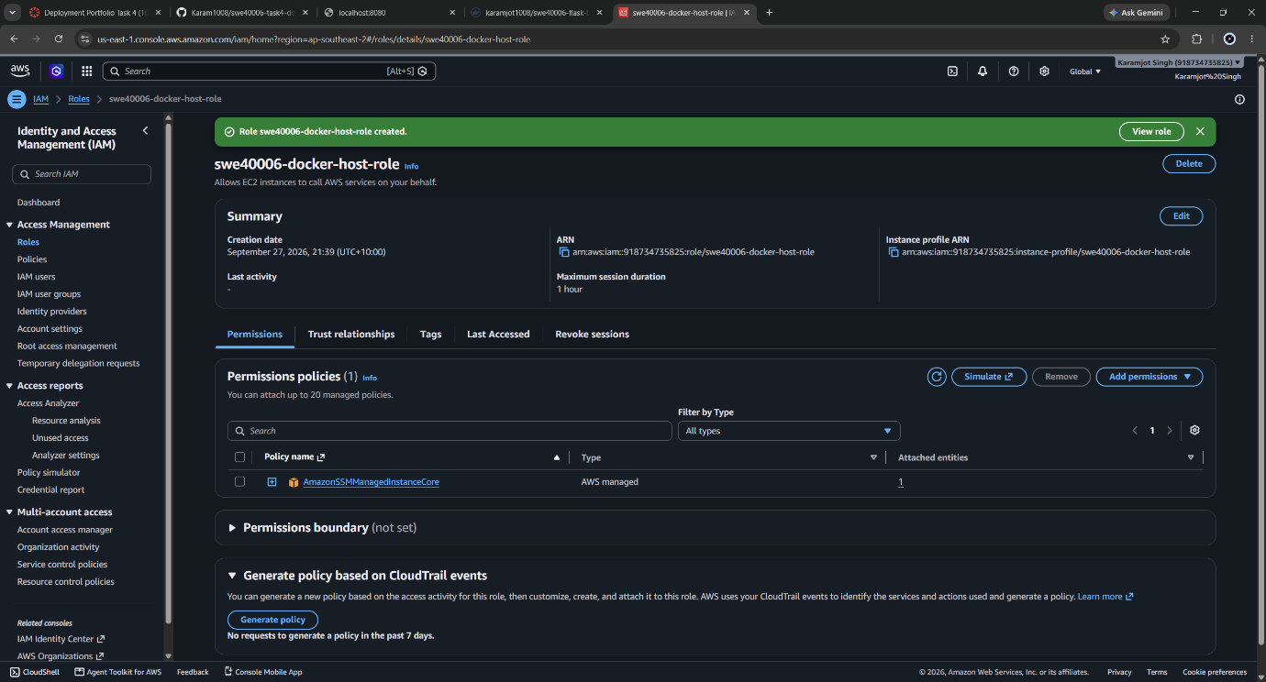
Figure 20: IAM role swe40006-docker-host-role with AmazonSSMManagedInstanceCore as its only policy
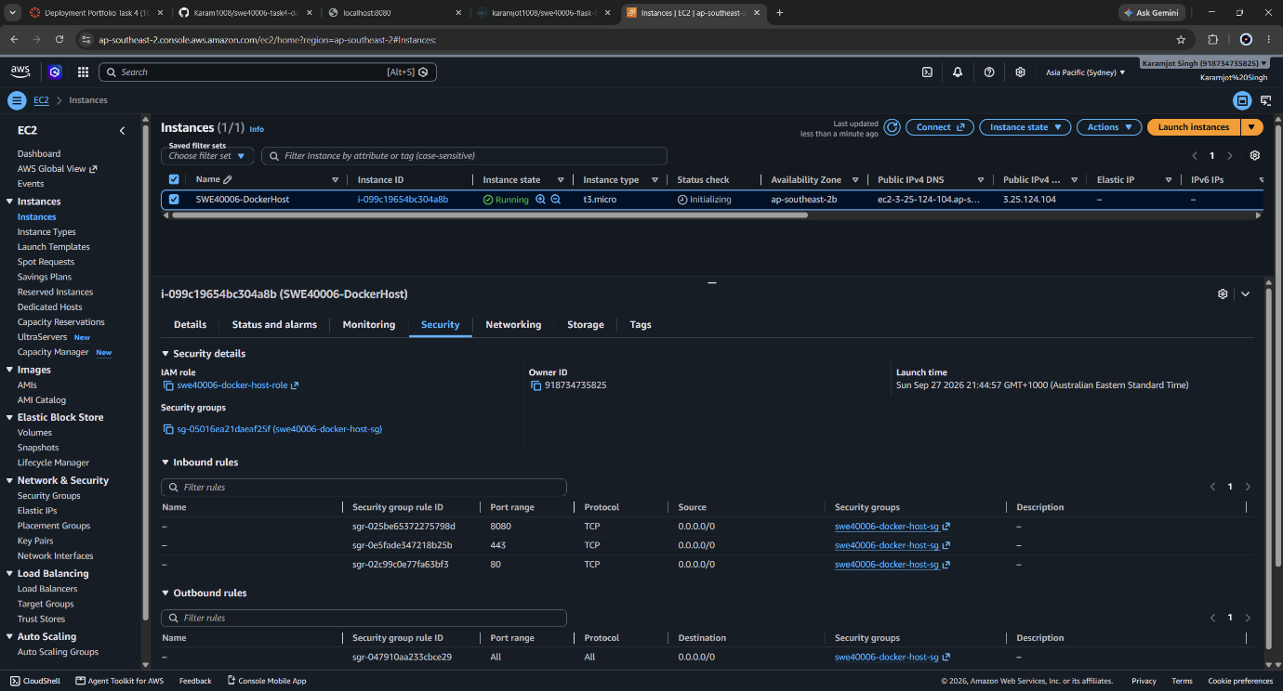
Figure 21: Inbound rules of swe40006-docker-host-sg: 80, 443 and 8080 only, no port 22
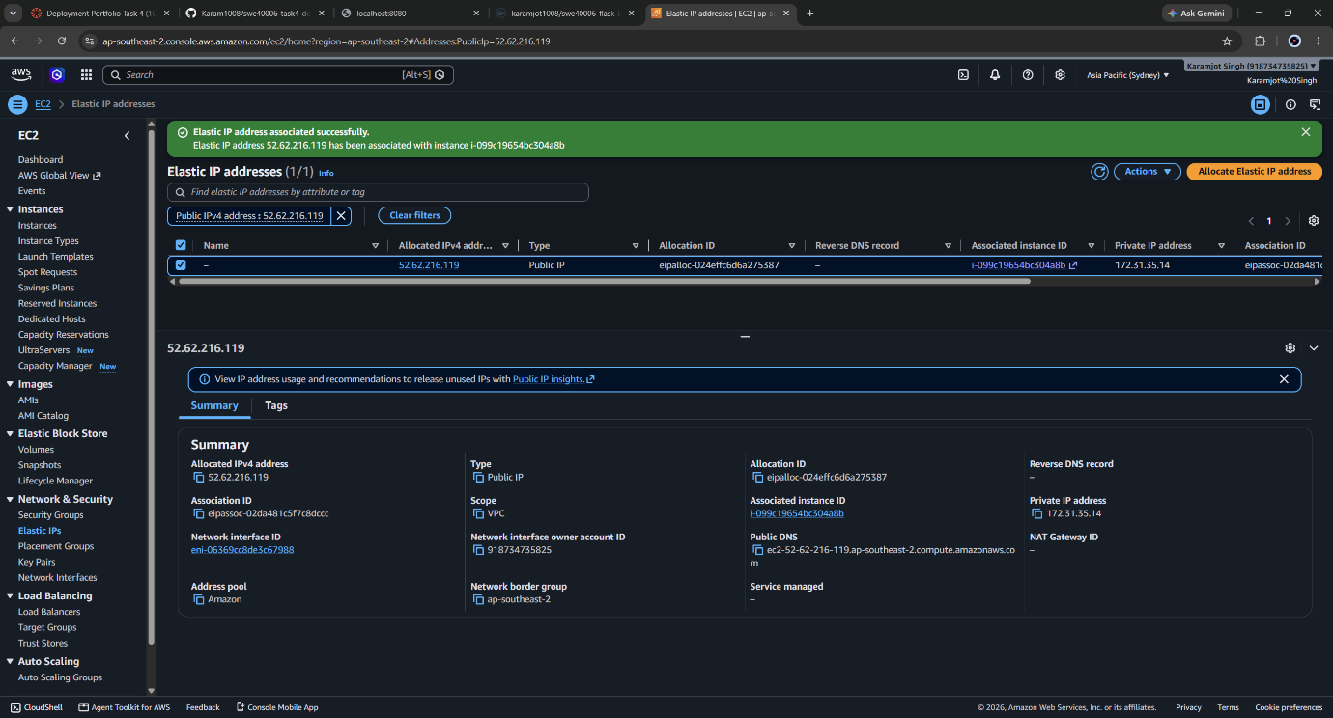
Figure 22: SWE40006-DockerHost details showing the Elastic IP, instance type and IAM role
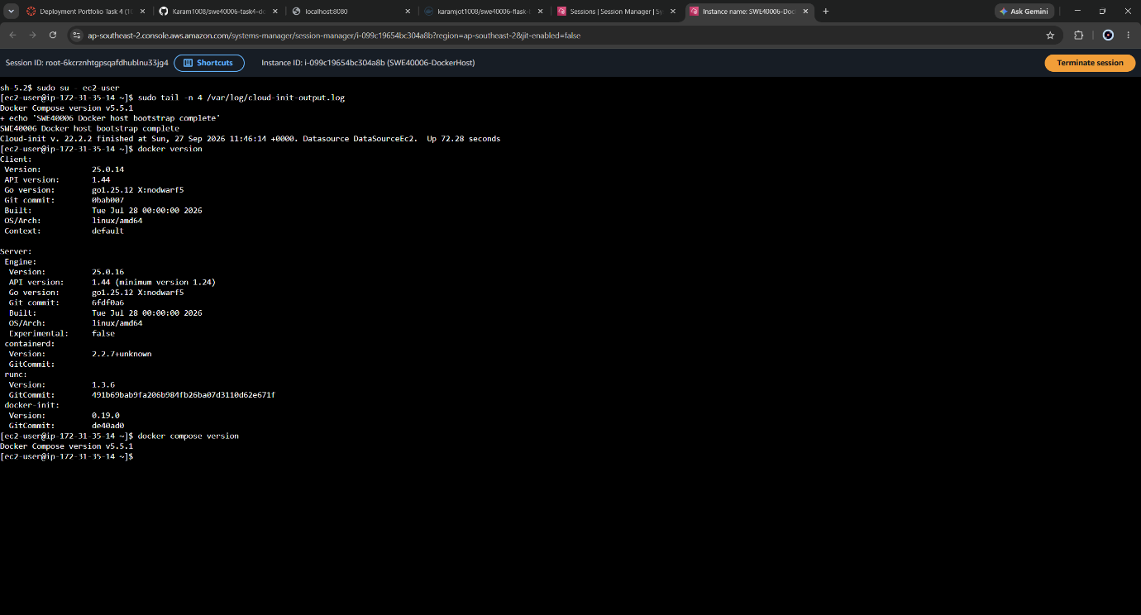
Figure 23: Session Manager session confirming bootstrap completion and the Docker Engine and Compose versions

4.8 Multi-Host Verification
# Host 2 - Session Manager, as ec2-user
docker pull karamjot1008/swe40006-flask-basic:1.0.0
docker images --digests karamjot1008/swe40006-flask-basic
docker run -d --name flask-basic --restart unless-stopped \
-p 8080:5000 -e DEPLOY_HOST=aws-ec2 karamjot1008/swe40006-flask-basic:1.0.0
The digest on Host 2 is identical to the one recorded on Host 1, which proves the image is byte-for-byte the same artefact rather than a similar rebuild. The browser response then shows docker_host: aws-ec2 and a container hostname different from the figure above, which proves a separate container on a separate host is serving the same code. --restart unless-stopped keeps the container running across instance reboots and Docker daemon restarts during the grading period.
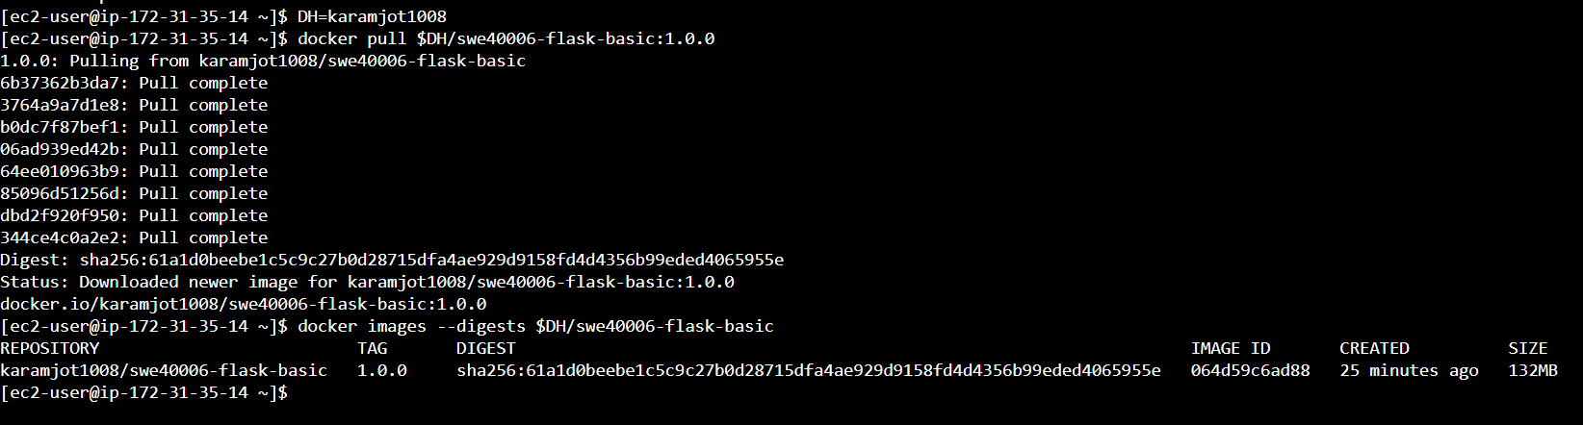
Figure 24:docker pull on Host 2 and a digest
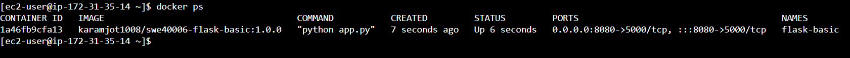
Figure 25: docker ps on Host 2 showing the container running with port 8080 published
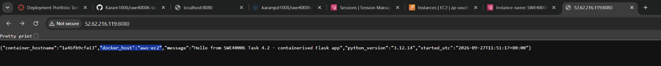
Figure 26: The same image served publicly from Host 2 at http://52.62.216.119.8080

4.9 Weaknesses of the Credit-Level Design
The deployment meets the Credit requirements but has five weaknesses, each addressed at Distinction level:
- The process runs as root inside the container, so a compromise of the application gives root within the container.
- It uses Flask's development server, which is single-process and, as its own warning states, not intended for production.
- There is no health check. Docker reports the container as Up as long as the process exists, even if it has stopped answering requests.
- It is a single stateless container. A real web application needs state, and state needs storage that outlives the container.
- Configuration is two environment variables typed on the command line, with no repeatable definition of how the container should be run.

5. Task 4.3 - Distinction Level: Custom Web Application with an Optimised Build
Objective: develop a new custom web application, write an optimised Dockerfile, deploy it to a containerised environment with exposed network ports, configure container networking and environment variables, and verify public accessibility over HTTP/HTTPS.

5.1 Application Design
DockNotes is a small deployment notes board written with FastAPI. Visitors add short notes, which are stored in Redis together with a visit counter. The page header shows which container served the request, the image version and the configured environment. These values make the container runtime visible in the browser in the same way the Credit application does in JSON.
Route | Behaviour
GET / | Renders notes, the container information panel and the visit counter
POST /notes | Validates the note (at most 280 characters), stores it, then redirects with HTTP 303
GET /api/info | JSON: container hostname, version, environment, Redis reachability, counters
GET /healthz | Liveness probe used by the image's HEALTHCHECK

Three application-level decisions support a reliable deployment:
- Post/Redirect/Get. The 303 redirect after a POST means refreshing the page never resubmits a note.
- Escaped output. User input is HTML-escaped by Jinja2's autoescaping. A test note containing a <script> tag was displayed as plain text, not executed.
- Graceful degradation. If Redis is unreachable, the page explains the fault and names the Redis host instead of returning an HTTP 500 error.

5.2 Service Architecture
The application runs as three services defined in compose.yaml:
Service | Image | Role | Ports | Networks
proxy | caddy:2-alpine | Reverse proxy, TLS termination, security headers | 80, 443 published | frontend
web | Karamjot1008/swe40006-docknotes:1.0.0 | FastAPI application under uvicorn (2 workers) | 8000 exposed only | frontend, backend
redis | redis:7-alpine | Notes and counter store, append-only persistence | none | backend

A reverse proxy gives the stack one public entry point, similar to the Application Load Balancer in Task 3. Caddy terminates TLS, compresses responses, adds X-Content-Type-Options, X-Frame-Options and Referrer-Policy headers, and removes the Server header. This keeps TLS and header concerns out of the application image, so the image does not change when the certificate or domain does.

5.3 Optimised Dockerfile
# ---------- Stage 1: builder ----------
FROM python:${PYTHON_VERSION}-slim AS builder
ENV PIP_NO_CACHE_DIR=1 PIP_DISABLE_PIP_VERSION_CHECK=1
COPY requirements.txt .
RUN python -m venv /opt/venv && /opt/venv/bin/pip install -r requirements.txt

# ---------- Stage 2: runtime ----------
FROM python:${PYTHON_VERSION}-slim AS runtime
ENV PYTHONDONTWRITEBYTECODE=1 PYTHONUNBUFFERED=1 PATH="/opt/venv/bin:$PATH"
RUN groupadd --system app && useradd --system --gid app --no-create-home app
COPY --from=builder /opt/venv /opt/venv
COPY app/ ./app/
USER app
EXPOSE 8000
HEALTHCHECK --interval=30s --timeout=3s --start-period=10s --retries=3 \
CMD ["python", "-c", "import urllib.request; urllib.request.urlopen('http://127.0.0.1:8000/healthz', timeout=2)"]
CMD ["uvicorn", "app.main:app", "--host", "0.0.0.0", "--port", "8000", "--workers", "2", "--proxy-headers", ...]
Technique | Effect
Slim base image | Removes compilers, headers and documentation present in the full python:3.12 image (measured in Section 5.4)
Multi-stage build | Dependencies are installed into a virtual environment in the builder stage, and only /opt/venv is copied to the runtime stage. Build tooling and caches never reach the final image
Dependency layer before code | A code change does not reinstall dependencies
PIP_NO_CACHE_DIR, PYTHONDONTWRITEBYTECODE | No pip cache or .pyc files are written into image layers
.dockerignore | Excludes .git, .env, caches and Dockerfiles from the build context, so secrets cannot be copied into a layer by accident
Non-root user app | Fixes the Credit-level weakness: a compromised process has no root privileges in the container
HEALTHCHECK with the Python standard library | Lets Docker detect a hung application without adding curl to the image just for probing
uvicorn with 2 workers, exec-form CMD | Production ASGI server replaces the development server; --proxy-headers preserves the client's scheme and IP behind Caddy; uvicorn is PID 1 and receives SIGTERM
Pinned versions, OCI labels | Reproducible dependency resolution; source repository recorded in image metadata

5.4 Measured Effect of the Optimisation
To quantify the optimisation, the same application was also built from Dockerfile.naive, a conventional single-stage file using the full python:3.12 base and COPY . .:
docker build -f Dockerfile.naive -t docknotes:naive .
docker compose build
docker images --format "table {{.Repository}}:{{.Tag}}`t{{.Size}}" | Select-String docknotes
Image | Dockerfile | Size
docknotes:naive | Single stage, python:3.12 | 1.65 GB
Karamjot1008/swe40006-docknotes:1.0.0 | Multi-stage, python:3.12-slim, non-root | 221 MB

A smaller image pulls faster onto Host 2, consumes less registry storage and, more importantly, contains fewer packages that could carry vulnerabilities. The naive image ships a full compiler toolchain that the running application never uses.
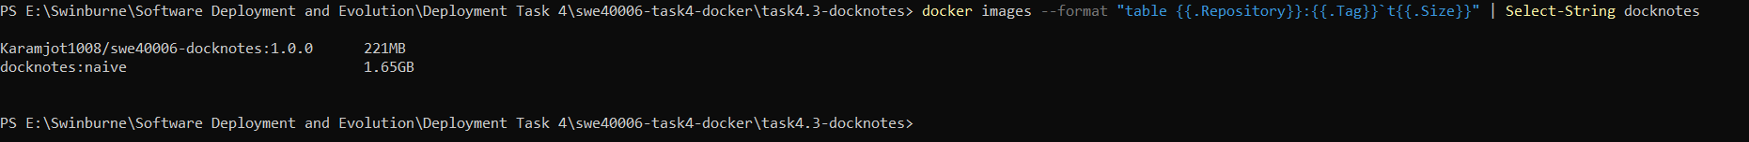
Figure 27: Image size comparison: naive single-stage build versus optimised multi-stage build
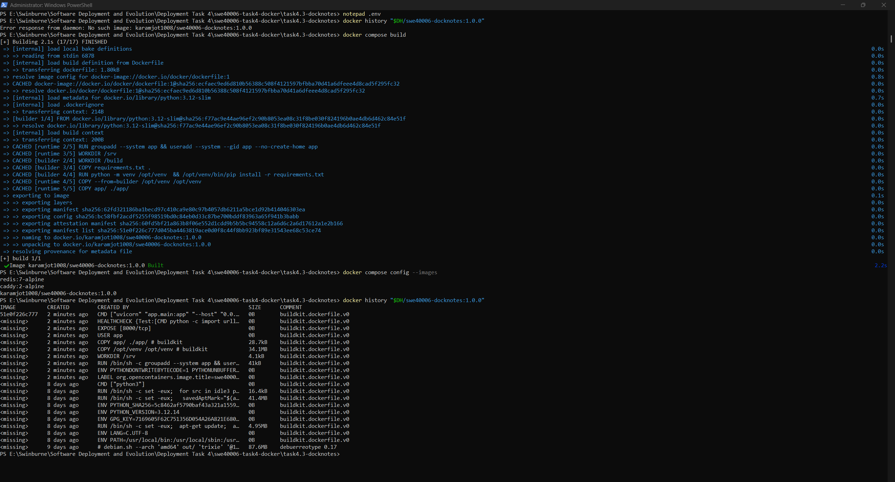
Figure 28: docker history of the optimised image showing only runtime layers
Layer caching was demonstrated by adding a comment to app/main.py and rebuilding. The dependency installation step was reported as CACHED and the rebuild completed. The comment was then discarded in GitHub Desktop and the image rebuilt, so that the published image matches the repository.

5.5 Local Deployment and Health Checks
docker compose up -d
docker compose ps
curl.exe http://localhost/api/info
docker compose logs --tail 15 proxy web
Start-up order is driven by health, not just by process start. Redis has a redis-cli ping health check. The web image has its own HEALTHCHECK. depends_on: condition: service_healthy makes web wait for a healthy Redis, and proxy wait for a healthy web. Without this, Caddy could start forwarding requests before uvicorn was ready, and the first visitors would receive 502 errors.
/healthz deliberately returns HTTP 200 even when Redis is down, and reports Redis status in the response body instead. It is a liveness probe, answering whether this container needs restarting. A Redis outage is not fixed by restarting the web container, and treating it as a web failure would add restart churn to an unrelated fault. restart: unless-stopped on every service restores the stack after a crash or host reboot.
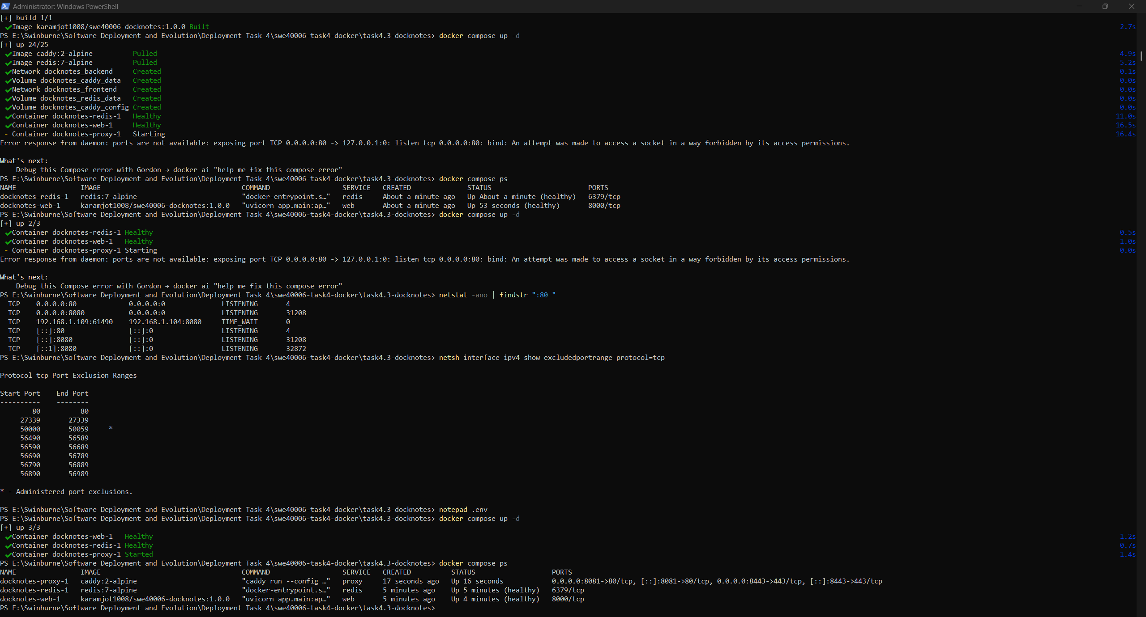
Figure 29: docker compose ps: web and redis healthy, only proxy publishing ports
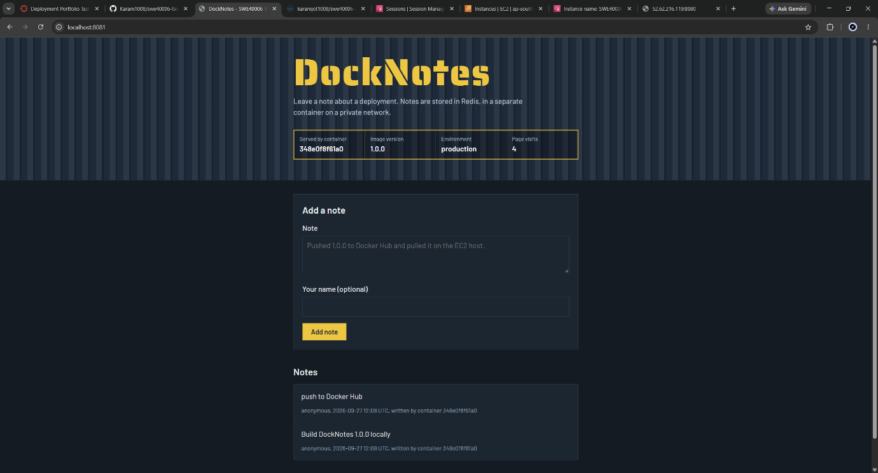
Figure 30: DockNotes at http://localhost showing the container information panel and saved notes
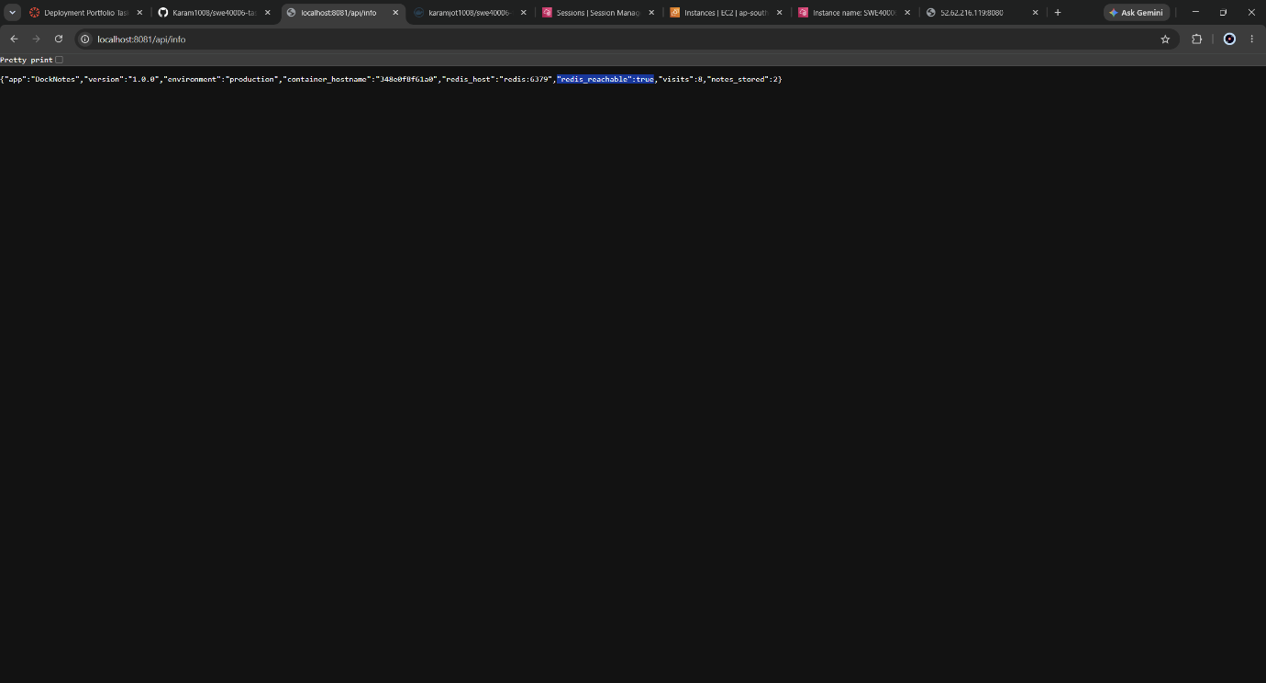
Figure 31: /api/info reporting container identity and redis_reachable: true
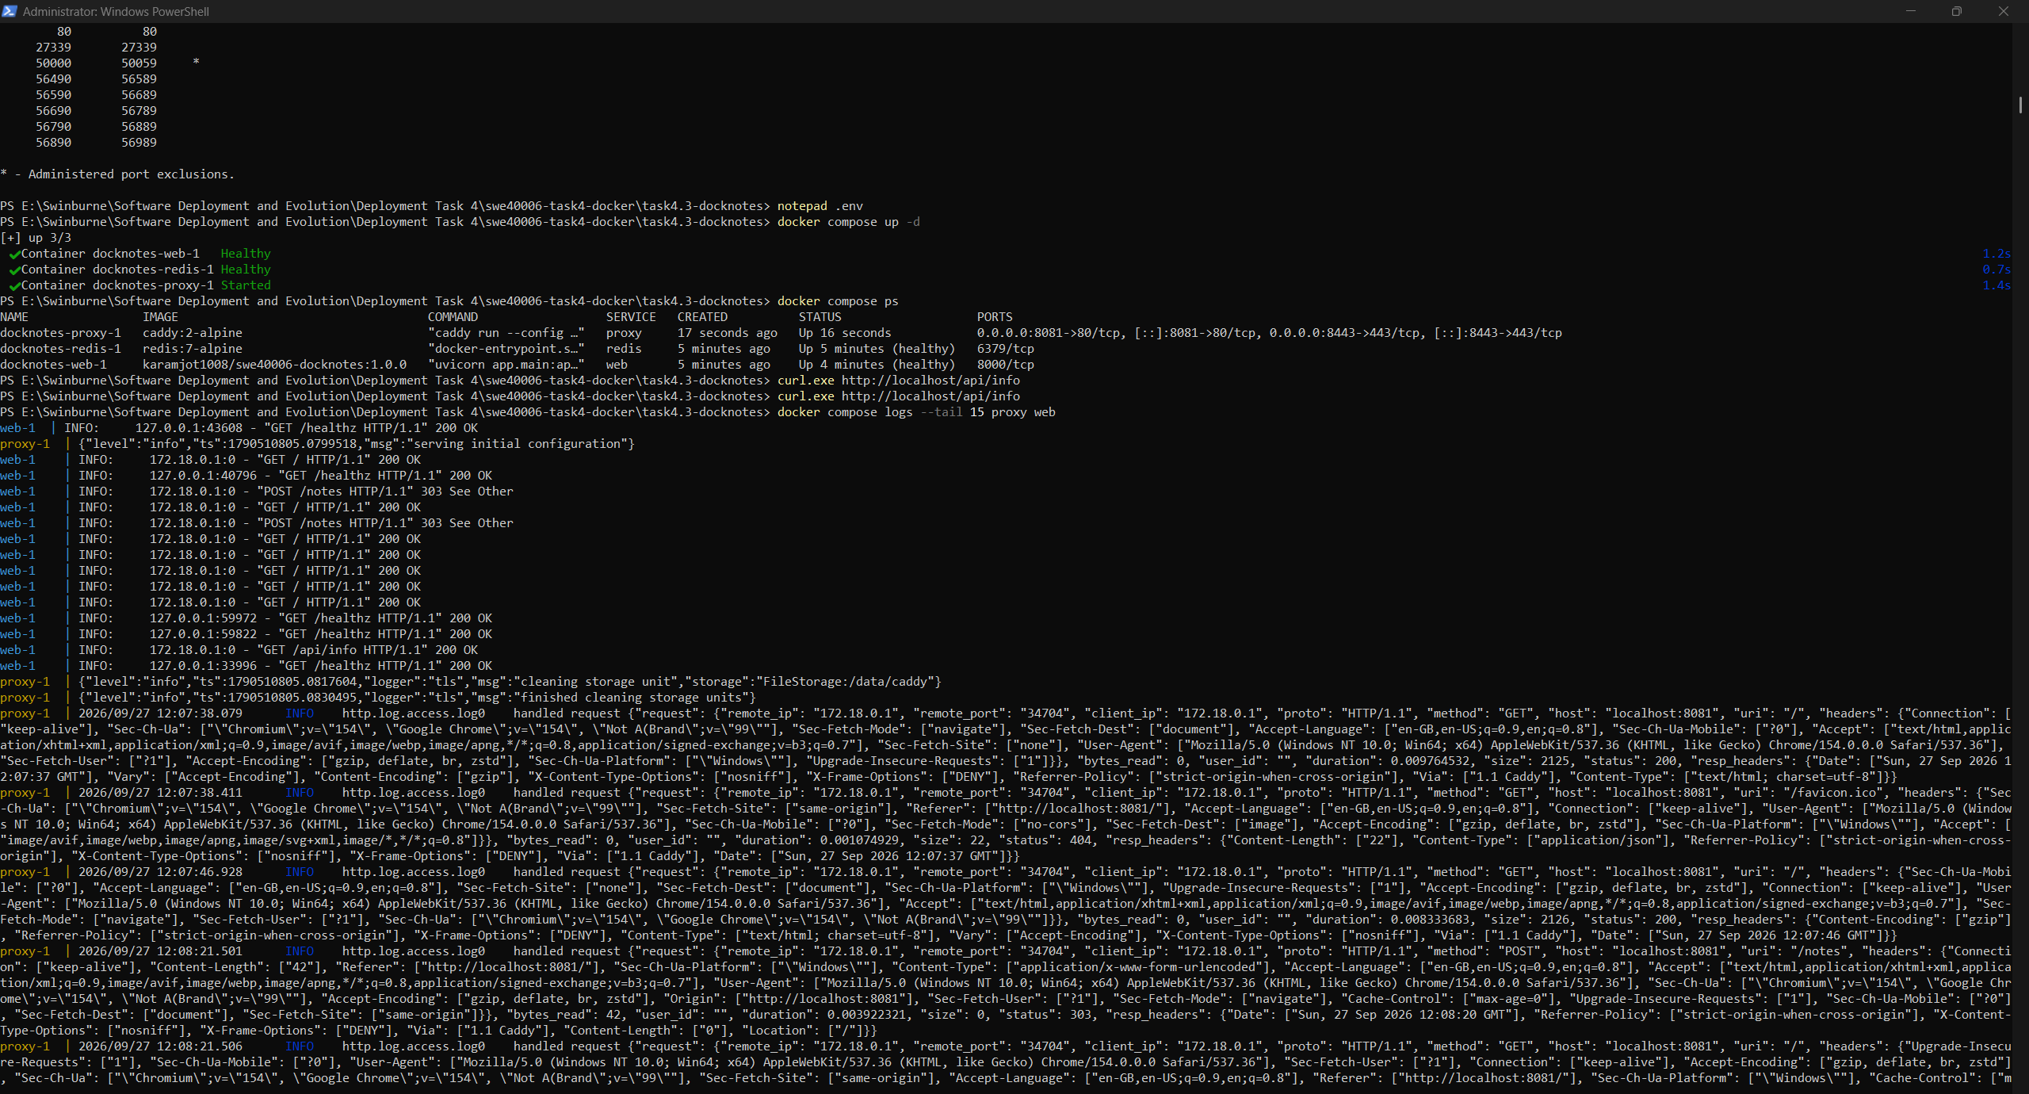
Figure 32: Caddy access logs and uvicorn start-up logs collected by docker compose logs

5.6 Container Networking
Network | Internal | Members | Purpose
docknotes_frontend | No | proxy, web | Carries proxied HTTP from Caddy to the application
docknotes_backend | Yes | web, redis | Carries Redis traffic; no route to or from outside Docker

User-defined bridge networks provide DNS-based service discovery, which the default bridge network does not: a container can reach another by its service name. The application is configured with REDIS_HOST=redis, and Docker's embedded DNS resolves that name to the Redis container's current IP address. The address can change on every recreation, so hard-coding IPs would break.
Marking the backend internal: true removes its gateway to the outside world. Redis cannot be reached from the host or the internet, and cannot initiate outbound connections. Only the proxy publishes ports; the web service uses expose, which documents the port without publishing it. This mirrors the Task 3 design, where each security group admitted traffic only from the tier directly above it.
docker network inspect docknotes_backend --format "internal={{.Internal}} containers={{range .Containers}}{{.Name}} {{end}}"
docker compose exec web python -c "import socket; print('redis ->', socket.gethostbyname('redis'))"
docker compose exec proxy wget -q -T 3 -O- http://redis:6379 # expected to fail
curl.exe -m 3 http://localhost:8000 # expected to fail
Web resolves redis to a private address. The proxy cannot even resolve the name, because it is not attached to the backend network. The web container's port 8000 is unreachable from the host. The two failures are the intended result: they are the evidence that isolation is enforced by configuration, not merely assumed.
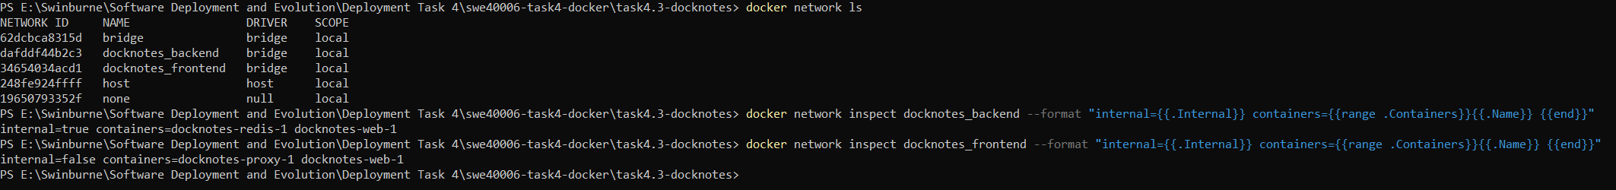
Figure 33: Network inspection: backend is internal with only web and redis attached
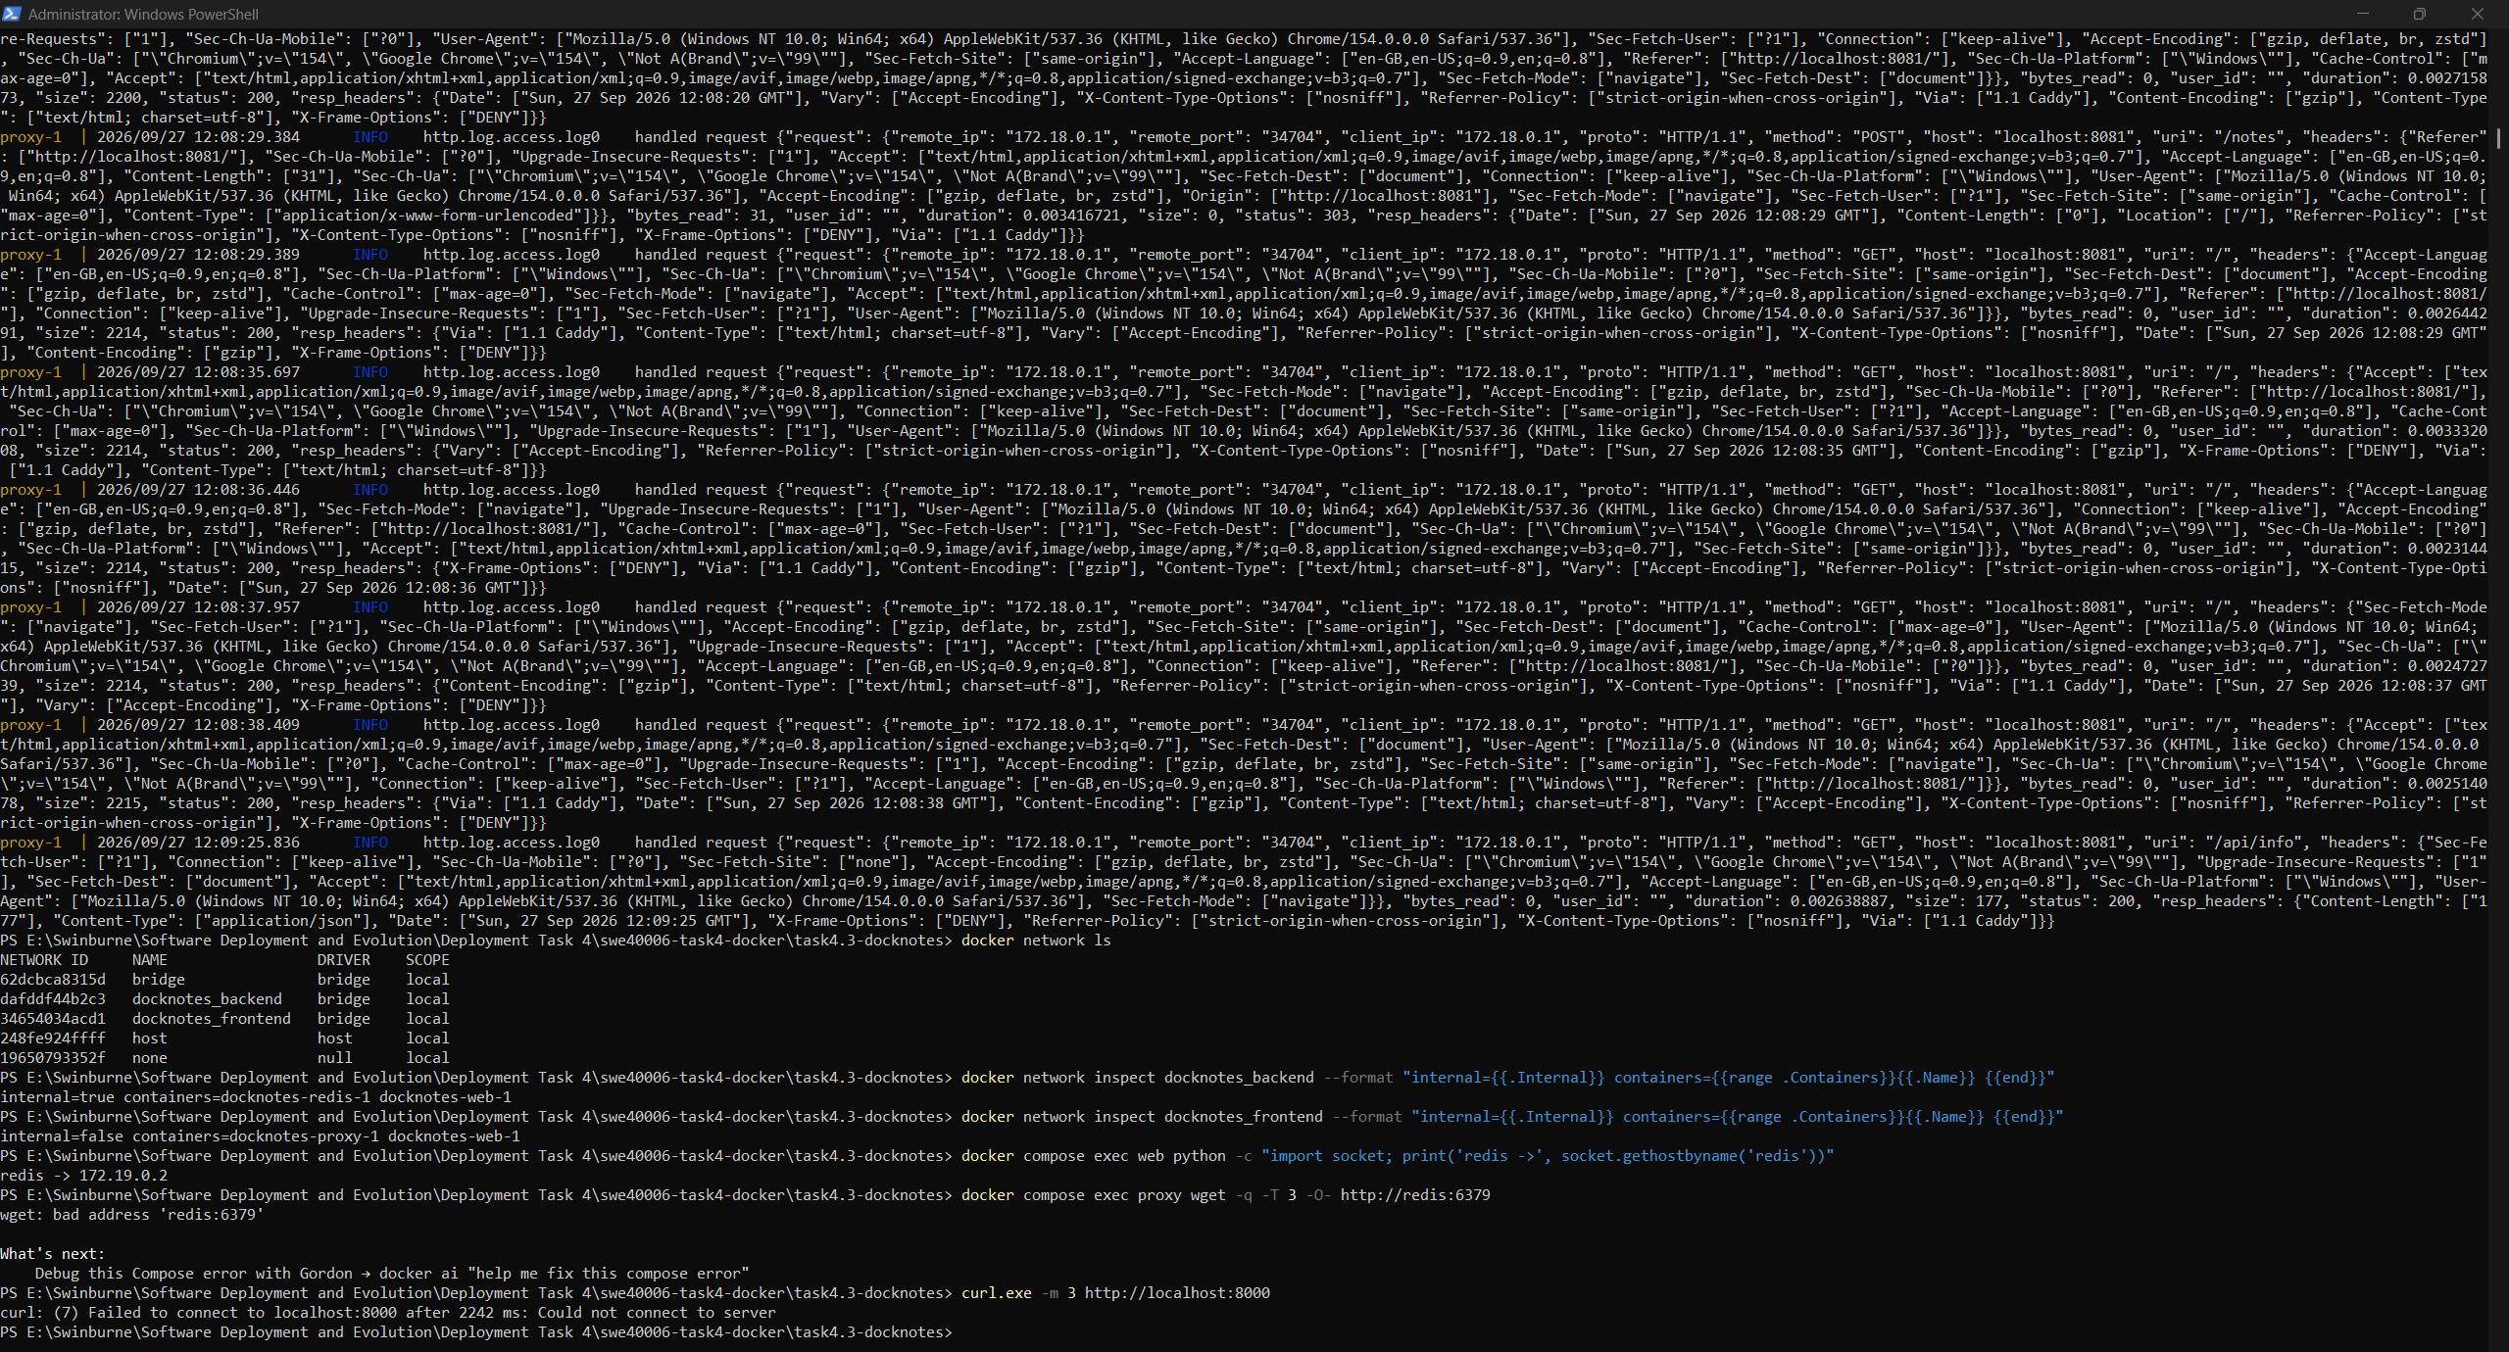
Figure 34: Isolation tests: web resolves redis; proxy cannot; port 8000 is not published to the host

5.7 Environment Variable Configuration
Variable | Source | Effect
DOCKERHUB_USER, APP_VERSION | .env (Compose substitution) | Image name and tag to build, push and pull
APP_ENV, MAX_NOTES | .env, passed into web | Runtime behaviour shown on the page
SITE_ADDRESS | .env, passed into proxy | :80 for HTTP, or a hostname for automatic HTTPS
HTTP_PORT, HTTPS_PORT | .env (port mapping) | Host ports, adjustable if 80/443 are in use
REDIS_HOST, REDIS_PORT | compose.yaml | Service discovery by name on the backend network

Compose reads .env automatically for variable substitution. .env.example is committed as a template, while .env itself is git-ignored and excluded from the build context. Configuration therefore lives outside the image: one image serves every environment, and nothing environment-specific is baked into a layer. ${DOCKERHUB_USER:?Set DOCKERHUB_USER in .env} makes Compose stop with a clear message rather than silently building an image under a blank namespace.
To demonstrate this, APP_ENV was changed to staging and docker compose up -d re-run. Compose recreated only the web container, and the page reported the new value without any rebuild. The same step confirmed the process runs as the non-root app user.
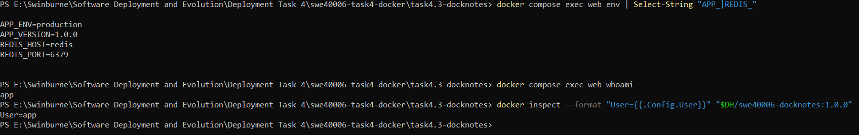
Figure 35: Environment variables inside the web container, and whoami returning app
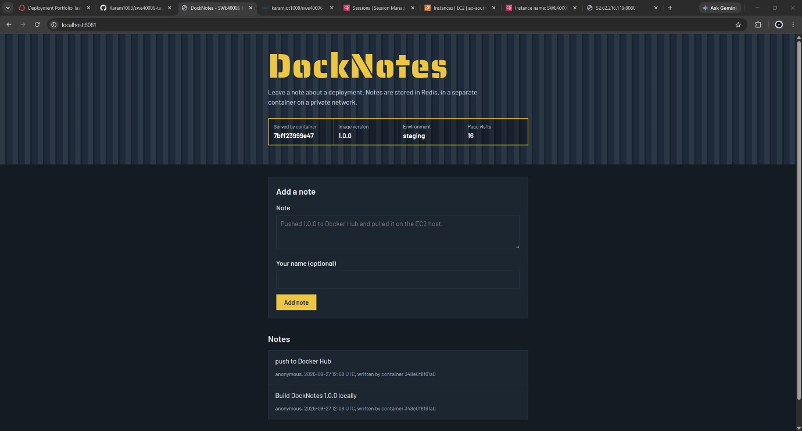
Figure 36: Configuration change applied without rebuilding: the page now reports staging and Notes still present after docker compose down and up

5.8 Persistence Across Container Recreation
Redis runs with --appendonly yes, writing every change to an append-only file on the redis_data named volume. docker compose down removes the containers and networks but keeps named volumes unless -v is given. After a full down/up cycle, all notes were still present.

5.9 Publishing to Docker Hub
docker compose push web
Only the web image is custom. The proxy and Redis images are official images that Host 2 pulls directly from Docker Hub. The compressed size shown on Docker Hub, smaller than the local figure because layers are stored compressed.
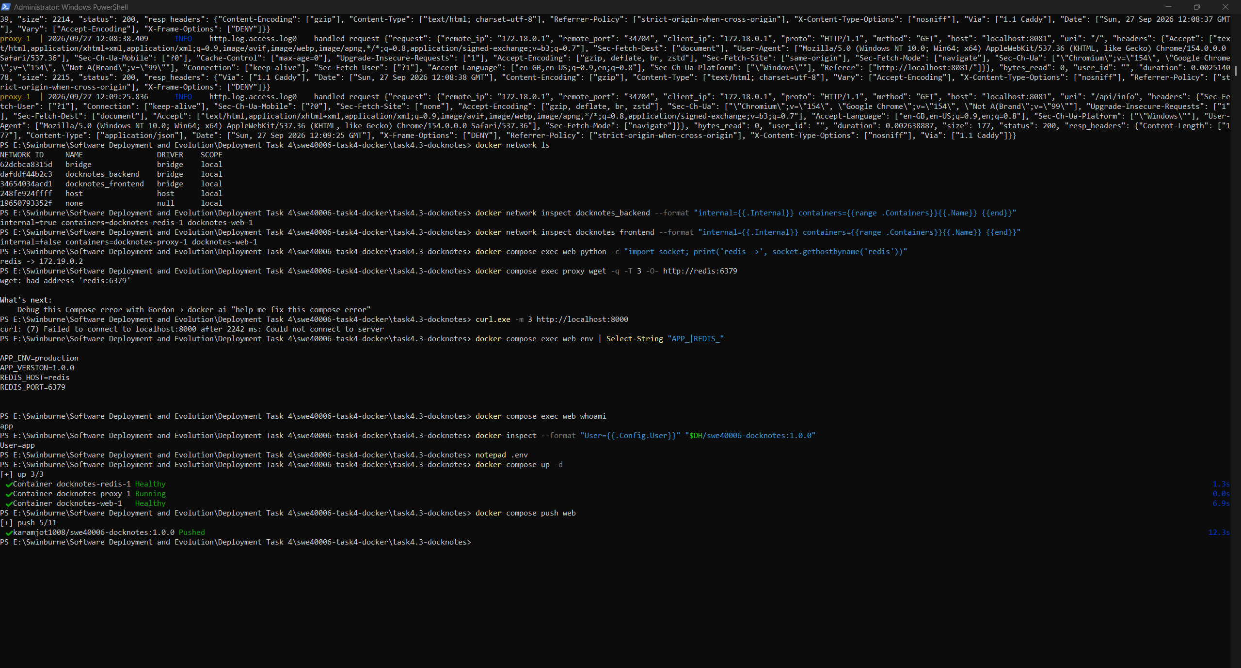
Figure 37: Docker Hub repository swe40006-docknotes with tag 1.0.0

5.10 Public Deployment on the Secondary Host
git clone https://github.com/Karam1008/swe40006-task4-docker.git
cd swe40006-task4-docker/task4.3-docknotes
cp .env.example .env && nano .env # DOCKERHUB_USER, SITE_ADDRESS=:80
docker compose pull
docker compose up -d --no-build
docker compose ps
Host 2 needs only three small files: compose.yaml, Caddyfile and .env. --no-build guarantees that every container comes from the registry. If an image were missing, the command would fail instead of quietly building a different one on the server. The public page reports a container hostname different from the one on Host 1, and a note added through the public page was stored and displayed.
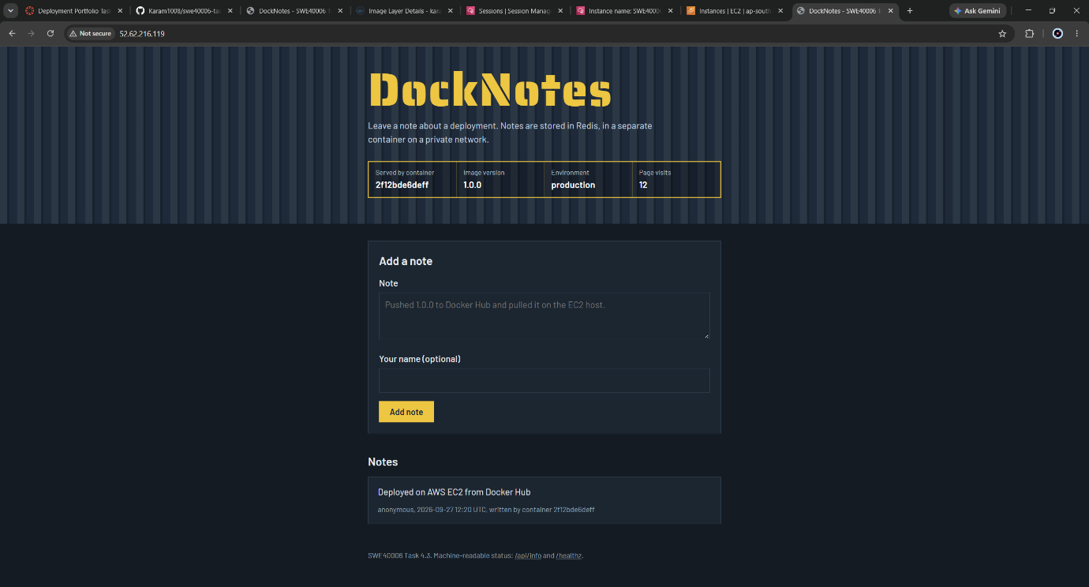
Figure 38: DockNotes served publicly at http://52.62.216.119

5.11 HTTPS with Automatic Certificates
Task 3 identified the lack of HTTPS as its most significant weakness, because a certificate requires a domain name that can be validated. That was resolved here without purchasing a domain. sslip.io is a public wildcard DNS service that resolves 52.62.216.119.sslip.io to 52.62.216.119, giving the Elastic IP a publicly resolvable hostname. With SITE_ADDRESS set to that hostname, Caddy's automatic HTTPS obtains a certificate through the ACME protocol, redirects HTTP to HTTPS, and renews the certificate before it expires. Certificates are stored on the caddy_data volume, so recreating the proxy container does not request a new certificate and does not exhaust issuance rate limits.
The switch from HTTP to HTTPS was a single environment variable, with no change to the application image. This is the separation of concerns intended when TLS was placed in the proxy rather than in the application.
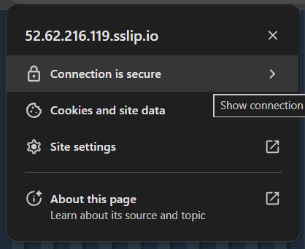
Figure 39: DockNotes served over HTTPS with a valid certificate

6. Task 4.4 - High Distinction Level: Containerised Non-Web Application
Objective: design and implement a simple non-web application, containerise it using Docker best practices, handle persistent volume storage or host mounts, and verify correct container lifecycle execution through logs.

6.1 Tool Design
logalyzer is a command-line tool that analyses web server access logs in the Combined Log Format used by Apache, Nginx and most load balancers. This is the log format the web tiers in Task 3 and in this task produce. For each input file it reports request volume, status-code classes, error rate, top paths, top client IPs, the most frequent errors, requests per hour and bytes served. It writes each report as both JSON (for machines) and Markdown (for people). It uses only the Python standard library, so the image installs no third-party packages.
Sub-command | Behaviour
analyze [files] | Analyses the given files, or every *.log in the input directory, then exits
watch --interval N | Long-running: scans the input directory every N seconds and analyses each new file once
history | Lists previous runs recorded on the state volume
generate-sample | Writes a reproducible synthetic access log (seeded) for demonstration

Exit code | Meaning
0 | Success
1 | Unexpected error, including an unwritable mount
2 | Usage error or no input files found
3 | An input's error rate exceeded --fail-on-error-rate

Exit codes are the interface a non-web container presents to whatever runs it. A CI pipeline, cron job or scheduler cannot read a report, but it can branch on exit code 3 to raise an alert. Logging is structured key=value lines written to stdout. Docker collects a container's stdout and stderr as its logs, so writing log files inside the container would hide them from docker logs and lose them when the container is removed.

6.2 Dockerfile and Container Best Practices
FROM python:${PYTHON_VERSION}-slim AS base
ENV PYTHONDONTWRITEBYTECODE=1 PYTHONUNBUFFERED=1

FROM base AS test
COPY logalyzer/ ./logalyzer/
COPY tests/ ./tests/
RUN python -m unittest discover -s tests -v

FROM base AS runtime
ARG APP_UID=10001
RUN useradd --system --uid ${APP_UID} --no-create-home --shell /usr/sbin/nologin logalyzer \
&& mkdir -p /data/input /data/output /data/state && chown -R logalyzer:logalyzer /data
COPY logalyzer/ ./logalyzer/ # owned by root: the app cannot modify its own code
ENV INPUT_DIR=/data/input OUTPUT_DIR=/data/output STATE_DIR=/data/state
USER logalyzer
ENTRYPOINT ["python", "-m", "logalyzer"]
CMD ["--help"]
Practice | Implementation | Reason
Tests at build time | test stage runs the unit tests | Broken code cannot produce a tested image
Minimal runtime | Slim base; standard library only; no pip install | No third-party supply chain and a small attack surface
Fixed non-root UID | User logalyzer, UID 10001 | Predictable ownership for mounted storage
Read-only code | Code copied as root-owned | The running user cannot alter the program
ENTRYPOINT + CMD split | ENTRYPOINT is the tool; CMD is the default argument | The image behaves like an executable: docker run img analyze passes arguments; no arguments shows help
Signal-aware PID 1 | Exec form plus explicit SIGTERM/SIGINT handlers | The kernel ignores signals sent to PID 1 unless the process installs a handler; without one, docker stop waits and then kills
Environment configuration | INPUT_DIR, OUTPUT_DIR, STATE_DIR, LOG_LEVEL, WATCH_INTERVAL | Paths and behaviour change without a rebuild
Runtime hardening | --read-only, --tmpfs /tmp, --cap-drop ALL, no-new-privileges | Immutable filesystem and no Linux capabilities
No VOLUME instruction | Storage declared at run time instead | VOLUME silently creates an anonymous volume on every run, leaving orphaned volumes behind

6.3 Tests at Build Time
docker build --target test --progress=plain -t logalyzer:test .
Six unit tests cover line parsing, query-string stripping, rejection of malformed lines and invalid dates, error-rate arithmetic, the empty-input edge case, and persistence of run history across separate database connections. The last test is a stand-in for a new container attaching to the same volume. BuildKit builds only the stages a target needs, so tests are run explicitly with --target test. In a CI pipeline, this step would gate the build and push.
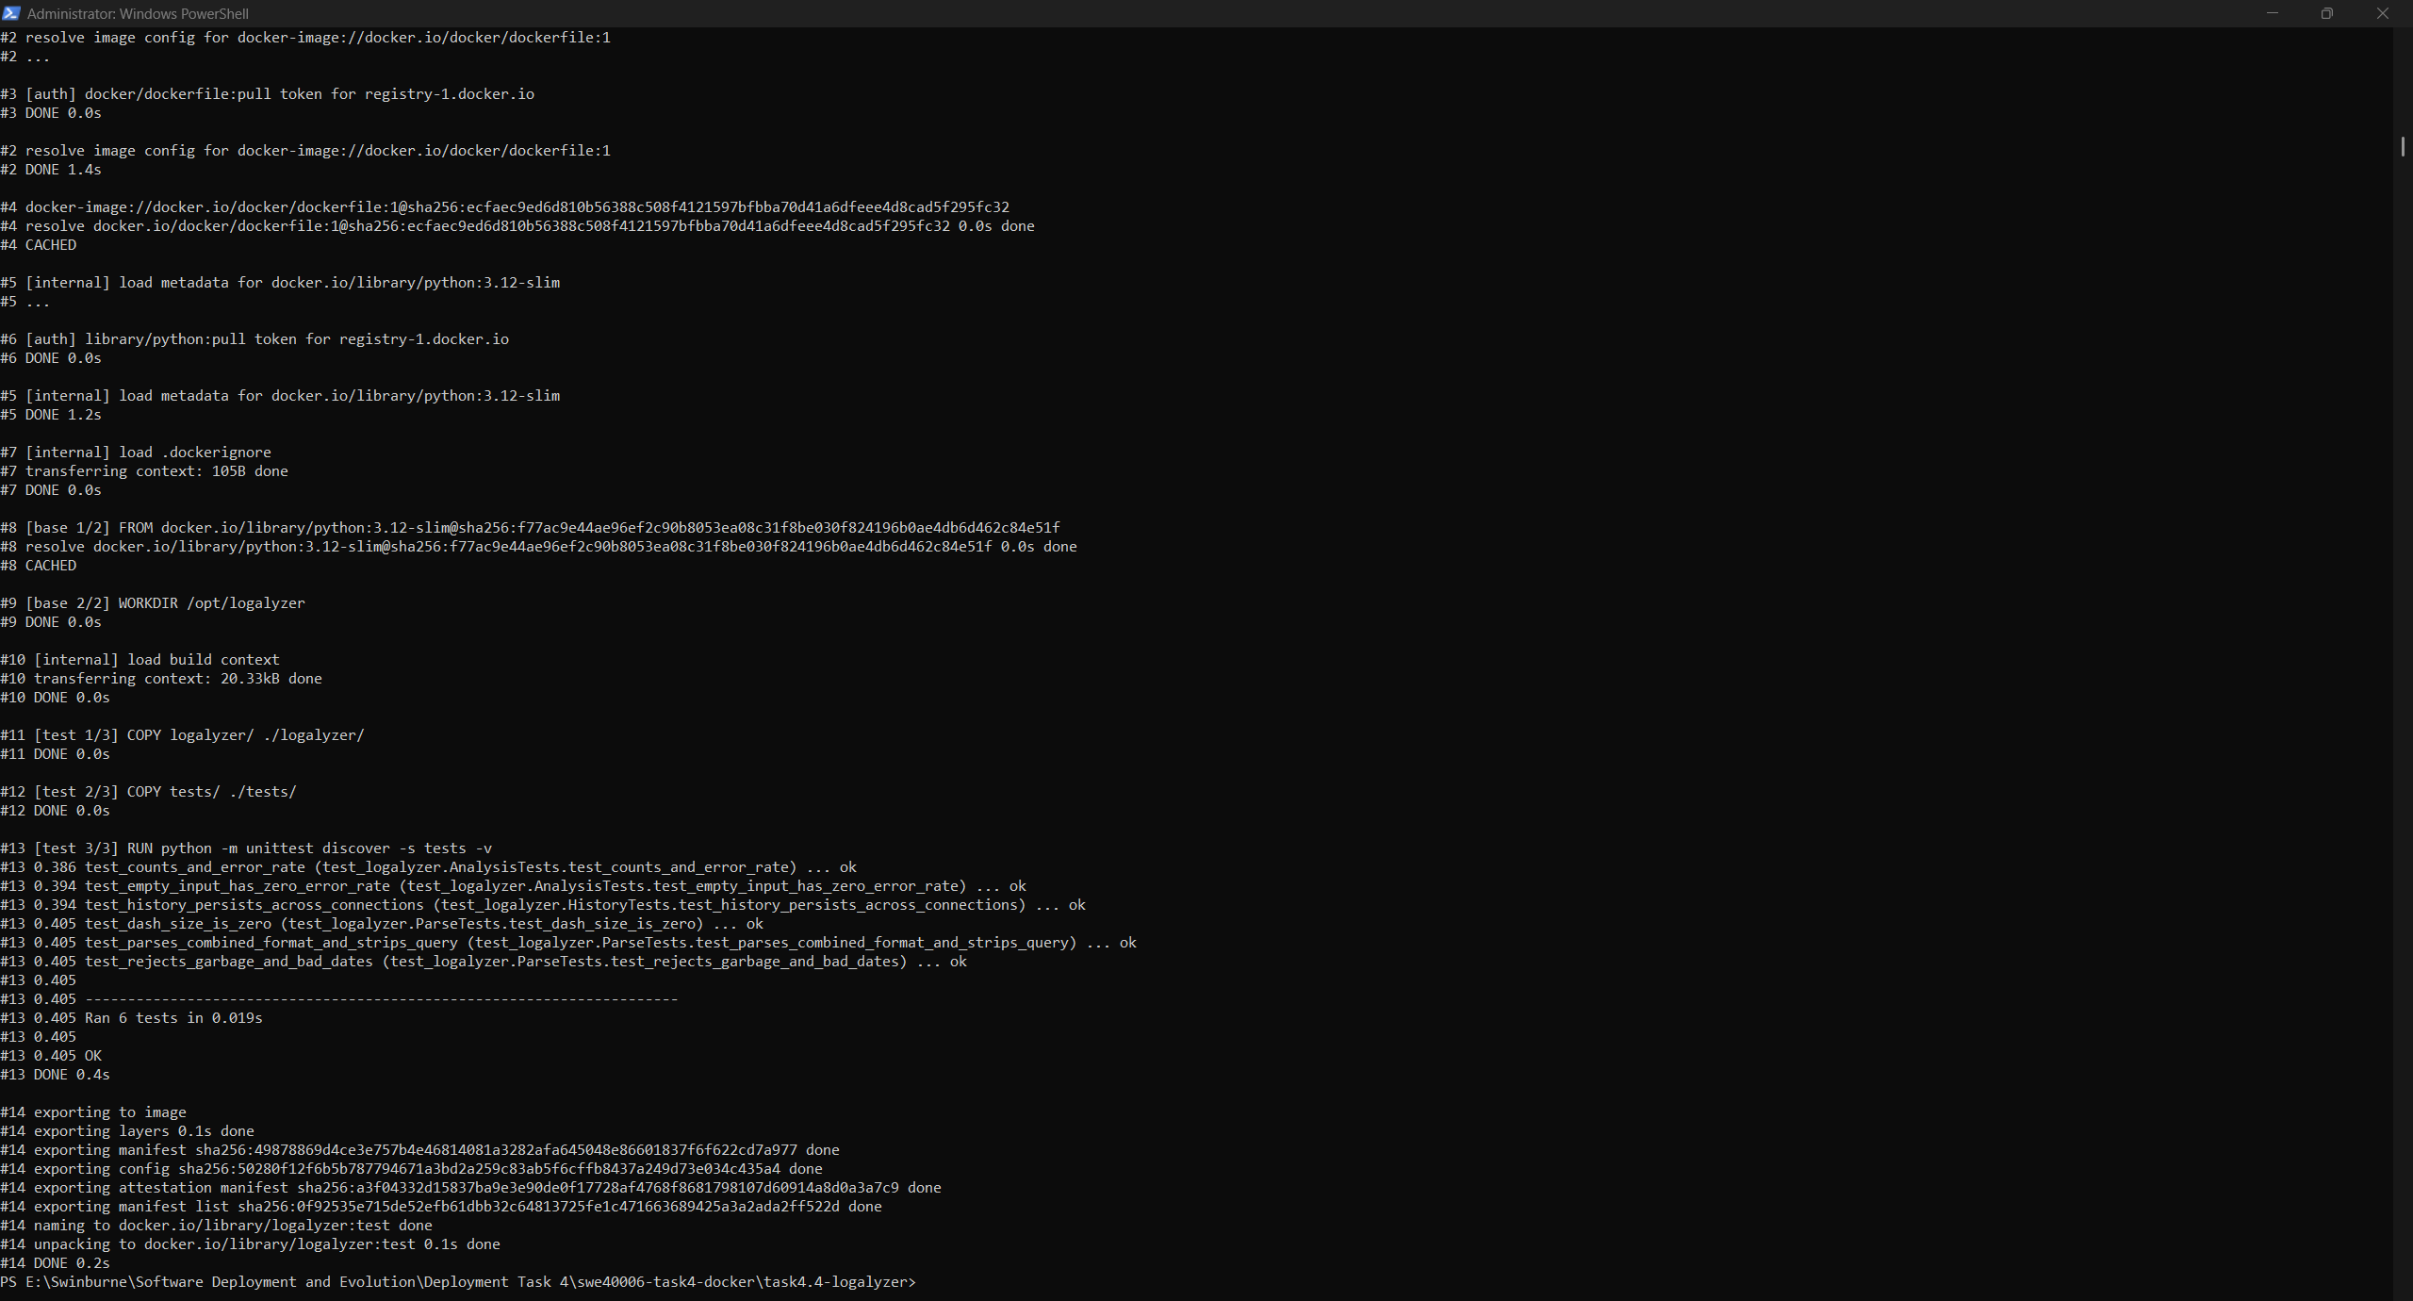
Figure 40: Unit tests running inside the Docker build: Ran 6 tests, OK

6.4 Build and Interface
docker build -t karamjot1008/swe40006-logalyzer:1.0.0 .
docker run --rm karamjot1008/swe40006-logalyzer:1.0.0
docker run --rm karamjot1008/swe40006-logalyzer:1.0.0 --version
docker inspect --format "User={{.Config.User}} Entrypoint={{.Config.Entrypoint}} Cmd={{.Config.Cmd}}" ...
The runtime image is 43.3 MB, essentially the slim Python base plus a few kilobytes of code. Run with no arguments, it prints its help text, which is the default CMD. docker inspect confirms the non-root user and the ENTRYPOINT/CMD split.
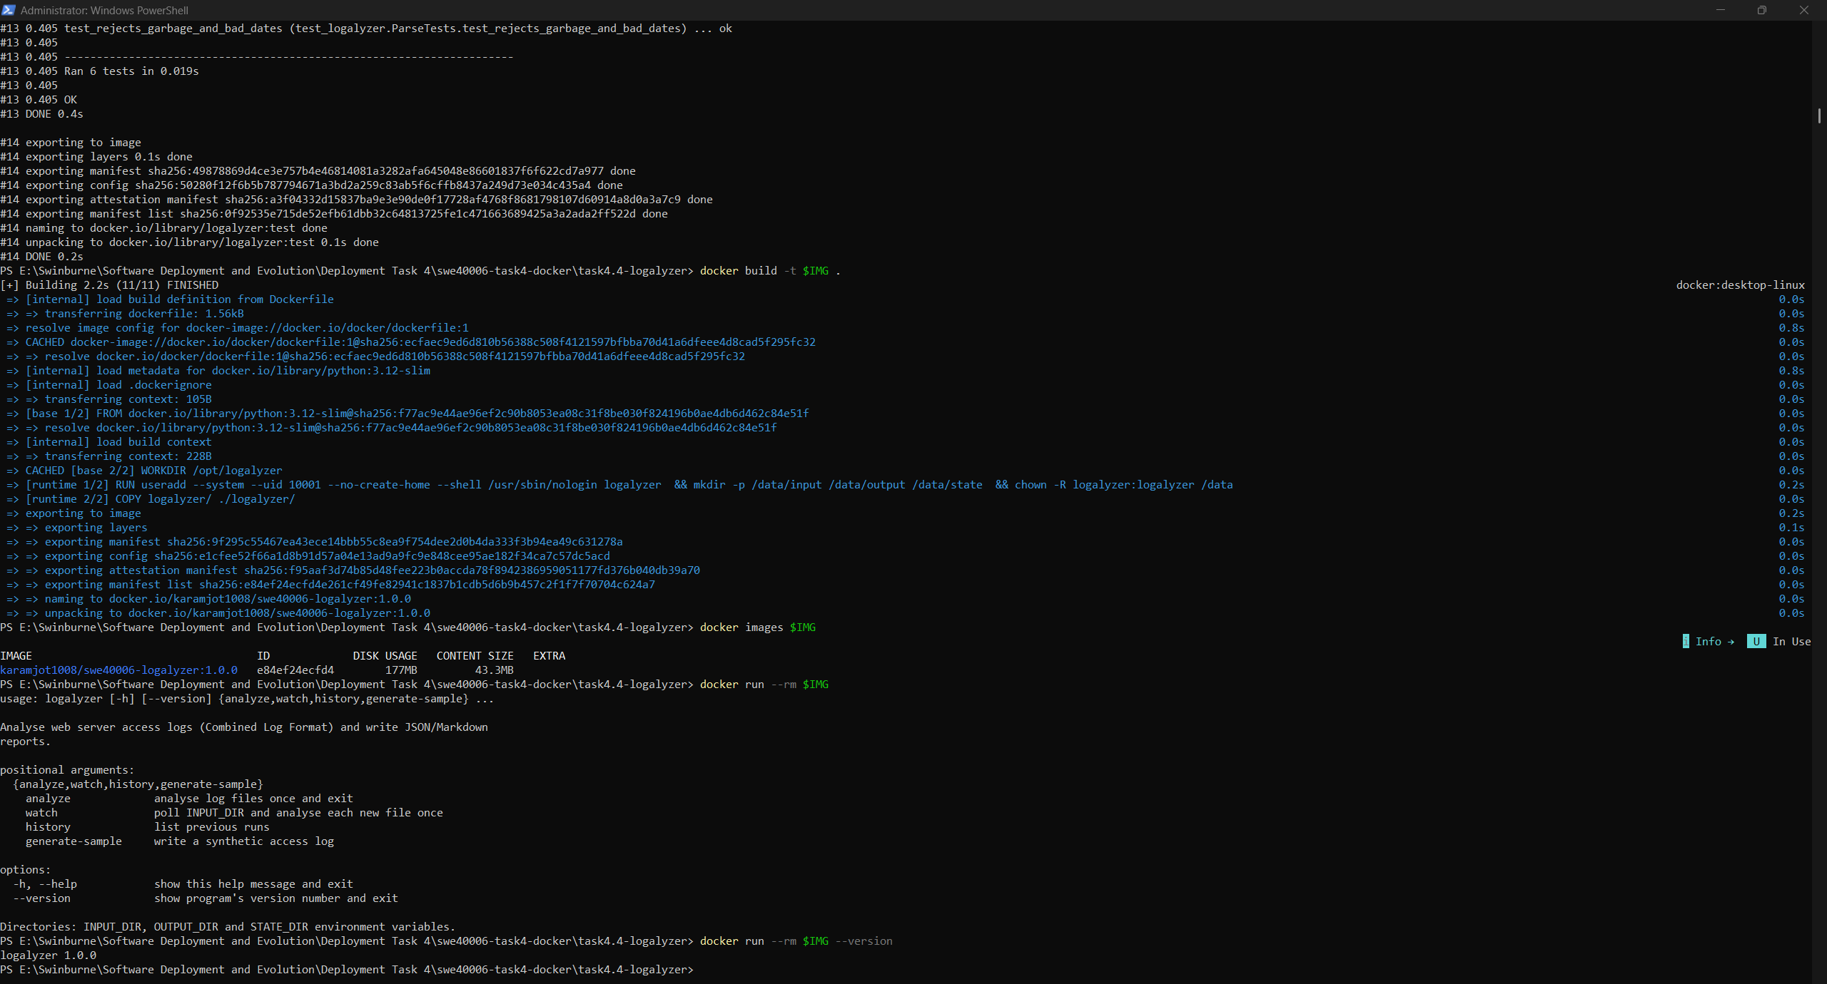
Figure 41: logalyzer image size
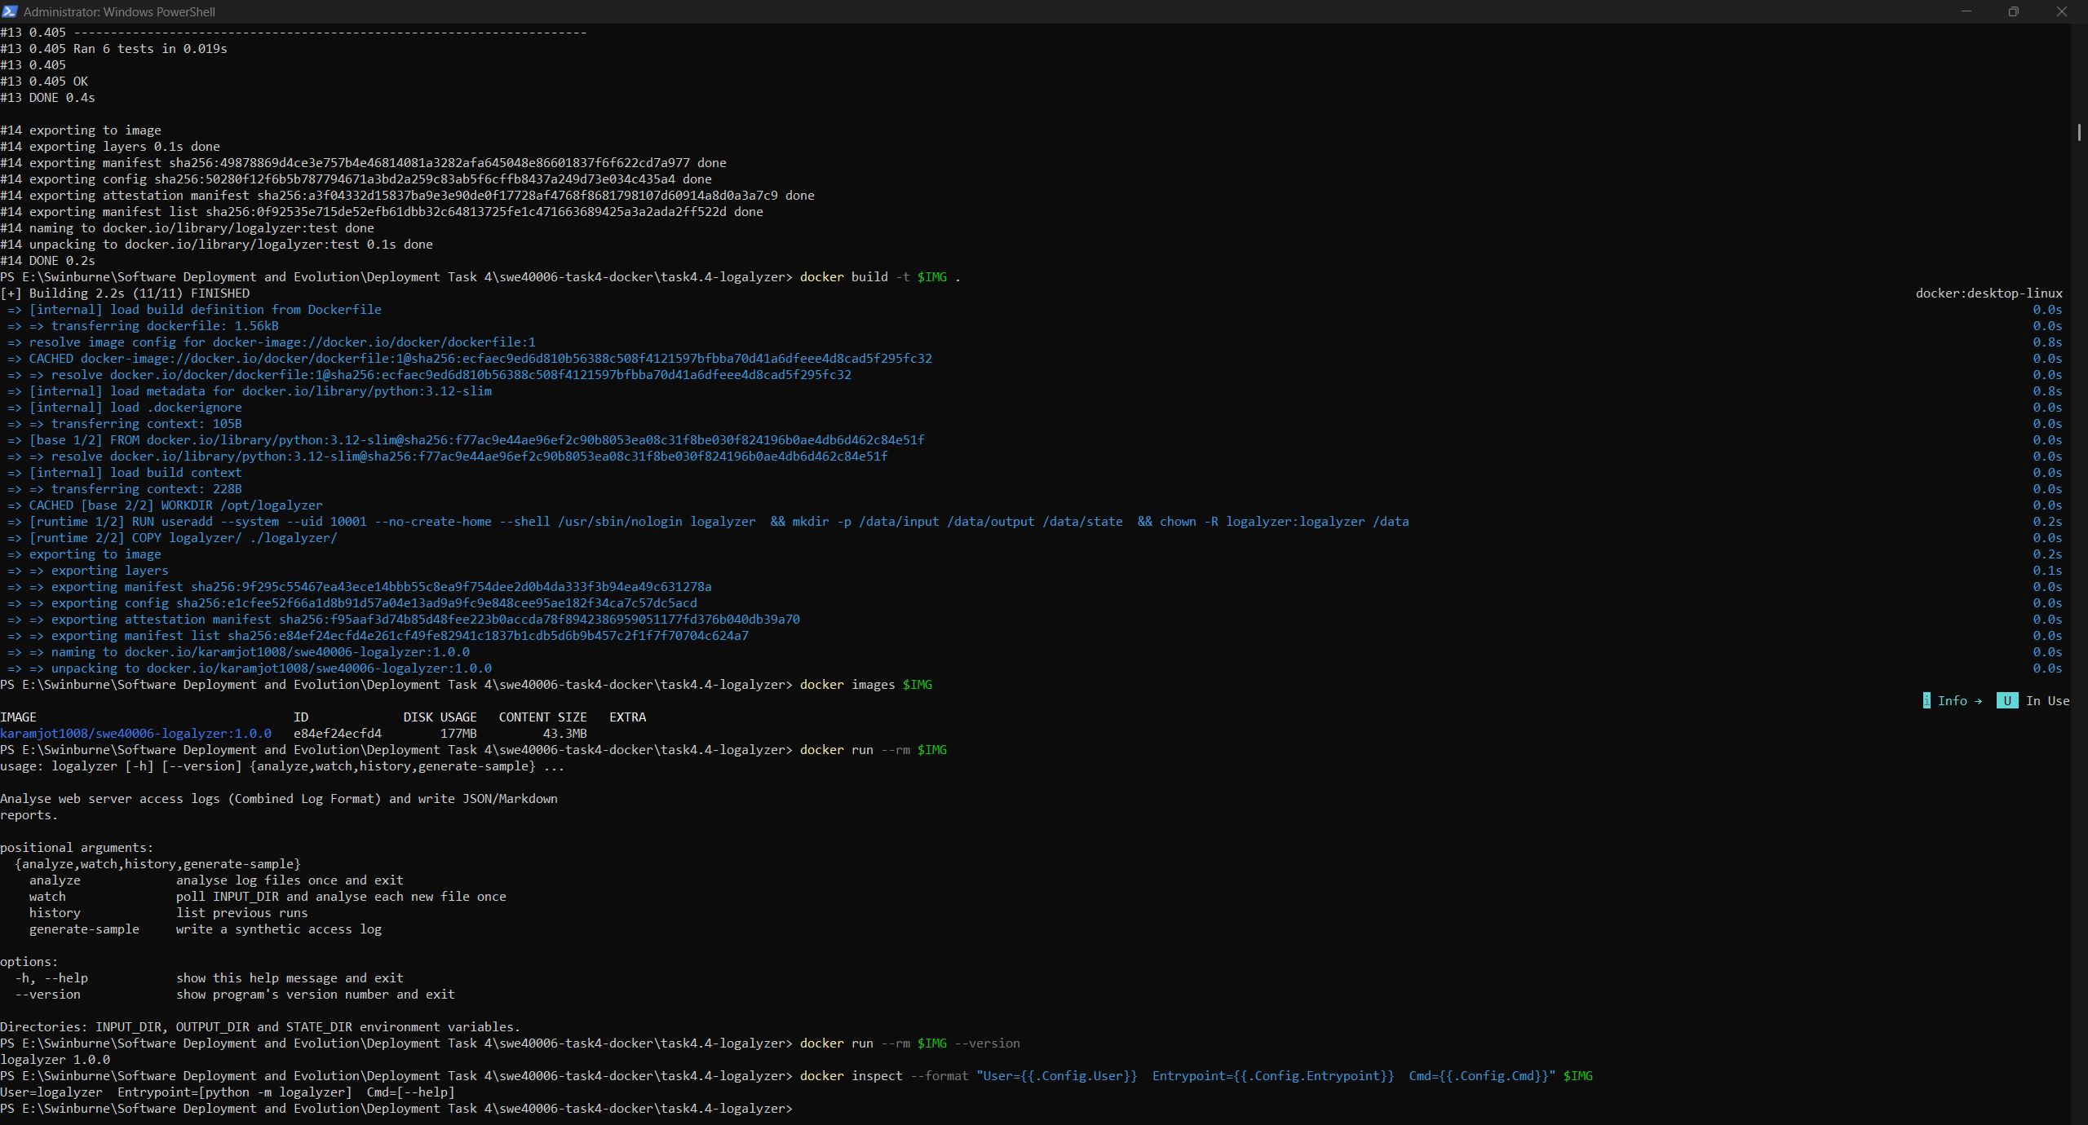
Figure 42: Image configuration: User=logalyzer, ENTRYPOINT

6.5 Storage Design
Container path | Mount type | Mode | Reason
/data/input | Bind mount (host folder) | Read-only | Logs arrive from outside; the tool must never alter its input
/data/output | Bind mount (host folder) | Read-write | Reports must be readable directly on the host
/data/state | Named volume logalyzer_state | Read-write | SQLite run history owned by the container and managed by Docker

Bind mounts suit data that people exchange with the container. Named volumes suit state the container owns: Docker manages their location, they work identically on Windows and Linux hosts, and a new volume is initialised with the ownership of the image directory it is mounted over. Each processed file's SHA-256 hash is recorded in the history database, so watch mode never analyses the same file twice, even across container restarts.
docker volume create logalyzer_state
docker run --rm -v "${PWD}\data\input:/data/input" karamjot1008/swe40006-logalyzer:1.0.0 generate-sample --lines 5000

6.6 One-Shot Execution in a Hardened Container
docker run --rm --name logalyzer-run `
--read-only --tmpfs /tmp --cap-drop ALL --security-opt no-new-privileges `
-v "${PWD}\data\input:/data/input:ro" `
-v "${PWD}\data\output:/data/output" `
-v logalyzer_state:/data/state `
karamjot1008/swe40006-logalyzer:1.0.0 analyze
The container ran with an immutable root filesystem, no Linux capabilities and no ability to gain privileges, and it still completed normally. This shows the application writes only where storage was deliberately provided. It analysed 5000 lines (4958 malformed lines skipped and counted) in 91 ms, exited with code 0, and --rm removed the container. The reports appeared in the host folder immediately.
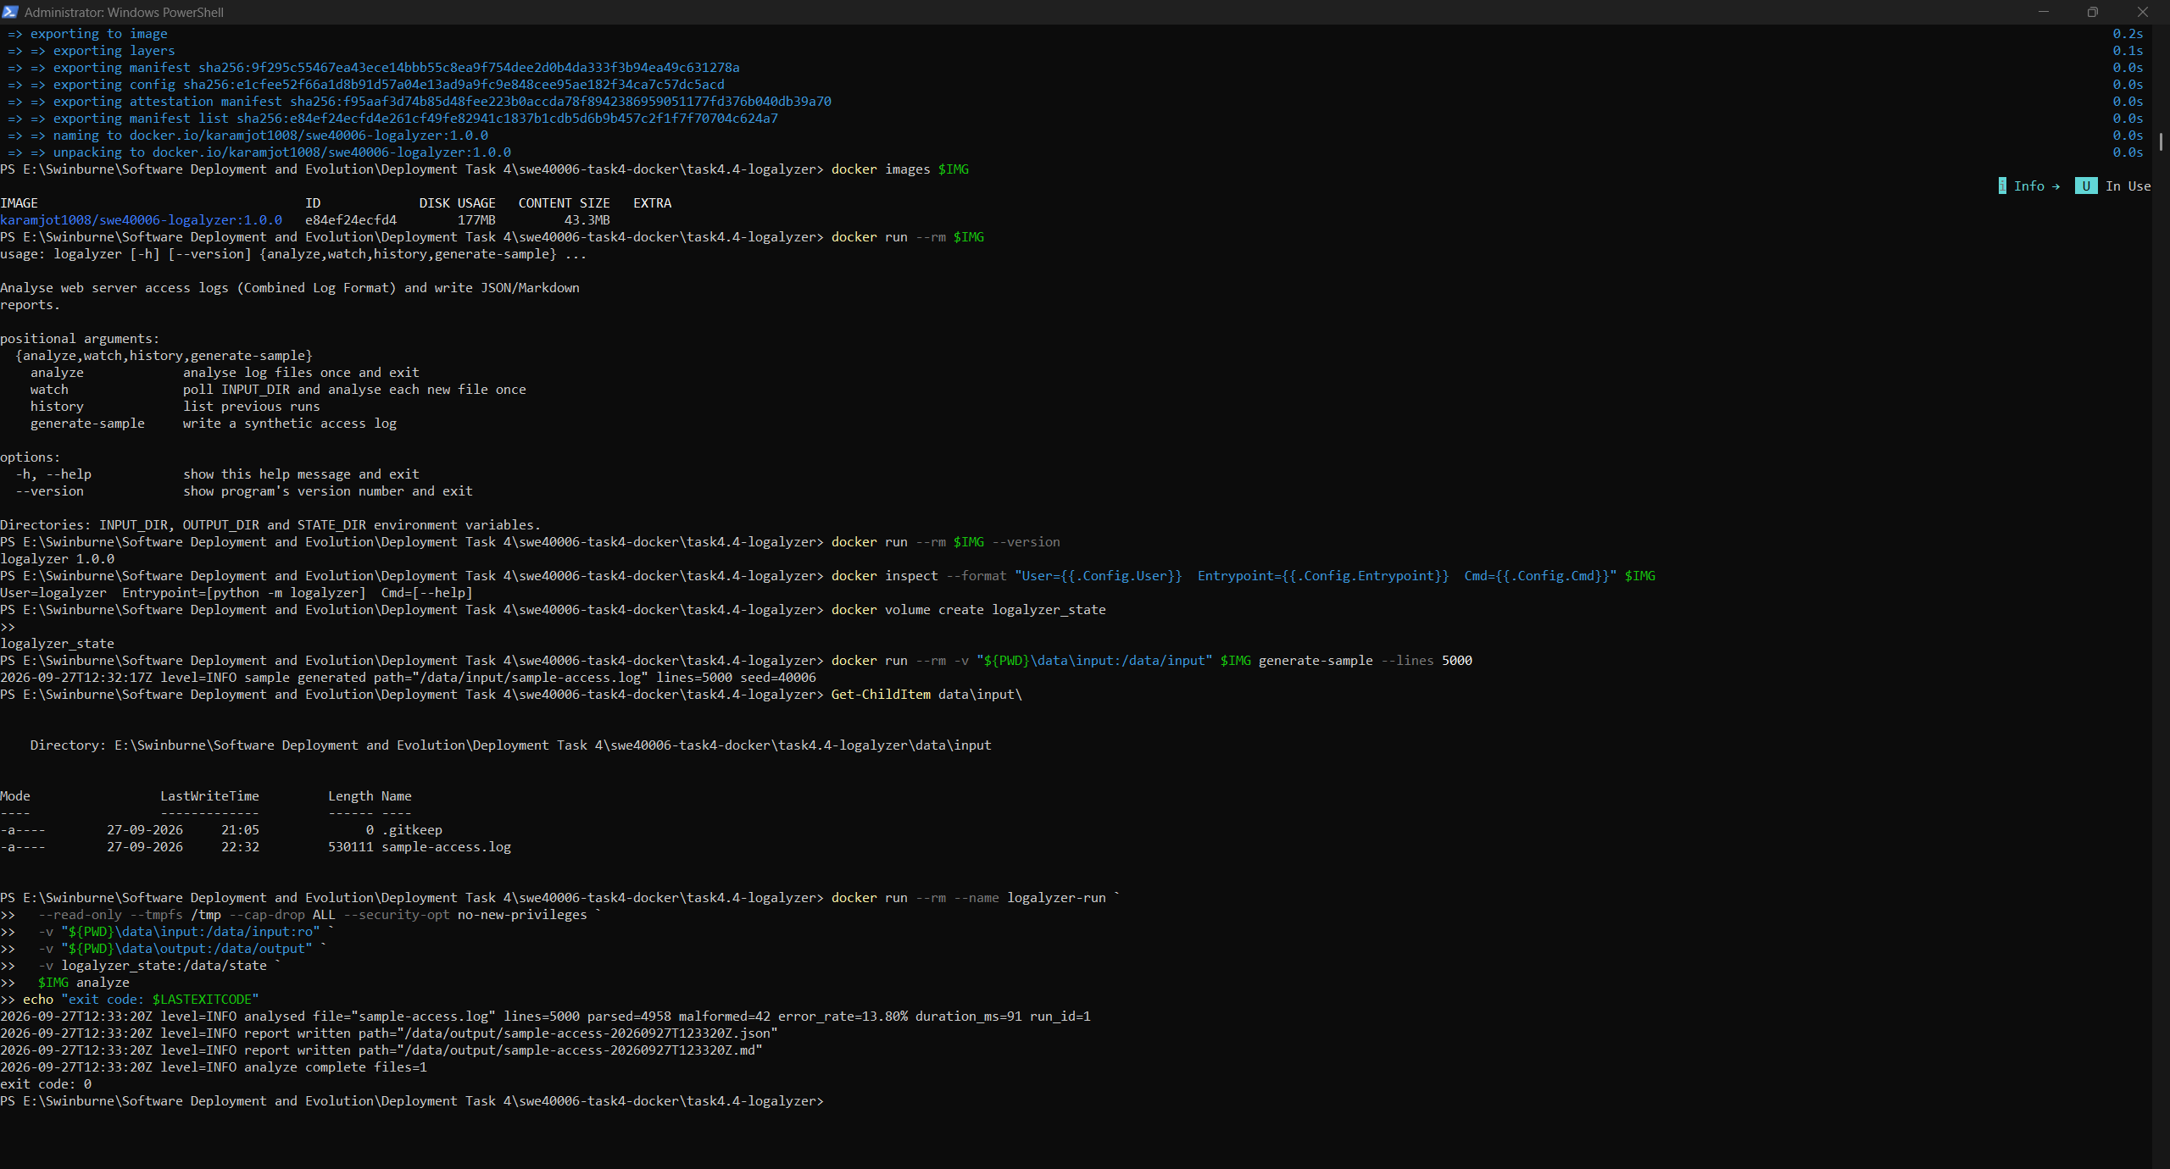
Figure 43: Structured log output of the hardened one-shot run, ending with exit code 0

6.7 Exit Codes
With --fail-on-error-rate 0.05, the sample's error rate of 13.80% exceeded the 5% threshold. The tool logged a warning and exited with code 3. When run without an input mount, it found no files and exited with code 2. Both outcomes are distinguishable by any automation that runs the container.
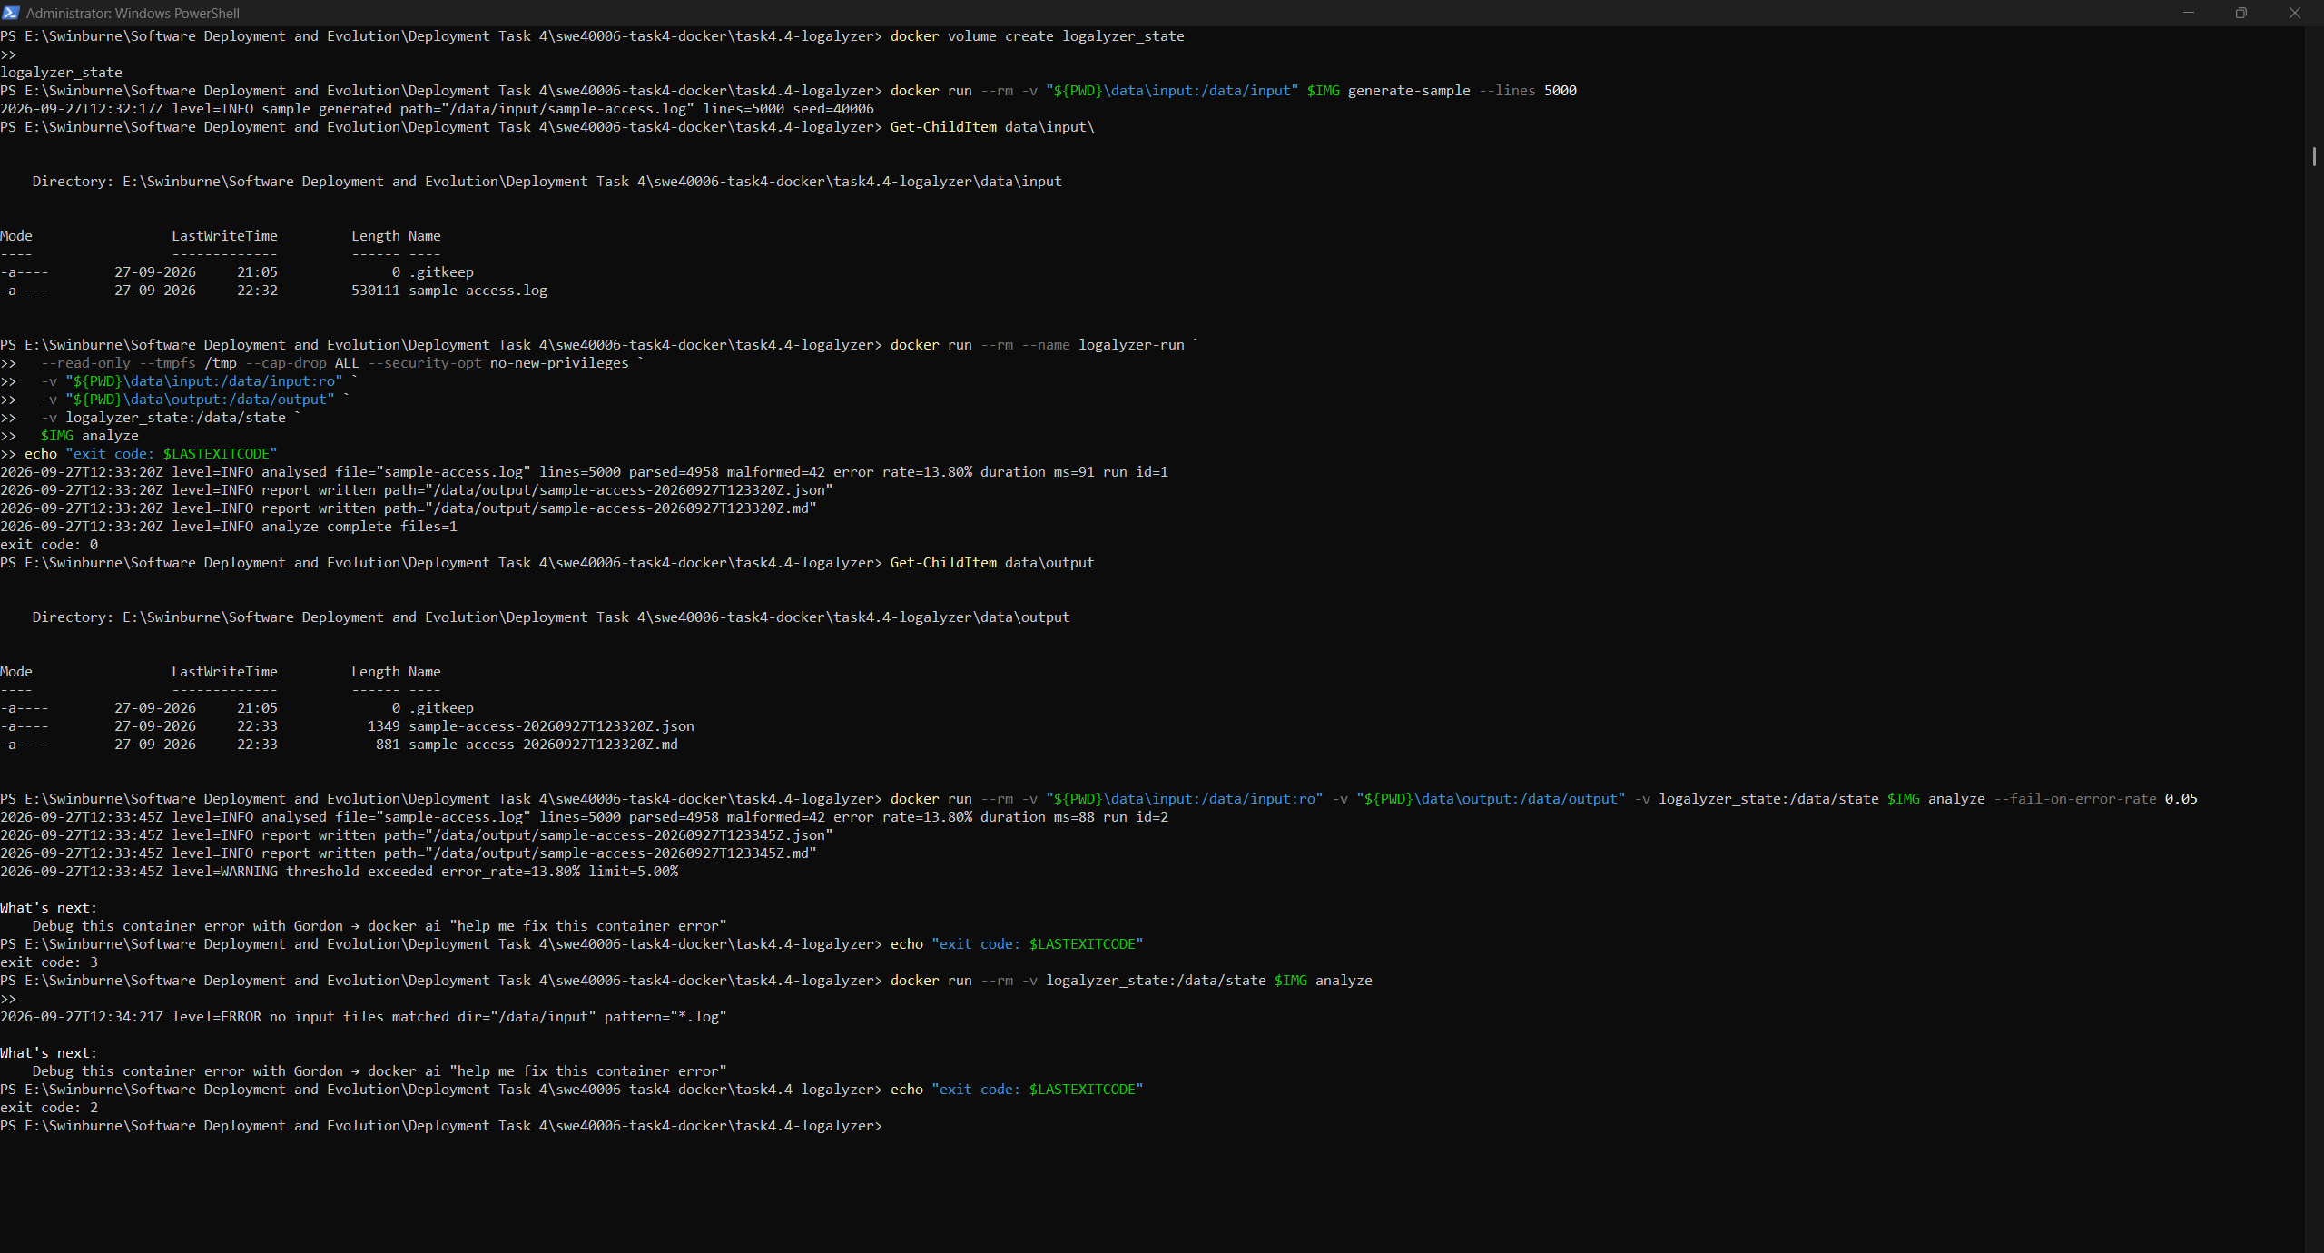
Figure 44: Threshold breach returning exit code 3, and missing input returning exit code 2

6.8 State Beyond the Container Lifetime
Every container in the preceding steps was removed on exit, yet logalyzer history lists all of their runs, each tagged with the hostname of a container that no longer exists. The state belongs to the volume, not to any container, which is the property that allows the tool to be run repeatedly or on a schedule.
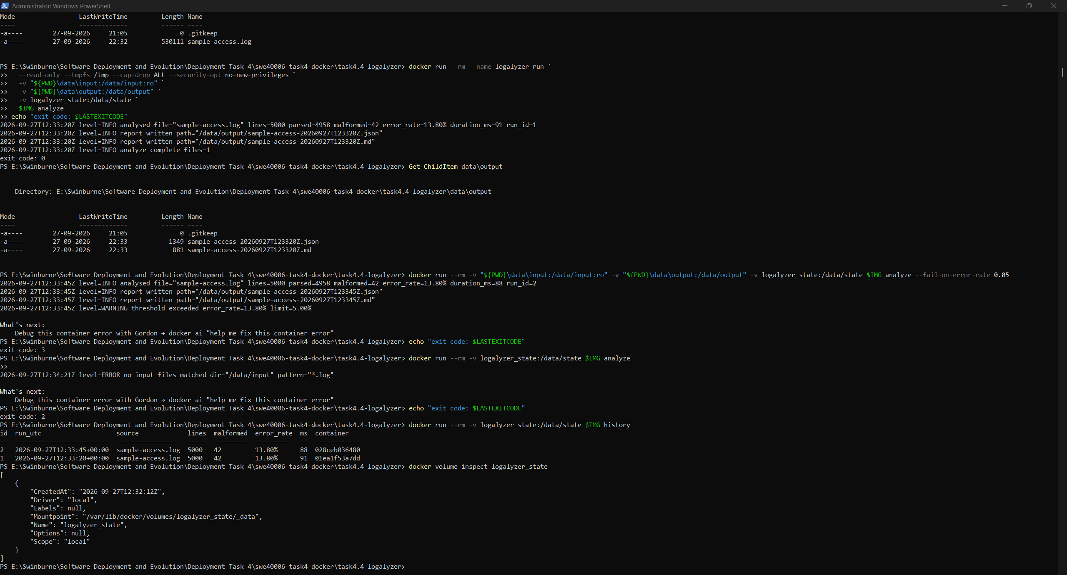
Figure 45: Run history read from the named volume, recorded by several since-deleted containers

6.9 Long-Running Lifecycle and Graceful Shutdown
Watch mode was run as a Compose service with restart: unless-stopped, read_only: true, cap_drop: [ALL] and stop_grace_period: 15s. While it ran, a new file was generated into the input folder from a separate container. The watcher detected and analysed it on its next scan, with no command issued to the watcher itself.
docker compose up -d
docker compose logs -f watcher
docker compose stop
docker inspect logalyzer-watcher-1 --format "status={{.State.Status}} exit={{.State.ExitCode}}"
docker compose stop sends SIGTERM. The log shows the handler acknowledging the signal, finishing the current cycle and exiting, and docker inspect reports the container as exited with code 0. That exit code is the evidence of a handled shutdown. An unhandled one would end in exit code 137 (SIGKILL) after the grace period, possibly in the middle of writing a report. The full lifecycle is therefore observable in the logs: created, running, processing, stop requested, exited cleanly.
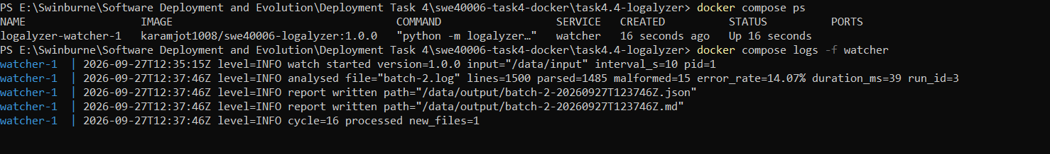
Figure 46: Watcher started under Compose: watch started log line
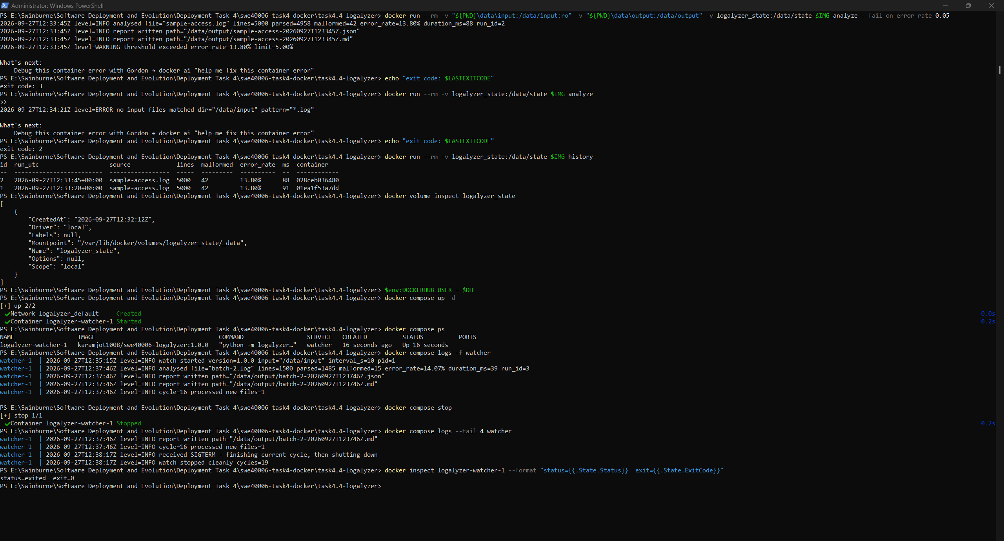
Figure 47: SIGTERM handled: watch stopped cleanly, container exited with code 0

6.10 Portability to the Secondary Host
The image was pushed to Docker Hub and run on Host 2. The first run failed with a permission error that had not occurred on Host 1. After the fix, the same image analysed a log on Amazon Linux and wrote its reports to the host.
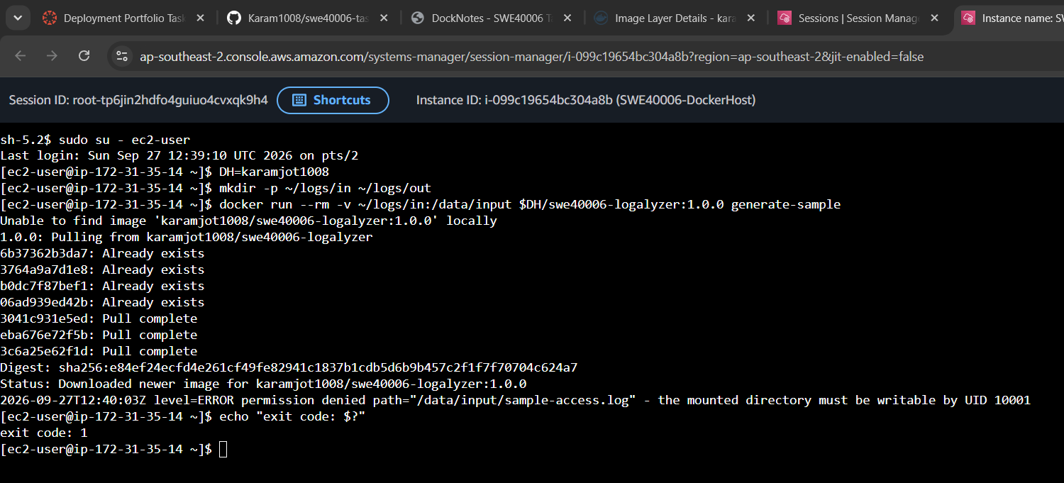
Figure 48: First run on Host 2 failing with permission denied, exit code 1

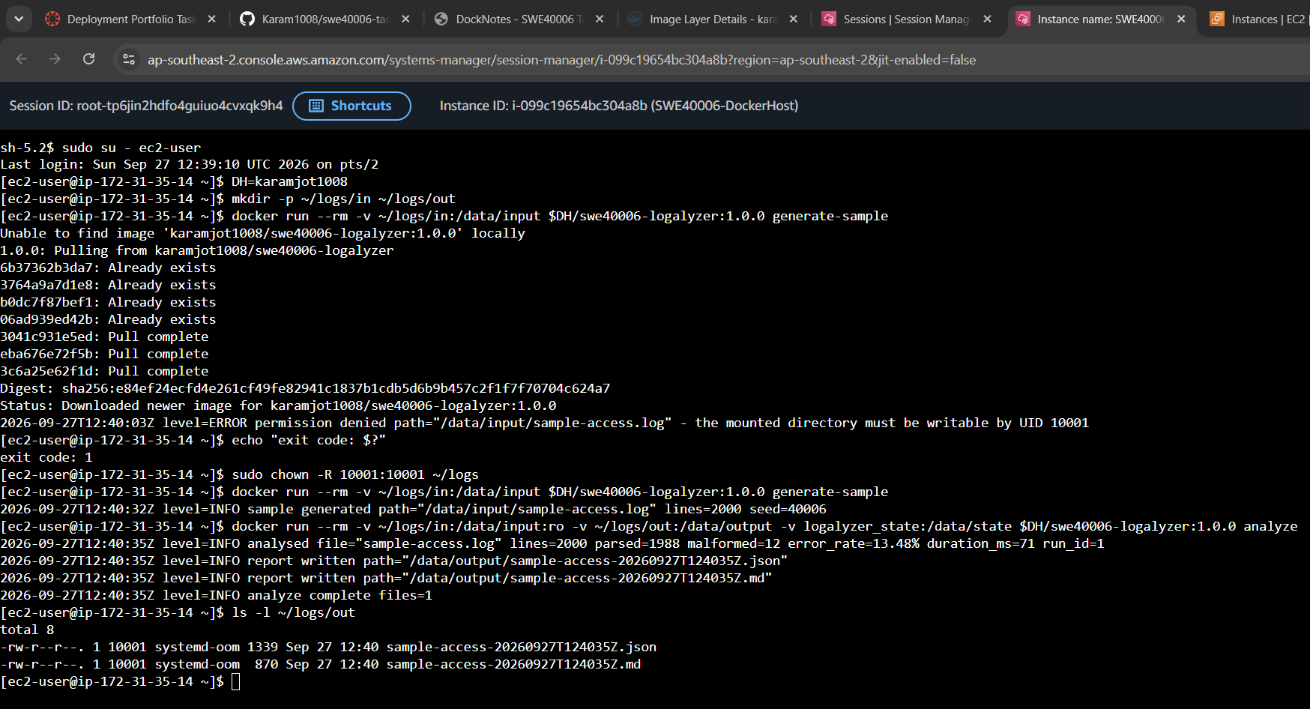
Figure 49: Successful analysis on Host 2 after correcting bind-mount ownership

6.11 Practice Across the Four Levels
Property | 4.1 Pass | 4.2 Credit | 4.3 Distinction | 4.4 High Distinction
Image source | Official image | Custom, single stage | Custom, multi-stage | Custom, with test stage
Process user | n/a | root | app (non-root) | UID 10001 (non-root)
Health / status | Exit only | None | HEALTHCHECK + health-gated start-up | Exit codes + structured logs
Configuration | None | Two ad-hoc env vars | .env with Compose substitution | Env vars + CLI arguments
State | None | None | Named volume (Redis AOF) | Bind mounts + named volume
Network exposure | None | One published port | Proxy only; internal backend | No listener at all
Shutdown | n/a | Default | Exec-form uvicorn | Explicit SIGTERM handler, exit 0

7. Self-Troubleshooting Log and Analysis
Each fault encountered is recorded with the observed symptom, the diagnosis, the resolution and the generalisable lesson. Where an easier but weaker resolution existed, it is stated along with the reason it was rejected.

7.1 Bind-Mount Permission Denied on the Linux Host
level=ERROR permission denied path="/data/input/sample-access.log" - the mounted directory must be writable by UID 10001
exit code: 1
Symptom: generate-sample failed on Host 2 with exit code 1. The identical command against a bind mount on Host 1 had succeeded .
Diagnosis: The container runs as UID 10001. A bind mount exposes the host directory with its real ownership: ~/logs/in belonged to ec2-user (UID 1000) with mode 775, so UID 10001 fell into the 'other' permission class and had no write access. On Host 1, Docker Desktop mediates Windows folders through its file-sharing layer, which presented the folder as writable and masked the issue. The fault therefore only surfaced on a native Linux engine, which is exactly the kind of difference a second host exists to expose.
Resolution: Ownership of the host folders was given to the container's UID with sudo chown -R 10001:10001 ~/logs, and the command re-run successfully.
Rejected alternatives: Running the container with --user $(id -u):$(id -g) would fix the bind mount but break the named volume, which Docker initialised from the image as owned by UID 10001, so history writes would then fail instead. Making the directory world-writable (mode 777), or dropping the non-root user, would remove the error by removing the protection.
Lesson: A non-root container makes file ownership part of its interface. Publishing a fixed UID lets the host prepare ownership once, and the application's error message names that UID so the fix is apparent from the log alone.

7.2 Reverse Proxy Restart Loop Caused by an Invalid Site Address
Symptom: After enabling HTTPS, the site refused connections, and docker compose exec reported the proxy container as continuously restarting.
Diagnosis: docker compose logs proxy showed Caddy exiting at start-up with parsing key: invalid port '52.62.216.119.sslip.io': strconv.Atoi: parsing ... invalid syntax. The restart policy then restarted it in a loop. cat -A .env showed the value :52.62.216.119.sslip.io. A colon left over from the original :80 value made Caddy treat the whole hostname as a port number. The container logs, not the browser, identified the fault: the browser only reported a refused connection.
Resolution: The value was corrected to SITE_ADDRESS=52-62-216-119.sslip.io and the proxy was recreated. Caddy parsed the address, obtained a certificate and began serving HTTPS
Lesson: A restart policy keeps a failing container alive but hides the failure behind a "Restarting" status. When a container restarts repeatedly, read its logs first, because the process's own start-up error is the direct evidence of the cause.

7.3 Host Port 80 Unavailable on the Windows Host
Symptom: docker compose up -d started redis and web, but proxy failed with ports are not available: exposing port TCP 0.0.0.0:80 ... bind: An attempt was made to access a socket in a way forbidden by its access permissions.
Diagnosis: The containers themselves were healthy. The failure happened when Docker tried to claim host port 80 on Windows.
Resolution: Only the host side of the port mapping was changed, using HTTP_PORT=8081 and HTTPS_PORT=8443 in .env. The container still listens on 80, and no Compose file or image change was needed. The public deployment on Host 2 keeps ports 80 and 443.
Rejected alternative: Stopping the Windows service or changing the reserved ranges would free the port, but it changes host operating-system configuration just to suit one development container.
Lesson: Making the host port an environment variable separates a machine-specific detail from the deployment definition. The same compose.yaml runs on a laptop with port 80 blocked and on a server that needs port 80.

7.4 HTTPS URL refused connections.
Symptom: the HTTPS URL refused connections.
Stage 1: docker compose up -d showed the proxy as "Started" rather than "Recreated", which meant the configuration Compose saw hadn't changed.
Stage 2: after recreating the proxy, it went into a restart loop. The logs showed invalid port '52.62.216.119.sslip.io', and cat -A .env revealed a leftover leading colon.
Fix: SITE_ADDRESS=52.62.216.119.sslip.io and recreate the proxy.
Lesson: check the value inside the running container, not the file, and read the logs when a container keeps restarting.

8. Limitations and Future Work
The following limitations are known and were accepted within the scope and cost constraints of this task. They are stated explicitly because an accurate account of what a deployment does not do is as informative as an account of what it does.

8.1 Single-Host Orchestration
Docker Compose orchestrates containers on one host. If SWE40006-DockerHost fails, the application is offline: nothing reschedules containers elsewhere, unlike the Auto Scaling Group in Task 3. A multi-host scheduler such as Docker Swarm, Kubernetes or Amazon ECS would place replicas across Availability Zones behind a load balancer. The images, health checks and environment-driven configuration built here would carry over unchanged.

8.2 Stateful Service Without Replication or Backup
Redis data lives on a single named volume on a single EBS volume, with no replica and no backup. The loss of the instance loses the notes. A managed service such as Amazon ElastiCache, or a scheduled copy of the volume to S3 following the Task 3 backup pattern, would address this.

8.3 Manual Build and Publish
Images are built and pushed by hand from the laptop, with no CI/CD. A GitHub Actions workflow could run the test stage, build multi-architecture images (amd64 and arm64) with Buildx, and push a versioned tag on each release. This would remove the laptop from the release path entirely.

8.4 No Image Scanning, Signing or Digest Pinning
Images are not scanned for known vulnerabilities or cryptographically signed, and base images are referenced by tag rather than by digest, so a rebuild could pick up a different base image. Docker Scout or Trivy scanning, cosign signing, and digest-pinned base images kept current by an automated dependency bot would close these gaps.

8.5 HTTPS Relies on a Shared Public Domain
HTTPS depends on sslip.io, a third-party DNS service whose shared domain is subject to certificate authority rate limits. A production deployment would use its own domain.

8.6 Registry Credentials and Private Images
All images are public, so Host 2 needs no registry credentials. Private images would require either a Docker Hub pull token stored on the host or migration to Amazon ECR, where the instance role could grant pull access without any stored secret.

8.7 Scope of the Log Analysis Tool
logalyzer understands the Combined Log Format only, and analyses each file in a single pass in memory. That is appropriate for files of megabytes, not gigabytes, and it has no streaming input. A production log pipeline would ship logs to a central service rather than analysing files on a host.

9. External Code and Script Repository
In accordance with the submission guidelines, no full source files, credentials or keys are reproduced in this report. All source code, Dockerfiles, Compose files and scripts are published in a public version-controlled repository: https://github.com/Karam1008/swe40006-task4-docker
Path | Purpose
README.md | Repository overview and quick start
task4.2-flask-basic/ | Credit: app.py, requirements.txt, Dockerfile, .dockerignore
task4.3-docknotes/app/ | Distinction: FastAPI application and HTML template
task4.3-docknotes/Dockerfile | Optimised multi-stage Dockerfile
task4.3-docknotes/Dockerfile.naive | Unoptimised baseline used only for the size comparison
task4.3-docknotes/compose.yaml, Caddyfile, .env.example | Three-service stack, reverse proxy configuration, configuration template
task4.4-logalyzer/logalyzer/ | HD: CLI source (analysis, history, command-line interface)
task4.4-logalyzer/tests/ | Unit tests executed in the Docker test stage
task4.4-logalyzer/Dockerfile, compose.yaml | Test and runtime stages; watcher service definition
scripts/ec2-docker-host-userdata.sh | Secondary Docker host bootstrap
docs/RUNBOOK.md | Step-by-step execution procedure

No credential is present in the repository. .env files are excluded by .gitignore and .dockerignore, and the Docker Hub token exists only in the local Docker credential store.

10. Generative AI Declaration
This declaration is provided in accordance with Swinburne University's policy on the use of generative artificial intelligence in assessment.

10.1 Tool Used and Scope of Use
A generative AI assistant (Anthropic Claude) was used during this task in three ways:
- Code generation: The assistant generated the initial versions of the three applications (the Flask application, the DockNotes FastAPI application and its HTML template, and the logalyzer CLI with its unit tests), together with the Dockerfiles, Compose files, Caddy configuration and the EC2 bootstrap script.
- Error feedback: When a command failed, I gave the error output to the assistant for feedback on which layer the fault was likely in. Every fault in Section 7 was confirmed against the actual system state, using the commands shown there, before any change was made.

10.2 What Was Performed by Me
The assistant had no access to my machine, my Docker Hub account, my GitHub account or my AWS account, and could not run any command. I personally:
- Installed WSL 2 and Docker Desktop, created the Docker Hub account and completed Task 4.1.
- Created and published the GitHub repository using GitHub Desktop.
- Ran every build, run, tag, push and pull command recorded in this report, on both hosts.
- Created the IAM role, security group, EC2 instance and Elastic IP, and deployed the containers on Host 2.
- Captured every screenshot and recorded every measured value (image sizes, digests, timings).
- Diagnosed and resolved the faults recorded in Section 7.

10.3 Verification and Independent Judgement
Generated code and guidance were treated as a starting point to be verified against the running system rather than as authoritative:
- The claim that both hosts ran the same artefact was verified by comparing image digests, not assumed from matching tags.
- Network isolation was verified by tests designed to fail, not inferred from the Compose file.
- Every exit code and the SIGTERM handling were observed directly in the container logs and in docker inspect.

10.4 Statement
I understand the architecture described in this report, the purpose of every Dockerfile instruction and Compose setting used, and the reasoning behind each design decision recorded. All deployment steps were executed, tested and verified by me. I accept full responsibility for the accuracy of the content of this submission.
Field | Detail
Signed | Karamjot Singh
Student ID | 104809887
Date | 27/09/2026

11. References
[1] Microsoft, “Install WSL,” Microsoft Learn, 2026. [Online]. Available: https://learn.microsoft.com/en-us/windows/wsl/install. [Accessed: Sep. 2026].
[2] Docker Inc., “Install Docker Desktop on Windows,” Docker Docs, 2026. [Online]. Available: https://docs.docker.com/desktop/setup/install/windows-install/. [Accessed: Sep. 2026].
[3] Docker Inc., “Dockerfile reference,” Docker Docs, 2026. [Online]. Available: https://docs.docker.com/reference/dockerfile/. [Accessed: Sep. 2026].
[4] Docker Inc., “Building best practices,” Docker Docs, 2026. [Online]. Available: https://docs.docker.com/build/building/best-practices/. [Accessed: Sep. 2026].
[5] Docker Inc., “Multi-stage builds,” Docker Docs, 2026. [Online]. Available: https://docs.docker.com/build/building/multi-stage/. [Accessed: Sep. 2026].
[6] Docker Inc., “Compose file reference,” Docker Docs, 2026. [Online]. Available: https://docs.docker.com/reference/compose-file/. [Accessed: Sep. 2026].
[7] Docker Inc., “Bridge network driver,” Docker Docs, 2026. [Online]. Available: https://docs.docker.com/engine/network/drivers/bridge/. [Accessed: Sep. 2026].
[8] Docker Inc., “Volumes,” Docker Docs, 2026. [Online]. Available: https://docs.docker.com/engine/storage/volumes/. [Accessed: Sep. 2026].
[9] Docker Inc., “Bind mounts,” Docker Docs, 2026. [Online]. Available: https://docs.docker.com/engine/storage/bind-mounts/. [Accessed: Sep. 2026].
[10] Docker Inc., “Start containers automatically,” Docker Docs, 2026. [Online]. Available: https://docs.docker.com/engine/containers/start-containers-automatically/. [Accessed: Sep. 2026].
[11] Docker Inc., “Repositories,” Docker Hub documentation, 2026. [Online]. Available: https://docs.docker.com/docker-hub/repos/. [Accessed: Sep. 2026].
[12] Docker Inc., “Personal access tokens,” Docker Docs, 2026. [Online]. Available: https://docs.docker.com/security/for-developers/access-tokens/. [Accessed: Sep. 2026].
[13] Caddy, “Automatic HTTPS,” Caddy Documentation, 2026. [Online]. Available: https://caddyserver.com/docs/automatic-https. [Accessed: Sep. 2026].
[14] Caddy, “reverse_proxy (Caddyfile directive),” Caddy Documentation, 2026. [Online]. Available: https://caddyserver.com/docs/caddyfile/directives/reverse_proxy. [Accessed: Sep. 2026].
[15] Redis Ltd., “Redis persistence,” Redis Documentation, 2026. [Online]. Available: https://redis.io/docs/latest/operate/oss_and_stack/management/persistence/. [Accessed: Sep. 2026].
[16] S. Ramírez, “FastAPI in Containers - Docker,” FastAPI Documentation, 2026. [Online]. Available: https://fastapi.tiangolo.com/deployment/docker/. [Accessed: Sep. 2026].
[17] Pallets, “Deploying to Production,” Flask Documentation, 2026. [Online]. Available: https://flask.palletsprojects.com/en/stable/deploying/. [Accessed: Sep. 2026].
[18] Amazon Web Services, “AWS Systems Manager Session Manager,” AWS Systems Manager User Guide, 2026. [Online]. Available: https://docs.aws.amazon.com/systems-manager/latest/userguide/session-manager.html. [Accessed: Sep. 2026].
[19] Amazon Web Services, “Elastic IP addresses,” Amazon EC2 User Guide, 2026. [Online]. Available: https://docs.aws.amazon.com/AWSEC2/latest/UserGuide/elastic-ip-addresses-eip.html. [Accessed: Sep. 2026].
[20] Python Software Foundation, “signal - Set handlers for asynchronous events,” Python 3 Documentation, 2026. [Online]. Available: https://docs.python.org/3/library/signal.html. [Accessed: Sep. 2026].
[21] Open Container Initiative, “Pre-Defined Annotation Keys,” OCI Image Format Specification, 2026. [Online]. Available: https://github.com/opencontainers/image-spec/blob/main/annotations.md. [Accessed: Sep. 2026].
[22] sslip.io, “sslip.io: DNS for any IP address,” 2026. [Online]. Available: https://sslip.io/. [Accessed: Sep. 2026].

