AI-POWERED EXAMINATION SEATING ARRANGEMENT FINDER
AND AUTOMATED PLANNER
FINAL PROJECT REPORT
SeatX: A full-stack system for automated, mixed-subject examination seating, student seat discovery, document ingestion, and report generation.
Prepared from the implemented GitHub project
KaramalaSurya / AI-Powered-Exam-Seating-Arrangement-Finder-and-Automated-Planner
Academic Year 2026

ABSTRACT
SeatX is an AI-assisted examination seating arrangement and student finder platform designed to reduce the manual effort involved in preparing examination rooms. The system combines a React front end, a FastAPI service layer, a SQLite/PostgreSQL persistence layer, document ingestion utilities, a checkerboard-based allocation engine, and report-generation services. Its main operational goal is to distribute students from different subjects across neighbouring positions so that the layout is easy to administer and less vulnerable to academic malpractice.
The application accepts student registration lists and examination schedules in common formats such as Excel, CSV, PDF, and text. It normalizes dates, identifies roll-number candidates, associates students with subjects, and stores the resulting records in a session-based schema. Administrators can preview an allocation before committing it. The planner supports both one-student-per-bench and two-students-per-bench modes. In the two-student mode, the seat index is interpreted using row, column, and side coordinates so that bench mates can be assigned different subjects.
The student-facing portal provides roll-number search, an interactive classroom representation, a seating slip, and room information. The administrator portal supports session management, ingestion, room seeding, allocation, validation, and PDF-oriented reporting. The implementation is also deployment-ready through a Render blueprint with a FastAPI service, React static site, and managed PostgreSQL database.
Testing in the repository verifies the principal constraints. The allocation tests place 29 students without leftovers, validate that adjacent occupied seats do not share a subject, verify 48-seat layouts, exercise tolerant matching for abbreviated or parenthesized subjects, and confirm database persistence. This report explains the system design, implementation, analysis, test evidence, limitations, and future improvements in a form suitable for a final-year project submission.

TABLE OF CONTENTS
CHAPTER / SECTION | PAGE
1. INTRODUCTION | 4
2. HARDWARE AND SOFTWARE REQUIREMENTS | 11
3. PROJECT ANALYSIS | 14
4. CONCLUSION AND FUTURE WORK | 20
5. CODE — MAIN PART | 22
6. OUTPUT SCREENSHOTS | 27
7. BIBLIOGRAPHY | 29
Note: Page allocation is organized to keep the principal sections within the requested ranges. The document is formatted with Times New Roman, 12-point body text, justified alignment, 1.5-line spacing, and 6-point paragraph spacing.

1.1 Background and Motivation
Examination seating is often prepared using spreadsheets, printed lists, and repeated manual checks. This approach becomes difficult when the number of students, subjects, rooms, and sessions increases simultaneously. Small errors in roll-number ranges or room assignments can cause confusion at the examination venue, delay invigilators, or force last-minute changes. SeatX addresses this operational problem by treating seating as a repeatable data-processing and optimization workflow rather than as a one-time manual drawing exercise.
The design is intentionally practical: each component corresponds to a real administrative activity, and the interfaces expose the intermediate states needed for review. This approach makes the project suitable for incremental deployment, beginning with local test data and extending to a hosted database and production web service.

1.2 Problem Statement
The project focuses on five related difficulties: collecting registration data from inconsistent files; arranging students in rooms while respecting capacity and adjacency rules; allowing administrators to verify a plan before publication; helping students find their exact room and seat quickly; and generating artifacts that can be printed or shared with invigilators. A useful solution must also remain usable when the institution has multiple examination sessions and when the same subject appears with minor naming variations.
The design is intentionally practical: each component corresponds to a real administrative activity, and the interfaces expose the intermediate states needed for review. This approach makes the project suitable for incremental deployment, beginning with local test data and extending to a hosted database and production web service.

1.3 Objectives
The primary objective is to build a reliable end-to-end examination planning application. Specific objectives are to automate ingestion of lists and schedules; maintain session-aware records; provide deterministic mixed-subject seating; support both 24-seat and 48-seat room configurations; expose administrative and public workflows through a REST API; show a visual room map; generate report-ready outputs; and keep the system deployable in both a local SQLite mode and a cloud PostgreSQL mode.
The design is intentionally practical: each component corresponds to a real administrative activity, and the interfaces expose the intermediate states needed for review. This approach makes the project suitable for incremental deployment, beginning with local test data and extending to a hosted database and production web service.

1.4 Scope of the Project
The implemented scope includes student registration ingestion, master schedule ingestion, room seeding, session activation, seating preview, allocation commit, student search, coordinate mapping, validation, PDF report generation, and cloud deployment configuration. The project is not intended to replace institutional examination policy. Instead, it provides the technical mechanism for applying policies consistently. Human approval remains important before a generated plan is published.
The design is intentionally practical: each component corresponds to a real administrative activity, and the interfaces expose the intermediate states needed for review. This approach makes the project suitable for incremental deployment, beginning with local test data and extending to a hosted database and production web service.

1.5 Proposed Solution
SeatX separates the problem into layers. The presentation layer contains the student finder and administrator portal. FastAPI routes requests and applies administrator authentication. The ingestion layer converts source files into normalized records. The planning engine selects the largest remaining subject pools and distributes them through alternating positions. The database preserves sessions, rooms, registrations, schedules, and seating ranges. Finally, the student search and reporting functions translate stored records into human-readable room and seat information.
The design is intentionally practical: each component corresponds to a real administrative activity, and the interfaces expose the intermediate states needed for review. This approach makes the project suitable for incremental deployment, beginning with local test data and extending to a hosted database and production web service.

1.6 Significance
The value of the system is not limited to faster allocation. Deterministic algorithms make outcomes reproducible; preview and commit stages reduce accidental publication; tolerant subject matching improves resilience to ordinary data-entry differences; session-aware storage reduces cross-examination contamination; and visual outputs reduce the interpretation burden on students and invigilators. Together, these features improve operational consistency and provide a foundation for further automation.
The design is intentionally practical: each component corresponds to a real administrative activity, and the interfaces expose the intermediate states needed for review. This approach makes the project suitable for incremental deployment, beginning with local test data and extending to a hosted database and production web service.

1.7 Organization of the Report
This report first introduces the problem and the system context. It then lists hardware and software requirements, analyzes the architecture and core algorithms, discusses database design and testing, and summarizes the main implementation excerpts. The final sections show representative output views and identify the technical sources used to understand and document the implementation.
The design is intentionally practical: each component corresponds to a real administrative activity, and the interfaces expose the intermediate states needed for review. This approach makes the project suitable for incremental deployment, beginning with local test data and extending to a hosted database and production web service.

2. HARDWARE AND SOFTWARE REQUIREMENTS
2.1 Hardware Requirements
SeatX is a web application and therefore does not require specialized hardware for ordinary use. A development machine should have a modern dual-core processor, at least 8 GB of RAM, approximately 5 GB of free storage for source code, dependencies, databases, and generated artifacts, and a stable network connection when Gemini services or cloud deployment are used. The administrator device should have a current browser and a display large enough to review room grids and preview tables. Student users can use desktop or mobile browsers because the search workflow is lightweight.
Component | Recommended baseline | Purpose
Processor | 2 cores or more | Run FastAPI, Vite, tests, and document parsing
Memory | 8 GB RAM | Support browser, development tools, and database
Storage | 5 GB free | Source, dependencies, SQLite database, reports
Network | Stable broadband | Cloud database, deployment, optional Gemini API
Display | 1366 × 768 or better | Review dashboard and room map
2.2 Software Requirements
The backend uses Python 3.10 or later with FastAPI and Uvicorn. File processing depends on pdfplumber, openpyxl, python-multipart, Pillow, and ReportLab. Google generative AI libraries support the optional vision and parsing workflow. PostgreSQL connectivity is provided by psycopg2-binary, while SQLite is available through the Python standard library. The front end uses React 19, Vite, Lucide icons, and custom CSS. Git is used for version control, and Render is described as the target cloud deployment platform.

2.3 Development and Deployment Environment
During local development, the API can be started with the Python module entry point and the front end with the Vite development server. The default local API port is 8085 and the default front-end port is 5173. Database initialization creates the required schema and ensures that an administrator password setting exists. For deployment, render.yaml defines a Python web service, a React static service, and a managed PostgreSQL instance. The database URL is injected as an environment variable, allowing the same application logic to operate against PostgreSQL without changing route-level code.
Layer | Technology | Role
Client | React + Vite | Student finder, admin portal, responsive presentation
API | FastAPI + Uvicorn | HTTP routes, authentication middleware, lifecycle
Storage | SQLite / PostgreSQL | Sessions, rooms, schedules, registrations, ranges
AI services | Google Gemini API | Vision OCR and document interpretation
Documents | pdfplumber, openpyxl, ReportLab | Read input files and produce printable outputs
Hosting | Render Blueprint | Backend, frontend, and managed database
The dual-database wrapper is an important portability feature. SQLite is appropriate for local demonstrations and offline development, while PostgreSQL is more suitable for persistent cloud operation. The wrapper translates parameter placeholders and selected SQLite insert patterns for PostgreSQL, while presenting a common cursor and connection interface to the rest of the backend.

3. PROJECT ANALYSIS
The project can be understood as a pipeline that transforms unstructured or semi-structured institutional data into validated seating records and user-facing outputs. The pipeline has a clear boundary between data preparation, planning, persistence, and presentation. This separation is useful because each stage can be tested independently and because errors can be reported at the stage where they occur.

3.1 System Architecture
The presentation layer contains two modes: Student Finder and Admin Portal. The API layer exposes routes below the /api prefix. The service layer includes ingestion, validation, allocation, seat mapping, and report generation. Data is persisted in six principal tables: sessions, rooms, seating_ranges, settings, student_registrations, and exam_schedules. This structure reflects the operational model of an examination: a session contains rooms and data; a schedule defines the slot; registration identifies the students; and seating_ranges describes the published plan.
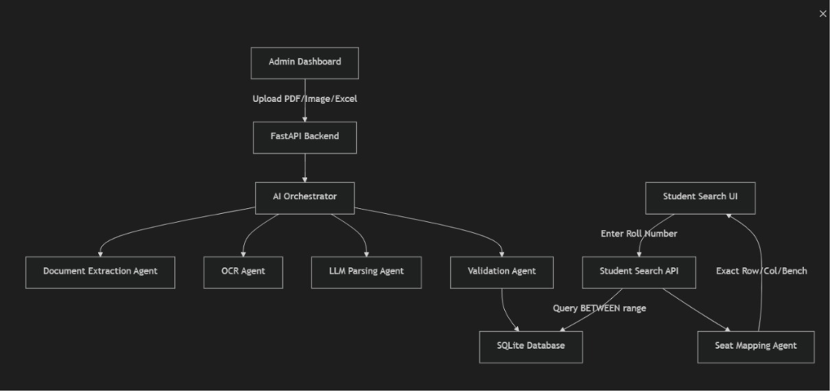
Figure 3.1: Project architecture diagram supplied with the repository.

3.2 Data Ingestion and Normalization
Ingestion accepts Excel, CSV, text, and PDF sources. Excel parsing discovers likely headers such as roll, PIN, subject, date, time, or slot. PDF parsing first attempts table extraction and then falls back to plain text lines. Candidate roll numbers are cleaned, upper-cased, checked for length and digit content, and compared against an exclusion list of document words. Dates are normalized to an ISO-like YYYY-MM-DD representation. This combination of structural and heuristic parsing is appropriate for institutional files that are not always generated from one template.

3.3 Allocation Algorithm
The planner first loads rooms for the chosen session and optionally filters them by block. It then retrieves subjects scheduled for the selected date and time and loads registrations for the session. Student subjects are matched exactly when possible and then matched tolerantly after removing parenthetical abbreviations and normalizing case, punctuation, and spaces. Remaining students are grouped by subject and sorted by roll number. The two largest remaining groups become subject A and subject B for the next room.

3.4 Checkerboard and Capacity Logic
For one student per bench, the room is represented as 24 positions with six rows and four columns. The parity of row plus column determines which subject is preferred at a position. For two students per bench, the representation expands to 48 positions and includes side: left or right. The parity of row plus column plus side alternates the preferred subject. If one subject is exhausted before a room is filled, the planner uses a fallback to place remaining students while preserving the best available alternation.
The two main formulas are: for single seating, seat parity = (row + column) mod 2; for double seating, seat parity = (row + column + side) mod 2. Equal parity positions prefer one subject, while the other parity prefers the second subject. Because neighbouring positions change parity, the construction naturally discourages same-subject adjacency in the normal two-subject case.

3.5 Persistence, Search, and Reporting
Preview results are not immediately written to seating_ranges. The administrator can commit a preview, which clears prior ranges for affected rooms, updates room configuration, and inserts one record per seat position, including empty seats. The search service reads the stored ranges and maps a roll number to room, row, column, side, and bench number. ReportLab services can use the same metadata to render door charts and other printable documents. This preview-commit separation protects the published state from accidental intermediate calculations.

3.6 Validation, Security, and Reliability
The validation agent checks for overlapping ranges and capacity warnings before arrangements are accepted. The tests explicitly create two overlapping ranges in the same room and verify that the result is invalid. A second case exceeds room capacity and verifies that the condition is reported as a warning. Administrator routes are protected by a bearer-token middleware that compares the supplied token with the configured administrative password. The front end stores the token locally for the active browser session.
Reliability is strengthened by deterministic room sorting, numerical/alphabetical student sorting, transaction rollback on commit failures, foreign-key relationships, and unique constraints on sessions, rooms, schedules, and registrations. These measures do not eliminate the need for operational review, but they reduce accidental nondeterminism and make failures more visible.
3.7 Test Evidence
Test area | Observed result
Room seeding | 85 target classrooms created
Mixed allocation | 29 students placed, 0 leftovers
Adjacency rule | No adjacent occupied seats share a subject
Database commit | 48 seating range records written
Tolerant subject matching | Parenthesized and department-prefixed names accepted
Two-student bench mode | 60 students placed with 48-seat room logic
Coordinate mapping | Column-wise, row-wise, and bench numbering verified
The repository test suite therefore covers both business rules and integration boundaries. The results used in this report were obtained by running backend/test_allocation.py, which completed successfully and printed pass messages for each scenario.

4. CONCLUSION AND FUTURE WORK
SeatX demonstrates how a conventional administrative process can be converted into a structured, web-based planning workflow. The project combines practical file ingestion, database persistence, deterministic seat allocation, visual lookup, and report generation in one coherent system. Its most important technical contribution is the separation between data preparation, seating preview, committed publication, and student lookup. This separation makes the system easier to reason about and gives administrators an opportunity to verify an arrangement before it becomes visible to students.
The implemented checkerboard strategy is effective for the tested two-subject cases and supports both single and double seating. Tolerant subject matching makes the planner resilient to common naming differences, while the validation tests show that overlapping ranges and capacity issues can be identified. The deployment blueprint also gives the project a path from local SQLite testing to hosted PostgreSQL operation.
Future work should include stronger authentication with hashed passwords and expiring tokens; role-based access for examination staff; a formal constraint solver for more than two subjects and special accommodations; richer audit trails; automated notification by email or messaging; bulk export to institutional formats; database migrations; and property-based tests for arbitrary room sizes. Performance testing should also be conducted with realistic institutional data volumes and concurrent student searches. Finally, OCR confidence scores and human correction screens would make AI-assisted ingestion safer for low-quality scans.

5. CODE — MAIN PART
The following excerpts are selected from the implemented repository. They are presented as explanatory code samples rather than as a direct copy of a presentation. Each excerpt illustrates a design decision that is important to the overall system.
5.1 Allocation Entry Point
def run_12_12_allocation(session_id, exam_date, exam_time, conn, block=None, students_per_bench=1):
cursor = conn.cursor()
rooms = load_rooms(cursor, session_id, block)
if not rooms:
return {"success": False, "error": "No classrooms found"}
slot_subjects = load_slot_subjects(cursor, session_id, exam_date, exam_time)
students = load_matching_students(cursor, session_id, slot_subjects)
students_by_subject = group_and_sort(students, slot_subjects)
return allocate_rooms(rooms, students_by_subject, students_per_bench)
The real implementation performs the same sequence explicitly: load rooms, validate the slot, retrieve registrations, normalize subject names, group students, allocate rooms, and return a preview object. Returning a structured result rather than writing immediately is what enables the administrator preview workflow.
5.2 Subject Normalization
def normalize_subject(subj: str) -> str:
cleaned = re.sub(r"\(.*?\)", "", subj)
cleaned = re.sub(r"[^a-zA-Z0-9\s]", " ", cleaned)
return " ".join(cleaned.lower().split())
This small helper allows a registration such as “Universal Human Values” to match a schedule entry written as “Universal Human Values (UHV)”. The same normalized comparison also supports department-prefixed names when the registered course name is contained in the scheduled name.

5.3 Checkerboard Position Calculation
if students_per_bench == 2:
col = i // 12
row = (i % 12) // 2
side = (i % 12) % 2
is_even = (row + col + side) % 2 == 0
else:
row = i % 6
col = i // 6
is_even = (row + col) % 2 == 0
The index transformation is deliberately explicit. In double-seating mode, each column contains six benches and each bench contains two side positions. In single-seating mode, the same room dimensions produce 24 positions. Keeping the formula in the allocation engine makes the generated layout deterministic and allows tests to inspect the exact adjacency rule.
5.4 Database Schema Core
CREATE TABLE IF NOT EXISTS seating_ranges (
id SERIAL PRIMARY KEY,
session_id INTEGER NOT NULL,
room_id INTEGER NOT NULL,
roll_prefix VARCHAR(255) NOT NULL,
start_num VARCHAR(255) NOT NULL,
end_num VARCHAR(255) NOT NULL,
exam_date VARCHAR(255),
exam_time VARCHAR(255),
subject VARCHAR(255),
order_index INTEGER DEFAULT 0
)
The seating range table stores the published arrangement as ordered positions. Empty seats are retained as explicit records, which simplifies room-map rendering and preserves the physical grid even when the room is not full. Foreign keys connect ranges to sessions and rooms, so deleting a session can remove dependent data consistently.

5.5 Ingestion and Candidate Validation
def is_valid_roll_candidate(token: str) -> bool:
cleaned = re.sub(r'^[^\w]+|[^\w]+$', '', str(token).strip()).upper()
if not (3 <= len(cleaned) <= 18):
return False
if not any(c.isdigit() for c in cleaned):
return False
if cleaned in excluded_words:
return False
return True
Input files often contain headings, page numbers, room labels, and other words that resemble data. The validation function filters such tokens before they reach the database. The parser also records each roll number once, which reduces duplicate ingestion from repeated headers or multiple extraction passes.
5.6 API Lifecycle and Authentication
@asynccontextmanager
async def lifespan(app: FastAPI):
init_db()
yield

@app.middleware("http")
async def admin_auth_middleware(request, call_next):
if request.url.path.startswith("/api/admin/"):
token = read_bearer_token(request)
verify_token(token)
return await call_next(request)
FastAPI initializes the database when the application starts. Administrative routes are protected before the request reaches the route handler. In a production system, the token mechanism should be strengthened, but the current structure clearly separates public search from administrative operations.

5.7 Coordinate Mapping
column_capacity = rows * students_per_bench
offset = student_index
column = offset // column_capacity
within_column = offset % column_capacity
row = within_column // students_per_bench
side = "Right" if within_column % students_per_bench else "Left"
Seat mapping translates a stored range position into a human-readable coordinate. The test suite verifies that the first two students occupy the left and right sides of the first bench, that the next student moves to the next row, and that the thirteenth student moves to the next column in a 6-by-4 room.
5.8 Commit and Transaction Handling
try:
clear_existing_ranges(cursor, allocated_room_ids)
for room in allocation_result["room_allocations"]:
update_room_layout(cursor, room)
insert_seat_records(cursor, room)
conn.commit()
return {"success": True}
except Exception as error:
conn.rollback()
return {"success": False, "error": str(error)}
The commit step changes the durable state only after all room records have been inserted. A failure rolls back the transaction and returns an explicit error. This behavior is important because partial seating plans would be more dangerous than a visible failure.

5.9 Front-End View Switching
const [view, setView] = useState('student');

{view === 'student' ? (
<StudentSearch />
) : (
adminToken ? <AdminPortal token={adminToken} /> : <AdminLogin />
)}
The React shell keeps the public finder as the default view and switches to the administrator portal only when requested. An authenticated token determines whether the admin dashboard or login screen is rendered. The same application therefore supports two audiences without duplicating the overall page shell.
5.10 Deployment Configuration
services:
- type: web
name: seatx-backend
env: python
buildCommand: pip install -r requirements.txt
- type: static
name: seatx-frontend
buildCommand: npm install && npm run build
databases:
- name: seatx-postgres
The deployment file describes the three resources required by the hosted system. Environment injection keeps database credentials outside source code, while the front end is served as a static build. This arrangement is economical for an academic project and can later be replaced with institutional infrastructure without changing the core allocation logic.

6. OUTPUT SCREENSHOTS
The following figures represent the principal output views implemented by the repository. They are prepared in the visual style and information structure of the application so that the report communicates the expected user experience clearly.
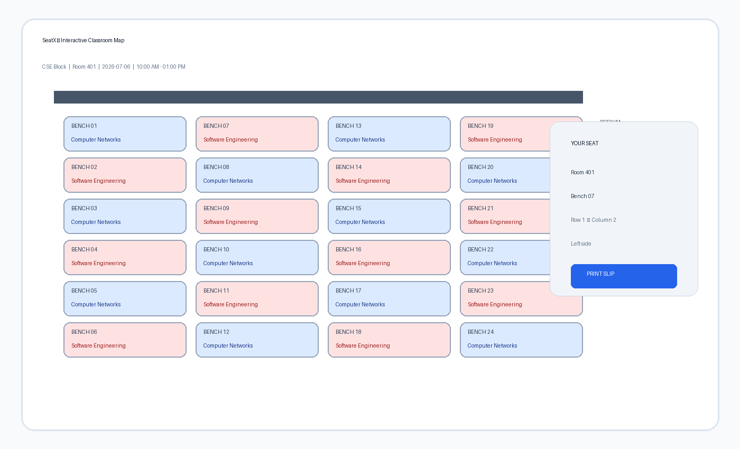
Figure 6.1: Student Finder output — classroom map, room identity, bench, row, column, and side.
A successful roll-number search is intended to give the student an immediately actionable result. The room map shows the spatial context, while the highlighted details identify the precise location. The print action supports a physical slip for use at the venue.

6.1 Administrator Output
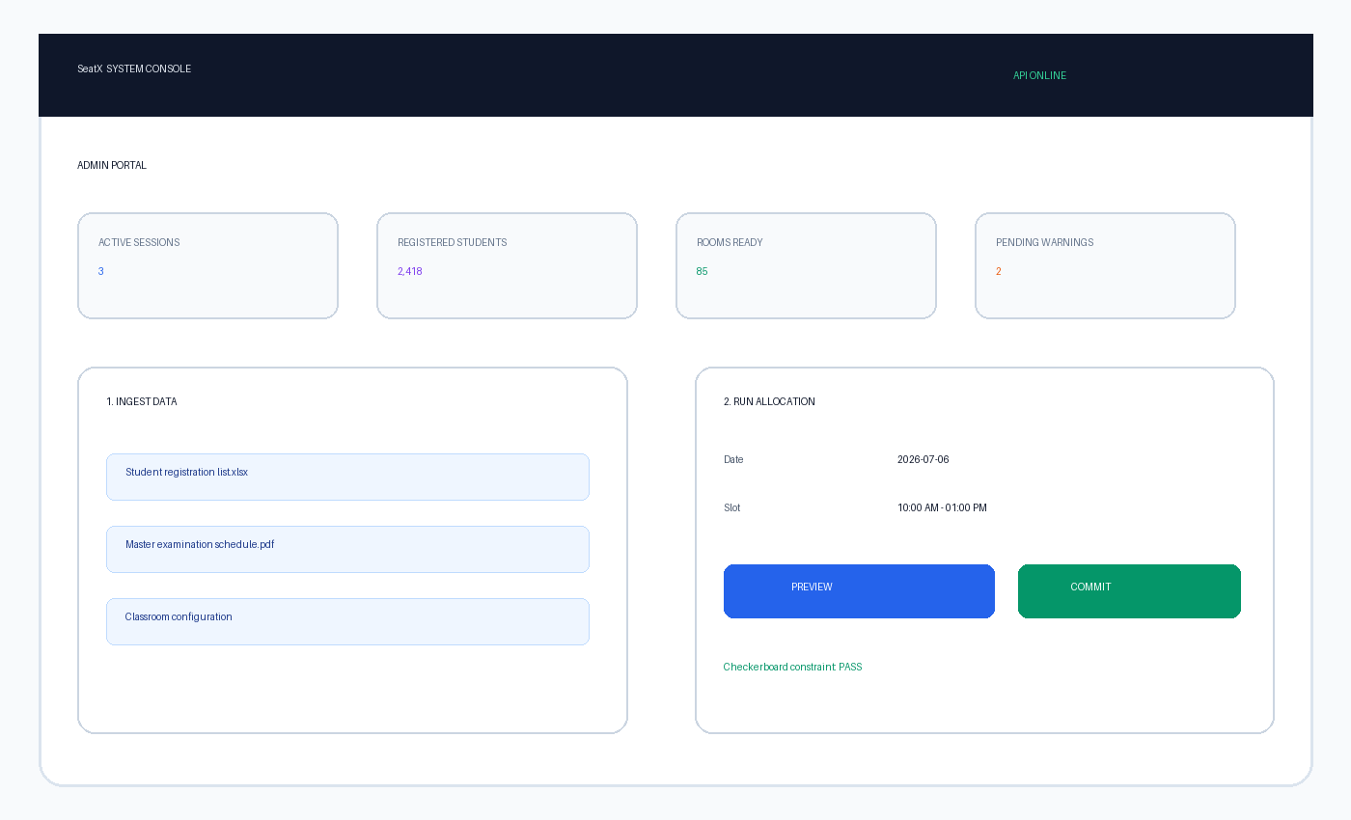
Figure 6.2: Administrator output — data ingestion, allocation preview, status cards, and commit action.
The administrator view exposes the workflow as a sequence: ingest source files, select the session and slot, preview the generated plan, review warnings, and commit the result. Separating preview from commit supports institutional review and makes it possible to correct input data before students can search for seats.

7. BIBLIOGRAPHY
[1] KaramalaSurya, “AI-Powered Exam Seating Arrangement Finder and Automated Planner,” GitHub repository, source code, README, tests, and deployment configuration, accessed November 2026.
[2] FastAPI Documentation, “FastAPI — Modern, Fast Web Framework for Building APIs with Python,” https://fastapi.tiangolo.com/.
[3] React Documentation, “React — The library for web and native user interfaces,” https://react.dev/.
[4] Vite Documentation, “Vite — Next Generation Frontend Tooling,” https://vite.dev/.
[5] Python Software Foundation, “sqlite3 — DB-API 2.0 interface for SQLite databases,” https://docs.python.org/3/library/sqlite3.html.
[6] PostgreSQL Global Development Group, “PostgreSQL Documentation,” https://www.postgresql.org/docs/.
[7] Google, “Gemini API Documentation,” https://ai.google.dev/.
[8] ReportLab, “ReportLab PDF Library User Guide,” https://www.reportlab.com/documentation/.
[9] pdfplumber Documentation, “Extract text and tables from PDF files,” https://github.com/jsvine/pdfplumber.
[10] openpyxl Documentation, “A Python library to read/write Excel 2010 xlsx/xlsm files,” https://openpyxl.readthedocs.io/.
[11] Render Documentation, “Blueprint Specification,” https://render.com/docs/blueprint-spec.
[12] Python Packaging Authority, “Python Packaging User Guide,” https://packaging.python.org/.

7.1 Repository Artifacts Consulted
Artifact | Contribution to this report
README.md | Features, setup, technology stack, project structure
system_architecture.md | Layered architecture and component relationships
backend/allocation.py | Planner algorithm, capacity logic, commit behavior
backend/ingestion.py | File parsing, date normalization, roll validation
backend/database.py | SQLite/PostgreSQL wrapper and schema
backend/agents.py | Seat mapping and validation behavior
backend/test_allocation.py | Allocation, adjacency, persistence, and matching tests
backend/test_agents.py | Coordinate and validation tests
frontend/src/App.jsx | Public/admin view shell and service status
render.yaml | Cloud deployment topology
The report intentionally explains the implementation in original prose and uses short, representative excerpts to connect the discussion to the source. It does not reproduce the contents of a presentation deck. The final document is organized as a technical project report with emphasis on design rationale, measurable behavior, and test evidence.

