Roll No.

ANNA UNIVERSITY (UNIVERSITY DEPARTMENTS)
B.E. / B. Tech (Full Time) - END SEMESTER EXAMINATIONS, NOV/DEC 2025
DATA STRUCTURES
Semester 3
CS23302 - Data Structures
(Regulation R2023)
Time: 3 hours | Max. Marks: 100

CO 1 | Understand the concepts of arrays, linked lists, and their operations
CO 2 | Apply stack and queue data structures to solve computational problems
CO 3 | Analyze tree structures including BST, AVL, and heap operations
CO 4 | Evaluate graph algorithms for shortest path, spanning tree, and traversal
CO 5 | Design and implement hashing techniques and advanced data structures
BL – Bloom's Taxonomy Levels
(L1 - Remembering, L2 - Understanding, L3 - Applying, L4 - Analysing, L5 - Evaluating, L6 - Creating)
PART- A (10 x 2 = 20 Marks)
(Answer all Questions)
Q. No | Questions | Marks | CO | BL
1 | Define a data structure. Give two examples of linear data structures. | 2 | 1 | L1
2 | Distinguish between a singly linked list and a doubly linked list with respect to memory usage and traversal.  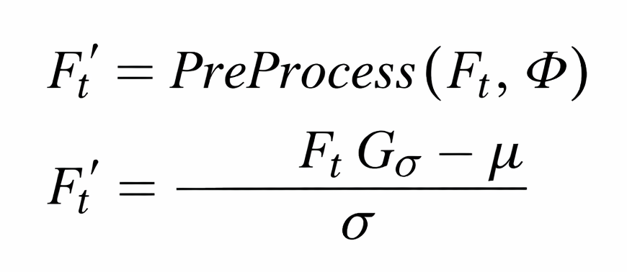 | 2 | 1 | L2
3 | State the conditions for stack overflow and stack underflow in an array-based stack of size $N$. | 2 | 2 | L1
4 | Evaluate the postfix expression: $6 3 2 * + 4 −$ using a stack. Show the stack contents at each step. | 2 | 2 | L2
5 | Define a Binary Search Tree (BST). What is the time complexity of searching an element in a balanced BST with $n$ nodes? | 2 | 3 | L1
6 | Explain the difference between a complete binary tree and a full binary tree. If a complete binary tree has $n$ nodes, what is the maximum height $h=⌊\log_{2}n⌋$? | 2 | 3 | L2
7 | Given the adjacency matrix $A$ of a graph $G$ with 4 vertices, determine the number of edges:  $A=\left(\begin{matrix}0 & 1 & 1 & 0 \\ 1 & 0 & 1 & 1 \\ 1 & 1 & 0 & 1 \\ 0 & 1 & 1 & 0\end{matrix}\right)$ | 2 | 4 | L1
8 | Define the terms: (i) Degree of a vertex, (ii) In-degree and Out-degree in a directed graph. | 2 | 4 | L1
9 | Compute the hash values for keys $\{23, 48, 35, 10, 67\}$ using the hash function $h(k)=kmod7$. Identify any collisions. | 2 | 5 | L2
10 | Explain open addressing in hashing. Write the probe sequence formula for linear probing: $h_{i}(k)=(h(k)+i)modm$, where $i=0,1,2,…$ | 2 | 5 | L2
PART- B (5 x 13 = 65 Marks)
(Answer any FIVE questions, choosing one from each unit)
Q. No | Questions | Marks | CO | BL
11 (a) | Implement a doubly linked list with the following operations:  (i) Insert at the beginning: set $\text{newNode}→\text{next}=\text{head}$  (ii) Delete a node with key $k$  (iii) Reverse the list in $O(n)$ time.  Analyze the time complexity of each operation using Big-O notation.  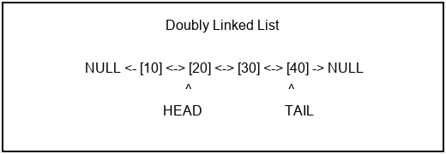 | 13 | 1 | L3
 | OR
11 (b) | Design and implement a circular queue using an array of size $N$. Show that the queue is full when $(\text{rear}+1)modN=\text{front}$ and empty when $\text{front}=\text{rear}=−1$. Write the enqueue and dequeue operations with boundary checks. | 13 | 2 | L3
12 (a) | Convert the infix expression $A+B×C−(D/E+F)×G$ to:  (i) Postfix notation using the stack algorithm  (ii) Prefix notation  Show the stack trace at each step. What is the time complexity of the conversion algorithm? | 13 | 2 | L4
 | OR
12 (b) | A priority queue is implemented using a binary min-heap. Given the initial heap: $[5, 10, 15, 20, 25, 30]$.  (i) Insert key $k=3$ and show the up-heap bubbling process.  (ii) Perform Extract-Min and show the down-heap process.  (iii) Prove that both operations run in $O(logn)$ time where $n$ is the number of elements. | 13 | 2 | L4
13 (a) | Construct a Binary Search Tree by inserting the keys $\{50, 30, 70, 20, 40, 60, 80, 10\}$ in order.  (i) Draw the resulting BST.  (ii) Perform in-order, pre-order, and post-order traversals.  (iii) Delete node 30 (which has two children). Show the resulting tree after deletion.  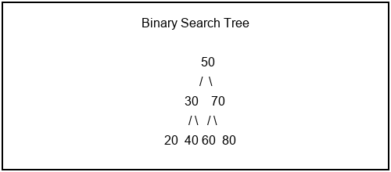 | 13 | 3 | L4
 | OR
13 (b) | Construct an AVL tree by inserting the keys $\{10, 20, 30, 15, 25, 5\}$.  (i) Show the tree after each insertion.  (ii) Identify the type of rotation (LL, RR, LR, RL) needed at each imbalance.  (iii) Prove that the height of an AVL tree with $n$ nodes satisfies $h=O(logn)$.  Use the balance factor formula: $\text{BF}(v)=h(v.\text{left})−h(v.\text{right})$.  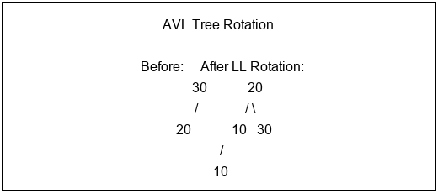 | 13 | 3 | L4
14 (a) | Apply Dijkstra's algorithm on the weighted graph shown in the figure to find the shortest path from vertex $A$ to all other vertices.  (i) Show the distance table $d[v]$ after each iteration.  (ii) Trace the shortest path from $A$ to $F$.  (iii) What is the total time complexity if implemented with a min-priority queue? Express as $O((V+E)logV)$.  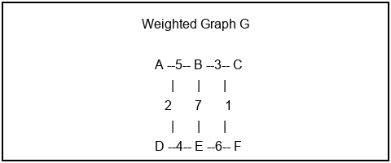 | 13 | 4 | L4
 | OR
14 (b) | Apply Kruskal's algorithm to find the Minimum Spanning Tree of a graph with edges:  (i) Sort edges by weight and apply the Union-Find method.  (ii) Show the MST edges and total weight.  (iii) Prove that the MST weight satisfies: $W_{\text{MST}}≤\sum_{i=1}^{n−1}{w_{i}}$ where $w_{i}$ are the $n−1$ smallest edge weights.  $\left\{(A,B,5),(A,D,2),(B,C,3),(B,E,7),(C,F,1),(D,E,4),(E,F,6)\right\}$ | 13 | 4 | L5
15 (a) | A hash table of size $m=11$ uses double hashing with:  Insert the keys $\{20, 34, 45, 56, 23, 67, 78, 89\}$ in order.  (i) Show the hash table after all insertions.  (ii) Count the number of collisions and probe sequences.  (iii) Calculate the load factor $α=n/m$ and expected number of probes: $\frac{1}{1−α}$ for successful search.  $h_{1}(k)=kmod11,h_{2}(k)=7−(kmod7)$ | 13 | 5 | L3
 | OR
15 (b) | Implement a hash table using separate chaining for the keys $\{12, 25, 37, 48, 53, 61, 79\}$ with $h(k)=kmod7$.  (i) Draw the hash table with linked list chains.  (ii) Calculate the average chain length.  (iii) Explain rehashing: when $α>0.75$, create a new table of size $m^{′}=2m+1$ (next prime) and reinsert all keys.  Compare the worst-case time complexity $O(n)$ vs. average-case $O(1+α)$. | 13 | 5 | L3
PART- C (1 x 15 = 15 Marks)
(Q.No. 16 is compulsory)
Q. No | Questions | Marks | CO | BL
16 | A university library system manages book records using a combination of data structures. The system uses a BST for searching books by ISBN and a hash table for quick author-based lookups.  (a) Design the BST structure where each node stores $(\text{ISBN}, \text{title}, \text{author})$. Insert the following books with ISBNs: $\{978, 245, 567, 123, 389, 701, 890\}$. Draw the resulting BST. (5 marks)  (b) The hash table for author lookup uses $h(k)=\sum_{i=0}^{n−1}{k_{i}}×{31}^{n−1−i}modm$ where $k_{i}$ are ASCII values of author name characters and $m=13$. Compute hash values for authors: "Knuth", "Cormen", "Sedgewick". Resolve any collisions using quadratic probing: $h_{i}=(h(k)+i^{2})modm$. (5 marks)  (c) Analyze the overall time complexity of the system:  - BST search: $O(logn)$ average, $O(n)$ worst case.  - Hash lookup: $O(1)$ average, $O(n)$ worst case.  Propose an improvement using an AVL tree for the BST component and prove that the balanced height $h≤1.44\log_{2}(n+2)−0.328$ guarantees $O(logn)$ worst-case search. (5 marks) | 15 | 3 | L5

