**MATLAB**

**Basics**

1. Ans in workspace == most recent word that was answered
2. Clc == clear command window
3. Whos === to see variablesA screenshot of a computer

   Description automatically generated
4. Char == defined if (‘x’) single apostrophe
5. Sting == (“x”) doble apostrophe
6. ; == used to stop displaying the output
7. A screenshot of a computer

   Description automatically generated
8. “,” == comma used to display more values
9. New script === to run – click on run – use of script – can write multiple lines of code
10. Crtl + enter – Run

**Vectors and matrices**

1. 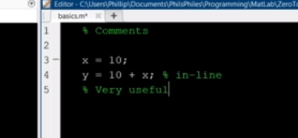
2. Clc, ckearvars --- start with this
3. Vectors – Arrays -- interchangeable
4. 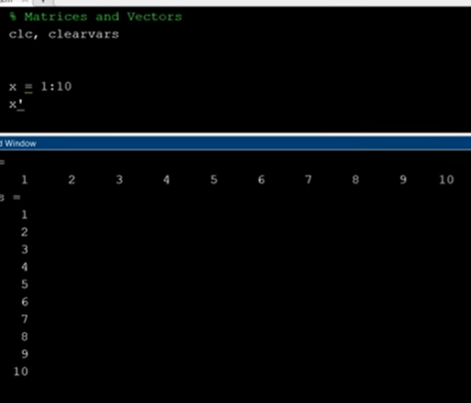
5. Linspace === creates evely spaced terms , use commas between argumentsA screenshot of a computer

   Description automatically generated
6. Manual array A screenshot of a computer

   Description automatically generated only seperator required is a space
7. A black background with white text

   Description automatically generated
8. 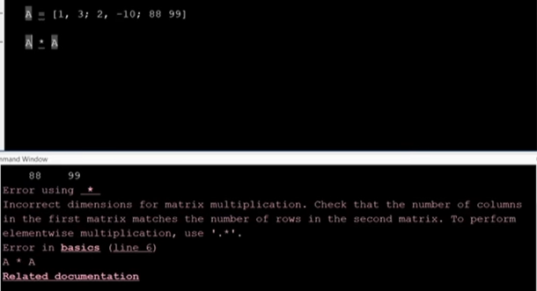It follows linear algebra
9. 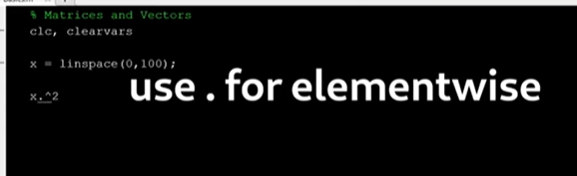
10. A screenshot of a computer program

    Description automatically generated
11. 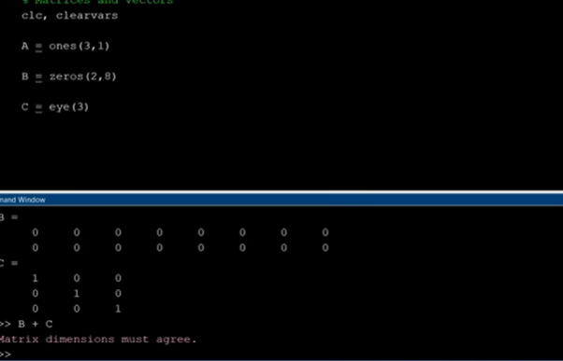

Eye== identity matrix

1. A screenshot of a computer

   Description automatically generated
2. 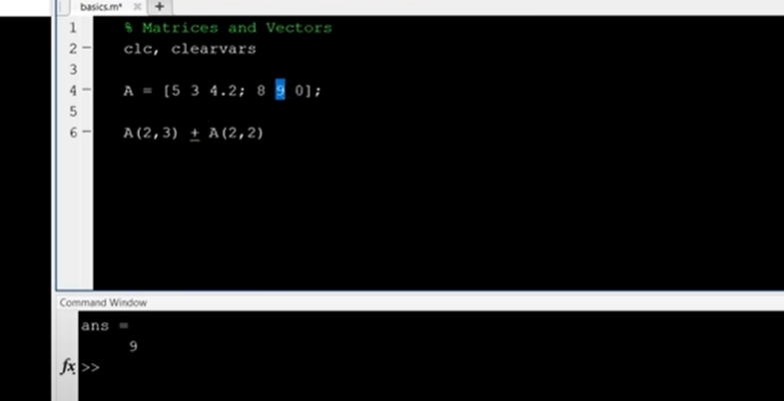 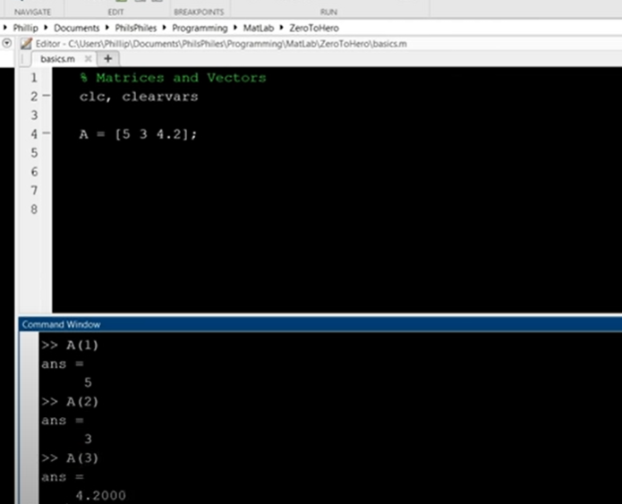
3. Memory indexing in Matlab . End – 10 == 10 spots before 10 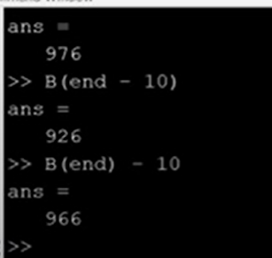 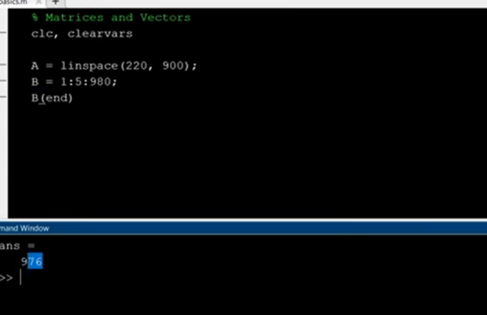
4. Pullout A screenshot of a computer

   Description automatically generated A screenshot of a computer

   Description automatically generated
5. Problem 1

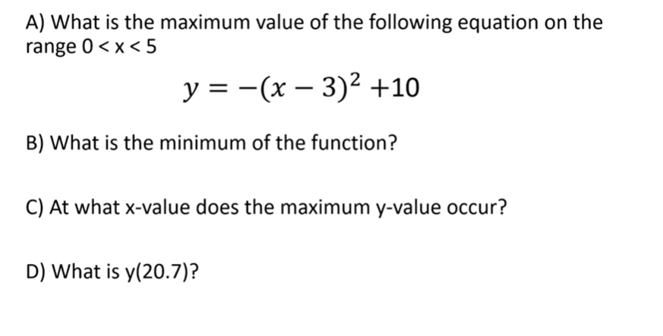 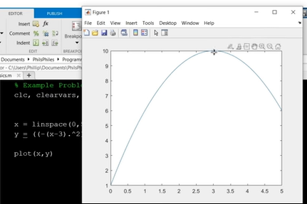 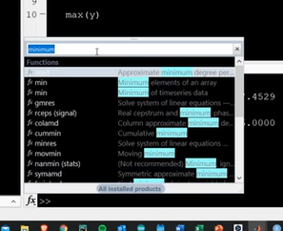 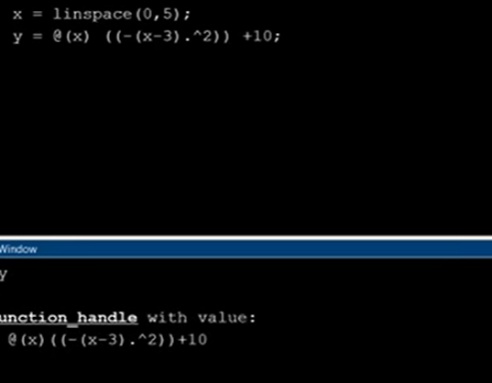

1. How to find the Y value for any given x

Use anonymous functions – custom funtions

1. Question 2

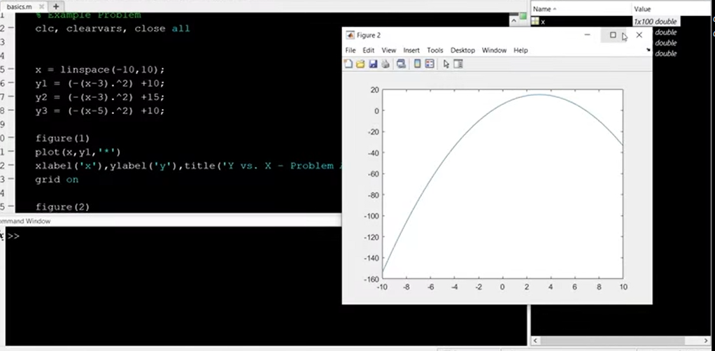Use hold on to add stuff to the same graph 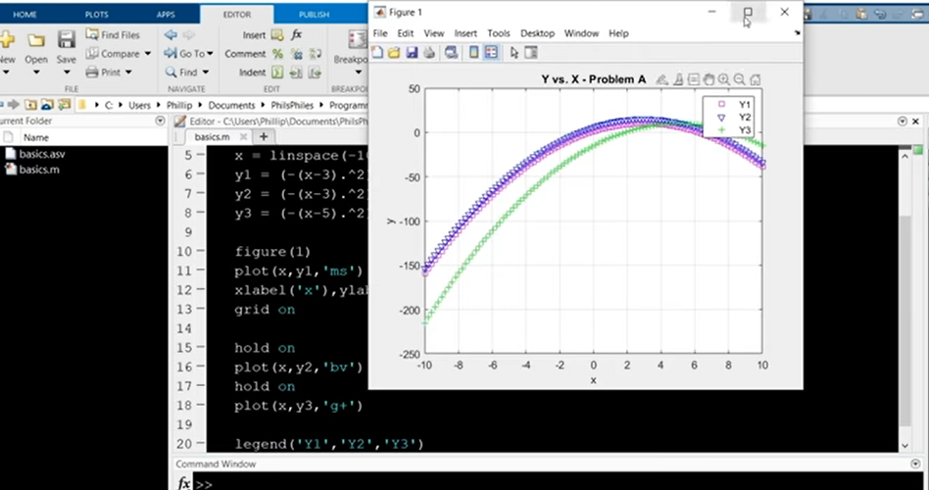to change the x axis or the y axis type x lim and y lim

Continue at 58.00 minutes 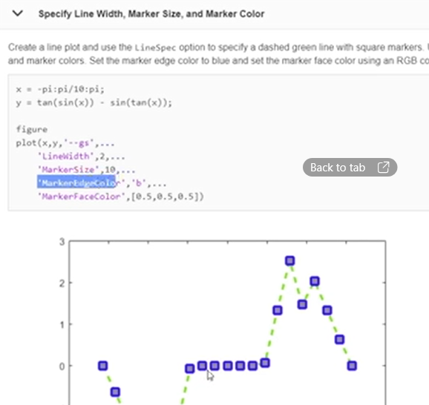

1. Subplot

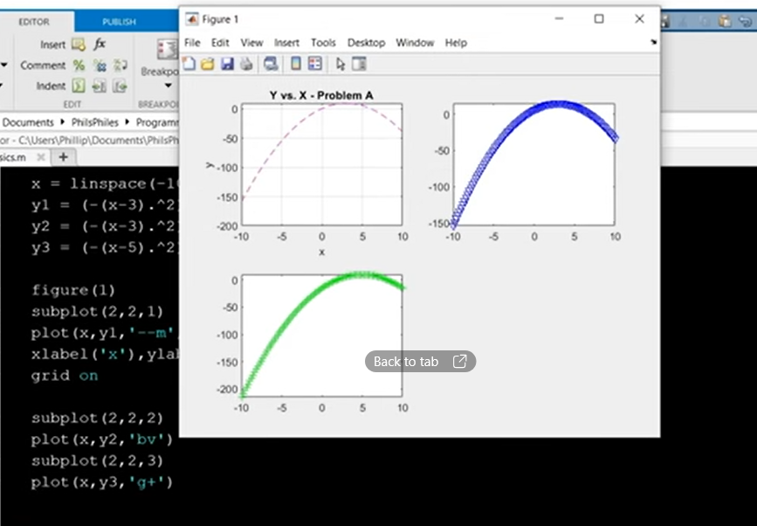

1. Problem 3

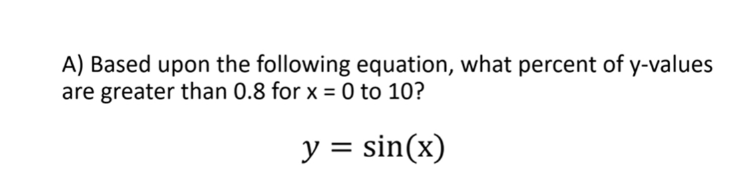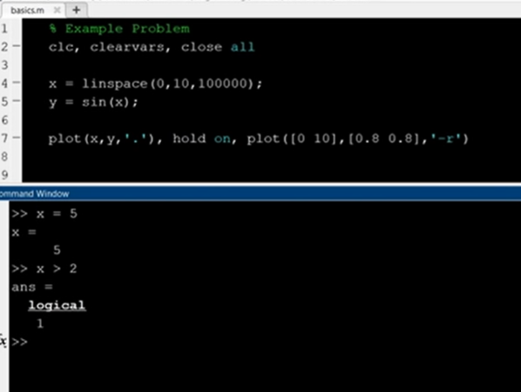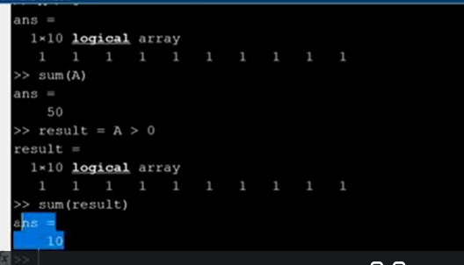

Not equal to (~=) 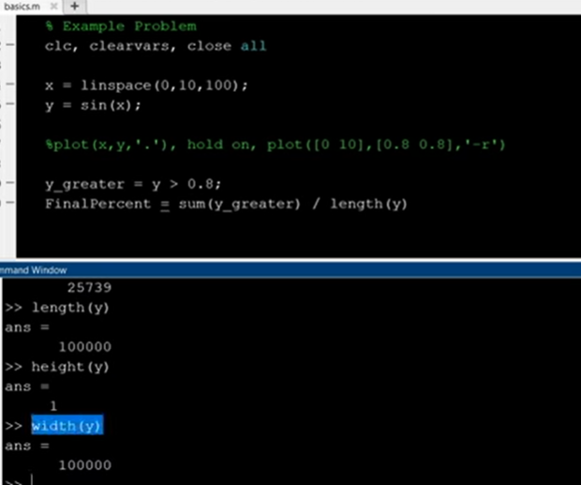

ans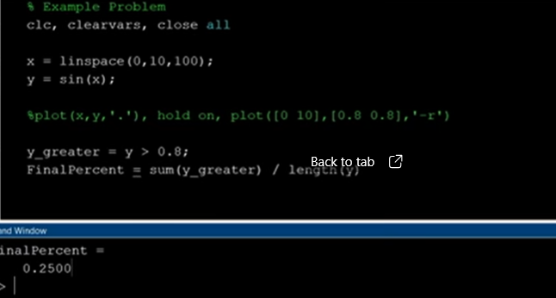

1. Good code form

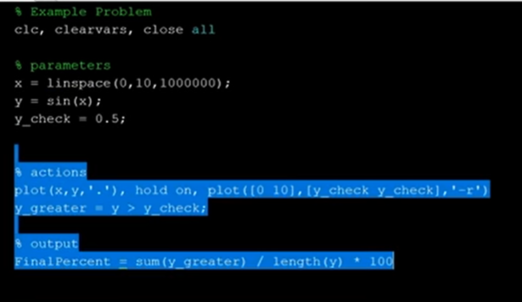

1. Problem 4

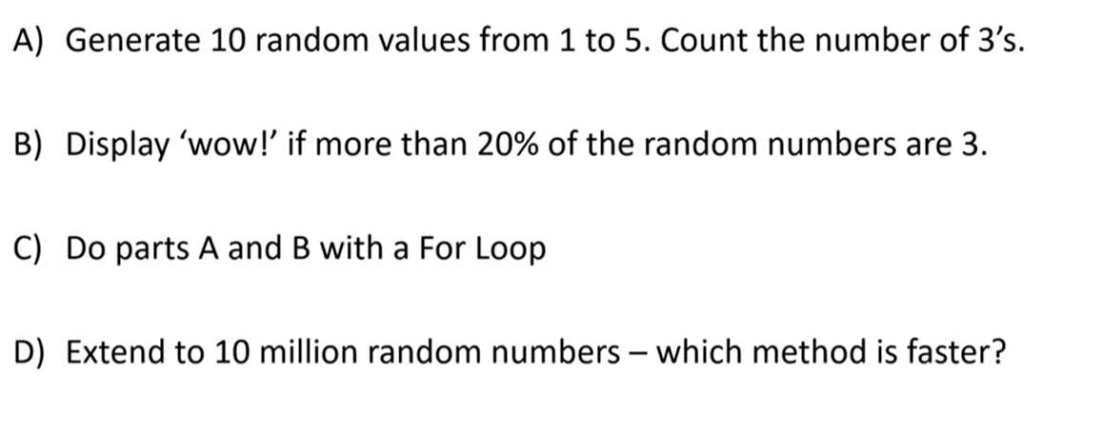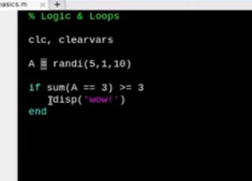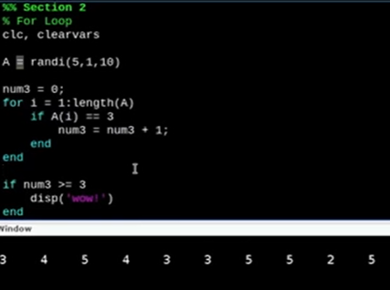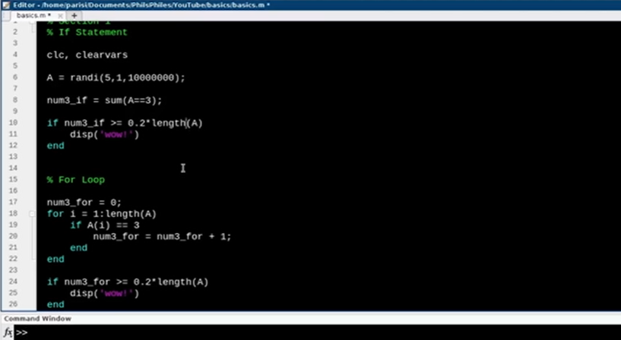

1. %% -- two of these signs create a new section
2. For loops

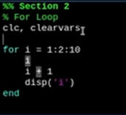

1. To time a function use tik and tok.
2. While loops

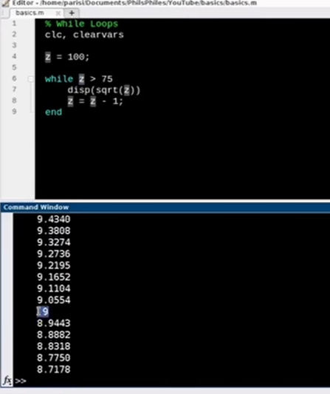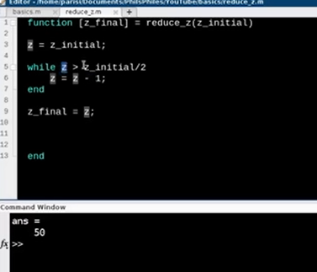

Type ‘who’ to see all the variables in your script