Assignment-6 Data Structures
  - Topic-Double and Circular Linked list
Name-Karanveer singh
Roll-1024200002
Batch-2C24

Ques-1)
Solution
#include <iostream>
#include <cstdlib>
using namespace std;
class Node {
public:
int data;
Node* next;
Node* prev;
Node(int val) {
data = val;
next = prev = nullptr;
}
};
class MyList {
private:
Node* head;
public:
MyList() {
head = nullptr;
}
void insertFirst(int x) {
Node* newNode = new Node(x);
if (!head) {
newNode->next = newNode;
newNode->prev = newNode;
head = newNode;
} else {
Node* last = head->prev;
newNode->next = head;
newNode->prev = last;
last->next = newNode;
head->prev = newNode;
head = newNode;
}
cout << "Inserted " << x << " at beginning\n";
}
void insertLast(int x) {
Node* newNode = new Node(x);
if (!head) {
newNode->next = newNode;
newNode->prev = newNode;
head = newNode;
} else {
Node* last = head->prev;
newNode->next = head;
newNode->prev = last;
last->next = newNode;
head->prev = newNode;
}
cout << "Inserted " << x << " at end\n";
}
void insertAfter(int key, int x) {
if (!head) {
cout << "List is empty\n";
return;
}
Node* temp = head;
do {
if (temp->data == key) {
Node* newNode = new Node(x);
newNode->next = temp->next;
newNode->prev = temp;
temp->next->prev = newNode;
temp->next = newNode;
cout << "Inserted " << x << " after " << key << "\n";
return;
}
temp = temp->next;
} while (temp != head);
cout << "Node " << key << " not found\n";
}
void insertBefore(int key, int x) {
if (!head) {
cout << "List is empty\n";
return;
}
Node* temp = head;
do {
if (temp->data == key) {
Node* newNode = new Node(x);
newNode->next = temp;
newNode->prev = temp->prev;
temp->prev->next = newNode;
temp->prev = newNode;
if (temp == head) head = newNode;
cout << "Inserted " << x << " before " << key << "\n";
return;
}
temp = temp->next;
} while (temp != head);
cout << "Node " << key << " not found\n";
}
void deleteNode(int key) {
if (!head) {
cout << "List is empty\n";
return;
}
Node* temp = head;
do {
if (temp->data == key) {
if (temp->next == temp && temp->prev == temp) {
head = nullptr;
delete temp;
cout << "Deleted node " << key << "\n";
return;
}
temp->prev->next = temp->next;
temp->next->prev = temp->prev;
if (temp == head) head = temp->next;
delete temp;
cout << "Deleted node " << key << "\n";
return;
}
temp = temp->next;
} while (temp != head);
cout << "Node " << key << " not found\n";
}
void searchNode(int key) {
if (!head) {
cout << "List is empty\n";
return;
}
Node* temp = head;
do {
if (temp->data == key) {
cout << "Node " << key << " found\n";
return;
}
temp = temp->next;
} while (temp != head);
cout << "Node " << key << " not found\n";
}
void display() {
if (!head) {
cout << "List is empty\n";
return;
}
cout << "List: ";
Node* temp = head;
do {
cout << temp->data << " ";
temp = temp->next;
} while (temp != head);
cout << endl;
}
};
int main() {
MyList list;
int choice, val, key;
cout << "Circular Doubly Linked List Program\n";
while (true) {
cout << "\n1. Insert at Beginning\n";
cout << "2. Insert at End\n";
cout << "3. Insert After a Node\n";
cout << "4. Insert Before a Node\n";
cout << "5. Delete a Node\n";
cout << "6. Search a Node\n";
cout << "7. Display List\n";
cout << "8. Exit\n";
cout << "Enter choice: ";
cin >> choice;

switch (choice) {
case 1: cout << "Enter value: "; cin >> val; list.insertFirst(val); break;
case 2: cout << "Enter value: "; cin >> val; list.insertLast(val); break;
case 3: cout << "Enter key and value: "; cin >> key >> val; list.insertAfter(key, val); break;
case 4: cout << "Enter key and value: "; cin >> key >> val; list.insertBefore(key, val); break;
case 5: cout << "Enter node to delete: "; cin >> key; list.deleteNode(key); break;
case 6: cout << "Enter node to search: "; cin >> key; list.searchNode(key); break;
case 7: list.display(); break;
case 8: cout << "Program ended\n"; exit(0);
default: cout << "Invalid choice\n";
}
}
return 0;
}
Output
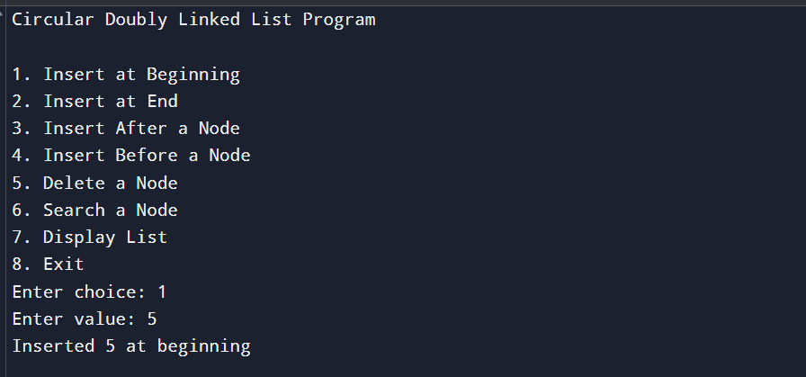
Ques-2)
Solution
Algorithm:
void display() {
if (!head) {
cout << "List is empty\n";
return;
}
cout << "List: ";
Node* temp = head;
do {
cout << temp->data << " ";
temp = temp->next;
} while (temp != head);
cout << head->data << endl;
}
Ques-3)
Solution
Program to find size of doubly linked list:
#include <iostream>
using namespace std;
class Node {
public:
int data;
Node* next;
Node* prev;
Node(int val) {
data = val;
next = prev = nullptr;
}
};
class DoublyLinkedList {
private:
Node* head;
public:
DoublyLinkedList() {
head = nullptr;
}
void insertEnd(int x) {
Node* newNode = new Node(x);
if (!head) {
head = newNode;
return;
}
Node* temp = head;
while (temp->next) {
temp = temp->next;
}
temp->next = newNode;
newNode->prev = temp;
}
int size() {
int count = 0;
Node* temp = head;
while (temp) {
count++;
temp = temp->next;
}
return count;
}
void display() {
Node* temp = head;
cout << "List: ";
while (temp) {
cout << temp->data << " ";
temp = temp->next;
}
cout << endl;
}
};
int main() {
DoublyLinkedList dll;
dll.insertEnd(10);
dll.insertEnd(20);
dll.insertEnd(30);
dll.display();
cout << "Size of Doubly Linked List = " << dll.size() << endl;
return 0;
}
Output

Program to find size of circular linked list:
#include <iostream>
using namespace std;
class Node {
public:
int data;
Node* next;
Node(int val) {
data = val;
next = nullptr;
}
};
class CircularLinkedList {
private:
Node* head;
public:
CircularLinkedList() {
head = nullptr;
}
void insertEnd(int x) {
Node* newNode = new Node(x);
if (!head) {
head = newNode;
newNode->next = head;
return;
}
Node* temp = head;
while (temp->next != head) {
temp = temp->next;
}
temp->next = newNode;
newNode->next = head;
}
int size() {
if (!head) return 0;
int count = 0;
Node* temp = head;
do {
count++;
temp = temp->next;
} while (temp != head);
return count;
}
void display() {
if (!head) {
cout << "List is empty\n";
return;
}
Node* temp = head;
cout << "List: ";
do {
cout << temp->data << " ";
temp = temp->next;
} while (temp != head);
cout << head->data << endl;
}
};
int main() {
CircularLinkedList cll;
cll.insertEnd(10);
cll.insertEnd(20);
cll.insertEnd(30);
cll.display();
cout << "Size of Circular Linked List = " << cll.size() << endl;
return 0;
}
Output
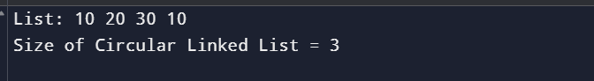
Ques->4
Solution
#include <iostream>
using namespace std;
class Node {
public:
char data;
Node* next;
Node* prev;
Node(char val) {
data = val;
next = prev = nullptr;
}
};
class DoublyLinkedList {
private:
Node* head;
Node* tail;
public:
DoublyLinkedList() {
head = tail = nullptr;
}
void insertEnd(char x) {
Node* newNode = new Node(x);
if (!head) {
head = tail = newNode;
} else {
tail->next = newNode;
newNode->prev = tail;
tail = newNode;
}
}
void display() {
Node* temp = head;
cout << "List: ";
while (temp) {
cout << temp->data << " ";
temp = temp->next;
}
cout << endl;
}
bool isPalindrome() {
if (!head) return true;
Node* left = head;
Node* right = tail;
while (left != right && right->next != left) {
if (left->data != right->data) {
return false;
}
left = left->next;
right = right->prev;
}
return true;
}
};
int main() {
DoublyLinkedList dll;
int n;
cout << "Enter number of characters: ";
cin >> n;
cout << "Enter characters:\n";
for (int i = 0; i < n; i++) {
char c;
cin >> c;
dll.insertEnd(c);
}
dll.display();
if (dll.isPalindrome())
cout << "The doubly linked list is a palindrome\n";
else
cout << "The doubly linked list is not a palindrome\n";
return 0;
}
Output
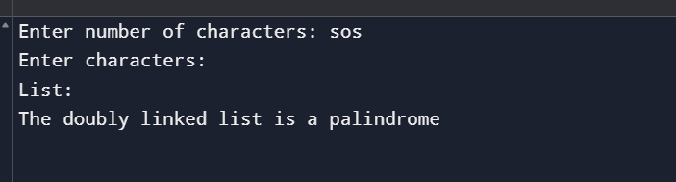
Ques-5)
Solution
#include <iostream>
using namespace std;
class Node {
public:
int data;
Node* next;
Node(int val) {
data = val;
next = nullptr;
}
};
class LinkedList {
private:
Node* head;
public:
LinkedList() {
head = nullptr;
}
void insertEnd(int x) {
Node* newNode = new Node(x);
if (!head) {
head = newNode;
return;
}
Node* temp = head;
while (temp->next) {
temp = temp->next;
}
temp->next = newNode;
}
void makeCircular() {
if (!head) return;
Node* temp = head;
while (temp->next) {
temp = temp->next;
}
temp->next = head;
}
bool isCircular() {
if (!head) return false;
Node* temp = head->next;
while (temp != nullptr && temp != head) {
temp = temp->next;
}
return (temp == head);
}
void display(int count) {
Node* temp = head;
cout << "List: ";
for (int i = 0; i < count && temp; i++) {
cout << temp->data << " ";
temp = temp->next;
}
cout << endl;
}
};
int main() {
LinkedList list;
list.insertEnd(10);
list.insertEnd(20);
list.insertEnd(30);
list.display(5);
if (list.isCircular())
cout << "The linked list is circular\n";
else
cout << "The linked list is not circular\n";
list.makeCircular();
if (list.isCircular())
cout << "The linked list is now circular\n";
else
cout << "The linked list is not circular\n";
return 0;
}
Output
