**1.Write a program to replace a substring inside a string with other string ?**

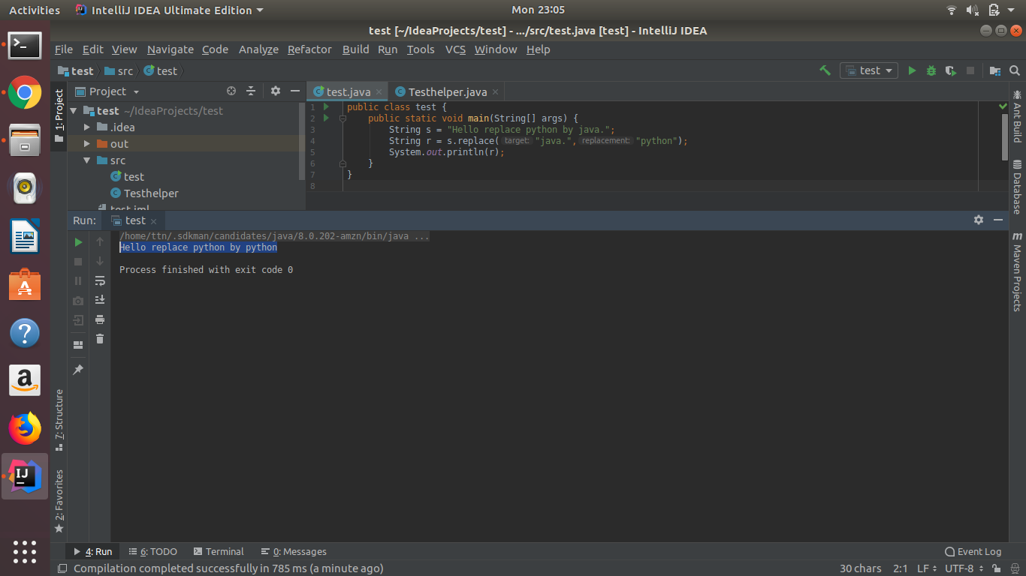

**2.Write a program to find the number of occurrences of the duplicate words in a string and print them ?**

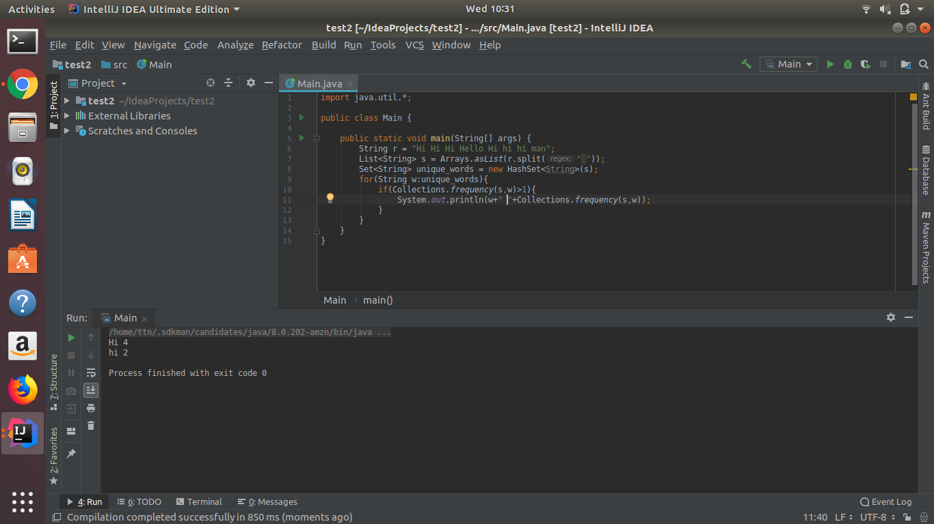

**3.Write a program to find the number of occurrences of a character in a string without using loop?**

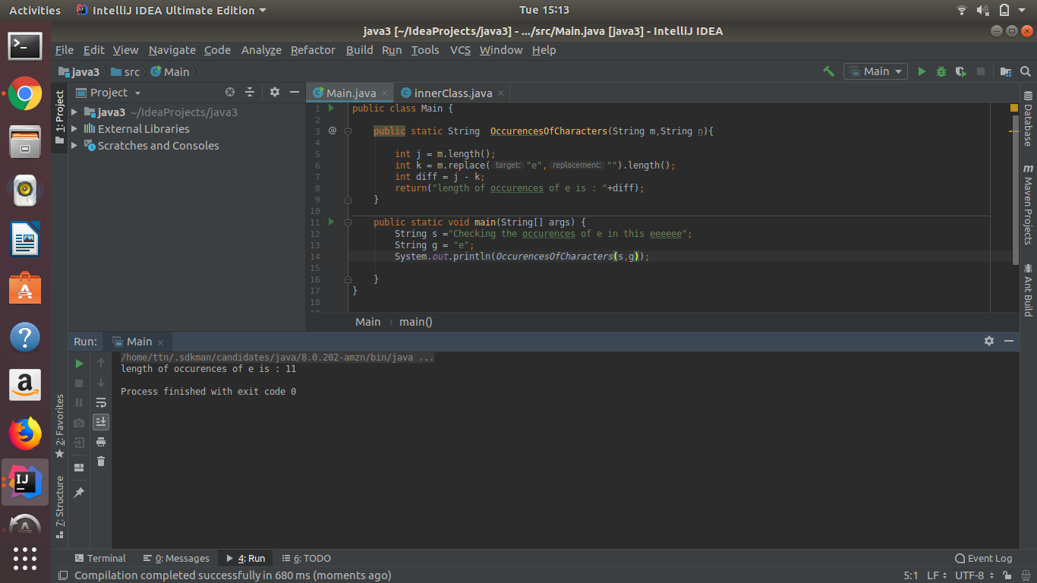

**4.Calculate the number Of Lowercase Letters,Uppercase Letters, Digits And Other Special Characters In A String**

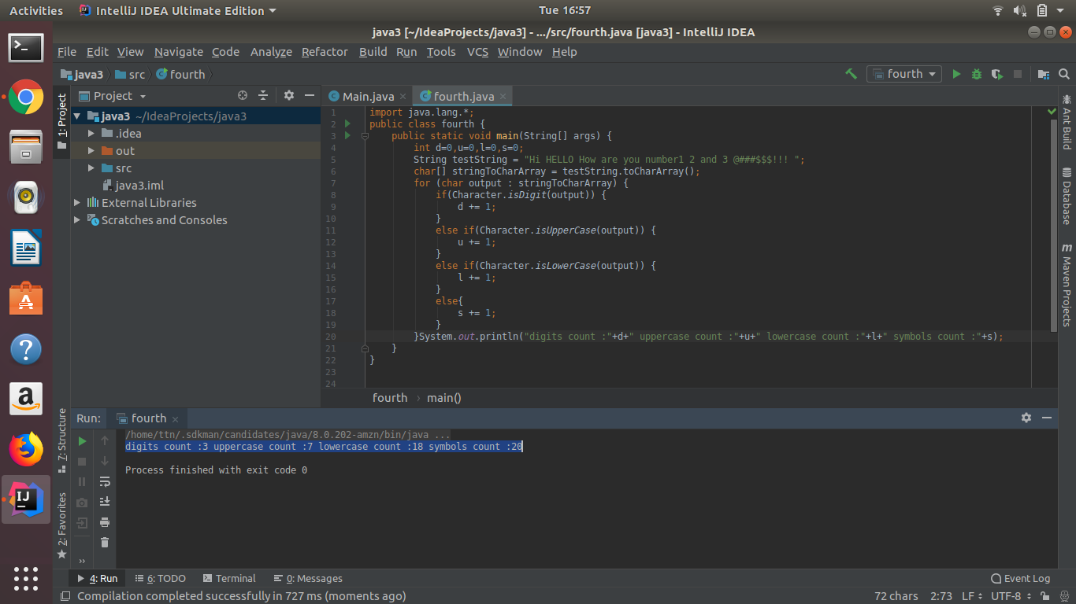

**5.Find common elements between two arrays.**

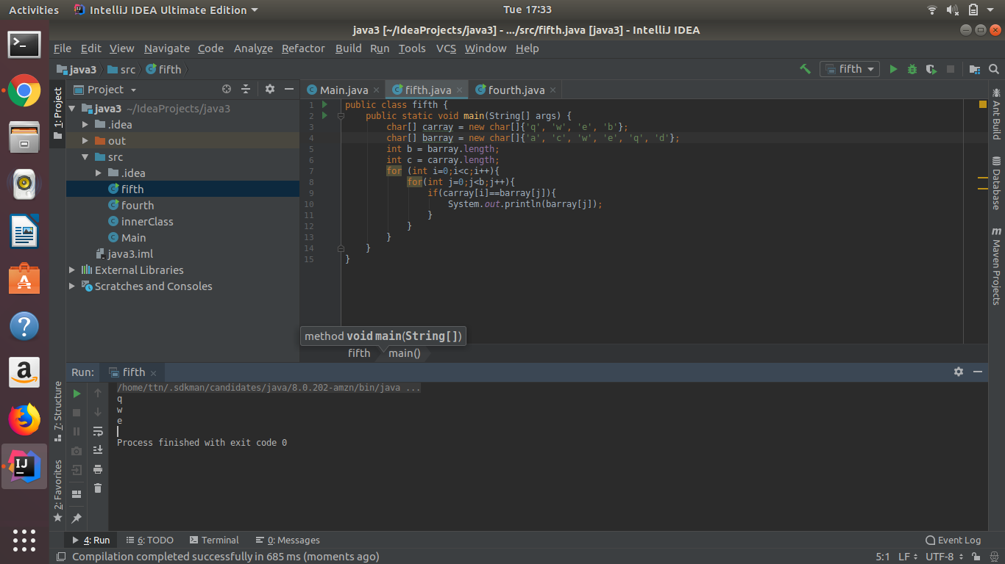

**6.There is an array with every element repeated twice except one. Find that element**

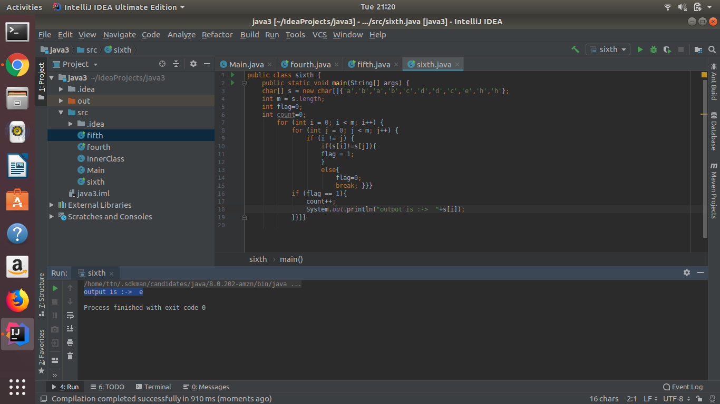

**7.Write a program to print your Firstname,LastName & age using static block,static method & static variable respectively**

**STATIC VARIABLE AND STATIC METHOD : - >**

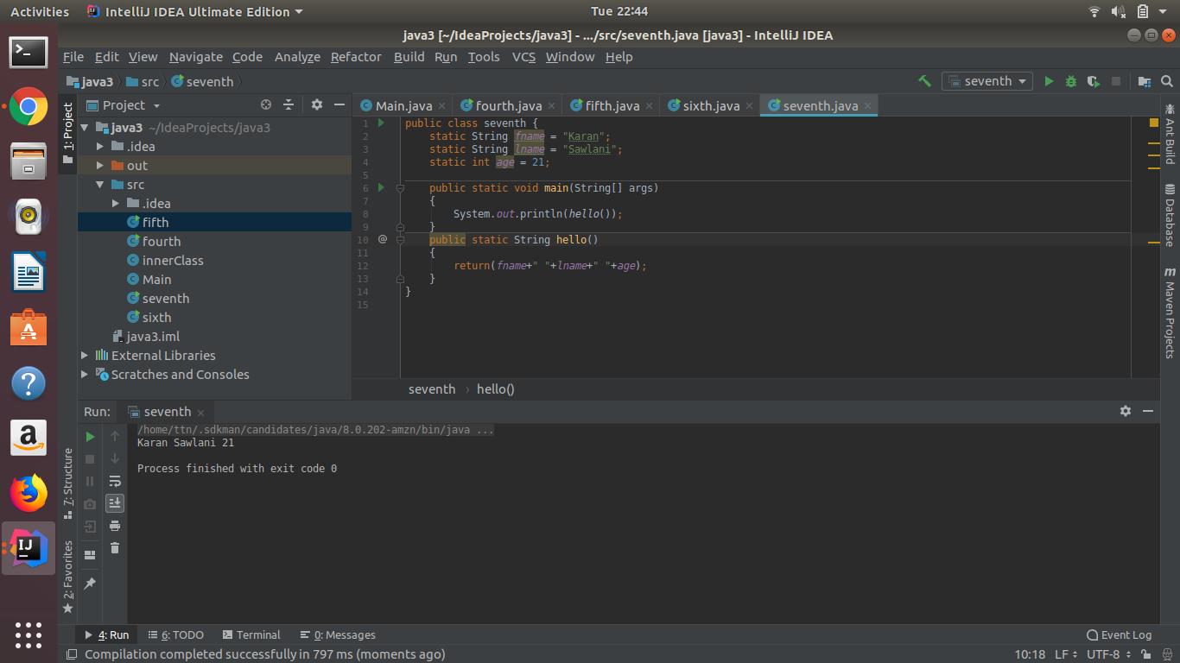

**STATIC BLOCK WITH STATIC VARIABLE AND STATIC METHOD : - >**

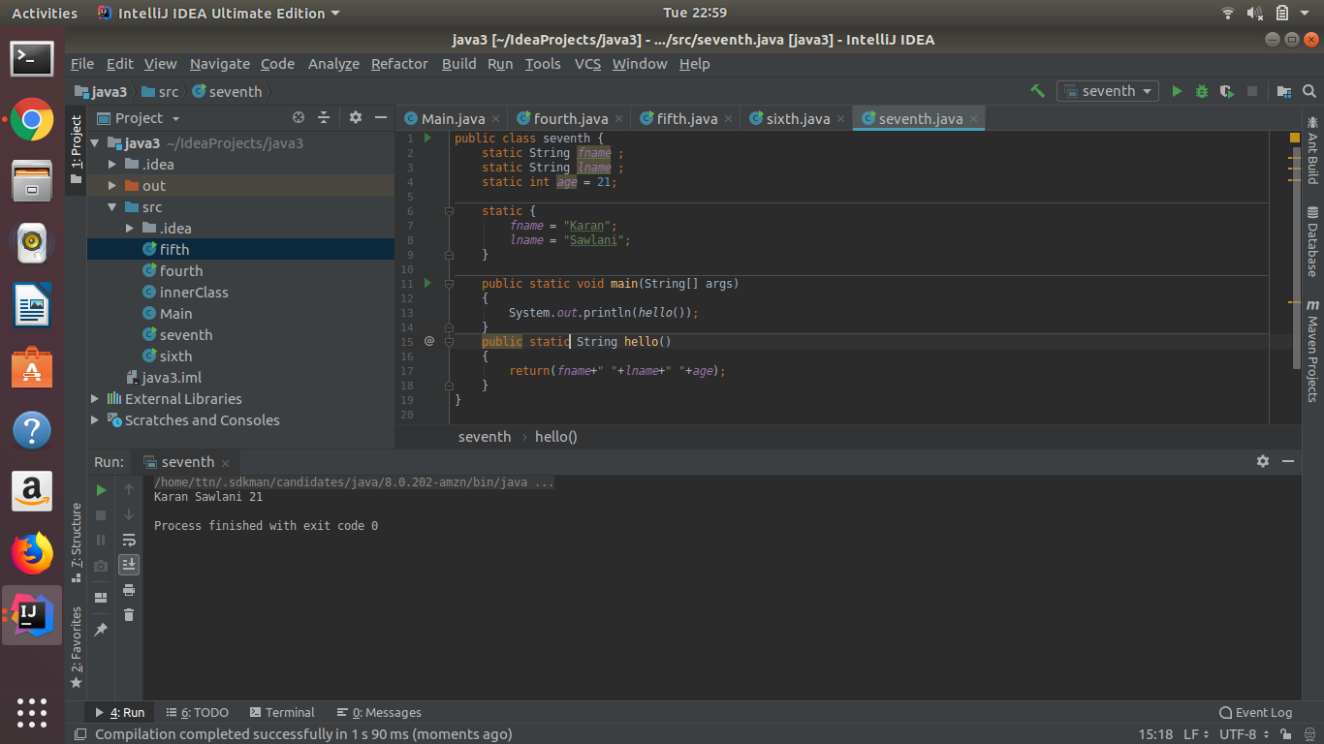

**8.Write a program to reverse a string and remove character from index 4 to index 9 from the reversed string using String Buffer**

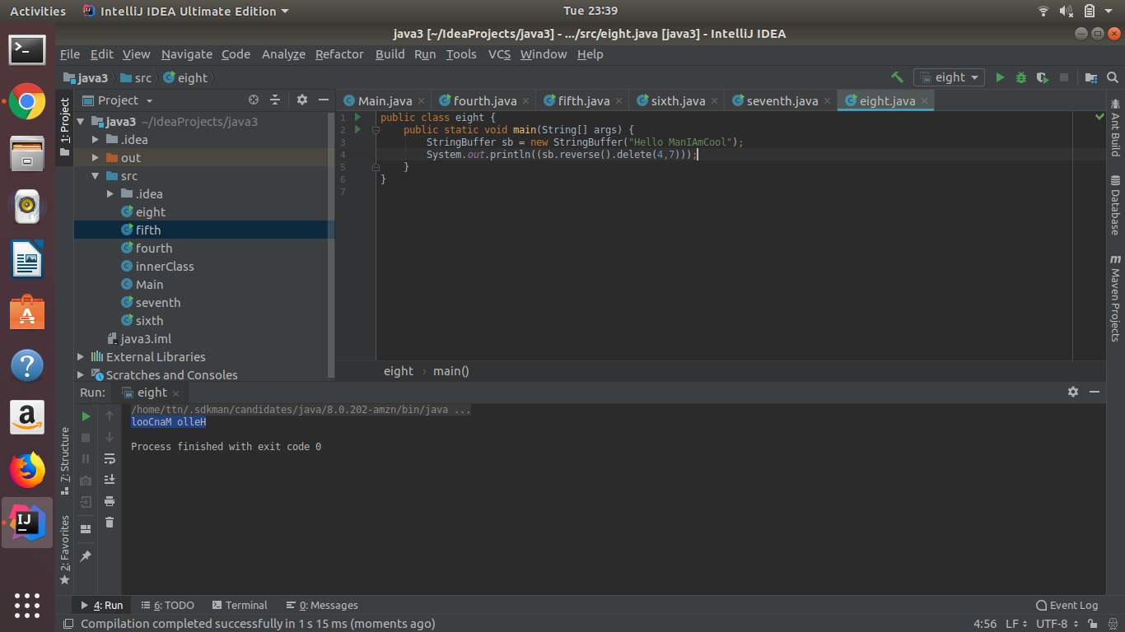

**9.Write a program to display values of enums using a constructor & getPrice() method (Example display house & their prices)**

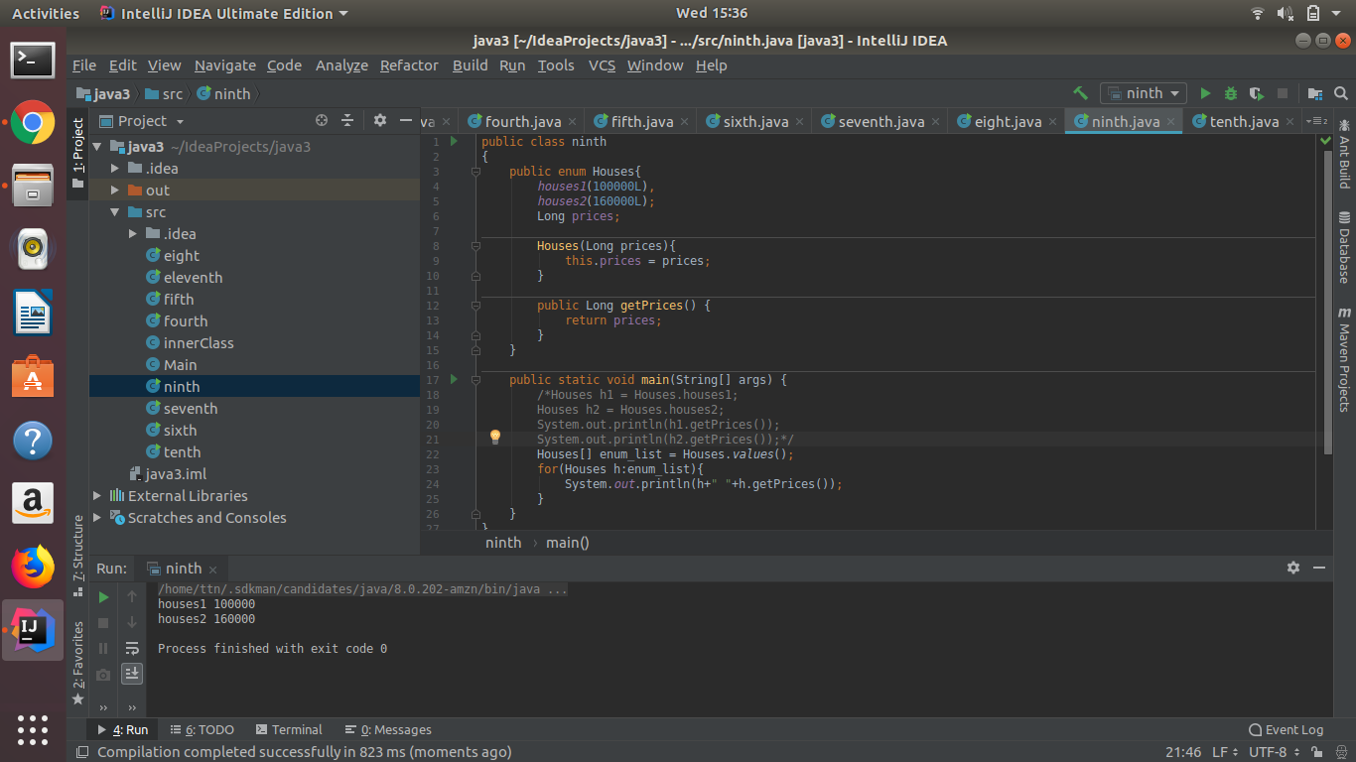

**10.Write a single program for following operation using overloading**

**A) Adding 2 integer number**

**B) Adding 2 double**

**C) multiplying 2 float**

**D) multiplying 2 int**

**E) concate 2 string**

**F) Concate 3 String**

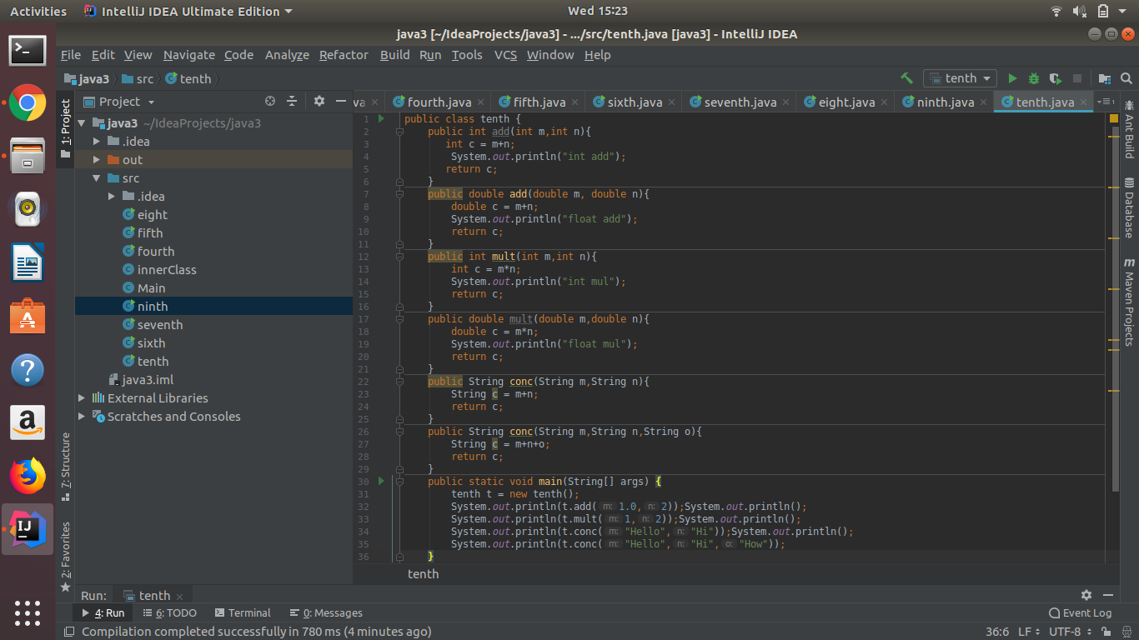

**Output is :->**

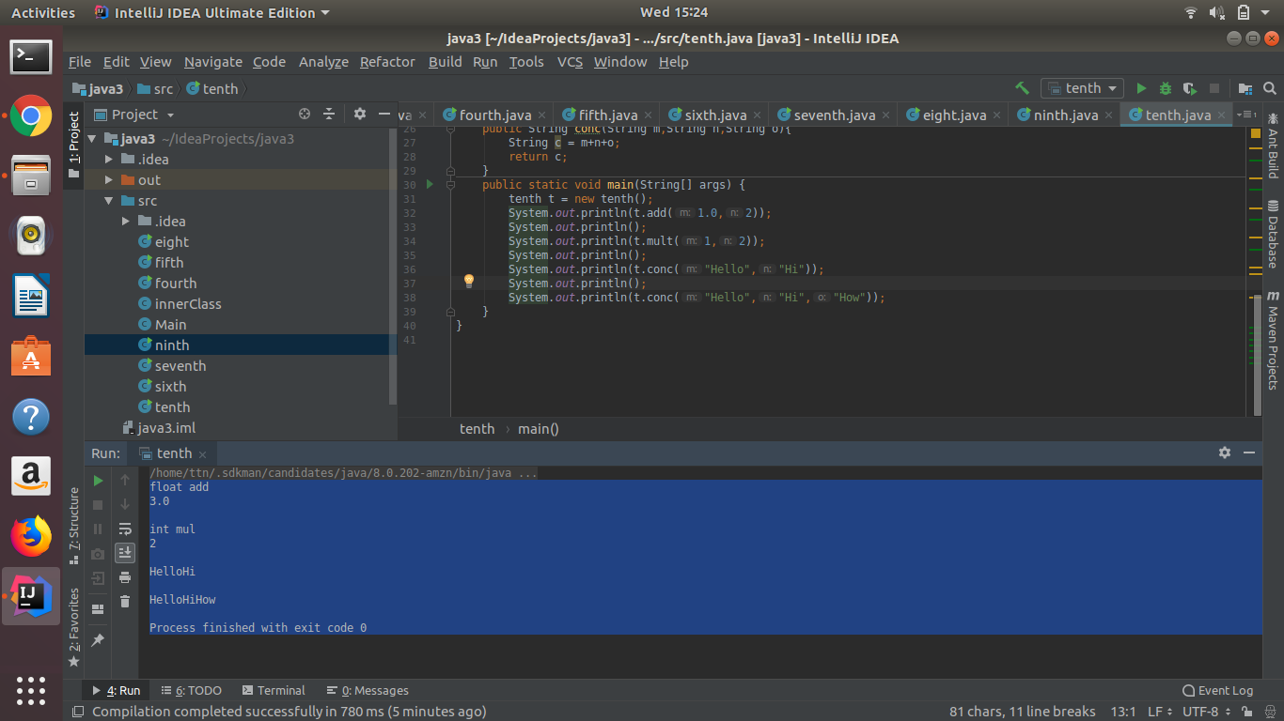

**11.Create 3 sub class of bank SBI,BOI,ICICI all 4 should have method called getDetails which provide there specific details like rateofinterest etc,print details of every banks**

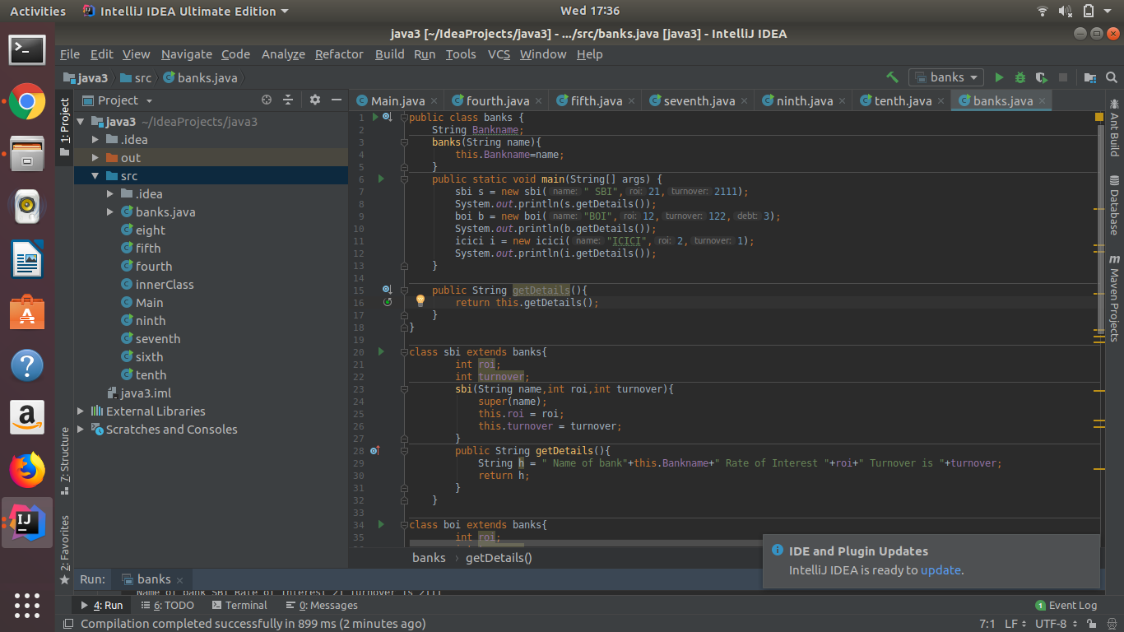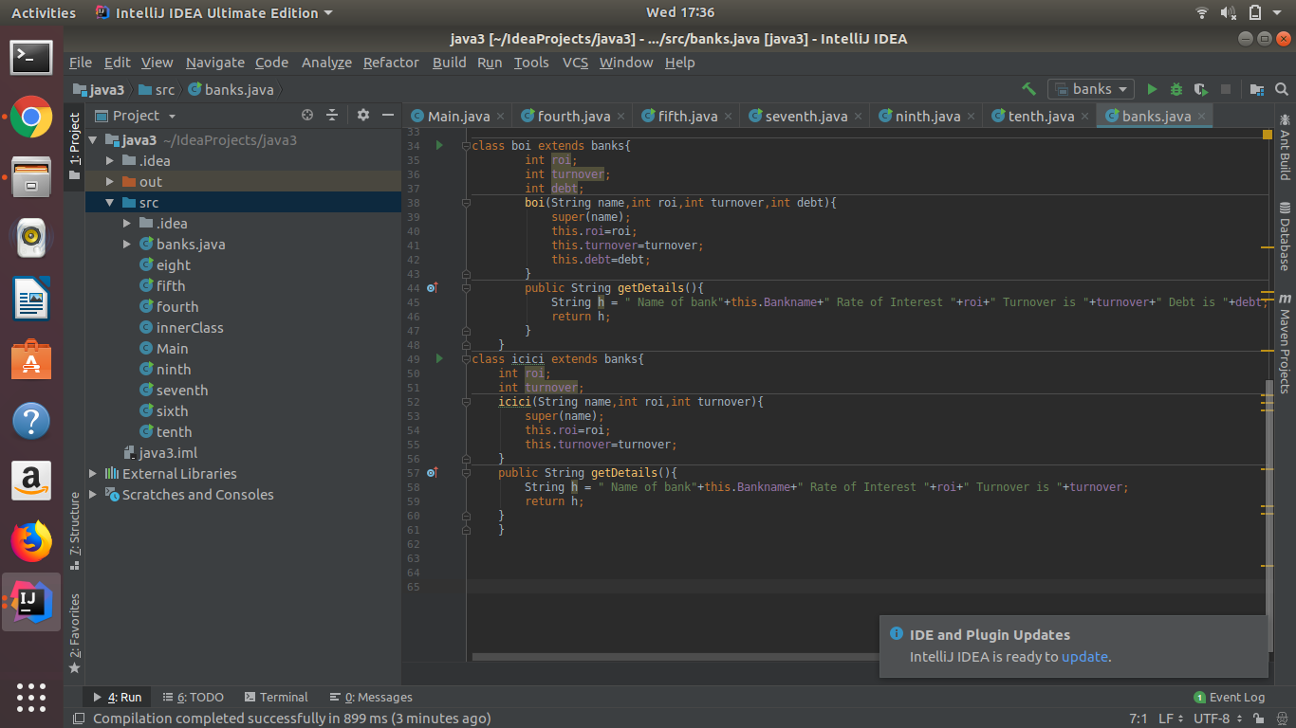

**Output is : - >**

