* Write the following a functional interface and implement it using lambda:
  + (1) First number is greater than second number or not Parameter (int ,int ) Return boolean
  + (2) Increment the number by 1 and return incremented value Parameter (int) Return int
  + (3) Concatination of 2 string Parameter (String , String ) Return (String)
  + (4) Convert a string to uppercase and return . Parameter (String) Return (String)

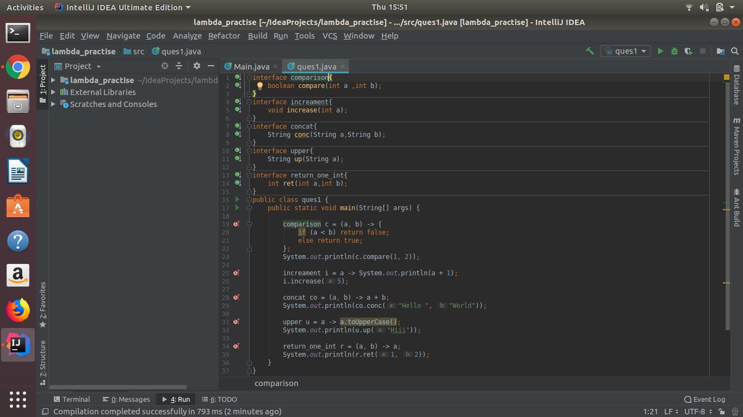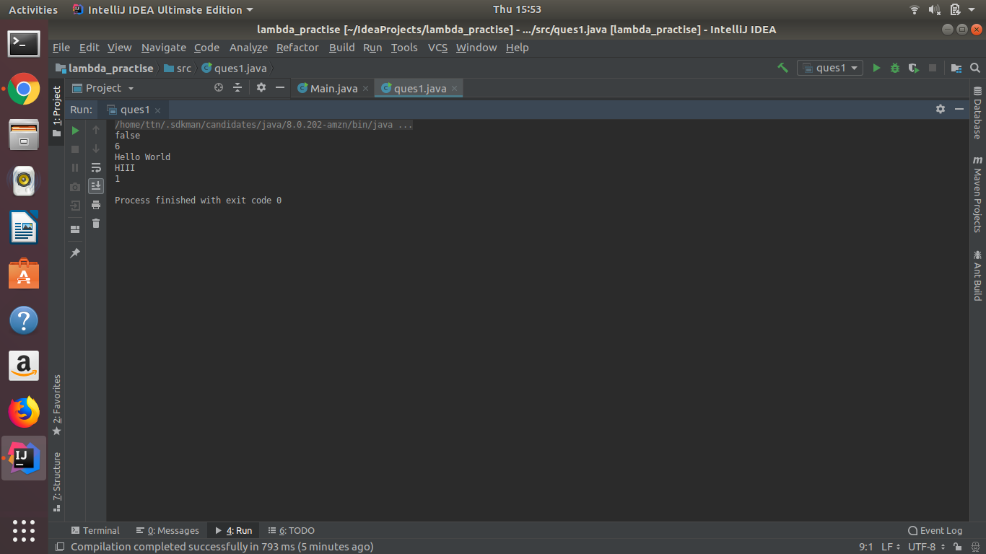

* Create a functional interface whose method takes 2 integers and return one integer.

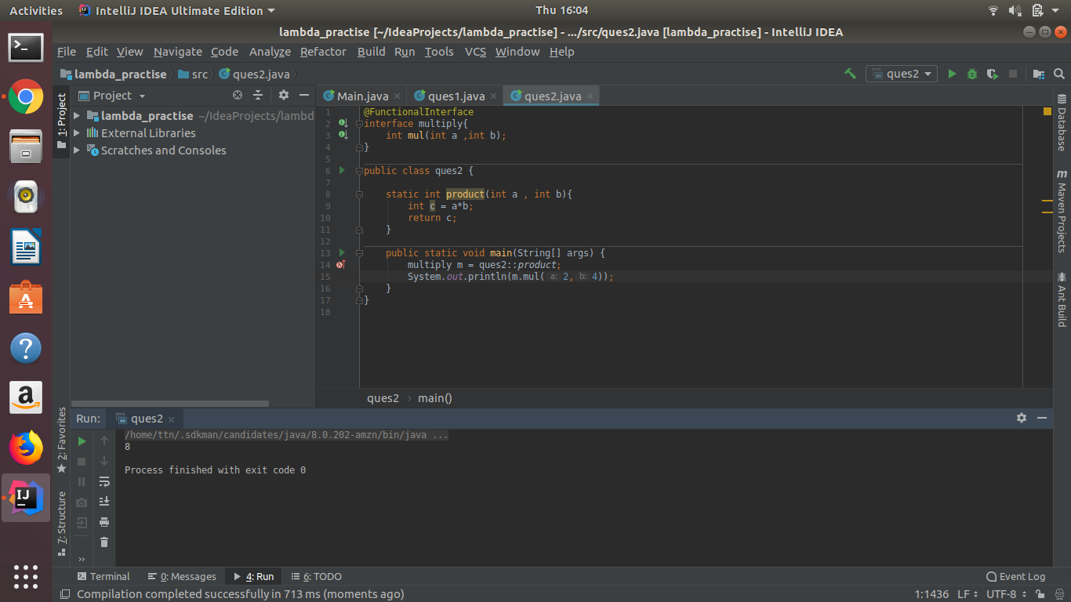

* Using (instance) Method reference create and apply add and subtract method and using (Static) Method reference create and apply multiplication method for the functional interface created.

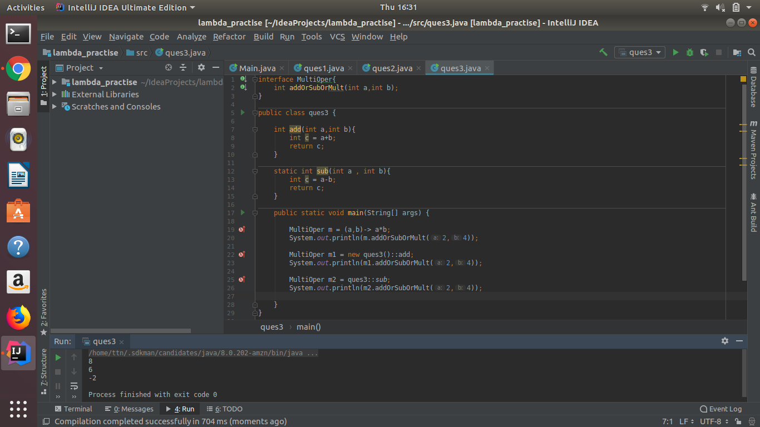

* Create an Employee Class with instance variables (String) name, (Integer)age, (String)city and get the instance of the Class using constructor reference

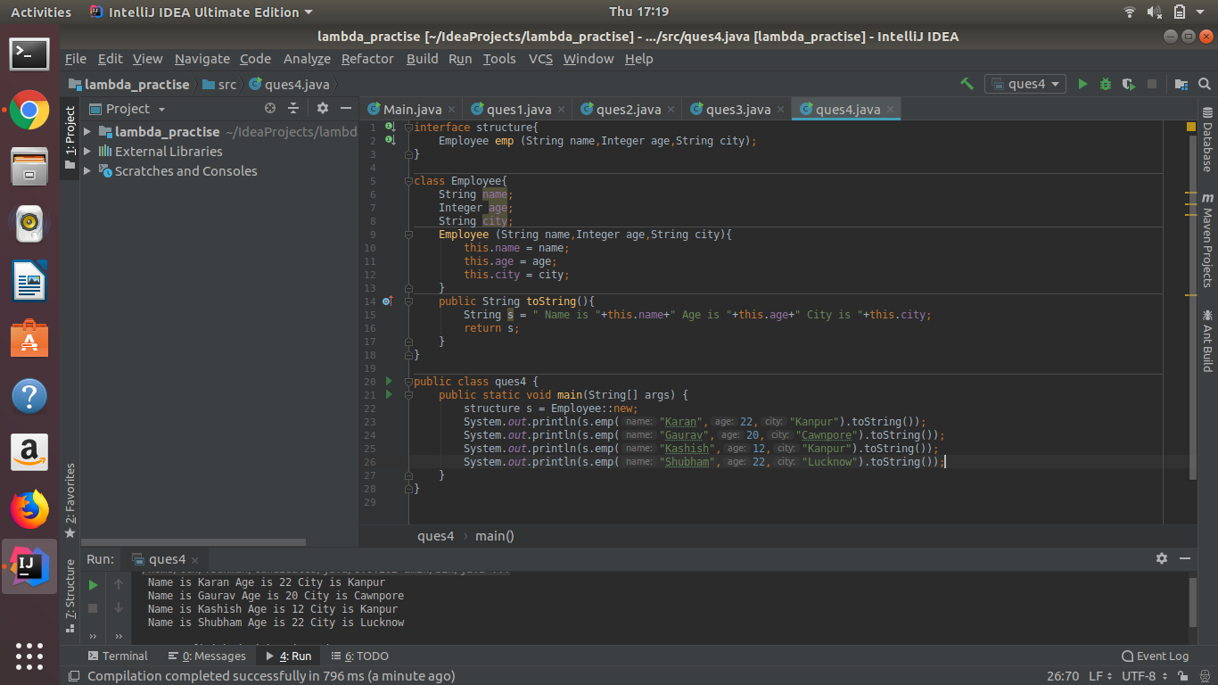

* Implement following functional interfaces from java.util.function using lambdas:
  + (1) Consumer
  + (2) Supplier
  + (3) Predicate
  + (4) Function

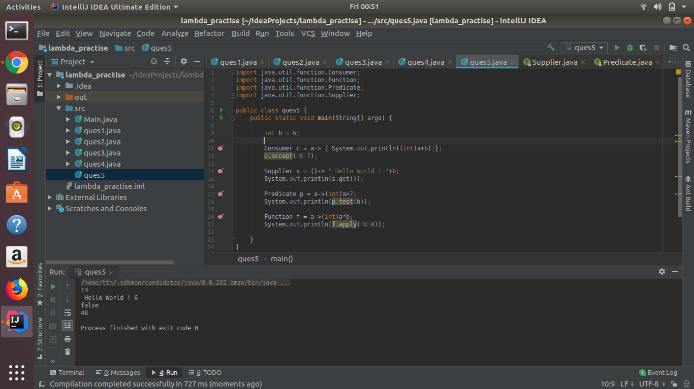

* Create and access default and static method of an interface.

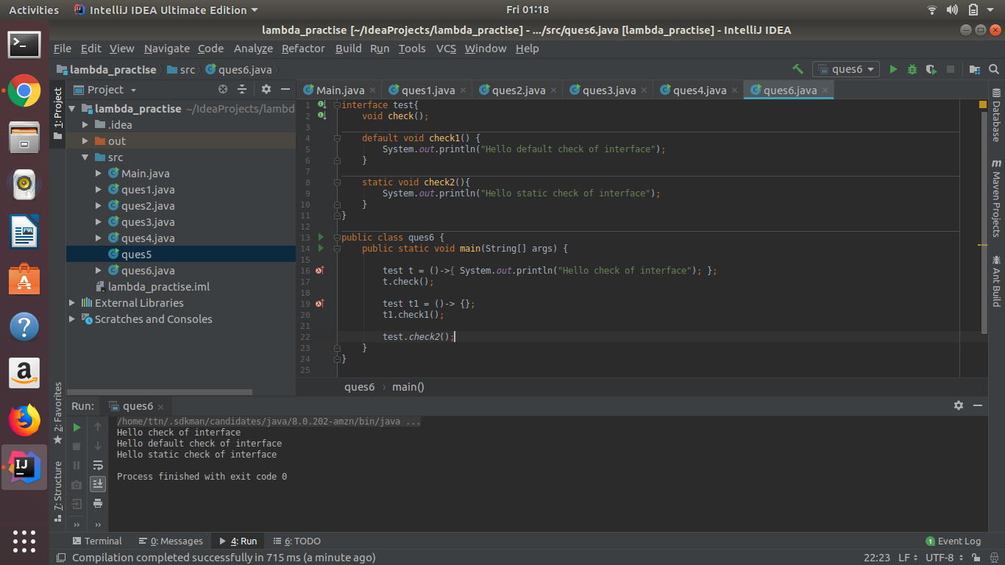

* Override the default method of the interface.

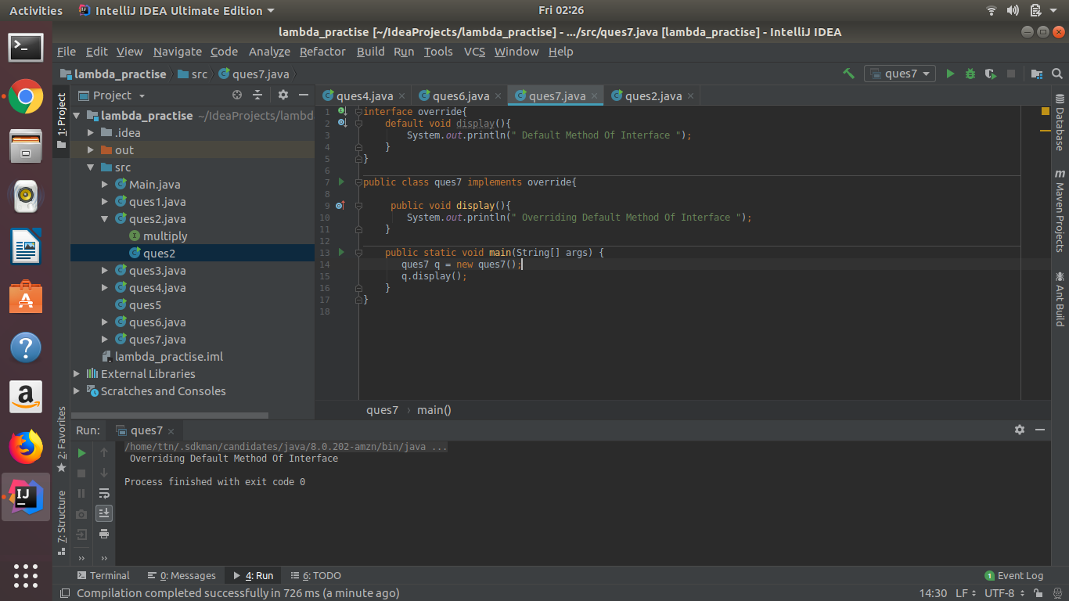

* Implement multiple inheritance with default method inside interface.

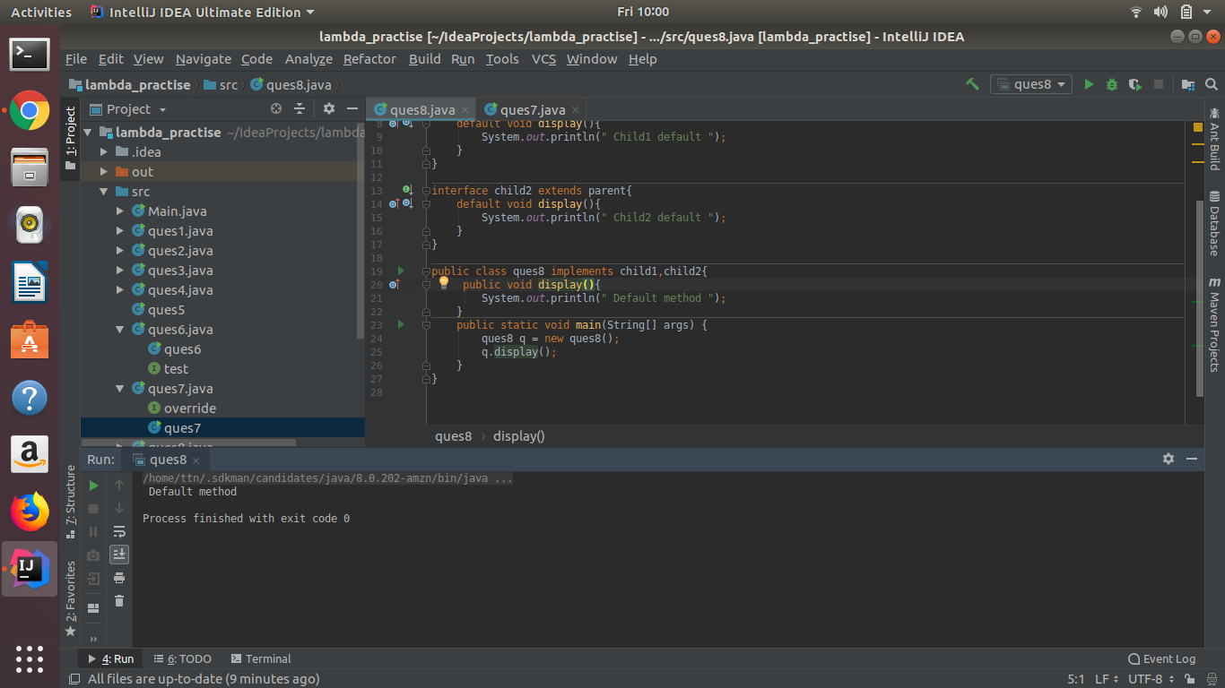

* Collect all the even numbers from an integer list.

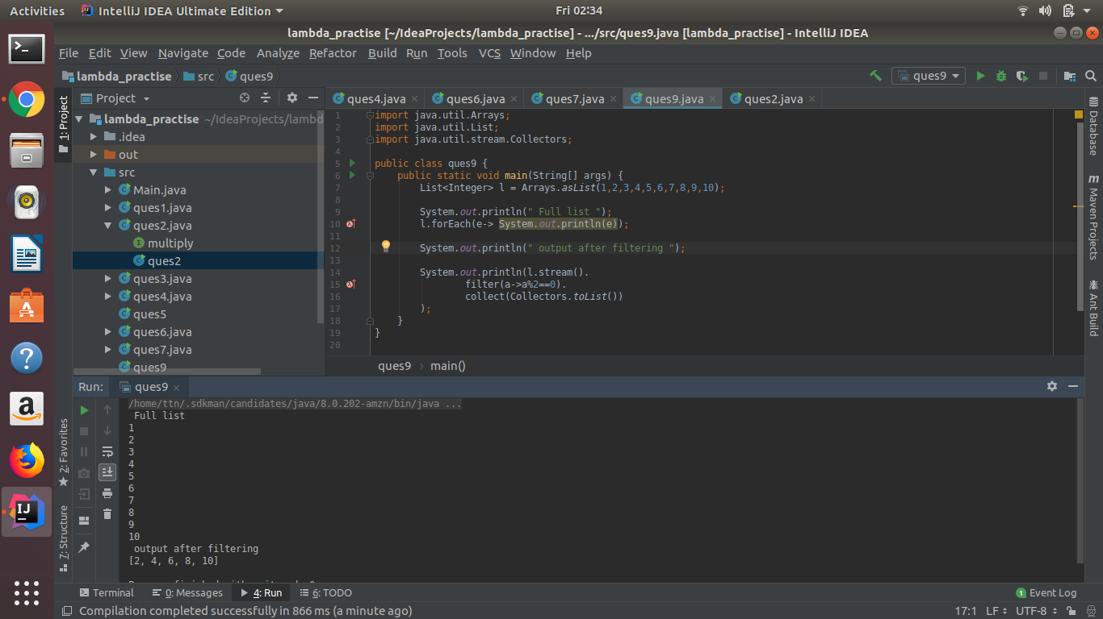

* Sum all the numbers greater than 5 in the integer list.

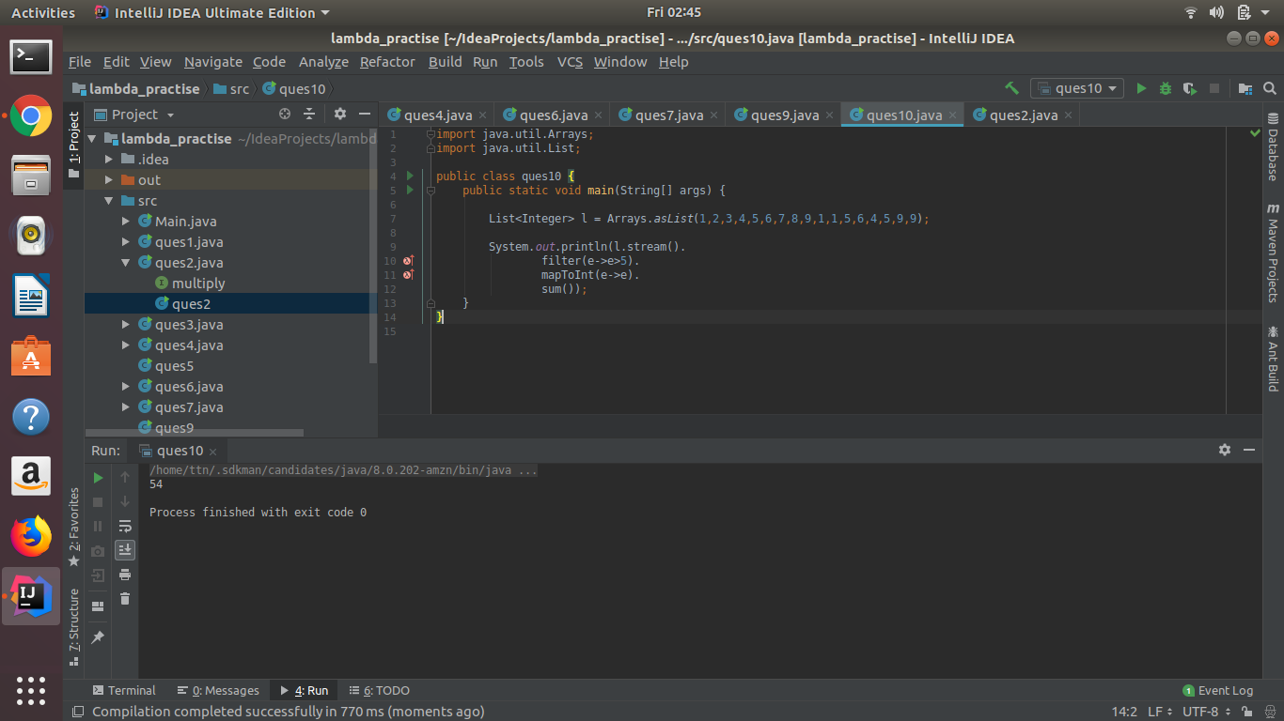

* Find average of the number inside integer list after doubling it.

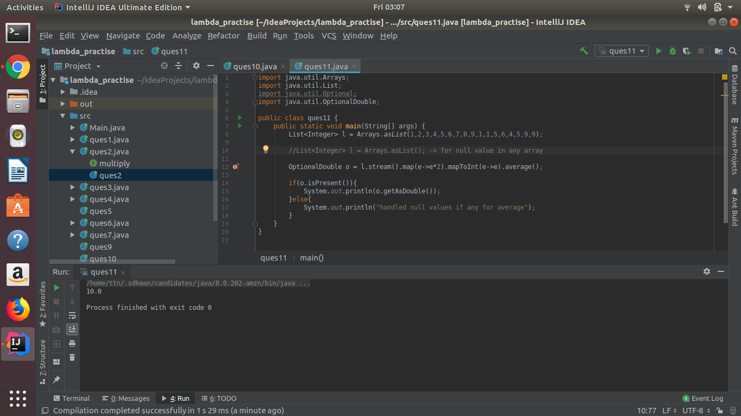

* Find the first even number in the integer list which is greater than 3.

