1. Git Setup<https://confluence.atlassian.com/bitbucket/set-up-git-744723531.html>

**sudo apt-get install git**

1. Initialize a Git Repository

**mkdir /home/ttn/git_practise**

**cd /home/ttn/git_practise**

**git init**

1. Add files to the repository

**nano exercise.txt**

**git add exercise.txt**

1. Unstage 1 file

**git reset HEAD exercise.txt**

1. Commit the file

**git commit exercise.txt**

1. Add a remote

**ssh-keygen -t rsa -p**

**-> Now set passwd desired**

**-> Make a github account copy public key of ssh generated there**

**(cat ~/.ssh/id_rsa.pub)**

**-> and then create new repository at last copy the link generated.**

**git remote add origin git@github.com:Karan-ttn/origin.git**

1. Undo changes to a particular file

**git commit exercise.txt**

**nano exercise.txt**

**cat exercise.txt**

**git checkout exercise.txt**

**cat exercise.txt**

1. Push changes to Github

**git push origin master**

1. Clone the repository

**git clone git@github.com:Karan-ttn/origin.git**

1. Add changes to one of the copies and pull the changes in the other.

**nano exercise.txt**

**git commit exercise.txt**

**git push origin master**

**cd ..**

**cd origin**

**git pull origin master**

**nano exercise.txt**

1. Check differences between a file and its staged version

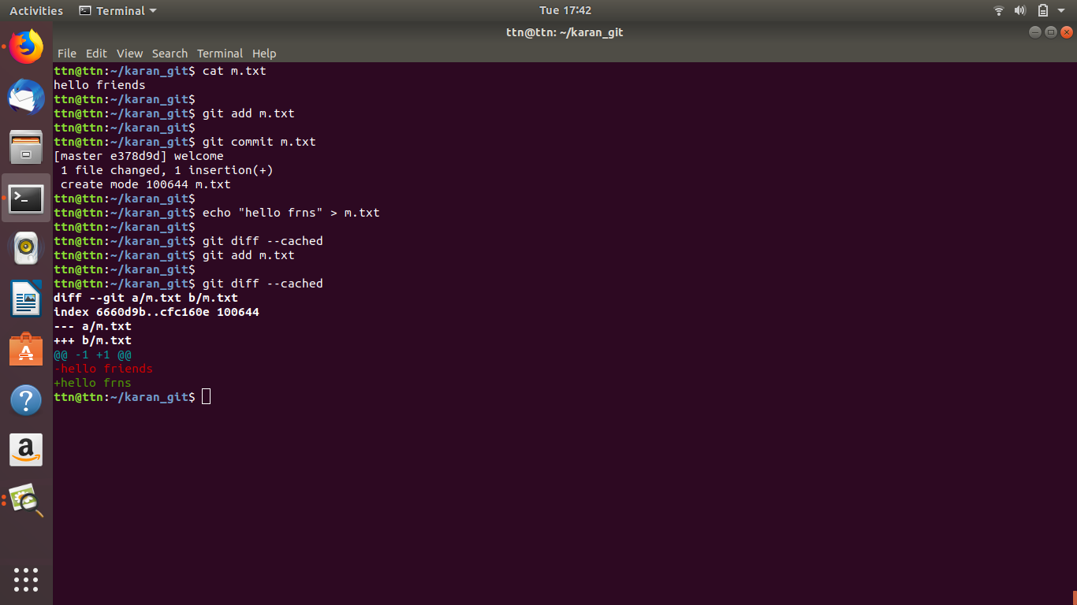

1. Ignore a few files to be checked in

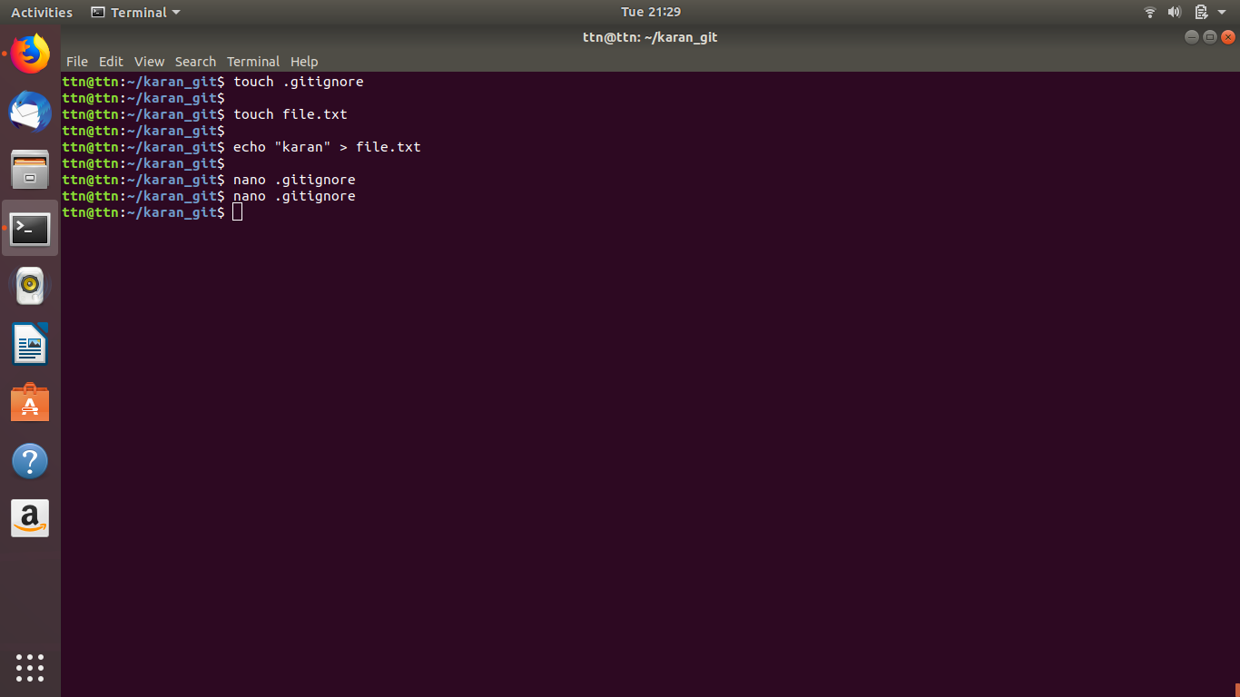

**nano .gitignore**

**-> type file.txt**

1. Create a new branch.

**git branch karan**

**Or**

**git checkout -b karan**

1. Diverge them with commits

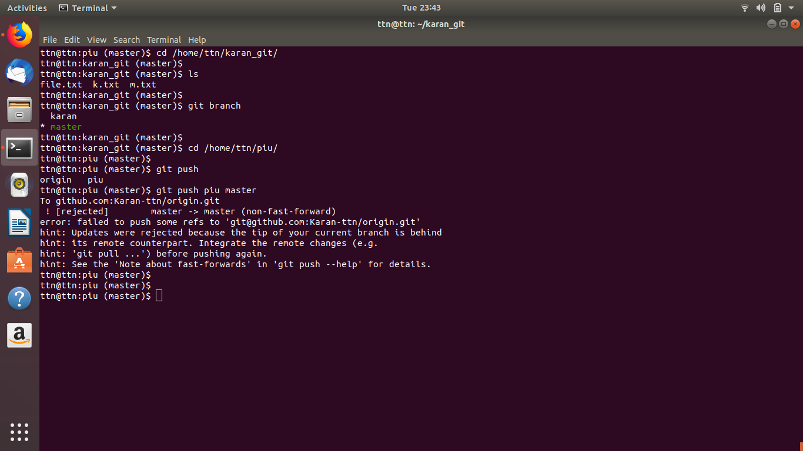

1. Edit the same file at the same line on both branches and commit



1. Try merging and resolve merge conflicts

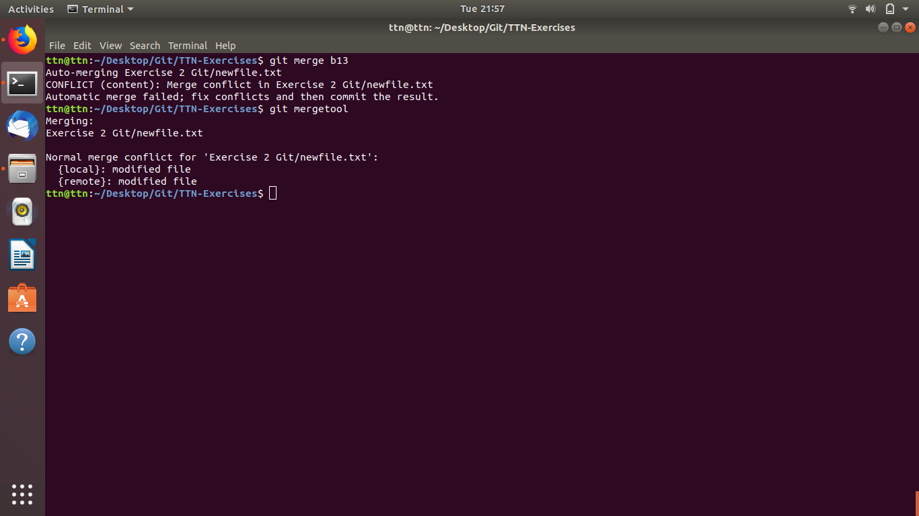

1. Stash the changes and pop them

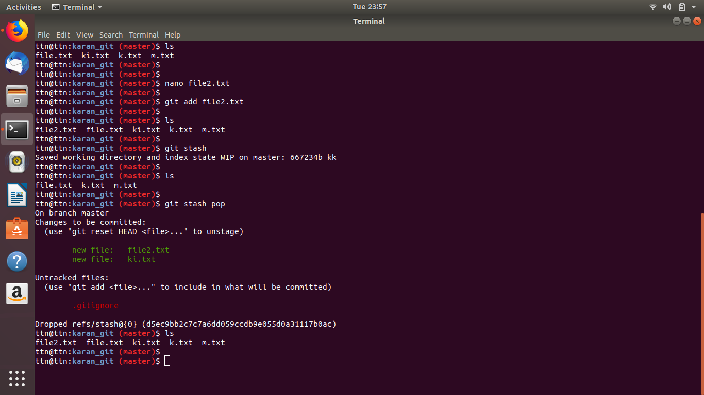

1. Add the following code to your .bashrc file : color_prompt="yes"  
    parse_git_branch() {  
    git branch 2> /dev/null | sed -e '/^[^*]/d' -e 's/* \(.*\)/(\1)/'  
    }  
    if [ "$color_prompt" = yes ]; then  
    PS1='\u@\h\[\033[00m\]:\[\033[01;34m\]\W\[\033[01;31m\] $(parse_git_branch)\[\033[00m\]\$ '  
    else  
    PS1='\u@\h:\W $(parse_git_branch)\$ '  
    fi  
    unset color_prompt force_color_prompt

