1. Create Database

**create database retail_db;**

**use retail_db;**

1. Design Schema

**create table order_items(order_employee_name varchar(25),order_item_order_id int(12) primary key auto_increment,order_item_name varchar(22));**

**create table orders (order_id int(12) primary key,order_item_id int(12),order_name varchar(20),foreign key (order_item_id) references order_items(order_item_order_id));**

1. Create tables

**create table departments (dep_id int(12) not null,dep_name varchar(25));**

**create table customers (cust_id int(12) primary key,cust_name varchar(22),cust_order_id int(12), foreign key (cust_order_id) references orders(order_id));**

**desc departments;**

**desc order_items;**

**desc orders;**

**desc customers;**

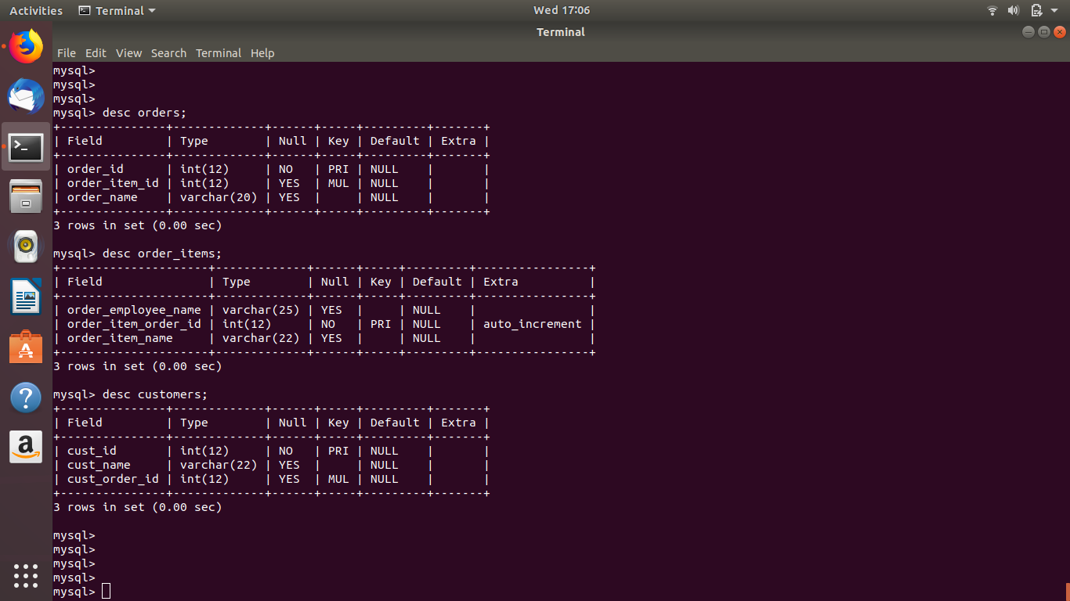

1. Insert sample data

**insert into departments values (1 , "cs"),(2,"ce");**

**select * from departments;**

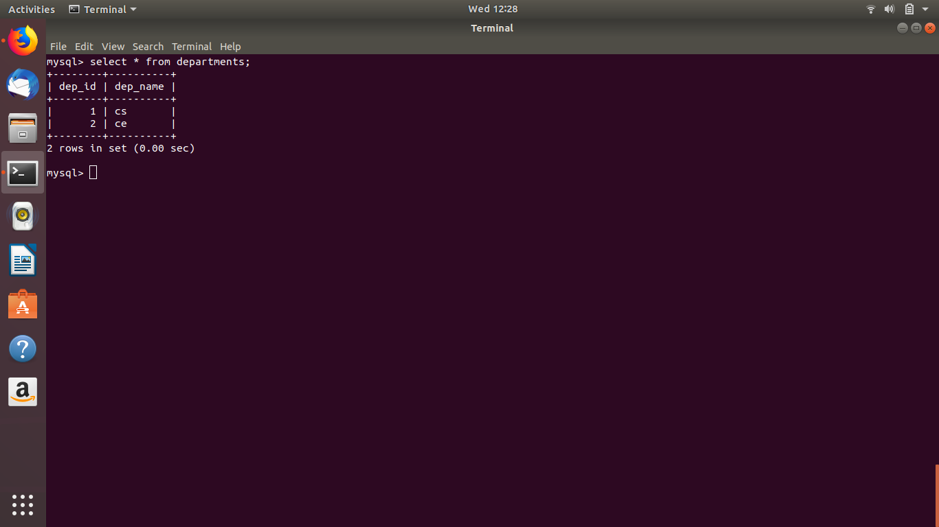

1. Find the sales person have multiple orders.

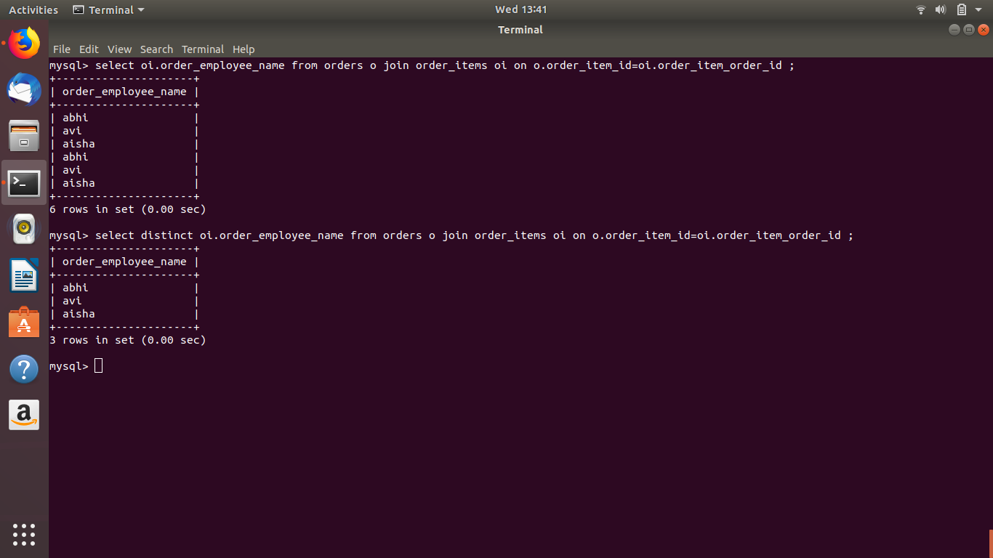

1. Find the all sales person details along with order details

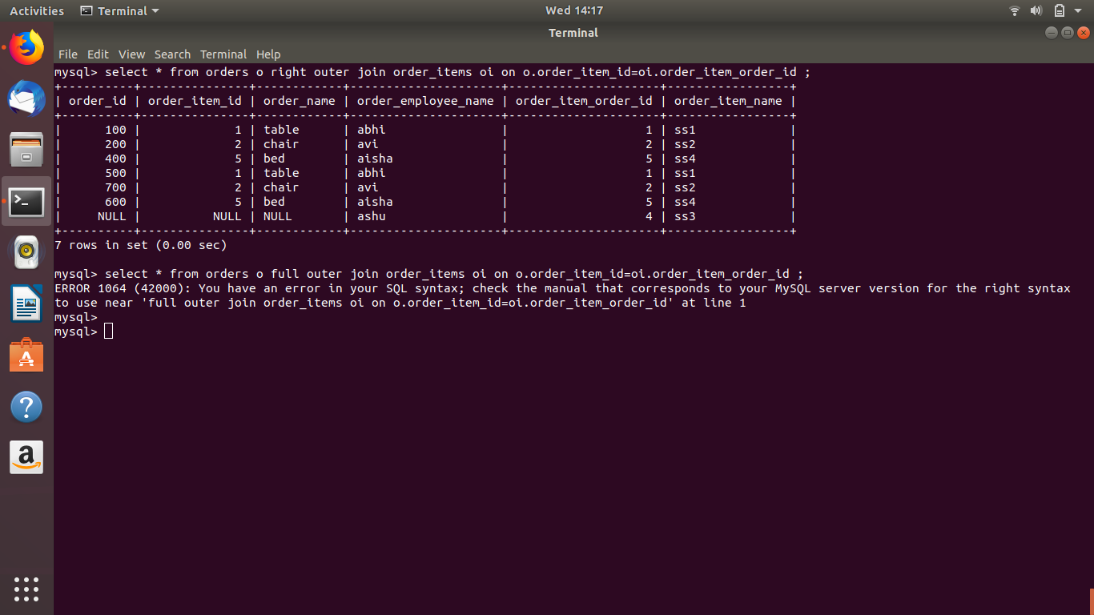

1. Create index

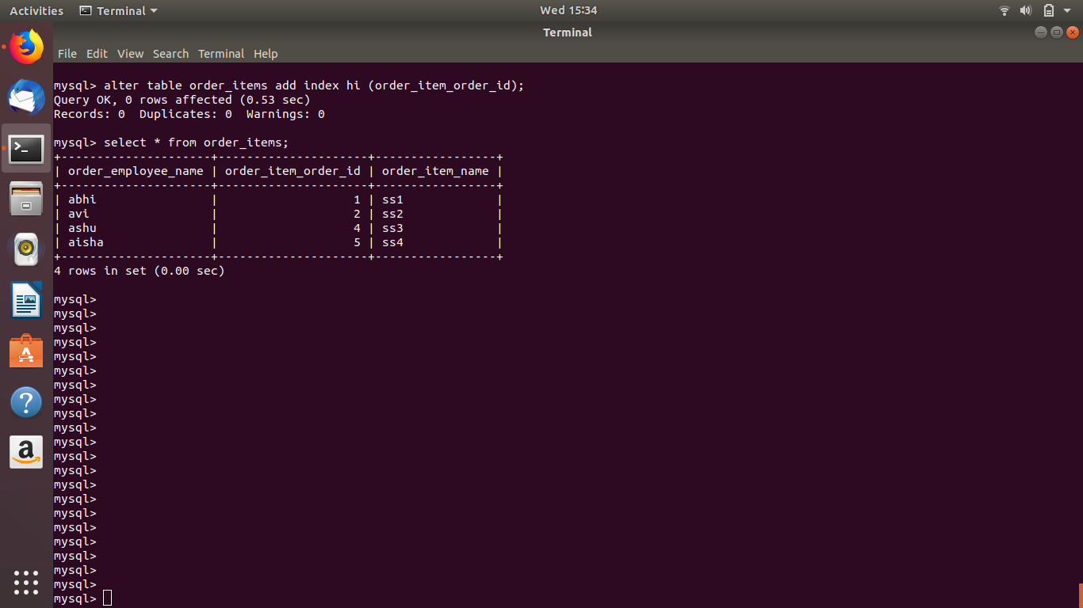

1. How to show index on a table

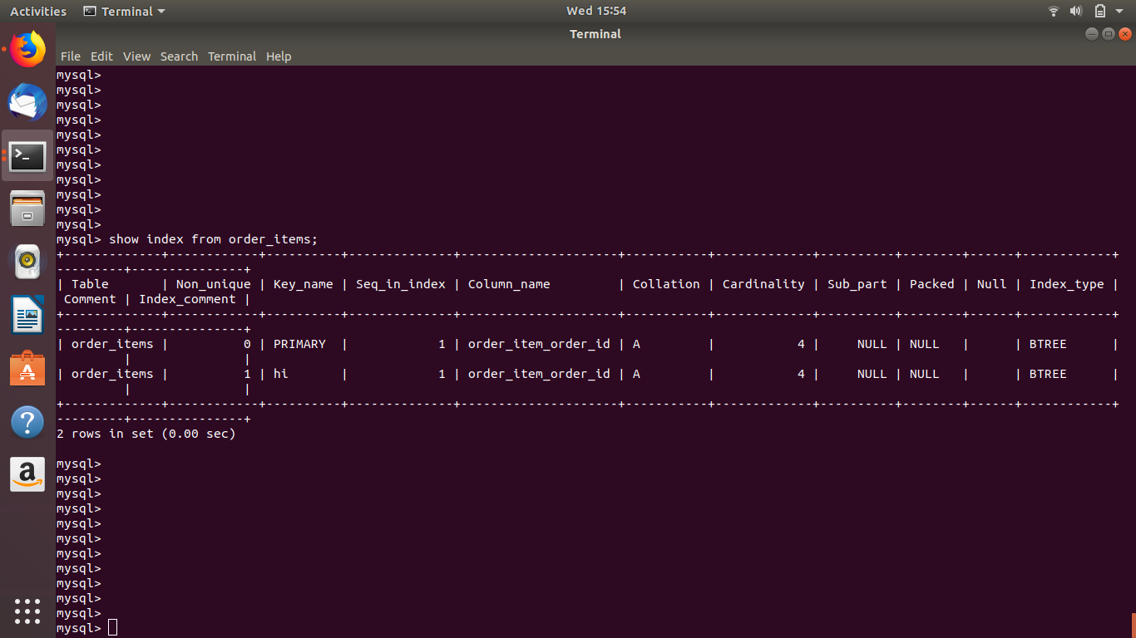

1. Find the order number, sale person name, along with the customer to whom that order belongs to

