* **Prompt for amount, interest rate and no. of years and calculate simple interest.**



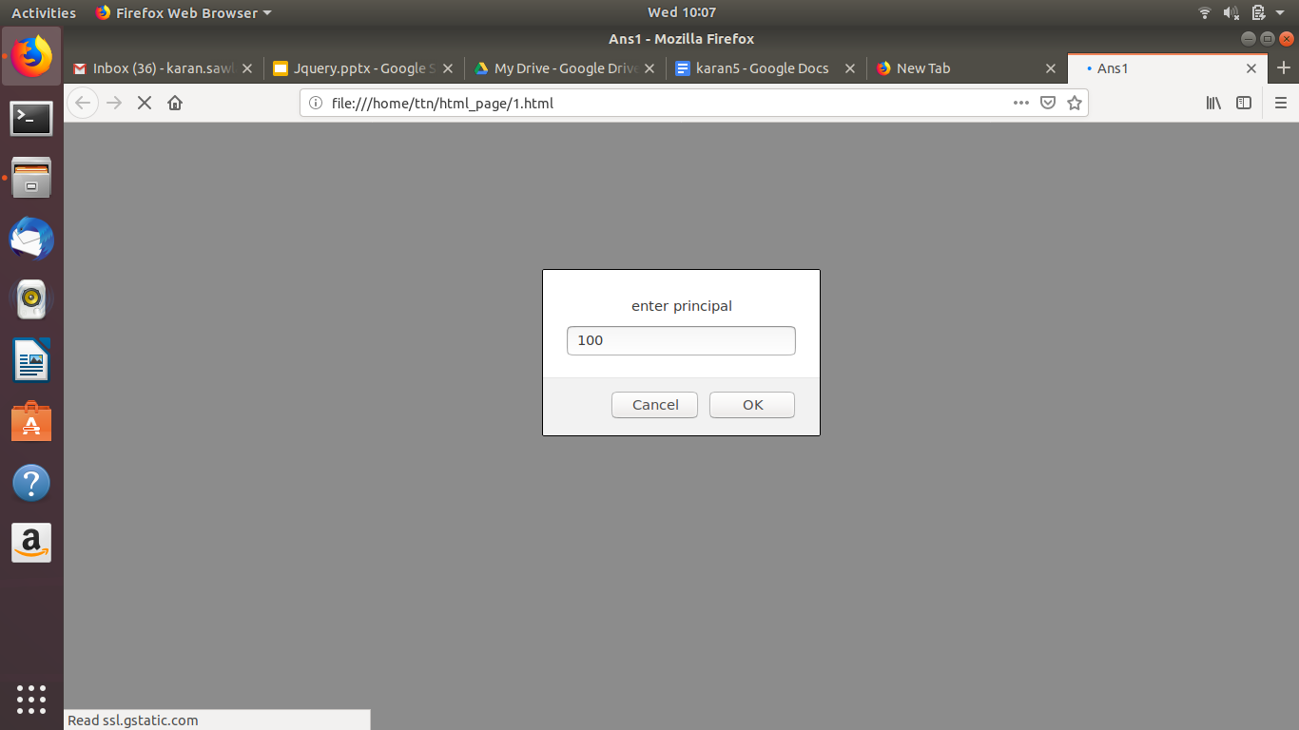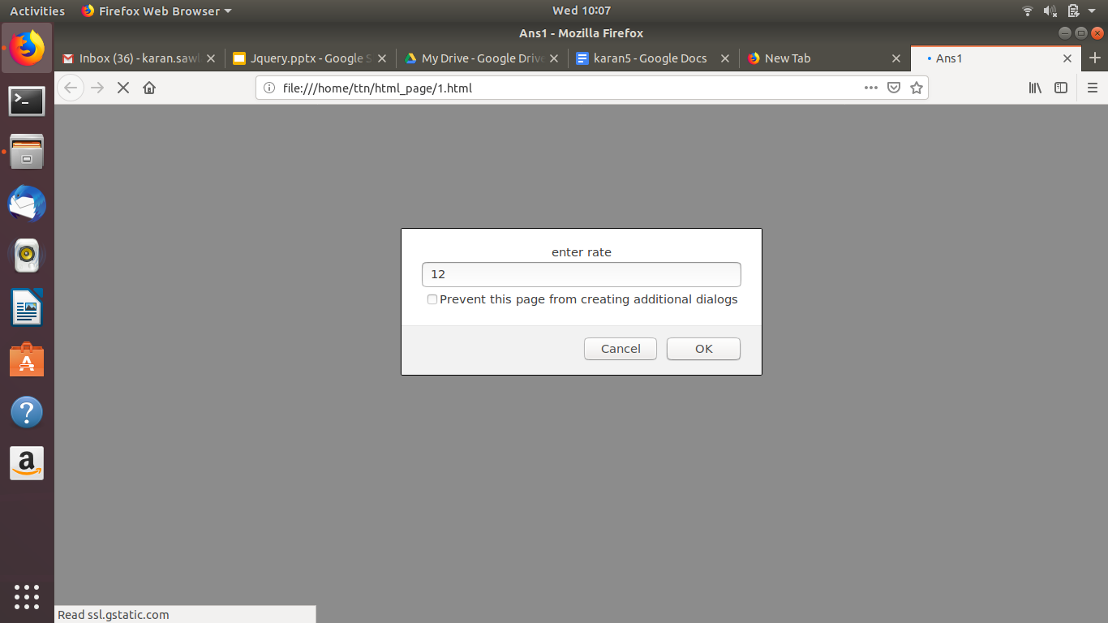

* **is palindrome string**



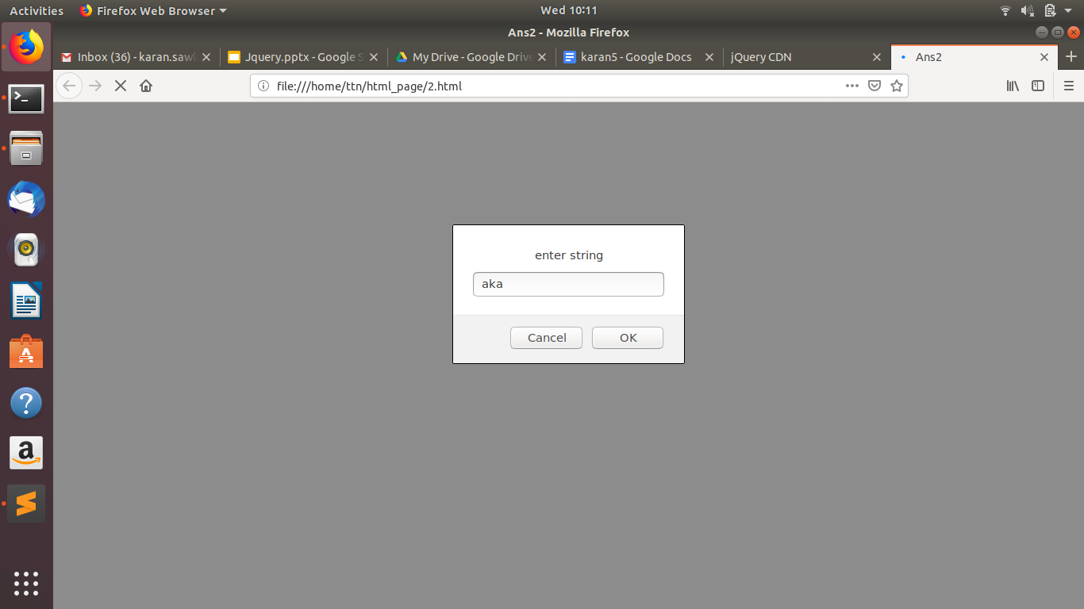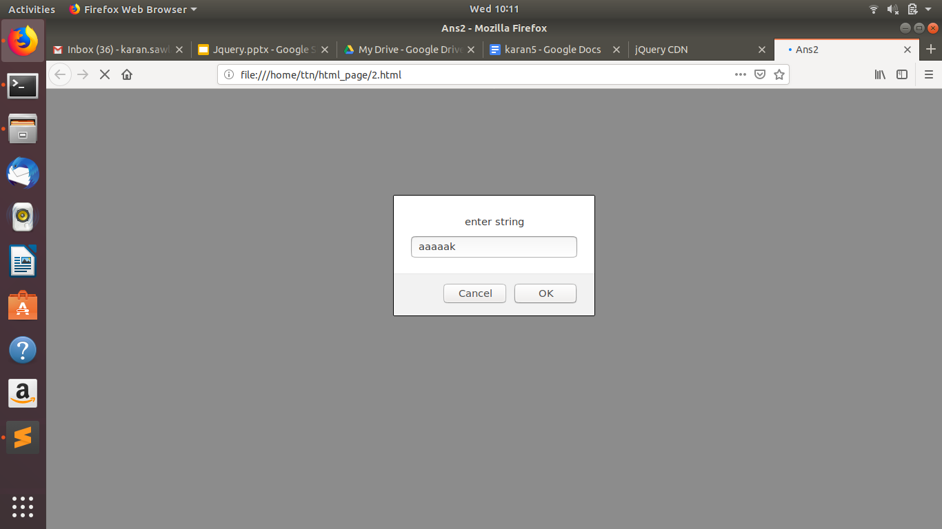

* **Area of circle**

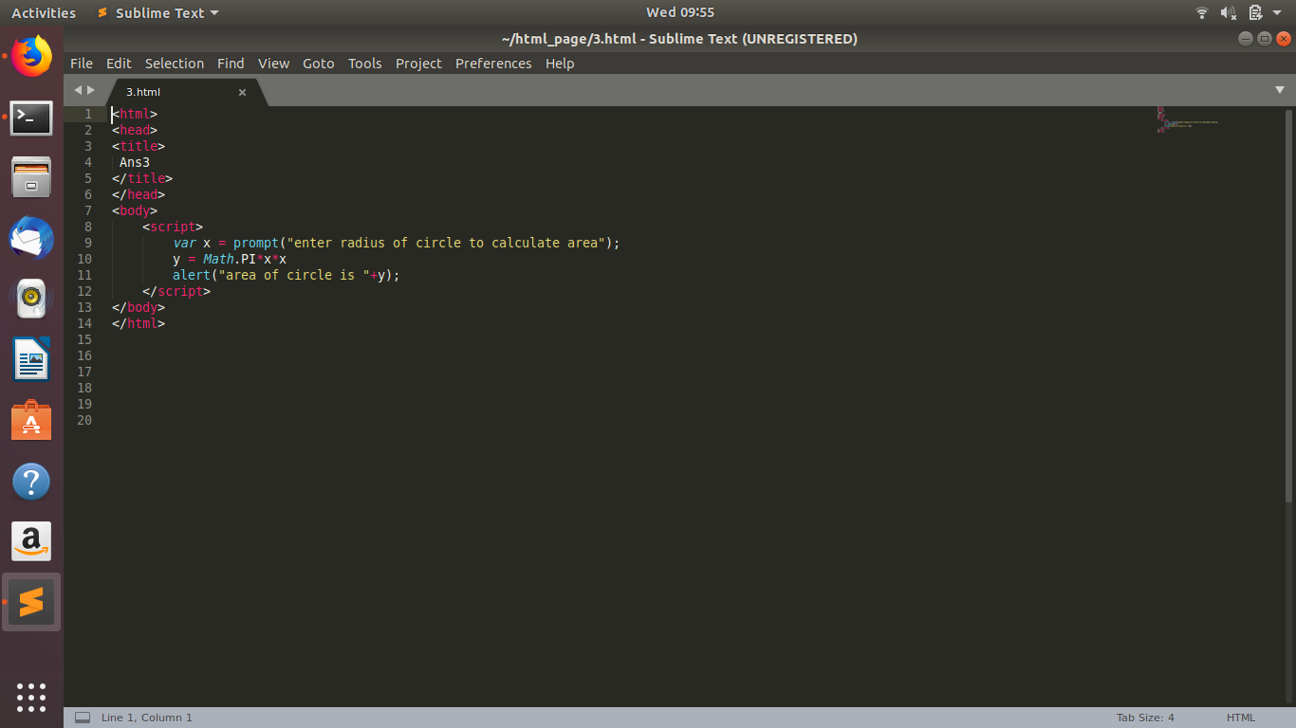

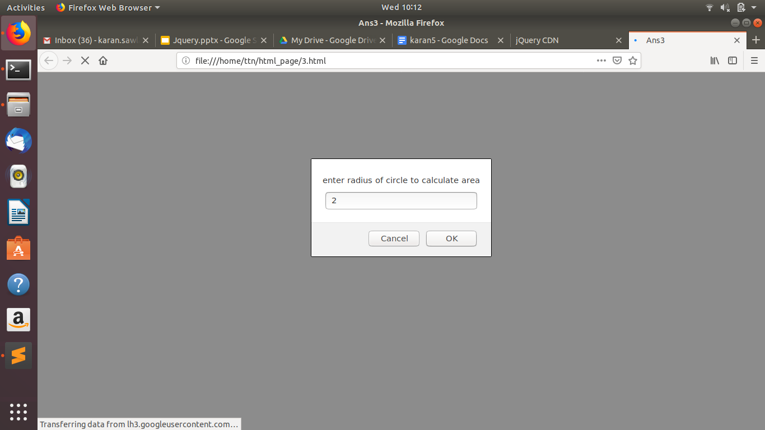

* **Copy information of one object to another and log it to console.**

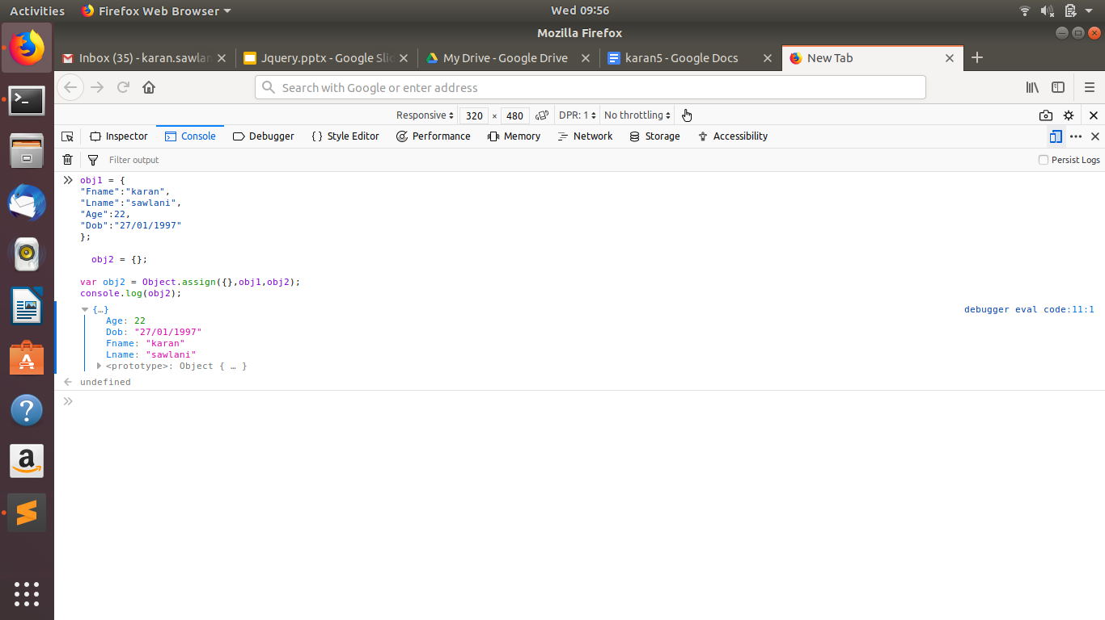

Code is :->

obj1 = { "Fname":"karan", "Lname":"sawlani", "Age":22, "Dob":"27/01/1997" };

obj2 = {};

var obj2 = Object.assign({},obj1,obj2);

console.log(obj2);

* **create a list of objects of Employee with info as follow :**
  1. **Name, age, salary ,DOB**
  2. **filter all employees with salary greater than 5000**
  3. **group employee on the basis of their age**
  4. **fetch employees with salary less than 1000 and age greater than 20. Then give them an increment 5 times their salary.**

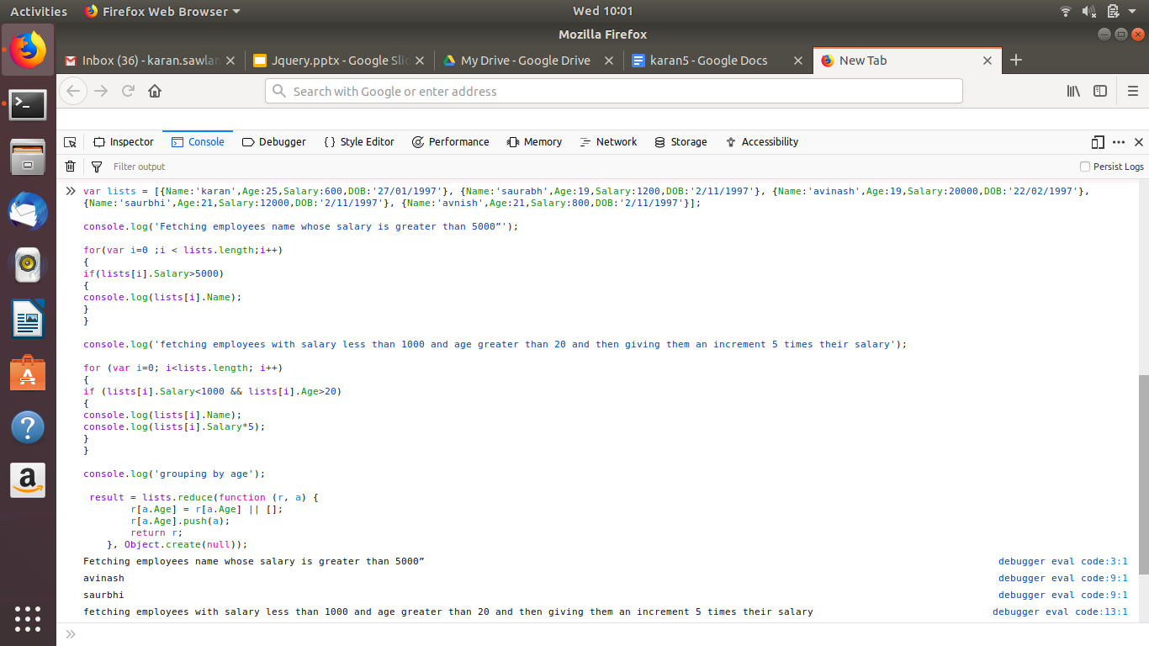

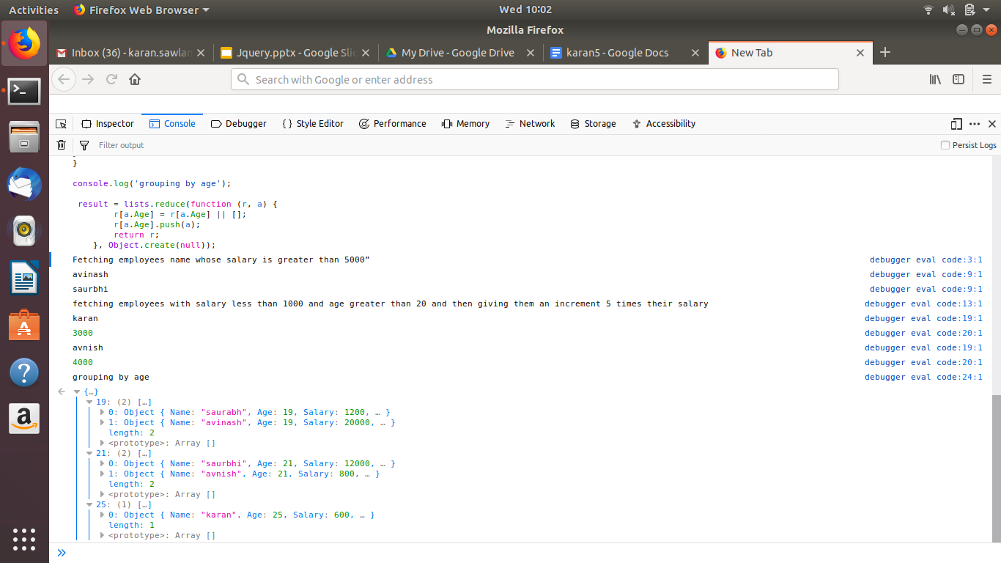

Code is :

var lists = [{Name:'karan',Age:25,Salary:600,DOB:'27/01/1997'}, {Name:'saurabh',Age:19,Salary:1200,DOB:'2/11/1997'}, {Name:'avinash',Age:19,Salary:20000,DOB:'22/02/1997'}, {Name:'saurbhi',Age:21,Salary:12000,DOB:'2/11/1997'}, {Name:'avnish',Age:21,Salary:800,DOB:'2/11/1997'}];

console.log(“Fetching employees name whose salary is greater than 5000”);

for(var i=0 ;i < lists.length;i++)

{

if(lists[i].Salary>5000)

{

console.log(lists[i].Name);

}

}

console.log(“fetching employees with salary less than 1000 and age greater than 20 and then giving them an increment 5 times their salary”);

for (var i=0; i<lists.length; i++)

{

if (lists[i].Salary<1000 && lists[i].Age>20)

{

console.log(lists[i].Name);

console.log(lists[i].Salary*5);

}

}

console.log(“grouping by age”);

result = lists.reduce(function (r, a) {

r[a.Age] = r[a.Age] || [];

r[a.Age].push(a);

return r;

}, Object.create(null));