Q1) Console "Hello Word" in document.ready function

<html>

<head>

<title>

Home

</title>

<meta charset="UTF-8">

</head>

<body>

<script type="text/javascript" src="./jquery.min.js"></script>

<script>

//we can use jQuery or $ in the beginning of each line

$(document).ready(function(){

console.log("Hello World");

});

</script>

</body>

</html>

Output:

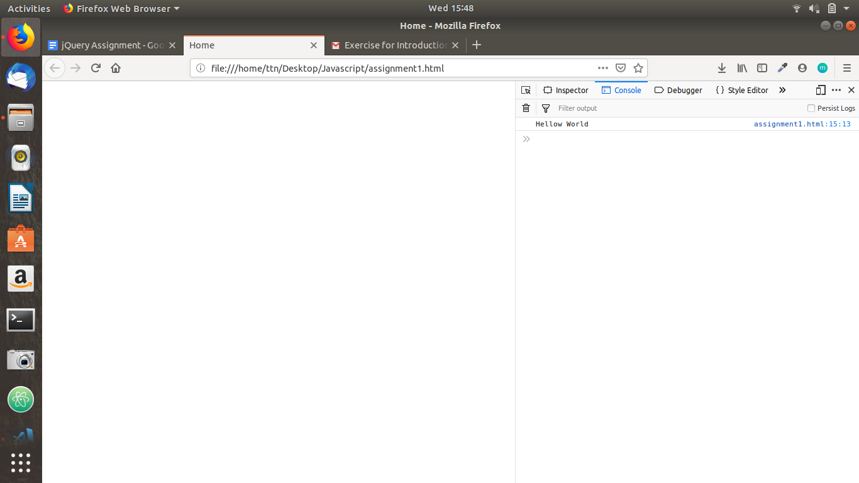

Q2) Select a ID name "#test" and add class "load" when DOM is loaded

<html>

<head>

<title>

Home

</title>

<meta charset="UTF-8">

<style>

.load

{

background: chartreuse;

}

</style>

</head>

<body>

<div>

<p id="test">

This is P tag.

</p>

</div>

<script type="text/javascript" src="./jquery.min.js"></script>

<script>

//we can use jQuery or $ in the beginning of each line

$(document).ready(function(){

console.log("Hello World");

$('#test').addClass("load");

});

</script>

</body>

</html>

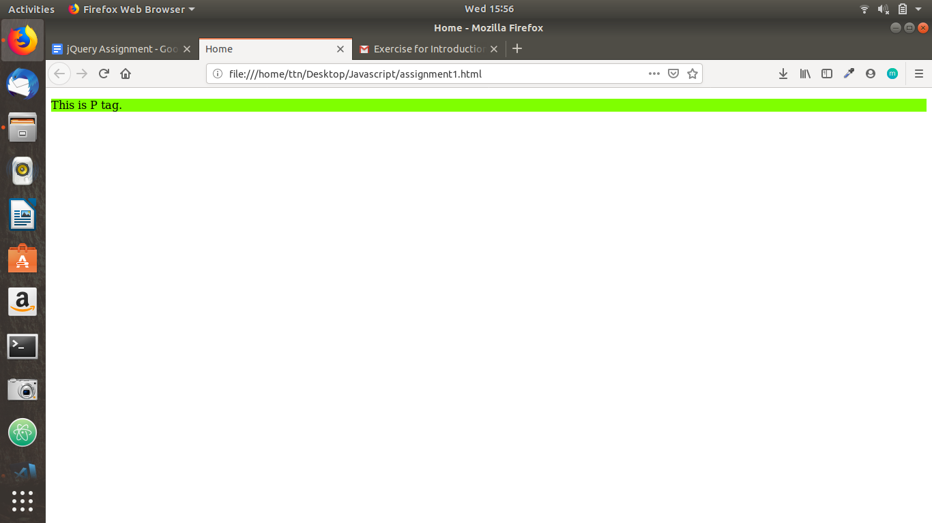

3) Change the color of element which class name end with "-new"

<html>

<head>

<title>

Home

</title>

<meta charset="UTF-8">

<style>

.load

{

background: chartreuse;

}

</style>

</head>

<body>

<div>

<p class="abcnew">

This is P tag.

</p>

<p>

One more

</p>

</div>

<script type="text/javascript" src="./jquery.min.js"></script>

<script>

//we can use jQuery or $ in the beginning of each line

$(document).ready(function(){

$("[class$=new]").css('color','red');

});

</script>

</body>

</html>

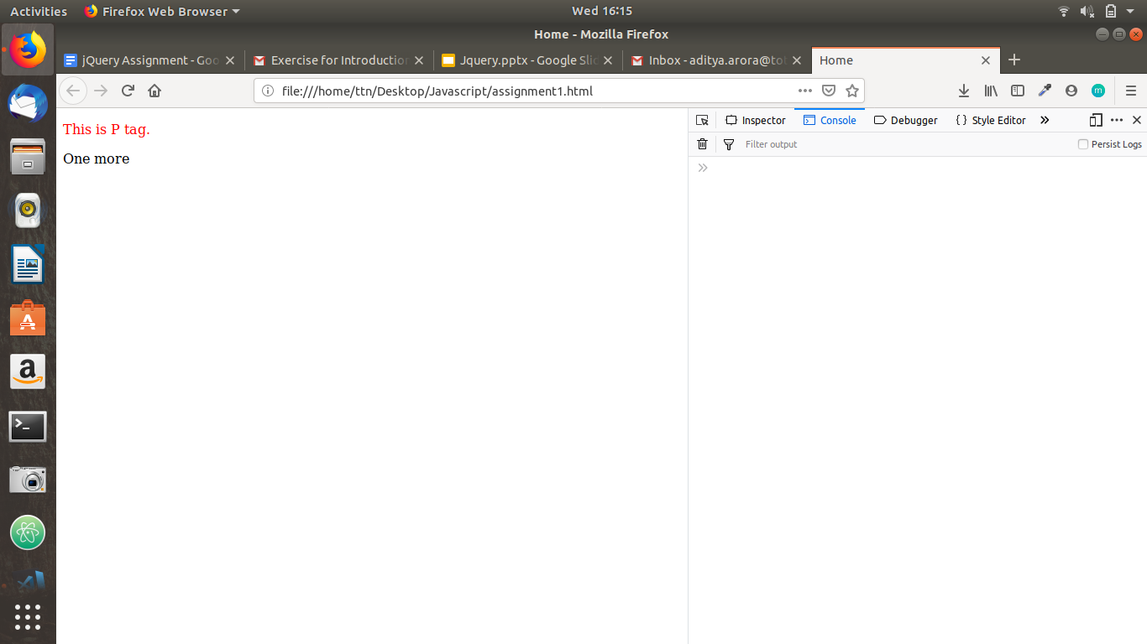

4) Disable submit button using jquery attr method

<html>

<head>

<title>

Home

</title>

<meta charset="UTF-8">

<style>

.load

{

background: chartreuse;

}

</style>

</head>

<body>

<div>

<p class="abcnew">

This is P tag.

</p>

<p>

One more

</p>

<input class="a" type="submit" value="Submit"/>

</div>

<script type="text/javascript" src="./jquery.min.js"></script>

<script>

//we can use jQuery or $ in the beginning of each line

$(document).ready(function(){

$(".a").attr("disabled","true");

});

</script>

</body>

</html>

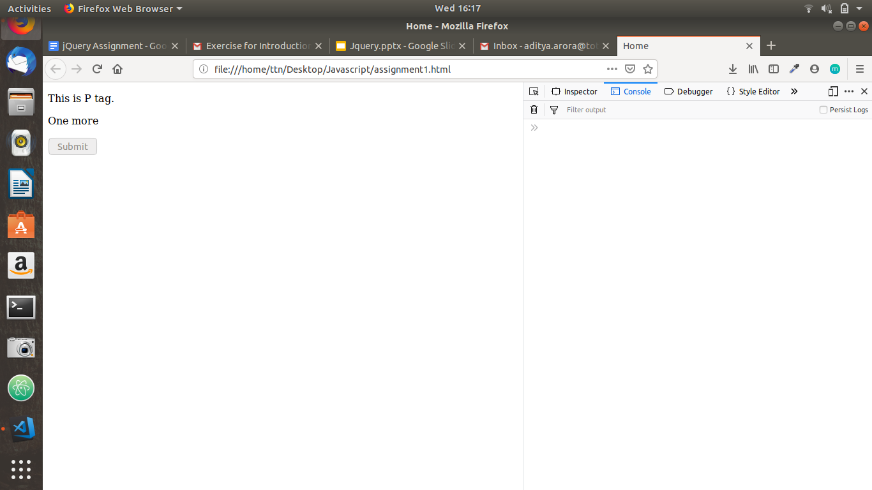

5) Change the font size of ".target" which has parent element with id name "#main"

<html>

<head>

<title>

Home

</title>

<meta charset="UTF-8">

<style>

.load

{

background: chartreuse;

}

</style>

</head>

<body>

<div id="main">

<p>

Text Within parent p tag.

<p class="target"> Text Within P target</p>

</p>

<input class="a" type="submit" value="Submit"/>

</div>

<script type="text/javascript" src="./jquery.min.js"></script>

<script>

//we can use jQuery or $ in the beginning of each line

$(document).ready(function(){

$('#main .target').css('font-size',40);

});

</script>

</body>

</html>

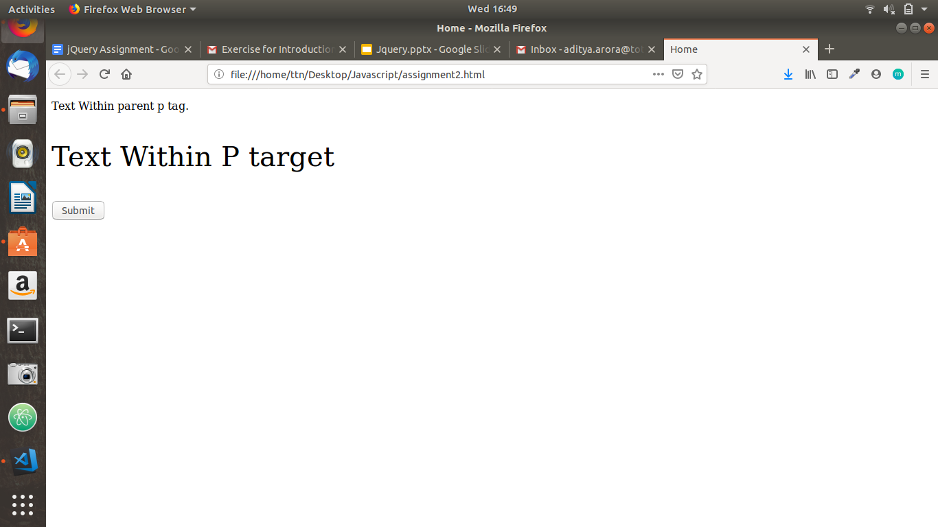

6) After page load change the HTML of div element with "p" element

<html>

<head>

<title>

Home

</title>

<meta charset="UTF-8">

<style>

.load

{

background: chartreuse;

}

</style>

</head>

<body>

<div id="main">

<input class="a" type="submit" value="Submit"/>

</div>

<script type="text/javascript" src="./jquery.min.js"></script>

<script>

//we can use jQuery or $ in the beginning of each line

$(document).ready(function(){

$('div').html('<p><b> tRY Text </b></p>');

});

</script>

</body>

</html>

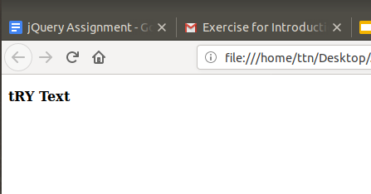

7) Bind a click function to a "click" element and append next "click" next to it.

<script>

$(document).ready(function(){

$("#abc").click(function() {

var abc1= $("<input type='submit' value='next'/>");

$('#main').append(abc1);

});

});

</script>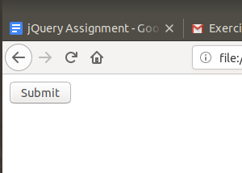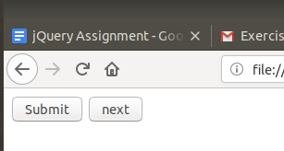

8) Click event not working on element which added dynamicly or via script, make it work using .on method

<html>

<head>

<title>

Home

</title>

<meta charset="UTF-8">

<style>

.load

{

background: chartreuse;

}

</style>

</head>

<body>

<div id="main">

<input id="abc" type="submit" value="Submit"/>

</div>

<script type="text/javascript" src="./jquery.min.js"></script>

<script>

$(document).ready(function(){

$("#abc").on("click",function(e) {

var abc1= $("<p> try </p>");

$('#main').append(abc1);

});

});

</script>

</body>

</html>

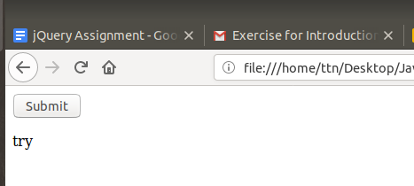

9. Get dropdown selected value on onchanage event and append in div container

<!DOCTYPE html>

<html>

<head>

<meta content="text/html;charset=utf-8" http-equiv="Content-Type">

<meta content="utf-8" http-equiv="encoding">

<title></title>

<script type="text/javascript" src="./jquery.min.js"></script>

<style type="text/css">

.load

{

background-color: red;

}

</style>

<script type="text/javascript">

$(document).ready(function()

{

$('#dropdownmen').on('change', function(){

var x= $('#dropdownmen :selected').text();

$('div').append(''+x);

})

});

</script>

</head>

<body>

<div>

<select id="dropdownmen">

<option value="one">one</option>

<option value="two">two</option>

<option value="three">three</option>

</select>

</div>

</body>

</html>

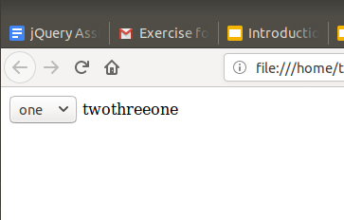

10. Create a dropdown menu using hover method in jquery

<!DOCTYPE html>

<html>

<head>

<meta content="text/html;charset=utf-8" http-equiv="Content-Type">

<meta content="utf-8" http-equiv="encoding">

<title></title>

<script type="text/javascript" src="./jquery.min.js"></script>

<style type="text/css">

.load

{

background-color: red;

}

</style>

<script type="text/javascript">

$(document).ready(function()

{

var dropD = $("<br><select><option value='volvo'>Volvo</option><option value='saab'>Saab</option><option value='mercedes'>Mercedes</option><option value='audi'>Audi</option></select>");

$( ".hoverMe" ).hover(

function() {

$( this ).append( $(dropD) );

}

);

});

</script>

</head>

<body>

<div>

<span class="hoverMe">Hover Me to get DropDown</span><br>

<hr>

</div>

</body>

</html>

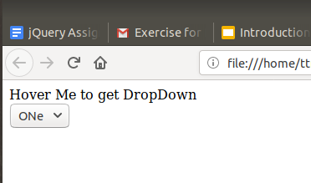

11. On clicking on "[google](https://www.google.com)" tag. It is taking us to google home page. Stop it from happening.

12.We have bind a click funtion to parent div but we want stop it from performing when user clicks on its child li

<!DOCTYPE html>

<html>

<head>

<meta content="text/html;charset=utf-8" http-equiv="Content-Type">

<meta content="utf-8" http-equiv="encoding">

<title></title>

<script type="text/javascript" src="./jquery.min.js"></script>

<style type="text/css">

.load

{

background-color: red;

}

</style>

<script type="text/javascript">

$(document).ready(function()

{

$('div').click(function()

{

console.log("User clicked")

})

$('li').on('click',function(e)

{

e.stopPropagation()

console.log("User clicked on li item")

})

});

</script>

</head>

<body>

<div>

Some text

<ul>

<li>1</li>

<li>2</li>

<li>3</li>

</ul>

</div>

</body>

</html>

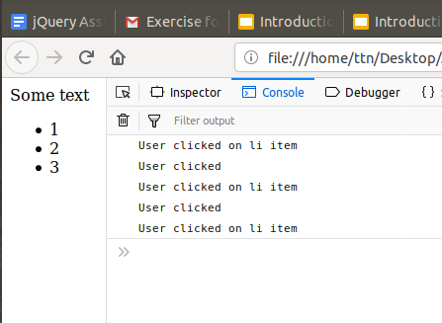

13) Get the max height of elements using jquery each method

<!DOCTYPE html>

<html>

<head>

<meta content="text/html;charset=utf-8" http-equiv="Content-Type">

<meta content="utf-8" http-equiv="encoding">

<title></title>

<script type="text/javascript" src="./jquery.min.js"></script>

<style type="text/css">

</style>

<script type="text/javascript">

$(document).ready(function()

{

max=$('li:first').height()

$('li').each(function(e)

{

var heights=$(this).css('height');

var hgt=parseInt(heights)

if(hgt>max)

{

max=hgt

}

})

console.log(max)

});

</script>

</head>

<body>

<ul>

<li style="height: 40px">A</li>

<li style="height: 50px">B</li>

<li style="height: 50px">C</li>

<li style="height: 75px">D</li>

</ul>

</body>

</html>

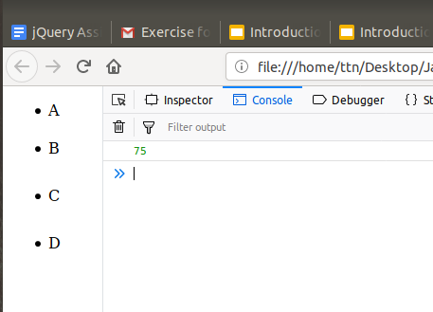

14. Chagne color of every cell which has numberl larger than 10.

<!DOCTYPE html>

<html>

<head>

<meta content="text/html;charset=utf-8" http-equiv="Content-Type">

<meta content="utf-8" http-equiv="encoding">

<title></title>

<script type="text/javascript" src="./jquery.min.js"></script>

<style type="text/css">

</style>

<script type="text/javascript">

$(document).ready(function()

{

$('td').each(function()

{

x=$(this).text()

if(x>10)

{

$(this).css('background-color','red')

}

})

});

</script>

</head>

<body>

<table>

<tbody>

<tr><td>15</td><td>17</td><td>8</td></tr>

<tr><td>4</td><td>7</td><td>12</td></tr>

<tr><td>11</td><td>6</td><td>19</td></tr>

</tbody>

</table>

</body>

</html>

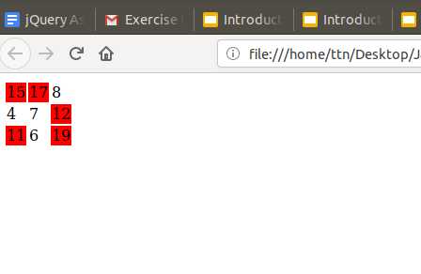

15. Retrive the data from server using ajax get call

<html lang="en">

<head>

<meta charset="UTF-8">

<meta name="viewport" content="width=device-width, initial-scale=1.0">

<meta http-equiv="X-UA-Compatible" content="ie=edge">

<title>Document</title>

</head>

<script type="text/javascript" src="./jquery.min.js"> </script>

<body>

<div class="abc" >

</div>

<script>

$(document).ready(function(){

$.ajax({

url:"https://jsonplaceholder.typicode.com/posts",

method:"get",

success:function(result){

var jsondata= JSON.stringify(result);

$('div').html(jsondata);

}

});

});

</script>

</body>

</html>

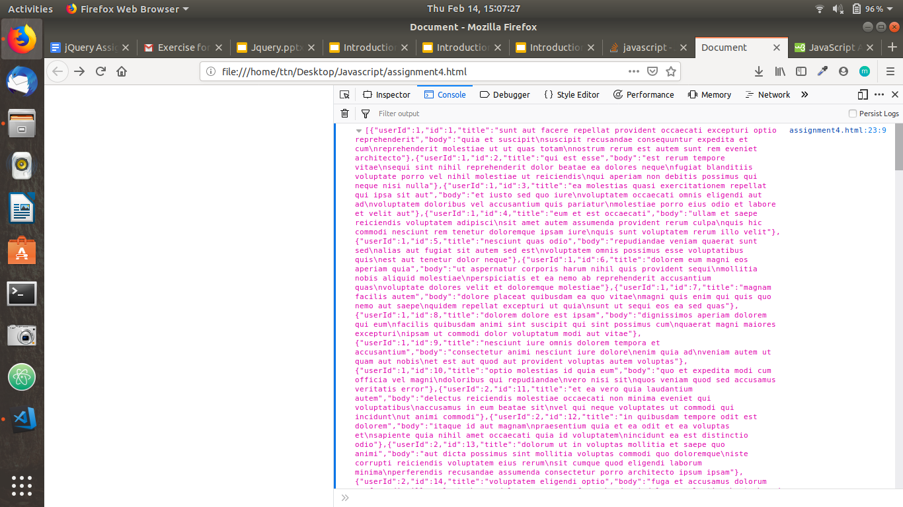

16 . Add cross button on row and bind click function which make a delete request to server, after success event remove the row from dom.

<!DOCTYPE html>

<html>

<head>

<meta content="text/html;charset=utf-8" http-equiv="Content-Type">

<meta content="utf-8" http-equiv="encoding">

<title></title>

<script type="text/javascript" src="./jquery.min.js"></script>

<style type="text/css">

.load

{

background-color: red;

}

</style>

<script type="text/javascript">

$(document).ready(function()

{

$(".button2").click(function(){

$.ajax({url: "abc.json",

dataType : "json",

type : "DELETE",

success: function(result){

$('.removeMe').remove();

alert("REMOVED");

},

error: function(request,msg,error) {

console.log("Request Failed");

$('.removeMe').remove();

}

});

});

}

);

</script>

</head>

<body>

<div>

<table>

<tr class="removeMe">

<td><button class="button2"> X </button></td>

</tr>

</table>

<hr>

</div>

</body>

</html>

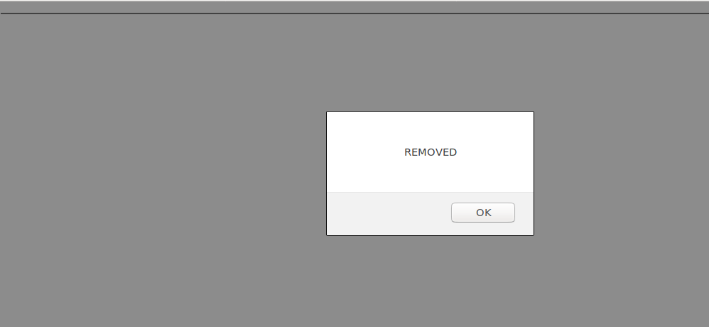

17. Create a image array and in div create a slide show to animate images of delay of 500ms.

Did not get implemented.