Create an android app to demonstrate custom Button, Radio Button, CheckBox through Custom View.
Name of Student:Karan Bhoker
Registration Number:11709986
Section:KM041
Roll No: 31
- Introduction
Here in thi project we will be working with custom view and we will try to implement the concept of custom Button ,custom Radio Button and Custom CheckBox using CustomView

- Working Screenshots

1.Home Screen:This is our home screen and from here we will be selecting the type of Customization we want to experience.
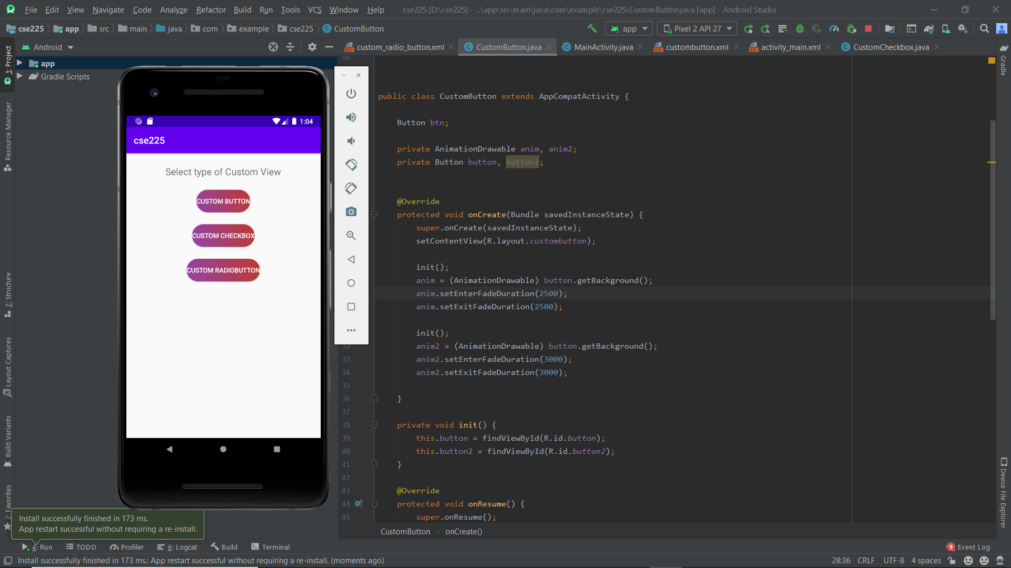

2.CustomButton:by clicking on custom button we can experience the button which we have customized here we have changed its color and shape and also by clicking on button the color of our custom button will keep on changing after few seconds.
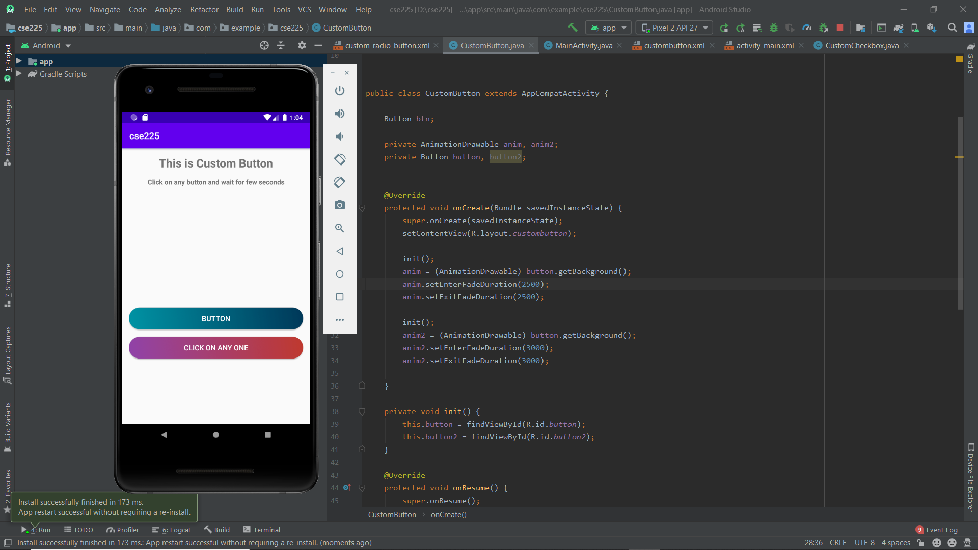

3.Custom CheckBox:Here we have customize the checkbox and we have customized the checkboxes instead of tics we have changed its view and how the checkbox is being selected.
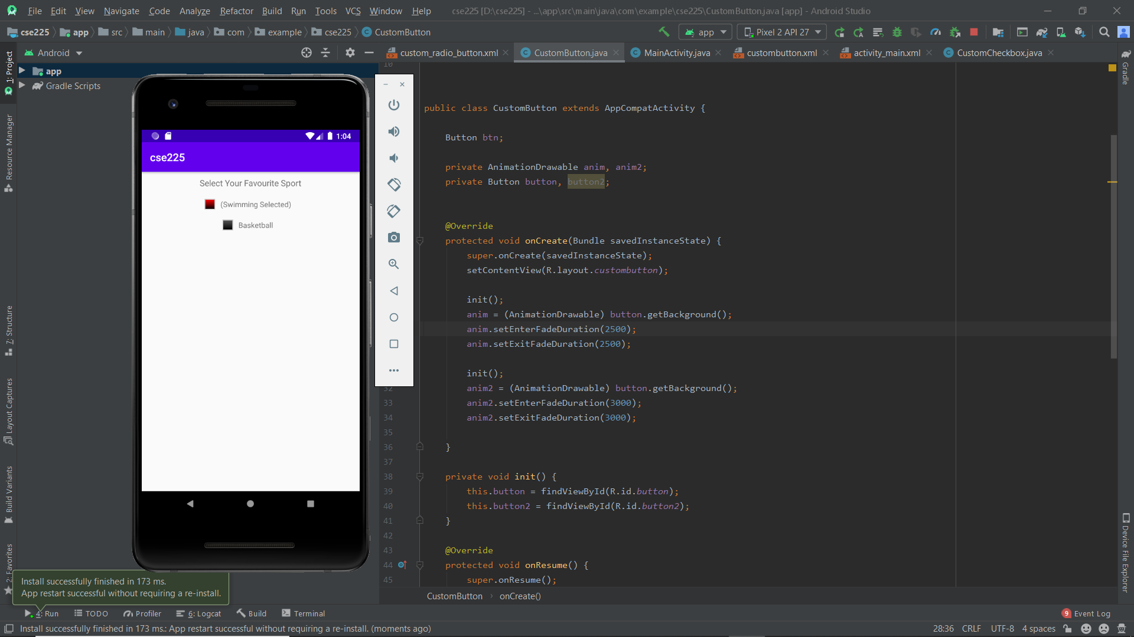

4.CustomRadioButton:Here we have created radio button inside the radio group and customized our radio button in a different and new style.
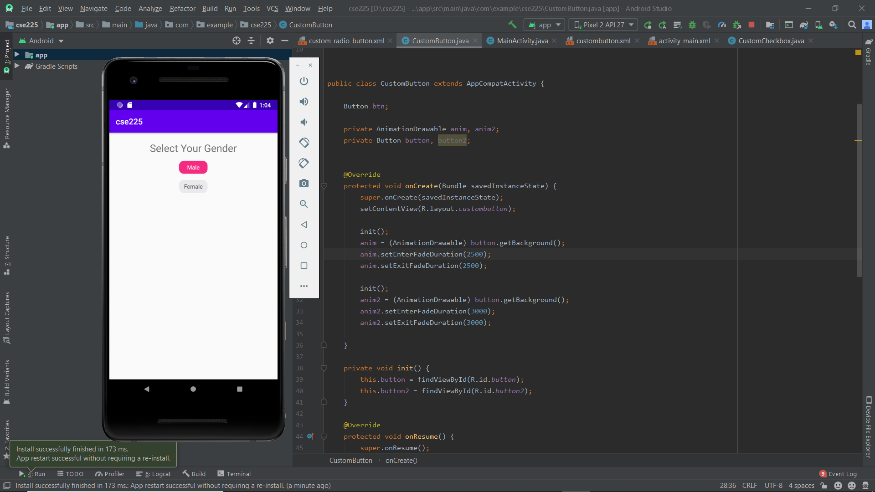

- Uses: We are using custom views to customize the required things we need to customize by doing so we can make our application more easy to access and also the UI will be more attractive because of the customization of our application we can change the button,custombutton etc according to our requirement and how the customer will like it.

References
https://www.javatpoint.com/android-tutorial
https://abhiandroid.com/

