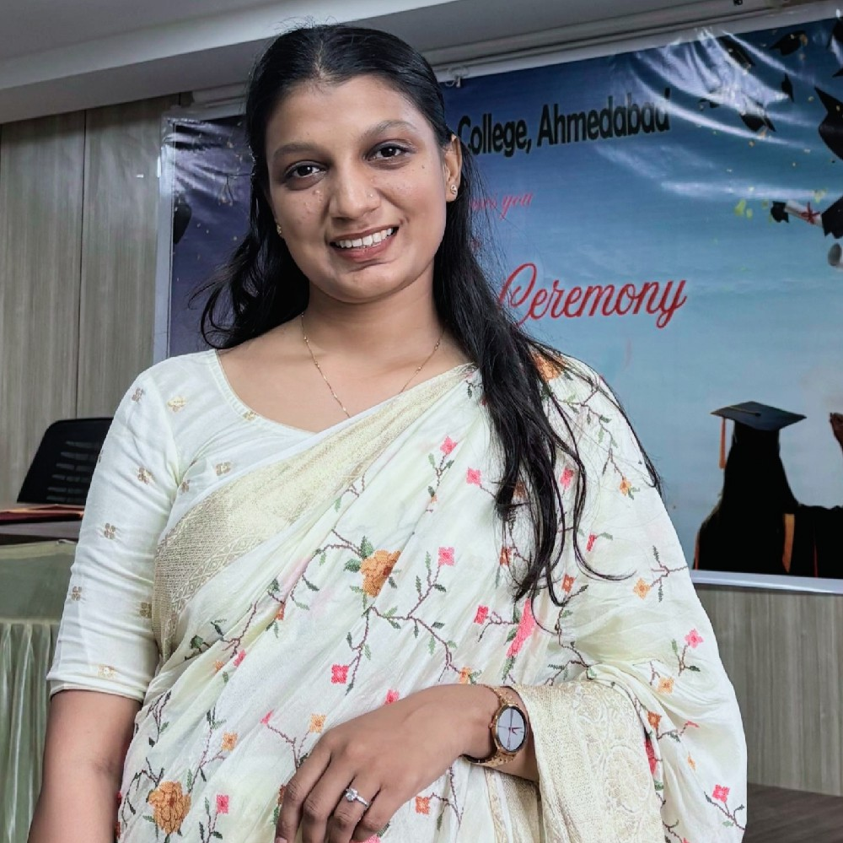
Dr. Gosai Hetal Yashvantgiri
Kesar 27, B/H Himalaya party plot, ankhol, new waghodia road, Vadodara
+919586068611 | gosaihetal21@gmail.com

To work in an environment which encourages me to succeed and grow professionally where I can utilize my skills and knowledge appropriately.
Objective
Personal Details
- Date of Birth : 19/04/1999
- Marital Status : Married
- Nationality : Indian
Education

Parul University
Doctor of Pharmacy
68.57% First class

Adarsh Vidhyalaya
HSC Board 59.07%

Adarsh Vidhyalaya
SSC Board 84.33%
Experience

- SwaminarayanUniversity Ahemdabad
Assistant Professor
(Total experience: 6.5Month)

2016-2022

March 2016

March 2014

1/10/2025 - 17/04/2026
As an assistant professor, I am handling Doctor of Pharmacy students for Pharmacotherapeutics, Pharmacology, Clinical research, and Pathophysiology as well as community pharmacy. Apart from that I handle ward rounds for Pharmd Students.

A one pharmacy college, SNME Campus, Naroda-Dahegam Road, near Sardar Patel Ring Road, Daskroi, Enasan,
Ahmedabad, Gujarat 382330
Assistant professor
(Total experience: 3 Years)
3/10/2022 – 30/09/2025
As an assistant professor, I am handling Doctor of Pharmacy students for Pharmacotherapeutics, Pharmacology, Clinical research, and Pathophysiology as well as community pharmacy. Apart from that I handle ward rounds for Pharmd second, third, fourth and fifth & sixth year students for case studies at sola civil hospital. Also I in charge for sola civil hospital file and Pharmd lesson plan file.
- Mentor for Pharmd 5th year students and pharmd 6th year internship students
-Guide for Pharmd 5th year students for their project work
-Guide for Bpharm projects
-Co- Guide for Mpharm projects

Sir sayajirao general hospital, vadodara, gujarat -
Clinical pharmacist intern
Posting at various departments General Medicine, Pediatric,Psychiatriy,Gynecology,Orthopedic,Dermatology
PPF documentation
Drug interactions form ADR reporting
Patient counselling
Cross verify dispensing medicine
Shree Vallabh hospital, Vadodara, Gujarat
2 months internship at shree Vallabh hospital
Cross verify dispensing medicine and Prescription checking
Sterling hospital Ahmedabad Clinical pharmacist
-

Identify various types of Medication error, Patient counselling, Check drug interactions, ADR reporting, NABH check list, Auditing for OP and IP patient.

Skills
- Problem Solving ,Judgment and Decision making Coordinating with others ,Time Management
- Clinical Skills, Proficient in various clinical services like medication chart review to rule out any Drug Related Problem. Patient Counseling. , Ward Round Participation , Medication Error Finding ,Prescription Monitoring Audit & monitoring
- Technical Skills, Knowledge of Ms-office. Ms-Excel, Ms-Powerpoint. , Handling of various software programs and databases like SPSS, Micromedex, PubMed, and ScienceDirect.
Projects

Knowledge, attitude, and practice (kap) towards COVID-1 9 : A quick online cross -sectional survey among population of india.
Mentor: Dr. Snigdha das mandal | Team Size: 3, Journal of hospital pharmacy (JOHP)
- Assessment of medication response pattern across different epilepsy types: A Cross Sectional investigation using CHI-SQUARE Analysis
- Comparative Efﬁcacy of Gabapentin Monotherapy and Combination Therapy for the Management of Radiating Pain: A Randomized Controlled Trial
- To evaluate anxiety and depression in hospitalized patients of Ahmedabad, Gujrat: A CROSS-SECTIONAL STUDY
- “Exploring the interconnection between obesity and related comorbidity: IMPACT AND PATIENT COUNSELLING”
- Clinical evaluation of respiratory disease in correlation to endocrinal and cardiovascular imbalance
Publications

Knowledge, attitude, and practice (kap) towards COVID-1 9 : A quick online cross -sectional survey among population of india.
Journal of hospital pharmacy (JOHP) ISSN No: 2348-7704
- Case Report On Brain Abscess With Intracranial Extension Of Chronic Suppurative Otitis Media (Csom) International journal of research and analytical review (IJRAR)
ISSN No: 2349-5138

Guillain–barre syndrome: case report
World Journal of Pharmacy and Pharmaceutical Sciences ISSN No: 2278-4357

To evaluate anxiety and depression in hospitalised patients of ahmedabad, gujarat: a cross-sectional study
World Journal of Pharmaceutical and Life Sciences WJPLS
Impact Factor: 7.409
ISSN 2454-22

Seminar/Webinar
- Attend 14th National Conference on Teenage & Young Adult Cancer (TYAcon 2025), to be held from September 12th to 14th, 2025.
- Attend Oncowin update 2025 - 3rd annual conference of oncowin held on August 30 - 31, 2025.
- NIDA Clinical Trial Network ( Good Clinical Practice)
- "Exploring Pharmacovigilance: Unraveling Latest Trends and Career Pathways" held by Sri Sivani College of Pharmacy in Association with
ClinoSol Research Private Limited on 24th May 2024
- 2 Day International Workshop On Leadership,Clinical Pharmacy And Its Opportunity Dec.13, 2021 - Dec. 14, 2021,Institute Name:Shree Dhanvantary Pharmacy College, Surat,Key Skills: Leadership, Clinical Pharmacy
- CME, Pharmacovigilance : The Process And Impact On Healthcare Sept. 17, 2019 -Sept. 17, 2019 ,Institute Name: Parul Institute Of Medical Sciences And Reserch
- An Update On ICH-GCP Guidelines & Schedule Y Nov. 27, 2018 - Nov. 27, 2018 , Institute Name: Parul Institute Of Medical Sciences And Reserch
- International Conference On Challenges,Opportunity And Newer Directions Of Pharmacovigilance And Clinical Reserch In India , Jan. 5, 2018 -Jan. 6, 2018 , Institute Name: Parul Institute Of Pharmacy
- Hypertension Screening, Institute Name: Parul Institute Of Pharmacy And Research,Vadodara
- Role Of Pharmd Graduates In Various HealthServices Sept. 13, 2016 - Sept. 13, 2016 ,Institute Name: Department Of Pharmacy,Sumandeep Vidhyapeeth, Vadodara

DR. GOSAI HETAL YASHVANTGIRI

