SHASHIKANT  Cardiac Perfusion  Muzaffarpur, Bihar | +91 9708877543 | skant4352@gmail.com | 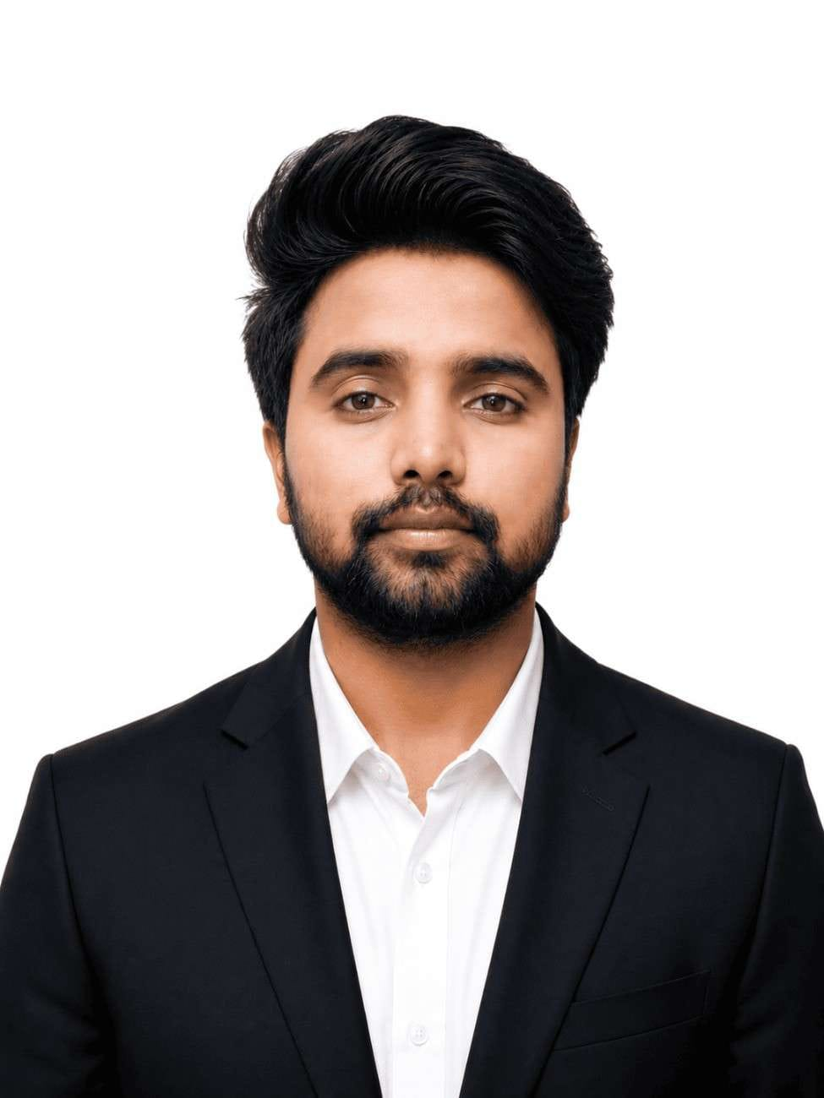

PROFILE SUMMARY
Cardiac Perfusion Technology graduate (2026) with hands-on clinical training in cardiopulmonary bypass management, ECMO initiation and weaning, IABP setup, and intraoperative hemodynamic monitoring across adult and pediatric cardiac procedures. Seeking a perfusionist role with a dynamic cardiac surgery team.
CLINICAL EXPERIENCE
Clinical Intern
Sterling Hospital, Gurukul, Ahmedabad Jul 2025 – Jan 2026
Manipal Hospital, Old Airport Road, Bangalore Jan 2026 – Jul 2026

- Independently managed perfusion, under the supervision of a senior perfusionist, in 20+ adult and pediatric cardiac procedures, including CABG, septal defect repairs (ASD, VSD), the Fontan procedure, minimally invasive cardiac surgery (MICS), intracardiac repairs (TOF, PAPVC), and valve surgeries (AVR, MVR).
- Prepared, assembled, and primed the cardiopulmonary bypass circuit for 350+ cases across a wide range of adult and pediatric cardiac procedures, including CABG, valvular surgeries, septal surgeries, and other complex repairs such as TAPVC, TOF, and the Ross procedure, maintaining full compliance with institutional sterility standards.
- Contributed to assembling, initiating, and weaning V-A/V-V ECMO support in 15 cases, developing a working knowledge of extracorporeal membrane oxygenation (ECMO).
- Supported the initiation and continuous management of IABP support.
- Assisted in donor heart retrieval for an orthotopic heart transplantation (OHT) procedure, and gained proficiency in autologous blood recovery using the C.A.T.S. Cell Saver system.
- Accurately documented case details in the perfusion record across all procedures.
EDUCATION
BSc Perfusion Technology — Manipal College of Health Profession, Manipal (CGPA: 8.66) 2026
Intermediate (AISSCE) — Indraprastha Int. School, Bochaha, Muzaffarpur (Percentage: 67.8%) 2019
Matriculation (AISSE) — SRT School Boddha Vihar, Chamarua, Muzaffarpur (CGPA: 10) 2016
TECHNICAL SKILLS
- Cardiopulmonary bypass management, circuit priming, and intraoperative hemodynamic monitoring
- ECMO setup, initiation, and weaning (V-A / V-V)
- IABP setup and management
- Equipment: HL 20, Stockert S3/S5, Sarns 9000, Rotaflow, Rotaflow 2, CentriMag, Arrow AutoCAT, Datascope CS300/CS100, C.A.T.S. Cell Saver
- Sterile technique, perfusion record documentation, and medical terminology
CONFERENCES & WORKSHOPS
- CME: "Exploring the Complexity of Pleural Effusion and Pneumothorax" & Workshop: "ECMO: A Bridge to Extended Life Support" — Dept. of Cardiovascular & Thoracic Surgery, KMC MAHE Manipal, and Perfusion Technology Program, MCHP Manipal, with the Indian Society of Thoracic Surgeons and Trust (May 7, 2023)
- "The Role of ECPR in Cardiac Emergencies: A Hope for the Failing Heart" — Perfusion Technology Program, MCHP Manipal (Feb 10, 2024)

