CURRICULUM VITAE
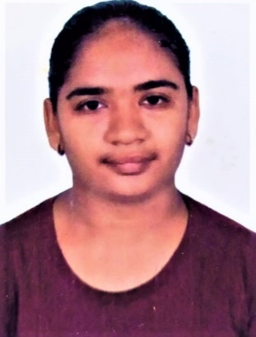

SOLANKI VISMITA MAHENDRABHAI
D-101, NIRMAL NAGAR, UMRA,
SURAT – 395007
MOBILE NO.: +91 7359956515
EMAIL ID: solankivismita2535@gmail.com

CAREER OBJECTIVE
TO ACHIEVE SUCCESS BY CONSTANTLY INNOVATING AND IMPROVING ONSELF AND TO ECVEL IN THE FIELD CHOSSEN THROUGH HARD WORK, OPENNESS TO LEARN AND DEDICATION.
EDUCATION QUALIFICATION

COURSE | PERCENTAGE | NAME OF  INSTITUTE | YEAR OF  PASSING | ATTEMPT
SSC | 53.33% | GSHEB | 2016 | 1
HSC(SCIENCE) | 48.42% | GSHEB | 2018 | 1
B.SC(CHEMISTRY) | 60.30% | VNSGU | 2021 | 1
PGDMLT | 61.20% | VNSGU | 2023 | 1
CERTIFICATIONS

- COURSE ON COMPUTER CONCEPTS (CCC)
SKILLS
- GOOD COMMUNICATION SKILL
- EASILY LEARNING ABILITY

EXPERIENCE
- FRESHER
PERSONAL DETAILS
FATHER’S NAME : MAHENDRABHAI GOMANBHAI SOLANKI
DATE OF BIRTH : 19/09/2000
SEX : FEMALE
RELIGION : HINDU
MARITIAL STATUS : UNMARRIED
NATIONALITY : INDIAN
LANGUAGES KNOWN : 1. GUJARATI
  - HINDI
  - ENGLISH

DECLARATION
I HEREBY DECLARE THAT THE ABOVE INFORMATION IS TRUE THE BEST OF MY KNOWLEDGE AND BELIEF.

SIGNATURE SOLANKI V. M.

