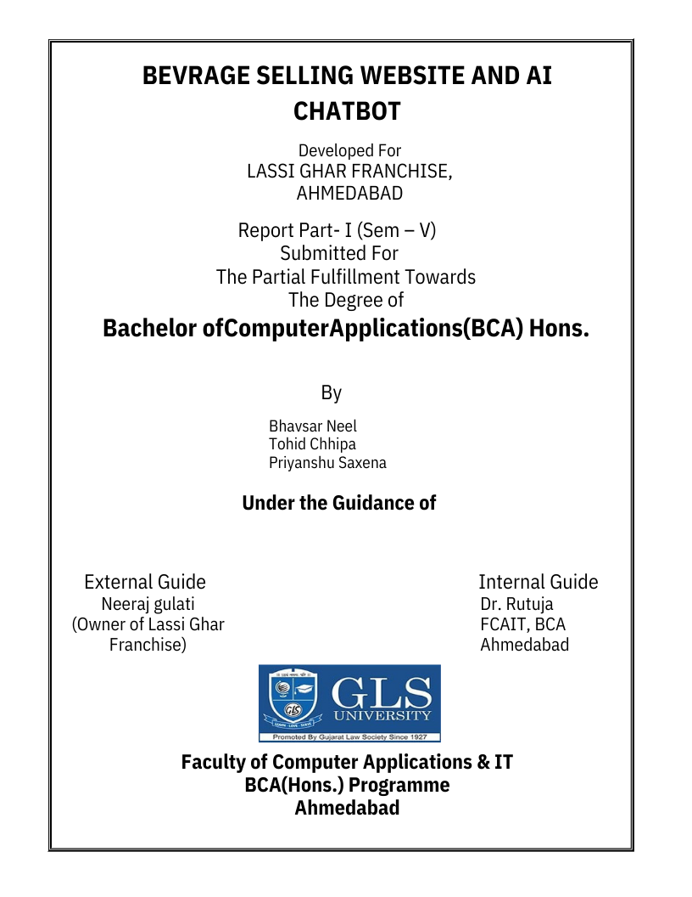

AI-Powered Website for Lassi Ghar – Full Project Documentation

Acknowledgement
We would like to express our heartfelt gratitude to everyone who supported and guided us throughout the development of the AI-Powered Website for Lassi Ghar.
We extend special thanks to:
- GLS University for providing us the platform to execute this project.
- Our faculty mentors for their continuous guidance and feedback.
- Our teammates Priyanshu Saxena, Neel Bhavsar, and Tohid Chhipa for their dedication and teamwork.
This project would not have been possible without the motivation, encouragement, and resources provided by our institution.

Index
Sr. No. | Topic
1 | Project Profile
2 | Introduction
3 | Project Objectives
4 | Key Features
5 | System Architecture
6 | UML Diagrams (with Explanation)
7 | Data Dictionary
8 | Technology Stack
9 | Expected Outcomes
10 | Conclusion
11 | Team Information

1. Project Profile
Project Title: AI-Powered Website for Lassi Ghar
Team Members: Priyanshu Saxena, Neel Bhavsar, Tohid Chhipa
University: GLS University
Year: 2025
Project Type: Web Application + AI Integration
Technologies Used: React.js, Node.js, Express, MongoDB, OpenAI API, AWS

2. Introduction
The aim of this project is to develop a smart and interactive website for Lassi Ghar, a beverage brand. The platform enhances customer engagement by integrating an AI-based chatbot that assists users in exploring the menu, placing orders, customizing flavors, and providing feedback.
This website modernizes the traditional ordering system by providing real-time AI assistance and personalized recommendations.

3. Project Objectives
- To build an attractive and user-friendly website for Lassi Ghar.
- To integrate an AI chatbot for real-time customer support.
- To automate ordering and menu exploration processes.
- To provide personalized flavor and combo suggestions.
- To collect user reviews and derive insights using AI analytics.

4. Key Features
4.1 AI Chatbot Assistant
- Answers customer queries.
- Provides flavor suggestions.
- Helps place orders.
4.2 Online Ordering System
- Easy checkout and secure payments.
- Order tracking and history.
4.3 User Management
- Login/Signup authentication.
- Personalized dashboard.
4.4 Feedback & Analytics
- Collects ratings and comments.
- AI analyses sentiment for business improvements.

5. System Architecture
Frontend: React.js
Backend: Node.js + Express
Database: MongoDB
AI Integration: OpenAI ChatGPT API
Hosting: AWS
The architecture ensures real-time communication between client, server, AI services, and database.

6. UML Diagrams (with Detailed Explanation)
6.1 Use Case Diagram
Explanation: Shows interactions between the user and the system.
- The user can browse menu, chat with AI, place orders, give feedback, and manage profile.
- The AI system responds to user queries and processes requests.
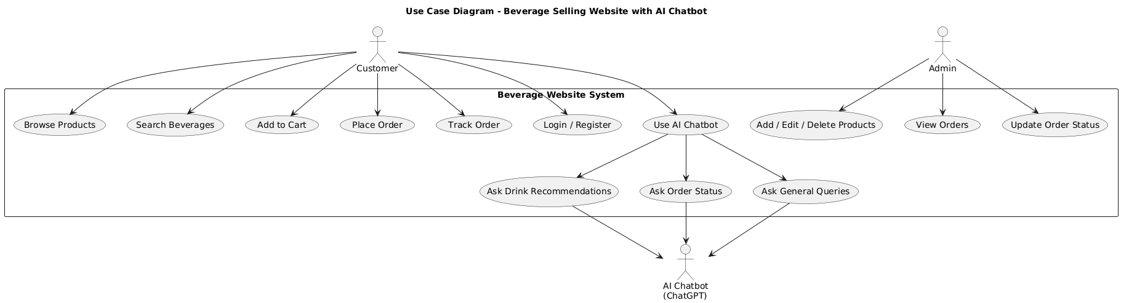

6.2 Class Diagram
Explanation: Displays system structure with classes and relationships.
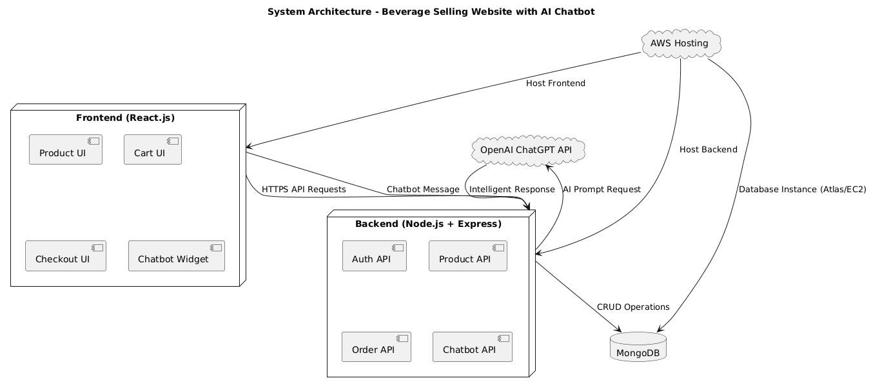

6.3 Sequence Diagram – Order Placement
Explanation: Shows step-by-step flow of how an order is placed.
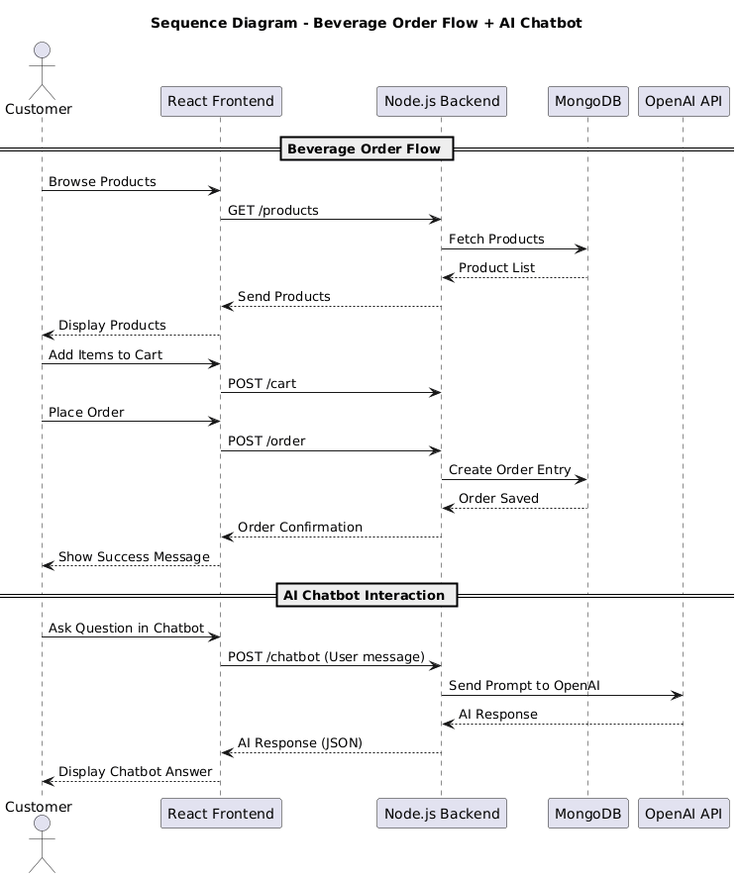

6.4 Activity Diagram – Feedback Submission
Explanation: Shows the steps involved in submitting feedback.
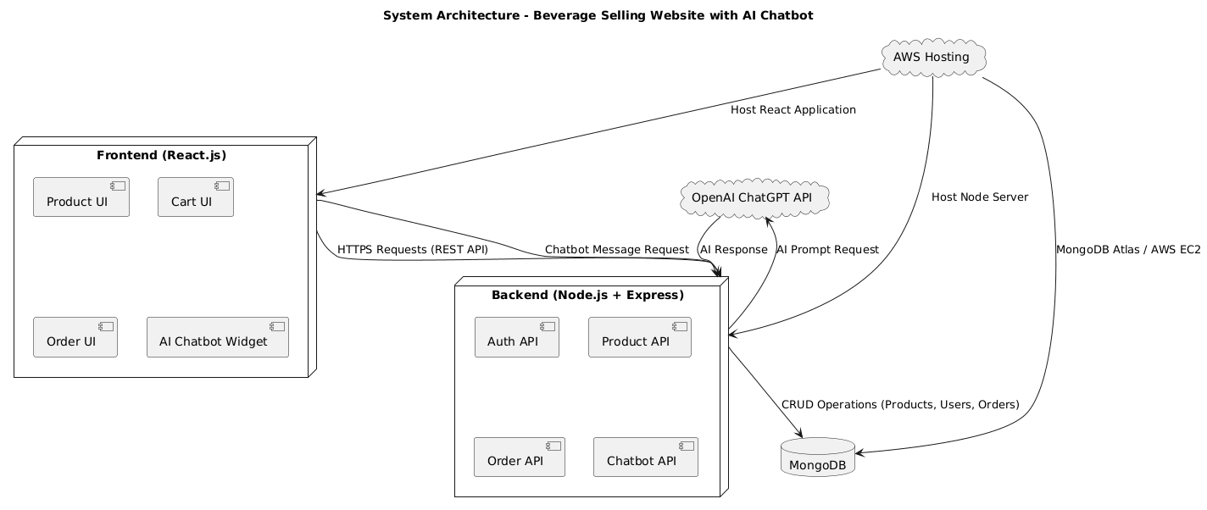

7. Data Dictionary
Below is a detailed data dictionary with field descriptions, constraints, and formats.
Users Table
Field Name | Data Type | Size | Constraints | Description
userID | Integer | 10 | Primary Key, Auto Increment | Unique identifier for each user
name | Varchar | 100 | Not Null | Full name of the user
email | Varchar | 150 | Unique, Not Null | Email used for login
password | Varchar | 255 | Not Null | Encrypted password
createdAt | Datetime | — | Default: Current Timestamp | Account creation date
updatedAt | Datetime | — | Auto-update | Last account update
Orders Table
Field Name | Data Type | Size | Constraints | Description
orderID | Integer | 10 | Primary Key, Auto Increment | Unique order identifier
userID | Integer | 10 | Foreign Key (Users.userID) | User who placed the order
items | Array/Object | — | Not Null | List of Lassi items in order
totalAmount | Float | — | Not Null | Final bill amount
paymentStatus | Varchar | 20 | Default: 'Pending' | Payment status (Paid/Pending)
orderStatus | Varchar | 20 | Default: 'Processing' | Order progress (Processing/Completed)
createdAt | Datetime | — | Auto Timestamp | Order creation time
Menu Table
Field Name | Data Type | Size | Constraints | Description
itemID | Integer | 10 | Primary Key, Auto Increment | Unique item ID
name | Varchar | 100 | Not Null | Name of Lassi flavor/beverage
category | Varchar | 50 | Not Null | Category (Classic, Special, Seasonal)
price | Float | — | Not Null | Price of item
availability | Boolean | — | Default: True | Whether item is available
Reviews Table
Field Name | Data Type | Size | Constraints | Description
reviewID | Integer | 10 | Primary Key, Auto Increment | Unique review identifier
userID | Integer | 10 | Foreign Key | Reviewer ID
rating | Integer | 1 | Not Null, Range: 1–5 | Customer rating
comment | Text | — | Optional | Customer-written feedback
createdAt | Datetime | — | Default Timestamp | Feedback date
Chat Logs Table
Field Name | Data Type | Size | Constraints | Description
chatID | Integer | 10 | Primary Key, Auto Increment | Chat session identifier
userID | Integer | 10 | Foreign Key | User involved in chat
message | Text | — | Not Null | Message text sent/received
sender | Varchar | 20 | Not Null | 'User' or 'Chatbot'
timestamp | Datetime | — | Auto Timestamp | When message was sent
8. Technology Stack Technology Stack**
- Frontend: React.js
- Backend: Node.js + Express
- Database: MongoDB
- AI: OpenAI API
- Hosting: AWS
- Version Control: Git & GitHub

9. Expected Outcomes
- Improved customer interaction.
- Smart and quick ordering process.
- Personalized Lassi recommendations.
- Higher customer satisfaction.
- Enhanced brand through AI adoption.

10. Conclusion
The AI-Powered Website for Lassi Ghar successfully integrates modern technologies to improve the digital beverage-ordering experience. With AI-driven recommendations, a responsive UI, and efficient backend architecture, the project delivers speed, personalization, and convenience.

11. Team Information
Developed By:
- Priyanshu Saxena
- Neel Bhavsar
- Tohid Chhipa
GLS University | 2025

End of Documentation

