|  |
| --- |
| Faculty of Applied Sciences and Technology |
| **XML/JSON Data Processing** |
| ITC5202 - Project |
|  |
| **Group Member name**  **Karan Punjabi – N01514624**  **Abhi Jayesh Priyadarshi – N01513842**  **Submission Date** |
| **[Pick the date]** |

|  |
| --- |
| This document explains how to process XML/JSON data …………………………. |

Table of Contents

Step 1 2

Step 2 3

Step 3 4

Step 4 5

Step 5 6

Summary 7

# Step 1

(Describe the major steps for designing the JavaScript function(s), how you test this program, add some screenshots of the output )

Ans:

Output:

Code: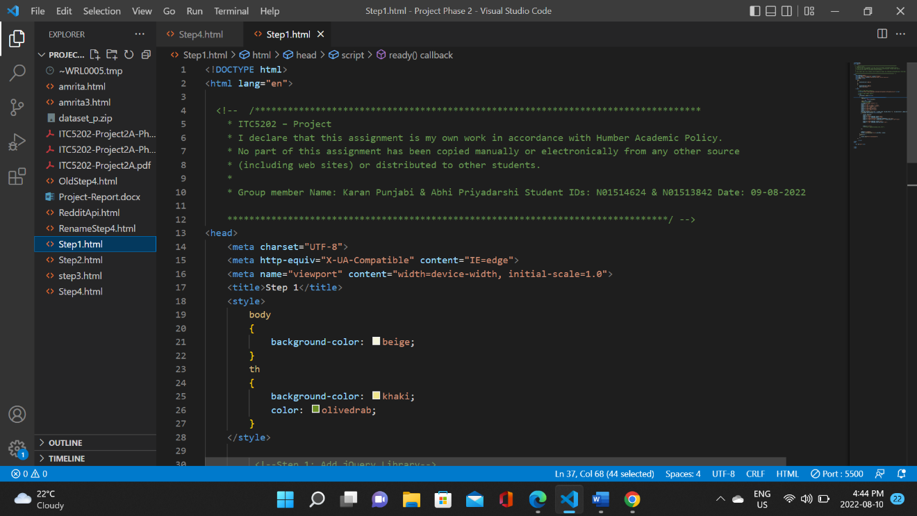

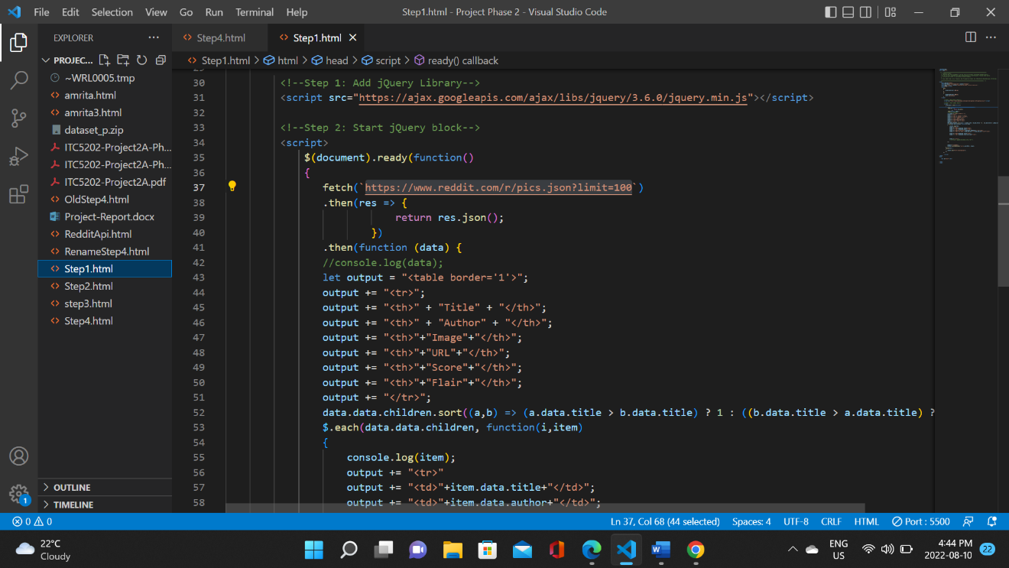

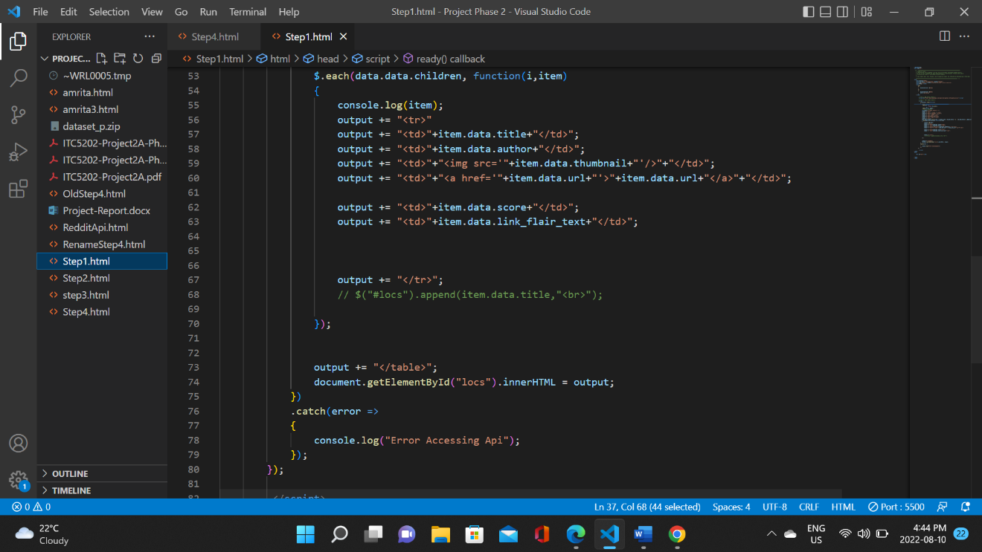

Difference between two Url:

<https://www.reddit.com/r/pics:->

When we run the above url we get a subreddit called Reddit pics, it is a simple reddit webpage which contains some text, style and images.

<https://www.reddit.com/r/pics.json:->

When we run the above url we get the json data of the subreddit page which contains fields such as thumbnail_width and link_flair_text and some img urls.

To begin with, for Step 1 we used this API: <https://www.reddit.com/r/pics.json>.

Using this API our target was to display Title, Author, Image, URl, Score and Flair. We were able to display all these things and decided to display it in table format. Displaying URL and Image was a bit tricky it took some time to figure out how to display them but at the end we were able to do it.

Also, another task was to display 100 records by default there were 25 so for that we added limit=100 at the end of the URL while fetching the data. And to sort the data based upon title we used sort function to manually sort data after fetching it.

We have used catch function at end to handle exception which occurs while fetching the data.

Also, we applied basic CSS to make it look more presentable.

# Step 2

(Describe the major steps for designing the JavaScript function(s), how you test this program, add some screenshots of the output)

Ans:

Code:

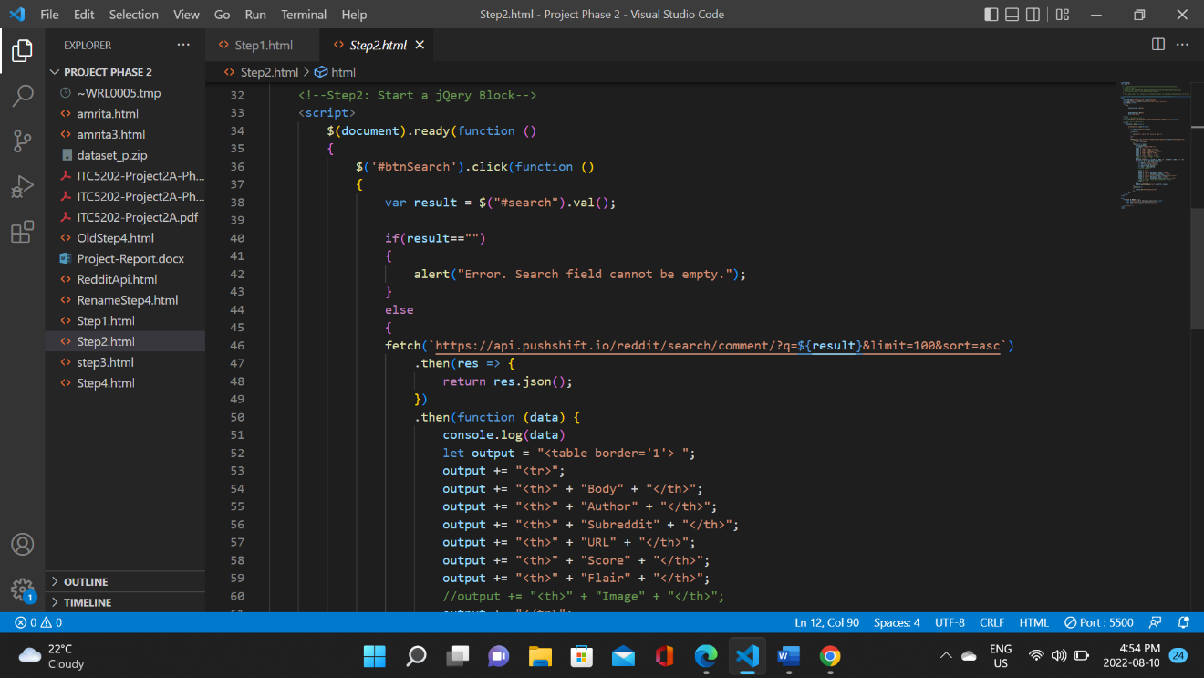

For step 2 we worked with this API:- <https://api.pushshift.io/reddit/search/comment/?q=family&subreddit=pics>

Using this Api our task was to take a keyword from user which they want to search and search for that keyword in the subreddit’s comment. And after that we had to display Body, author, subreddit, url, score, flair, and image. We were able to display all these things except Image. Here accessing url was also a but tricky as there was no direct field URL so after some time of googling and reading API documentation, I was able to figure out how to display URL and decided to display data in table format.

Also, another task was to display 100 records by default there were 25 so for that we added limit=100 at the end of the URL while fetching the data. And to sort the data based upon title we used sort function to manually sort data after fetching it.

We have used catch function at end to handle exception which occurs while fetching the data.

Also, we applied basic CSS to make it look more presentable.

Also, for this question we have applied one validation that search field cannot be empty. If it is empty, it gives user an alert message otherwise runs the code.

# Step 3

(Describe the major steps for designing the JavaScript function(s), how you test this program, add some screenshots of the output)

# Step 4

(Describe the major steps for designing the JavaScript function(s), how you test this program, add some screenshots of the output)

Ans:

Output:

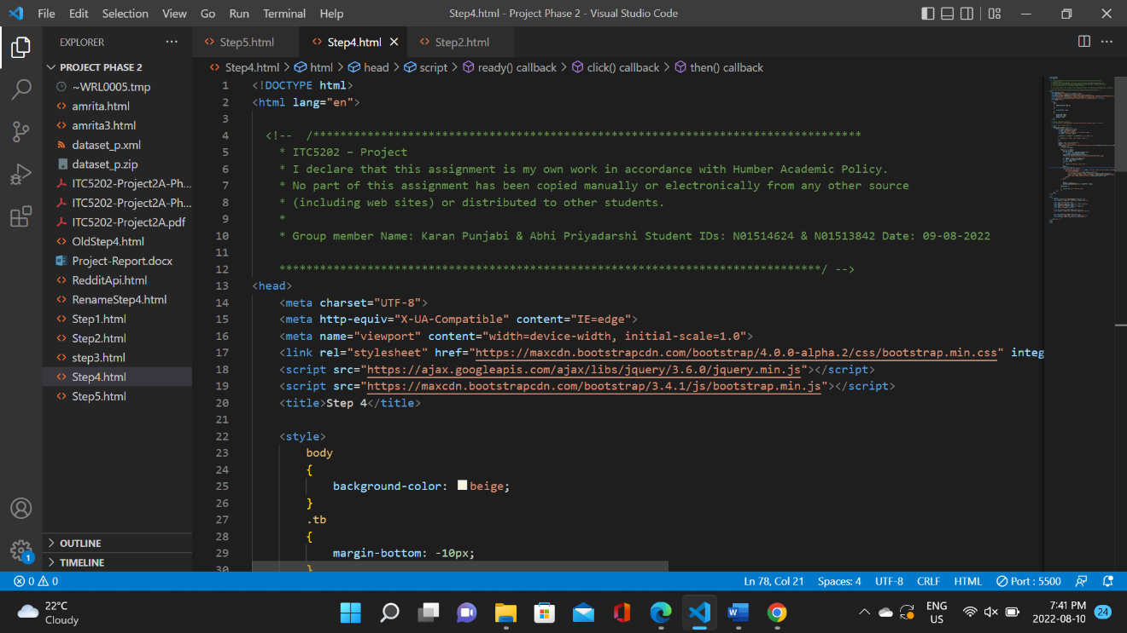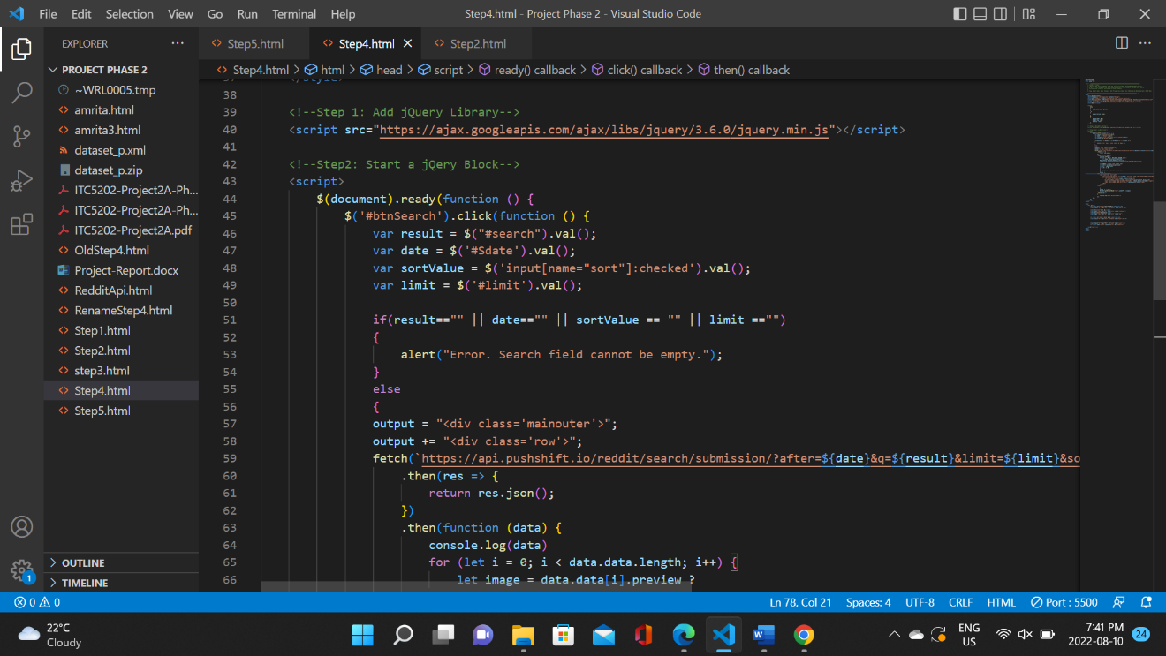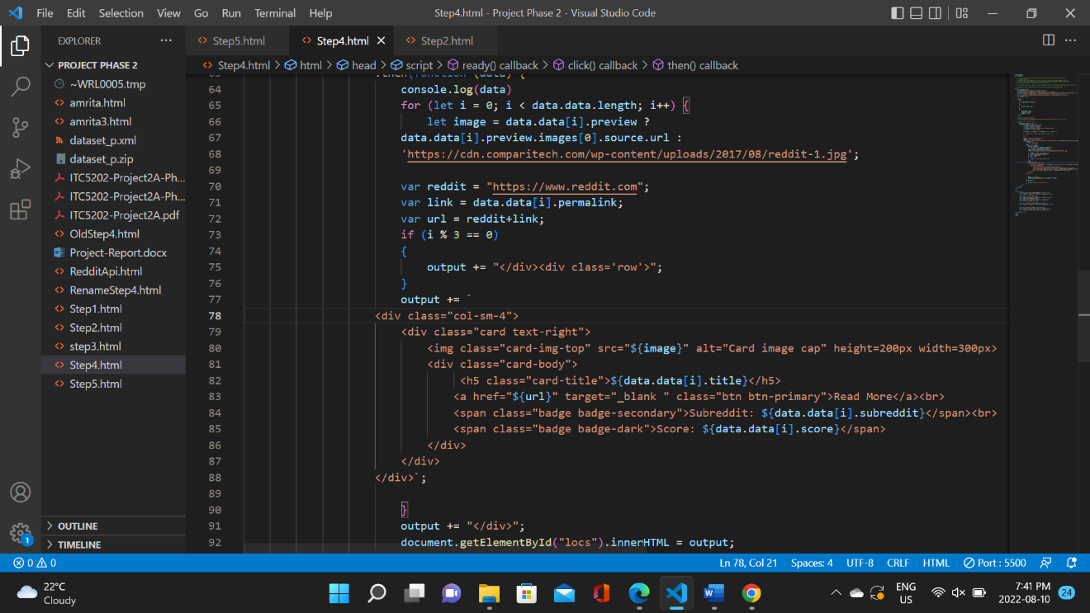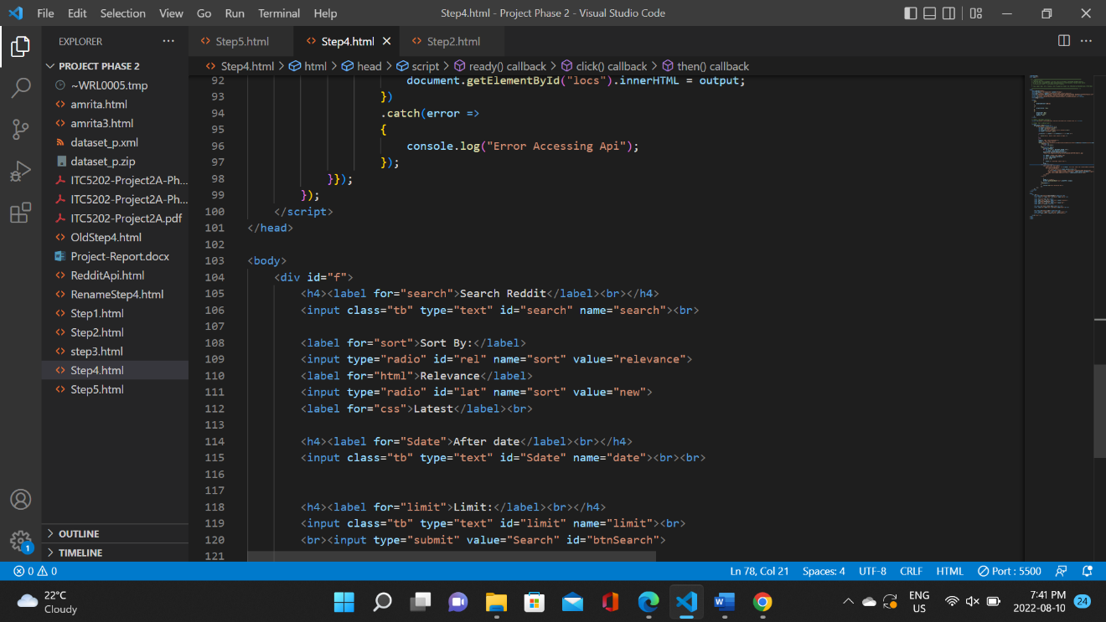

For this step we used this API:-

https://api.pushshift.io/reddit/search/submission/?after =1659338842&q=burger

In this step you asked to take multiple input from user and display output based upon that. Input’s include a search keyword, Sort By type which can be relevance or latest, After date which is in UNIX format and a limit which represents number of records to display.

After taking input from user and storing data in variable we append those variable to our API’s URL and fetch the data. The data which needs to be displayed includes Image, title, subreddit, score and flair.

Accessing Url and Image was a but tricky in this as there was no direct way to access it. I had permalink which I appended to reddit url and created a final URL variable which acts as a link to posts. While for Image there was a tag but for some posts it was empty so I had to use conditional operator to replace empty image space with a inbuilt reddit image I downloaded online.

At last, I used Bootstrap to display in required format and used CSS to make it look more presentable.

Also I used catch at last to handle exception and data validation to check that there are no empty fields while user is entering the data.

# Step 5

(Describe the major steps for designing the JavaScript function(s), how you test this program, add some screenshots of the output)

# Summary

(Describe how did you divide the work, share your feedback about this project like new points that you learn, challenges, …)