Name: Karan Punjabi

N01514624

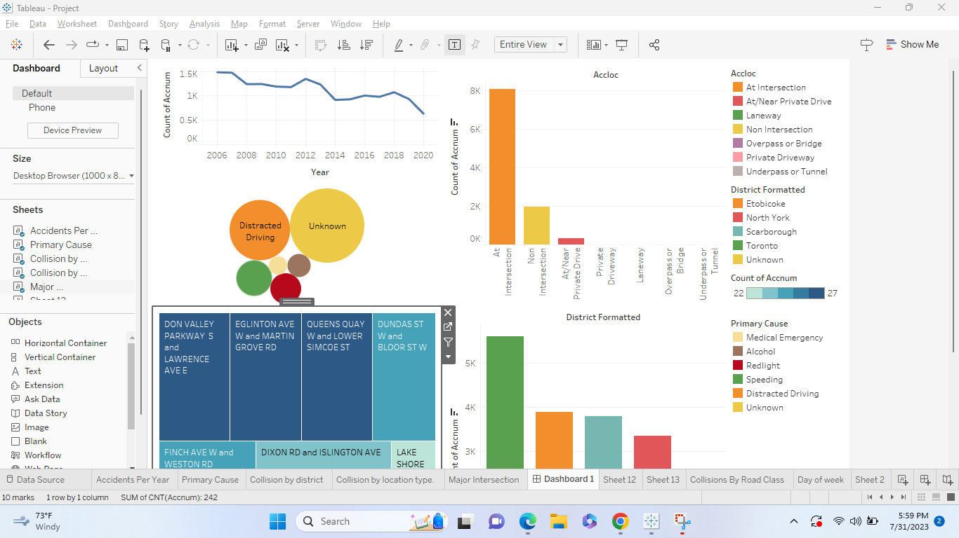

Insights:

1. Accidents Trend Over Years:

The trend of accidents in Toronto over the past years [2005-2021], shows a decline in the number of accidents, indicating the effectiveness of road safety measures and initiatives implemented in the city.

1. Toronto - Highest Number of Accidents:

According to the data, Toronto reported the highest number of accidents compared to other cities in the dataset. This highlights the need for focused road safety efforts in Toronto to reduce accidents and improve road conditions.

1. Primary Cause - Distracted Driving:

Distracted driving emerges as the primary cause of collisions in Toronto. This finding emphasizes the importance of raising awareness and enforcing strict measures to combat distracted driving and enhance road safety.

1. Major Accident Location - Intersections:

Intersections stand out as the most accident-prone locations in Toronto. To reduce the frequency of accidents at intersections, targeted traffic management and safety measures are crucial.