Customer Segmentation Dashboard (Banking & Finance Sector)
Sectoral Analytics Project
BBA (IBM) – 5th Semester, CT University
Group Members:
• Kirti Kochar Jain
• Parampreet Kaur
• Jashanjot Kaur
• Karan
Tool Used: Power BI

Objective
The objective of this project is to analyze customer data in the banking sector and segment them based on their spending behavior and balance patterns. Using Power BI, we created an interactive dashboard that provides insights into customer types, total purchases, credit limits, and spending trends.

Dataset Overview
The dataset used for this analysis contained information about customers, including their type (High Spender, Moderate Spender, Low Spender), account balance, total purchases, and credit limits. The data was cleaned and visualized in Power BI for analytical purposes.
- https://www.kaggle.com/datasets/arjunbhasin2013/ccdata
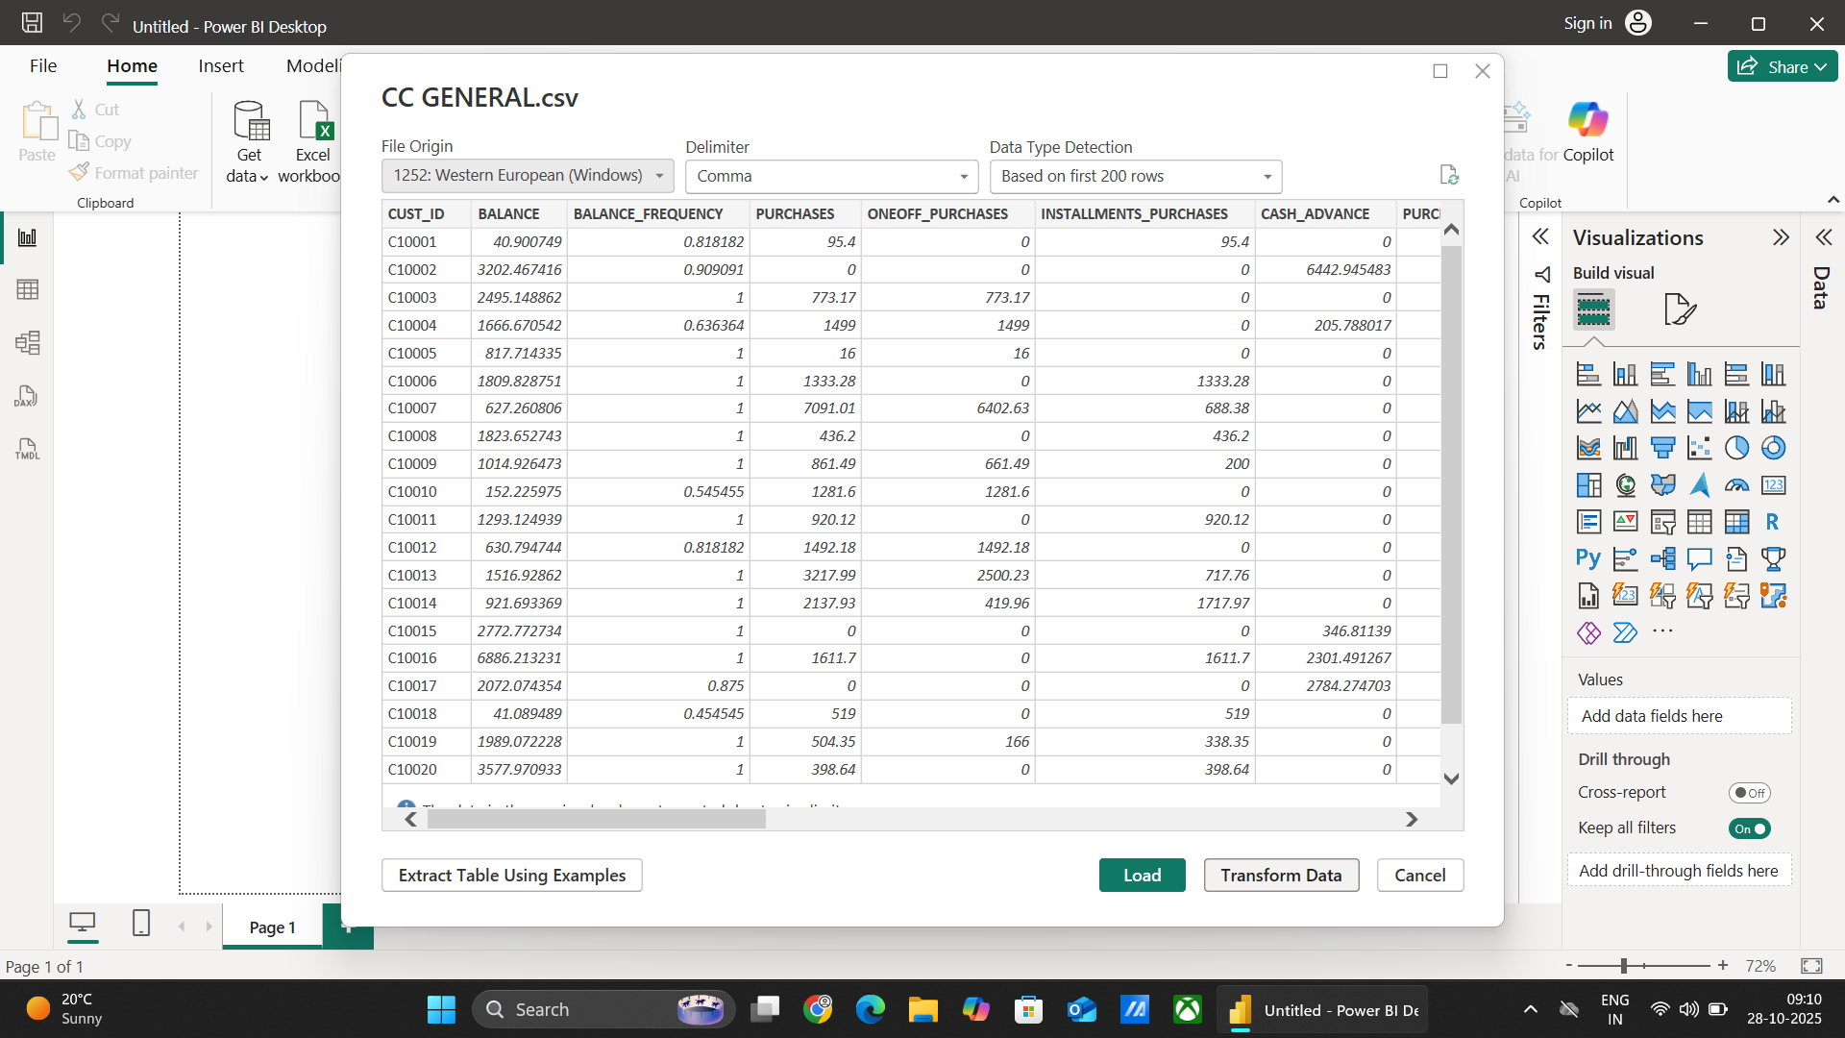

Methodology
- The dataset was imported into Power BI Desktop.
2. Unnecessary columns such as Customer ID were removed for simplicity.
3. Key measures such as total purchases, average balance, and total customers were calculated using Power BI fields.
4. Various visuals were added including bar charts, donut charts, and KPI cards to represent different metrics.
5. A professional layout was created with clear segmentation and easy-to-read insights.

Key Queries and Columns
- Customer Type
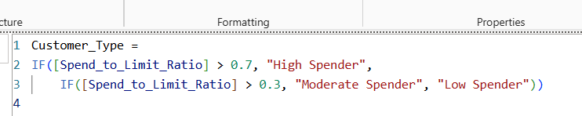

- Payment to limit ratio
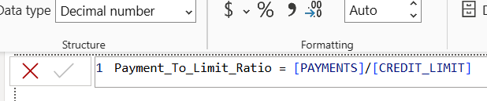

- Payment to limit ratio
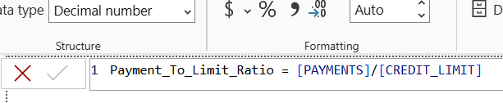

- Spend to limit ratio
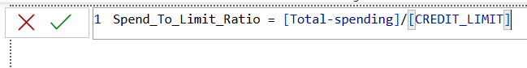

- Total Spending

Dashboard Description
The dashboard consists of multiple visualizations:
• Bar Chart – Average Balance by Customer Type.
• Tree Map – Total Spending by Customer Type.
• Donut Chart – Total Customers by Customer Type.
• KPI Cards – Representing total purchases, average credit limit, and total customers.
These visuals collectively provide a clear view of customer segmentation and spending patterns.
Tree Plot
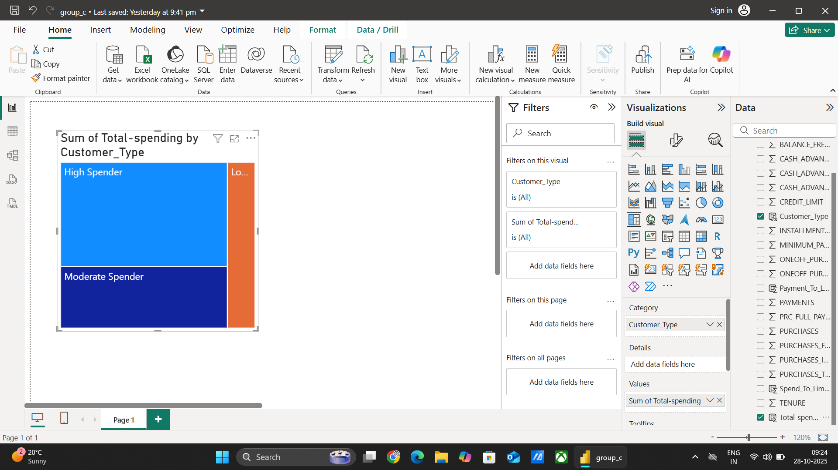

Cluster Bar Chart
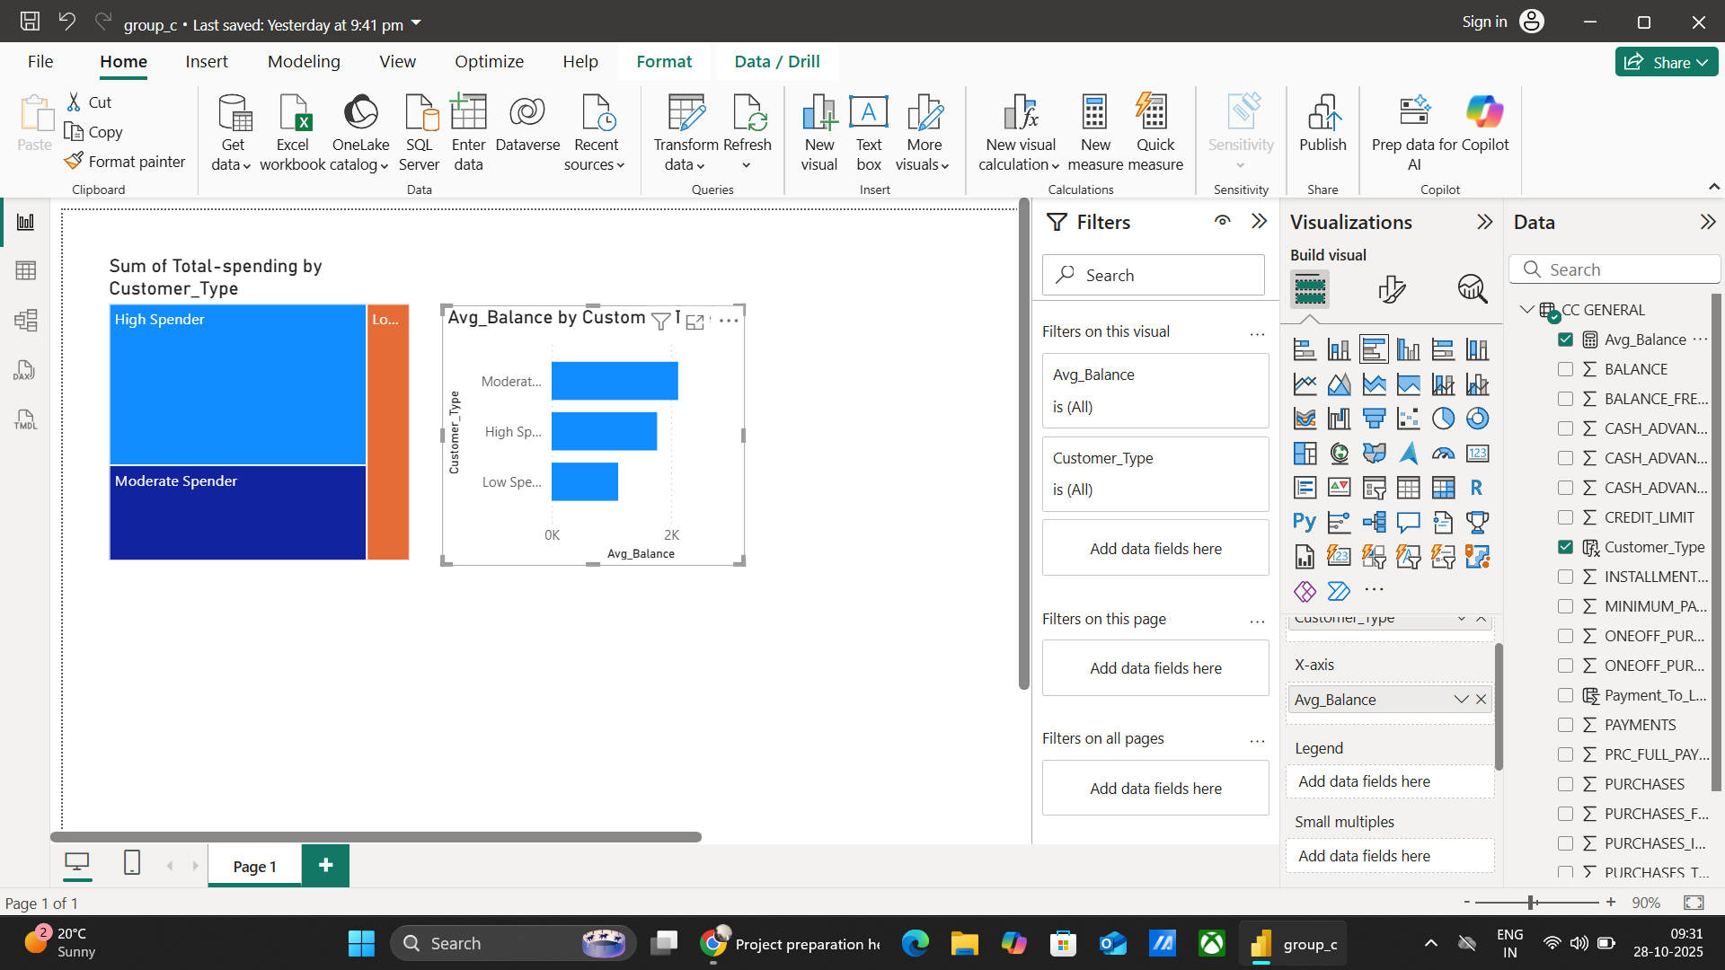

Pie Chart
Key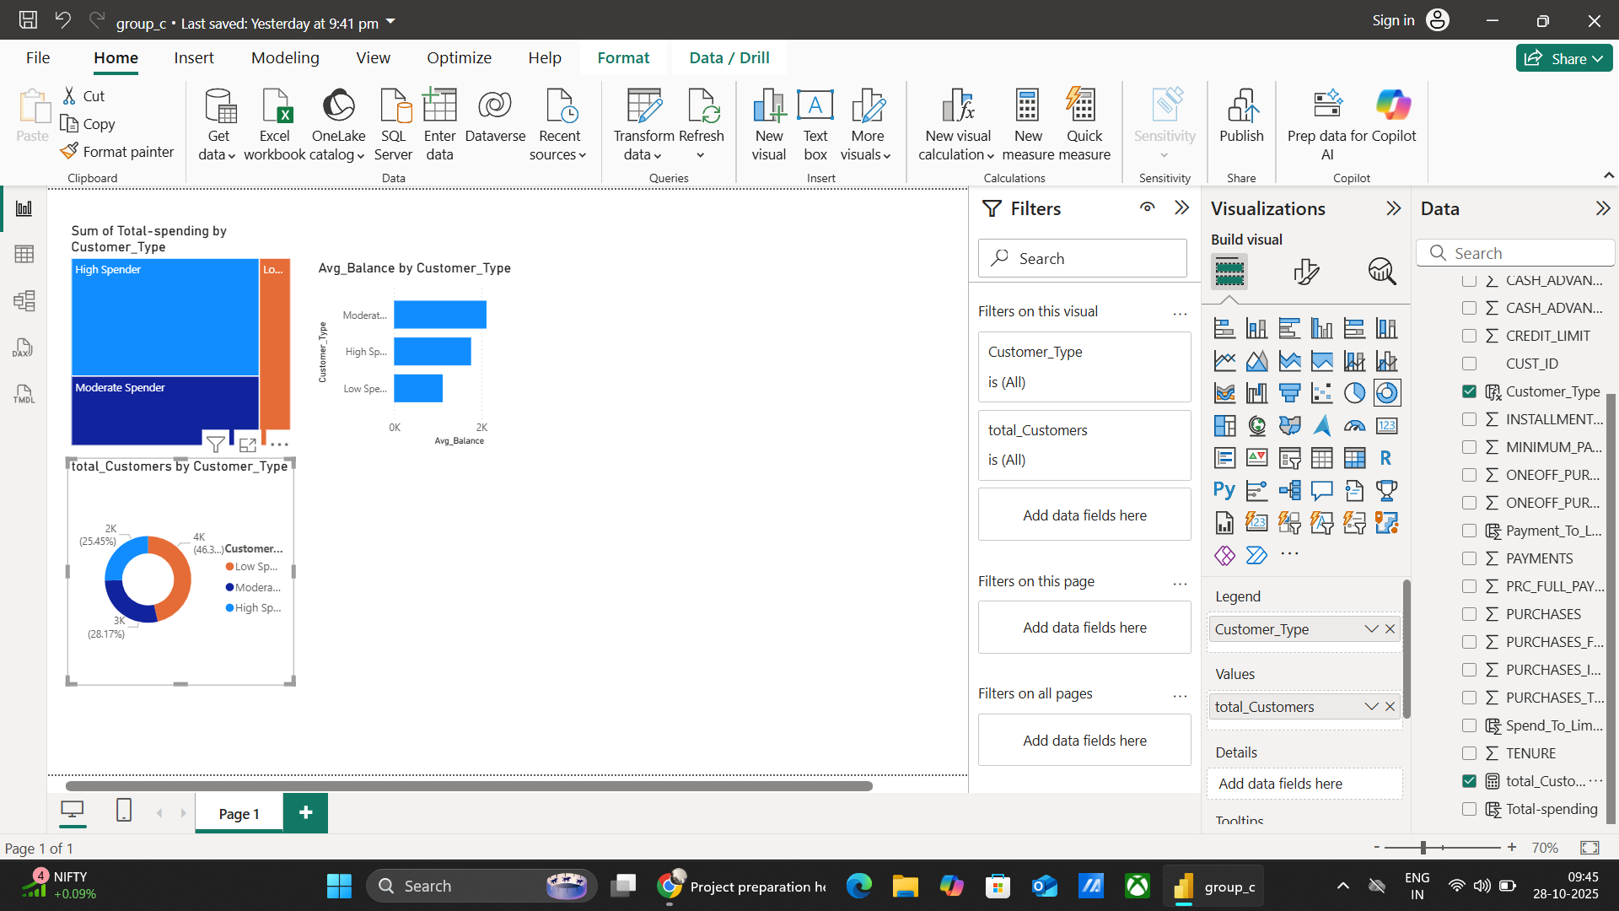
Cards
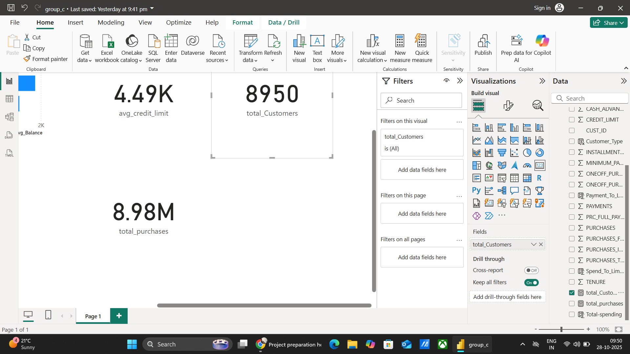

Insights & Analysis
From the analysis, it was observed that High Spenders contributed the maximum total spending, followed by Moderate and Low Spenders. The average account balance and credit limit also reflected similar trends. This segmentation helps financial institutions in targeting marketing strategies and optimizing customer relationship management.

Conclusion
This project demonstrates how Power BI can be effectively used in the Banking & Finance sector to perform Customer Segmentation Analysis. The dashboard provides an insightful overview of customer behaviors, which can support better decision-making and persCustomer Segmentation Dashboard Screenshot

Final output
