Software Requirements Specification (SRS) Document
Generalized Web Dashboard for image preprocessing
Team – 3 | Palle Sreeja  Karan Nijhawan  Sanchit Jalan  Manda Vaishnavi Reddy

Brief problem statement
The aim of this project is to create a user-friendly dashboard for handling 360-degree images. The dashboard will allow smooth navigation through panoramic views, adding labels to identify specific points, taking screenshots, and saving these labels in a database. It will also support exporting annotated images in different formats like YOLO or PNG. Additionally, users will have tools to draw and color annotations on images for better interaction and customization. Overall, this solution will make it easier to manage and analyze 360-degree images for various purposes.

System requirements
Software Requirements:
- Operating System: Compatible with major operating systems such as Windows, macOS, and Linux.
- Web Browser: Supports modern web browsers like Google Chrome, Mozilla Firefox, Safari, or Microsoft Edge for accessing the Label-Studio interface.
- Backend Framework: Label-Studio is built on Django (Python), so Python and Django dependencies must be installed.
- Database: Label-Studio supports various databases including SQLite, MySQL, PostgreSQL and others for storing project configurations and labeled data.

- Deployment: Label-Studio is to be deployed locally utilizing Docker for containerization or virtual environments for isolation.
- Port: Label Studio opens on port 8080 by default. To use a different port, specify it when starting Label Studio.
- Data Import
Images: jpg, jpeg, png

Languages and Libraries:
- Backend: Python for server-side logic and Django for web framework.
- Frontend: HTML, CSS, JavaScript,and React.js for building the user interface.
- Database: Depending on the chosen database system, use appropriate Django database drivers and libraries for interaction.
- Video Processing: Utilize relevant video processing libraries and tools as needed, integrated with Label-Studio's backend for video playback and frame extraction.
- Authentication and Authorization: Implement authentication and authorization mechanisms using Django's built-in authentication system or integrating with external authentication providers.
- Libraries Required: json, sys, os, logging, collections, datetime, functools, typing, platform, sys, threading, etc

Users profile
Users: The system is designed to be used by individuals involved in the process of image classifications. These users include data annotators who are responsible for manually labeling 360 degree images. They may have varying levels of familiarity with computer systems and software, ranging from basic to intermediate.
Mode of Use: Users will interact with the system via a web dashboard hosted locally on their machines. The dashboard provides functionalities such as navigating the 360-degree image and labeling the image directly within the browser interface.

Feature requirements (described using use cases)

No. | User Case Name | Description | Release
 | Login and Signup | This is a basic requirement which allows user to do login and signup onto software . | R1
 | Create Project | This is used to create a new project onto the software in which images will be imported and annotations will be done . | R1
 | Add new Labels | This feature is used to add new labels into the database as user wants . | R1
 | Importing 360 degree Image file . | This is used for importing 360 degree image file which has to be annotated . | R1
 | Moving the 360 degree to left or right . | This is used to rotate the imported 360 degree image file to left or write so as to capture the whole picture on a given field of view . | R1
 | Annotations using Bounding boxes | Making an annotation tool to draw bounding boxes around objects in images, facilitating easy annotation. | R2
 | Annotations using Dots | Making an annotation tool to draw bounding boxes around objects in images, facilitating easy annotation. | R2
 | Exporting Annotations | Develop a export format for image annotations to align with the client's specific requirements. (Typically in yolo format) | R2
 | Image Filtering Capability | Introduce filtering options for images based on client-defined criteria, enabling efficient image organization and retrieval. | R2
 | Image Sorting Functionality: | Provide sorting functionality for images based on various parameters as specified by the client, enhancing user experience and data management. | R2

UML Class Diagram

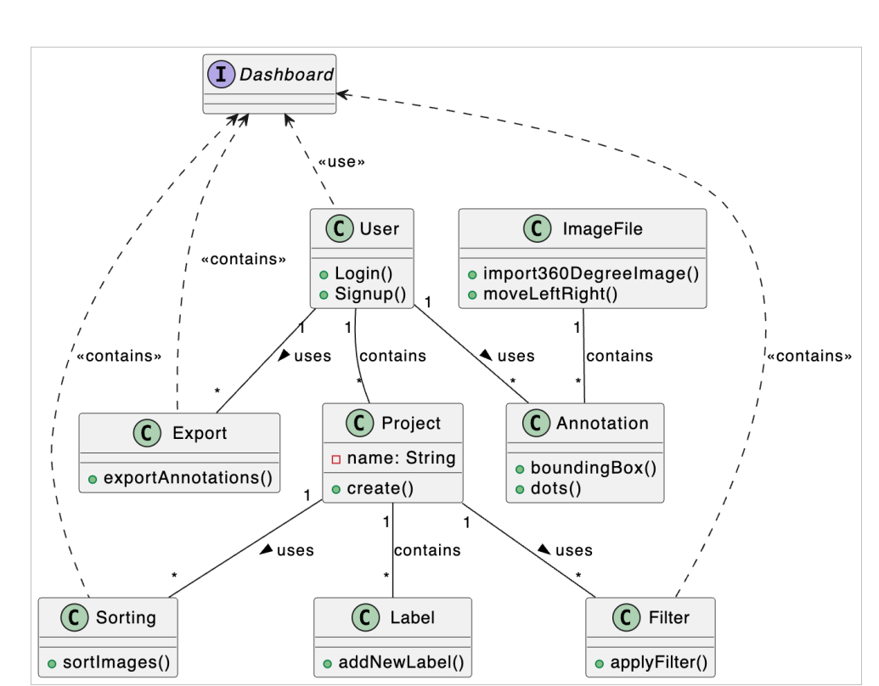

Use case diagram

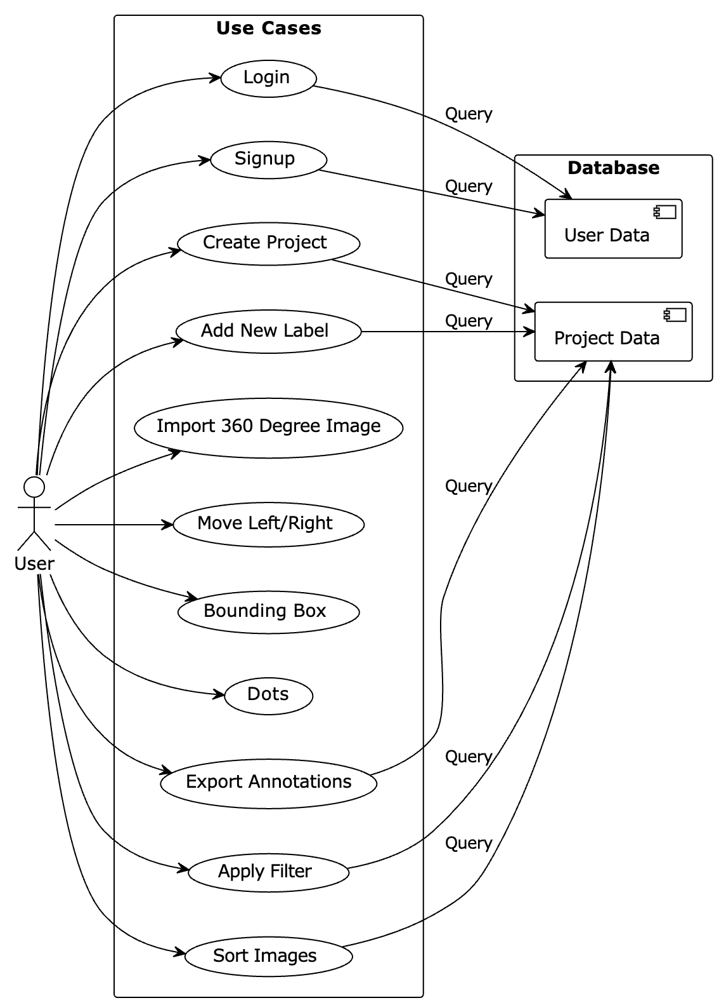

Use case description
Use Case Number: | UC-01
Use Case Name: | Login and Signup Page
Overview: | Create login and signup page
Actors: | User
Pre condition: | This is the first step . No pre requisites.
Flow: | - User comes to the main page .  - If user is not signed up, then user signs up otherwise user enters credentials .  - If credentials correct ,user is redirected to Projects page .
Alternate Flows:
- If the credentials are incorrect then a message is displayed saying credentials are wrong and login page is refreshed .
- If some credentials are left empty then a message is displayed saying that all details are not entered and page is refreshed.
Post Condition: | User is led to the Project page where he can view existing projects or he can create new projects

Use Case Number: | UC-02
Use Case Name: | Create Projects
Overview: | This is used to create a new project onto the software in which images will be imported and annotations will be done .
Actors: | User
Pre condition: | Database Already created for a particular user in other words user is logged in
Flow: | - For creating a new project in his profile, he clicks on add new button  - A form comes up for basic details like project name, type of project  - After clicking on create, a new project is created which is added to “my projects”.
Alternate Flows:
2. User is informed if a project already exists with the details the user entered. He is asked to enter new details.
Post Condition: | A new project is added to the software database

Use Case Number: | UC-03
Use Case Name: | Add Labels
Overview: | This feature is used to add new labels into the database as user wants .
Actors: | User
Pre condition: | Can only be added if a new project is created.
Flow: | 1. Add new labels as per user requirement.  2. Create new labels and take colour pallet input
Alternate Flow | 2. Show an error if such label already exists.
Post Condition: | A new label is shown every time you try to annotate an image

Use Case Number: | UC-04
Use Case Name: | Importing 360 degree Image file
Overview: | This is used for importing 360 degree image file which has to be annotated .
Actors: | User
Pre condition: | User should be present in a project .
Flow: | - User navigates to the file import section.  - User selects the images to be imported  - Then click on “ok” (jpg and png files are supported)
Alternate Flows:
- If any error occurs in between , user needs to re-upload images.
Post Condition: | The selected images are successfully imported into the software, ready for further processing or analysis.

Use Case Number: | UC-05
Use Case Name: | Moving the 360 degree to left or right .
Overview: | This is used to rotate the imported 360 degree image file to left or right so as to capture the whole picture on a given field of view .
Actors: | User
Pre condition: | A new panoramic image is available
Flow: | 1. User can use the user friendly experience to get a 360 deg experience from a 2d file
 | 1.If no images are available, the user is notified, and the annotation feature remains inactive.
Post Condition: | User can freely play around with the image
Use Case Number: | UC-06
Use Case Name: | Annotations using Bounding boxes
Overview: | Select a part of image by drawing a rectangle around it and adding designated labels to it.
Actors: | Annotator
Pre condition: | The label should be added before , no new labels are allowed at this step
Flow: | Main (success) Flow:  1. Deselecting the rotation and selecting the annotating feature  2. Draw a box around a portion of the image  3.Select a label and click ”ok”
Alternate Flows:
1. In case the label is not added to the list , go back add the label and then go back to annotation
Post Condition: | The file from the given link should be imported or show an error.
Post Condition: | The chosen annotation should be saved in the given format in the given location.

Use Case Number: | UC-07
Use Case Name: | Annotations using Dots
Overview: | Create a custom design to annotate a specific part of image
Actors: | User
Pre condition: | The system has 360-degree images available for annotation. And labels that he wants to label
Flow: | 1.User accesses the 360-degree image annotation feature.  2.User selects a specific 360-degree image for annotation.  3.User adds annotations to the selected image.  4.The system allows manipulation of the structure for detailed annotations.  5.User requests extraction of 2D images containing annotations.
1.If no 360-degree images are available, the user is notified, and the annotation feature remains inactive.
2.In case of annotation errors, the system provides error messages for correction.
Post Condition: | User successfully annotates on the 360-degree image and obtains 2D images with annotations extracted.

Use Case Number: | UC-08
Use Case Name: | Exporting Annotations
Overview: | Export the image annotations in a form that is tailor made for client
Actors: | Annotator
Pre condition: | Annotations
Flow: | Main (success) Flow:  1. Choose the annotation to be imported  2. Select the file format of the export  3. Choose the location to export
 | Alternate Flows: 3. Display an error if the file cannot be eported in the given format in the given location.
Post Condition: | The chosen annotation should be saved in the given format in the given location.

Use Case Number: | UC-09
Use Case Name: | Filter Images
Overview: | Provide a feature to filter images on the basis of client requirements
Actors: | Annotator
Pre condition: | The system has a collection of images with annotations.
Flow: | Main (success) Flow:  1. Select the filter option  2. Specify the filtering criteria  3. Retrieve images matching the specified criteria.  4. Provide the option to delete the criteria if required.
Alternate Flows:
3. If specified filtering criteria do not match any images in the system, the system informs the client that no images match the specified criteria.
3. If there are no images in the system, ask to import data.
Post Condition: | Displays filtered set of images based on the specified criteria.

Use Case Number: | UC-10
Use Case Name: | Image Sorting Functionality:
Overview: | Provide sorting functionality for images based on various parameters as specified by the client, enhancing user experience and data management.
Actors: | User
Pre condition: | The system has a collection of images.
Flow: | Main (success) Flow:  Main (success) Flow:  1. Select the sort option  2. Specify the sorting criteria  3. Retrieve images matching the specified criteria.  4. Provide the option to delete the criteria if required.
3. In case of an error in sorting, an error message is displayed, and the user is notified.
3. If there are no images in the system, ask to import data.
Post Condition: | You can view the sorted set of images based on the specified criteria.

