Product Design

|  |  |
| --- | --- |
| **Team** | **Team-3**  Karan Nijhawan  Sanchit Jalan  Sreeja Palle  Manda Vaishnavi Reddy |

# Design Model

|  |  |
| --- | --- |
| User | Class state   * Maintains user information such as username, password, and user preferences.   Class behavior   * logging in * logging out * updating user information * managing user preferences. |
| Image | Class state   * *Information about the image file, such as file name, size, and format.* * *Metadata related to the image, such as creation date, uploader, etc.* * *Navigation controls state (e.g., current view angle, zoom level).*   Class behavior   * *Methods to import/upload image files.* * *Functionality to navigate the image using controls provided.* * *Functionality to save annotation data.* * *Export methods to save the annotated image with labels.* |
| Annotation | Class state   * *Metadata related to annotations (e.g., creation date, author).* * *Position and size information for the annotated regions.*   Class behavior   * *Methods to create, edit, and delete annotations.* * *Methods to retrieve annotation data associated with an image.* |
| Label | Class state   * *Labels or tags assigned to a project for categorization or classification purposes.* * *Metadata related to labels (e.g., creation date, color-coding).*   Class behavior   * *Methods to assign, remove, and modify labels.* * *Add Color for each label.* * *Methods to retrieve images or annotations based on specific labels.* |
| Project | Class state   * Project details such as name, description, and associated images.   Class behavior   * *Functionality to display uploaded images and navigate between them.* * *Interface methods to interact with user inputs and controls.* * *Sort and Filter options* |
| Dashboard | Class state   * Contains Project list and other navigations   Class behavior   * *Create Project option* * *Acts as an interface for other functionalities* |

.

**UML Class Diagram**

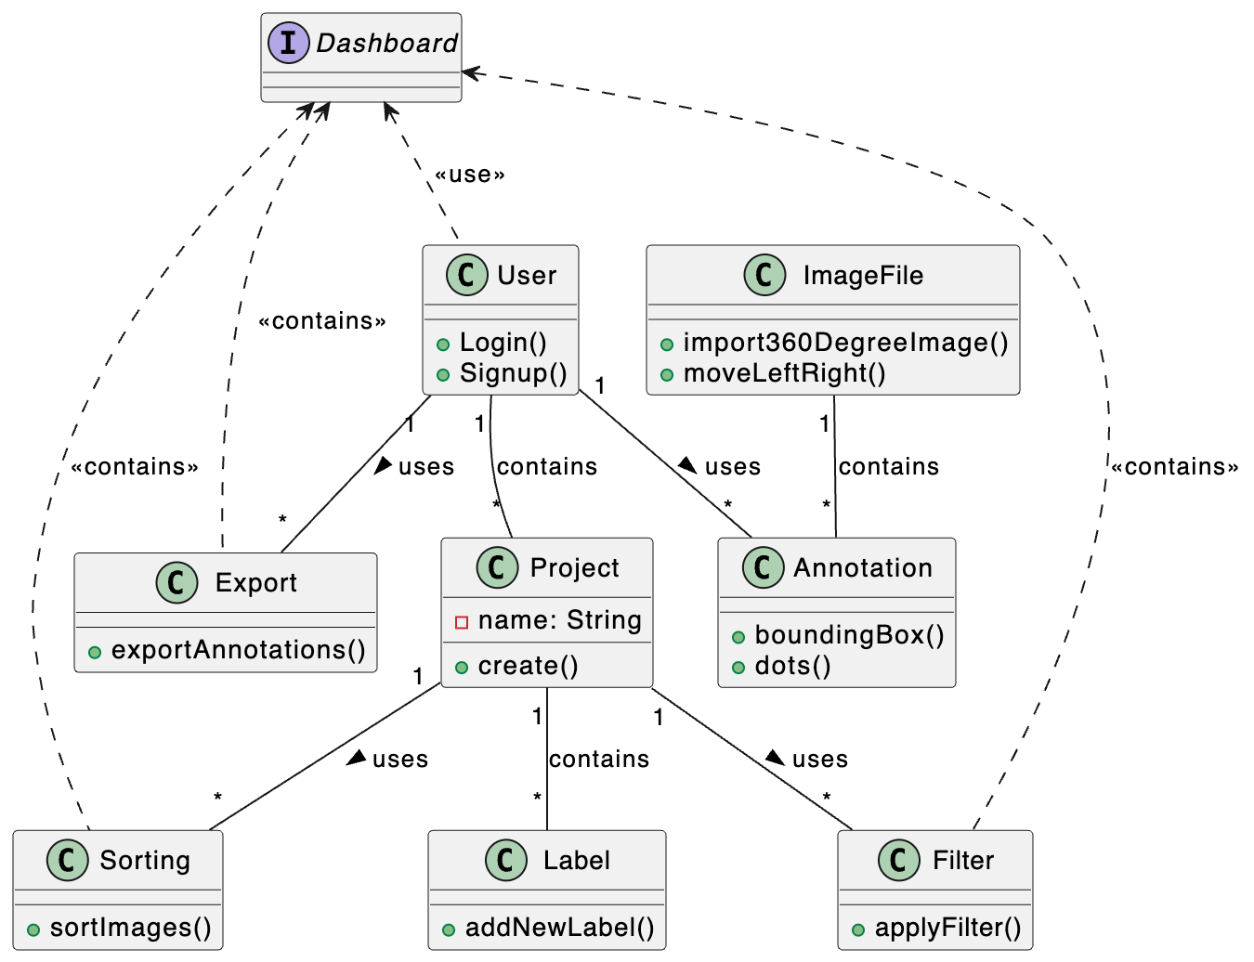

# Sequence Diagram(s)

# 1.

# 

2.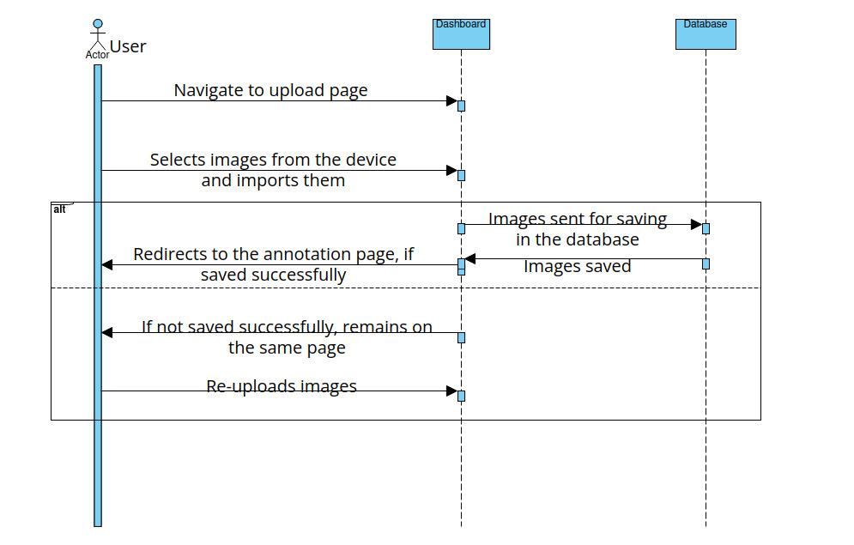

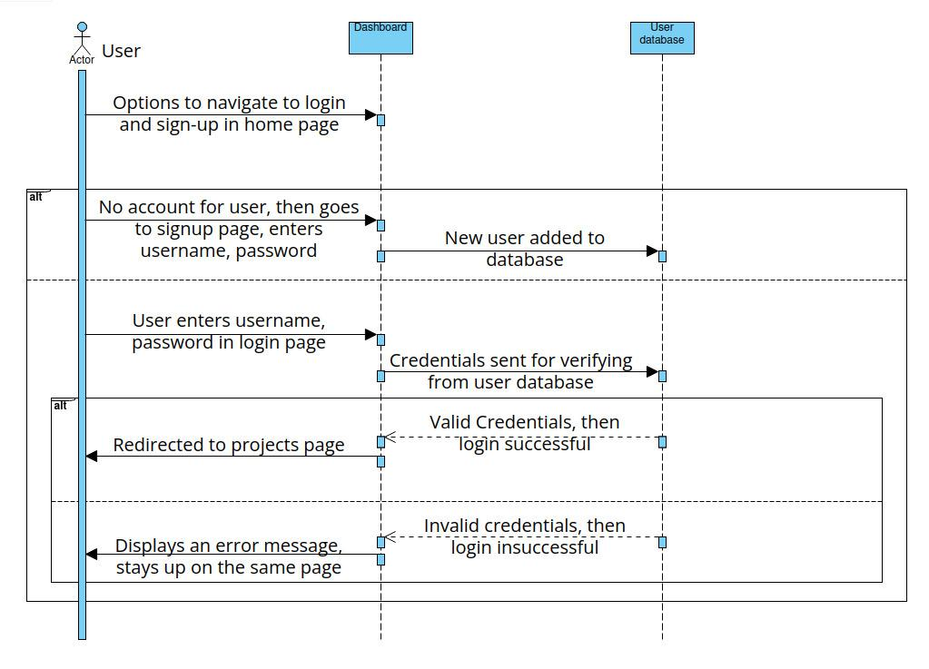

3.

4.

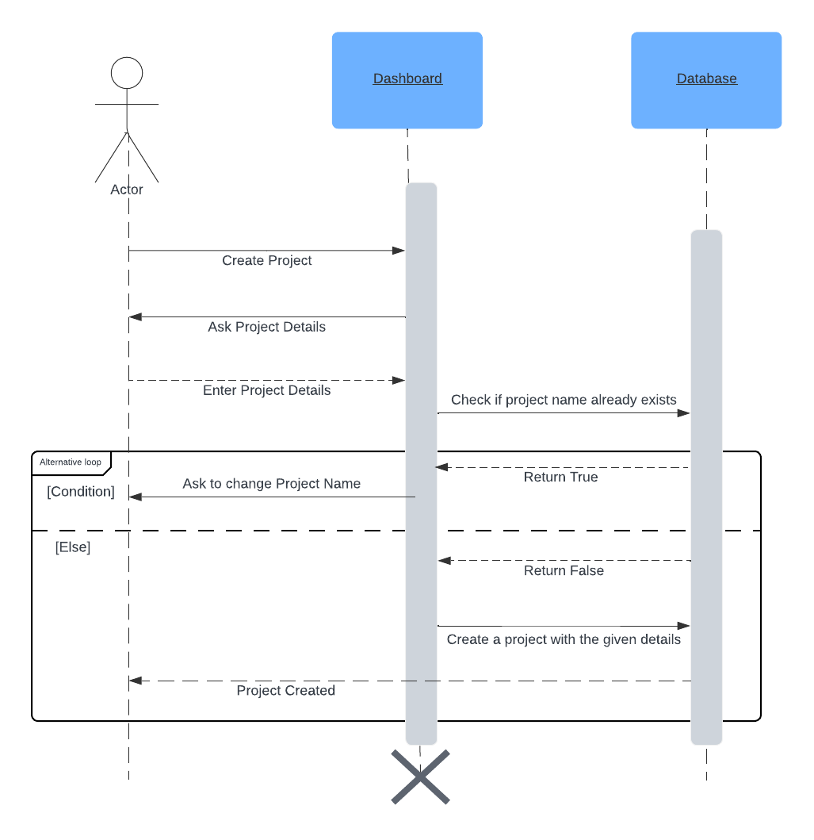

**Design Rationale**

First prototype , future changes will be recorded….