**Neural Networks**

**Objective:** To implement the understanding of Neural Networks for binary class classification and multi-class classification and experimenting with different number of neurons in the hidden layer and understand its effects.

**Methodology**: Using the file Final Project.pdf, we thoroughly understood the instructions on how to do the assignment and understand the concepts related to neural networks in a more efficient manner.

**Data Files:** *lab3cardata.mat* is the file which provides us data set which consists of 6 features to identify the acceptable rating of car to mark it out if it is ‘fit to drive’ or not.

**Program Files**: *sigmoid.m* is used to calculate the sigmoid of all elements inserted in the input array.

*dsigmoid.m* calculates the derivative of each of the sigmoid function values to go in the array.

*forward_propagation.m* is used to perform the forward propagation on the data matrix where it goes from the input layer to the hidden layer and from the hidden layer to the output layer.

*predict_class.m* is used to predict the class of the input dataset corresponding to the nearest weights. *part1.m* is used to solve the XOR problem with Gradient Descent using neural networks.

*costFunction_NN_reg.m* is used to calculates the accuracy of the outputs predicted where it returns the gradients of the weights and performs regularization on the dataset. It calculates the cost to use those weights in neural network as well as the gradient vector where each weight has its error gradient evaluated at these current weights. *part2.m* is used to predict the optimal car acceptability using the training dataset.

*part3.m* is used to recalculate the results of part 1 with the use of Support Vector Machines (SVMs) to solve the XOR problem. *part4.m* recalculates the results of part 2 using SVMs to solve the car acceptability.

*plot_XOR_and_reqgions.m* is used to plot the XOR graph and plotting the decision boundaries for each class with the provided matrices.

*fmcing.m* is used to calculate the minimum of a cost function using the conjugate gradient method to calculate the minimum.

**Outputs:**

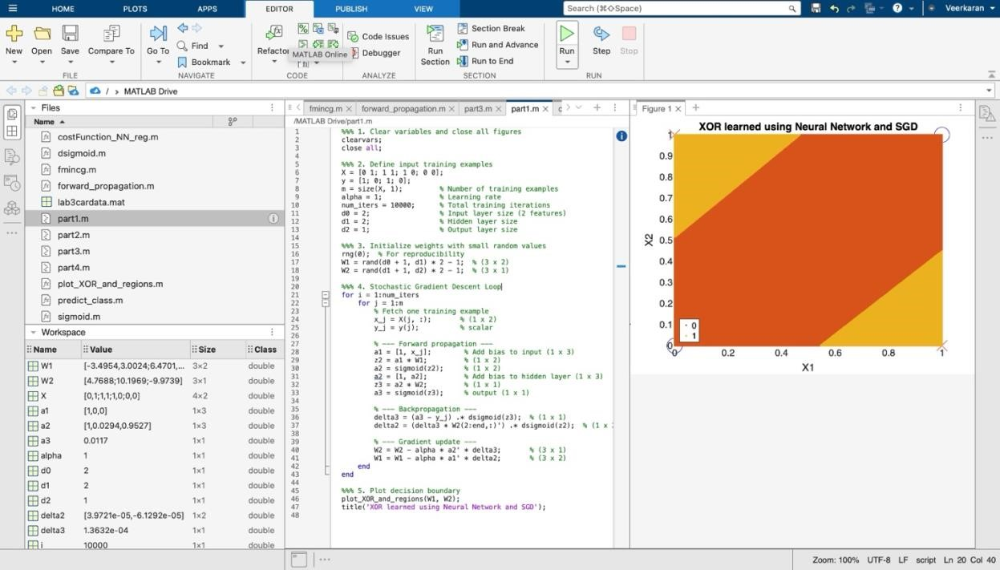

*Figure 1: Displays the learning using neural networks*

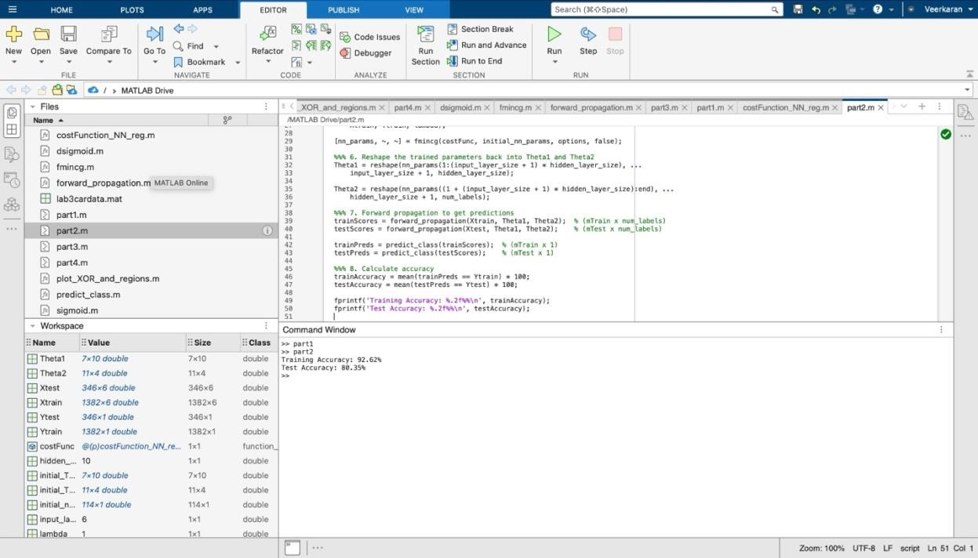

*Figure 2: Creating the prediction model and calculating its accuracy*

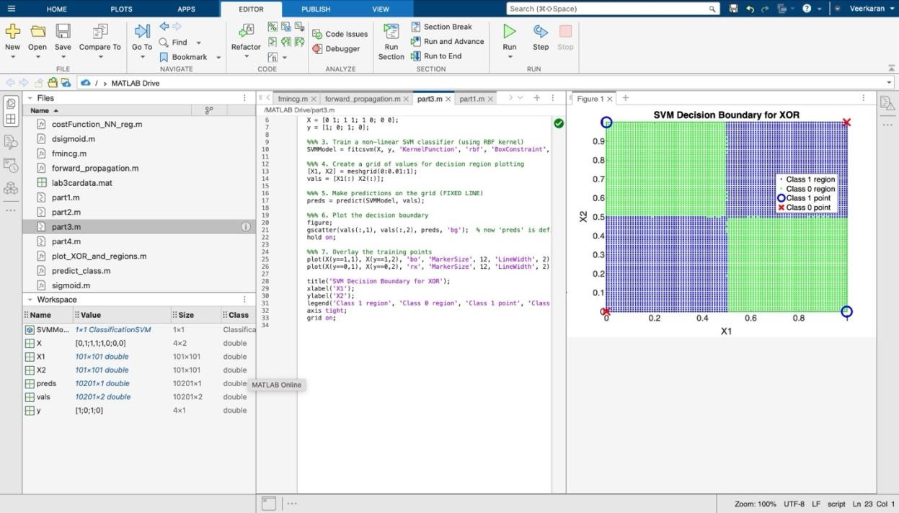

*Figure 3: Drawing the SVM decision boundary for XOR graph*

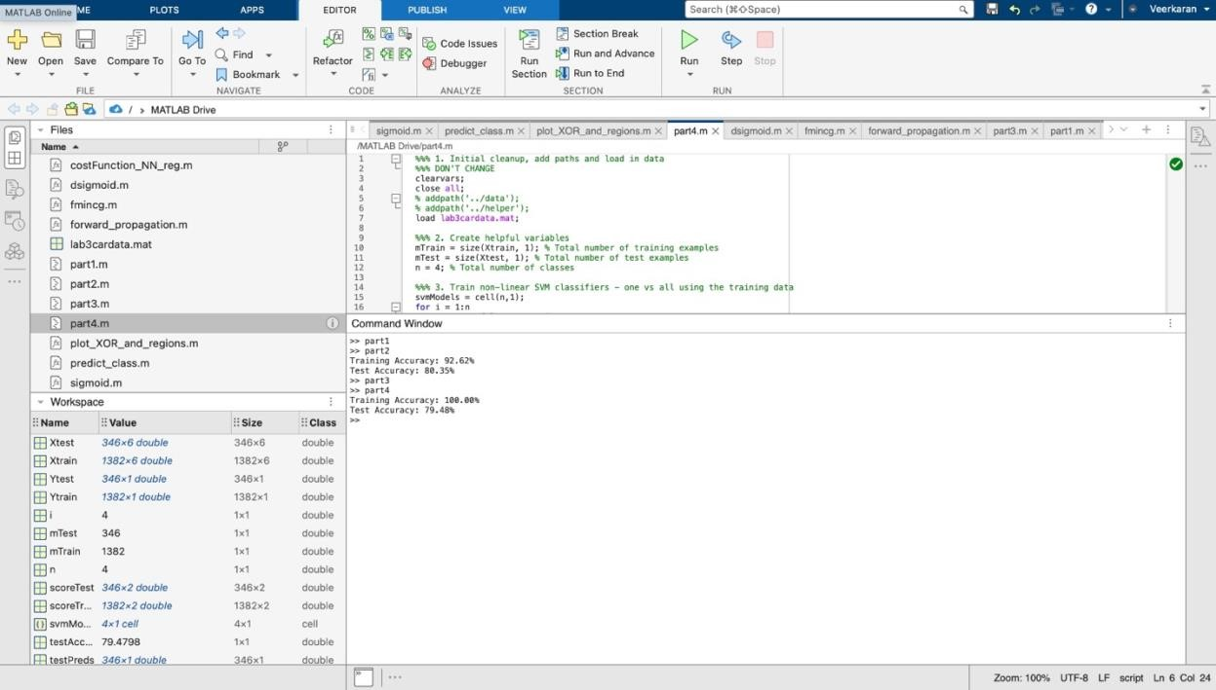

*Figure 4: Creating the prediction model and calculating its accuracy using SVM*

**Conclusion:** This assignment provided us a clear understanding of neural networks. We plotted a graph and drew a decision boundary to signify different classes. We used sigmoid and dsigmoid to calculate the g(z) and the derivative of g(z) respectively. In addition, we made predication and calculated its accuracy.